ARROWSTACK
PROJECT DOCUMENTATION
Multi-Table SQL Queries &
Cohort Retention Analysis
DATA ANALYTICS INTERNSHIP | TASK 1
Project detail | Information
Organization | Arrowstack
Internship domain | Data Analytics
Assignment | Task 1 — Multi-Table SQL Queries & Cohort Retention Analysis
Database | PostgreSQL 18 (arrowstack_ecommerce)
Database tool | pgAdmin 4
Dataset | Brazilian E-Commerce Public Dataset by Olist
Dataset period | 2016–2018
Prepared by | [Add your full name]
GitHub repository | [Add repository URL after publishing]
Prepared as an internship project submission

Document Guide
1. Project Overview
2. Technology Stack
3. Dataset Description
4. Project Structure
5. Database Design
6. Data Import and Preparation
7. Data Validation
8. Business SQL Analysis
9. Customer Cohort Retention Analysis
10. Business Insights
11. SQL Concepts Demonstrated
12. Limitations and Considerations
13. Conclusion

1. Project Overview
This project analyzes Brazilian e-commerce transaction data using PostgreSQL. It focuses on business performance, customer purchasing behavior, product and seller performance, payment patterns, delivery performance, and monthly customer cohort retention.
The workflow covers relational database setup, CSV ingestion, data validation, multi-table SQL analysis, cohort construction, retention measurement, and documentation.

Project Objectives
- Design and populate a relational PostgreSQL database.
- Import and organize multiple related CSV datasets.
- Perform data quality and integrity checks.
- Use multi-table joins and aggregate queries to answer business questions.
- Analyze revenue, customers, products, sellers, payments, and delivery performance.
- Identify repeat customers and calculate monthly cohort retention.
- Document methods, findings, limitations, and reproducibility steps.

2. Technology Stack
Technology | Purpose
PostgreSQL 18 | Relational database and SQL execution engine
pgAdmin 4 | Database administration, CSV imports, and query execution
SQL | Data extraction, transformation, validation, and analysis
CSV | Source data format
Git and GitHub | Version control and project hosting

3. Dataset Description
The project uses the Brazilian E-Commerce Public Dataset by Olist, a public dataset containing historical e-commerce transactions and related entities from 2016 to 2018.
Dataset source: https://www.kaggle.com/datasets/olistbr/brazilian-ecommerce
Table | Description | Expected records
customers | Customer identifiers and location attributes | 99,441
orders | Order status and lifecycle timestamps | 99,441
order_items | Products, sellers, prices, and freight per order item | 112,650
payments | Payment type, installments, and payment values | 103,886
products | Product attributes and category identifiers | 32,951
sellers | Seller identifiers and location attributes | 3,095
reviews | Customer review scores, comments, and timestamps | 99,224
geolocation | ZIP-prefix location and coordinate records | 1,000,163
category_translation | Portuguese-to-English category mapping | 71
Record counts are the expected reference counts for the source files. The category translation table should contain 71 mappings once the CSV header row is excluded from the import.

4. Project Structure
Repository layout used for this project:
Arrowstack-Task1/
├── data/
│ ├── raw/ # excluded from GitHub
│ └── demo/
├── sql/
│ ├── 01_create_tables.sql
│ ├── 02_data_validation.sql
│ ├── 03_business_analysis.sql
│ └── 04_cohort_retention.sql
├── analysis/
│ └── cohort_retention_results.csv
├── documentation/
│ ├── PROJECT_DOCUMENTATION.docx
│ ├── data_dictionary.md
│ ├── data_quality_report.md
│ └── business_insights.md
├── screenshots/
├── .gitignore
└── README.md

Raw datasets are excluded from the repository to avoid large uploads.

5. Database Design
The PostgreSQL database is named arrowstack_ecommerce and contains nine tables. The design connects customer records to orders, orders to order items and payments, and products and sellers to the corresponding order items.
Relationship | Description
customers → orders | A customer record can be associated with multiple orders.
orders → order_items | An order can contain multiple purchased items.
orders → payments | An order can have one or more payment records.
products → order_items | Product records describe the items purchased.
sellers → order_items | Seller records identify the seller for each item.
orders → reviews | Review records are associated with orders.
products → category_translation | Category names can be mapped to English labels.

The customer_unique_id field identifies a customer across multiple customer records and is used when constructing customer cohorts. customer_id is the order-level customer record key.
The pgAdmin Object Explorer and query result below confirm that the arrowstack_ecommerce database contains all nine tables in the public schema.
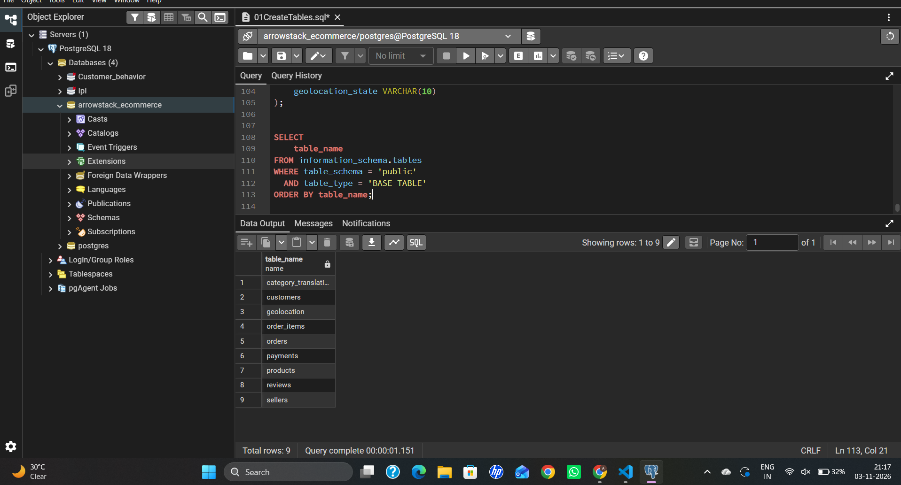
Figure 1: pgAdmin showing the arrowstack_ecommerce database and the nine tables in the public schema

6. Data Import and Preparation
The CSV files were imported into their corresponding PostgreSQL tables using pgAdmin's Import/Export Data feature. Imports were performed in dependency order so referenced customer, seller, and product records existed before dependent transactional rows.
- Create the arrowstack_ecommerce database.
- Create the nine table definitions using the schema script.
- Import customers, sellers, products, and category translations.
- Import orders and geolocation.
- Import order items, payments, and reviews.
- Verify row counts and inspect representative records.

The reviews table includes a generated review_row_id identity column. The source CSV does not contain this column, so it is omitted from the import column list to allow PostgreSQL to generate it.

7. Data Validation
Validation checks were run before business analysis. The checks included:
- Duplicate customer_id values.
- Duplicate order_id values.
- Orders without matching customer records.
- Orders without corresponding order items.
- Review scores outside the expected 1–5 range.
- Negative item prices.
- Missing order purchase timestamps.

The review source identifier review_id can repeat, so review_row_id is used as a generated row-level primary key to preserve every source record. Geolocation ZIP prefixes can also repeat and are not treated as a unique key. The validation queries are stored in sql/02_data_validation.sql.

8. Business SQL Analysis
The business analysis script answers eight questions using joins, aggregations, date functions, filtering, and grouping. Each result below was produced in pgAdmin against the imported database.

8.1 Overall Business Performance
Calculates total orders, unique customers, product revenue, freight revenue, and average order value.
Metric | Result
Total orders | 96,478
Unique customers | 93,358
Total product revenue | 13,221,498.11
Total freight revenue | 2,198,275.64
Average order value | 137.04
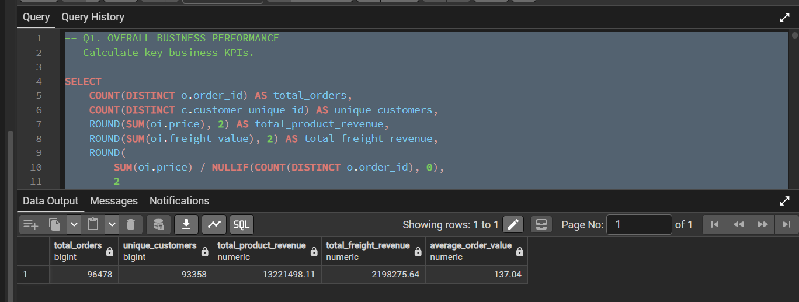
Figure 2: Q1 — Overall business KPIs

8.2 Monthly Revenue Trend
Groups orders by calendar month with DATE_TRUNC() and aggregates order volume and product revenue. The query returns 23 monthly rows, from September 2016 onward.
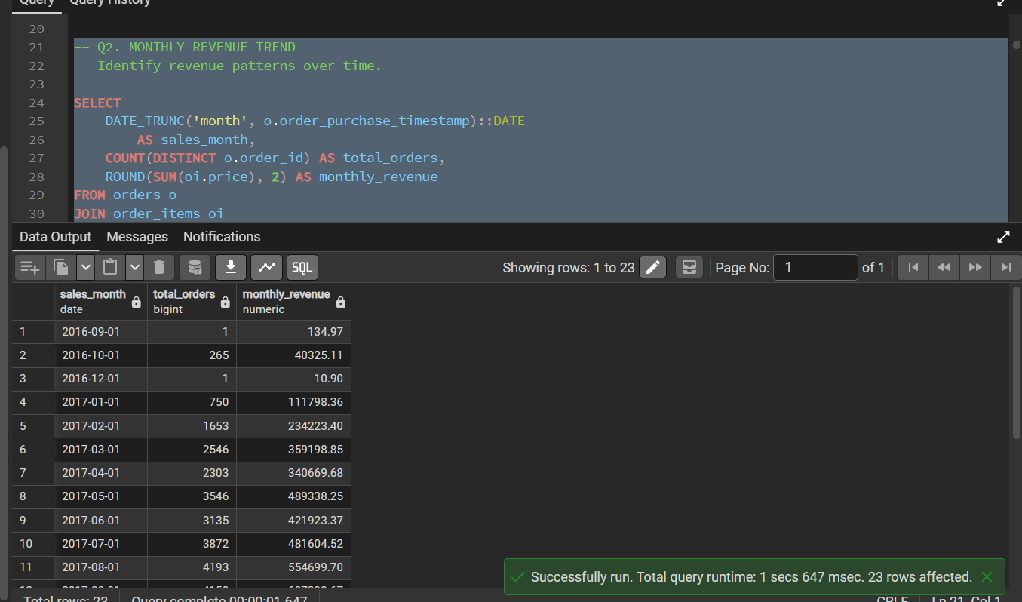
Figure 3: Q2 — Monthly orders and product revenue (rows 1–11 of 23 shown)

8.3 Top Customers
Ranks customer_unique_id values by total product spending on delivered orders and returns the top ten.
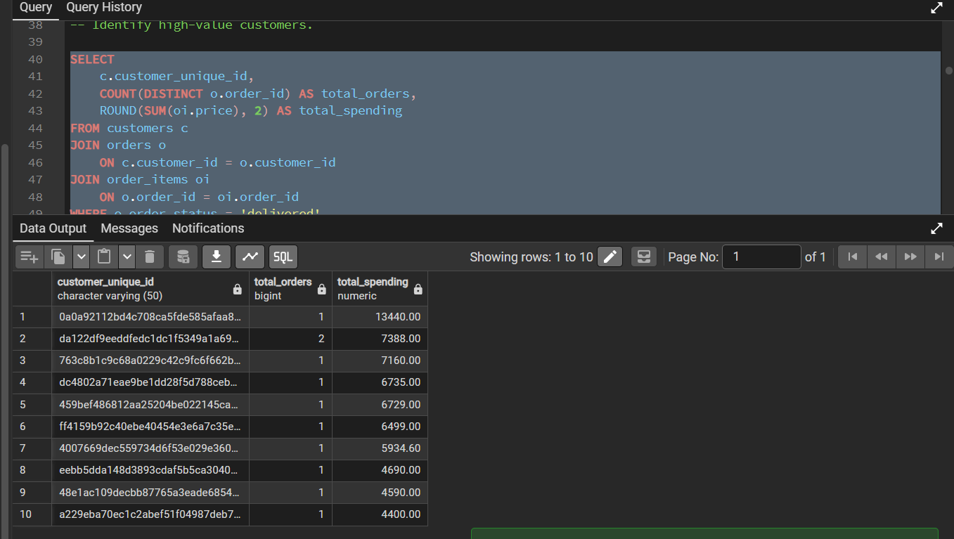
Figure 4: Q3 — Top 10 customers by total spending

8.4 Product Category Performance
Joins products, order items, and the category translation table to rank categories by product sales revenue. Revenue is item price and does not represent net profit.
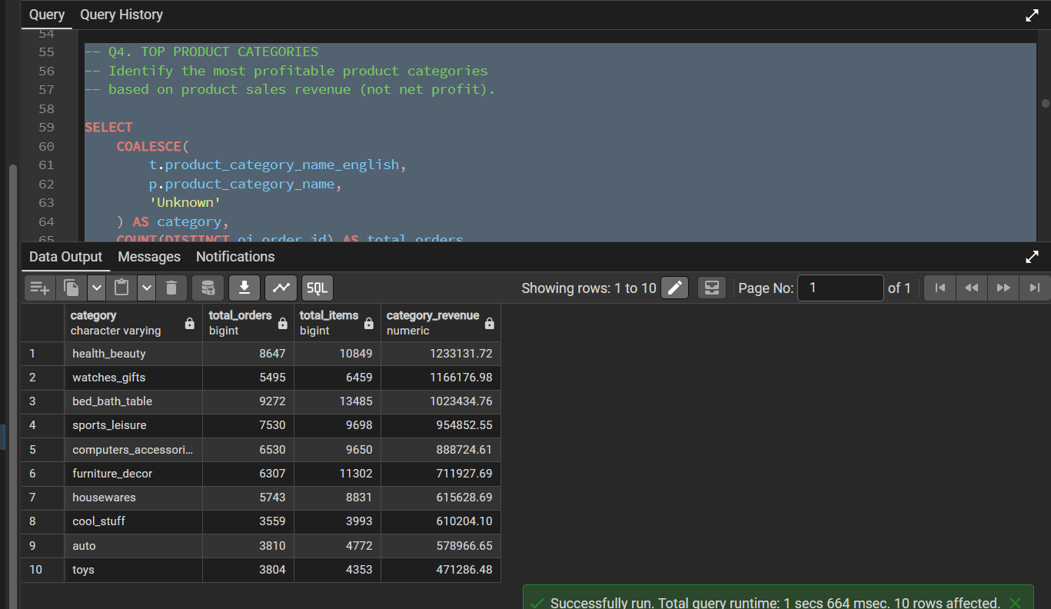
Figure 5: Q4 — Top 10 product categories by revenue

8.5 Payment Method Analysis
Summarises orders, total payment value, and average payment value by payment type.
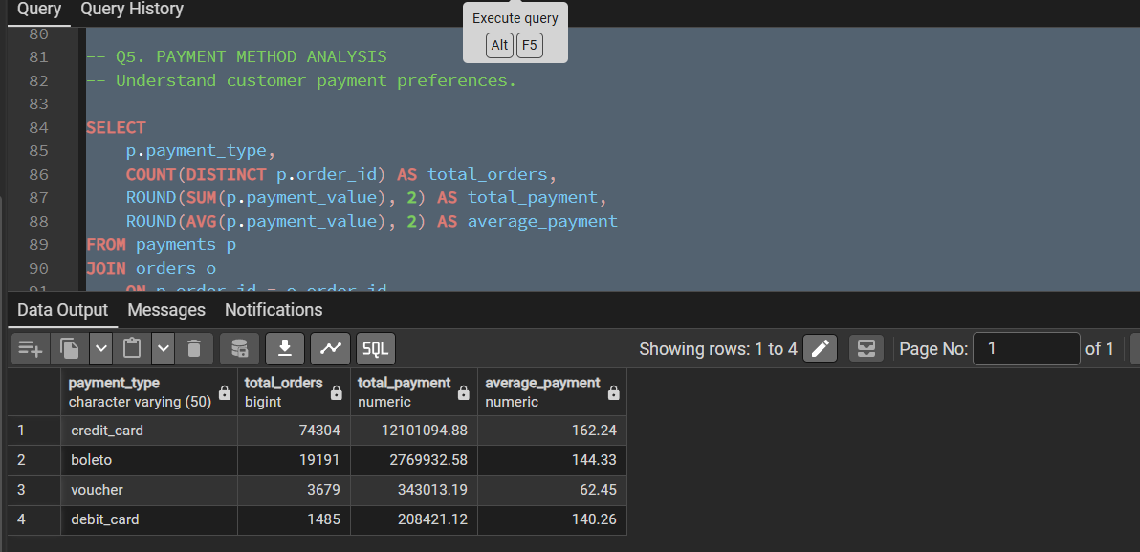
Figure 6: Q5 — Payment method analysis

8.6 Seller Performance
Ranks sellers by product revenue and reports seller city, state, distinct orders, and items sold.
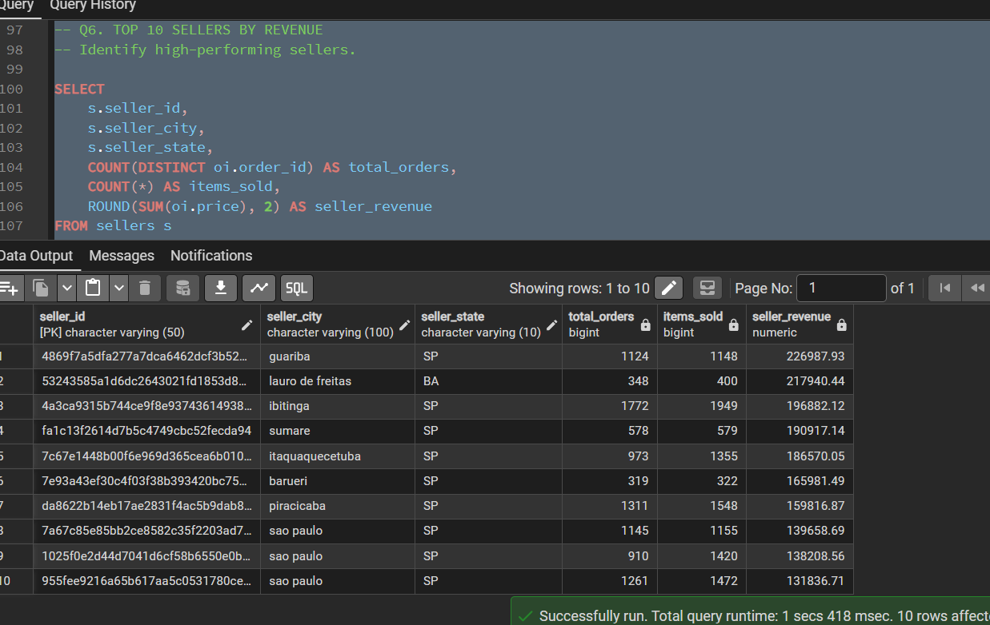
Figure 7: Q6 — Top 10 sellers by revenue

8.7 Delivery Performance
Uses purchase, estimated delivery, and actual delivery timestamps to calculate average delivery time and late deliveries.
Metric | Result
Delivered orders | 96,470
Average delivery time | 12.56 days
Late deliveries | 7,826
Late delivery percentage | 8.11%
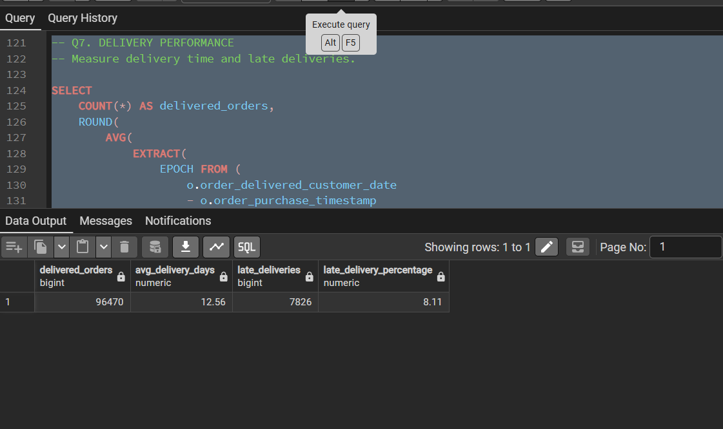
Figure 8: Q7 — Delivery performance

8.8 Repeat Customers
Lists every customer_unique_id with more than one delivered order, together with order count and total spending. The query returned 2,801 repeat customers.
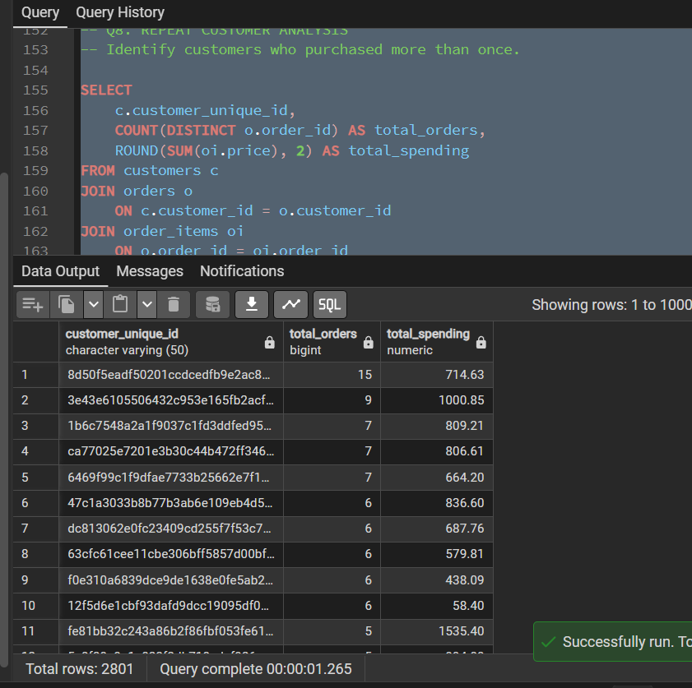
Figure 9: Q8 — Repeat customers ranked by number of orders (2,801 rows)

9. Customer Cohort Retention Analysis
Cohort analysis groups customers by a shared starting event. In this project, a customer's cohort month is the calendar month of their first delivered purchase. Subsequent delivered purchase activity is compared with that original cohort.

9.1 First Purchase and Cohort Assignment
The first delivered purchase timestamp is identified for each customer_unique_id using MIN(order_purchase_timestamp) grouped by customer_unique_id. DATE_TRUNC('month', …) converts that timestamp into a monthly cohort label.
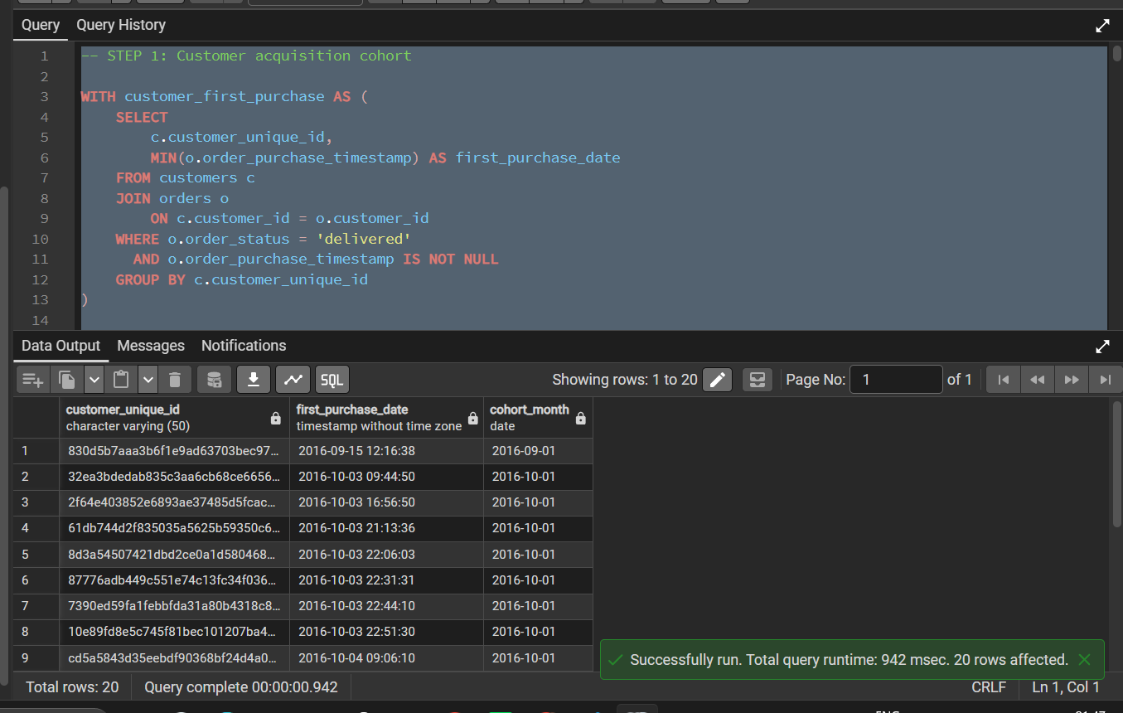
Figure 10: Step 1 — Customer acquisition cohort (first purchase date and cohort month)

9.2 Monthly Customer Activity
Customer activity is recorded by calendar purchase month. This produces customer-month combinations (95,194 rows) and is not a count of distinct customers across the dataset.
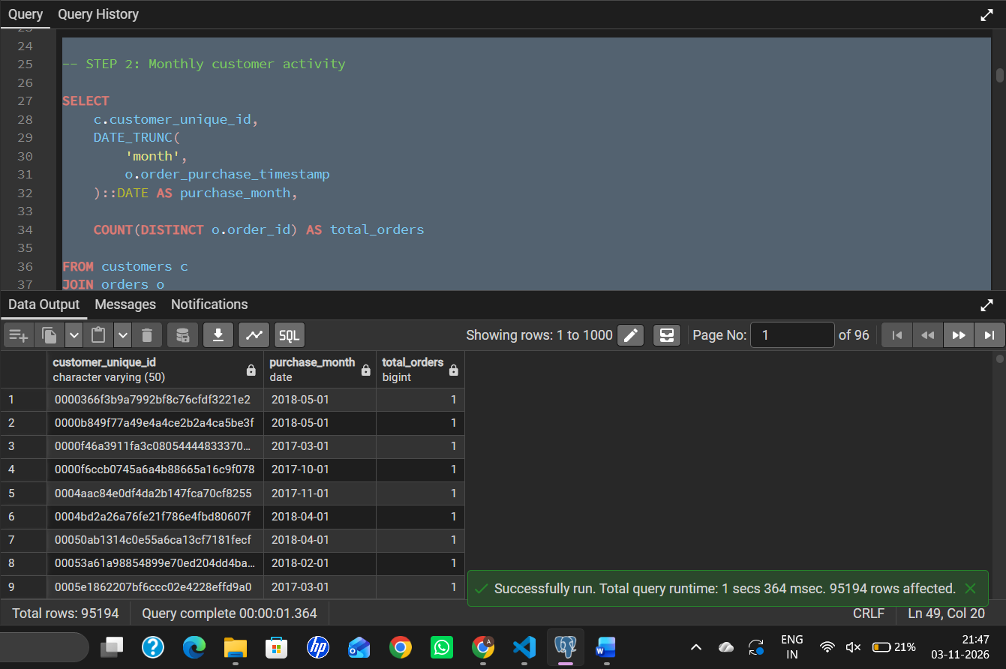
Figure 11: Step 2 — Monthly customer activity

9.3 Retention Calculation
Retention Rate (%) = (Active customers in cohort month ÷ Original cohort size) × 100
Month 0 represents the acquisition month and equals 100% for every cohort. Later months show the share of the original cohort that made at least one delivered purchase. The output has one row per cohort and month number (219 rows).
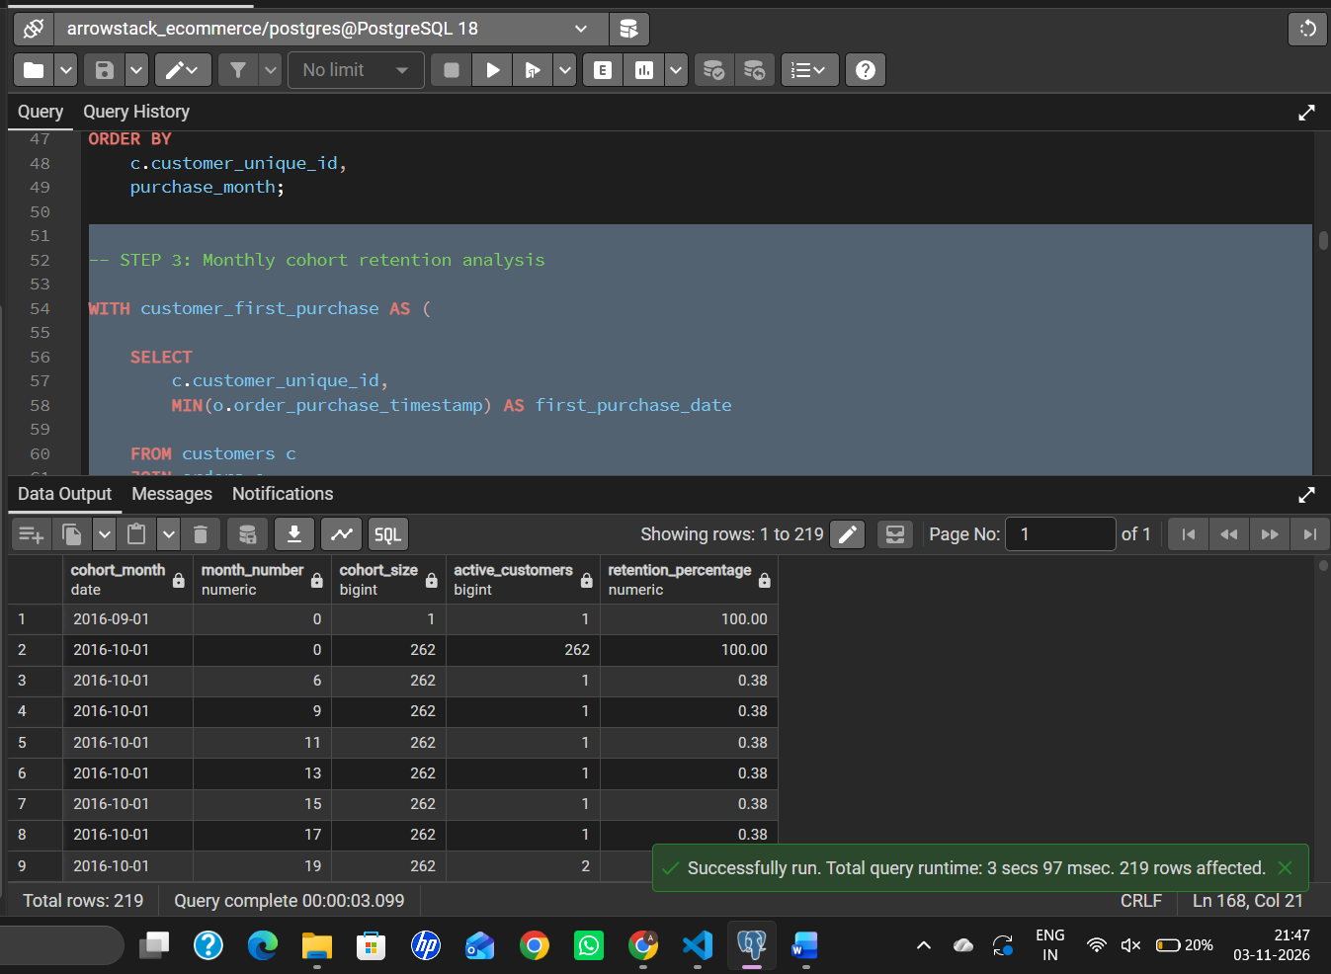
Figure 12: Step 3 — Monthly cohort retention (cohort size, active customers, retention %)

9.4 Cohort Retention Matrix
The matrix pivots the retention rows so that each cohort is a row and each month since acquisition is a column (month_0, month_1, …). A NULL indicates that no activity was recorded for that cohort and month, or that the period falls outside the observed data window; it is not a measured zero.
Reading the values: percentages are expressed on a 0–100 scale, so 0.44 means 0.44% of the cohort, not 44%.
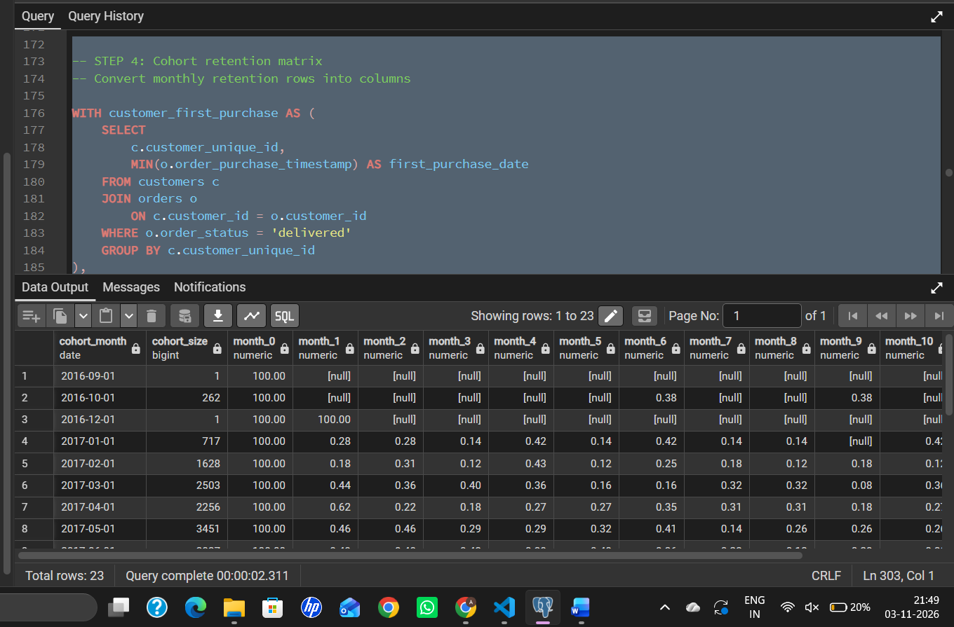
Figure 13: Step 4 — Cohort retention matrix (23 cohorts)

9.5 Month 1 Retention by Cohort
Cohorts are ranked by the share of customers who purchased again in the month immediately after acquisition.
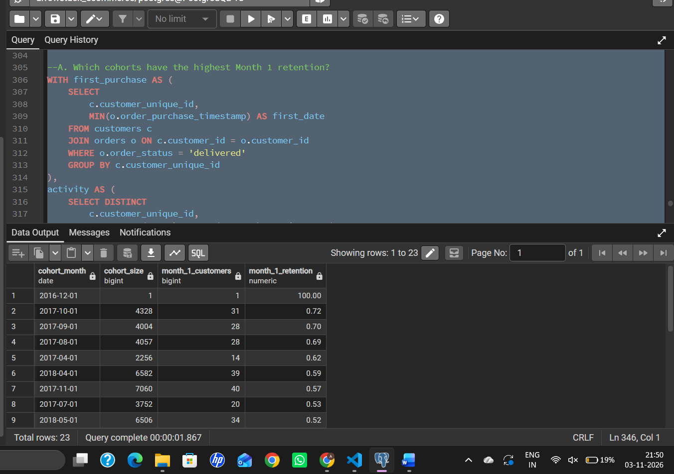
Figure 14: Month 1 retention ranked by cohort

9.6 Overall Repeat Customer Percentage
A repeat customer is a customer_unique_id with more than one delivered order. The percentage is repeat customers divided by all customers with at least one delivered order, multiplied by 100.
Metric | Result
Total customers | 93,358
Repeat customers | 2,801
Repeat customer percentage | 3.00%
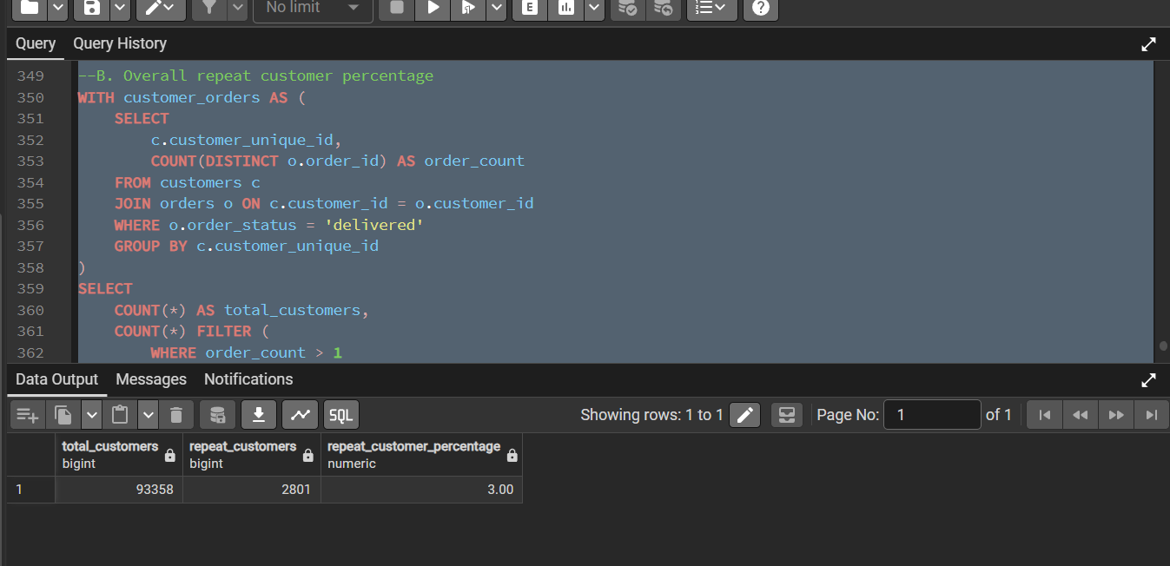
Figure 15: Overall repeat customer percentage

10. Business Insights
The findings below are taken directly from the query outputs shown in this document.
Area | Finding
Overall performance | 96,478 orders from 93,358 unique customers generated 13,221,498.11 in product revenue plus 2,198,275.64 in freight, with an average order value of 137.04.
Revenue trend | The business scaled quickly after a negligible start in late 2016 (1 order in September, 265 in October, 1 in December). Monthly orders rose from 750 in January 2017 to 4,193 in August 2017, and monthly revenue from 111,798.36 to 554,699.70 over the same period.
Product categories | health_beauty (1,233,131.72), watches_gifts (1,166,176.98) and bed_bath_table (1,023,434.76) lead on revenue. Together these three make up roughly 26% of total product revenue, and the top ten categories roughly 62%. bed_bath_table has the highest volume (9,272 orders, 13,485 items) but ranks third on revenue, while watches_gifts earns more revenue from fewer orders.
Customers | The highest-spending customer placed a single order worth 13,440.00; the next, with 2 orders, spent 7,388.00. Top spending in this dataset comes mostly from single large purchases rather than frequent buying.
Sellers | Nine of the top ten sellers by revenue are based in São Paulo state (SP). The leading seller, in Guariba (SP), earned 226,987.93 from 1,124 orders, while the second, in Lauro de Freitas (BA), earned 217,940.44 from only 348 orders, indicating a much higher revenue per order. The top ten sellers account for roughly 13% of product revenue.
Payments | Credit card dominates: 74,304 orders and about 78.5% of total payment value, followed by boleto (19,191 orders, about 18.0%). Vouchers have a much lower average payment (62.45) than credit card (162.24) and boleto (144.33), consistent with their use for smaller or partial payments. Debit cards are rarely used (1,485 orders).
Delivery | Delivered orders took an average of 12.56 days, and 7,826 of 96,470 (8.11%) arrived after the estimated delivery date.
Repeat purchasing | Only 2,801 of 93,358 customers (3.00%) placed more than one delivered order. The most active customer placed 15 orders.
Cohort retention | Retention after the first month is very low across cohorts. Among the larger cohorts, Month 1 retention is highest for October 2017 (0.72%; 31 of 4,328), September 2017 (0.70%) and August 2017 (0.69%). The December 2016 cohort shows 100% but contains a single customer and is not meaningful. Early cohorts such as January–May 2017 return only 0.18%–0.62% in Month 1.

Recommendations
- Prioritise customer retention: with only 3.00% repeat customers and Month 1 retention below 1% in every sizeable cohort, post-purchase engagement (follow-up offers, reminders, loyalty incentives) represents the largest growth opportunity.
- Focus category and inventory investment on health_beauty, watches_gifts, bed_bath_table, and sports_leisure, which lead revenue.
- Review seller concentration in São Paulo state and assess whether onboarding sellers in other regions could improve delivery coverage.
- Investigate the causes of the 8.11% late-delivery rate, since delivery delays can affect customer satisfaction and repeat purchase behavior.

11. SQL Concepts Demonstrated
SQL concept | How it is used
SELECT / WHERE | Selecting and filtering relevant records, such as delivered orders.
JOIN | Combining customers, orders, order items, products, sellers, and payments.
GROUP BY / HAVING | Aggregating records and filtering grouped results.
COUNT(DISTINCT) | Counting unique customers and orders.
SUM / AVG / ROUND | Calculating revenue, totals, and averages.
COALESCE / NULLIF | Handling missing category names and avoiding division by zero.
CTEs | Breaking cohort logic into readable stages.
DATE_TRUNC | Grouping timestamps by calendar month.
MIN() | Identifying each customer's first purchase.
FILTER | Conditional aggregation in retention and repeat-customer calculations.

12. Limitations and Considerations
- The dataset contains historical transactions from 2016–2018 and does not describe current market conditions.
- The analysis represents Brazilian e-commerce activity.
- A customer with no purchase in a month is inactive for that month, but this does not prove permanent churn.
- Product revenue based on item price is not equivalent to net profit.
- Cohort analysis is based on delivered orders and the observed data window; later cohorts have fewer months of follow-up, which produces NULL values in the matrix.
- Cohorts with very small sizes (for example September 2016 and December 2016, each with one customer) produce unstable percentages and should not be compared with larger cohorts.
- Q1 reports 96,478 delivered orders while Q7 reports 96,470. The two queries use different filters, so this small difference should be checked against the SQL scripts before the figures are quoted together.
- The data does not establish why a customer did not return.

13. Conclusion
This project demonstrates an end-to-end SQL analytics workflow using PostgreSQL. It combines relational database design, multi-table querying, data validation, business performance analysis, and monthly customer cohort retention.
The analysis shows a business that grew rapidly through 2017, is driven by credit-card payments and a few leading categories, and delivers in about 12.6 days on average. Its most significant challenge is customer retention, with only 3.00% repeat customers and very low month-over-month cohort retention. The resulting SQL scripts and documented evidence provide a reproducible basis for reviewing the work and discussing analytical decisions.
END OF DOCUMENT

