BGP Project Capstone – One Pager (Version 1.2)
Objective
Our company, XFT, is incorporating Border Gateway Protocol (BGP) into its sites. BGP will run between the company's sites and its partners to exchange the prefixes that meet the business needs of the company and its partners.

Architecture – version 1.2
We currently have three branches: California (CA), Texas (TX), and New York (NY).
California remains the headquarters.
In the south, we have three partner companies: A (AS 65001), B (AS 65002), and C (AS 65003).
In the north, we have three partner companies: X (AS 65010), Y (AS 65011), and Z (AS 65012).
XFT runs as a single autonomous system, AS 65000, with an OSPF area 0 backbone across all three sites and a full iBGP mesh between the CA, TX, and NY border routers (the CA–NY session rides through TX; there is no direct CA–NY link). No eBGP yet — partner peering arrives in version 2.
Design notes (v1.2)
Partner C is assigned AS 65003, continuing the south block (65001–65003).
TX is an accepted single point of failure: it is the only physical path between CA and NY, and the CA–NY iBGP session transits it. Accepted for v1; revisit when a CA–NY link is priced.
OSPF area 1 (Texas) internals — including which router originates the default route into it — are deferred to a later version.
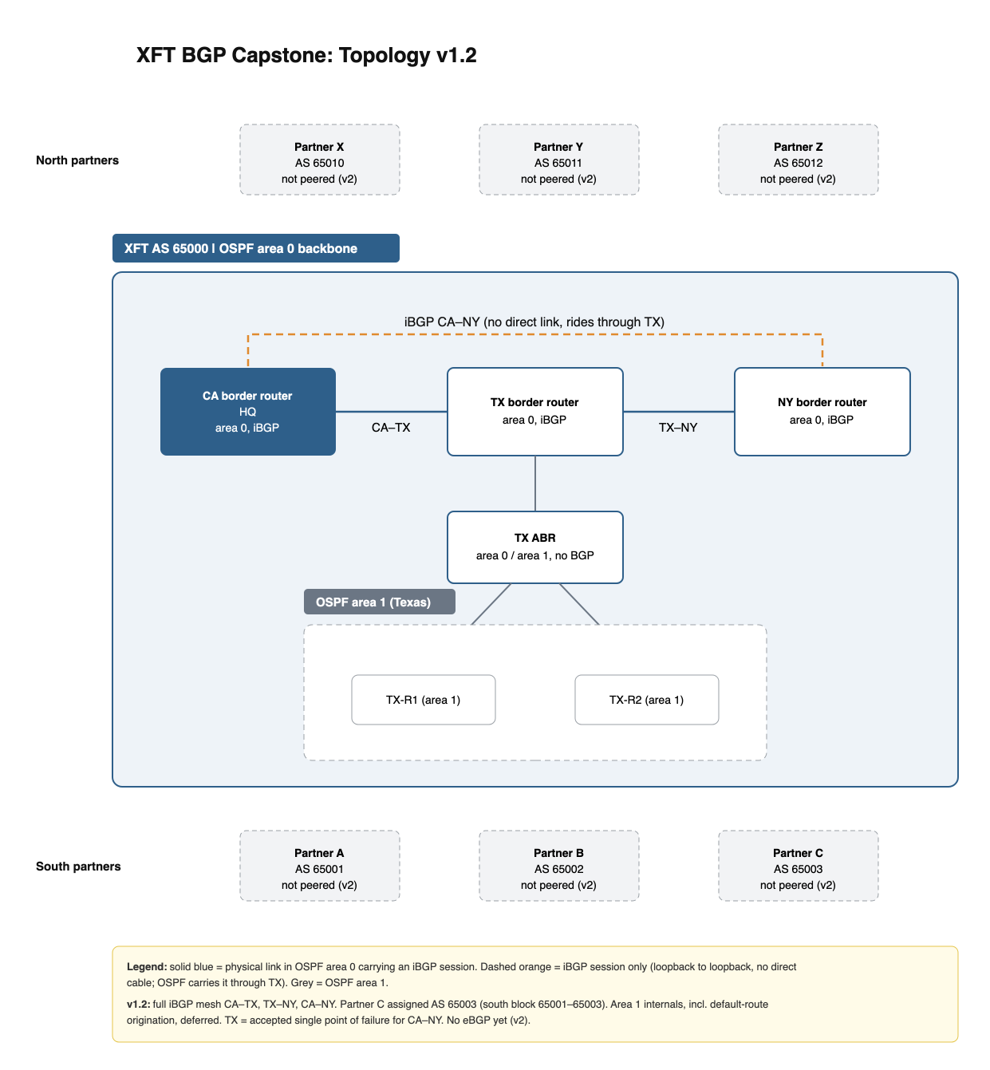
Figure 1: XFT topology v1.2

