BGP Project Capstone – Design Doc (Version 2.1)
Objective
Our company, XFT, is incorporating Border Gateway Protocol (BGP) into its sites. BGP will run between the company's sites and its partners to exchange the prefixes that meet the business needs of the company and its partners.

Architecture – version 1.2
We currently have three branches: California (CA), Texas (TX), and New York (NY).
California remains the headquarters.
In the south, we have three partner companies: A (AS 65001), B (AS 65002), and C (AS 65003).
In the north, we have three partner companies: X (AS 65010), Y (AS 65011), and Z (AS 65012).
XFT runs as a single autonomous system, AS 65000, with an OSPF area 0 backbone across all three sites and a full iBGP mesh between the CA, TX, and NY border routers (the CA–NY session rides through TX; there is no direct CA–NY link). No eBGP yet — partner peering arrives in version 2.
Design notes (v1.2)
Partner C is assigned AS 65003, continuing the south block (65001–65003).
TX is an accepted single point of failure: it is the only physical path between CA and NY, and the CA–NY iBGP session transits it. Accepted for v1; revisit when a CA–NY link is priced.
OSPF area 1 (Texas) internals — including which router originates the default route into it — are deferred to a later version.
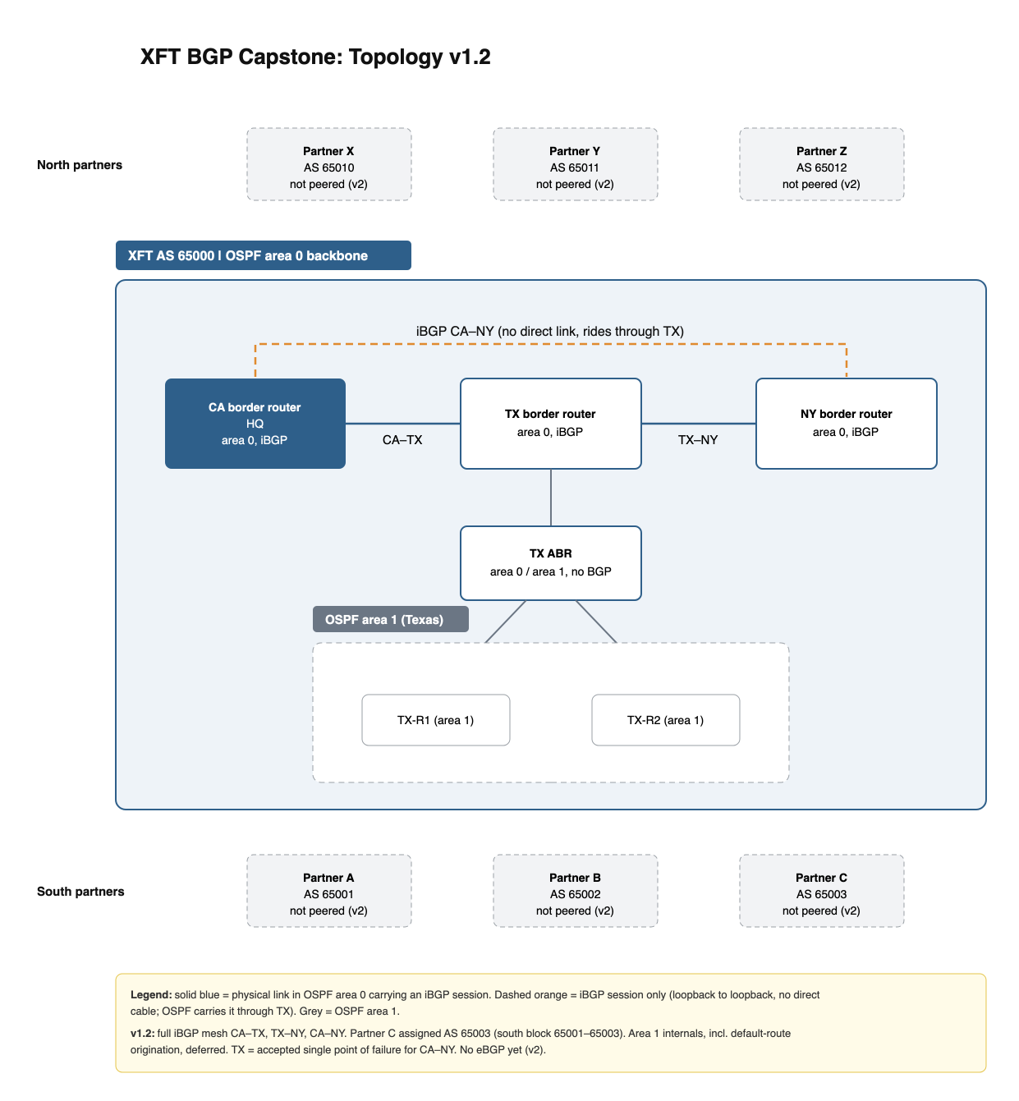
Figure 1: XFT topology v1.2

Architecture – version 2.0
XFT must exchange prefixes with its partner companies and between its branches, and later across the Atlantic.
XFT adds a new site in Oklahoma (OK). OK is the partner edge: it hosts the border routers b1 and b2, which run eBGP to every partner (each partner peers with both b1 and b2) and iBGP to the site routers. OK sits in OSPF area 0 and has a link to each site: CA, TX, and NY.
The CA, TX, and NY routers become site routers that run iBGP only. iBGP is a full mesh among b1, b2, CA, TX, and NY (10 sessions).
Design notes (v2.0)
OK is the single exit for all partner traffic; losing the OK site cuts off every partner. Accepted for v2.
The OK links give CA and NY a path that avoids TX, removing the v1 TX single point of failure for internal traffic.
Route reflectors, planned for OK, will replace the full mesh as sites are added.
Future: transatlantic long-haul links and more data centers. Capacity grows by adding border routers in OK or by moving the border role into new data centers.
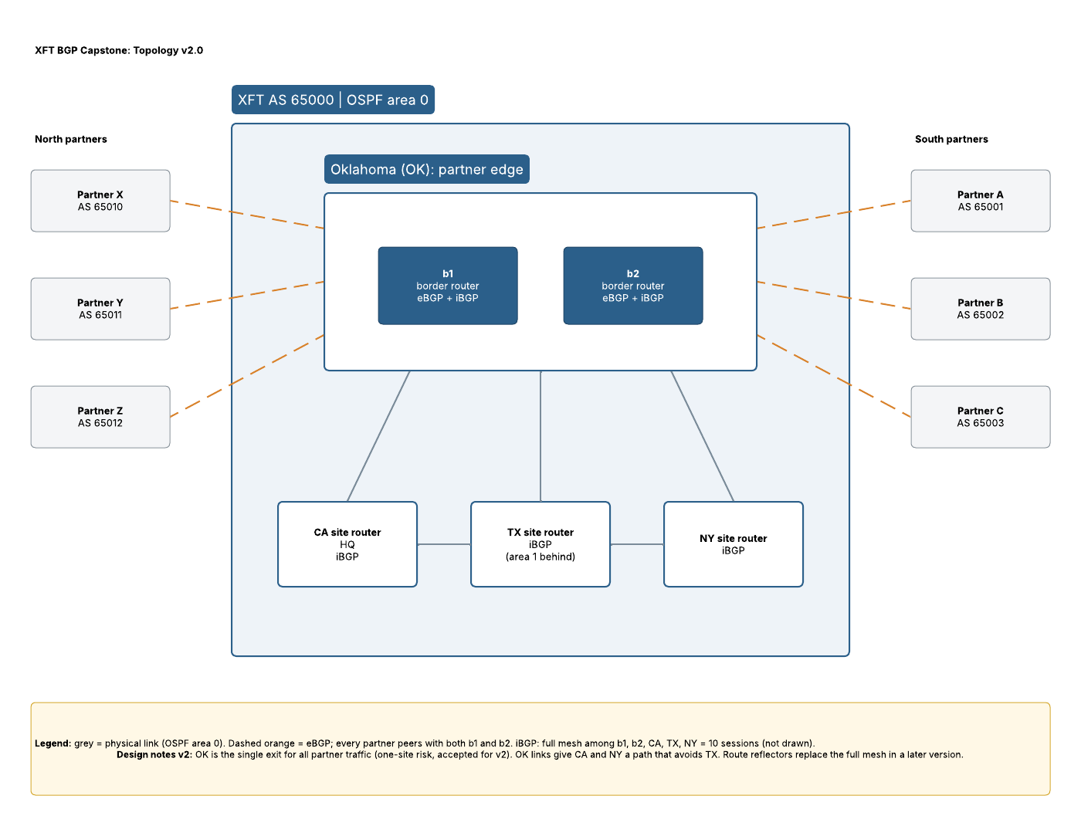
Figure 2: XFT topology v2.0

OSPF design (v2.1)
Area 0 is XFT's single OSPF backbone. It contains the border routers b1 and b2 in Oklahoma, each site's ABR (x1, x2, x3), and the links between them. Area 0 therefore reaches every site through that site's ABR; it is not limited to Oklahoma.
Every other area attaches directly to area 0 through an ABR. Areas never attach to each other.
Area numbering
Areas 1–10 are site areas: area 1 = California, area 2 = Texas, area 3 = New York. Areas 4–10 are reserved for future sites.
Departmental areas use one block per site, so numbers never collide: California 100–199, Texas 200–299, New York 300–399. Each departmental area attaches to area 0 through its site's ABR. Exact areas are assigned at deployment.
ABRs
Each site has a local ABR, named after its site area: x1 for area 1, x2 for area 2, x3 for area 3. ABRs stay at their own site, so LSA flooding from a site's areas stays local and only summary LSAs cross the long-haul links into area 0.
The CA, TX, and NY site routers sit in their site's area and run iBGP. A router's OSPF area is independent of its BGP role.
Design notes (v2.1)
One ABR per site for now; a second ABR per site is planned. Until then, losing a site's ABR isolates that site's areas. Accepted for v2.1.
Open: which area the CA–TX and TX–NY links belong to (dashed in Figure 3).
Open: what areas 1–3 contain beyond the site router.
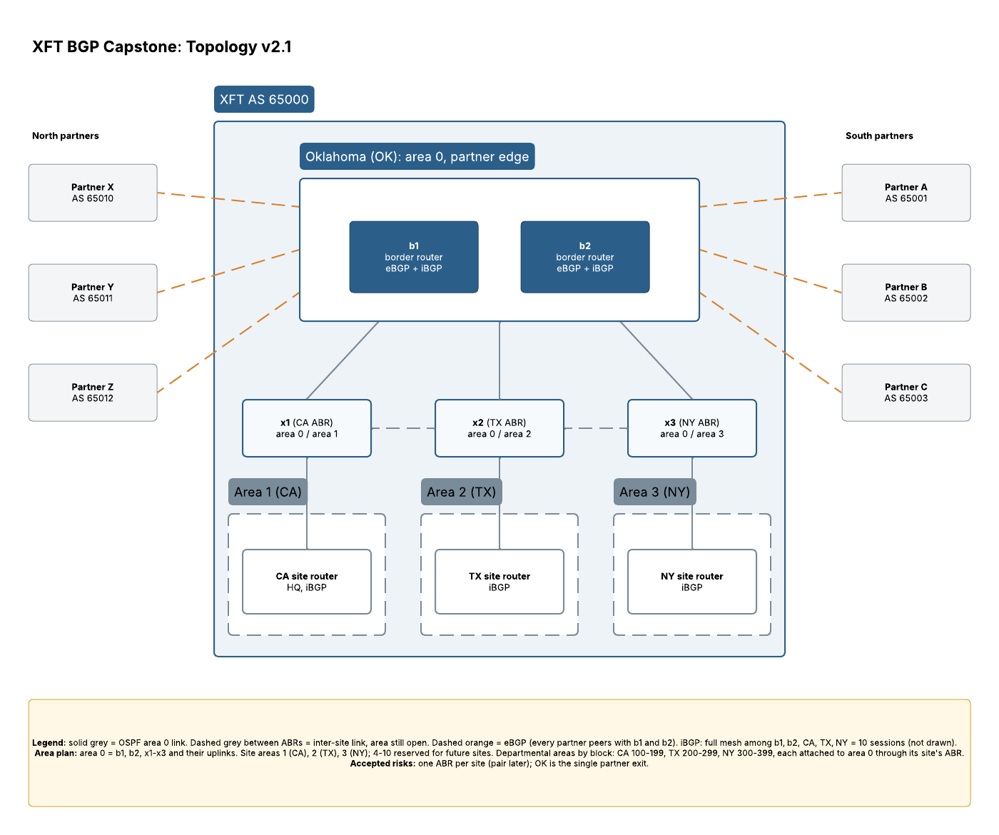
Figure 3: XFT topology v2.1 with OSPF areas

Next session
Which XFT prefixes we advertise to each partner.
Which prefixes we accept from each partner (XFT is not transit in v2, so nothing is passed between partners).

