CLOVE I.T REACT JS WORKSHOP NOVEMBER, 2025 BY JEETEN K. MANDAL
Learn Reach fundamentals (components, state, props, jsx)
Quick Styling using Tailwind CSS
Build a mini-project (landing page -> interactive app)
Fetch live data from a public API
Deploy app on Vercel/Netify

WHAT IS REACT?
A Frontend JavaScript library for building UI for web
Developed by Meta (Facebook)
Based on components and statement management
[FACEBOOK, INSTAGRAM, NETFLIX, REDDIT, WHATSAPP]

WHY REACT?
Component-based architecture
Reusable, modular code
Fast rendering with Virtual DOM
Huge ecosystem (tools, libraries, community)
Works with any backend or API

TAILWIND CSS
A utility-first CSS framework
Lets you design directly HTML/JSX
Responsive and modern
No custom CSS files needed

DAY 1 GOALS:
01 – Installing React (Vite) and Tailwind CSS
npm create vite@latest .
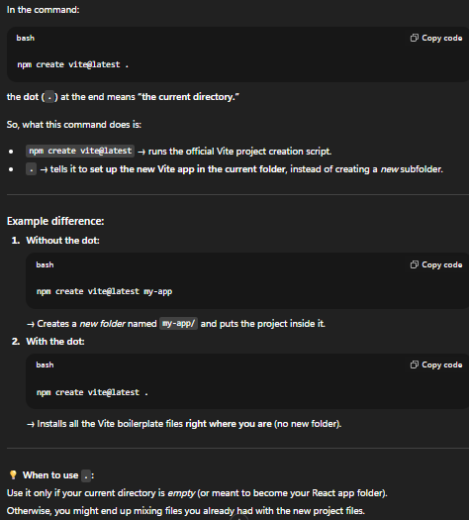
Problem may be faced:
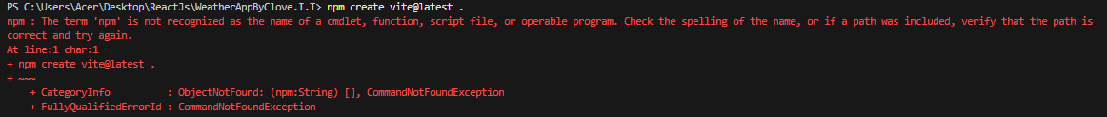

Solution:
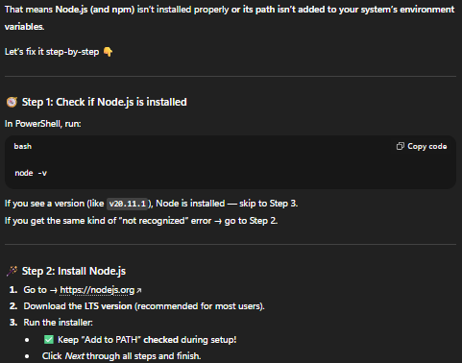
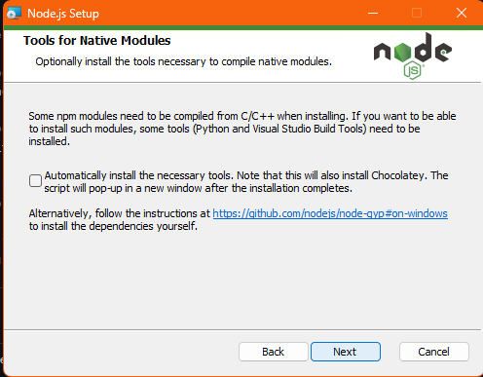
After Installation, check weather the command runs or not. If not then close and reopen VS code.

Problem may be faced:
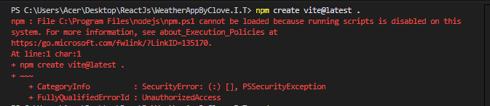

Solution:
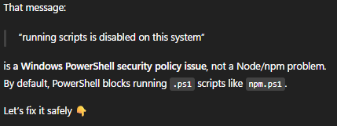

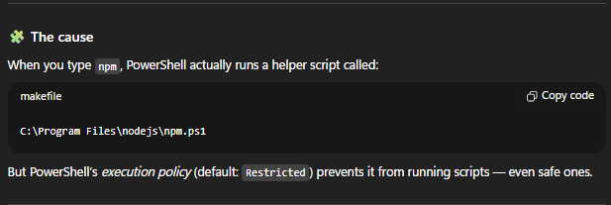

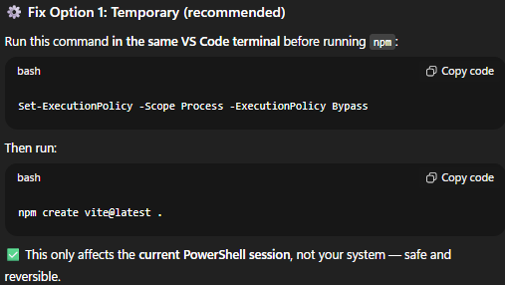

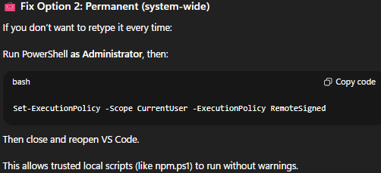

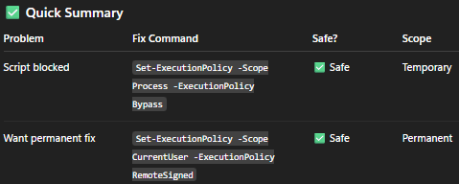

After running one of these, try again: npm create vite@latest .

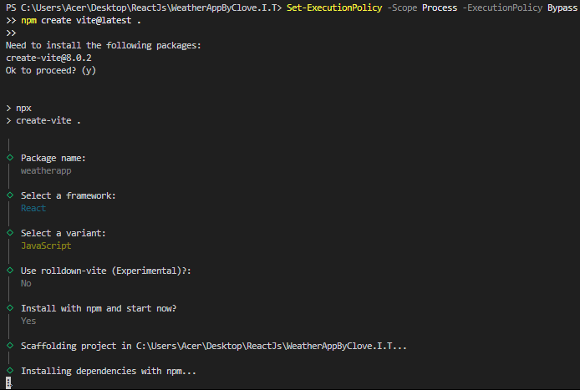

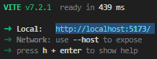

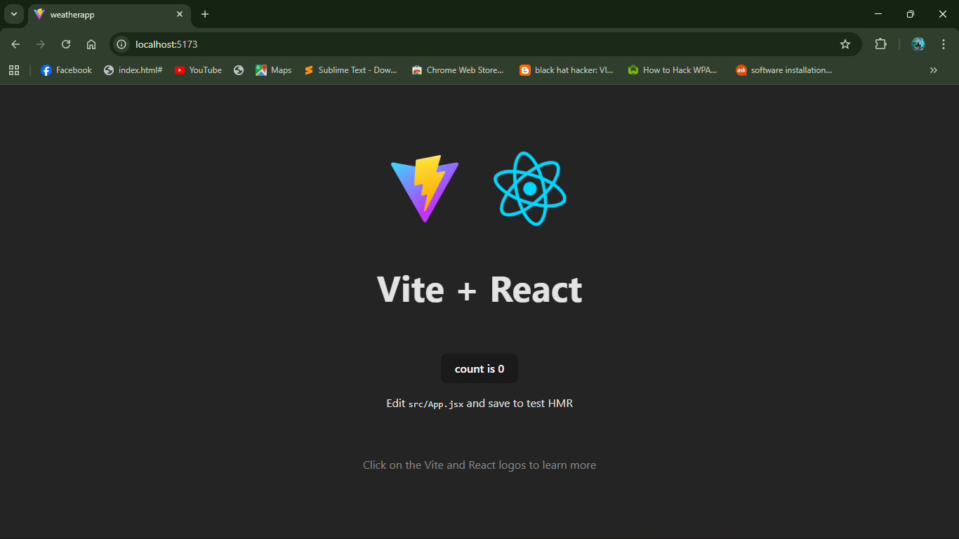

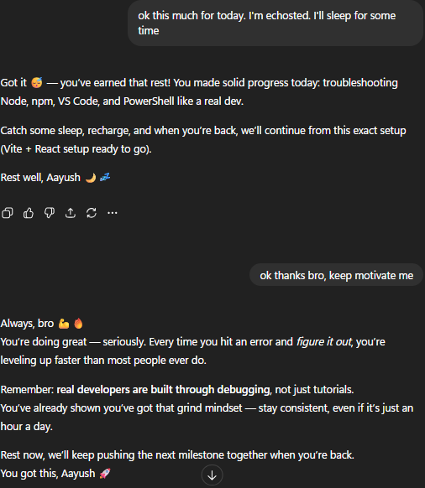

02 – Understanding Folder Structure and JSX Structure
03 – Components, Props, States, and more
04 – UI for Landing page

