

**DBMS Project**

**Group 3.06**

*Topic:- VACATION RENTALS AND EXPERIENCES DATABASE*

Group Members

Aayush Agrawal - 201501139

Chirag Chandnani - 201501145

Dhvani Patel - 201501164

**Aman Vangani - 201501183**

**ERD**

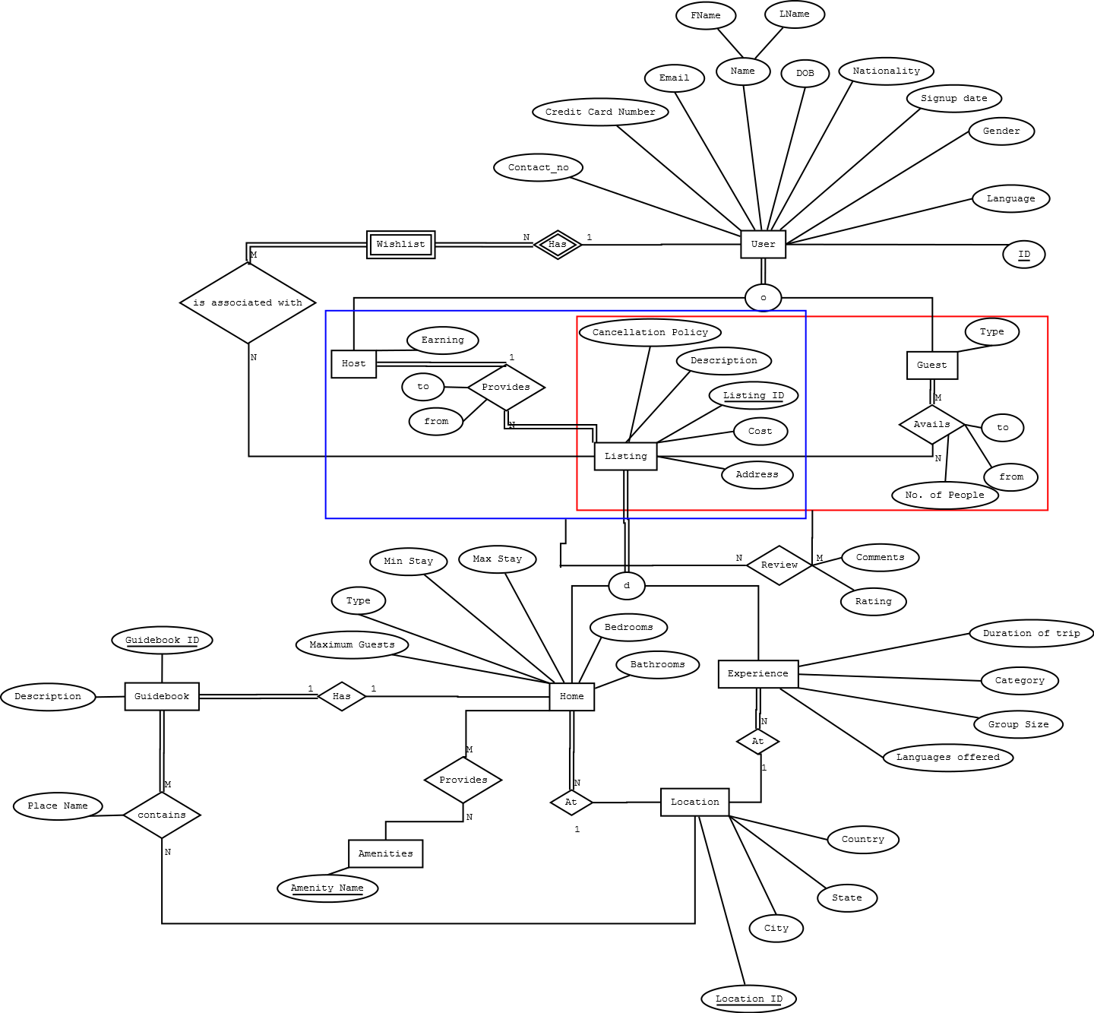

**Relational Schema**

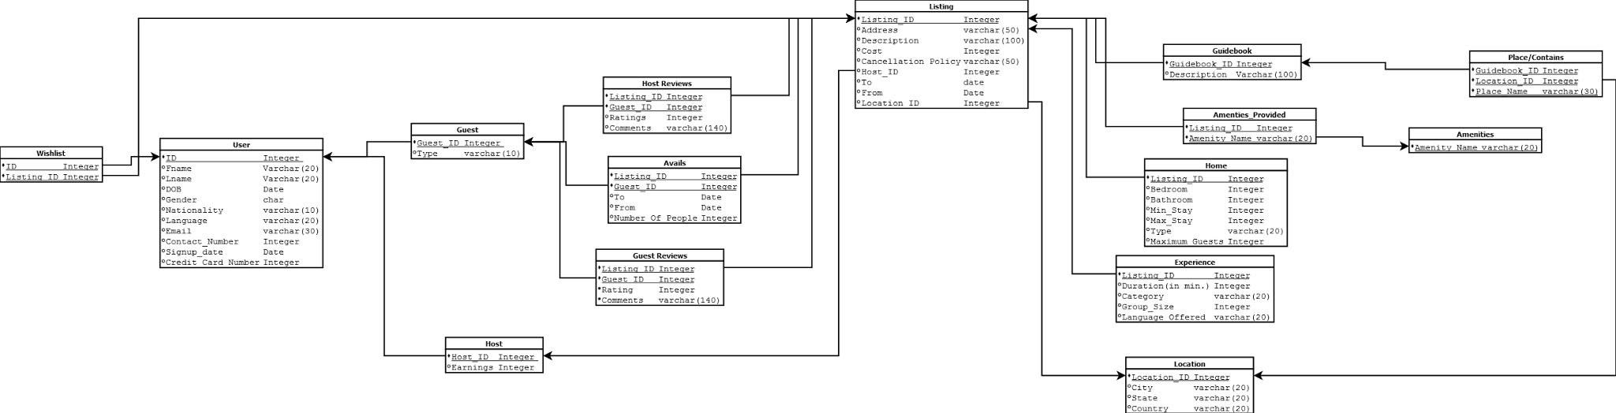

**Functional Dependencies and proof of BCNF.**

1. **WishList (ID,Listing_ID)**

Key:{ID,Lisitng_ID}

FD: No FDs . Because both attributes make composite key. Hence the BCNF is

formally satisfied since there are no FDs.

1. **User(ID,Fname,Lname,DOB,Gender,Nationality,Language,Email,Contact No, Signup date, Credit Card No)**

Key: ID

FD:

ID → Fname

ID → Lname

ID → DOB

ID → Gender

ID → Nationality

ID → Language

ID → Email

ID → Contact No.

ID → Signup date

ID → Credit Card No

Here, ​ID ​​is the primary key, and for every FD X → Y that holds on a relation, X is key, where X is

ID. Hence this relation is in BCNF.

1. **Guest(Guest_ID,Type)**

Key: Guest_ID

FD:

Guest_ID → Type

Here, ​Guest_ID ​​is the primary key, and for every FD X → Y that holds on a relation, X is key, where X is

Guest_ID. Hence this relation is in BCNF.

1. **Host (Host_ID,Earning)**

Key:Host_ID

FD:

Host_ID → Earning

Here, ​Host_ID ​​is the primary key, and for every FD X → Y that holds on a relation, X is key, where X is

Host_ID. Hence this relation is in BCNF.

1. **Avails(Listing_ID,Guest_ID,To ,From,No of people)**

Key:{Listing_ID, Guest_ID}

FD:

{Listing_ID,Guest_ID} → To

{Listing_ID,Guest_ID} → From

{Listing_ID,Guest_ID} → No of people

Here, ​{Listing_ID,Guest_ID} ​​is the primary key, and for every FD X → Y that holds on a relation, X is key, where X is {Listing_ID,Guest_ID}. Hence this relation is in BCNF.

**6.Guest Reviews (Listing_ID,Guest_ID, Comments,Rating)**

Key: {Listing_ID,Guest_ID}

FD:

{Listing_ID,Guest_ID} → Comments

{Listing_ID,Guest_ID} → Rating

Here, {Listing_ID,Guest_ID} ​​is the primary key, and for every FD X → Y that holds on a relation, X is key, where X is {Listing_ID,Guest_ID}. Hence this relation is in BCNF.

**7. Host Reviews (Listing_ID,Guest_ID, Comments,Rating)**

Key: {Listing_ID,Guest_ID}

FD:

{Listing_ID,Guest_ID} → Comments

{Listing_ID,Guest_ID} → Rating

Here, {Listing_ID,Guest_ID} ​​is the primary key, and for every FD X → Y that holds on a relation, X is key, where X is {Listing_ID,Guest_ID}. Hence this relation is in BCNF.

We decomposed review table into guest and host review to differentiate between host reviewing guests and guests reviewing host.

Also Host_ID is removed, as Host_ ID is implicitly found out from Listing_ID .

Also the occurrence of FD

Listing_ID → Host_ID

results in the relation not being BCNF . Decomposition algorithm hints towards the creation of listing table which is already there.

**8.Listing(Listing_ID,Address,Description,Cost,Cancellation_Policy,Host_ID,To,From,Location_ID)**

Key: Listing_ID

FD:

Listing_ID → Address

Listing_ID → Description

Listing_ID → Cost

Listing_ID → Cancellation_Policy

Listing_ID → Host_ID

Listing_ID → To

Listing_ID → From

Listing_ID → Location_ID

Here, ​Listing_ID ​​is the primary key, and for every FD X → Y that holds on a relation, X is key, where X is Listing_ID. Hence this relation is in BCNF.

**9.Home(Listing_ID,Bedroom,Bathroom,Min_Stay,Max_Stay,Type,Maximum_Guests)**

Key: Listing_ID

FD:

Listing_ID → Bedroom

Listing_ID → Bathroom

Listing_ID → Min_Stay

Listing_ID → Max_Stay

Listing_ID → Type

Listing_ID → Maximum_Guest

Here, ​Listing_ID ​​is the primary key, and for every FD X → Y that holds on a relation, X is key, where X is Listing_ID. Hence this relation is in BCNF.

**9.Experience(Listing_ID,Duration,Category,Group_Size,Language_Offered)**

Key: Listing_ID

FD:

Listing_ID → Duration

Listing_ID → Category

Listing_ID → Group_Size

Listing_ID → Language_Offered

Here, ​Listing_ID ​​is the primary key, and for every FD X → Y that holds on a relation, X is key, where X is Listing_ID. Hence this relation is in BCNF.

**10. Guidebook (Guidebook_ID, Description, Listing_ID)**

Key: Guidebook_ID

FD:

Guidebook_ID → Description

Guidebook_ID → Listing_ID

Here, Guidebook_ID ​​is the primary key, and for every FD X → Y that holds on a relation, X is key, where X is Guidebook_ID. Hence this relation is in BCNF.

**11. Amenities Provided (Listing_ID, Amenity_Name)**

Key: {Listing_ID, Amenity_Name)

FD: No FDs . Because both attributes make composite key. Hence the BCNF is

formally satisfied since there are no FDs.

**12. Amenities (Amenity_Name)**

Key: Amenity_Name

FD: No FDs . Because there is a single attribute which is the key. Hence the BCNF is

formally satisfied since there are no FDs.

**13. Place/Contains(Guidebook_ID,Location_ID,Place_Name)**

Key: {Guidebook_ID,Location_ID,Place_Name}

FD: No FDs . Because the combination of all the attributes is the key. Hence the BCNF is

formally satisfied since there are no FDs.

**14.Location (Location_ID,City,State,Country)**

Key:Location_ID

FD:

Location_ID → City

Location_ID → State

Location_ID → Country

Here, Location_ID ​​is the primary key, and for every FD X → Y that holds on a relation, X is key, where X is Location_ID. Hence this relation is in BCNF.