Index.html



This page has 3 buttons:

* Home: Brings the user back to homepage.
* Search: It searches for the given currency name & takes the user to coin.html.
* Get Started: Takes the user to popularCurrencies.html

popularCurrencies.html

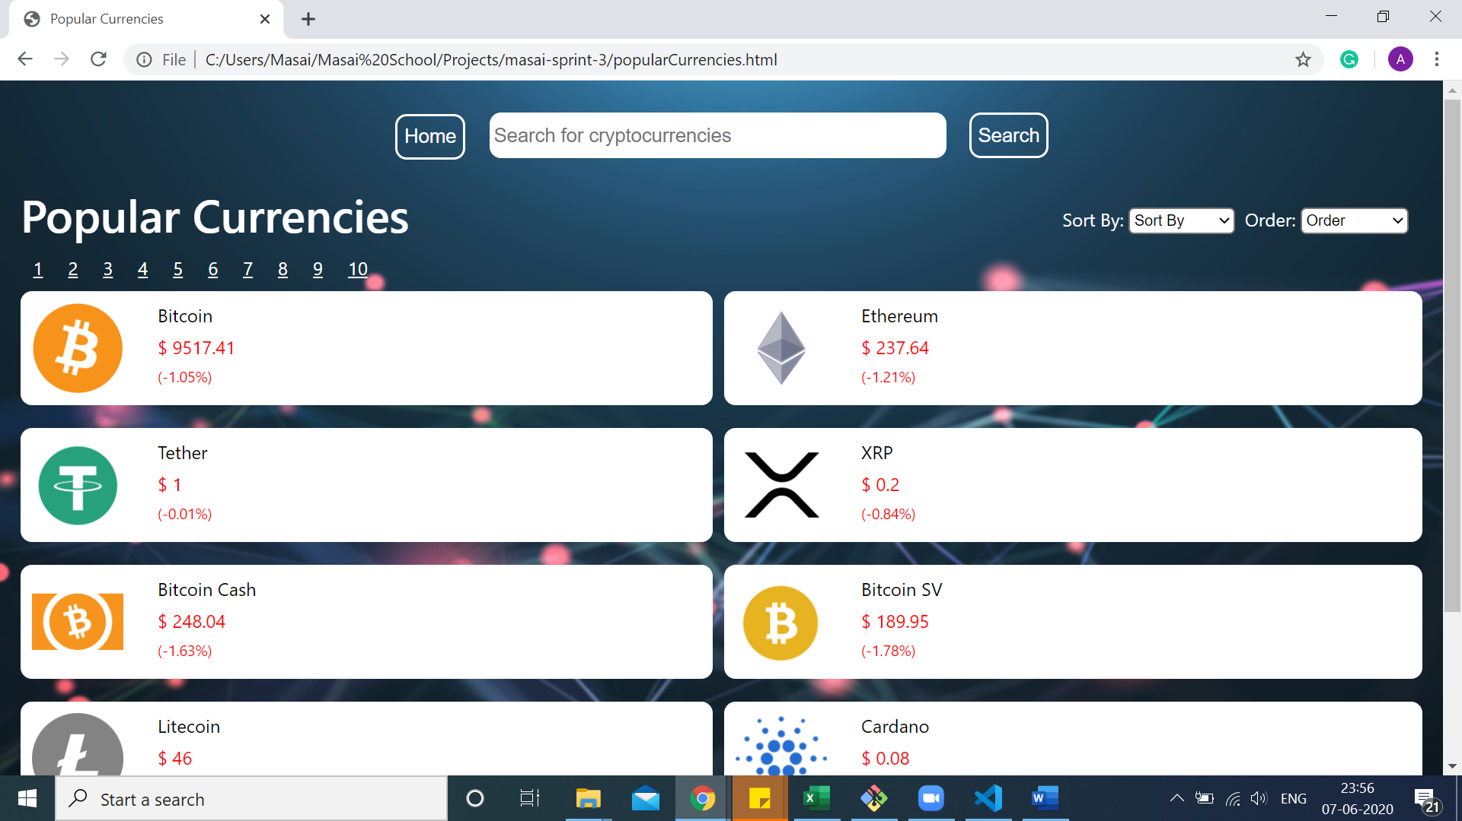

The numbers 1, 2, 3 etc. are page numbers.

There are 10 coin cards on a page divided in 2 columns of 5 each

On the top right are 2 dropdown inputs:

* Sort by: Sorts the coin cards based on Market Cap, Gecko, Volume or ID
* Order by: Coin cards can be shown in ascending or descending order

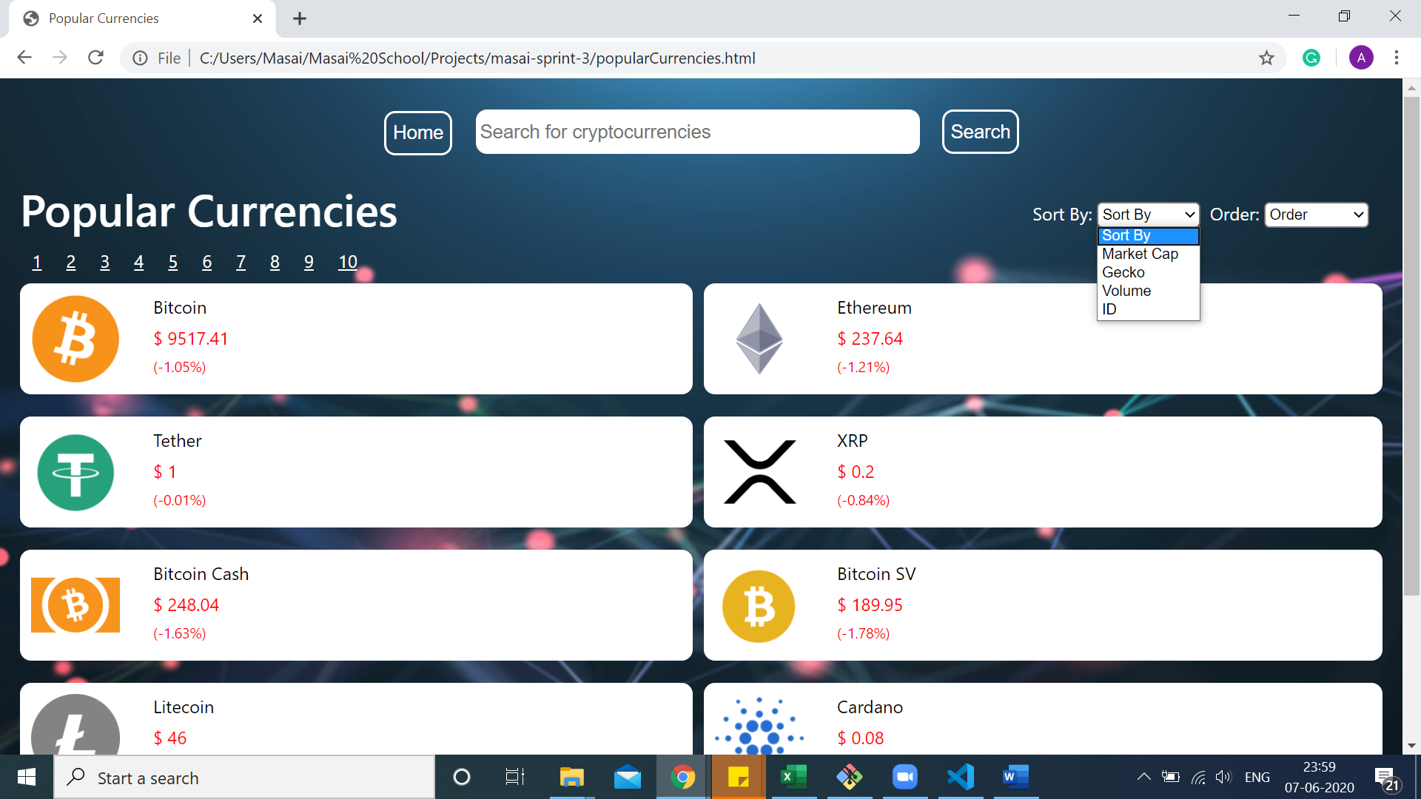 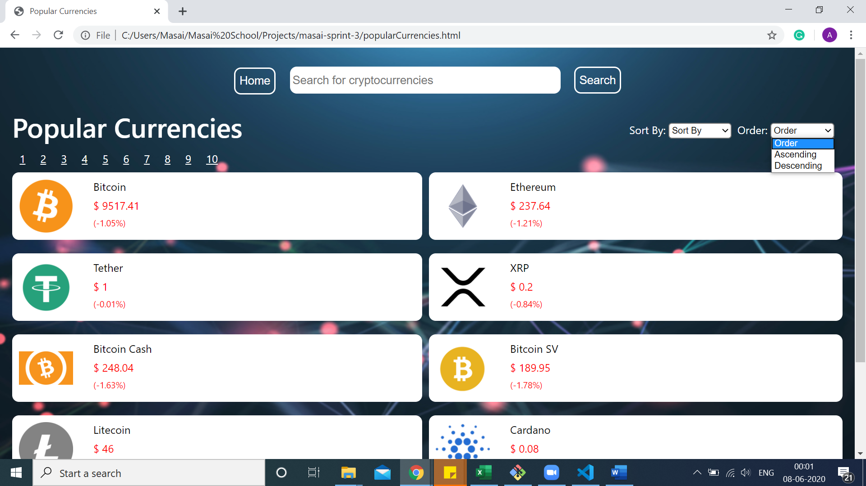

Each coin card has an image, name & price details.

If price change in last 24 hrs is negative the price colour changes to red. Otherwise green.

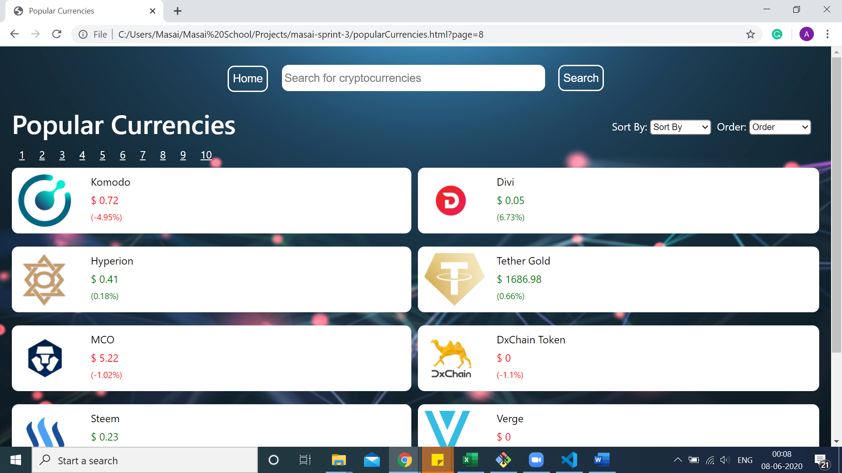

coin.html

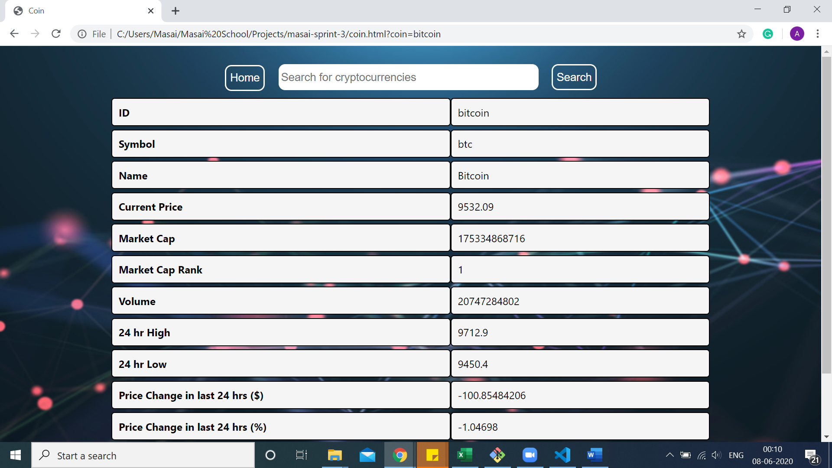

This page has detailed information about a given cryptocurrency:

**ID**

**Symbol**

**Name**

**Current Price**

**Market Cap**

**Market Cap Rank**

**Volume**

**24 hr High**

**24 hr Low**

**Price Change in last 24 hrs ($)**

**Price Change in last 24 hrs (%)**

**All time High**

**All time Low**