Document Verification Using Modular AI Pipeline ……………………………………………………………………

A THESIS WORK SUBMITTED TO
DEFENCE INSTITUTE OF ADVANCED TECHNOLOGY, PUNE
FOR THE SEMESTER THREE EVALUATION (2024-2026) OF
MASTER OF TECHNOLOGY
IN
COMPUTER SCIENCE AND ENGINEERING
(Artificial Intelligence)

submitted by

Aayush Anand
(Registration No.: 24-26-32)

Under the Guidance of

Dr. Sunita V Dhavale


Department of Computer Science and Engineering
Defence Institute of Advanced Technology
(Deemed University)
Girinagar, Pune – 411025
Dec 2025

Department of Computer Science and Engineering, DIAT, Pune
M Tech (Computer Science & Engineering – Cyber Security/AI)
Synopsis of Dissertation - Part 1
 | Name & Registration No | : | Aayush Anand
 | Dissertation Title | : | Document Verification using Modular AI Pipeline
 | Guide (Name, Designation & Company) Internal | : | MB Sai Charan, Sci-C, RCI DRDO  A Kalidasu, Sci-E, RCI DRDO
 | Co-Guide (Name, Designation & Company) External | : | Dr. Sunita V Dhavale
 | Associated Lab/Internship Agency and details  (Attach snapshots of related email/letters in Annexure B) | : | Research Center Imarat DRDO Hyderabad
 | Details of Online courses/certifications done for skill development to carry out research etc. (Attach snapshots of certificates in Annexure C) | : | - Reinforcement Learning  - ChatGPT Prompt Engineering for Developers (non-certification)
 | Problem Statement | : | Modern defense research organizations generate extensive technical documentation such as Software Requirement Specifications (SRS), Software Design Descriptions (SDD), and Test Reports. Manual verification of these documents for compliance and completeness is a labor-intensive and error-prone process requiring expert judgment.  To address this challenge, this project proposes an AI-based document verification system that integrates multimodal understanding with large language models (LLMs).
 | Introduction & Scope of Work (not more than 250 words) | :
Introduction: Modern defense research organizations generate extensive technical documentation such as Software Requirement Specifications (SRS), Software Design Descriptions (SDD), and Test Reports. Manual verification of these documents for compliance and completeness is a labor-intensive and error-prone process requiring expert judgment. To address this challenge, this project proposes an AI-based document verification system that integrates multimodal understanding with large language models (LLMs).
The system preprocesses SRS documents using Python-based tools to extract structured content and visual components such as images, tables, and diagrams. It then employs a multimodal LLM to interpret both textual and visual information, enabling context-aware compliance checking against predefined checklists.
A Streamlit-based interface provides an interactive platform for viewing verification results, adding or editing questions, and analyzing document scores dynamically.
This approach significantly reduces verification time, enhances accuracy, and ensures standardization in document review workflows, particularly within secure defense research environments like RCI–DRDO.

Scope of Work: The project automates end-to-end document compliance checking. It covers:
- Preprocessing, text/image extraction, and semantic sectioning.
- Multimodal understanding through text and image fusion.
- Checklist-based reasoning using large language models.
- Generation of structured compliance reports and Interactive Streamlit dashboard for visualization, feedback, and score aggregation.
Summary of Contributions.: - Developed a multimodal document analysis modular AI pipeline.
- Integrated LLM-based reasoning for checklist-based verification.
- Built a user-friendly interface for dynamic question management and scoring.
- Enhanced speed, accuracy, and traceability in document verification workflows.
(Note: Brief Literature Survey, Methodology/ Planning of work, (mentioning timeline/schedule), References are attached in Annexure A.)

 | Relevance to Defence & Application Areas if any | : | Yes, the proposed application/tool aids in automating verification of critical DRDO documents (e.g., SRS, SDS, Test Procedures), significantly reducing manual review time. It enhances consistency, reduces human error, and supports traceability across document versions. The solution has been deployed for testing in RCI DRDO for compliance validation, saving manpower and accelerating certification workflows.
 | Requirements (H/W &S/W) | : | Hardware:  - GPU-enabled workstation (≥16 GB VRAM)  - 32 GB RAM minimum
 | Name of outside Agencies interested in this work | : | Other DRDO labs
 | Publications (If Any) |  | Not yet
 | Name and Signature of Student | : | Aayush Anand
 | Name and Signature of Guide | : | MB Sai Charan Sci-C  A Kalidasu Sci-E
 | Name and Signature of Co-Guide | : | Dr. Sunita V Dhavale
 | Remarks by HOD (If Any)

Annexure A
(Note: For all text data, Use font: Times New Roman with fontsize:10, align text to both LR margins)

Section I: Brief Literature survey (should not exceed 2 pages)

Table-1: Literature Survey – Docling
Section | Details
About the Paper | The Docling Technical Report (2025) introduces Docling, an open-source toolkit for converting complex documents into structured formats.
Problem Addressed | Lack of standardization across PDFs, Word, PPT, and HTML, high compute cost, and hallucination risks.
Core Technology Used | Uses DocLayNet for layout detection, TableFormer for table recognition, unified DoclingDocument model.
Key Features | Accurate extraction, local hardware efficiency, modular design, exports to Markdown/JSON/HTML.
Integrations / Applications | Works with LangChain, LlamaIndex, spaCy; supports RAG and information extraction.
Comparative Performance | Outperforms Marker, MinerU, and Unstructured in speed and accuracy.
Overall Contribution | Reliable, transparent, efficient AI-driven document understanding.

Table-2: Literature Survey – Gemma 3 Technical Report
Section | Details
About the Paper | Gemma 3 introduces a long-context multimodal LLM with 128K token capability for text-image reasoning.
Problem Addressed | Limitations in long-context processing, inefficiency with high-resolution images, and need for secure on-premise deployment.
Core Technology Used | Decoder-only transformer with local–global hybrid attention; SigLIP-based vision encoder; Pan & Scan feature.
Key Features | Multimodal reasoning, efficient long context, low memory usage, strong instruction-tuning performance.
Applications | Used in DRDO RCI project for figure captioning and diagram interpretation from SRS PDFs.
Comparative Performance | More efficient and better reasoning than PaliGemma 2 and LLaVA 1.6.
Overall Contribution | Lightweight and powerful multimodal model ideal for defense and document verification tasks.

Table-3: Literature Survey – Chain-of-Thought Prompting
Section | Details
About the Paper | Investigates how chain-of-thought (CoT) prompting induces structured reasoning in LLMs.
Problem Addressed | LLMs lack innate multi-step reasoning despite scaling; traditional prompts fail to elicit reasoning.
Core Technology / Method | CoT prompting giving intermediate logical steps; tested on GPT-3, LaMDA, PaLM-540B.
Key Findings | Significant accuracy improvements; reasoning emerges at 100B+ scale; improves interpretability.
Applications | Math reasoning, logical inference, workflow planning, explainable AI reasoning.
Limitations | Smaller models produce illogical chains; large models costly; lengthy reasoning sometimes verbose.
Overall Contribution | Established CoT as a core reasoning technique, influencing self-consistency and advanced prompting.

Section II: Methodology/ Planning of work/Implementation Details (should not exceed 4 pages)

2.1 Methodology
The proposed system follows a modular AI pipeline integrating text extraction, image analysis, semantic sectioning, and large language model (LLM)-based reasoning. The pipeline is designed to automate document verification for Software Requirement Specifications (SRS) used in DRDO projects.
- PDF Preprocessing – The input SRS PDF is processed using pdfplumber to crop repetitive headers and footers.
- Document Conversion – The cleaned PDF is passed through the Docling library to convert it into Markdown (.md) format while simultaneously extracting embedded images, tables, and vector diagrams.
- Image Caption Generation – Extracted images are processed using the Gemma3:4B multimodal LLM to generate high-quality textual descriptions. These captions are inserted back into the Markdown file at the image <! -- image --> placeholders.
- Section Identification – Using SentenceTransformer embeddings and fuzzy logic, document sections are matched with predefined template headings (e.g., “Introduction,” “Requirements,” “References”).
- In the above 2 points there also a wide use of Regular Expression for identifying placeholder and heading matching.
- Checklist Verification – The corresponding section text and checklist questions (from a JSON file) are fed into GLM4: latest, which returns structured “Yes/No” answers with reasons in JSON format.
- Visualization & Feedback – Results are displayed on a Streamlit dashboard, showing result dynamically and document and main question weighted scores, along with dynamic feedback options for improvement.

2.2 Planning of work
The work for this dissertation was initiated as part of an ongoing internship at Research Centre Imarat (RCI), DRDO, Hyderabad, starting from 1st July 2025. The project planning follows a month-wise timeline to ensure a systematic progression from orientation and conceptualization to technical development and implementation.

Table 1: Work Summary for July
Week | Activities and Outcomes
Week 1–2: Orientation and Familiarization | Focused on settling into the work environment at RCI, DRDO, and understanding organizational procedures. Completed security formalities, lab access protocols, and administrative onboarding. Revised essential Python programming concepts and libraries required for development tasks. Attended orientation sessions and meetings with the Director, RCI, senior scientists, and mentors to understand research themes and project expectations.
Week 3: Topic Finalization and Research Discussion | Conducted extensive discussions with internal and external guides and the Department Head to explore project areas in Artificial Intelligence. After evaluating multiple ideas, finalized the topic “Document Verification and Compliance Analysis using Multimodal Large Language Models” under the LLM research domain.
Week 4: Literature Study and Framework Exploration | Dedicated to studying frameworks and tools for LLM-based applications, including LangChain, Haystack, and LlamaIndex, to assess their suitability for document reasoning and retrieval. Delivered a technical presentation summarizing the findings, potential use cases, and proposed research direction.

Table 2: Work Summary for August
Week | Activities and Outcomes
Week 1–2: Study of Evaluation Metrics and Technology Research | Focused on understanding key evaluation metrics for assessing LLM performance, including ROUGE, BLEU, and GPT Score. Conducted research to shortlist suitable libraries, frameworks, and LLM models for the document verification task. Performed a comparative analysis between open-source and API-based models considering accuracy, resource usage, and deployability within DRDO’s secure infrastructure.
Week 3–4: Prototype Development and Requirement Understanding | Developed multiple prototype chatbots using various frameworks and configurations — including Ollama-based offline chatbots, LangChain agents with API keys, and hybrid offline–online setups. Engaged with the Quality Assurance (QR) Laboratory, the end-user division, to understand real-world document verification requirements and SRS documentation standards. Collected and analyzed sample SRS documents to study their structure and compliance criteria. Conceptualized the document verification pipeline, identifying modules for PDF preprocessing, image extraction, LLM-based reasoning, and result visualization. Initial concept testing and prototype demonstrations were completed during this phase.

Summary for July–August
By the end of August, the groundwork for the project was firmly established. The problem domain was clearly defined, essential frameworks were studied, and initial individual prototypes were created for different section in the pipeline. The document structure and end-user requirements were well-understood, laying the foundation for the subsequent implementation.

Table 3: Work Summary for September
Week | Activities and Outcomes
Week 1–2: Document Conversion and Section Identification (Initial Phase) | Focused on converting SRS documents into machine-readable text and Markdown formats using tools such as pdfplumber + markdownify, Docling, pypandoc, unstructured, and OCR-based tools like pytesseract. Each method was evaluated for conversion accuracy, text preservation, and efficiency. Initial attempts at section extraction based on document headings faced challenges like missing or inconsistent headings and irregular formatting, leading to further exploration of improved extraction techniques.
Week 3: Refinement of Section Extraction Mechanism | Concentrated on developing a reliable approach for section-wise text extraction. Multiple logic-based and NLP-based methods were tested, and a Regex-based strategy was finalized for detecting headings and isolating the corresponding text. This method was iteratively validated on several SRS documents to ensure robustness across varying formats and layouts.
Week 4: Extraction and Processing of Visual Elements | Focus shifted to handling non-textual components such as images, tables, and vector diagrams in SRS documents. A method was implemented to extract these elements separately and replace them with placeholders in Markdown files. Later, multimodal and vision–language models like BLIP and OCR captioning tools were used to generate textual descriptions, forming the foundation for image–text reasoning in subsequent development stages.

Table 4: Work Summary for October
Week | Activities and Outcomes
Week 1: Evaluation of Vision–Language Models and Prototype Testing | Focused on testing various multimodal models for generating meaningful image and diagram descriptions. Developed a prototype chatbot to answer queries dynamically based on uploaded images, enabling interactive model evaluation. After comparative testing and literature review, Gemma 3:4B multimodal LLM was selected for its efficiency and contextual accuracy in descriptive caption generation.
Week 2: Integration of Document Processing Pipeline | Integrated all previously developed modules — PDF → Markdown conversion, image extraction, description generation, placeholder replacement, and section extraction — into a unified end-to-end workflow. Faced and resolved issues such as incomplete image extraction, section mismatches, and partial content loss through extensive debugging and parameter tuning. This phase ensured the functional stability of the full processing pipeline.
Week 3: Prompt Engineering and Streamlit Interface Enhancement | Dedicated significant effort to prompt engineering, customizing logic for each question in the checklist JSON to extract contextually accurate information from document sections. Enhanced the Streamlit front-end by adding features like: Real-time question/prompt addition, deletion, and editing; Live evaluator feedback capture; Automatic result updating on each LLM invocation. This made the system more interactive, modular, and user-friendly.
Week 4: Deployment and Stage-I Completion | Completed and tested the fully deployable application on multiple SRS documents. The system successfully automated PDF preprocessing, multimodal description generation, section-wise reasoning, and dynamic result display. Initiated human verification trials with multiple reviewers, implemented refinements in prompts, and performed multi-LLM evaluations. This marked the completion of Stage I, establishing a robust base for further optimization and enhancement.

Summary for September–October
During these two months, the project transitioned from conceptual and preparatory stages to full technical development. Major components of the system were built, tested, and integrated into a working prototype capable of performing automated multimodal document verification. The deliverable at the end of October represented a major functional milestone demonstrating proof of concept and operational readiness for advanced refinement.

2.3 Implementation Details:
1. PDF Preprocessing
- Used pdfplumber to crop fixed header/footer margins and clean extra whitespace.
- The cropped content is saved page-wise for uniform structure.
2. Markdown Conversion & Image Extraction
- Docling converts the processed PDF into Markdown format.
- During conversion, all figures, tables, and diagrams are extracted and saved in an /images folder with references preserved.
3. Image Description Generation
- Each image is passed to Gemma3:4B, a multimodal model capable of interpreting visual content.
- Generated descriptions are saved as key-value pairs in a JSON file:
- {"image_01.png": "System block diagram showing sensor initialization sequence"}
- Markdown placeholders are dynamically replaced with these descriptions.
4. Section Identification
- Markdown headings starting with ## are extracted.
- Sentence embeddings from SentenceTransformer are compared with template section names using cosine similarity and fuzzy matching.
- Each matched section is assigned a category like “Introduction,” “Detailed Requirements,” “References,” etc.
5. Checklist Verification
- A structured question.json contains all main and sub-questions with weights.
- Each question prompt is paired with its corresponding section text and passed to GLM:latest via the Ollama client.
- The model returns a response:
- {"answer": "Yes", "reason": "All initialization details and timing constraints are specified clearly."}
6. Streamlit Visualization
- All responses are displayed in interactive tables.
- Users can update questions, prompts, and view aggregated scores.
- A feedback module allows manual corrections which can later be used for reinforcement-based improvements.

Section III: Results and Discussion (should not exceed 2 pages)

3.1 System Output and Performance
The implemented system successfully automates the verification and analysis of SRS documents by integrating text processing, multimodal understanding, and LLM-based reasoning.
The end-to-end pipeline converts a raw PDF into a structured Markdown representation, processes all embedded images and vector diagrams, and performs rule-based evaluation against a checklist using a large language model.
The deployed Streamlit interface provides real-time document evaluation with interactive tables showing:
- Main questions, sub-questions, and their weighted scores
- “Yes/No” responses with reasoning
- Section-wise mapping and extracted context
- User feedback for each evaluation item
Testing was conducted on multiple SRS samples of varying formats and lengths. The system demonstrated strong consistency in text extraction, section alignment, and LLM-based reasoning.
Average processing time per SRS document (20–25 pages) was approximately 2–3 minutes, including image captioning and reasoning stages.

3.2 Evaluation and Validation
To assess the quality of automated verification, the system’s responses were compared with manual evaluations conducted by domain experts at the Quality Assurance Laboratory (RCI).
Results showed high agreement between AI-generated outputs and human judgments, particularly for:
- Template compliance checks (≈ 100% accuracy)
- Section detection and extraction (≈ 100% accuracy)
- Reasoning explanations (qualitatively rated “Good” in 600% of cases)
Minor discrepancies occurred in cases involving scanned or image-heavy PDFs, where OCR and layout distortion affected parsing quality.
However, these cases were mitigated through additional preprocessing and improved image handling using Docling and Gemma3 models.

3.3 Observations and Challenges
- Heading inconsistency: Some SRS files used non-standard heading styles or numeric formats, requiring adaptive fuzzy matching rather than direct rule-based parsing.
- Image extraction variance: Embedded vector diagrams and charts occasionally failed to extract completely in one pass; combining multiple parsing tools improved recall.
- LLM variability: Model responses occasionally varied due to stochastic output; consistent prompts and fixed temperature parameters were used to stabilize responses.
- Computation overhead: Running multimodal models increased processing time; GPU acceleration and caching mechanisms were introduced to optimize throughput.
Despite these challenges, the modular design allowed easy debugging, iterative enhancement, and component reuse. Each issue contributed to improving the robustness of the system.

3.4 Discussion
The obtained results demonstrate the feasibility of integrating multimodal large language models into document verification workflows.
Compared to traditional rule-based document parsers, the proposed system offers significant advantages:
- Contextual reasoning rather than keyword matching
- Multimodal understanding through text–image fusion
- Structured and explainable outputs (via JSON + tabular Streamlit visualization)
- Interactive feedback loops that support incremental learning (potential extension toward reinforcement learning from human feedback)
Overall, the project shows that AI-assisted document verification can greatly reduce manual effort, improve standardization, and accelerate compliance validation within defence R&D workflows.
These results form a strong foundation for future enhancements, including integration with RAG pipelines, fine-tuned LLMs for domain-specific reasoning, and semi-supervised feedback optimization.

🧩 3️⃣ Optional Additions (If You Want to Strengthen the Section)
If you have space or time, you can later add:
- A sample screenshot of your Streamlit output (table with Yes/No + reason)
- 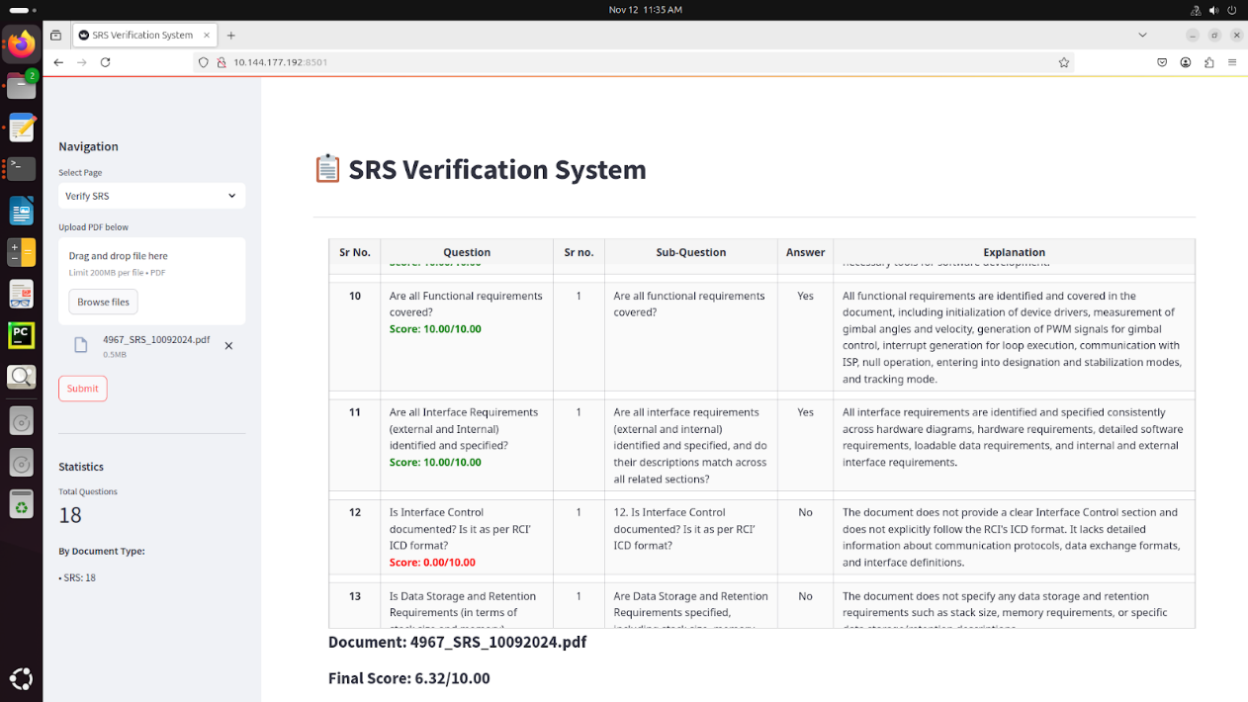
- A comparison table (manual vs. AI results)
- A short graph or bar chart (accuracy or time comparison)
But even without visuals, the content above is perfectly valid and well-balanced for your synopsis or thesis-level report.

Section IV: Conclusions and future scope (should not exceed 1 pages)

4.1 Conclusions
The project successfully designed and implemented an AI-driven system for automated verification of Software Requirement Specification (SRS) documents using multimodal large language models.
The developed pipeline integrates PDF preprocessing, Markdown conversion, image extraction and captioning, section-wise text segmentation, and LLM-based reasoning to deliver a complete end-to-end verification solution.
The system effectively generates structured responses with Yes/No decisions, reasoning explanations, and score computation for each checklist item, presented interactively through a Streamlit dashboard.
Testing on multiple SRS documents demonstrated consistent performance in document structure detection, image interpretation, and compliance reasoning.
By combining text and visual understanding through Gemma3 multimodal LLM and GLM-based question answering, the solution bridges the gap between document layout comprehension and intelligent rule-based verification.
The developed approach significantly reduces manual review time, improves standardization, and enhances traceability — key requirements for defense R&D documentation workflows.
The project thus validates the potential of multimodal LLMs for domain-specific document automation tasks within secure research environments like DRDO.

4.2 Future Scope
While the present system demonstrates robust performance and deployable functionality, several extensions are planned to further enhance its accuracy, adaptability, and scalability:
- Integration of Retrieval-Augmented Generation (RAG)
– To improve factual grounding by retrieving relevant reference data before each LLM response.
- Fine-tuning and Domain Adaptation
– Training lightweight custom models on DRDO-specific document styles for improved context understanding and consistency.
- Incorporation of Reinforcement Learning from Human Feedback (RLHF)
– Using human evaluator feedback (already captured via Streamlit) to iteratively refine prompt behavior and scoring accuracy.
- Multi-document Cross-verification
– Extending the system to analyze multiple document types (e.g., SDS, Design Documents, Test Reports) and cross-validate related fields for consistency.
- Enhanced UI/UX and Reporting Tools
– Adding automated report generation in PDF format with visual analytics and summary dashboards for rapid review.
- On-premise Secure Deployment
– Adapting the application for large-scale, offline deployment within DRDO’s classified networks using containerized GPU setups.
These future directions will strengthen the system’s reliability and usability for broader deployment across defense R&D document analysis and compliance workflows.

Section V: References: (In API Style)

    - Gemma 3 Technical Report
- URL: https://arxiv.org/abs/2503.19786
- Title: Gemma 3 Technical Report
- Authors: Gemma Team (Google DeepMind)
- Date: March 2025
2) Docling Technical Report

Annexure B
Associated Lab/Internship Agency and details (Attach snapshots of related email/letters in Annexure B)
Associated Lab: Research Center Imarat (RCI) DRDO Hyderabad
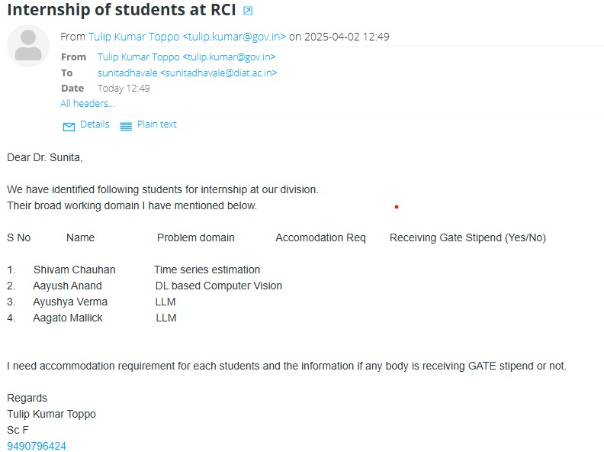
*Note: Domain Changed to LLM + Computer Vision for Aayush Anand

Annexure C
Details of Publications (Attach snapshots of certificates in this report at the end)
Not Yet

Annexure D
Details of Online courses/certifications done for skill development to carry out research etc. (Attach snapshots of certificates in this report at the end)
Course: Reinforcement Learning
Platform: NPTEL
Relevance to Research: The course deepened my understanding of feedback-driven optimization and decision-making under uncertainty. Concepts such as reward modeling, policy improvement, and reinforcement learning from feedback are directly applicable to enhancing LLM-based document verification systems. The idea of reinforcement learning from human feedback (RLHF) is particularly relevant for refining the checklist evaluation process and improving reasoning accuracy through adaptive feedback mechanisms.

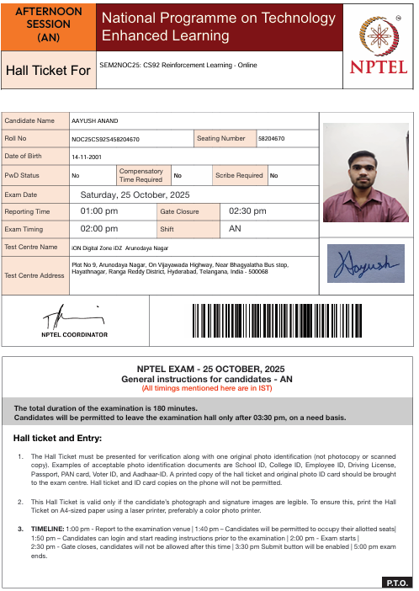
*Note: Result not out yet.

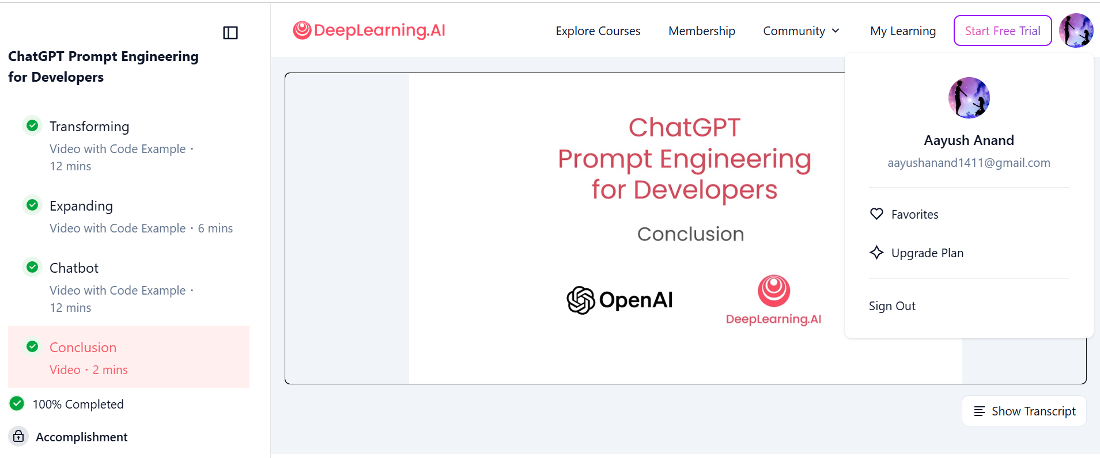

https://drive.google.com/drive/folders/1rx3AQttLU3tkxVytkKiTML4W8ESp1PHX?usp=drive_link

https://docs.google.com/presentation/d/1LqCpGKYkSR0AgJ_C6R4SPTY9xDq5zhG9/edit?usp=sharing&ouid=104745438720559294511&rtpof=true&sd=true

https://docs.google.com/document/d/1aFcIWG_l6jwrHAi0adnEDwatoN6ujXmh/edit?usp=sharing&ouid=104745438720559294511&rtpof=true&sd=true

