CSS Media Query

It is used add the CSS rules based on some conditions,

@media is the keyword we use to apply CSS rules with some conditions

Ex: For Printer you want all the fonts to be with certain colors like black, Whenever the screen width is certain size you want to change your CSS.

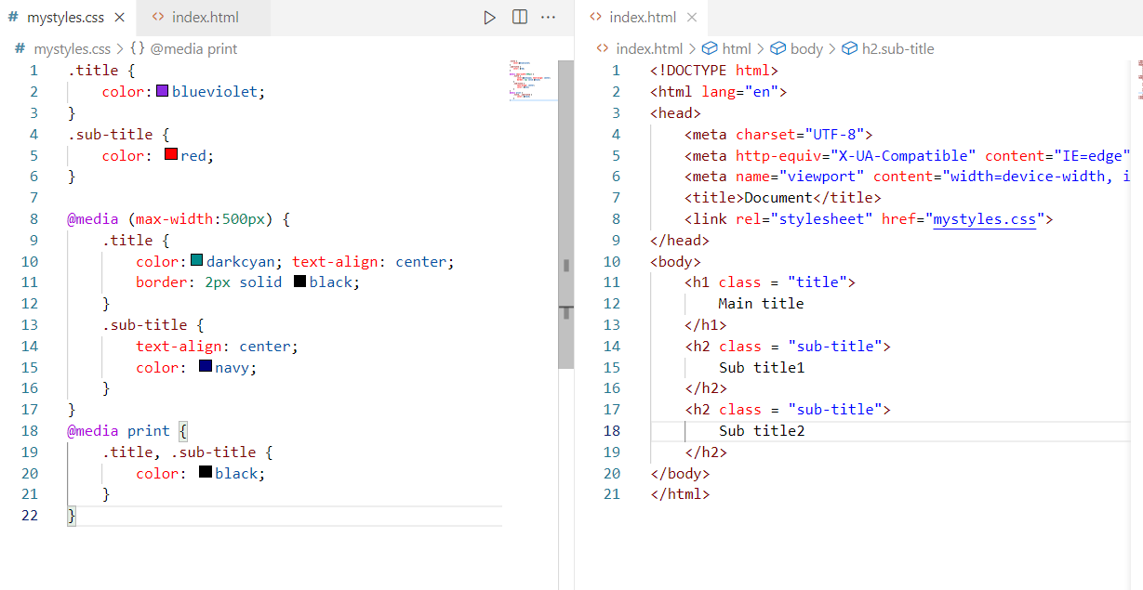

Output: When the size of screen is less than or equal to 500

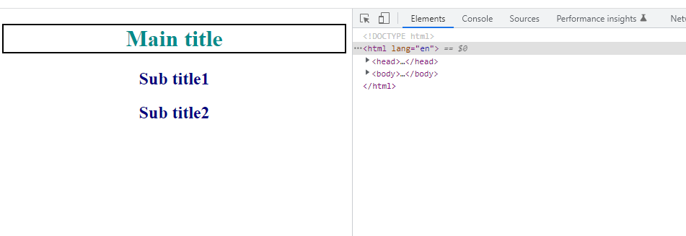

Output: When you take print

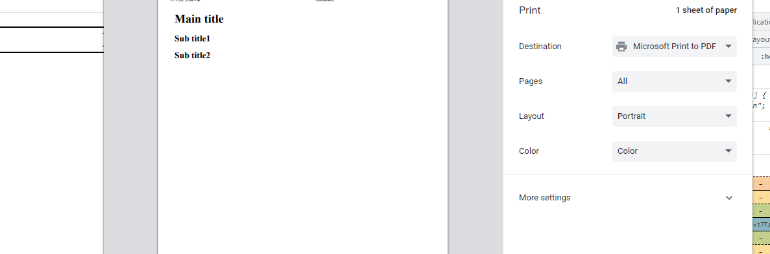

You can add multiple conditions in @media query

@media (max-width:300px and min-width:200px) {  
 …..  
}

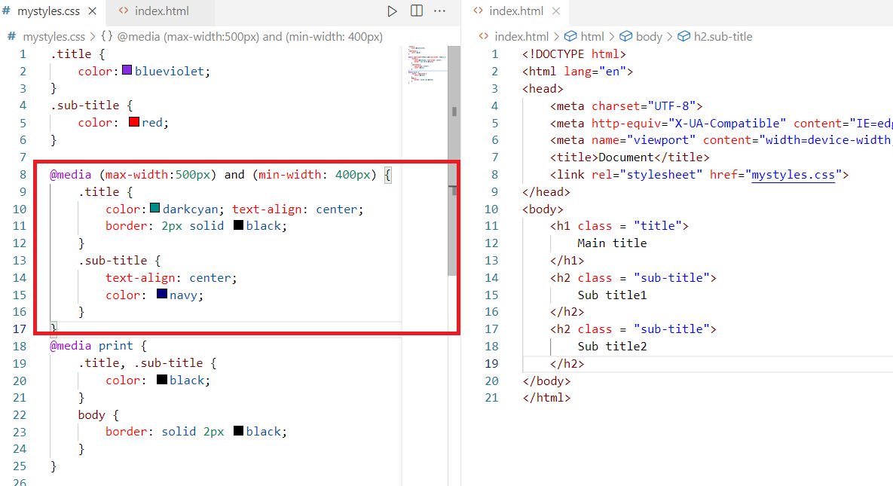

Above media query applies CSS rules when the width is between 400 & 500.

Grid System

When you want the elements to appear in row & column wise you can use display:grid

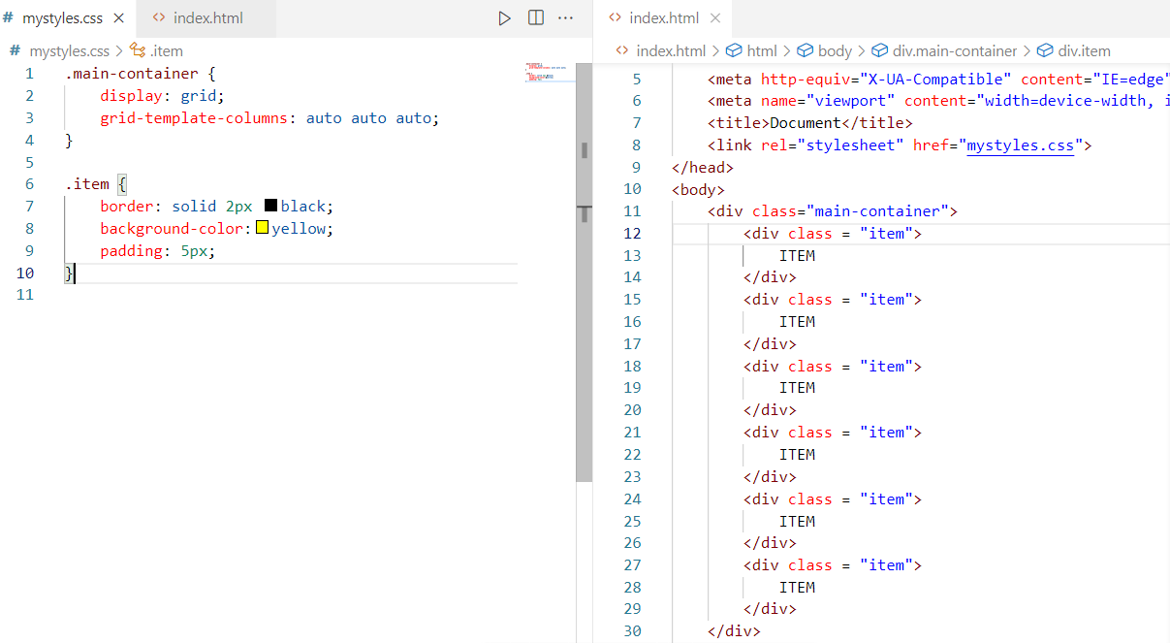

Here grid-template-columns arranges the elements based on the number of times you have mentioned auto.

Output:



Flex Box

It provides a layout where the elements align equally by equally sharing the width of the page.

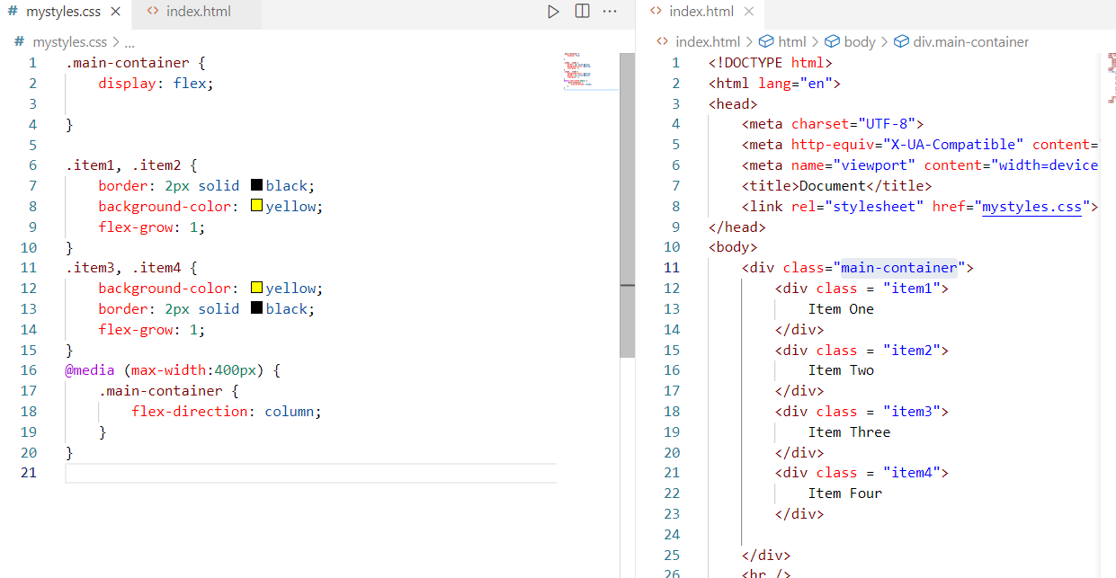

Output:

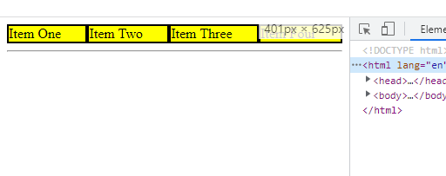

When the above page is reduced to 400 it will arrange same items vertically as below

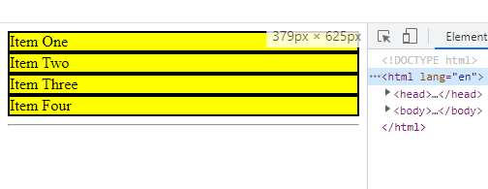

Animations:

It adds a smooth transitions to the HTML elements, you can provide multiple CSS properties to the HTML elements and smoothly change them through animations, you have @keyframes to add animations to the HTML elements.

Syntax:

@keyframes animation-name {  
 add animation rules from start to end  
}

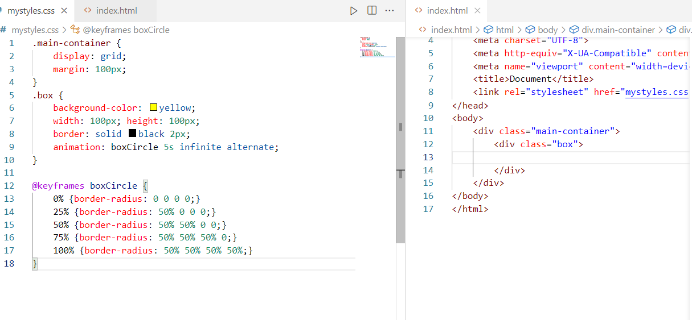

Output:

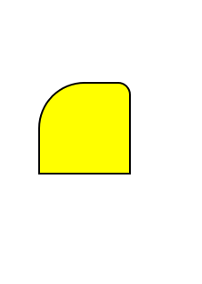

Activity:

1. Create an element that looks like square and increase its size to two times bigger and decrease its size to its default size through animation

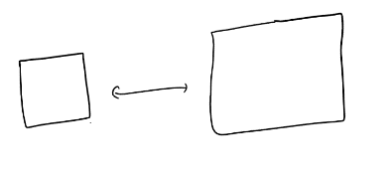

1. Create an element that looks like square & rotate that in both clock wise & anti-close wise using animation
2. Create your own animation to add some smooth transitions to the element

Solution for elements to rotate

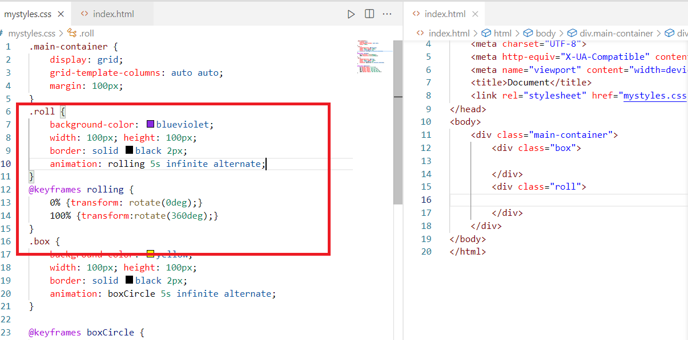

Output:

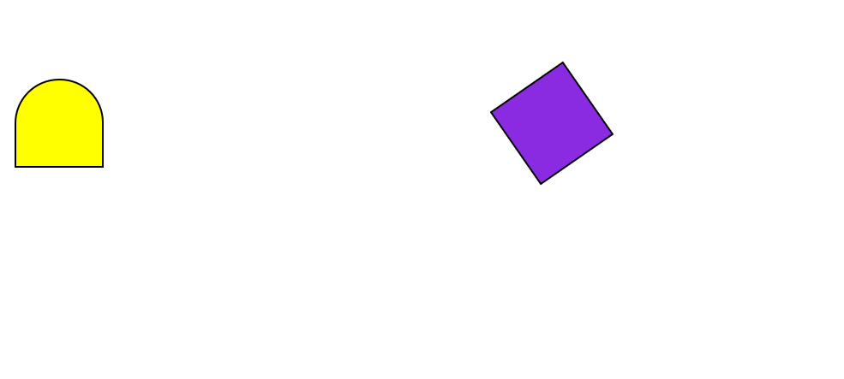

Javascript:

* Javascript is mainly used to access HTML & CSS at runtime, so that you can add/remove HTML or CSS dynamically.
* You can perform client side validations in Javascript
* You can handle events and perform some tasks
* You can write various programming constructs like loops, conditions, functions and so on.

Javascript code to increase/decrease font

