**Methodist High International School**

**Cambridge International Examinations**

Cambridge International General Certificate of Secondary Education

CANDIDATE NAME

CENTRE NUMBER CANDIDATE NUMBER

**MATHEMATICS** **580/Paper 4**

**HALF YEARLY** **September 2016**

**Class IX-I** **2.5 HOURS**

Candidates answer on the Question Paper.

Additional Materials: Electronic Material Geometrical Instruments

Graph Paper (Optional)

**READ THESE INSTRUCTIONS FIRST**

Write your Centre Number, Candidate Number and Name on all the Work you hand in.

Write in dark blue or black pen.

You may use an HB pencil for any diagrams or graphs.

Do not use staples, paper clips, glue or correction fluid.

Answer **all** questions.

If working is needed for any question, it must be shown below that question.

Electronic calculators should be used.

If the degree of accuracy is not specified in the question, and if the answer is not exact, give the answer to three significant figures. Give answers in degrees to one decimal place.

For $π$, use either your calculator value or 3.142.

At the end of the examination, fasten all your work securely together.

The number of marks is given in brackets [ ] at the end of each question or part question.

The total of the marks for this paper is **130**.

*This document consists of 14 printed pages.*

Q-1) The diagram shows a shaded region R.

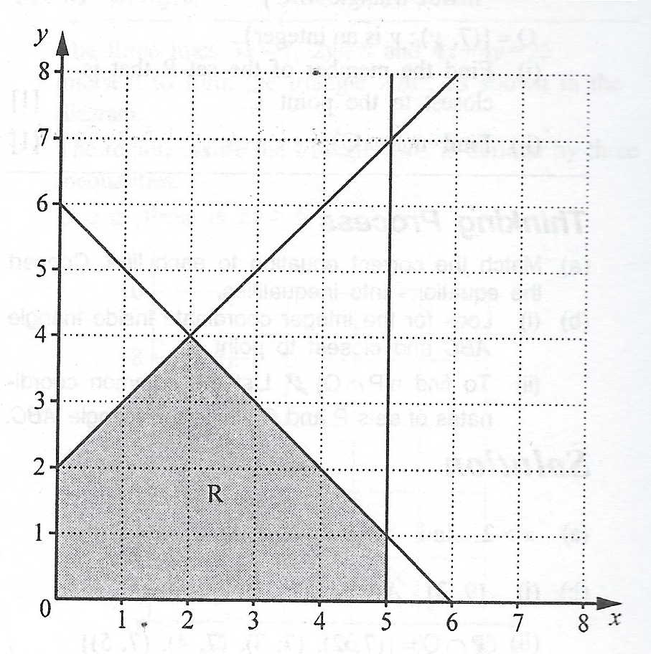

a) Write down the name of shaded polygon. [1]

*Answer: ___________________.*

b) Three of the inequalities that define the region R are

$x≥0, y≥0$ and $y≤x+2$.

Write down the other two inequalities that define this region. [2]

*Answer: ___________________.*

c) On the diagram draw the line that is parallel to $y=x+2$ and passes through the point (5, 0). [2]

d) Find the gradient of the line that is perpendicular to $y=x+2$. [2]

*Answer: ___________________.*

Q-2) The table below is for $y=x^{2}-4x-1$

|  |  |  |  |  |  |  |  |  |  |
| --- | --- | --- | --- | --- | --- | --- | --- | --- | --- |
| x | -2 | -1 | 0 | 1 | 2 | 3 | 4 | 5 | 6 |
| y |  | 4 | -1 |  | -5 | -4 |  | 4 |  |

a) Complete the table. [4]

b) Using a scale of 2cm to 1 unit, draw a horizontal x-axis for $-2≤x≤6$.

Using a scale of 2cm to 5 units, draw a vertical y-axis for $-10≤y≤15$.

Plot the points from the table and join them with a smooth curve. [4]



d) i) Find the least value of $y$. [2]

*Answer: ___________________.*

ii) $y≤4$ for $a≤x≤b$.

Find the least possible value of $a$ and the greatest possible value of $b$. [4]

*Answer: ___________________.*

e) **Use your graph** to solve the equation $x^{2}-4x+2=0$. Show your working to explain how you used your graph. [4]

Q-3) a) $T=2π\sqrt{\frac{h}{g}}$

i) Find $T$ when $h=125$ and $g=981$. [2]

*Answer: ___________________.*

ii) Make $h$ the subject of the formula. [3]

*Answer: ___________________.*

b) Solve the equation $45-\left(p+3\right)=2p$. [2]

*Answer: ___________________.*

c) Solve the equation $\frac{2x-3}{4}+\frac{5-x}{3}=0$ [3]

*Answer: ___________________.*

d) Solve the equation $3y^{2}+11y+4=0$.

Give your answers correct to 2 decimal places. [4]

*Answer: ___________________.*

Q-4) A light aircraft flew from Maseru to Nata and returned to Maseru.

a) The distance from Maseru to Nata is 1080 km.

i) On the outward flight, the average speed of the aircraft was $x$ kilometres per hour.

Write down an expression, in terms of $x$, for the time taken in hours. [2]

*Answer: ___________________.*

ii) On the return flight, the average speed was 30 km/h greater than the average speed on the outward flight. Write down an expression, in terms of $x$, for the time taken, in hours, on the return flight. [2]

*Answer: ___________________.*

b) The time taken on the return flight was half an hour less that the time taken on the outward flight. Form an equation in $x$ and show that it reduces to: [4]

$$x^{2}+30x-64800=0$$

*Answer: ___________________.*

c) Solve the equation: $x^{2}+30x-64800=0$. [4]

*Answer: ___________________.*

d) Calculate:

i) The time taken, in hours, on the outward flight. [2]

*Answer: ___________________.*

ii) The average speed for the whole flight from Maseru to Nata and back to Maseru. [4]

*Answer: ___________________.*

Q-5) a) In 2013, Mary worked for Company A. Her salary for the year was $18750.

i) $5625 of her salary was not taxed.

What percentage of her salary was not taxed? [3]

*Answer: ___________________.*

ii) The remaining $13125 of Mary’s salary was taxed.

22% of this amount was deducted for tax. Mary’s take-home pay was the amount $18750 after tax had been deducted. She received this is 52 equal amounts as a Weekly Wage.

Calculate Mary’s Weekly Wage. [4]

*Answer: ___________________.*

iii) In 2012, Mary had worked for Company B. When she moved from Company B to Company A, her salary increased by 25% to $18750. Calculate her salary when she worked for Company B. [3]

*Answer: ___________________.*

b) The rate of exchange between pounds (£) and Indian Rupees (R) is £1 = R87.21

The rate of exchange between Pounds (£) and Swiss Francs (F) is £1 = F1.53.

i) Mavis changed £750 into Indian Rupees, how many did she receive? [2]

*Answer: ___________________.*

ii) David changed F450 into Pounds. How many Pounds did he Receive? [2]

*Answer: ___________________.*

iii) Brian changed R50,000 into Swiss Francs. How many Swiss Francs did she Receive? [3]

*Answer: ___________________.*

Q-6) a) A shopkeeper buys some plates from a manufacturer for $10 each.

i) 1) The shopkeeper sells a plate for $12. Calculate the percentage profit. [2]

*Answer: ___________________.*

2) The shopkeeper buys some 240 plates and sells 180 at $12 each. The rest were sold to a café for a total of $540.

Calculate the percentage discount given to the café. [3]

*Answer: ___________________.*

ii) The manufacturer made a profit of 60% when he sold each plate for $10.

Calculate the cost of manufacturing each plate. [3]

*Answer: ___________________.*

b) Another shopkeeper bought 100 pans at $5 each. He sold 63 at $6 each and $x$ at $4 each.

He did not sell all the pans nor enough to make an overall profit.

i) Form an inequality in $x$. [2]

*Answer: ___________________.*

ii) Hence find greatest possible number of pans that were sold. [3]

*Answer: ___________________.*

c) One day, the rate of exchange between American Dollars ($) and British Pounds (£) was $\$1.45=£1$.

i) Alan changed £300 into dollars. Calculate how many dollars he received. [2]

*Answer: ___________________.*

ii) On the same day, the rate of exchange between South African Rands (R) and Pounds was R10.44 = £1.

Calculate the number of Rands received in exchange for One Dollar. [3]

*Answer: ___________________.*

Q-7) It is given that $x=a+\sqrt{a^{2}+b^{2}}$.

a) i) Calculate $x$ when $a=0.73$ and $b=1.84$.

Give your answer correct to 2 decimal places. [3]

*Answer: ___________________.*

ii) Express $b$ in terms of $x$ and $a$. [4]

*Answer: ___________________.*

b) A shopkeeper sells pens and pencils. Each pen costs $5 and each pencil costs $3. One day he sole $x$ pens. On the same day, he sold 9 more pens than pencils.

i) Write down the expression, in terms of $x$, for his total income from the sale of these pens and pencils. [3]

*Answer: ___________________.*

ii) This total income was less than $300. Form an inequality un $x$ and solve it. [3]

*Answer: ___________________.*

iii) Hence write down the maximum number of pens that he sold. [2]

*Answer: ___________________.*

Q-8) a) Solve the equation $\frac{3t+1}{2}=4$. [3]

*Answer: ___________________.*

b) Solve the simultaneous equations. [4]

$$2x+y=12$$

$$3y-2x=56$$

*Answer: ___________________.*

c) Simplify: $\frac{3y^{2}+8y+4}{y^{2}-4}$. [4]

*Answer: ___________________.*

d) Given that $3h+2x=2f-gx$, express $x$ in terms of $f, g$ and $h$. [4]

*Answer: ___________________.*

e) P is (-1, 3) and Q is (5, -1)

i) Find the coordinates of the midpoint of the Line PQ. [2]

*Answer: ___________________.*

ii) Find the gradient of the line PQ. [2]

*Answer: ___________________.*

iii) Given that the length of $PQ=2\sqrt{n}$ units, where $n$ is an integer, find the value of $n$. [4]

*Answer: ___________________.*

Blank space for **Rough Work**.