Intro to CS

Final Project Documentation

Submitted by Aayusha Shrestha and Mariam Anwar

Project: Space Traffic

The game is a multiplayer game, where each player attempts to reach the green planet (final destination) to win. The players will face obstacles such as asteroids and fireballs (colliding with them causes a loss of life), and instances where they will be required to step on rockets to avoid losing a life. Players can also collect coins to boost their score. A time bar decreases as the game goes on and the less the player takes to win, the higher their score. Game is over when either all lives are lost, or when time is up

The obstacles are instantiated from their respective classes, and each have attributes for their current x and y positions, x1 and x2 which tell us where the line of objects should begin and end. We use a limited number of objects (such as asteroids in a range of 3), and “re-use” them by using the x2 and x1.

Each player has 3 lives to begin with, and a life is lost each time the alien falls off a rocket, or collides with an asteroid or a fireball. The collision detection for asteroids and fireballs is done by calculating the distance between the centers of the objects. For the rocket section, once the alien is in the range of rockets, if it collides with a rocket, it will have the same x and y of the rocket and so will move with it. However, if it moves off the rocket, it will lose a life and the go back to starting from the beginning. The range of the rocket segment of the game is determined by an if statement that tests if the alien’s y is lower than the maximum y of all the rockets, and higher than the minimum y of all the rockets.

Background music starts to play once a level is chosen, and a collision sound plays upon the collision of the alien with an asteroid or rocket, while a falling sound plays if the alien falls of a rocket.

The y coordinate of each game (y0 and y1) allow us to move through the game, and shifts the background.

The score is implemented based on the remaining number of lives, remaining time and number of coins collected.

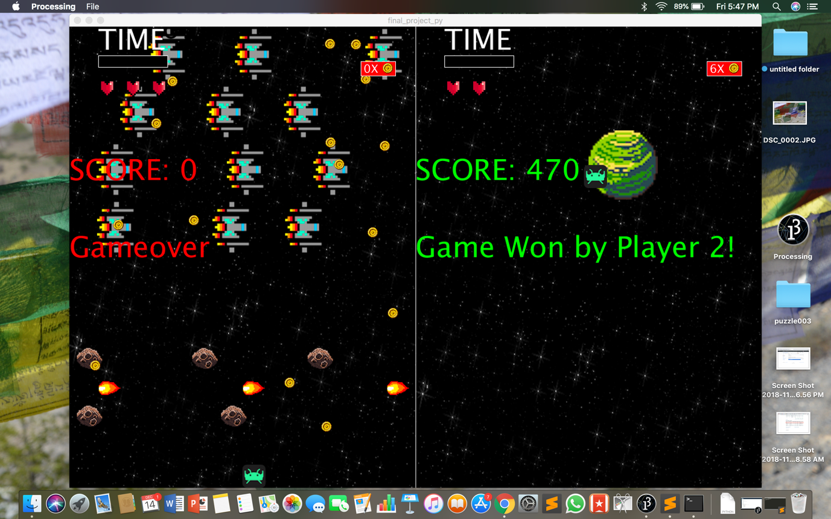

The left side is player1, (whose game is over because time ran out) and the right player is player2. Player 2 won as it reached the green planet. The red bar shows the number of coins collected.