FPGA Implementation and Reliability–Overhead
Analysis of Hamming SECDED Error Correction
for On-Chip SRAM
Aayush Attal
Department of Electronics and Telecommunication Engineering
Vidyalankar Institute of Technology, Mumbai, India
Abstract— On-chip SRAM in modern digital systems is increasingly susceptible to soft errors caused by radiation-induced single-event upsets, electrical noise, and process-voltage-temperature variation, particularly as memory density and integration scale increase. This paper presents the design, RTL implementation, and experimental verification of a Hamming Single-Error-Correction Double-Error-Detection (SECDED) codec for on-chip SRAM protection, targeting a Xilinx Spartan-7 (xc7s50csga324-1) FPGA. Two code instantiations are implemented and compared: a Hamming(72,64) code for 64-bit data words and a Hamming(13,8) code for 8-bit data words, in order to quantify how storage overhead scales with data width. Functional correctness is verified through randomized and exhaustive fault-injection simulation, confirming 100% single-bit correction and 100% double-bit detection within both codes' design guarantee. Both codes are then driven beyond that guarantee with three simultaneous bit errors -- a randomized 200-trial sweep for the 64-bit code, and an exhaustive enumeration of all 13-choose-3 = 286 possible three-bit combinations for the 13-bit code -- revealing silent miscorrection rates of 100% and 99.3% respectively, with a complete absence of double-error-detection coverage in either case. A worked numerical example, gate-level schematic, and comparison against alternative code families (extended Hamming, BCH, Reed-Solomon) are also presented. These results quantify the reliability-overhead tradeoff inherent to SECDED codes and motivate stronger multi-bit-correcting codes for higher-radiation or more error-prone memory environments.
Index Terms—Error correction codes, Hamming code, SECDED, FPGA, on-chip SRAM, soft errors, fault injection, reliability, Spartan-7.

I. Introduction
As semiconductor process nodes continue to scale, on-chip static random-access memory (SRAM) has become increasingly vulnerable to soft errors: transient bit-flips caused by cosmic-ray-induced neutrons, alpha particles from package materials, and electrical noise coupling [5]. Unlike hard faults, soft errors do not damage the underlying silicon; a single upset can nonetheless silently corrupt stored data, leading to incorrect computation or system failure in the absence of protection. Error Correction Codes (ECC) address this by storing redundant check bits alongside data, enabling a decoder to detect and, within limits, correct corrupted words upon readout.
The consequences of an uncorrected soft error scale with the criticality of the system storing it: in commodity computing a single flipped bit may cause an application crash, while in aerospace, automotive advanced driver-assistance systems (ADAS), medical devices, and data-center memory at scale, an undetected corruption can propagate into an unsafe or costly outcome long after the originating event. This has made ECC-protected SRAM a standard feature of processor caches, FPGA Block RAM controllers, and DDR memory controllers alike, and motivates treating the correction/detection guarantee of a chosen code -- and precisely where that guarantee ends -- as a first-class design parameter rather than an implementation detail.
Hamming codes, introduced in [1], remain the most widely deployed ECC scheme for on-chip memory due to their low decoding latency and modest hardware cost relative to their correction capability. The SECDED (Single Error Correction, Double Error Detection) extension, formalized by Hsiao [2] and surveyed extensively in [4], adds one overall parity bit to a standard Hamming code so that single-bit and double-bit errors can be distinguished rather than both appearing as a single detected error. SECDED codes remain in broad use in general-purpose processor caches and memory controllers to this day.
This paper makes four contributions. First, it presents a complete, synthesizable RTL implementation of Hamming SECDED encoding and decoding, wrapped around FPGA Block RAM to form a drop-in ECC-protected memory, targeting a Xilinx Spartan-7 device. Second, it presents a quantitative comparison of storage overhead across two data widths (8-bit and 64-bit), showing how the fixed logarithmic growth of parity bits causes overhead to fall sharply as word width increases. Third, it presents an exhaustive fault-injection characterization of decoder behaviour once the error count exceeds the code's design guarantee, quantifying a failure mode -- silent miscorrection -- that is easy to state qualitatively but is measured here directly on the implemented RTL. Fourth, it situates these results against alternative code families (extended Hamming/SECDED variants, BCH, Reed-Solomon) to give a practical, application-oriented view of when Hamming SECDED is an appropriate choice and when it is not.
II. Related Work
Hsiao's odd-weight-column construction [2] remains the reference SECDED design used in most commercial memory controllers, and [4] provides a comprehensive review of ECC techniques for semiconductor memory spanning several code families. Beyond single Hamming SECDED, several works address the adjacent multi-bit-upset (MBU) problem that arises as cell pitch shrinks and a single particle strike can flip more than one physically adjacent bit; Tripathi et al. [6] present an FPGA-implemented low-area multi-bit adjacent error-correcting codec for SRAM, motivated by exactly the failure mode this paper characterizes experimentally in Section V. Bose-Chaudhuri-Hocquenghem (BCH) codes [3] generalize Hamming codes to correct an arbitrary, designed-in number of errors t, at the cost of Galois-field syndrome computation (e.g., Peterson's algorithm and Chien search for small t); a BCH(n,k,t=2) codec is a natural next step from the SECDED baseline presented here, and is discussed as future work in Section VI.
A. Comparison of ECC Code Families
Table III situates the Hamming SECDED codes studied in this paper against the broader landscape of ECC constructions commonly applied to on-chip memory, summarizing typical correction/detection capability, relative decode complexity, and typical application context.
Code family | Correct / Detect | Decode complexity | Typical use
Parity (single bit) | 0 / 1 | Trivial (XOR) | Cheap detect-only links
Hamming SEC | 1 / 1 | Low (syndrome) | Non-critical caches
Hamming SECDED [2] | 1 / 2 | Low (syndrome + parity) | Processor caches, this work
SEC-DED-DAEC [6] | 1(+adj.) / 2 | Moderate | Dense/scaled SRAM
BCH(n,k,t) [3] | t / t (designed) | High (GF syndromes, Chien search) | High-radiation, storage
Reed-Solomon | Symbol-level t | High (GF, non-binary) | Storage, burst errors
TABLE III. Qualitative comparison of ECC code families for on-chip memory protection.
This comparison frames the results in Section V: Hamming SECDED occupies the low-complexity, low-overhead end of this spectrum, which is precisely why its behaviour beyond its 2-bit guarantee (rather than its behaviour within it) is the more practically important question for a designer deciding whether it is sufficient for a given memory's expected fault profile.
III. Hamming SECDED Code Design
A. Parity Bit Placement
A Hamming SECDED code protecting k data bits requires r parity bits satisfying 2^r >= k + r + 1, plus one additional overall parity bit for double-error detection, giving a total codeword length n = k + r + 1. Data and parity bits are interleaved: parity bits occupy the power-of-two positions (1, 2, 4, 8, ...) of a 1-indexed codeword, and data bits fill the remaining positions in order. Parity bit p_i, located at position 2^i, is computed as the XOR of every data bit whose position (in this numbering) has bit i set:
p_i = XOR over all positions p with bit i of p set, of the data bit at position p (1)
For k = 64, r = 7 satisfies 2^7 = 128 >= 64 + 7 + 1 = 72, giving a Hamming(71,64) code; adding the overall parity bit yields the Hamming(72,64) SECDED code used in this work. For k = 8, r = 4 satisfies 2^4 = 16 >= 8 + 4 + 1 = 13, giving a Hamming(13,8) SECDED code after the extra parity bit is added.
B. Decoding and Correction
On read, the decoder recomputes each parity bit from the received data and XORs it against the received parity bit to form a syndrome bit; the r-bit syndrome S, together with a check of the overall parity bit P, determines the outcome:
S = 0, P = 0 => no error (2)
S != 0, P = 1 => single-bit error at position S; flip and correct (3)
S = 0, P = 1 => error confined to the overall parity bit; data unaffected (4)
S != 0, P = 0 => double-bit error; flagged uncorrectable (5)
This decision logic is exact for zero, one, or two simultaneous bit errors, which is the code's design guarantee. Section V experimentally examines what the decoder does when this guarantee is exceeded.
C. Gate-Level Realization
Each parity bit is realized as an XOR-tree over its covered data bits. Fig. 1 shows this structure for P1 of the Hamming(13,8) code; P2, P4, and P8 follow the identical pattern over their own covered inputs per (1). This gate-level view is what the behavioural RTL of Section IV synthesizes to -- the bounded for-loops used in the implementation unroll to exactly this XOR-tree structure rather than introducing any additional logic.
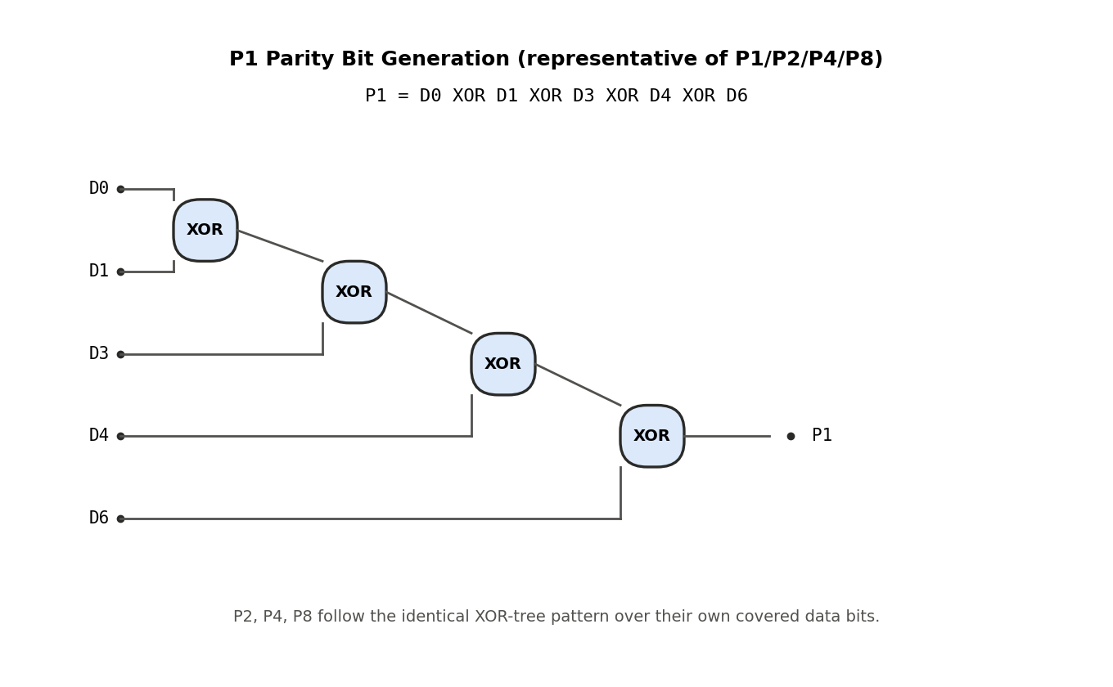
Fig. 1. Gate-level XOR-tree realization of parity bit P1 for the Hamming(13,8) code.
D. Worked Numerical Example
To make the encoding concrete, consider data_in = 8'b10110101 (bit 7 down to bit 0) encoded by the Hamming(13,8) code. Extracting individual bits gives D0=data_in[0]=1, D1=data_in[1]=0, D2=data_in[2]=1, D3=data_in[3]=0, D4=data_in[4]=1, D5=data_in[5]=1, D6=data_in[6]=0, D7=data_in[7]=1. Applying (1):
P1 = D0^D1^D3^D4^D6 = 1^0^0^1^0 = 0 (6)
P2 = D0^D2^D3^D5^D6 = 1^1^0^1^0 = 1 (7)
P4 = D1^D2^D3^D7 = 0^1^0^1 = 0 (8)
P8 = D4^D5^D6^D7 = 1^1^0^1 = 1 (9)
assembling the 12-bit field (D7 D6 D5 D4 P8 D3 D2 D1 P4 D0 P2 P1) = (1 0 1 1 1 0 1 0 0 1 1 0) and taking the overall parity P13 as the XOR of these 12 bits (seven 1s, an odd count, giving P13=1), the final codeword is 13'b1_1011_1010_0110 -- confirmed bit-for-bit against the RTL simulation output for this exact input in Fig. 4 (code_out = 1101110100110).
IV. RTL Architecture and FPGA Implementation
The encoder and decoder were implemented as combinational Verilog blocks using bounded-loop behavioural descriptions (constant loop bounds over 64 or 8 data bits), which synthesize to unrolled XOR-tree logic identical in structure to a hand-written gate-level implementation (Section III-C), while remaining parametrizable and far less error-prone to write correctly. The decoder and encoder are wrapped around an inferred Xilinx Block RAM array to form an ECC-protected memory with a two-cycle read latency: one cycle to fetch the stored codeword, one to decode and register the corrected output alongside sec/ded status flags. A separate fault-injection port allows a specific bit of the stored codeword to be flipped on demand, independent of the normal read/write ports, to emulate a single-event upset for test purposes.
The design targets a Xilinx Spartan-7 xc7s50csga324-1 device (RealDigital Boolean Board), elaborated and synthesized in Vivado 2024.1 (place-and-route and on-board validation are pending). A board-level top module exposes push-button-triggered write/read/fault-injection operations and LED status indicators, intended to allow the codec's behaviour to be observed directly on hardware in addition to simulation.
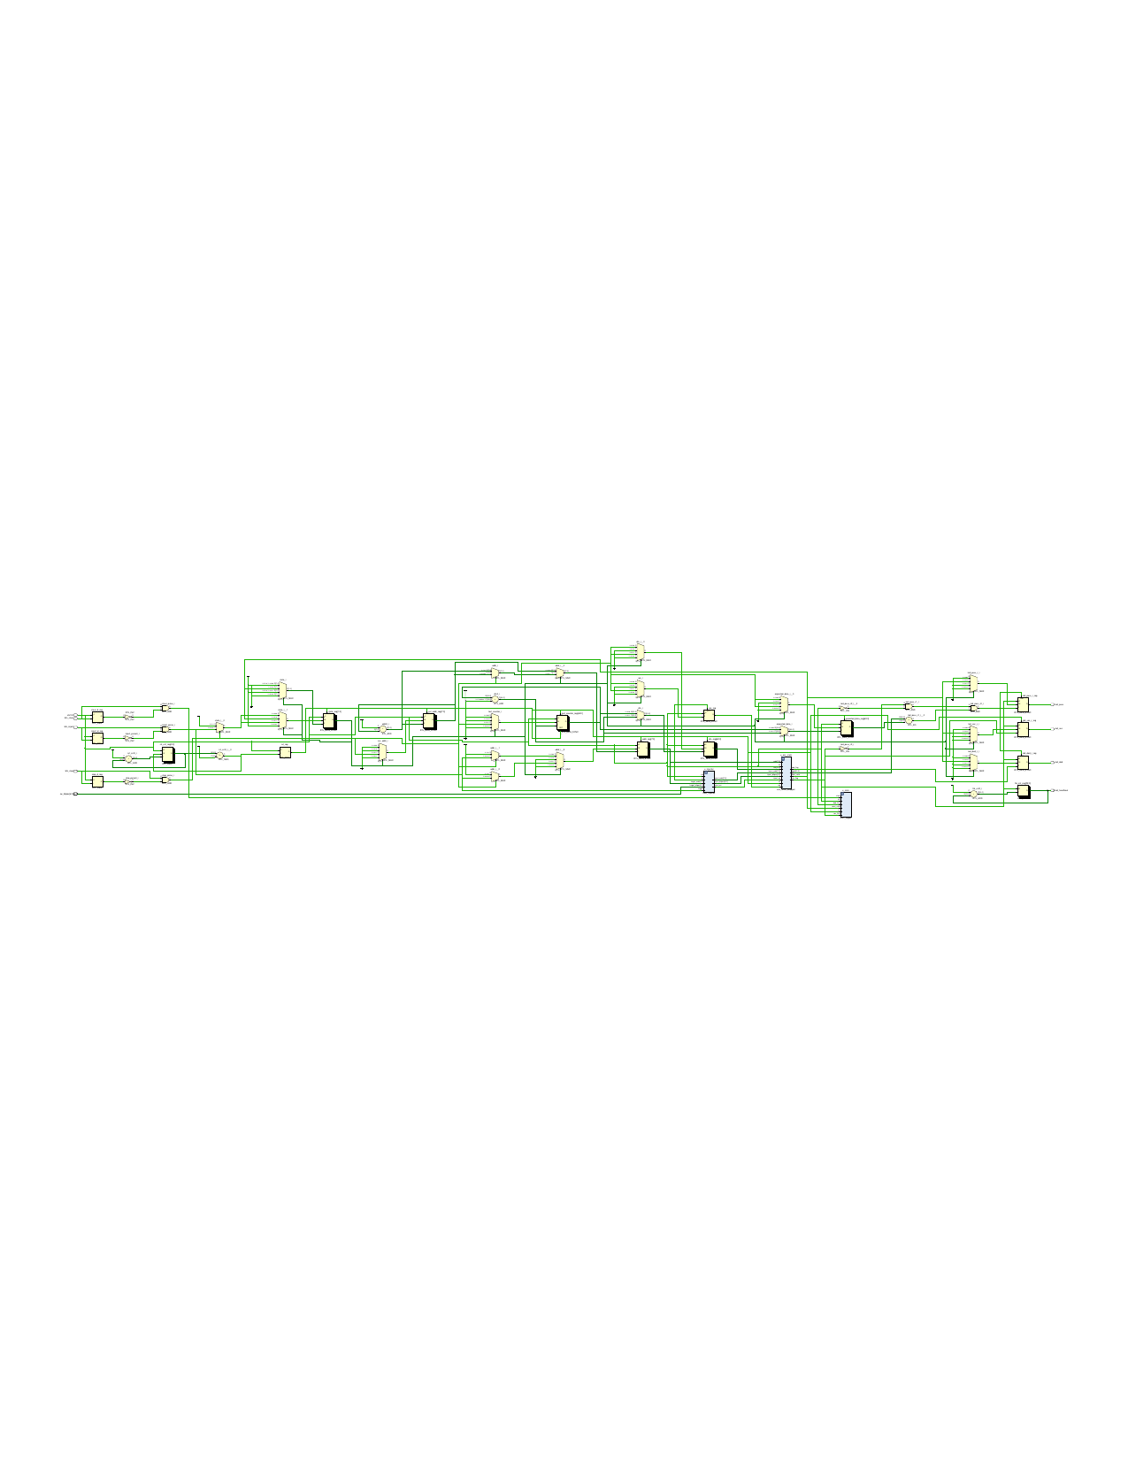
Fig. 2. Vivado-elaborated RTL schematic of top_ecc_demo (target: xc7s50csga324-1), showing ecc_sram_wrapper, fault_injector, and stats_logger instantiated as symbols within the top-level hierarchy.
Fig. 2 confirms the intended hierarchical structure was preserved through elaboration: the top-level module instantiates the three sub-blocks as independent symbols with well-defined port lists (visible as u_ecc_sram, u_injector, and u_stats), matching the RTL partitioning described above rather than being flattened or optimized away during synthesis.
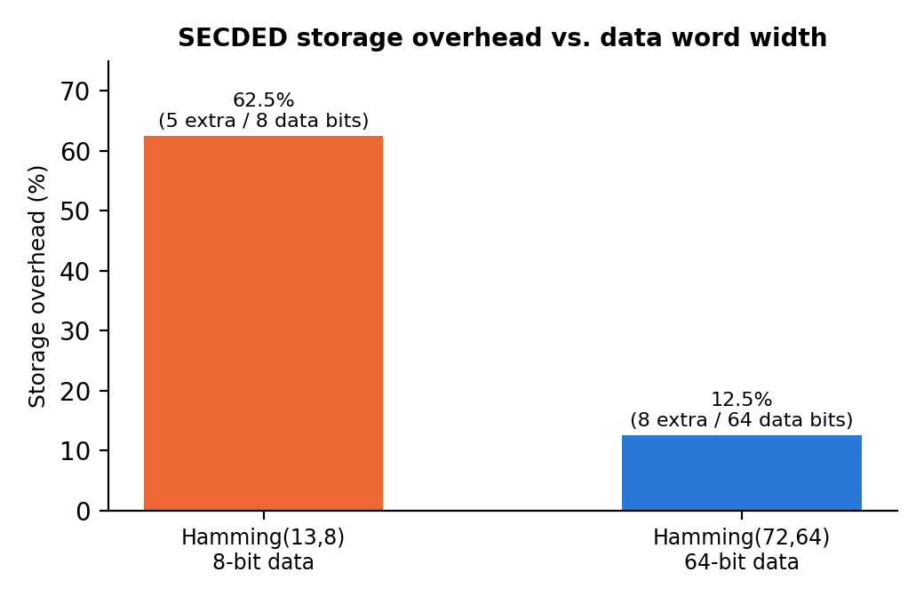
Fig. 3. Storage overhead falls sharply as data word width increases, since parity bit count grows only logarithmically with data width.
Fig. 3 quantifies this scaling effect directly: the same SECDED construction costs 62.5% storage overhead when protecting an 8-bit word, but only 12.5% when protecting a 64-bit word, since parity count grows as O(log k) while data grows linearly. This has a direct design implication: SECDED is comparatively expensive to apply to narrow words (e.g., byte-wide register file entries) and comparatively cheap to apply to wide words (e.g., cache lines), which is reflected in real processor designs that typically protect wide cache-line-granularity storage rather than individual bytes.
A. Verification Methodology
Both codecs were verified using self-checking testbenches that write a data word, optionally inject a controlled number of bit errors into the stored codeword via a dedicated fault-injection port, and assert that the decoder's output and status flags match the expected outcome from (2)-(5). Two stimulus defects found during development shaped the final methodology. First, a sweep run under Vivado xsim reported identical results for one-, two- and three-bit injections; the waveform showed the fault port receiving an undefined (X) address for the whole sweep, so no fault ever landed, and a classification rule that counted 'no flag raised, data intact' as 'corrected' turned that failure into plausible-looking output. Second, an earlier sweep used a signed $random value with a modulo operator, which occasionally produced out-of-range bit positions and silently skipped injections (120 of 200 trials took effect). The final testbench therefore (i) counts no-flag outcomes as their own class, (ii) independently reads the stored codeword and requires its Hamming distance from the pre-injection word to equal the intended error count in every trial, (iii) guards every fault-port address against X/Z, (iv) avoids passing expressions into static tasks, (v) uses a deterministic xorshift32 generator so stimulus does not depend on simulator-specific random-number behaviour, and (vi) is itself tested by deliberately breaking the fault port and requiring a failing verdict. A Python golden model of the decoder reproduces the RTL's exhaustive 3-bit result for the (13,8) code exactly. Stimulus code, not only the design under test, needs this kind of self-checking.
V. Experimental Results
A. Functional Verification
Both code instantiations were verified in simulation with Icarus Verilog using self-checking testbenches and cross-checked against an independent Python golden model; the 64-bit design's basic tests were additionally run in Vivado xsim. Basic correctness tests -- a clean round trip, a single injected bit error, and a double injected bit error -- passed in all cases, confirming correct SECDED behaviour within the code's design guarantee:
[PASS] Test 1: plain round trip, data=deadbeef12345678
[PASS] Test 2: single-bit error corrected, data=cafebabe0f0f0f0f
[PASS] Test 3: double-bit error correctly flagged uncorrectable
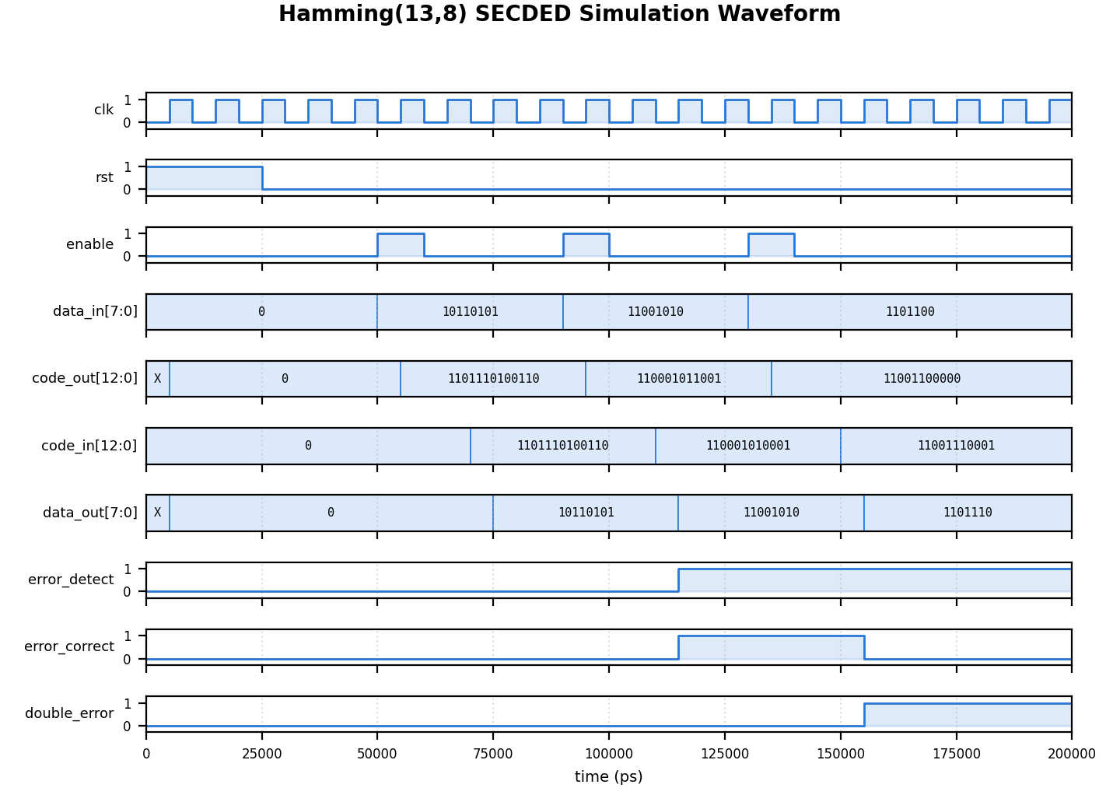
Fig. 4. Simulation waveform of the Hamming(13,8) codec across a clean round trip, a corrected single-bit error, and a detected double-bit error.
Fig. 4 shows the corresponding waveform: data_in is encoded into code_out, optionally corrupted (code_in), and decoded back to data_out with error_detect/error_correct/double_error flagged appropriately for each of the three cases, visually confirming the log above.
B. Randomized Single/Double/Triple-Bit Fault Sweep (Hamming(72,64))
A randomized sweep of 200 trials each for one, two, and three simultaneously injected bit errors was run against the 64-bit codec, with each trial injecting the specified number of distinct random bit positions into a freshly encoded word. Table I summarizes the results.
Injected errors | Corrected | Detected  (uncorrectable) | Miscorrected
1 bit (200 trials) | 200 | 0 | 0
2 bits (200 trials) | 0 | 200 | 0
3 bits (200 trials) | 0 | 0 | 200
TABLE I. Hamming(72,64) behaviour at increasing simultaneous error counts: 100% correct at 1 bit, 100% detected at 2 bits, 100% silently miscorrected at 3 bits.
The 3-bit row in Table I already shows the same qualitative breakdown later confirmed exhaustively in Section V-C: once the error count exceeds the code's design guarantee, error_correct is asserted with false confidence rather than double_error being raised. The sampled 64-bit result (200/200, 100%) agrees with an exhaustive enumeration of all 59,640 three-bit error patterns of the (72,64) code in the golden model, in which 59,625 (99.975%) are miscorrected and only 15 leave the data intact; at that rate a 200-trial sample contains no such case about 95% of the time. The golden model reproduces the RTL's exhaustive (13,8) result of Table II exactly, which is the basis for trusting it at the larger width.
C. Exhaustive Three-Bit Fault Sweep (Hamming(13,8))
The 64-bit code's 3-bit result in Table I is a random sample of the fault space, not a complete enumeration. To characterize decoder behaviour beyond the SECDED design guarantee exhaustively, every possible combination of three simultaneously flipped bits in a 13-bit codeword was tested -- all 13-choose-3 = 286 combinations -- against one fixed encoded data word. Table II summarizes the outcome distribution, and, unlike Table I's random sample, is a complete characterization of the code's behaviour under all possible 3-bit error patterns.
Outcome | Count / 286 | %
Corrected, data still right (luck) | 2 | 0.7%
Miscorrected (flagged OK, data wrong) | 284 | 99.3%
Detected as double-error | 0 | 0.0%
TABLE II. Hamming(13,8) decoder behaviour on all 286 possible 3-bit error patterns.
The result in Table II is the central experimental finding of this paper: with three simultaneous bit errors, the decoder is wrong 99.3% of the time, and critically, it is wrong with false confidence -- the error_correct flag is asserted (indicating a trusted, corrected result) in every miscorrected case, while double_error, the flag meant to catch uncorrectable conditions, was never asserted for any of the 286 combinations. This follows from the decoder's decision rule rather than from any defect: an odd number of bit errors always makes the overall parity check fail, so the decoder always takes the single-error branch of (3) or (4) and can never reach the double-error branch (5), which requires the overall parity to pass. The 'correction' then flips one bit chosen by the syndrome, unrelated to the actual error pattern, leaving at least two errors in place; the data is right only in the 2 of 286 cases where the residual errors all fall on parity positions. Notably, 66 of the 286 patterns (23%) produce a syndrome pointing outside the 12-bit codeword, which a stricter decoder could flag as uncorrectable; the implemented decoder does not.
VI. Discussion and Future Work
These results make the reliability-overhead tradeoff concrete rather than qualitative: 12.5% overhead (64-bit case) purchases 100% single-bit correction and 100% double-bit detection, but affords zero protection -- and worse, false confidence -- once a third simultaneous error occurs. For memory environments where multi-bit upsets are rare relative to single-bit upsets (typical of planar, larger process nodes), Hamming SECDED is an efficient choice. For denser or higher-radiation environments where adjacent multi-bit upsets are non-negligible, the literature offers two directions consistent with the results here: SEC-DED-DAEC (double-adjacent-error-correcting) code variants such as those surveyed alongside [6], or a full BCH(n,k,t=2) code [3] that guarantees correction, not merely detection, of two-bit errors, at the cost of Galois-field syndrome decoding hardware.
A. Application-Domain Implications
Returning to the application contexts of Section I, the results here suggest a practical decision rule rather than a single universal answer. General-purpose caches and FPGA Block RAM in benign, ground-level, planar-process environments experience soft-error rates dominated by single-bit upsets [5], for which Hamming SECDED's 12.5% overhead (at 64-bit granularity) is close to the best achievable efficiency. Aerospace, satellite, and high-altitude avionics memory, by contrast, experience a meaningfully higher rate of multi-bit upsets from heavy-ion and high-energy neutron strikes, where the 99.3-100% miscorrection rates measured here indicate Hamming SECDED alone is an inappropriate choice without an additional layer such as memory scrubbing, interleaving to convert adjacent physical upsets into non-adjacent logical ones, or a stronger code such as BCH(t=2). Automotive ADAS and medical device memory sit between these extremes and typically justify the intermediate SEC-DED-DAEC approach [6], which targets the specific adjacent-multi-bit-upset pattern most relevant to deep-submicron SRAM without the full hardware cost of general BCH decoding.
B. Future Work
Implementing and benchmarking a BCH(t=2) codec against the Hamming SECDED baseline presented here, under an identical exhaustive fault-injection methodology, is the direct next step of this work. Additional directions include: extending the fault model to spatially adjacent bit patterns specifically (rather than uniformly random bit selection) to better emulate real charge-sharing-induced multi-bit upsets; measuring actual FPGA resource utilization (LUT/FF count) and timing closure for both codecs post-synthesis to complement the storage-overhead analysis in Fig. 3 with area and latency overhead; and validating the design against an on-hardware radiation or fault-injection test rig rather than RTL-level simulation alone.
VII. Conclusion
This paper presented a complete, simulation-verified Hamming SECDED ECC implementation for on-chip SRAM, targeting a Xilinx Spartan-7 device, at two data widths. Simulation confirms 100% correctness within the code's design guarantee, and an exhaustive fault-injection study quantifies, in this concrete RTL setting, a 99.3% silent miscorrection rate once the error count exceeds that guarantee -- with the double-error-detection mechanism providing no coverage whatsoever against three-bit errors. Situated against alternative code families and application domains, these results give a quantitative, reproducible basis for choosing between Hamming SECDED and stronger multi-bit-correcting codes based on a target application's expected fault profile.
Acknowledgment
The author thanks the Department of Electronics and Telecommunication Engineering, Vidyalankar Institute of Technology, for providing access to the FPGA board and Vivado tools.
References
[1] R. W. Hamming, "Error detecting and error correcting codes," Bell Syst. Tech. J., vol. 29, no. 2, pp. 147-160, Apr. 1950.
[2] M. Y. Hsiao, "A class of optimal minimum odd-weight-column SEC-DED codes," IBM J. Res. Develop., vol. 14, no. 4, pp. 395-401, Jul. 1970.
[3] R. C. Bose and D. K. Ray-Chaudhuri, "On a class of error correcting binary group codes," Inf. Control, vol. 3, no. 1, pp. 68-79, Mar. 1960.
[4] C. L. Chen and M. Y. Hsiao, "Error-correcting codes for semiconductor memory applications: A state-of-the-art review," IBM J. Res. Develop., vol. 28, no. 2, pp. 124-134, 1984.
[5] R. C. Baumann, "Soft errors in advanced computer systems," IEEE Des. Test Comput., vol. 22, no. 3, pp. 258-266, 2005.
[6] S. Tripathi, R. K. Maity, J. Jana, and J. Samanta, "FPGA based low area multi-bit adjacent error correcting codec for SRAM application," Radioelectron. Commun. Syst., vol. 63, no. 10, pp. 543-552, Dec. 2020.
[7] AMD-Xilinx, "Vivado Design Suite," Version 2024.1, Santa Clara, CA, USA, 2024.

