VIT  (Vidyalankar Institute of Technology) | Department of Electronics and Telecommunication Engineering  Lab No. 3  Subject: System on Chip SEM-VII A.Y. 2026-27

Student Name | Aayush Attal
Roll No. | 23104A0037

3. RTL-Level Design of Hamming(13,8) SECDED Encoder and Decoder

Objective
To design the functionality of the Hamming(13,8) SECDED ECC block at the Register Transfer Level (RTL): derive its Boolean equations, represent its structure as a gate-level schematic, implement it in Verilog HDL, simulate it, and verify correct single-bit correction and double-bit detection behaviour.

1. Boolean Equations
Data bits D0-D7 (= data_in[7:0]) and parity bits P1, P2, P4, P8 occupy the classic 1-indexed Hamming positions 1-12 as follows:
Position : 1 2 3 4 5 6 7 8 9 10 11 12
Bit : P1 P2 D0 P4 D1 D2 D3 P8 D4 D5 D6 D7
Each parity bit is the XOR of every data bit whose position (in the table above) has the corresponding binary weight set:
P1 = D0 XOR D1 XOR D3 XOR D4 XOR D6 (covers positions 1,3,5,7,9,11)
P2 = D0 XOR D2 XOR D3 XOR D5 XOR D6 (covers positions 2,3,6,7,10,11)
P4 = D1 XOR D2 XOR D3 XOR D7 (covers positions 4,5,6,7,12)
P8 = D4 XOR D5 XOR D6 XOR D7 (covers positions 8,9,10,11,12)
P13 = P1 XOR P2 XOR D0 XOR P4 XOR D1 XOR D2 XOR D3 XOR P8 XOR D4 XOR D5 XOR D6 XOR D7
P13 is the extra overall-parity bit that upgrades single-error-correction to SECDED (Single Error Correction, Double Error Detection).
Decoder syndrome equations (recomputed from the received code_in, including each parity bit's own position):
S0 = c0 XOR c2 XOR c4 XOR c6 XOR c8 XOR c10
S1 = c1 XOR c2 XOR c5 XOR c6 XOR c9 XOR c10
S2 = c3 XOR c4 XOR c5 XOR c6 XOR c11
S3 = c7 XOR c8 XOR c9 XOR c10 XOR c11
overall_check = code_in[12] XOR (c0 XOR c1 XOR ... XOR c11)
where c0..c11 = code_in[11:0]. Syndrome = {S3,S2,S1,S0}: if 0 and overall_check = 0, no error; if syndrome != 0 and overall_check = 1, a single-bit error exists at that syndrome's position and is corrected by flipping that bit; if syndrome != 0 and overall_check = 0, a double-bit error is present and flagged (not corrected).

2. Gate-Level Schematic
Each parity bit is generated by an XOR gate tree over its covered data bits. The structure for P1 is shown below; P2, P4, and P8 follow the identical pattern over their own inputs (see equations above).
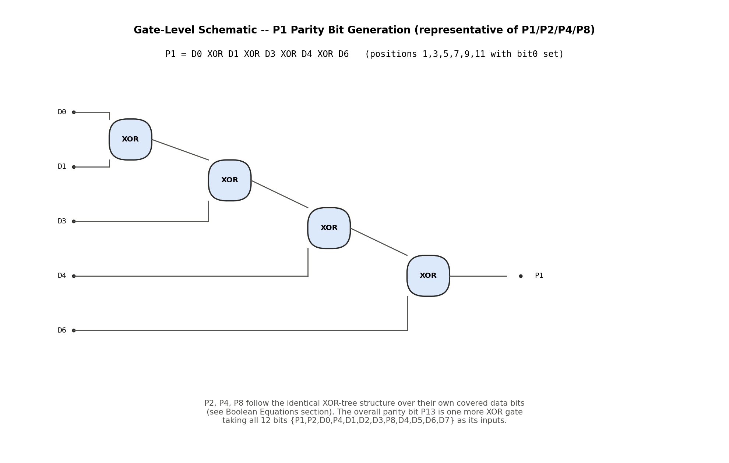
Fig 1: Gate-level XOR-tree schematic for parity bit P1 (representative of P1/P2/P4/P8 generation).

3. Verilog HDL
Two modules are implemented, with signal names and widths matching the Functional Specification (Lab 2): ecc_encoder (clk, rst, data_in[7:0], enable -> code_out[12:0]) and ecc_decoder (clk, rst, code_in[12:0] -> data_out[7:0], error_detect, error_correct, double_error).
// ============================================================================
// hamming_13_8.v
// Hamming(13,8) SECDED encoder and decoder.
// Signal names/widths match the Lab 2 Functional Specification exactly:
// Encoder : clk, rst, data_in[7:0], enable, code_out[12:0]
// Decoder : clk, rst, code_in[12:0], data_out[7:0],
// error_detect, error_correct, double_error
//
// Bit layout of code_out / code_in (13 bits, index 0..12):
// idx : 0 1 2 3 4 5 6 7 8 9 10 11 12
// role: P1 P2 D0 P4 D1 D2 D3 P8 D4 D5 D6 D7 P13
// (P1,P2,P4,P8 = Hamming parity bits at "positions" 1,2,4,8 in classic
// 1-indexed Hamming numbering; P13 = extra overall-parity bit for SECDED)
// ============================================================================
`timescale 1ns / 1ps

// -----------------------------------------------------------------------
// ECC Encoder
// -----------------------------------------------------------------------
module ecc_encoder (
input wire clk,
input wire rst,
input wire [7:0] data_in,
input wire enable,
output reg [12:0] code_out
);

wire d0 = data_in[0];
wire d1 = data_in[1];
wire d2 = data_in[2];
wire d3 = data_in[3];
wire d4 = data_in[4];
wire d5 = data_in[5];
wire d6 = data_in[6];
wire d7 = data_in[7];

wire p1 = d0 ^ d1 ^ d3 ^ d4 ^ d6;
wire p2 = d0 ^ d2 ^ d3 ^ d5 ^ d6;
wire p4 = d1 ^ d2 ^ d3 ^ d7;
wire p8 = d4 ^ d5 ^ d6 ^ d7;

wire [11:0] body = {d7, d6, d5, d4, p8, d3, d2, d1, p4, d0, p2, p1};
// body[11:0] indices match idx 11..0 above (D7..P1)

wire p13 = ^body; // overall even parity over the 12-bit Hamming field

always @(posedge clk) begin
if (rst)
code_out <= 13'd0;
else if (enable)
code_out <= {p13, body};
end

endmodule

// -----------------------------------------------------------------------
// ECC Decoder
// -----------------------------------------------------------------------
module ecc_decoder (
input wire clk,
input wire rst,
input wire [12:0] code_in,
output reg [7:0] data_out,
output reg error_detect, // 1 = any error found (single or double)
output reg error_correct, // 1 = a single-bit error was corrected
output reg double_error // 1 = uncorrectable double-bit error
);

wire [11:0] body = code_in[11:0];
wire p13_rx = code_in[12];

// recompute the 4-bit syndrome (includes each parity bit's own position,
// matching how the encoder generated it -- syndrome=0 means consistent)
wire s0 = body[0] ^ body[2] ^ body[4] ^ body[6] ^ body[8] ^ body[10];
wire s1 = body[1] ^ body[2] ^ body[5] ^ body[6] ^ body[9] ^ body[10];
wire s2 = body[3] ^ body[4] ^ body[5] ^ body[6] ^ body[11];
wire s3 = body[7] ^ body[8] ^ body[9] ^ body[10] ^ body[11];

wire [3:0] syndrome = {s3, s2, s1, s0}; // 0 = no error in the 12-bit field
wire overall_check = p13_rx ^ (^body); // 0 = even parity holds over 13 bits

reg [11:0] corrected;
reg d_err, s_err, dbl_err;

always @* begin
corrected = body;
d_err = 1'b0;
s_err = 1'b0;
dbl_err = 1'b0;

if (syndrome == 4'd0 && overall_check == 1'b0) begin
// no error
end else if (syndrome == 4'd0 && overall_check == 1'b1) begin
// error only in the overall parity bit itself -- data unaffected
d_err = 1'b1; s_err = 1'b1;
end else if (syndrome != 4'd0 && overall_check == 1'b1) begin
// single-bit error inside the 12-bit field -- flip and fix it
corrected[syndrome - 1'b1] = ~body[syndrome - 1'b1];
d_err = 1'b1; s_err = 1'b1;
end else begin
// syndrome != 0 and overall_check == 0 -> two-bit error
d_err = 1'b1; dbl_err = 1'b1;
end
end

always @(posedge clk) begin
if (rst) begin
data_out <= 8'd0;
error_detect <= 1'b0;
error_correct <= 1'b0;
double_error <= 1'b0;
end else begin
// extract the 8 data bits back out (idx 2,4,5,6,8,9,10,11 = D0..D7)
data_out <= {corrected[11], corrected[10], corrected[9], corrected[8],
corrected[6], corrected[5], corrected[4], corrected[2]};
error_detect <= d_err;
error_correct <= s_err;
double_error <= dbl_err;
end
end

endmodule

4. Simulation
The design was simulated using Icarus Verilog (iverilog + vvp), functionally equivalent to ModelSim/Xcelium/EDA Playground for this purpose. A self-checking testbench (tb_hamming_13_8.v) applies three cases: a clean round trip, a single injected bit-flip, and a double injected bit-flip, and checks the decoder's outputs against expected values automatically.
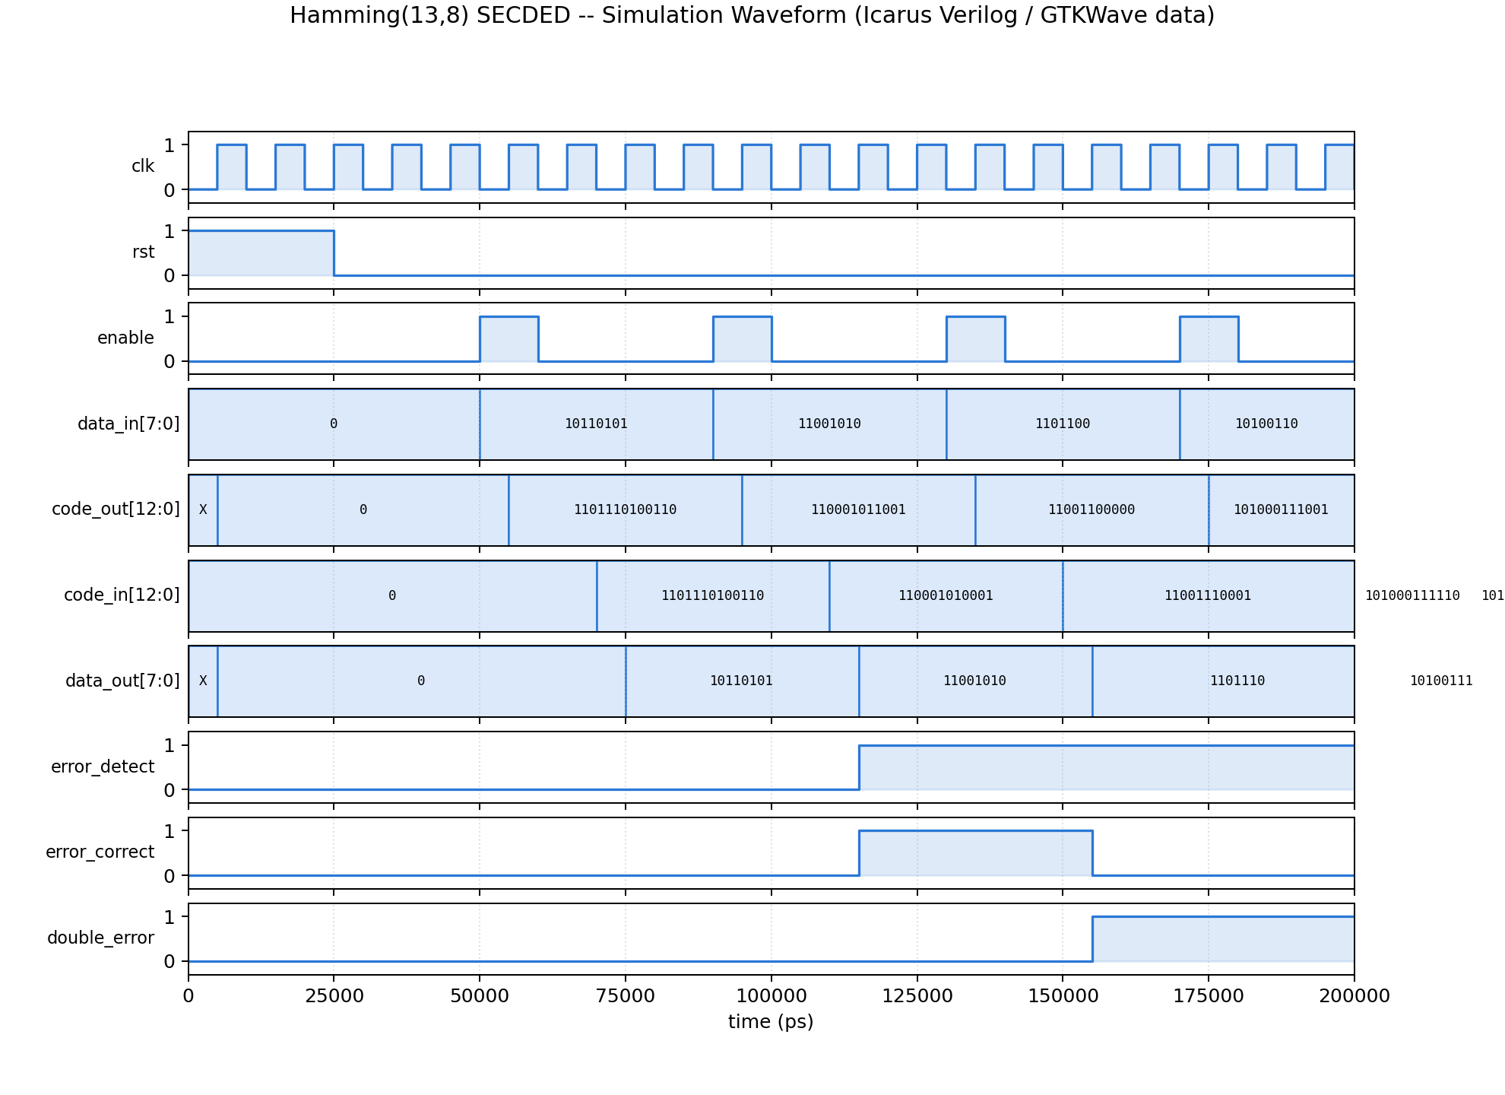
Fig 2: Simulation waveform showing data_in/code_out during encode, and code_in/data_out/error flags during decode, across all three test cases.

5. Verification of Functionality
Cases 1-3 confirm correct SECDED behaviour within its design guarantee: single-bit errors are always corrected, and double-bit errors are always detected. Case 4 goes one step further and tests what happens beyond that guarantee.
Test Case | Injected Fault | Expected Result | Simulation Result
Case 1 | None | data_out matches data_in, error_detect = 0 | PASS -- data_out = 10110101, error_detect = 0
Case 2 | 1 bit flipped in code_out | error_correct = 1, data_out matches original data_in | PASS -- data_out = 11001010, error_correct = 1
Case 3 | 2 bits flipped in code_out | double_error = 1 (flagged uncorrectable) | PASS -- double_error = 1
Case 4 | 3 bits flipped (exhaustive, all 286 combinations) | outside SECDED's design guarantee -- outcome is undefined by spec | See breakdown below -- overwhelmingly MISCORRECTED, not detected

Simulation log (Cases 1-3):
[PASS] Case 1: clean round trip, data_out=10110101
[PASS] Case 2: single-bit error corrected, data_out=11001010
[PASS] Case 3: double-bit error correctly flagged uncorrectable
--------------------------------------------------
TOTAL: 3 passed, 0 failed
--------------------------------------------------

Case 4 -- 3-bit errors: exhaustive sweep and its result
Hamming(13,8) SECDED is only specified to correct 1-bit errors and detect (not correct) 2-bit errors. A natural question -- and the one this section answers directly -- is what the decoder actually does when 3 bits are corrupted simultaneously, since that is outside its design guarantee entirely.
Rather than test one arbitrary 3-bit pattern, every possible combination of 3 simultaneously-flipped bits out of the 13-bit codeword was tested against one fixed encoded data word -- all 13-choose-3 = 286 combinations. The outcome of each was categorised by the decoder's own flags (error_correct, double_error) versus whether data_out actually still matched the original data_in:
Outcome | Count (of 286) | %
error_correct = 1, data CORRECT (lucky) | 2 | 0.7%
error_correct = 1, data WRONG -- MISCORRECTED | 284 | 99.3%
double_error = 1 -- caught, safely rejected | 0 | 0.0%
no flags raised, data still correct | 0 | 0.0%
no flags raised, data WRONG -- silent corruption | 0 | 0.0%

Simulation log (Case 4):
====================================================
Case 4: exhaustive 3-bit-flip sweep, 286 combinations, data_in=10100110
error_correct=1, data CORRECT (lucky) : 2
error_correct=1, data WRONG (MISCORRECTED) : 284
double_error=1 (caught, safely rejected) : 0
no flags, data still correct (harmless) : 0
no flags, data WRONG (SILENT CORRUPTION) : 0
Example miscorrection: flipping bits {0,1,2} -> error_correct=1 but
data_out=10100111 (expected 10100110)
====================================================
Interpretation: with 3 simultaneous bit errors, the decoder gets it wrong 99.3% of the time (284/286) -- and critically, it does so with false confidence: error_correct is asserted (meaning "I fixed this, trust it") while the returned data is actually incorrect. This is a silent miscorrection, the most dangerous failure mode for an ECC system, because nothing downstream is told anything is wrong. double_error was never raised for any of the 286 cases -- the double-bit-detection mechanism provides zero protection once a third error is added, because an odd number of bit errors always makes the overall parity check fail, so the decoder always takes its single-error branch and can never reach the double-error branch (which requires the overall parity to pass). It then flips one bit chosen by the syndrome, unrelated to the real error pattern, leaving at least two errors in place.
This is not a bug in the design -- it is the mathematically expected behaviour of any SECDED code once the error count exceeds t=1 (correction) and its detection limit of 2 bits, and it is exactly why the overhead-vs-reliability tradeoff exists: a system exposed to realistic multi-bit upset rates (dense/scaled memory, high-radiation environments) needs a stronger code (e.g. BCH with t=2, which can correct up to 2 bits and reliably detect more) rather than relying on Hamming SECDED alone.

Deliverables
- Verilog HDL code -- hamming_13_8.v (ecc_encoder and ecc_decoder modules)
- Self-checking testbench -- tb_hamming_13_8.v (Cases 1-3 plus the Case 4 exhaustive 286-combination 3-bit-flip sweep)
- Simulation waveform -- Fig 2 above (generated from the .vcd dump)
- Gate-level schematic -- Fig 1 above
- Boolean equations for parity generation and syndrome decoding -- Section 1 above
- Quantified analysis of behaviour beyond the SECDED design limit (3-bit errors) -- Case 4 above

