Table of Contents
I. INTRODUCTION 2
II. C PROGRAM STRUCTURE AND EXAMPLES 2
A. Basic Hello World Program 2
B. Program with User Input 3
C. Program with Formatted Output 4
III. GCC COMPILATION PROCESS 6
A. Installing GCC on Linux 6
B. Four Stages of Compilation 6
C. COMPILATION STAGE EXAMPLES 7
IV. RETURN VALUES AND EXIT STATUS 9
A. Understanding Return Values 9
V. KNOWLEDGE CHECK QUESTIONS 10
A. Question 1 10
B. Question 2 10
C. Question 3 11
D. Question 4 11
E. Question 5 12
F. Question 6 12
VI. LAB TASKS COMPLETED 13
VII. CONCLUSION 14
VIII. GITHUB REPOSITORY 14

Lab 2: C Programming Basics Lab Report and Knowledge Check

I. INTRODUCTION
This lab report presents the practical work completed for Lecture 2 of ST5003CMD Operating Systems, Security and Networks. The main focus of the lab was to understand the basics of C programming, GCC compilation, and commonly used Linux commands. The practical tasks also helped demonstrate how C source code is converted into an executable program through different compilation stages.

II. C PROGRAM STRUCTURE AND EXAMPLES

A. Basic Hello World Program
This program demonstrates the basic structure of a C program using the stdio.h header file and the main() function. It uses printf() to display a message and returns 0 to indicate successful execution.

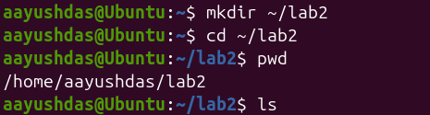

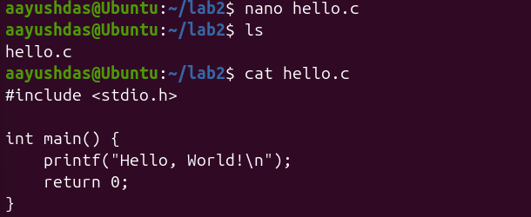

The program was successfully compiled using GCC and executed in the Linux terminal. The output displayed “Hello, World!”, and the exit status was 0, indicating that the program completed successfully.
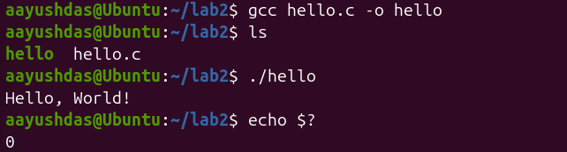

B. Program with User Input
This example demonstrates the use of printf and scanf for input/output operations: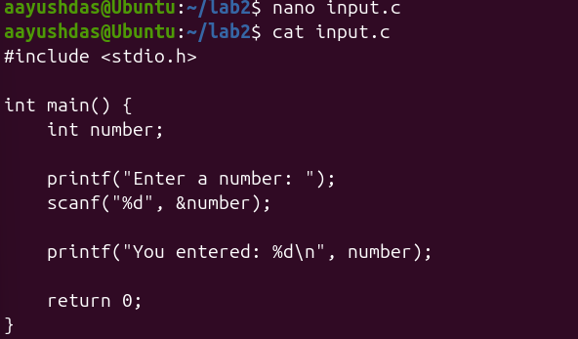
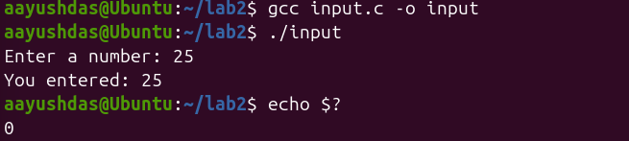

C. Program with Formatted Output
Demonstrating multiple format specifiers and variables:
This program demonstrates how different types of data can be accepted from the user and displayed using formatted output. It uses a character array for the name, an integer for age, and a floating-point variable for height.

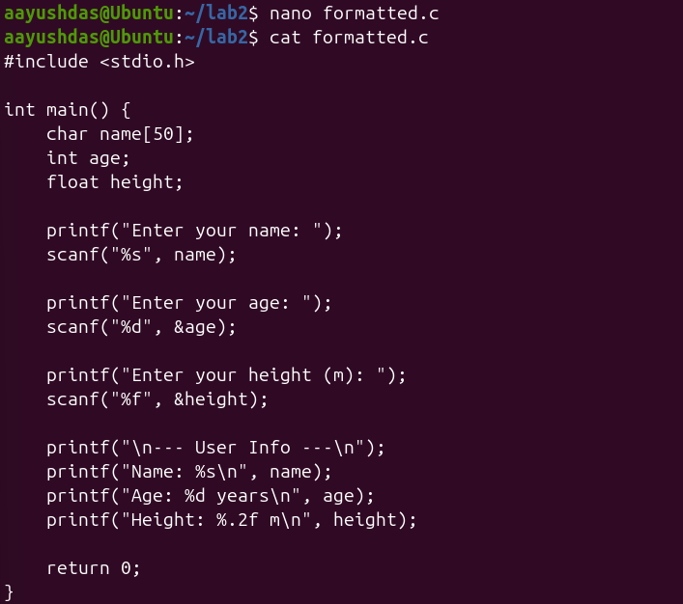

The program was compiled successfully using GCC and accepted the user's name, age, and height. The formatted output displayed each value using the appropriate format specifier, and the program returned an exit status of 0.

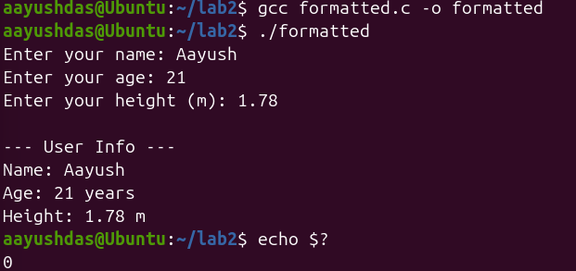

III. GCC COMPILATION PROCESS

Installing GCC on Linux
GCC is a compiler used to compile C programs on Linux. In this task, the GCC package was installed and its version was checked to confirm that the compiler was available and working correctly.
The following commands are used to install and verify GCC:

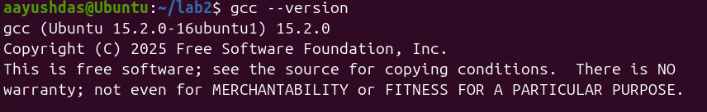

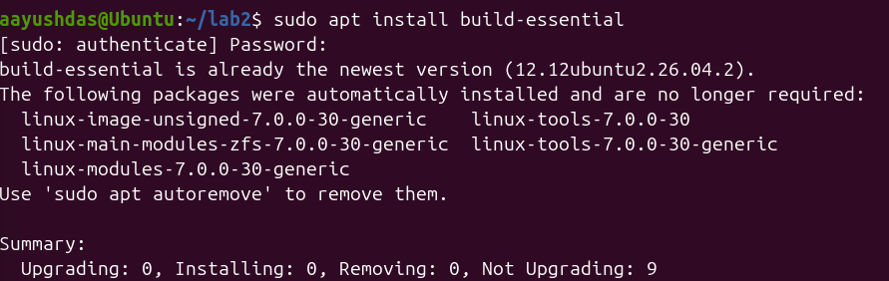

B. Four Stages of Compilation
The C compilation process consists of four main stages: preprocessing, compilation, assembly, and linking. Each stage transforms the source code into a different form until the final executable program is produced.
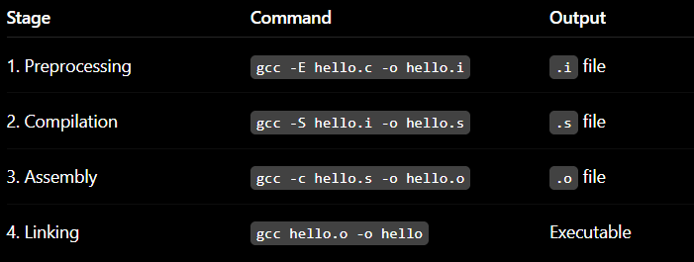

C. COMPILATION STAGE EXAMPLES
1) Stage 1: Preprocessing
In the preprocessing stage, the source code is processed before compilation. Header files and macros are expanded, and the resulting preprocessed code is saved in a .i file.
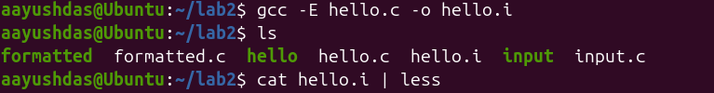

2) Stage 2: Compilation to Assembly
In this stage, the preprocessed C code is converted into assembly language instructions. The generated assembly code is saved in a file with the .s extension.
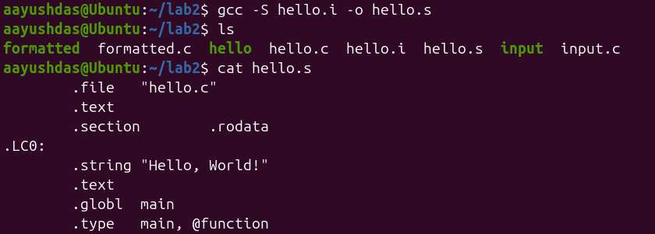

The assembly file was generated successfully from the preprocessed file. The .s file contains the assembly instructions produced from the C program and can be used in the next assembly stage.
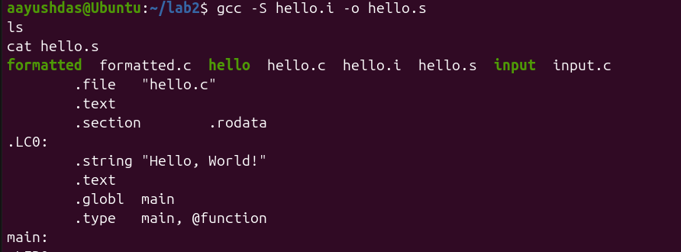
3) Stage 3: Assembly to Object File
In this stage, the assembly code is converted into an object file containing machine-level code. The object file is saved with the .o extension and will be used during the final linking stage.
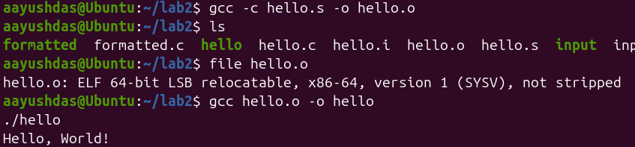
The assembly code was successfully converted into an object file using GCC. The generated hello.o file was checked using the file command, confirming that the object file was created successfully.
4) Stage 4: Linking
In the linking stage, the object file is combined with the required libraries to create the final executable program. The executable can then be run directly from the Linux terminal.
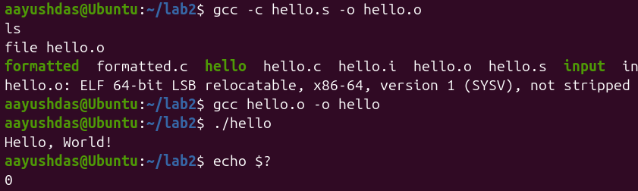

IV. RETURN VALUES AND EXIT STATUS

A. Understanding Return Values
The return value of the main() function provides an exit status to the operating system after a program finishes. A return value of 0 normally indicates successful execution, while a non-zero value represents another exit status.

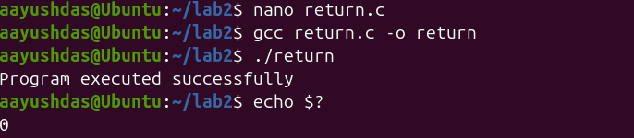

The program was successfully compiled and executed, displaying the expected message. The exit status was 0, which indicates that the program completed successfully.
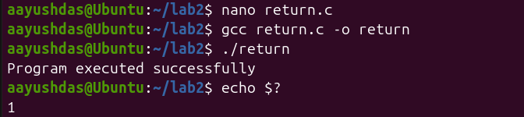

The program was modified to return 1 instead of 0 and was recompiled successfully. After execution, the echo $? command displayed 1, showing that the program returned a non-zero exit status.

V. KNOWLEDGE CHECK QUESTIONS

A. Question 1
Q: What is the purpose of the #include directive in C programming? Provide an example of its usage.
The #include directive is used to include header files in a C program. Header files provide functions and definitions that can be used in the program. For example, #include <stdio.h> allows us to use functions such as printf() and scanf().
Example:
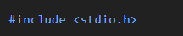

B. Question 2
Q: Explain the difference between the four stages of compilation. What file extension is produced at each stage?
The C compilation process consists of four stages: preprocessing, compilation, assembly, and linking. Preprocessing expands headers and macros and produces a .i file, while compilation converts the code into assembly language and produces a .s file. Assembly converts the assembly code into an object file with a .o extension, and linking creates the final executable program.
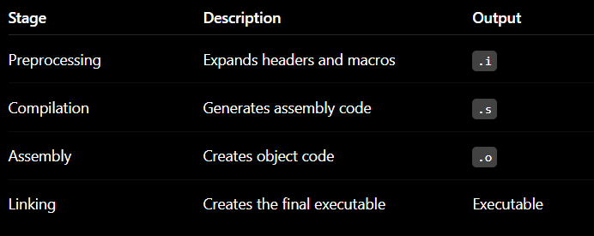

C. Question 3
Q: What does a return value of 0 from the main() function indicate to the operating system? What about a non-zero return value?
A return value of 0 from the main() function normally indicates that the program completed successfully. A non-zero return value indicates another exit status and is commonly used to indicate that an error or different condition occurred. The exit status can be checked in Linux using echo $?.

D. Question 4
Q: Write a C program that:
- Declares an integer variable
- Asks the user to input a value
- Displays the entered value back to the user
The following program declares an integer variable and uses scanf() to receive a value from the user. It then uses printf() to display the entered value.

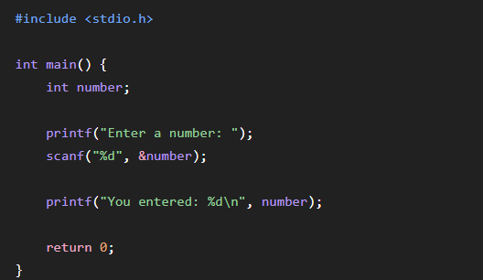

E. Question 5
Q: What GCC command would you use to:
- Only preprocess a file without compiling?
2. Generate assembly code but not assemble it?
3. Create an object file without linking?
The -E option performs only preprocessing, -S generates assembly code, and -c creates an object file without performing the linking stage. These commands were also used during the practical compilation stages of this lab.

F. Question 6
Q: Explain why C is called a "compiled language" and how this differs from interpreted languages.
C is called a compiled language because its source code is converted into machine-level code by a compiler such as GCC before the program is executed. The compilation process produces an executable program that can be run by the operating system. In contrast, interpreted languages generally execute source code through an interpreter rather than producing a standalone executable in the same way.

VI. LAB TASKS COMPLETED

1. Task 1: Hello World Program
Created and compiled a basic C program that displayed “Hello, World!”. The program was executed successfully and its exit status was checked using echo $?.
2. Task 2: Return Values
Modified a C program to return different values from the main() function. The exit status was checked after execution to observe the difference between 0 and 1.
3. Task 3: User Input
Created a C program that accepts an integer value from the user and displays the entered value. The program was compiled and executed successfully using GCC.
4. Task 4: Four Compilation Stages
Performed the four stages of C compilation separately using GCC. The intermediate .i, .s, and .o files were generated and the final executable was created through linking.
5. Task 5: Formatted Output
Created and executed a C program that accepts the user's name, age, and height. Different format specifiers were used to display the entered information in a structured format.

VII. CONCLUSION
This lab provided practical experience with basic C programming, GCC commands, and the Linux development environment. The tasks helped demonstrate how C source code passes through preprocessing, compilation, assembly, and linking before becoming an executable program. The lab also improved understanding of user input, formatted output, and program exit status.

VIII. GITHUB REPOSITORY
https://github.com/aayushbaniya69/240715_linux_reports.git

