Table Of Contents

I. FILE OPERATIONS 2
II. APT PACKAGE MANAGEMENT 7
III. C COMPILATION 9
A. Step 1: Write the Code 9
B. Step 2: Compile and Run 9
C. Step 3: Modify and Recompile 11
IV. CLEANUP AND VERIFICATION 13

Class Work Linux Lab: Files, APT, and C Programming

I. FILE OPERATIONS

mkdir ~/linux_lab
-created a new directory named linux_lab in the home folder. We used this directory to keep all the files and programs created during the lab in one place.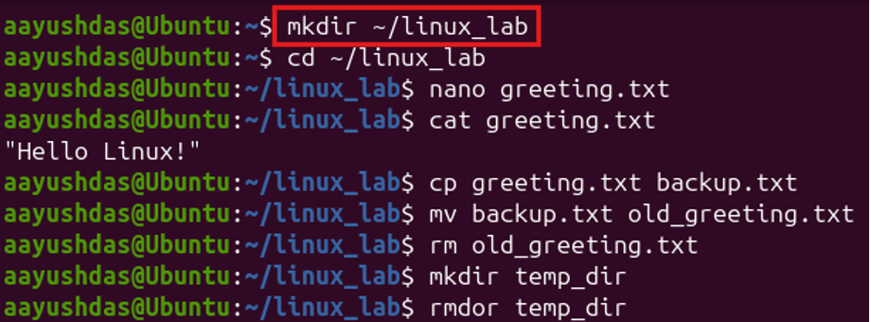

cd ~/linux_lab
-moved us from the home directory into the newly created linux_lab directory. After this command, the files we created were stored inside the lab folder.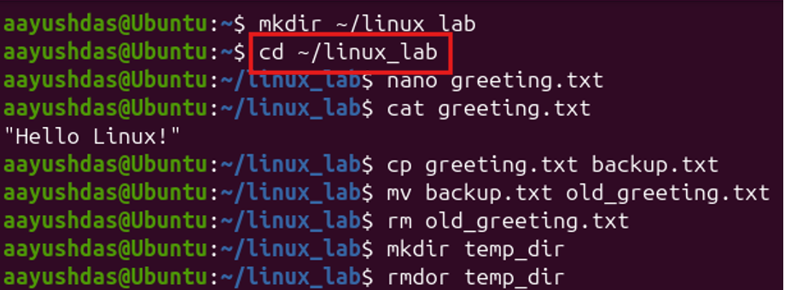

nano greeting.txt
-opened the Nano text editor and created a new file called greeting.txt. We then entered "Hello Linux!" into the file and saved it.
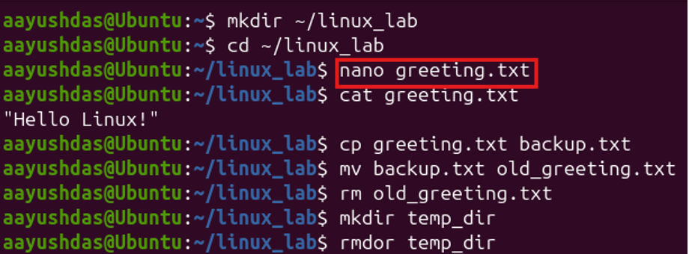
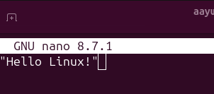

cat greeting.txt
-displayed the content of the greeting.txt file directly in the terminal. This allowed us to check that "Hello Linux!" had been saved correctly.
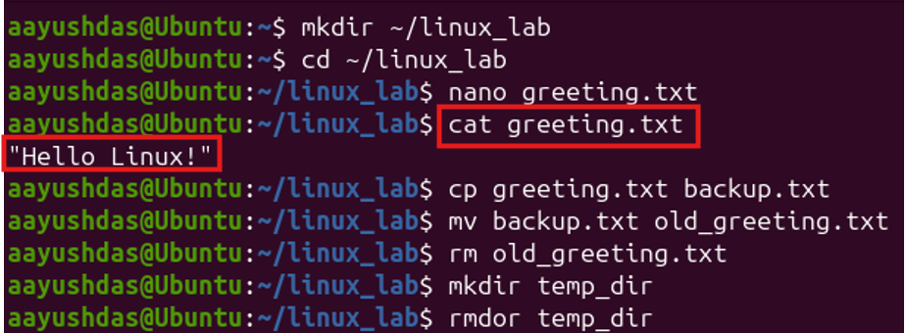

cp greeting.txt backup.txt
-made a copy of the original greeting.txt file. The new copy was named backup.txt, while the original file remained unchanged.
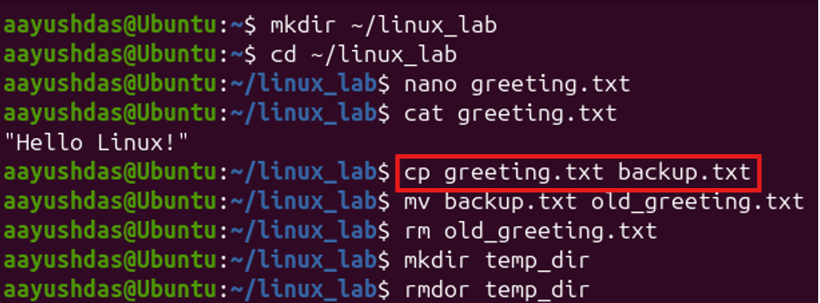

mv backup.txt old_greeting.txt
-changed the name of the copied file from backup.txt to old_greeting.txt. The file itself was not deleted; only its name was changed.
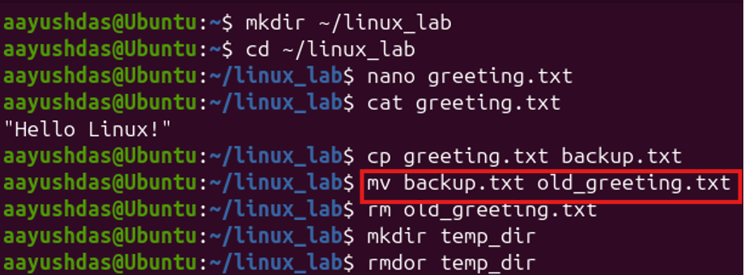

rm old_greeting.txt
-removed the old_greeting.txt file from the directory. After running this command, the file was no longer available in the lab folder.
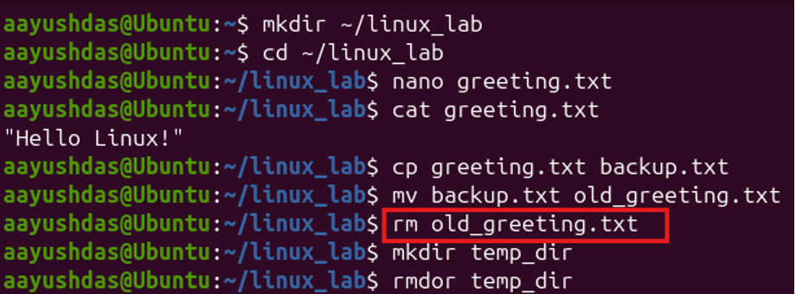

mkdir temp_dir
-created a new directory named temp_dir. This was only used as a temporary directory for practicing directory removal.
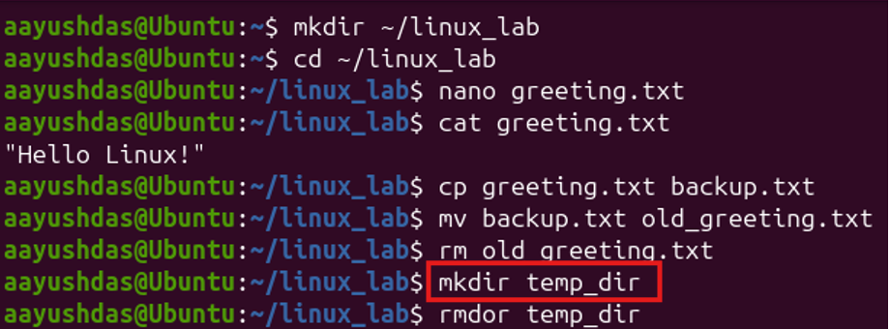

rmdir temp_dir
-removed the temp_dir directory because it was empty. This command is useful when we want to remove an empty directory without deleting any files inside it.
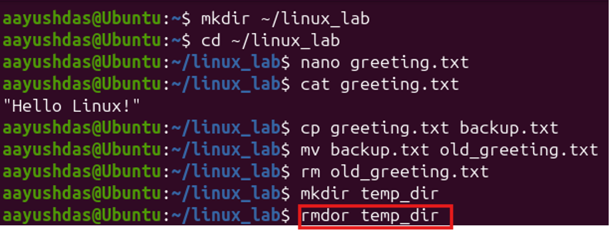

ls -l greeting.txt
-displayed detailed information about the greeting.txt file. The output showed details such as the file permissions, owner, size, and modification time.
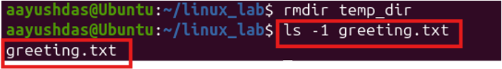

II. APT PACKAGE MANAGEMENT
sudo apt update
-updated the list of available software packages on the Linux system. We did this before installing the required tools so that Linux could use the latest available package information.
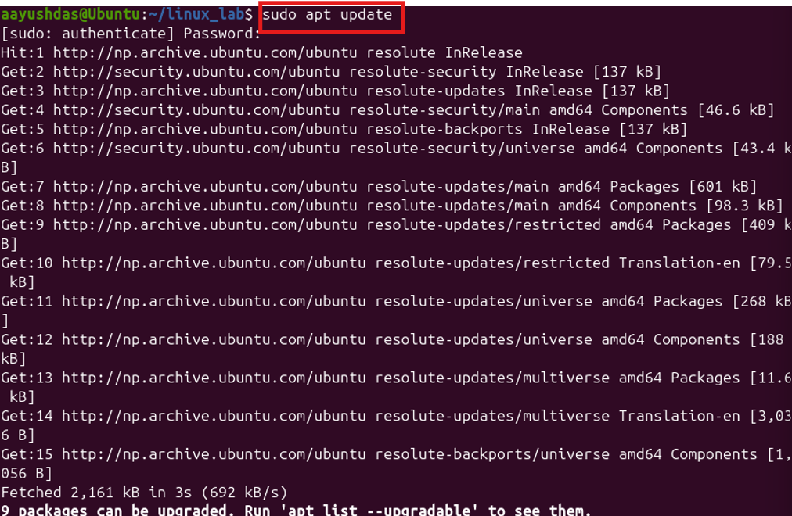
sudo apt install build-essential
-installed the basic development tools needed for the lab. This package includes GCC, which we needed later to compile our C program.
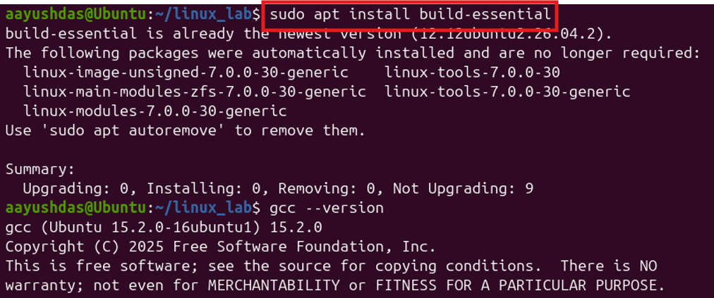
gcc --version
-checked whether GCC was installed correctly on the system. It also displayed the version of the GCC compiler currently installed.
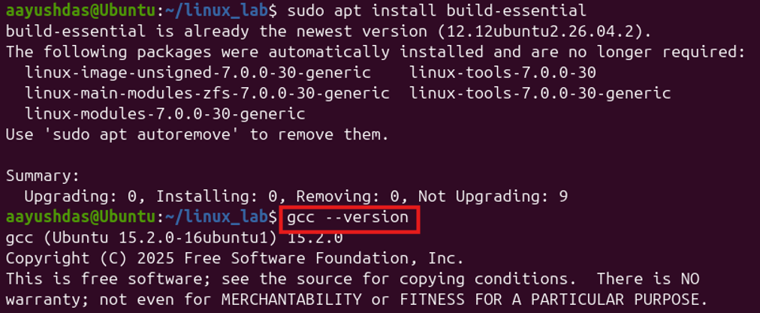
apt search python3
searched the available Linux packages related to Python 3. This was an example of how we can search for software packages using APT.
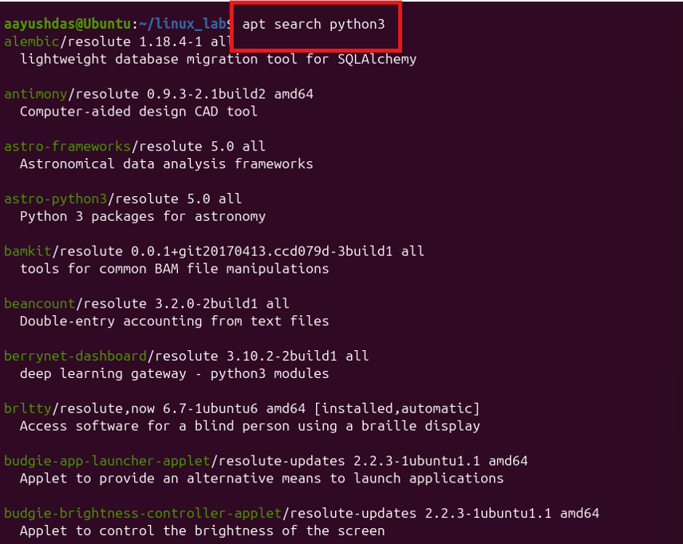

III. C COMPILATION

A. Step 1: Write the Code
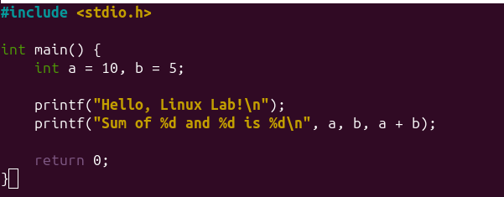

B. Step 2: Compile and Run

nano hello.c
-opened the Nano editor and created a new C source file named hello.c. We then wrote the simple C program inside this file and saved it.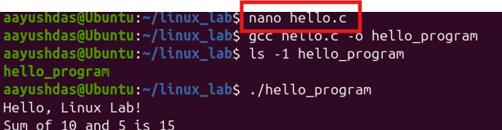

gcc hello.c -o hello_program
-compiled the C source code written in hello.c. If there were no errors, it created a new executable file called hello_program.
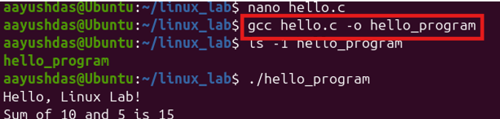
ls -l hello_program
-checked whether the compiled executable had been created successfully. The command also displayed detailed information about the new program file.
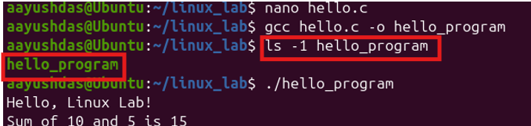

./hello_program
-ran the C program that we had just compiled. The program displayed "Hello, Linux Lab!" and calculated the sum of the two numbers given in the code.
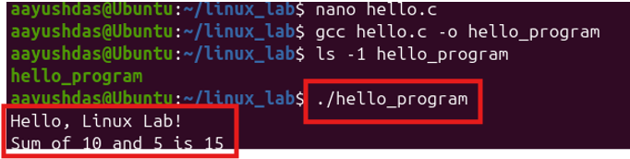

gcc -Wall hello.c -o hello_program_warn
-compiled the C program again, but this time with warnings enabled. The -Wall option helps us notice possible problems or mistakes in our code while compiling.
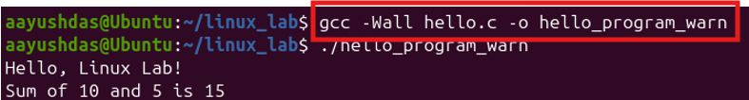

./hello_program_warn
-ran the version of the program that was compiled with warnings enabled. Since there were no problems with our code, the program ran normally and displayed the expected output.
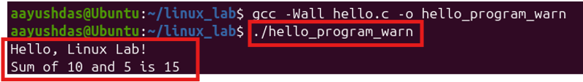

C. Step 3: Modify and Recompile
nano hello.c
-opened the C source file again so that we could make changes to the program. We changed the value of a from 10 to 200 and then saved the file.
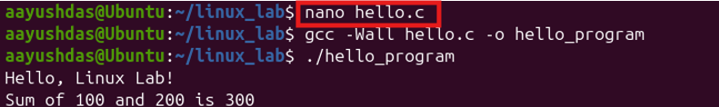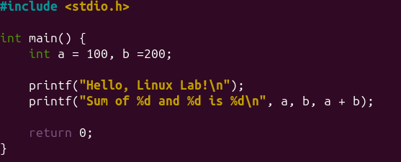

We used gcc -Wall hello.c -o hello_program to compile the modified C program again. Recompiling was necessary so that the changes we made to the source code were included in the executable program.
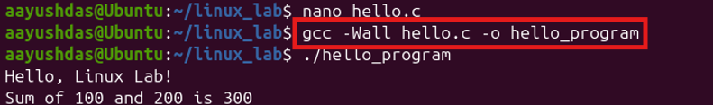

./hello_program
-ran the updated program after recompilation. The output now showed the new sum using 200 instead of the previous value of 10, demonstrating that our changes had been successfully applied.
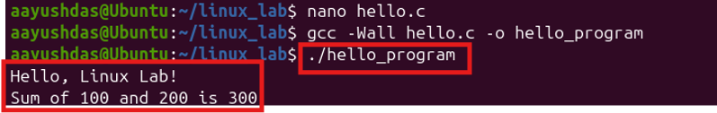

IV. CLEANUP AND VERIFICATION

ls -lh ~/linux_lab/
-displayed the files inside our lab directory along with their sizes and other details. This allowed us to check what files and compiled programs had been created during the lab.
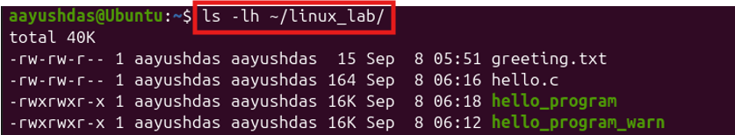

cat ~/linux_lab/hello.c
-displayed the final C source code directly in the terminal. We used this as a final check to make sure the code was saved correctly.
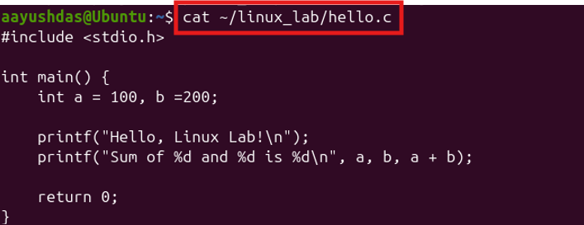

rm -rf ~/linux_lab/
-removes the entire linux_lab directory along with everything inside it.
