**Aayush Batwara** About Skills Projects Contact

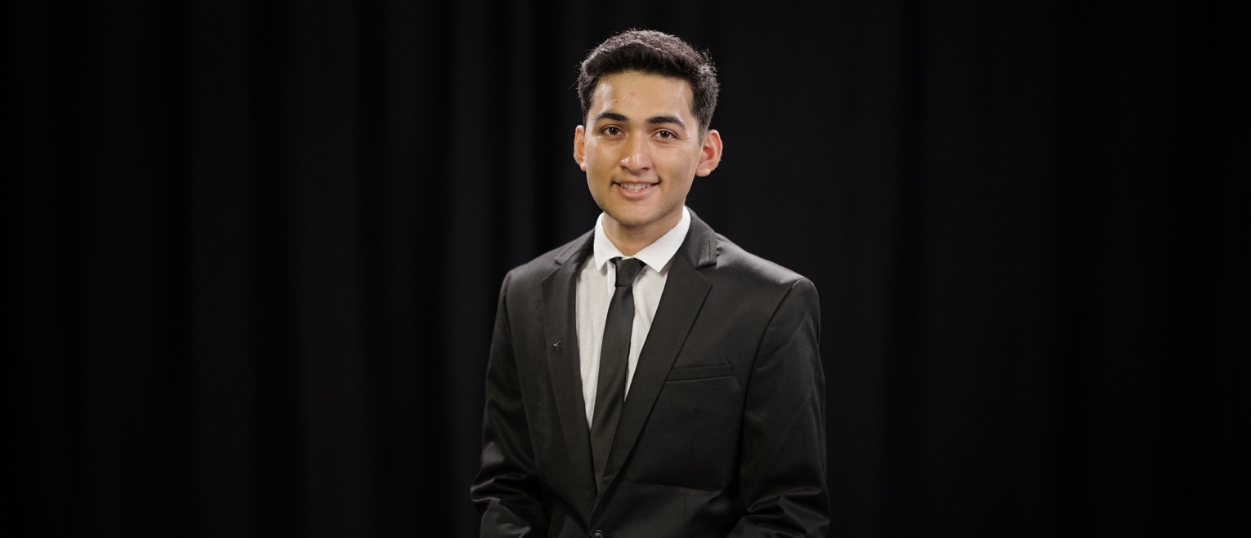

I am a student / developer / ??

Namaskar. *Hello*. 你好。



Skills

*Chammak challo*

Ministry incubators

Made a video for …

3 board tic-tac-toe AI

Snake game

Projects



Use tab view to display variety of contacts

Contact me

Born in India, raised in Hong Kong.

Currently a Freshmanat the University of Hong Kong, enrolled in a new program called Bachelor’s of Arts and Sciences in Financial Technologies.

I enjoy programming, though I am only beginning my coding journey.

Utilizing my knowledge in **programming,** core mathematical concepts, **capacity to learn**, and ability to establish rapport with diverse groups, I am always looking for opportunity to **acquire invaluable practical understanding,** ultimately endeavoring to make a **real-world contribution.**