# Assignment 3 – Implement Image classification using convolutional neural networks (CNNs) for multiclass classification.

Name : Aayush Bokde

Roll No: 382016

PRN: 22310316

## Problem Statement

Implement a convolutional neural network (CNN) in Python using Keras and TensorFlow to classify images from the CIFAR-10 dataset into 10 categories such as airplane, automobile, bird, cat, etc.

## Objectives

* To understand the working of convolutional neural networks (CNNs) for multiclass image classification.
* To preprocess the CIFAR-10 dataset using normalization and one-hot encoding.
* To build, compile, and train a CNN model using Keras and TensorFlow.
* To evaluate model performance using test accuracy and learning curves.
* To visualize sample predictions with true and predicted labels.

## Requirements

Operating System: Windows/Linux/MacOS

Python Version: 3.x

Tools: Jupyter Notebook / Anaconda / Google Colab

Libraries Used:

* TensorFlow, Keras
* NumPy
* Matplotlib
* Scikit-Learn

## Theory

The CIFAR-10 dataset is a benchmark dataset containing 60,000 32x32 color images across 10 classes. A Convolutional Neural Network (CNN) is well-suited for this task due to its ability to capture spatial hierarchies of features in images.  
  
Input Layer: Accepts 32x32x3 RGB images.  
Convolutional Layers: Extract spatial features like edges and patterns.  
Pooling Layers: Downsample feature maps to reduce dimensionality.  
Dense Layers: Fully connected layers for classification.  
Output Layer: Softmax activation for 10-class classification.

## Methodology

1. Data Acquisition: The CIFAR-10 dataset is loaded from Keras datasets.
2. Data Preparation: Images normalized to range [0,1], labels one-hot encoded.
3. Model Architecture: CNN with multiple Conv2D, MaxPooling, Dense, and Dropout layers.
4. Model Compilation: Optimizer = Adam, Loss Function = Categorical Crossentropy, Metric = Accuracy.
5. Model Training: Trained for 15 epochs with batch size 64, validation on test set.
6. Model Evaluation: Test accuracy calculated, predictions demonstrated on sample images.
7. Performance Analysis: Training/validation accuracy and loss plotted over epochs.

## Graphs and Visualizations

Accuracy vs. Epochs: Plots show training and validation accuracy over 15 epochs.

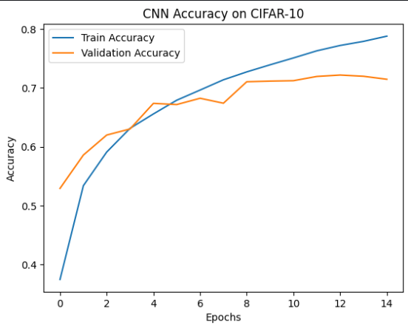

Loss vs. Epochs: Plots show training and validation loss convergence.

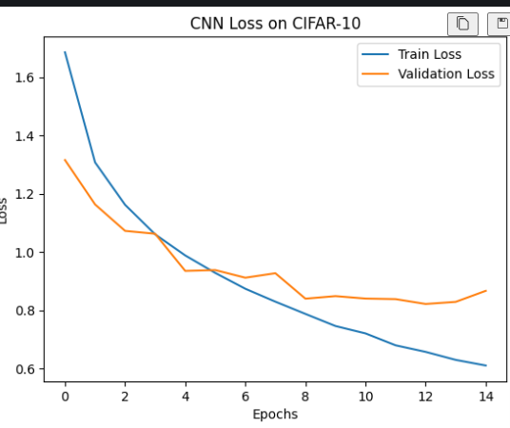

Sample Predictions: Random test images displayed with true and predicted class labels.

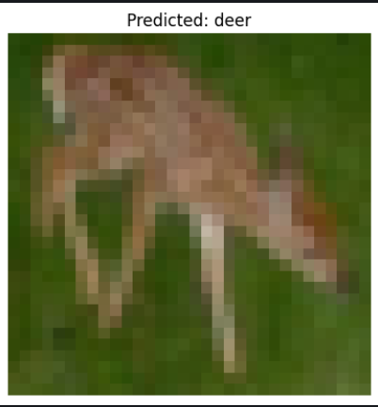

## Advantages

* CNNs automatically learn spatial features from raw images.
* High performance on image classification benchmarks like CIFAR-10.
* Visualization of predictions provides interpretable insights.

## Limitations

* Requires large computational resources for training.
* Performance depends on hyperparameters like learning rate, batch size, and architecture depth.
* May overfit if regularization techniques like dropout are not applied.

## Applications

* Autonomous vehicles – object and traffic sign recognition.
* Healthcare – medical image classification.
* Security – surveillance and anomaly detection.
* Retail – product recognition in stores.

## Working / Algorithm

1. Import necessary libraries.
2. Load CIFAR-10 dataset using Keras.
3. Normalize image pixel values to [0,1].
4. Convert labels to one-hot encoding format.
5. Build CNN model with Conv2D, MaxPooling, Dense, and Dropout layers.
6. Compile the model with Adam optimizer and categorical crossentropy loss.
7. Train the model for 15 epochs with validation.
8. Evaluate on test set to measure accuracy.
9. Plot accuracy and loss curves to analyze learning behavior.
10. Predict random test images and display results with true and predicted labels.

## Conclusion

A convolutional neural network was implemented for CIFAR-10 image classification. The model achieved good accuracy and demonstrated the ability to distinguish between 10 object categories. Performance analysis using accuracy/loss plots and random predictions confirmed the effectiveness of CNNs for multiclass image classification tasks.