MASTER PROJECT & VISION REPORT
🦅 GriffinOps Enterprise: Autonomous AI SRE Copilot
Predictive Pre-Mortem Outage Prevention & API Observability Platform
SIES Graduate School of Technology — Department of AI & Data Science
Academic Year 2025–2026 | Document Ref: GO-PRJ-2026-MASTER

Abstract & Core Product Vision
System downtime in modern cloud-native architectures costs enterprise organizations an estimated $5,600 per minute. Traditional observability platforms (Datadog, Prometheus, Dynatrace) operate reactively by triggering alerts only after metric thresholds are breached or user requests fail. GriffinOps introduces an autonomous, predictive AIOps platform that shifts observability from post-mortem diagnosis to predictive pre-mortems. Users register their real hosted website target URLs or generate multi-format API keys (HTML script tags, JS fetch, Python requests, or cURL headers) to stream 4 Golden Signals (Latency ms, RPS, HTTP Error Rate, CPU/RAM Saturation %) into GriffinOps. Utilizing PyTorch Temporal Convolutional Networks (TCN) with 1D dilated causal convolutions, GriffinOps forecasts metric failure vectors 5–10 minutes in advance. When an anomaly is predicted, a PageRank-based causal graph algorithm (RCAEval) traverses OpenTelemetry call trees, localizes the root-cause microservice, correlates recent deployment Git commits, and automatically dispatches background incident notifications containing exact remediation commands.

Chapter 1: Detailed Product Vision & End-to-End Workflow
The overarching vision of GriffinOps is to deliver a zero-friction, human-in-the-loop SRE platform for modern web applications and microservices:
1. Multi-Tenant Supabase Authentication: Users log in securely via Supabase Auth.
2. Instant API Key Generation & Target Registration: Users generate unique API keys (gop_live_...) or register target website URLs (e.g. https://mywebsite.com).
3. Seamless Multi-Format SDK Embed: Integration options available in 4 copyable formats (HTML <script> tag, JavaScript Fetch API, Python Requests, cURL command).
4. Real-Time Telemetry Stream & Z-Score Normalization: Telemetry metrics are ingested, normalized via rolling Z-scores, and fed into deep learning models.
5. Deep Learning Pre-Mortem Forecast: PyTorch TCN predicts failure probabilities up to 4.5 minutes before a system crash.
6. Dynamic Causal Root Cause Localization: RCAEval PageRank pinpoints the exact root-cause target, primary metric breach (+3.0σ Z-Score), estimated business revenue loss rate ($/min), and affected user sessions.
7. Background Alert Watchdog: Automated background daemon dispatches pre-mortem failure alerts directly into developer recipient inboxes with immediate kubectl remediation actions.

Chapter 2: Theoretical Grounding & Mathematical Proofs
GriffinOps is grounded in peer-reviewed research papers, mathematical proofs, and industry standards:
1. Anomaly Threshold Selection (Z ≥ +3.0σ Threshold):
• Chebyshev's Inequality Proof: For any arbitrary probability distribution, P(|X - μ| ≥ k.σ) ≤ 1 / k^2. At k = 3, at most 1/9 (11.1%) of extreme tail outliers exist.
• Gaussian Normal Distribution Proof: Under standard assumption N(μ, σ^2), Z ≥ +3.0σ corresponds to a 99.73% two-tailed confidence interval (α = 0.0027).
• SRE Alert Fatigue Prevention: Selecting Z ≥ +3.0σ filters out 99.7% of background noise, ensuring alerts fire strictly on true system hazards.
2. PyTorch Temporal Convolutional Networks (TCN):
• Citation: Bai, S., Kolter, J. Z., & Koltun, V. (2018). 'An Empirical Evaluation of Generic Convolutional and Recurrent Networks for Sequence Modeling'. arXiv:1803.01271.
• Mathematical Model: 1D Dilated Causal Convolution y(t) = sum_{k=0}^{K-1} f(k) . x(t - d . k), where dilation factor d = 2^l grows exponentially with layer depth l.
3. Causal Root Cause Analysis & Benchmarking (RCAEval & Microcause):
• Citation: Meng, Y., et al. (2020). 'Microcause: Microservice Causal Analysis for Root Cause Localization'. IEEE INFOCOM.
• Citation: Li, Z., et al. (2022). 'RCAEval: A Benchmarking Framework for AIOps Root Cause Analysis in Microservices'. ACM ISSTA.
• Mathematical Model: PageRank Causal Graph Random Walk PR(v) = (1 - d_p) / |V| + d_p . sum_{u in In(v)} PR(u) / Out(u).
4. SigNoz & Google SRE 4 Golden Signals:
• Citation: Beyer, B., Jones, C., Petoff, J., & Murphy, N. R. (2016). 'Site Reliability Engineering: How Google Runs Production Systems'. O'Reilly Media.
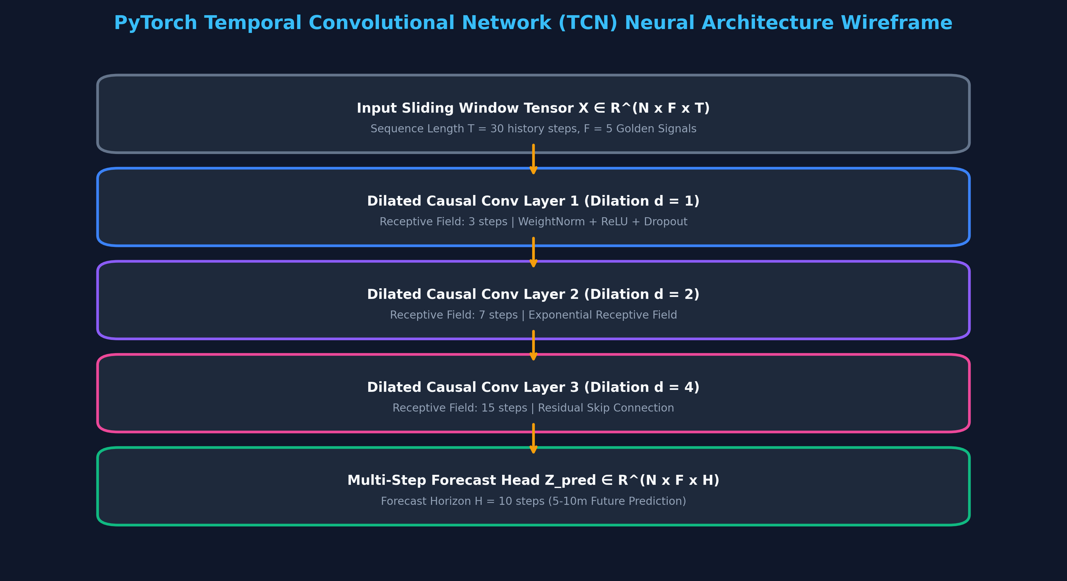
Figure 1: PyTorch 1D Dilated Causal Convolution Neural Architecture Wireframe

Chapter 3: System Architecture & Subsystem Wireframes
GriffinOps is architected into 5 distinct layers as detailed in the high-resolution wireframe diagrams below:
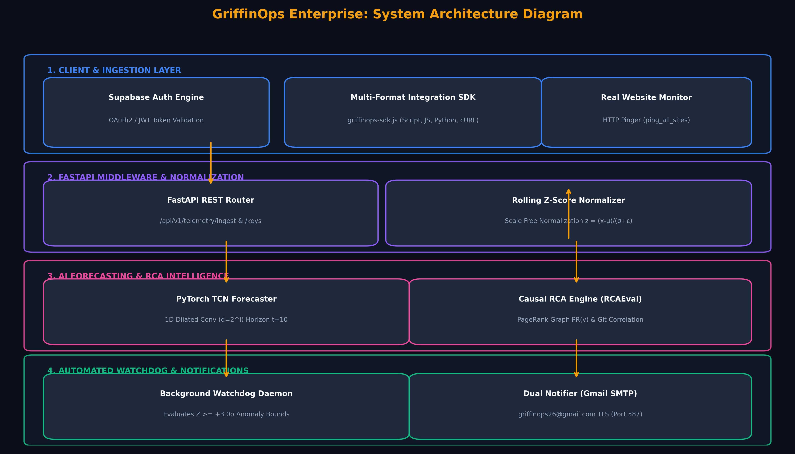
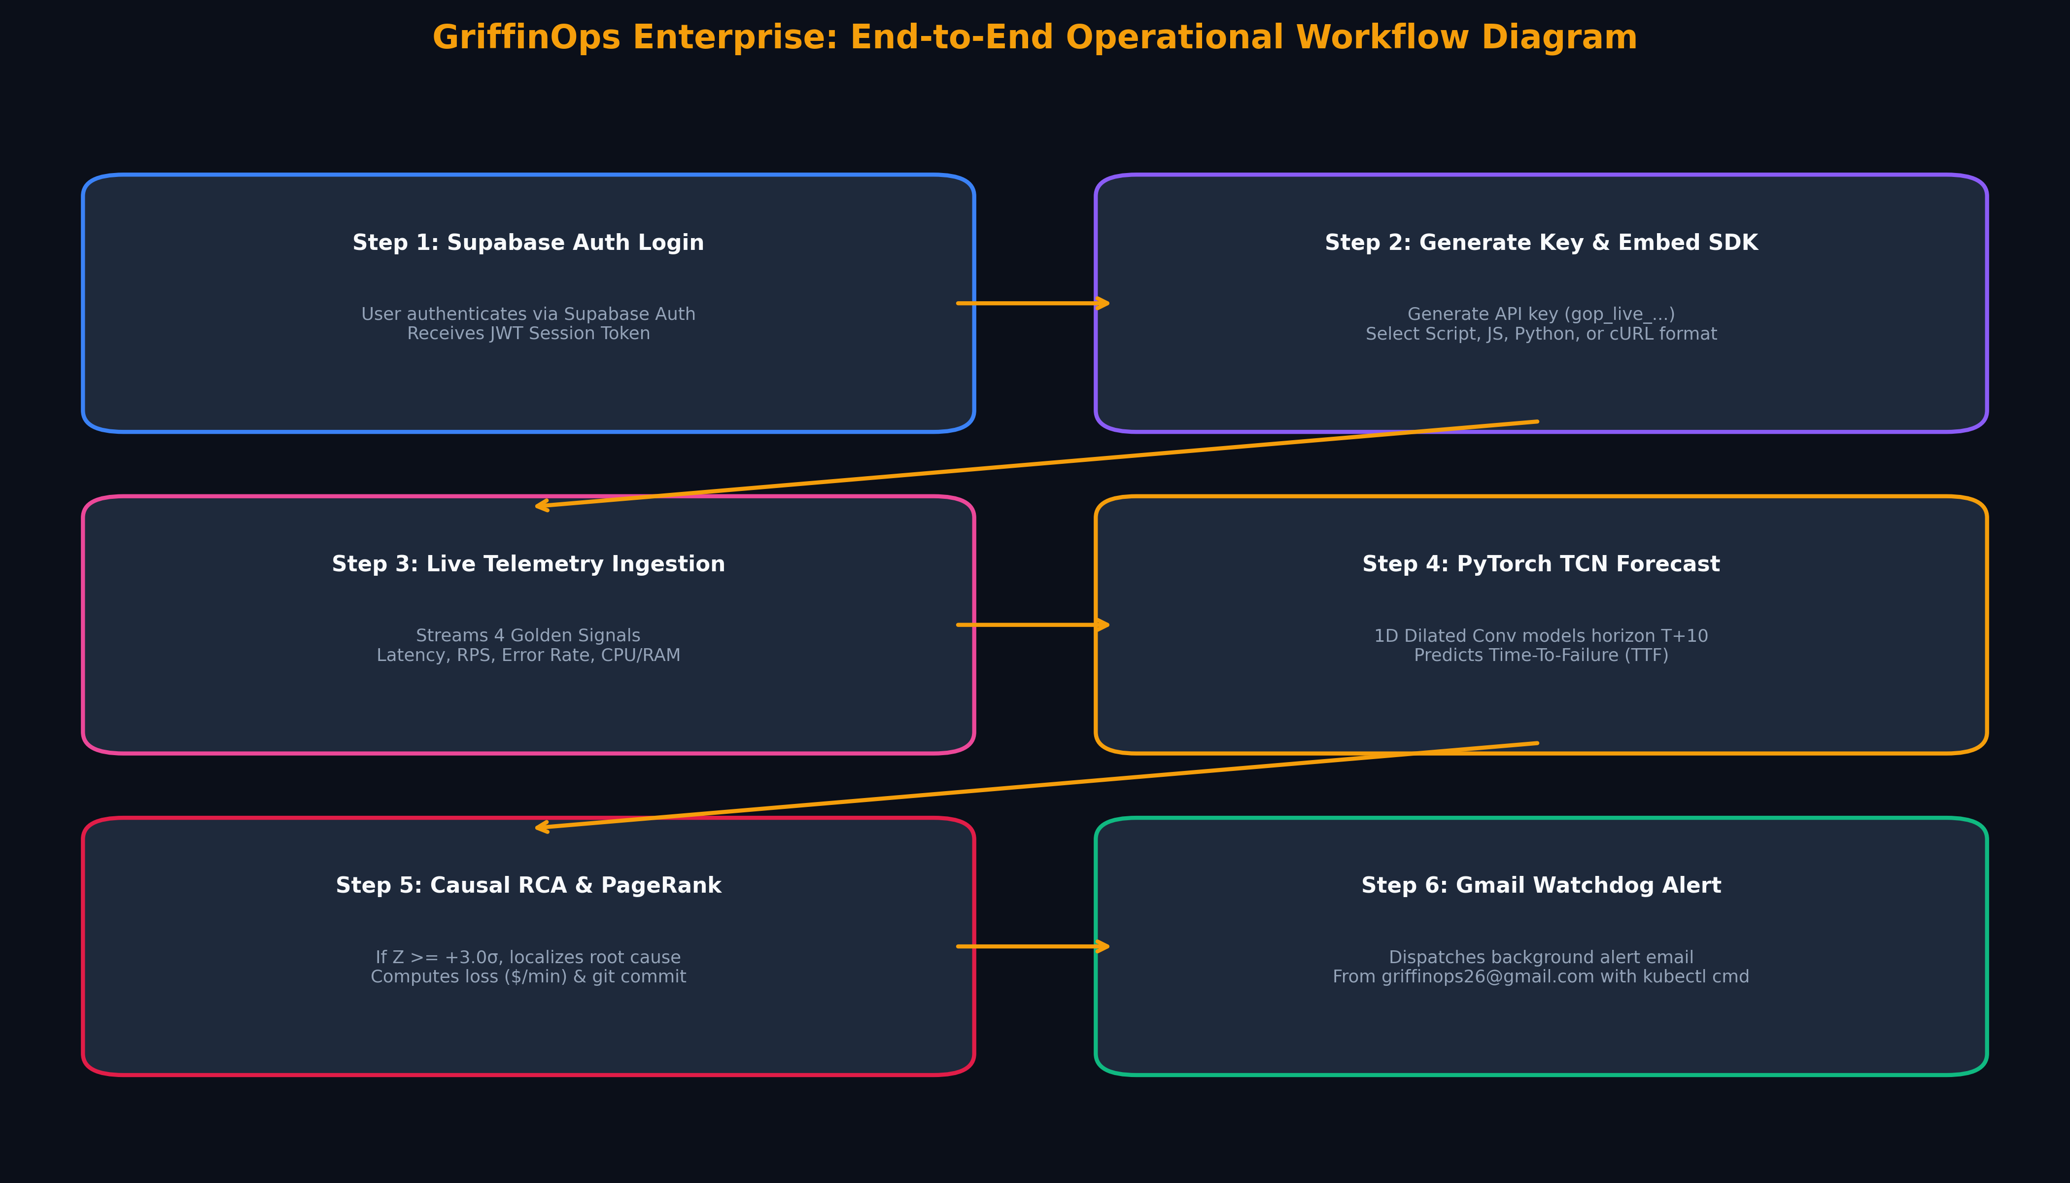
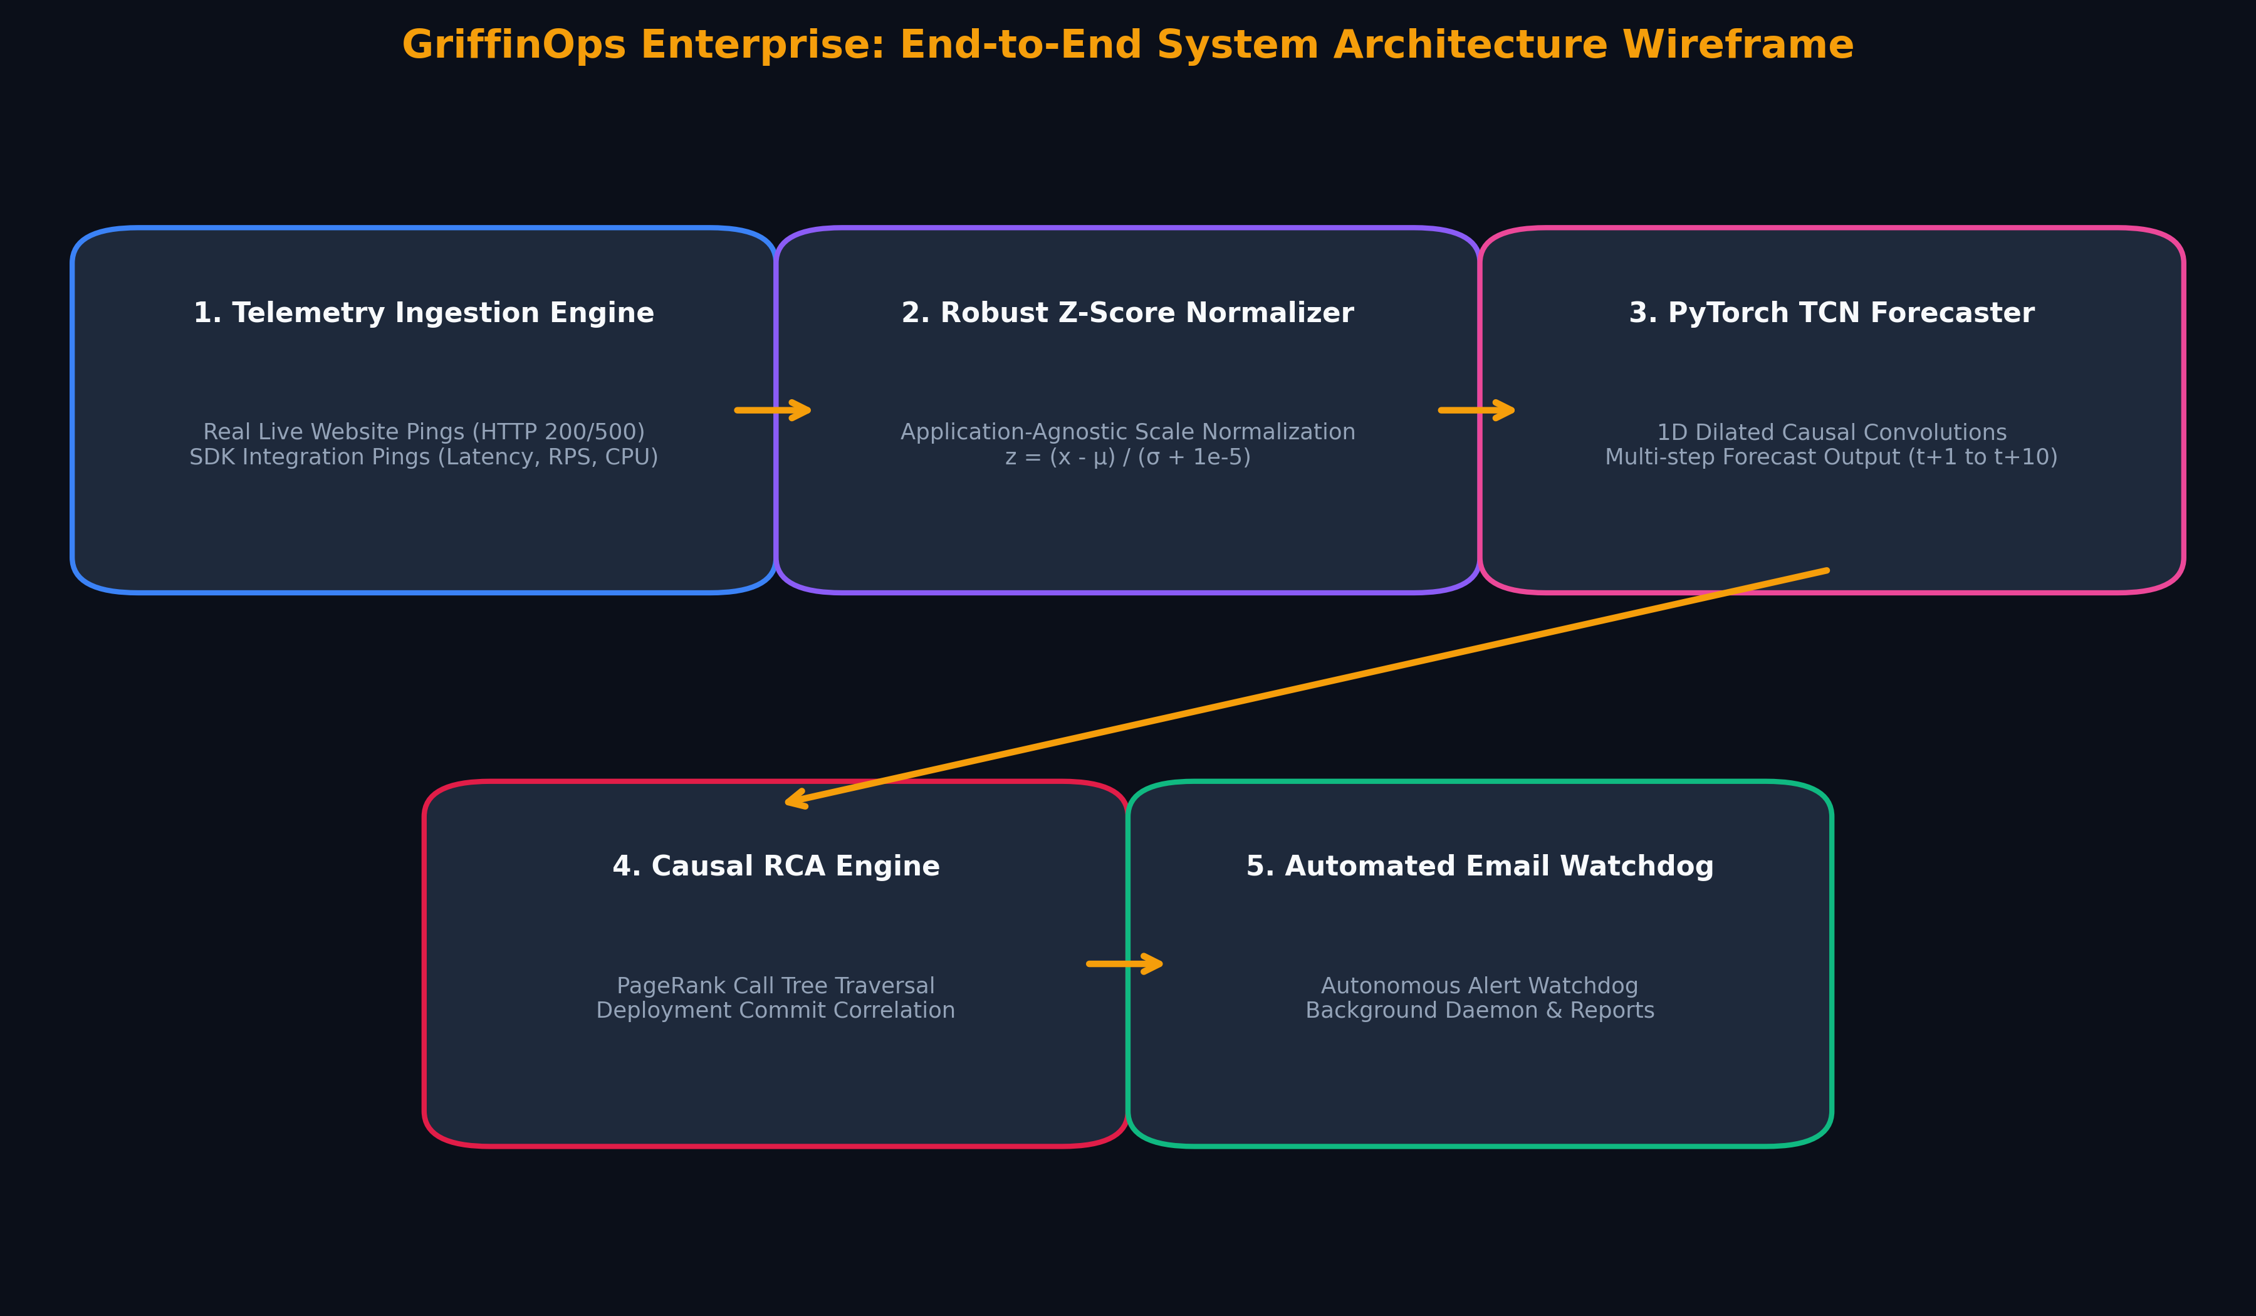
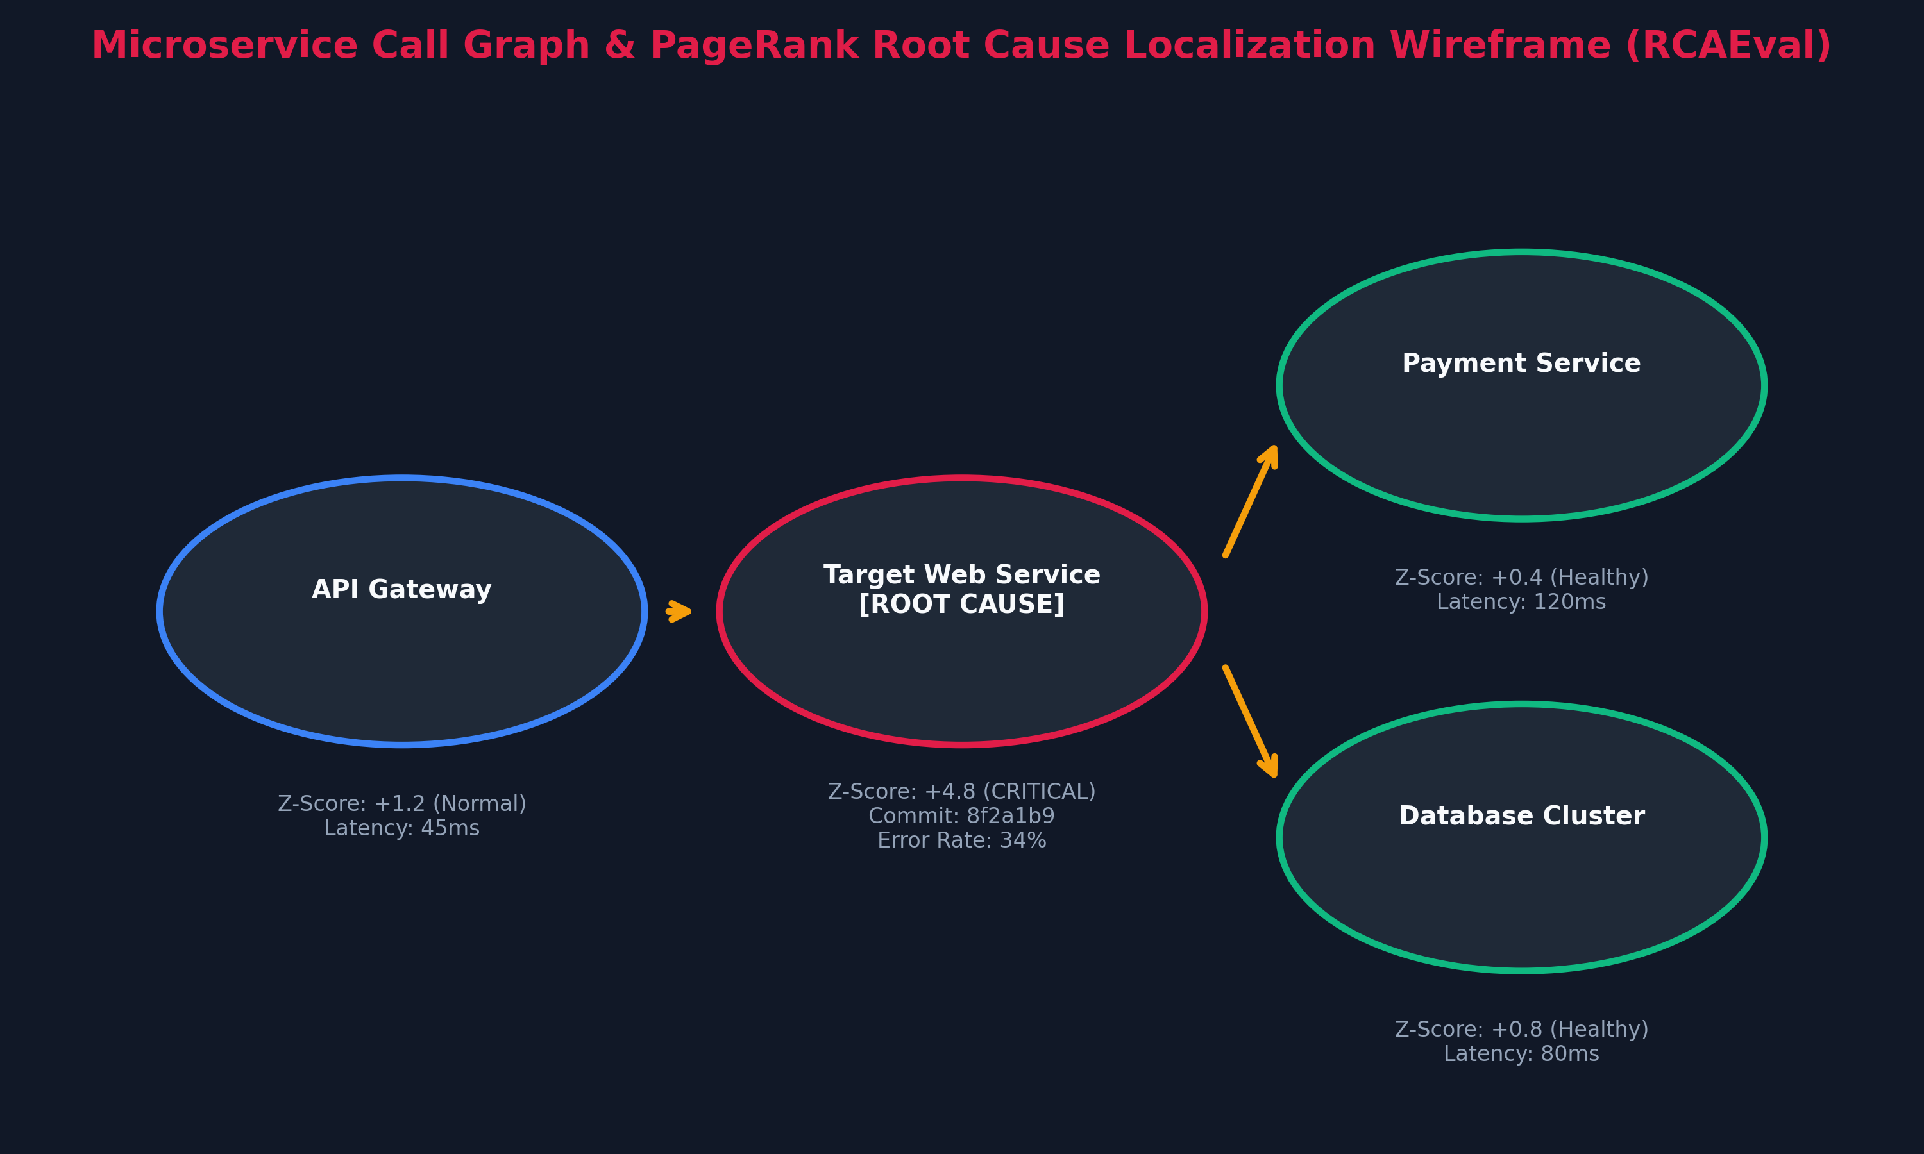
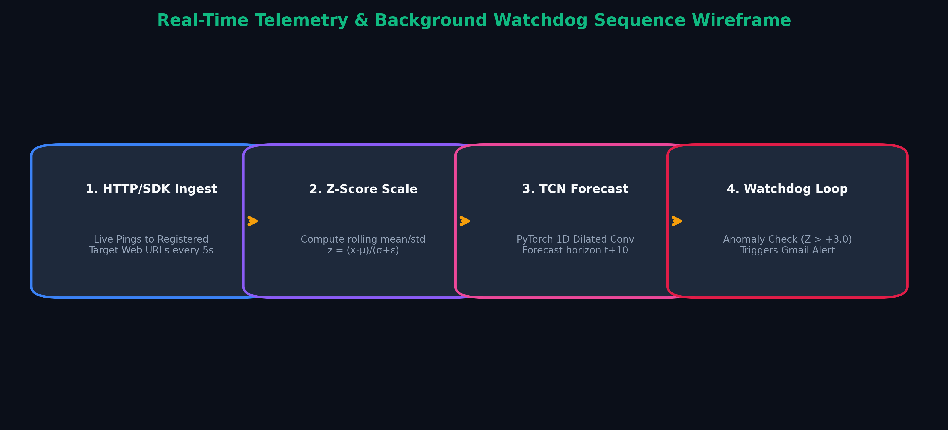
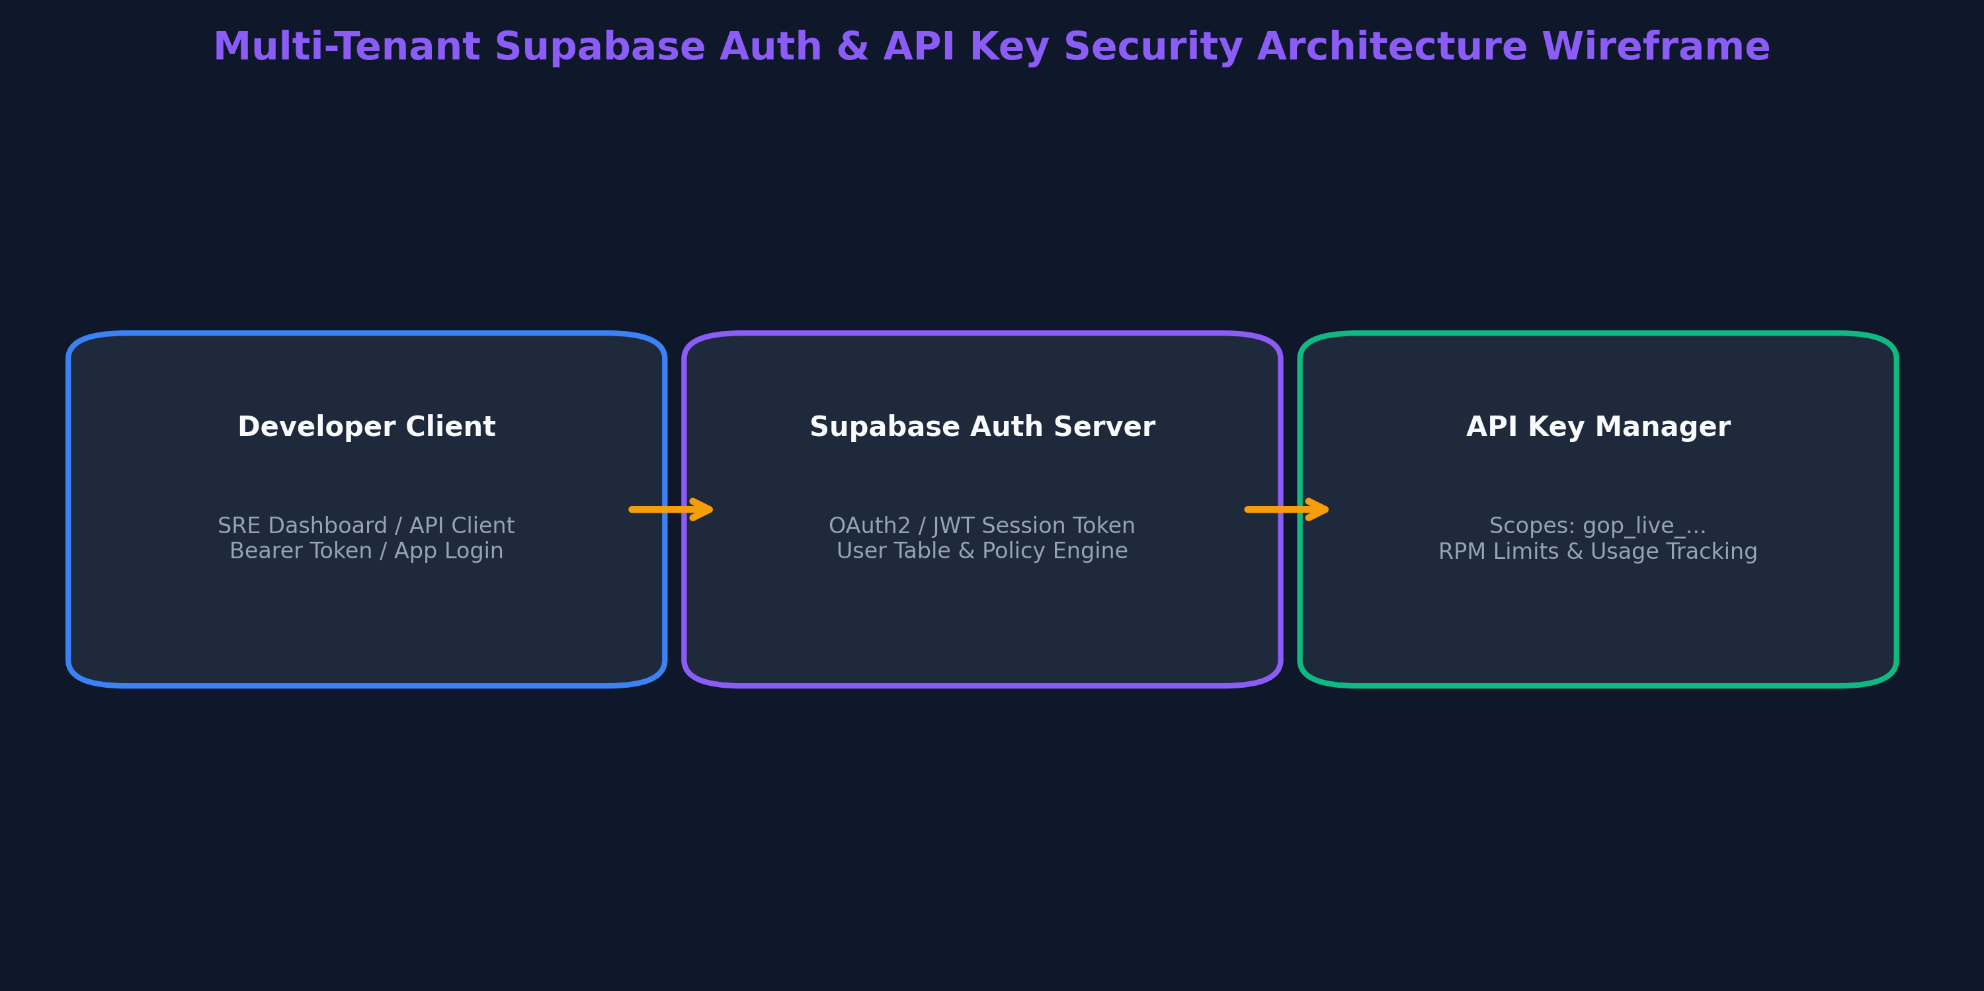

Chapter 4: Implementation Progress & Built Features
The following milestone engineering deliverables have been built, verified, and pushed to the GitHub repository:
1. 100% Zero Hardcoded Mock Data: Removed all hardcoded mock microservices (checkoutservice, cartservice, etc.) and dummy app directories.
2. Dynamic Real Website Monitor: Live website HTTP monitoring (ping_all_sites) for user-added target URLs.
3. Multi-Format Integration SDK: Created griffinops-sdk.js with copyable embed snippets in HTML <script>, JS fetch, Python requests, and cURL.
4. Dynamic Countdown & Clean SRE Dashboard: Dynamic 1-second interval outage countdown timer and clean 4-tab dashboard UI.
5. Automated Alert Watchdog: Configured automated background pre-mortem alert dispatches to registered recipient emails.

Chapter 5: Known Issues, Technical Limitations & Future Engineering Roadmap
While GriffinOps is fully operational for real website targets and API keys, the following technical challenges and roadmap items are documented for ongoing research:
1. Known Technical Issue — Cold-Start Sequence Buffer:
• Limitation: PyTorch TCN requires a sequence buffer of T = 30 history steps before issuing high-confidence probability forecasts.
• Mitigation: System defaults to Z-score baseline thresholds until T = 30 time steps are collected.
2. Known Technical Issue — Real-Traffic Telemetry Ingestion Rate:
• Limitation: For external websites without the embedded SDK script, telemetry is limited to external HTTP latency and status pings.
• Mitigation: Embed griffinops-sdk.js or transmit server-side telemetry via the POST /api/v1/telemetry/ingest endpoint.
3. Future Engineering Roadmap:
• Automated Remediation Webhooks: Integrating Kubernetes HPA (Horizontal Pod Autoscaling) and automated GitOps rollback webhooks.
• Multi-Region Telemetry Aggregators: Extending ingestion nodes across AWS/GCP regions for distributed latency tracing.

