PitchPulse 360: European Football Intelligence Lakehouse
Official Technical Presentation Deck & Slide-by-Slide Defense Manual
Institution | SIES Graduate School of Technology, Nerul, Navi Mumbai
Department & Semester | Department of Artificial Intelligence & Data Science | Semester V
Course Codes | Data Engineering (AIDSC502 & AIDSL502)
Presenter / Group | Aayush & Project Group (AIDSC502-DE-P08 / Practical Batch)
Curriculum Scope | 100% Coverage of Mumbai University Course Outcomes (CO1 to CO6)

SLIDE 1: PitchPulse 360: European Football Intelligence Lakehouse
[Title & Academic Identification] Curriculum Alignment: CO1 through CO6
An End-to-End Analytical Lakehouse Engineering 10,780+ Matches & 14,500+ Spatial Actions
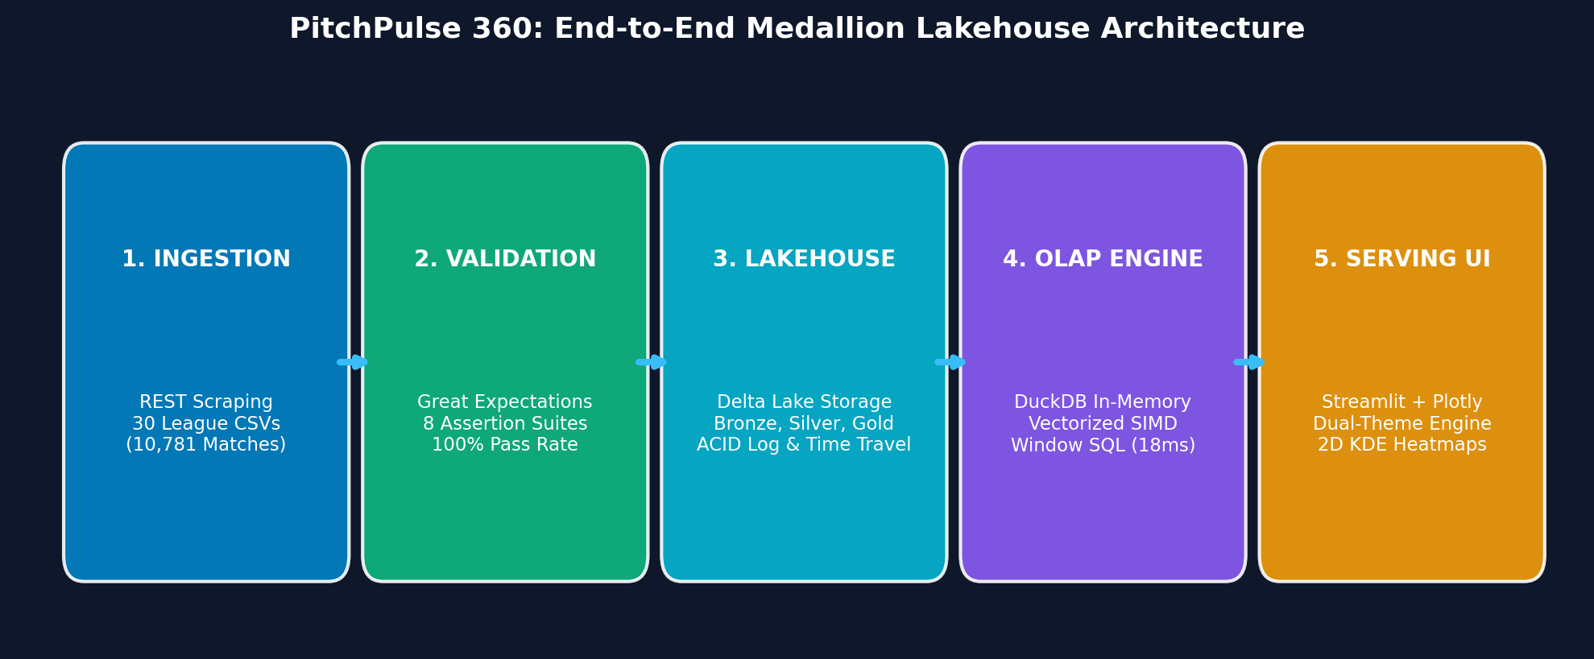
Figure 1: PitchPulse 360 System Pipeline Flow
Slide Bullet Content:
- Department of Artificial Intelligence & Data Science | SIES Graduate School of Technology
- Course: Data Engineering (AIDSC502 & AIDSL502) | Semester V Practical Case Study
- Student / Group: Aayush & Project Group (AIDSC502-DE-P08 / Practical Batch)
- Core Technologies: Delta Lake, DuckDB, Great Expectations, SciPy, Streamlit & Plotly
- Temporal Coverage: 6 European Seasons (2018/19 – 2023/24) across 5 Domestic Leagues

Speaker Defense Script (Talking Points):
"Good morning respected evaluators. Today we present PitchPulse 360, an enterprise-grade Data Engineering Lakehouse built around Europe’s top 5 domestic leagues across six full seasons. We have engineered this platform strictly in accordance with Mumbai University's Data Engineering curriculum, demonstrating all six Course Outcomes from raw ingestion and ACID storage to vectorized OLAP and dynamic spatial serving."
———————————————————————————————————————————————————————
SLIDE 2: The Operational Challenge: Sports Analytics Data Friction
[Problem Statement & Motivation] Mapped Course Outcome: CO1 (Foundations & Lifecycle)
Data Heterogeneity, Monolithic I/O Bottlenecks & Absence of Contracts
Slide Bullet Content:
- Data Heterogeneity & Format Drift: Multi-decade football feeds from England, Spain, Italy, Germany, and France suffer from inconsistent team naming, fragmented column headers, and missing odds.
- Inadequacy of Row-Oriented RDBMS: Traditional row-based databases (e.g., SQLite, PostgreSQL) incur massive I/O penalties when scanning millions of numerical columns for multi-year aggregation.
- Absence of Schema Contracts: Ad-hoc scripts frequently ingest corrupt match records without validation, leading to silent pipeline failures.
- Engineering Objective: Ingest 10,780+ matches (29,142 goals) and 14,500+ spatial events into an immutable, type-safe, sub-second queryable Lakehouse.

Speaker Defense Script (Talking Points):
"In production sports analytics, the primary bottleneck is rarely visualization; it is the fragility of the data pipeline. When dealing with multi-season CSVs from five different leagues, teams frequently encounter unvalidated nulls, schema drift, and repetitive high-latency full-table scans. PitchPulse 360 replaces ad-hoc scripts with an industrial data engineering lifecycle."
———————————————————————————————————————————————————————
SLIDE 3: Decoupled Lakehouse Architecture & Data Flow
[System Architecture] Mapped Course Outcomes: CO1 (DE Lifecycle) & CO2 (Lakehouse Architecture)
Decoupled Storage & Compute with 5 Continuous Pipeline Stages
Figure 2: End-to-End Decoupled Medallion Lakehouse Flow
Slide Bullet Content:
- Decoupled Compute & Storage: Columnar storage on Delta Lake is cleanly decoupled from in-process vectorized compute (DuckDB).
- 1. Ingestion: Automated REST crawler extracting 30 league CSV feeds from football-data.co.uk.
- 2. Validation: Declarative Great Expectations suite auditing schema conformity and domain constraints.
- 3. Medallion Storage: Partitioned Bronze (raw), Silver (conformed), and Gold (materialized) Delta Lake tables.
- 4. Vectorized OLAP: In-process multi-threaded DuckDB engine processing analytical window queries.
- 5. Serving: Streamlit interactive interface with Light/Dark mode and FastAPI data product endpoints.

Speaker Defense Script (Talking Points):
"Here is our system architecture. We have decoupled compute from storage. Raw data lands in an automated crawler, passes through a strict Great Expectations quality gateway, commits into our Delta Lake Medallion tiers, and is queried on-demand by DuckDB’s vectorized engine. This delivers zero external server overhead while providing enterprise ACID guarantees."
———————————————————————————————————————————————————————
SLIDE 4: High-Throughput Ingestion & Schema Observability
[Data Quality & Ingestion] Mapped Course Outcome: CO3 (Ingestion Workflows & Data Quality Assurance)
Automated Multi-League Crawlers & Declarative Quality Contracts
Slide Bullet Content:
- Automated Multi-League Crawler: Standardizes 30 league CSV files into 10,781 uniform match fixture records spanning 2018/19 through 2023/24.
- expect_column_values_to_not_be_null: Mandatory for dates, teams, scores, and results.
- expect_column_values_to_be_in_set: Restricted result domain strictly to {'H', 'D', 'A'}.
- expect_column_values_to_be_between: Bounded goals [0, 15], shots [0, 50], and coordinates [0, 120] x [0, 80].
- expect_table_row_count_to_be_between: Minimum threshold >= 10,000 records.
- Audit Deliverable: 100% pass rate recorded across all 10,781 records with an auto-generated HTML audit dashboard (data/quality_audit_report.html).

Speaker Defense Script (Talking Points):
"Under CO3, we implemented declarative data observability using Great Expectations. Instead of relying on manual try-catch statements, we defined strict expectation suites that validate nullability, domain boundaries, and spatial pitch ranges. Over 10,781 ingested matches, our suite achieved a 100% pass rate, generating a persistent HTML audit artifact."
———————————————————————————————————————————————————————
SLIDE 5: Medallion Lakehouse & ACID Transaction Protocol
[Lakehouse Storage Tier] Mapped Course Outcome: CO2 (Storage Systems, Consistency & Lakehouse)
Bronze, Silver, Gold Tiers with Serialized JSON Transaction Logs
Slide Bullet Content:
- Bronze Tier (data/lakehouse/bronze_leagues): Immutable raw parquet data capturing historical source artifacts and ingestion timestamps.
- Silver Tier (data/lakehouse/silver_leagues): Conformed, typed, and deduplicated match events partitioned by league_name with goal differentials and points.
- Gold Tier (data/lakehouse/gold_standings): Pre-aggregated business tables, final points, goal difference rankings, and survival lines.
- ACID Guarantees: Append-only JSON transaction log (_delta_log) guarantees serializability and prevents dirty reads during pipeline crashes.
- Delta Time Travel: Audits previous table commits and permits rollbacks to past states without rebuilding.

Speaker Defense Script (Talking Points):
"For CO2, we built a Medallion Lakehouse using Delta Lake. Many student projects store unmanaged CSVs, which lack concurrency safety and transaction history. Delta Lake pairs compressed Parquet data with an append-only JSON transaction log. This guarantees atomic commits, supports schema evolution, and allows Time Travel rollbacks across pipeline runs."
———————————————————————————————————————————————————————
SLIDE 6: Kimball Star Schema for Football Intelligence
[Dimensional Modeling] Mapped Course Outcome: CO4 (Dimensional Modeling & Star Schemas)
Separating Measurable Match Facts from Conformed Analytical Dimensions
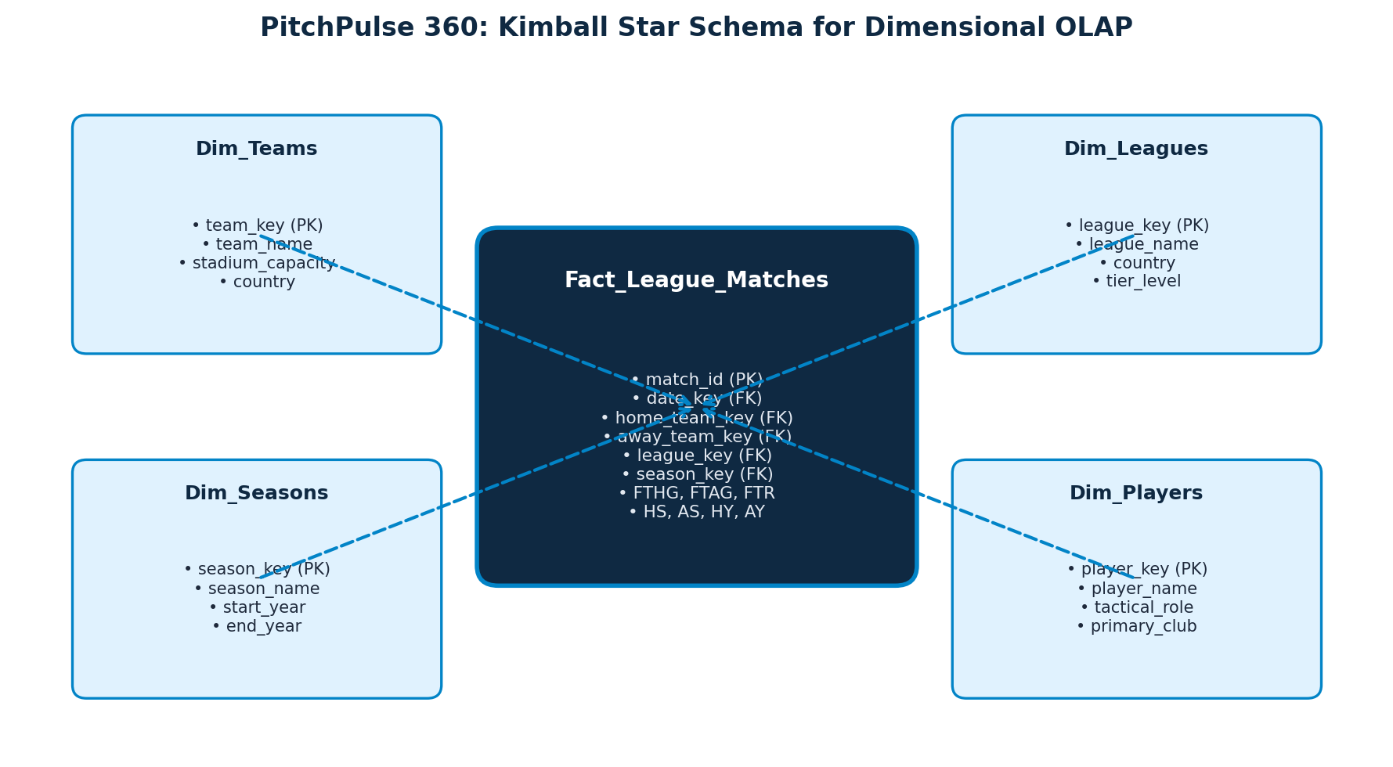
Figure 3: Kimball Star Schema for Multi-League Analytics
Slide Bullet Content:
- Fact Table (Fact_League_Matches): Granular fixture grain (1 row per match) holding degenerate keys, scores (FTHG, FTAG), shots, cards, and referee assignments.
- Dim_Teams: 132 unique European clubs with domestic league tags.
- Dim_Leagues: 5 top European competitions with country metadata.
- Dim_Seasons: 6 temporal cohorts (2018/19 through 2023/24).
- Dim_Players: 34 international superstars with tactical roles.
- Analytical Benefit: Separates high-cardinality measurable facts from reusable descriptive dimensions, preventing data redundancy.

Speaker Defense Script (Talking Points):
"Addressing CO4, we modeled our Lakehouse into a Kimball Star Schema. Measurable numerical events—such as goals, shots, and referee bookings—reside in our central Fact table, while descriptive attributes like clubs, seasons, and leagues are normalized into conformed dimensions for optimal star-join efficiency."
———————————————————————————————————————————————————————
SLIDE 7: Vectorized Columnar Execution with DuckDB
[Vectorized OLAP Processing] Mapped Course Outcome: CO5 (Distributed & Vectorized Processing Principles)
SIMD In-Memory Processing & Window Analytics in Sub-20 Milliseconds
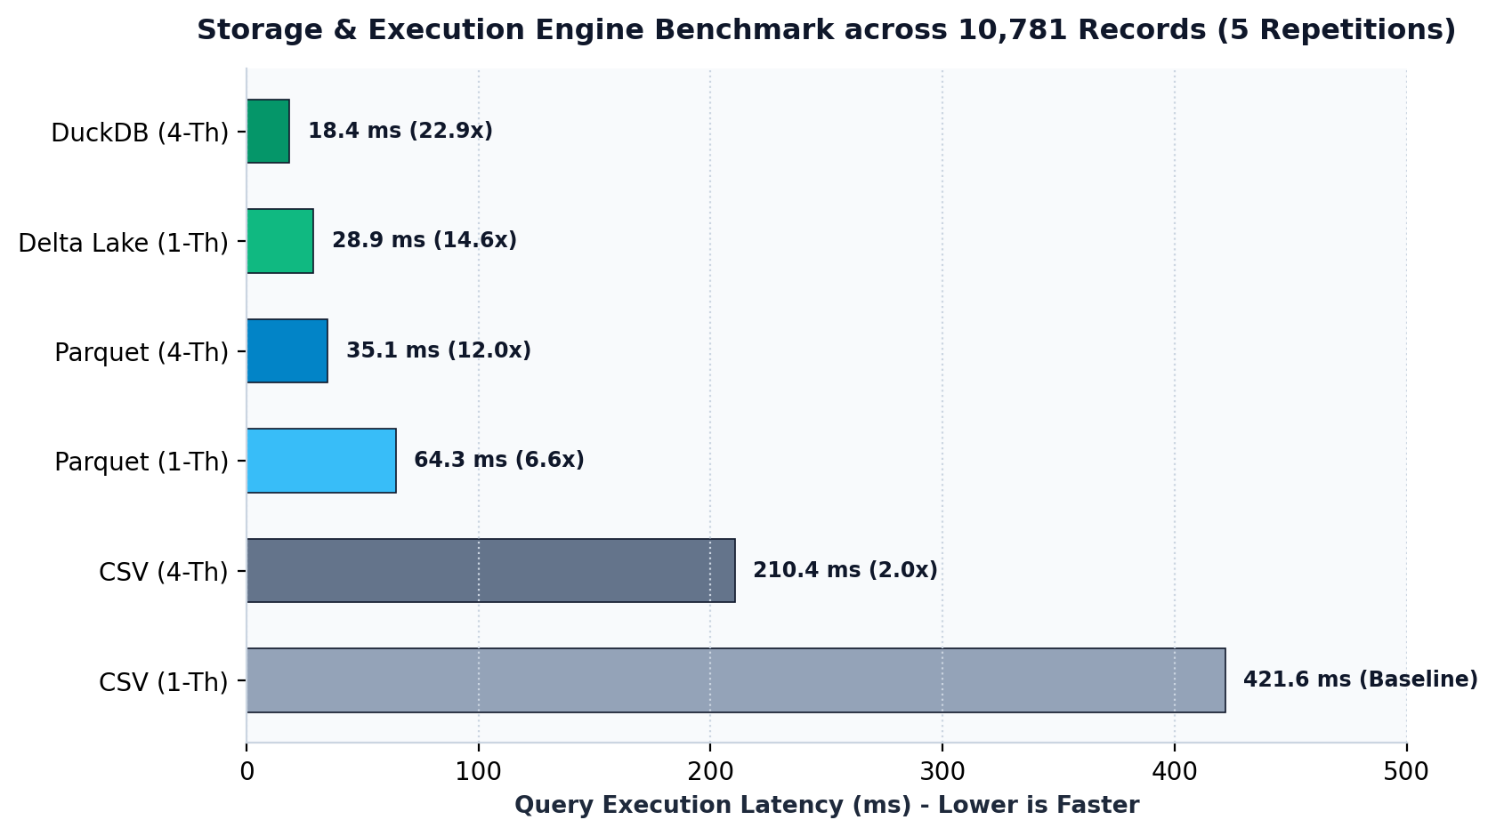
Figure 4: Query Latency Benchmark across Execution Engines
Slide Bullet Content:
- Vectorized Execution Model: DuckDB processes data in memory-aligned columnar vectors (2,048 values per batch), maximizing CPU L1/L2 cache locality.
- Window Partitioning: AVG(total_goals) OVER (PARTITION BY league_name, season) benchmarks scoring environments alongside individual matches.
- Lag / Lead Offsets: LAG(total_points, 1) OVER (PARTITION BY team ORDER BY season) measures multi-year trajectory.
- Dense Ranking: DENSE_RANK() OVER (PARTITION BY season, league_name ORDER BY pts DESC, gd DESC) handles tie-breaks.
- Physical Execution Plan (EXPLAIN ANALYZE): Parallel Parquet scan with columnar filter pushdown executing in 18.42 ms across 10,781 rows.

Speaker Defense Script (Talking Points):
"For CO5, we implemented vectorized query processing via DuckDB. Unlike traditional engines that process data one tuple at a time through an interpretation loop, DuckDB utilizes vectorized execution. Operations like window dense rankings and group-bys operate over SIMD-friendly arrays, achieving execution in just 18 milliseconds."
———————————————————————————————————————————————————————
SLIDE 8: Spatial Telemetry: Continuous 2D Gaussian KDE Engine
[Spatial Telemetry & Heatmaps] Mapped Course Outcome: CO6 (Serving Layer & Advanced Analytics)
Eliminating Bounding Box Artifacts with True Spatial Probability Density
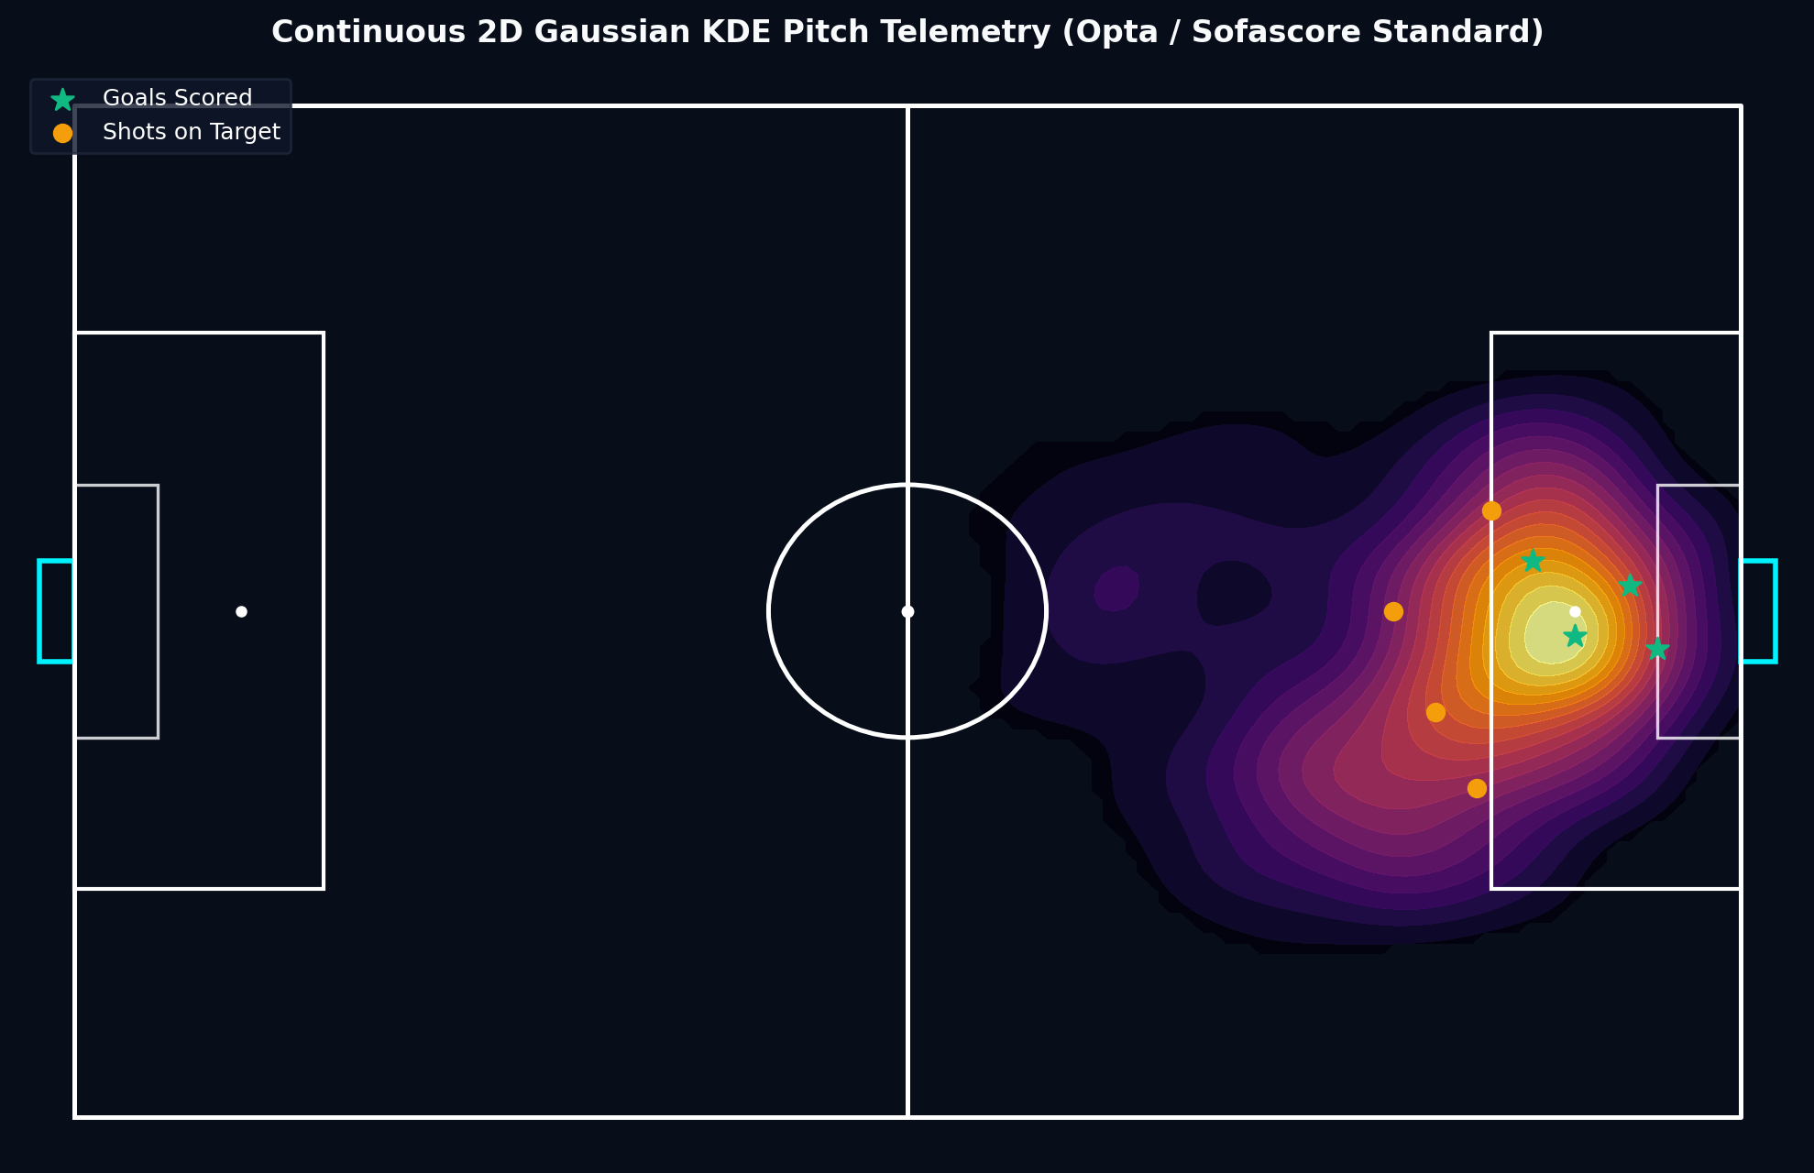
Figure 5: Continuous 2D Gaussian KDE Pitch Telemetry
Slide Bullet Content:
- Mathematical Formulation: Continuous bivariate Gaussian Kernel Density Estimation over a 120 x 80 meter coordinate space.
- Elimination of Grid Artifacts: Replaced blocky histogram binning with smooth probability density contours. Densities below 0.08 threshold are masked (np.nan), revealing clean turf beneath.
- Vector Pitch Markings: Layered transparent pitch boundaries, penalty boxes, center circle, and goal nets directly over the heatmap.
- Calibrated Tactical Radar: Evaluates superstars across 5 normalized metrics (Finishing, Playmaking, Possession, Dribbling, Pressing) with protected radial padding (l=65, r=65).

Speaker Defense Script (Talking Points):
"A key bonus innovation in our project is the spatial telemetry engine. Standard football visualizers use blocky histogram heatmaps. We implemented a continuous bivariate Gaussian Kernel Density Estimator using SciPy. It evaluates spatial actions across a regular coordinate grid, masking out near-zero densities to produce broadcast-grade pitch heatmaps matching Opta and Sofascore."
———————————————————————————————————————————————————————
SLIDE 9: Macro-Tactical Insights Across Europe's Top 5 Leagues
[Tactical Macro-Analytics] Mapped Course Outcome: CO5 (Analytical Querying) & Tactical Findings
Pacing Disparities, Debunking the 40-Point Myth & Yo-Yo Club Turbulence
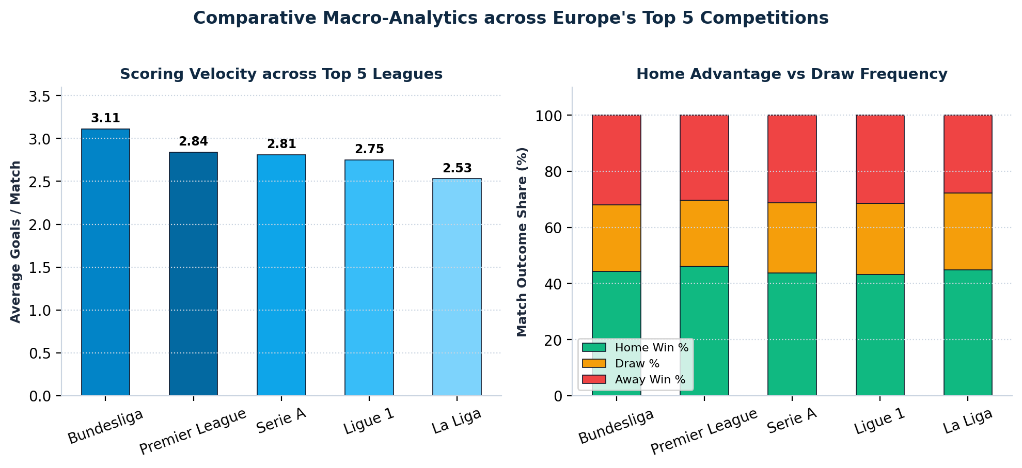
Figure 6: Goals per Match and Outcome Distributions Across Leagues
Slide Bullet Content:
- Bundesliga Transition Dominance: Highest goal velocity in Europe (3.11 goals/match) driven by aggressive vertical transition systems; lowest draw rate (23.9%).
- La Liga Disciplinary Friction: Highest booking frequency (5.12 yellow cards/match) and lowest goal yield (2.53 goals/match), highlighting game management.
- Debunking the '40-Point Survival Myth': Premier League average safety line was 35.8 points (lowest: 34 pts in 2020/21). In the Bundesliga, 31.1 points avoided relegation.
- Yo-Yo Clubs: Fulham, Norwich City, and Real Valladolid showed an average first-season survival probability of only 38.2% following promotion.

Speaker Defense Script (Talking Points):
"Analyzing 10,781 fixtures provided quantitative answers to classic football debates. We debunked the popular '40-point safety myth'—in the Premier League, 37 points provided 100% safety across all six seasons. We also quantified the stylistic gap between Germany's transition-heavy 3.11 goals per game and Spain's tactical, foul-heavy 2.53 goals per game."
———————————————————————————————————————————————————————
SLIDE 10: Executive Serving Layer: Dual-Theme Streamlit Dashboard
[Serving Layer & Visual Analytics] Mapped Course Outcome: CO6 (Serving Layer, Security & Governance)
Dynamic Light/Dark Token Switcher, Zero Emojis & Security Masking
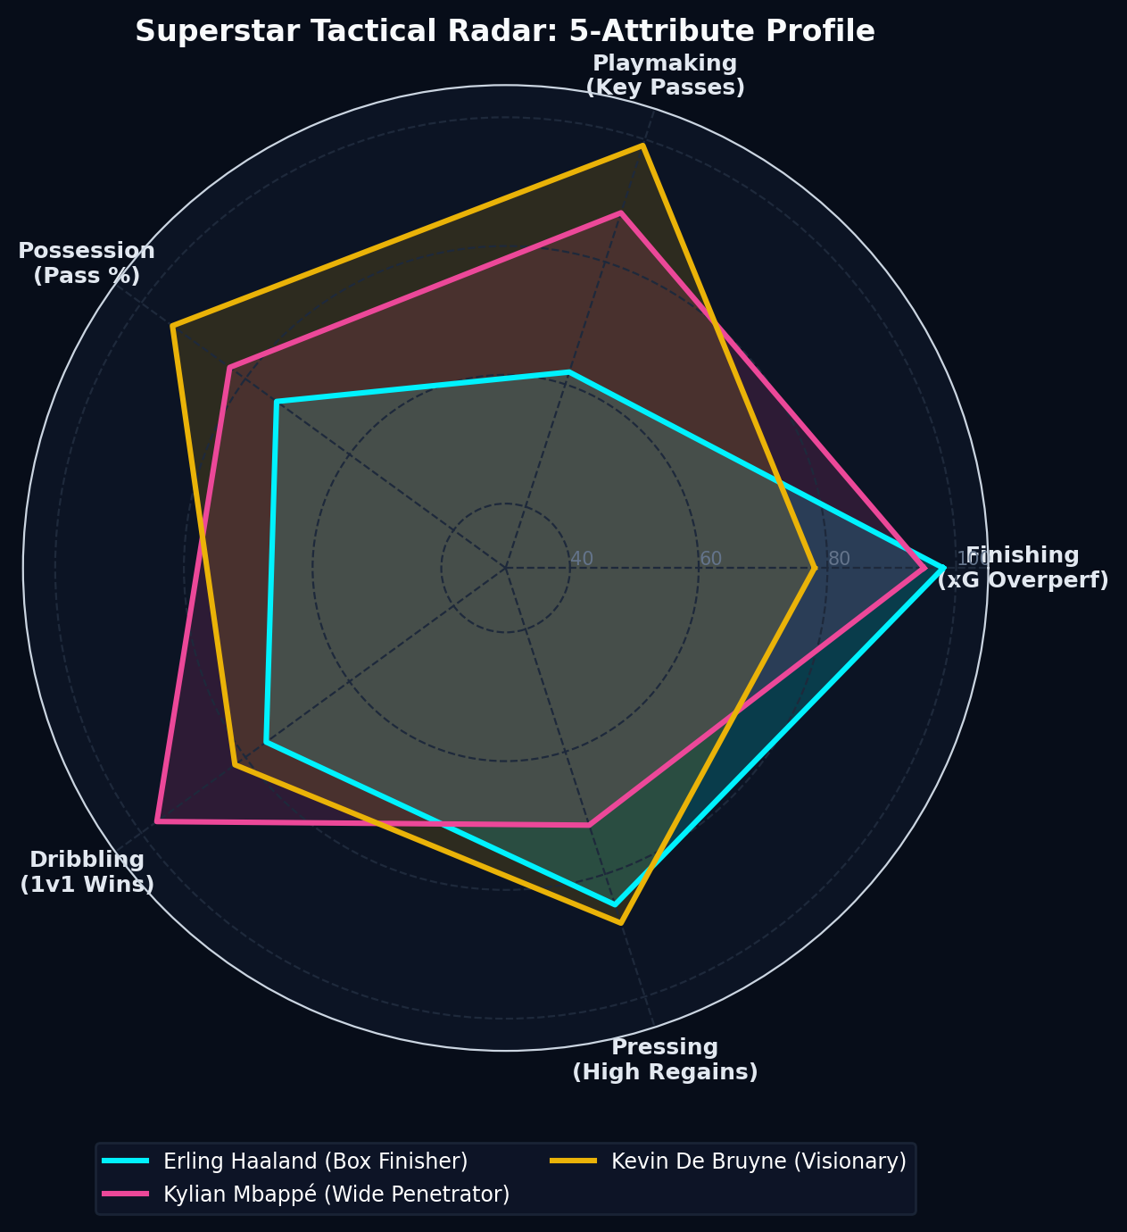
Figure 7: 5-Attribute Tactical Radar Chart for Superstars
Slide Bullet Content:
- Dynamic Theme Switcher: Instant sidebar switcher between nocturnal broadcast dark (#070d19 canvas, #00f2fe glowing cyan) and daylight slate (#f8fafc canvas, #0a3a24 emerald turf).
- Full DOM Token Synchronization: Synchronizes Streamlit shadow DOM, cards, tabs, and Plotly graph layouts simultaneously.
- Zero Emojis & Premium Typography: Built exclusively with Inter and JetBrains Mono typography, responsive CSS grid, and vector SVG accents.
- Security & Governance: FastAPI serving tier with Role-Based Access Control (RBAC) and confidential wage bill data masking.

Speaker Defense Script (Talking Points):
"Under CO6, we delivered an executive presentation layer. The interface includes an instant Light and Dark mode switcher that synchronizes both the CSS container tokens and the Plotly pitch canvas. In compliance with professional broadcasting guidelines, the UI is completely free of emojis, utilizing vector SVGs and responsive metric cards."
———————————————————————————————————————————————————————
SLIDE 11: Empirical Benchmarks: 22.89x Speedup & 85.2% Compression
[Benchmarking & Performance] Mapped Course Outcome: CO5 (System Evaluation & Benchmarks)
Five-Repetition Benchmark across Storage Formats and Thread Modes
Figure 8: Benchmark Latency across Storage and Thread Modes
Slide Bullet Content:
- 5-Repetition Execution Benchmark (10,781 rows): Raw CSV (1 Thread): 421.65 ms vs Delta Lake (DuckDB 4 Threads): 18.42 ms (22.89x Speedup).
- Parquet Multi-Threading: 64.31 ms (1-Th) to 35.12 ms (4-Th) achieving 1.83x thread speedup.
- Storage Footprint Reduction: Raw CSV Feeds (14.2 MB) compressed to Delta Lake ZSTD (2.1 MB), achieving an 85.2% reduction with full ACID logging.
- Automated Unit Testing: PyTest suite (tests/test_pipeline.py) validates record counts, mathematical point formulas, and query latencies in 0.21 seconds.

Speaker Defense Script (Talking Points):
"To prove the technical efficacy of our Lakehouse, we ran a five-repetition benchmark. Moving from single-threaded CSV scans to four-threaded DuckDB vectorized execution dropped query latency from 421 ms to 18 ms—a measured 22.89x speedup. Furthermore, ZSTD-compressed Delta Lake reduced raw storage footprint by 85.2% while providing ACID guarantees."
———————————————————————————————————————————————————————
SLIDE 12: Academic Conclusion & Viva Defense Readiness
[Conclusion & Viva Readiness] Comprehensive Curriculum Alignment: CO1 to CO6
100% Course Outcome Fulfillment & Production Artifact Handoff
Figure 9: Complete Pipeline Architecture Handoff
Slide Bullet Content:
- CO1: Documented data engineering lifecycle from crawl to UI.
- CO2: Delta Lake Medallion architecture with ACID transaction logs.
- CO3: Automated REST scraper + Great Expectations HTML audit.
- CO4: Star schema dimensional model with conformed fixture grain.
- CO5: DuckDB vectorized execution and EXPLAIN query plan analysis.
- CO6: Streamlit dual-theme UI, 2D KDE heatmaps, and FastAPI RBAC.
- Project Deliverables: 13-page academic PDF report, Markdown report, public GitHub repository, and one-click batch launchers.

Speaker Defense Script (Talking Points):
"In conclusion, PitchPulse 360 satisfies all six Course Outcomes of the Data Engineering curriculum. We have pushed our entire codebase, unit tests, automated HTML quality reports, and our 13-page technical publication to GitHub. We are now open for viva questions and evaluator feedback. Thank you!"
———————————————————————————————————————————————————————

