**Heaps**

1. Min Heap

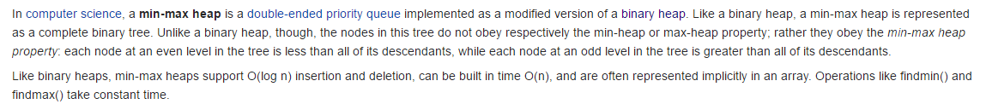

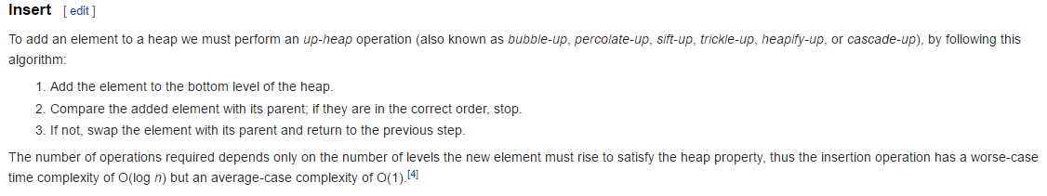

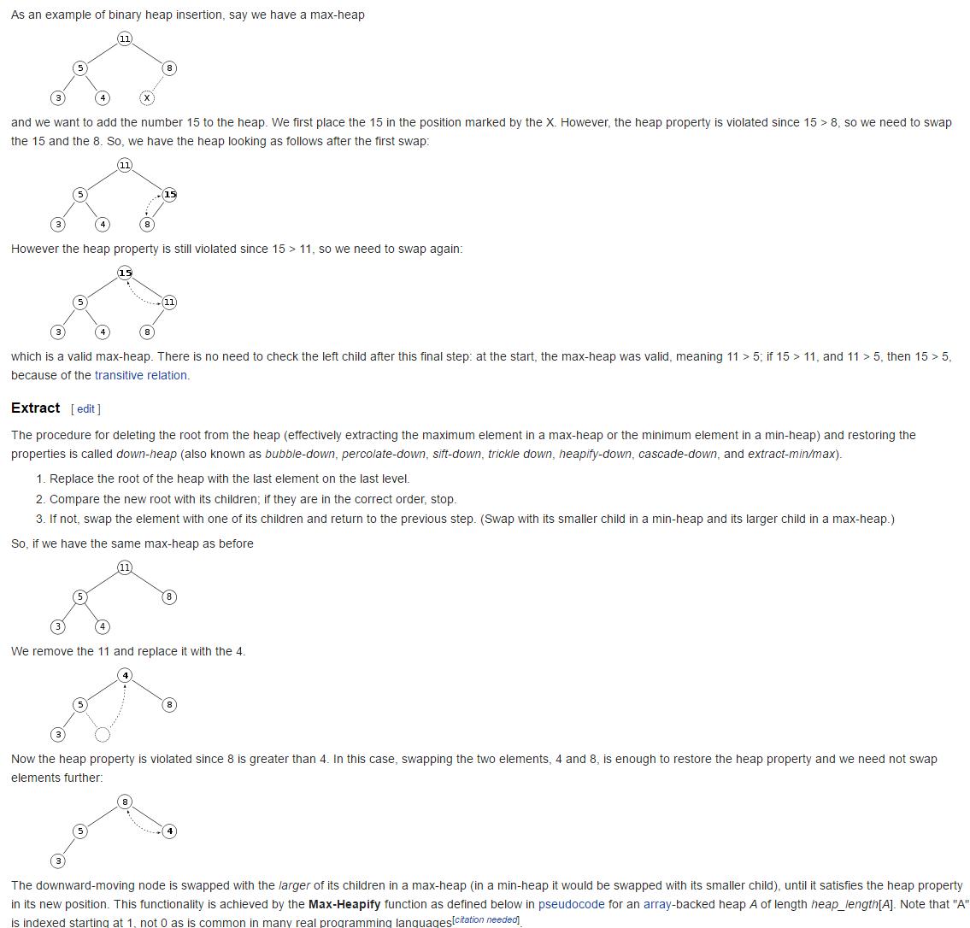

// A C++ program to demonstrate common Binary Heap Operations

#include<iostream>

#include<climits>

**using** **namespace** std**;**

// Prototype of a utility function to swap two integers

void swap**(**int **\***x**,** int **\***y**);**

// A class for Min Heap

class MinHeap

**{**

int **\***harr**;** // pointer to array of elements in heap

int capacity**;** // maximum possible size of min heap

int heap_size**;** // Current number of elements in min heap

public**:**

// Constructor

MinHeap**(**int capacity**);**

// to heapify a subtree with root at given index

void MinHeapify**(**int **);**

int parent**(**int i**)** **{** **return** **(**i**-**1**)/**2**;** **}**

// to get index of left child of node at index i

int left**(**int i**)** **{** **return** **(**2**\***i **+** 1**);** **}**

// to get index of right child of node at index i

int right**(**int i**)** **{** **return** **(**2**\***i **+** 2**);** **}**

// to extract the root which is the minimum element

int extractMin**();**

// Decreases key value of key at index i to new_val

void decreaseKey**(**int i**,** int new_val**);**

// Returns the minimum key (key at root) from min heap

int getMin**()** **{** **return** harr**[**0**];** **}**

// Deletes a key stored at index i

void deleteKey**(**int i**);**

// Inserts a new key 'k'

void insertKey**(**int k**);**

**};**

// Constructor: Builds a heap from a given array a[] of given size

MinHeap**::**MinHeap**(**int cap**)**

**{**

heap_size **=** 0**;**

capacity **=** cap**;**

harr **=** **new** int**[**cap**];**

**}**

// Inserts a new key 'k'

void MinHeap**::**insertKey**(**int k**)**

**{**

**if** **(**heap_size **==** capacity**)**

**{**

cout **<<** "\nOverflow: Could not insertKey\n"**;**

**return;**

**}**

// First insert the new key at the end

heap_size**++;**

int i **=** heap_size **-** 1**;**

harr**[**i**]** **=** k**;**

// Fix the min heap property if it is violated

**while** **(**i **!=** 0 **&&** harr**[**parent**(**i**)]** **>** harr**[**i**])**

**{**

swap**(&**harr**[**i**],** **&**harr**[**parent**(**i**)]);**

i **=** parent**(**i**);**

**}**

**}**

// Decreases value of key at index 'i' to new_val. It is assumed that

// new_val is smaller than harr[i].

void MinHeap**::**decreaseKey**(**int i**,** int new_val**)**

**{**

harr**[**i**]** **=** new_val**;**

**while** **(**i **!=** 0 **&&** harr**[**parent**(**i**)]** **>** harr**[**i**])**

**{**

swap**(&**harr**[**i**],** **&**harr**[**parent**(**i**)]);**

i **=** parent**(**i**);**

**}**

**}**

// Method to remove minimum element (or root) from min heap

int MinHeap**::**extractMin**()**

**{**

**if** **(**heap_size **<=** 0**)**

**return** INT_MAX**;**

**if** **(**heap_size **==** 1**)**

**{**

heap_size**--;**

**return** harr**[**0**];**

**}**

// Store the minimum vakue, and remove it from heap

int root **=** harr**[**0**];**

harr**[**0**]** **=** harr**[**heap_size**-**1**];**

heap_size**--;**

MinHeapify**(**0**);**

**return** root**;**

**}**

// This function deletes key at index i. It first reduced value to minus

// infinite, then calls extractMin()

void MinHeap**::**deleteKey**(**int i**)**

**{**

decreaseKey**(**i**,** INT_MIN**);**

extractMin**();**

**}**

// A recursive method to heapify a subtree with root at given index

// This method assumes that the subtrees are already heapified

void MinHeap**::**MinHeapify**(**int i**)**

**{**

int l **=** left**(**i**);**

int r **=** right**(**i**);**

int smallest **=** i**;**

**if** **(**l **<** heap_size **&&** harr**[**l**]** **<** harr**[**i**])**

smallest **=** l**;**

**if** **(**r **<** heap_size **&&** harr**[**r**]** **<** harr**[**smallest**])**

smallest **=** r**;**

**if** **(**smallest **!=** i**)**

**{**

swap**(&**harr**[**i**],** **&**harr**[**smallest**]);**

MinHeapify**(**smallest**);**

**}**

**}**

// A utility function to swap two elements

void swap**(**int **\***x**,** int **\***y**)**

**{**

int temp **=** **\***x**;**

**\***x **=** **\***y**;**

**\***y **=** temp**;**

**}**

// Driver program to test above functions

int main**()**

**{**

MinHeap h**(**11**);**

h**.**insertKey**(**3**);**

h**.**insertKey**(**2**);**

h**.**deleteKey**(**1**);**

h**.**insertKey**(**15**);**

h**.**insertKey**(**5**);**

h**.**insertKey**(**4**);**

h**.**insertKey**(**45**);**

cout **<<** h**.**extractMin**()** **<<** " "**;**

cout **<<** h**.**getMin**()** **<<** " "**;**

h**.**decreaseKey**(**2**,** 1**);**

cout **<<** h**.**getMin**();**

**return** 0**;**

**}**

1. Min Max Heap