Environment Isolation for Dev / Test / Prod
Using VPC Design and IAM
Architecture and Build Guide

1. Overview
This project implements strict environment isolation inside a single AWS account. Development, Test/UAT and Production each get their own VPC, and access is controlled through IAM roles that are assumed with AWS STS. This balances governance and security with cost and operational simplicity.
Each environment is isolated at both the network layer and the identity layer, so a failure, misconfiguration or unauthorized access in one environment does not affect the others, especially Production.

2. Isolation Boundaries
Network
- Each environment has a dedicated VPC with a unique, non overlapping CIDR block.
- No VPC peering, Transit Gateway or shared routing between Dev, Test and Prod.
- Each VPC has its own route tables, subnets, security groups and internet gateway.
Identity and access
- No direct IAM user access to Production resources.
- Access is granted only through IAM roles using STS AssumeRole.
- One role per environment: Dev-Access-Role, Test-Access-Role and Prod-Access-Role.
Permissions
- Write access is restricted with tag based IAM policies.
- A role can modify only resources tagged with its own Environment value. For example, the Prod role only touches resources tagged Environment=Prod.
- All access is temporary (1 hour maximum session) and auditable.
Why this design
- Prevents accidental or unauthorized access to Production.
- Enforces separation of duties.
- Removes long lived Production credentials.
- Supports auditing through AWS CloudTrail.
- Reduces the blast radius of mistakes.

3. Architecture
Three isolated VPCs sit inside one AWS account. An IAM user or SSO identity assumes an environment specific role through STS, and each role can act only on its own environment. There is no peering or routing between the VPCs.
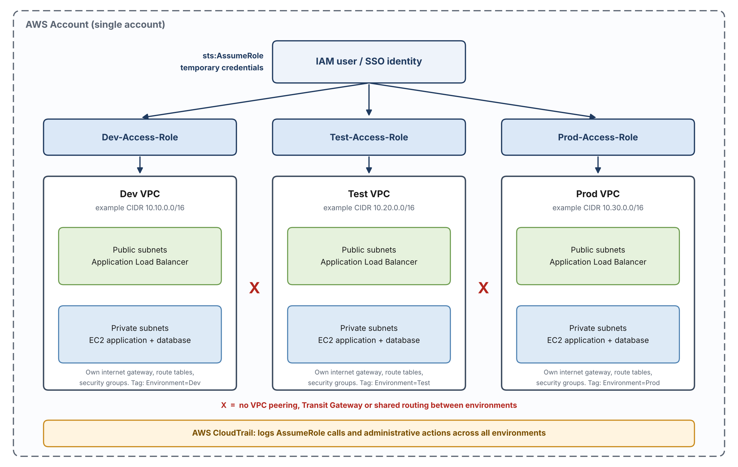
Figure 1. Environment isolation architecture (CIDR ranges are examples).
Each VPC contains:
- Public subnets for the load balancer
- Private subnets for application and database workloads
- A dedicated internet gateway
- Environment specific route tables and security groups
Example CIDR plan
Use your own ranges and make sure they do not overlap.
Environment | Example VPC CIDR
Dev | 10.10.0.0/16
Test | 10.20.0.0/16
Prod | 10.30.0.0/16

4. Build Guide

4.1 Network setup
- Create three VPCs (Dev, Test, Prod) with non overlapping CIDR blocks.
- In each VPC, create public and private subnets in at least two Availability Zones.
- Create an internet gateway for each VPC and attach it to that VPC only.
- Create separate route tables per VPC and associate them with that VPC's subnets. Do not add peering or cross VPC routes.
- Create one security group per environment. Allow inbound traffic only from within the same environment, and add no rules that reference another environment.
- Launch a sample EC2 instance in each environment.
- Apply the mandatory tag Environment with the value Dev, Test or Prod to every resource, including the instances.

4.2 IAM configuration
- Create the roles Dev-Access-Role, Test-Access-Role and Prod-Access-Role.
- Configure each role's trust policy to allow sts:AssumeRole. Example (replace the placeholder, and prefer a specific user or role over the account root where you can):
{
"Version": "2012-10-17",
"Statement": [
{
"Effect": "Allow",
"Principal": { "AWS": "arn:aws:iam::<YOUR_ACCOUNT_ID>:root" },
"Action": "sts:AssumeRole"
}
]
}
- Attach the AWS managed ReadOnlyAccess policy to each role.
- Add an inline, tag based policy to each role so it can change only its own environment. Example for the Prod role:
{
"Version": "2012-10-17",
"Statement": [
{
"Effect": "Allow",
"Action": [
"ec2:StartInstances",
"ec2:StopInstances",
"ec2:RebootInstances"
],
"Resource": "*",
"Condition": {
"StringEquals": { "aws:ResourceTag/Environment": "Prod" }
}
}
]
}
- Grant sts:AssumeRole on these roles to the source IAM users or SSO identities that should be able to use them.
- Set the maximum session duration to 1 hour.

4.3 Auditing
Enable an AWS CloudTrail trail for management events so that AssumeRole calls and administrative actions across all environments are logged to an S3 bucket.

5. Validation and Isolation Testing
Test 1: Network isolation
- Confirm the Dev and Prod CIDR blocks do not overlap.
- From a Dev instance, try to reach the private IP of a Prod instance (for example with ping or curl).
- Expected result: the traffic fails or times out.
Test 2: Read only visibility
- Assume Prod-Access-Role and view Dev and Test resources.
- Expected result: read only access works.
- Then try to modify a Dev resource while in the Prod role.
- Expected result: AccessDenied.

6. Cleanup
Terminate the sample instances, and delete any NAT gateways and Elastic IPs when you finish, to avoid ongoing charges.

Note on screenshots and confidentiality
This guide was originally built during an internship at CloudThat Technologies. CloudThat does not allow screenshots from its environment to be shared, so no screenshots are included. In line with company policy, which does not permit sharing credentials or AWS account IDs, this document also contains no credentials, account IDs or user identities. Every identifier is a placeholder, and the CIDR ranges are examples only.

