Group Field Normalization

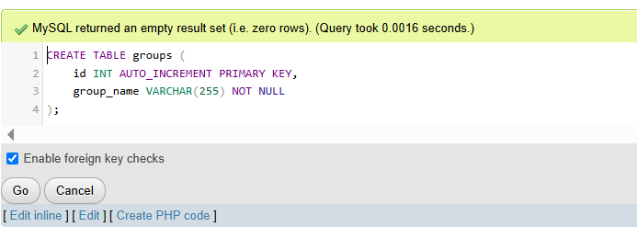
1. Creating a new table groups

2. Importing unique values from the student groups field into the created group classifier table
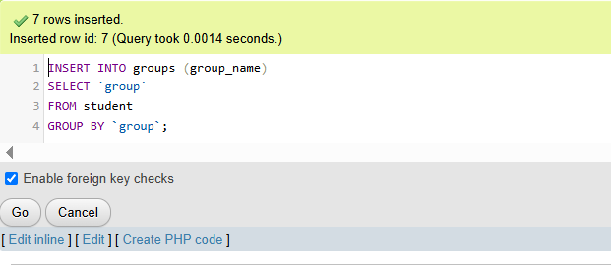

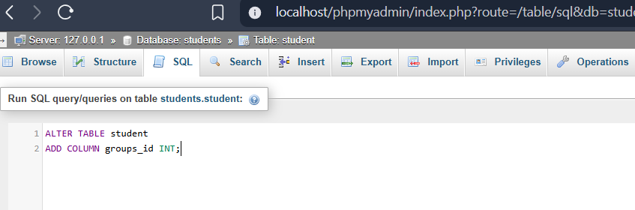
3. Creating a new field student table groups_ID for storing student group ID

4. For each student record, the ID of the groups entered in the groups_id field according to the new classifier table
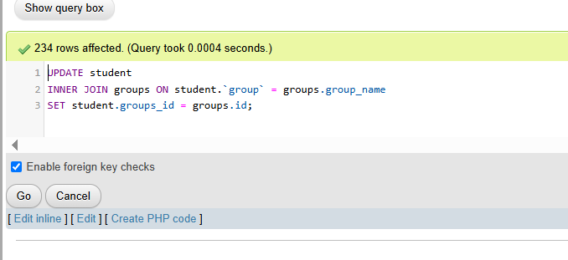

5. Removing the student table group field
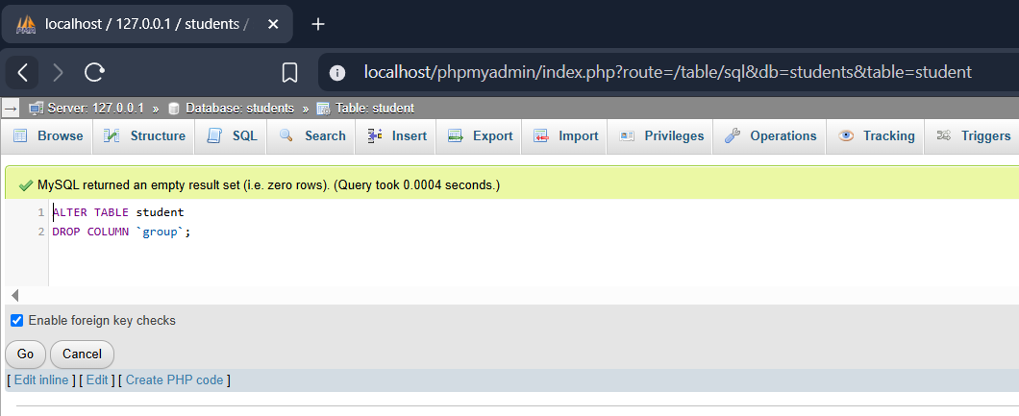

6. Creating the formal relationship (Foreign Key) to lock the group table to the student table.
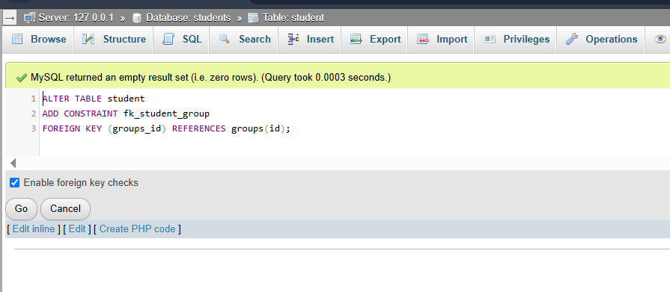

City Field Normalization

Step 1: Creating the new classifier table for the cities.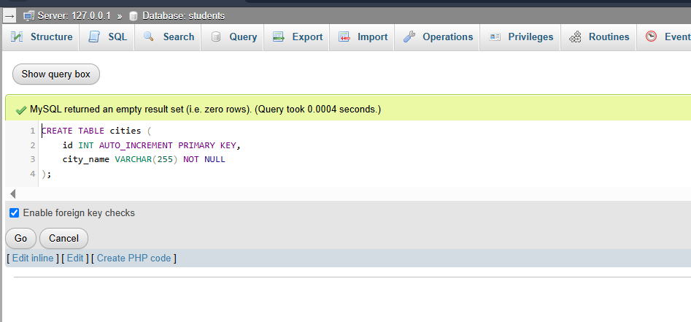

Step 2: extracting the unique city names from the main table and inserting them into my new cities table.
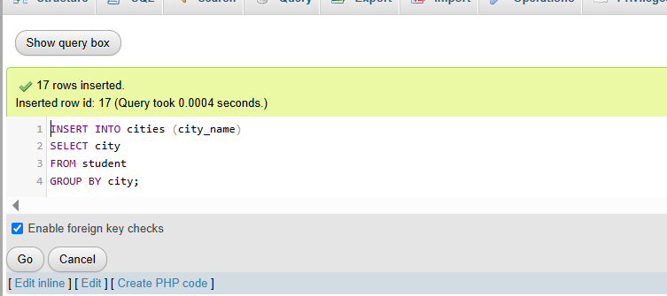

Step 3: adding the new, empty ID column to my main student table.
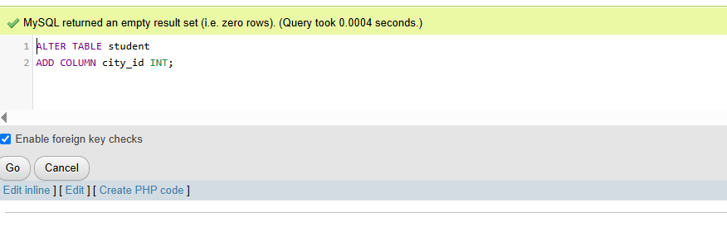
Step 4: Matching the city text in the main table with my new reference table and inject the IDs.
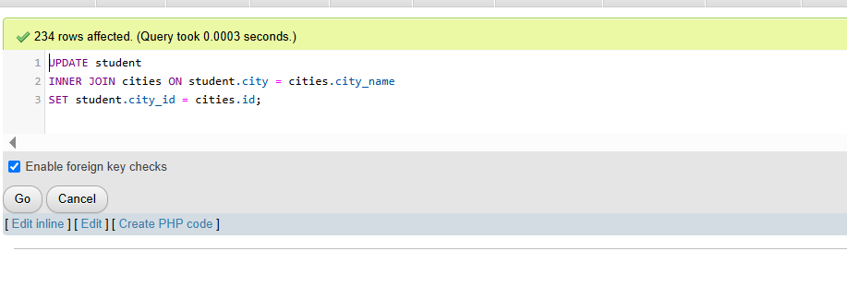
Step 5: Delete the old, redundant text column now that the numbers are in place.

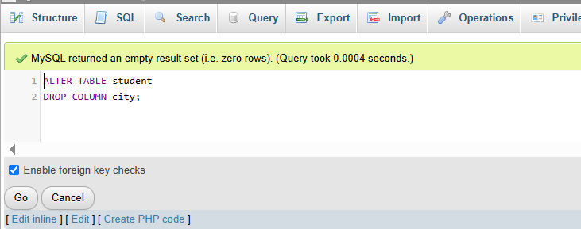
Step 6: Create the formal relationship (Foreign Key) to lock the cities table to the student table.

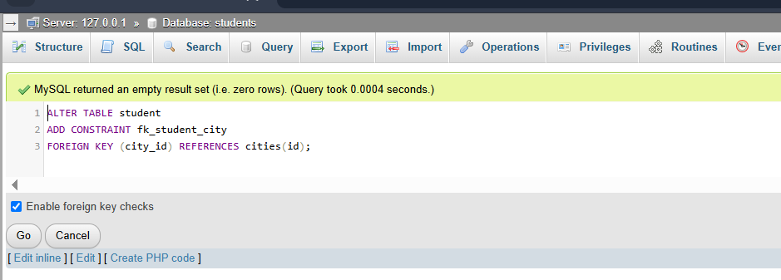

Status Field Normalization

Step 1: Creating new classifier table for the statuses
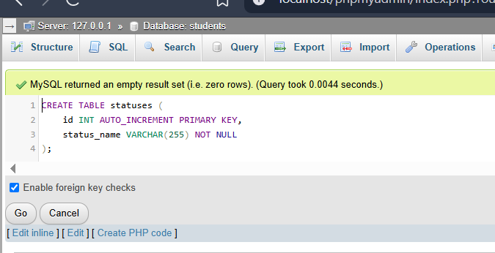

Step 2: Extracting the unique status values from the main table and insert them into your new statuses table.
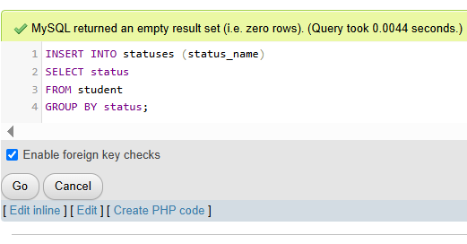

Step 3: Adding the new ID column to your main student table.
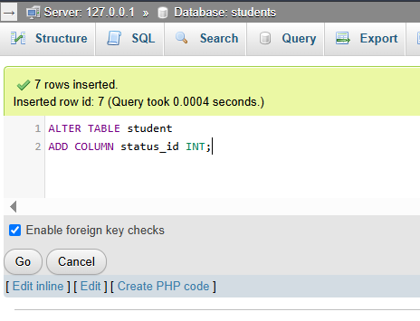

Step 4: Matching the status text and inject the IDs.

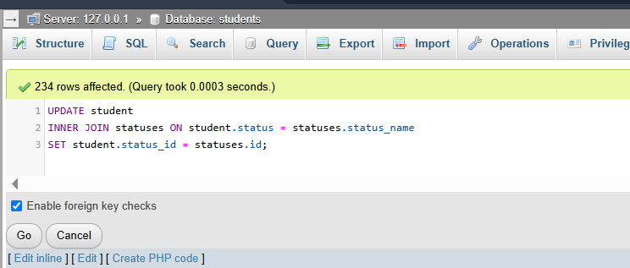

Step 5: Deleting the old text column.

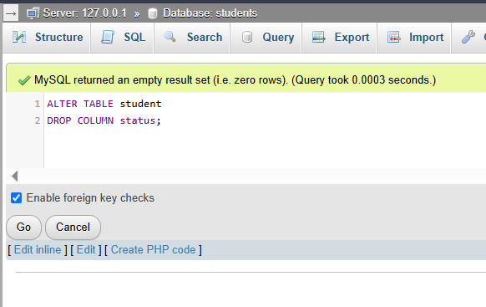

Step 6: Locking the tables together with the final Foreign Key relationship.

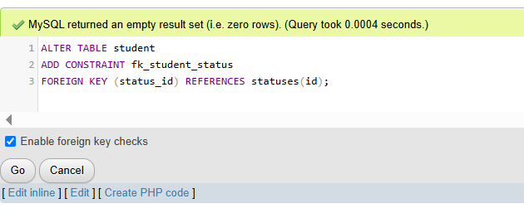

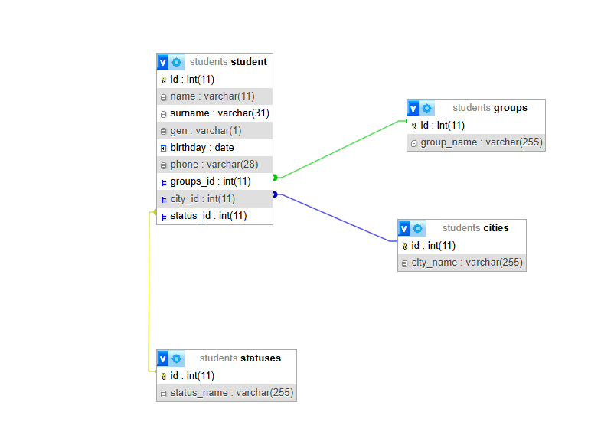
ER Diagram

The ER diagram shows how I changed my database structure. The student table now uses IDs (groups_id, city_id, and status_id) instead of storing the same group, city, and status names repeatedly. I created three separate tables called groups, cities, and statuses to store these names with their own IDs. The tables are connected using foreign keys, which can be seen as colored lines in the diagram. The groups_id is connected to groups, city_id to cities, and status_id to statuses. This makes the database more organized and reduces repeated data.

