Hotel Booking Data Analysis

End-to-End Hotel Booking Data Analytics Project

Submitted by:
AYUSH P G
Internship: Data Analytics Internship
Date: 23-06-2026

1. Introduction
This project was developed to analyze hotel booking data and convert raw reservation records into business insights. The complete workflow included data cleaning, exploratory analysis, dashboard creation, and business reporting using Python, MySQL and Power BI. The aim was to understand booking behaviour, pricing patterns, cancellations and customer trends.

2. Problem Statement
Hotels generate large amounts of booking data but raw records alone do not support decisions. This project focused on converting raw data into information that can support occupancy planning, pricing and customer management.
• Clean and prepare raw booking data
• Perform exploratory analysis
• Identify business insights
• Build interactive dashboard
• Present recommendations

4. Dataset Description
Dataset fields included hotel type, lead time, arrival dates, stay duration, customer details, market segment, booking status, ADR and reservation information.

5. Week 1 – Data Cleaning and Preparation
Imported dataset into Python using Pandas. Missing values were identified and treated. Duplicate records were removed. Feature engineering was performed by creating total_stay. Data consistency checks were completed and cleaned output was exported for analysis.
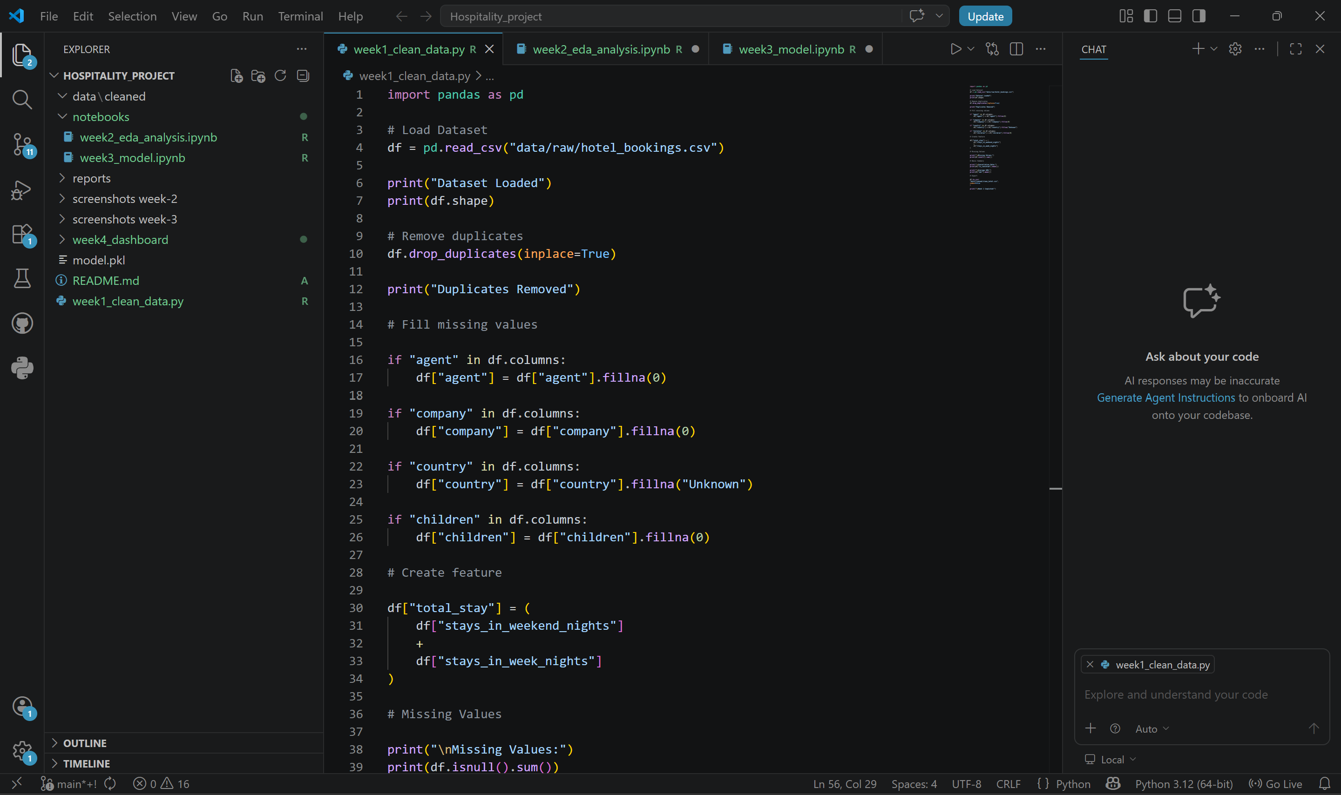

6. Week 2 – Exploratory Data Analysis (EDA)
Analyzed booking distributions, cancellation rate, ADR trends and customer behaviour. Jupyter Notebook, Matplotlib and Seaborn were used for visual analysis. Findings were documented as business observations.
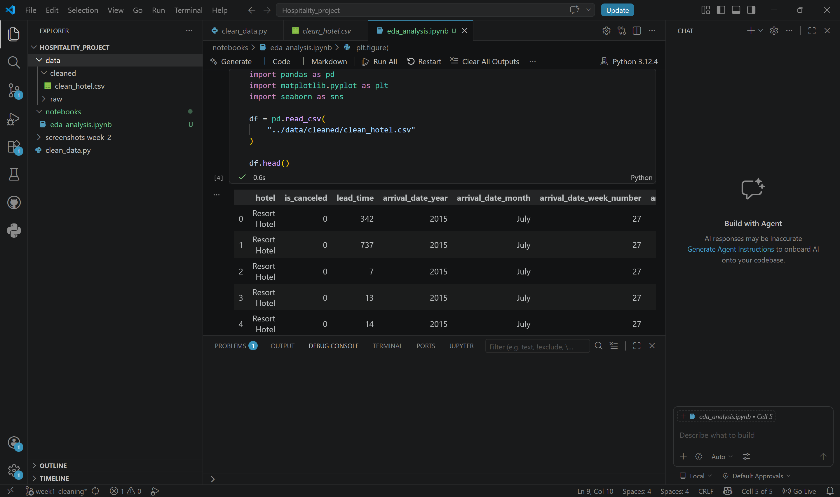
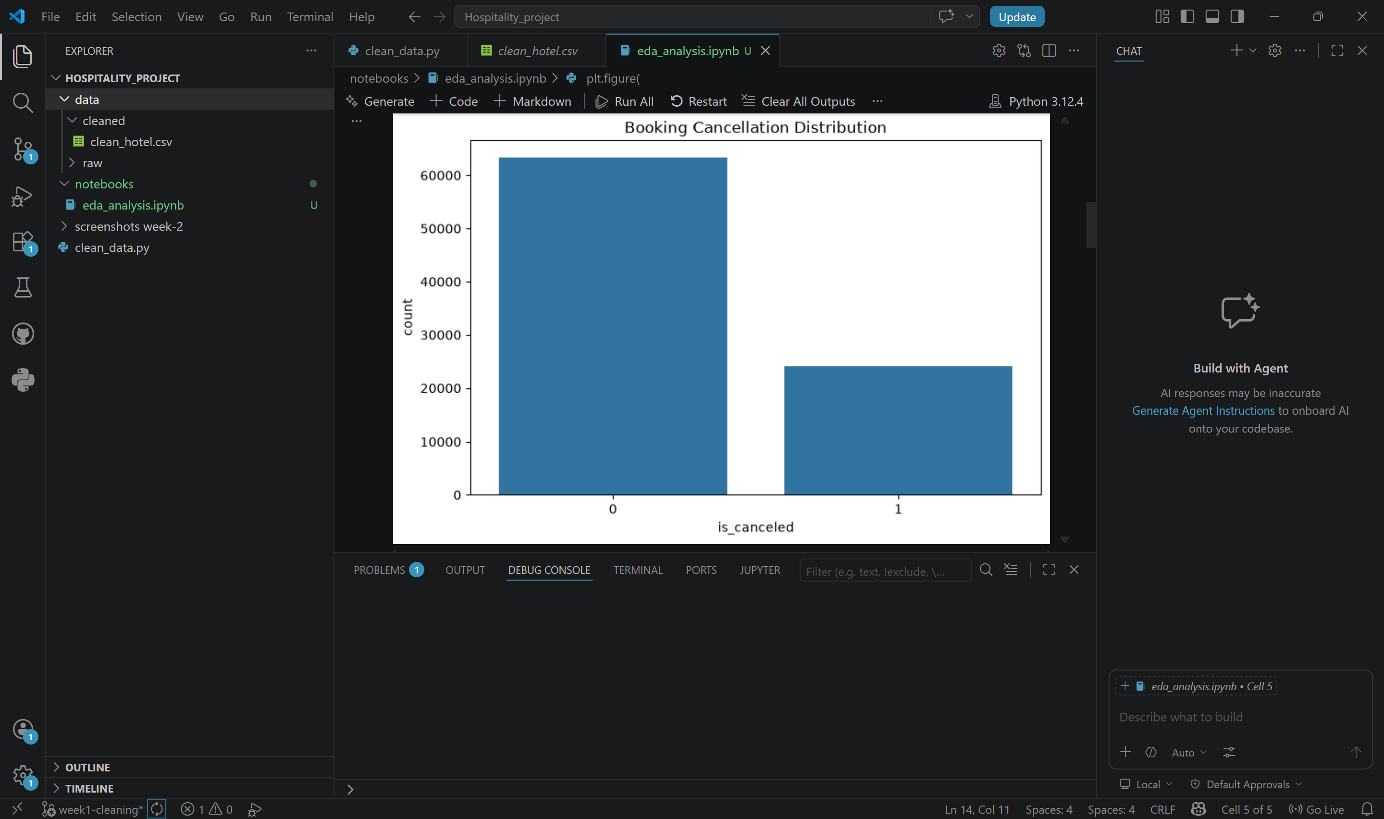
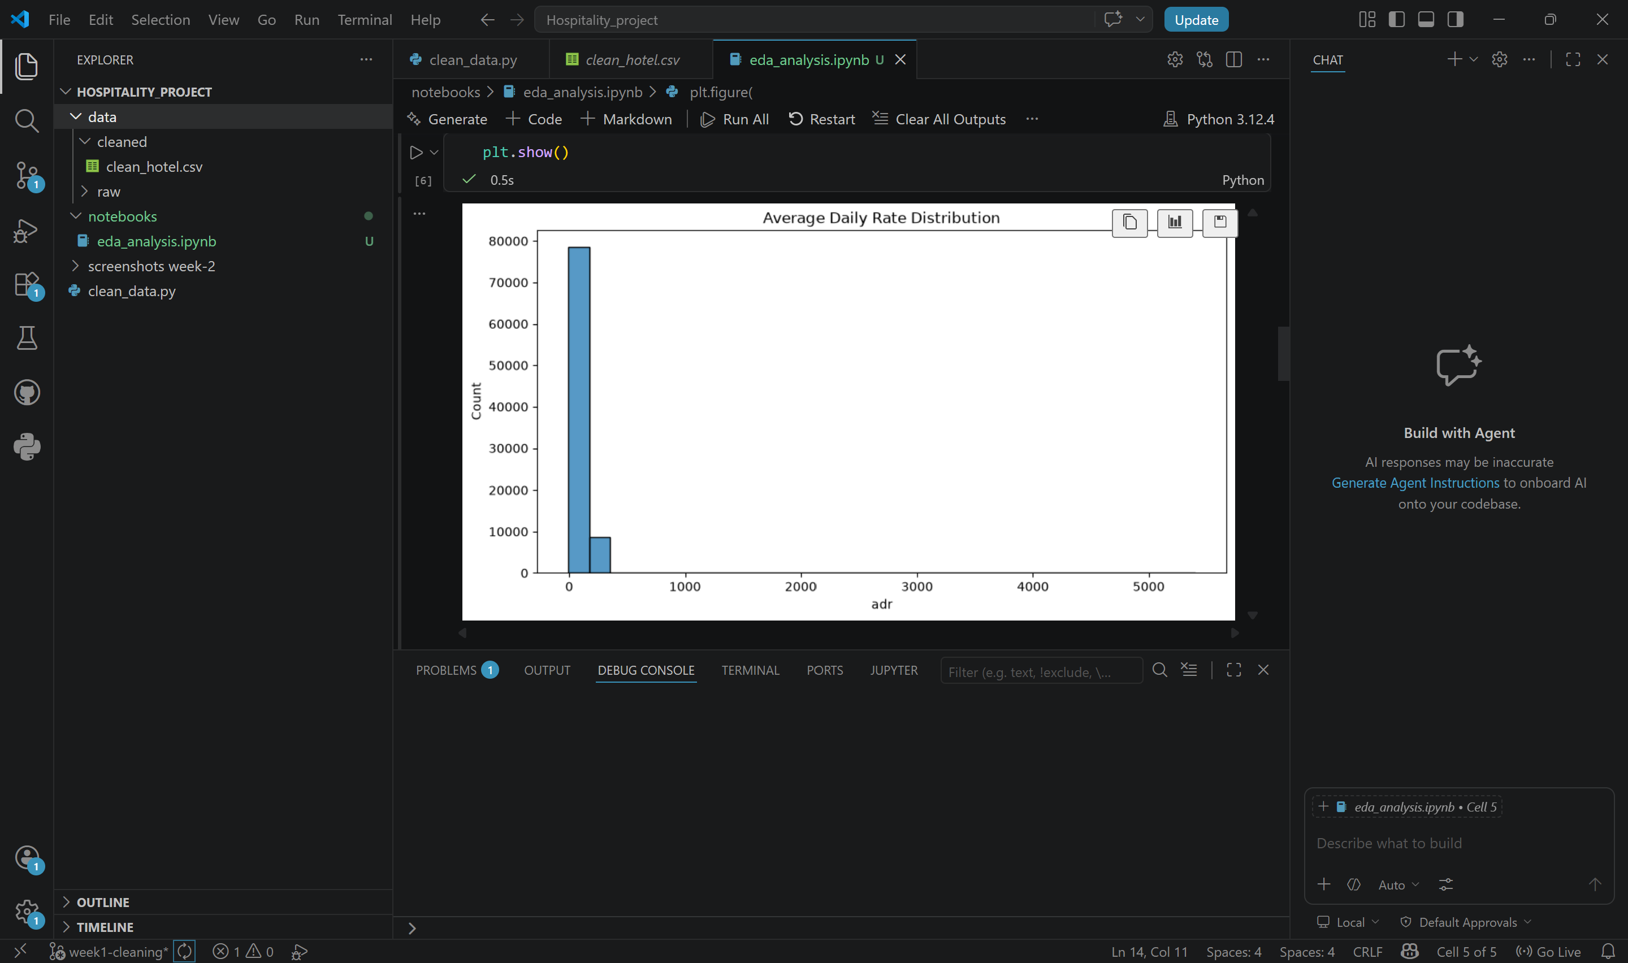
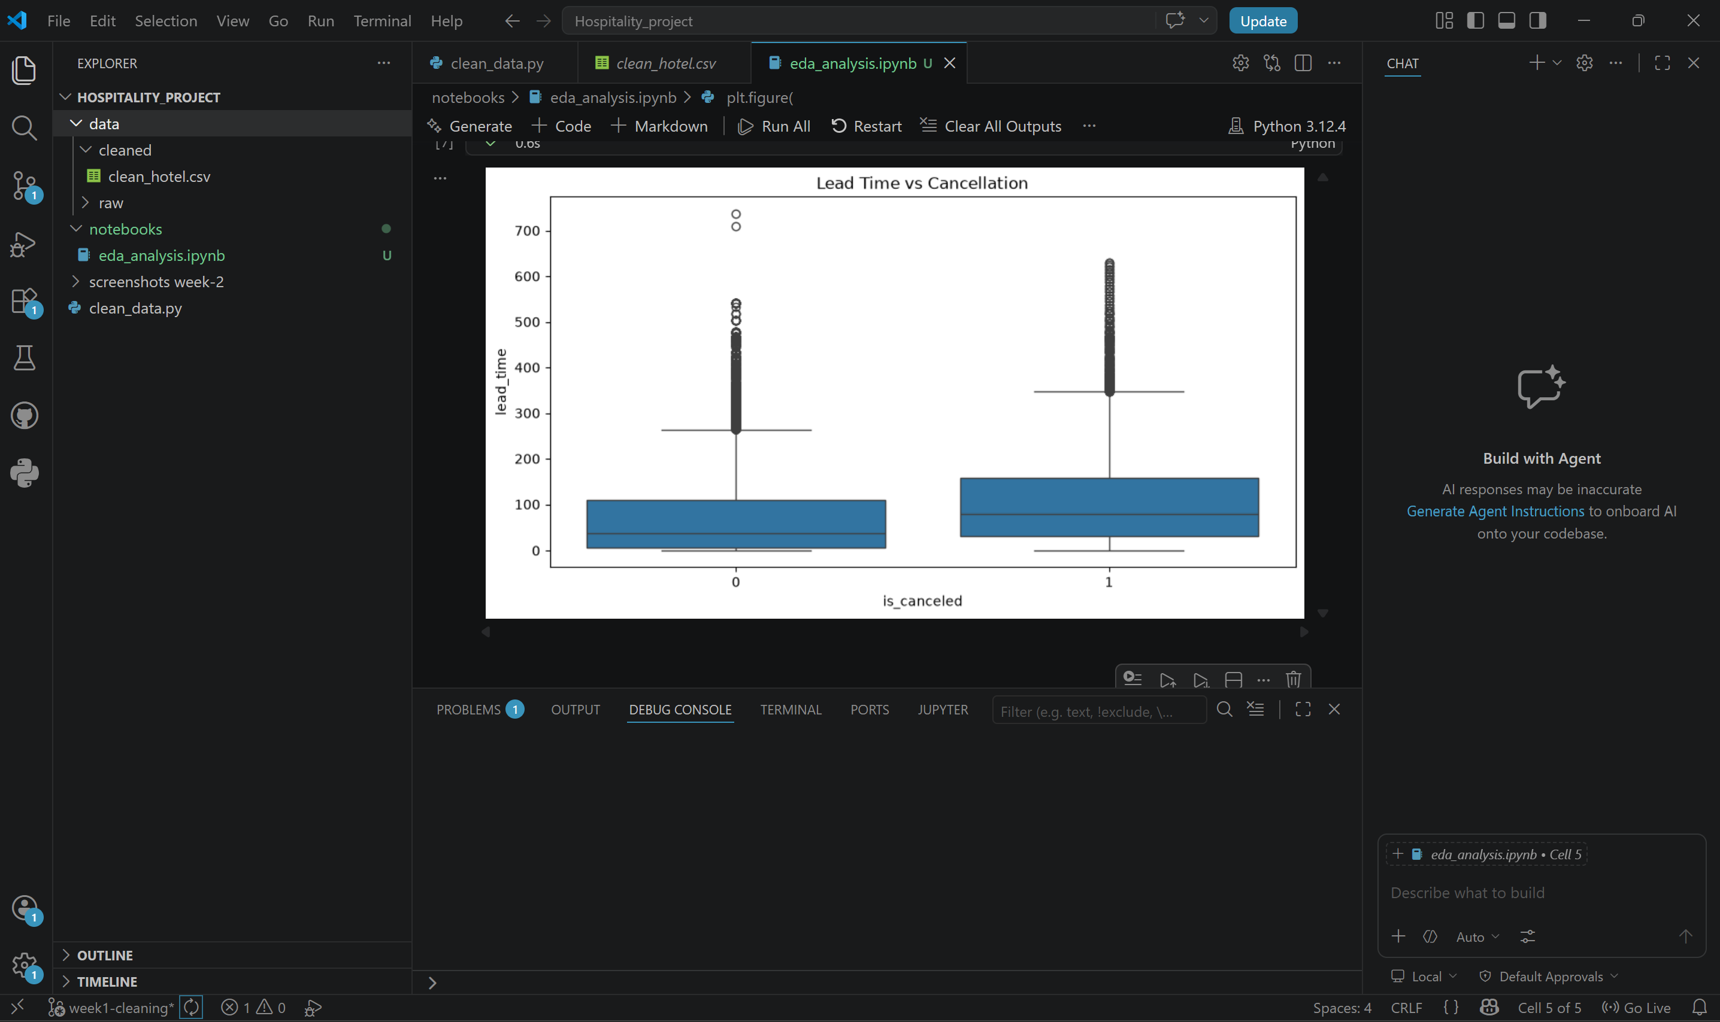
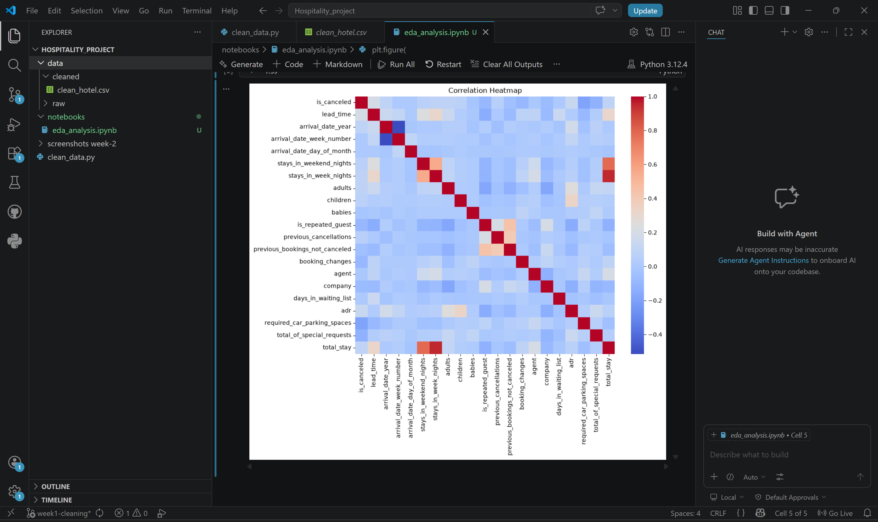

7. Week 3 – Dashboard Development
Created interactive Power BI dashboard. Added KPI cards, booking trends, cancellation visuals, filters and comparison visuals. Dashboard was designed for business storytelling and decision support.
KPIs: Total Bookings, Cancellation Rate, Average ADR, Average Stay.
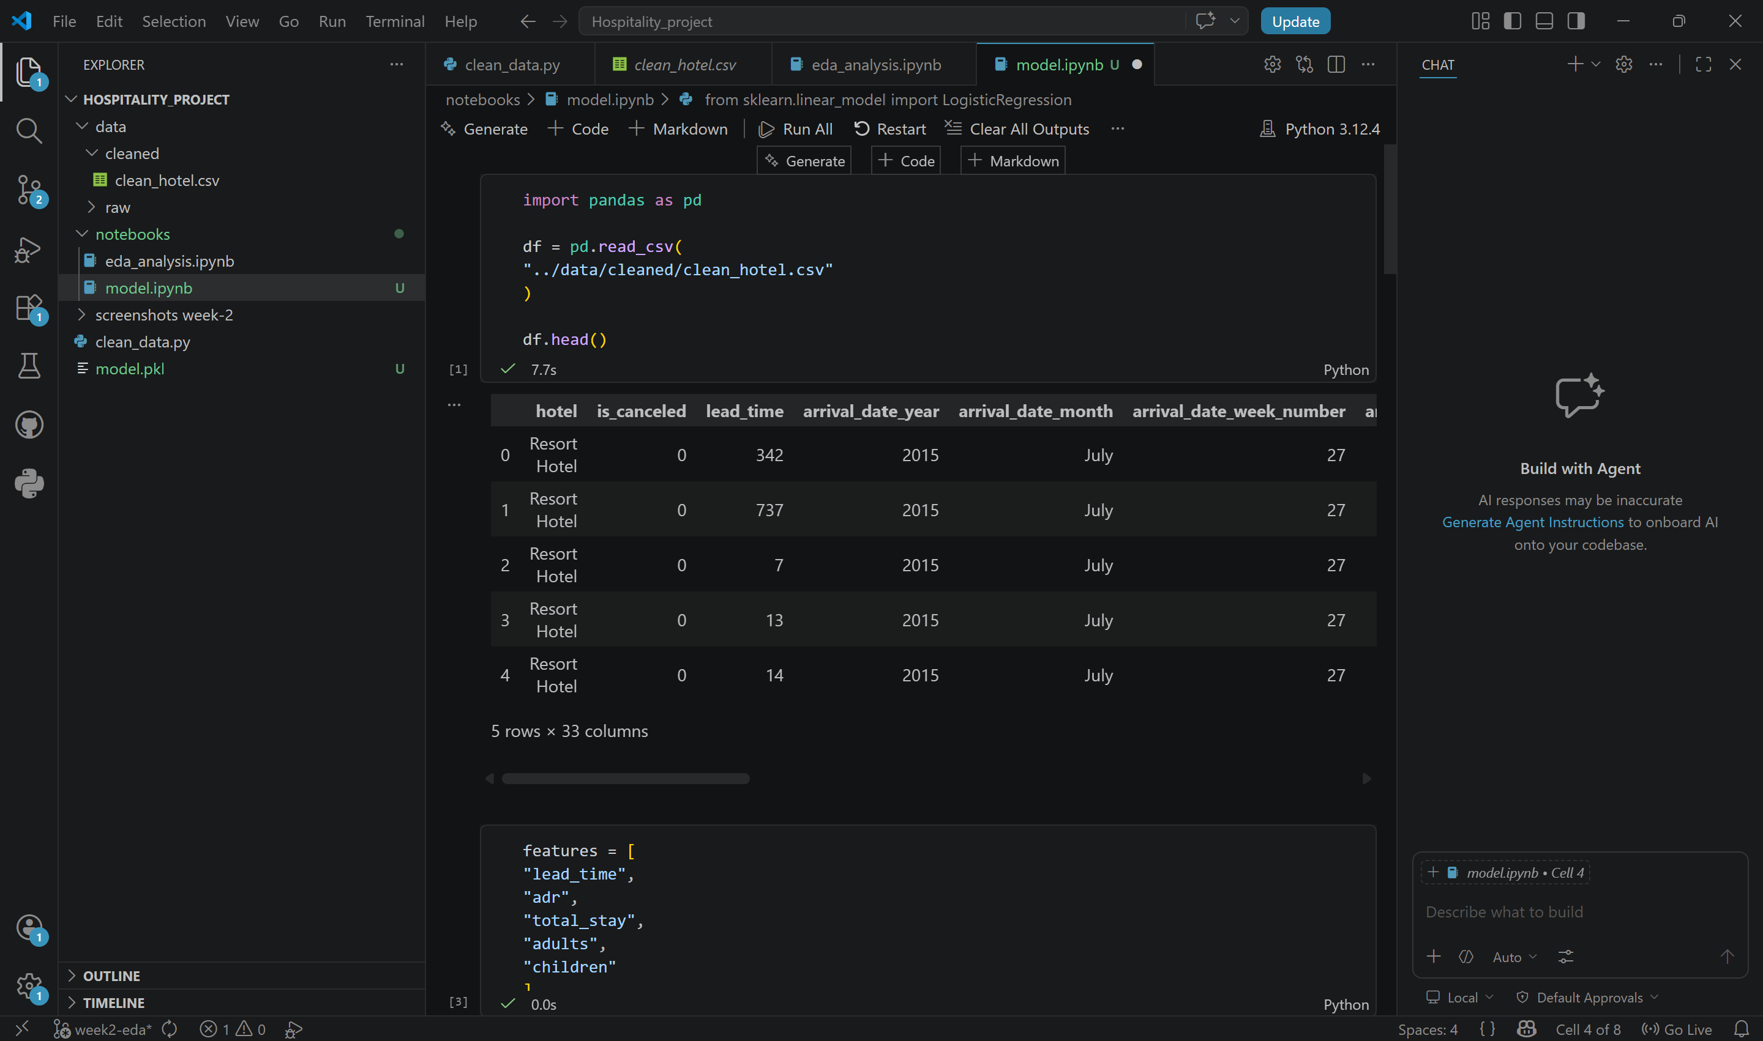
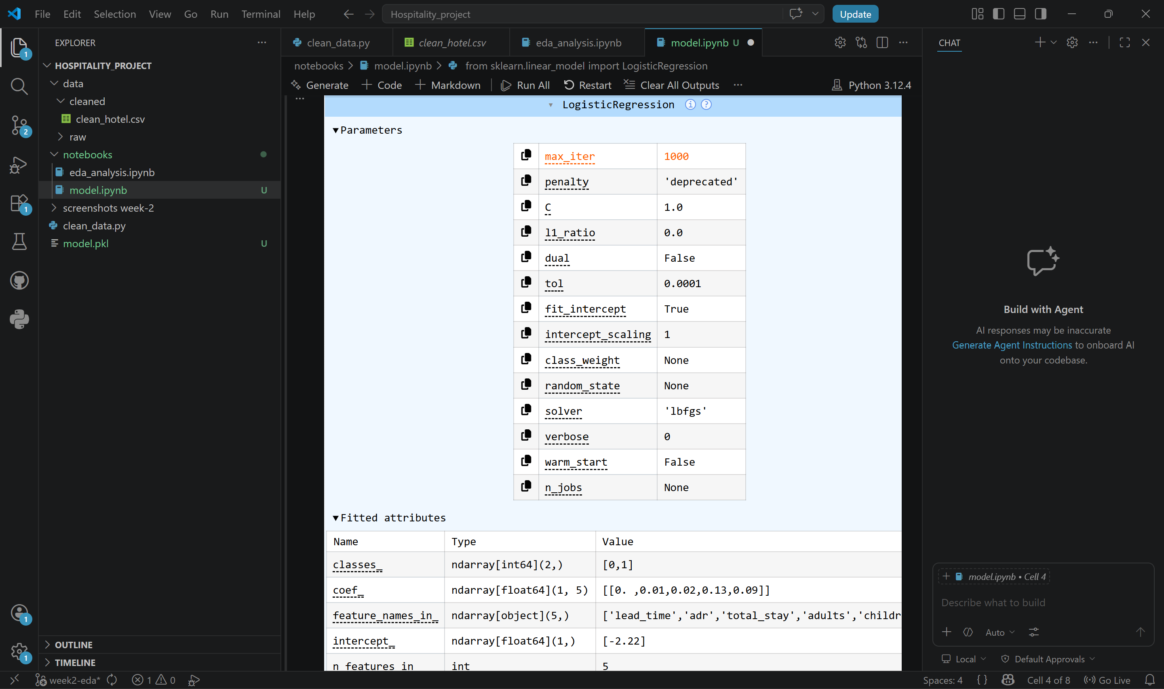
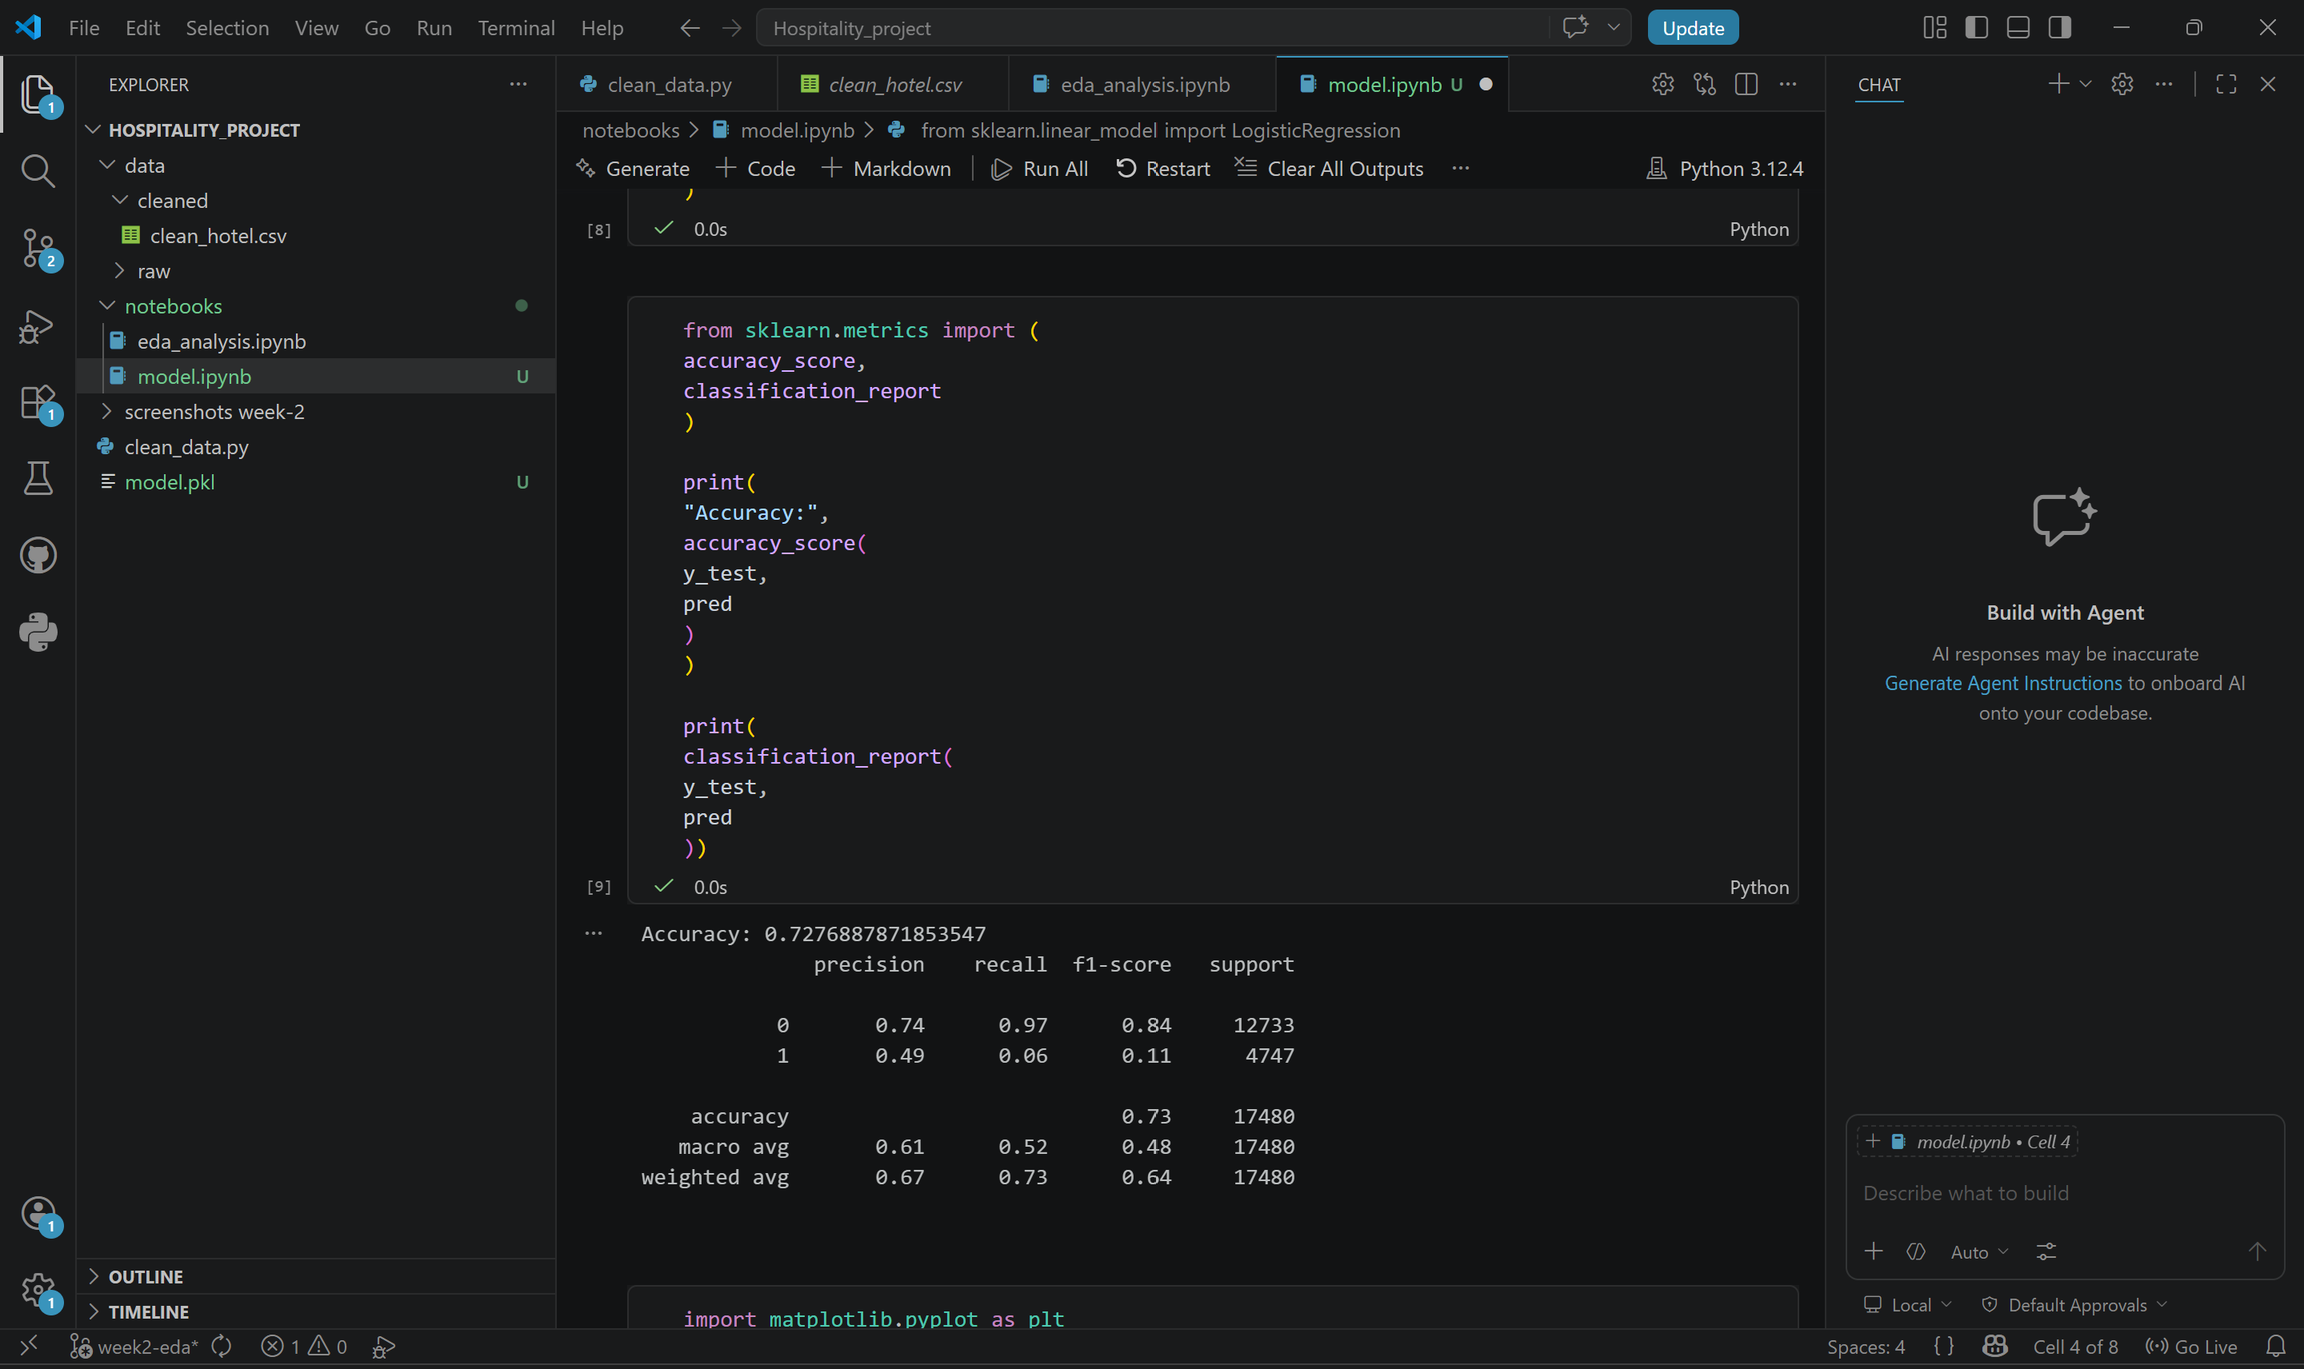
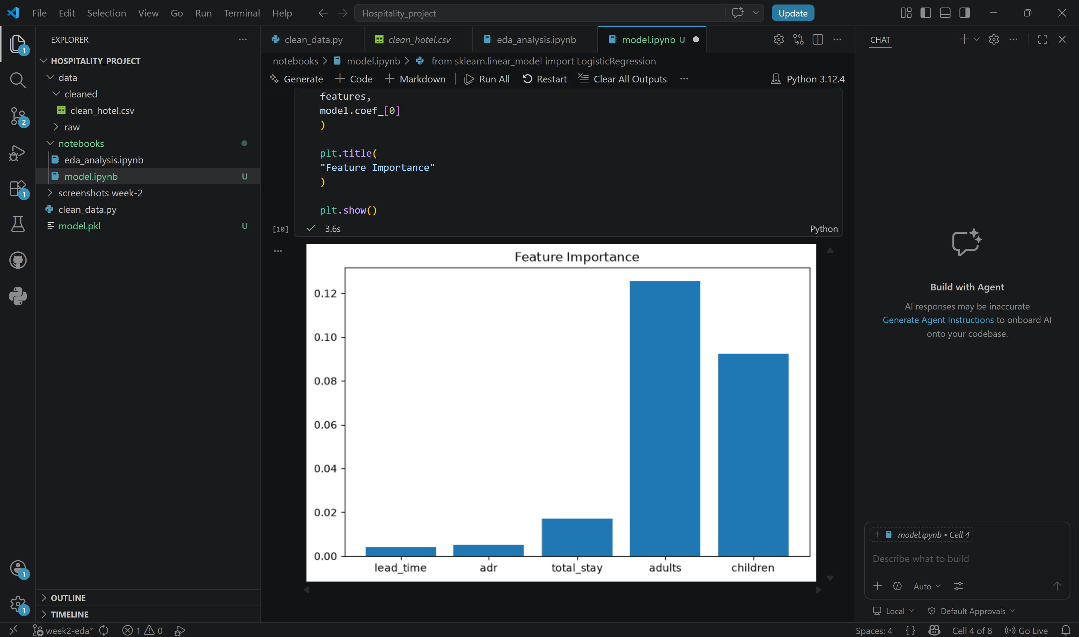

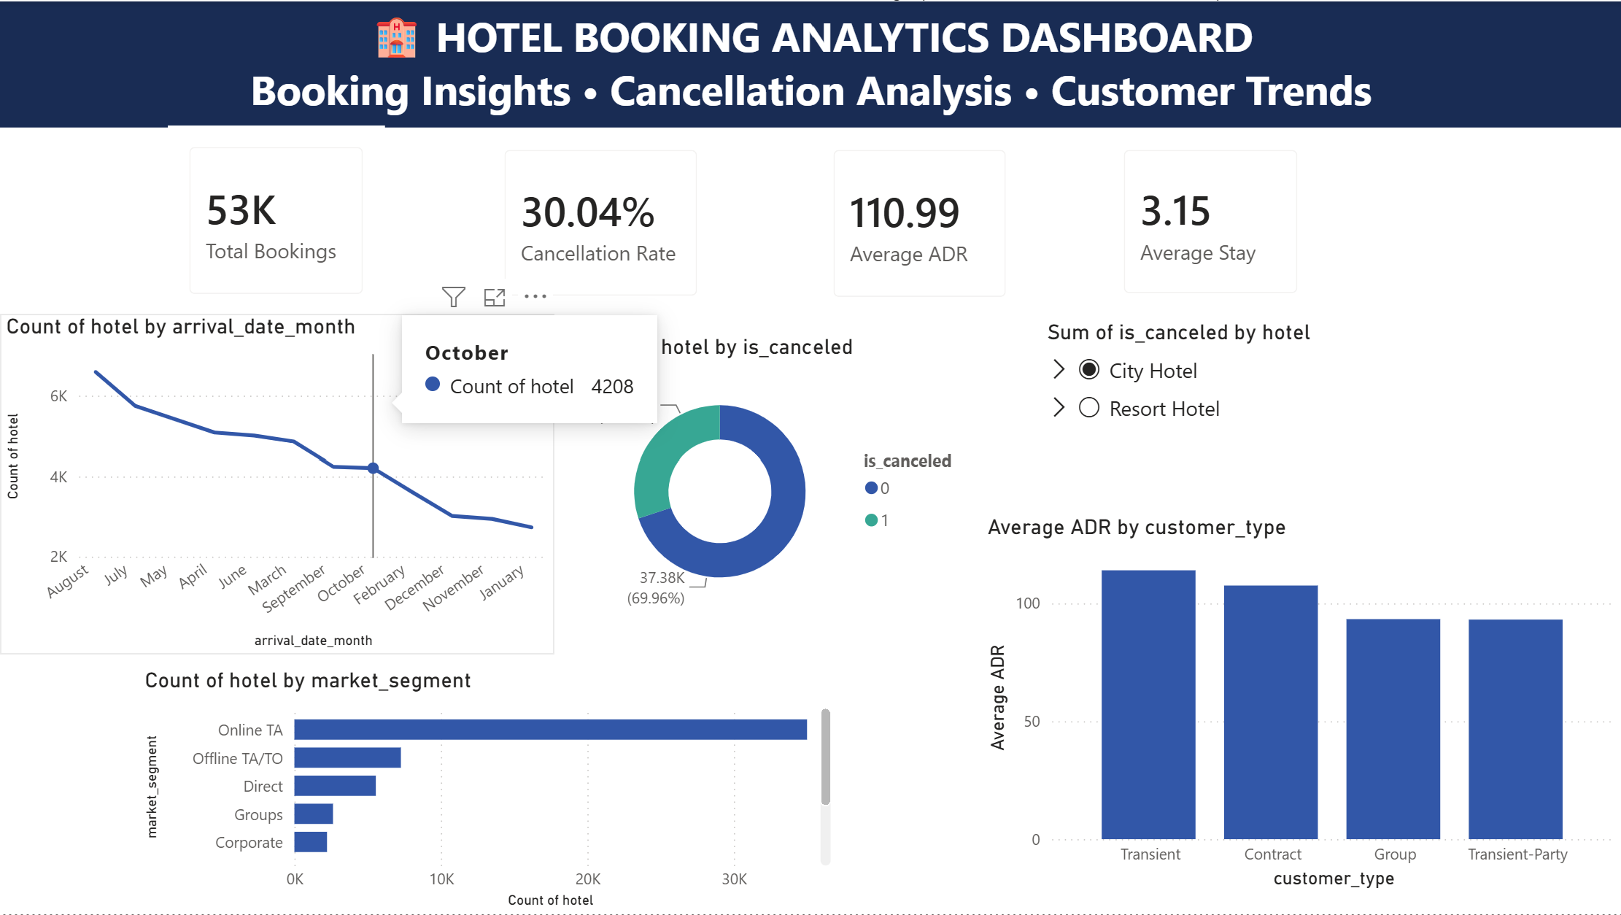

8. Business Insights
1. Booking volume varies across periods.
2. Higher lead time may increase cancellation probability.
3. ADR changes across categories.
4. Dashboard helps monitor business performance quickly.

9. Challenges and Solutions
Challenges included Jupyter setup, file path issues, Git branch management and Power BI configuration. These were resolved through debugging and structured version control.

10. Learning Outcomes
Python data processing, EDA, business analytics, dashboard design, Git workflow and reporting skills were strengthened.

11. Conclusion
The project successfully transformed hotel booking records into decision-ready insights through an end-to-end analytics workflow. The final dashboard and report demonstrate practical business analytics capability.

