Computer Graphics Assignment

Prog 1 2025: ray casting

Name: Aayush Pragneshkumar Brahmbhatt
Unity ID: abrahmb
Student ID: 200565518
Part-1:

I implemented a basic ray casting system that loads axis-aligned boxes from the class URL and renders them without lighting:
- Camera Configuration: Eye positioned at (0.5, 0.5, -0.5), image plane as 1×1 square centered at (0.5, 0.5, 0.0)
- Ray Casting: For each pixel, maps pixel center to world coordinates and shoots ray from eye through that point
- Intersection Testing: Uses axis-aligned bounding box (AABB) slab method with optimized per-axis calculations
- Depth Testing: Maintains nearest positive t-value to ensure proper depth ordering
- Rendering: Hit surfaces display box diffuse color (converted to 0-255 range), misses render black
Key Implementation Details:
- intersectRayAABB() function handles ray-box intersection with robust slab testing
- Per-axis t-near and t-far calculations with proper normal determination
- Handles edge cases like rays parallel to box faces and rays originating inside boxes

Output:
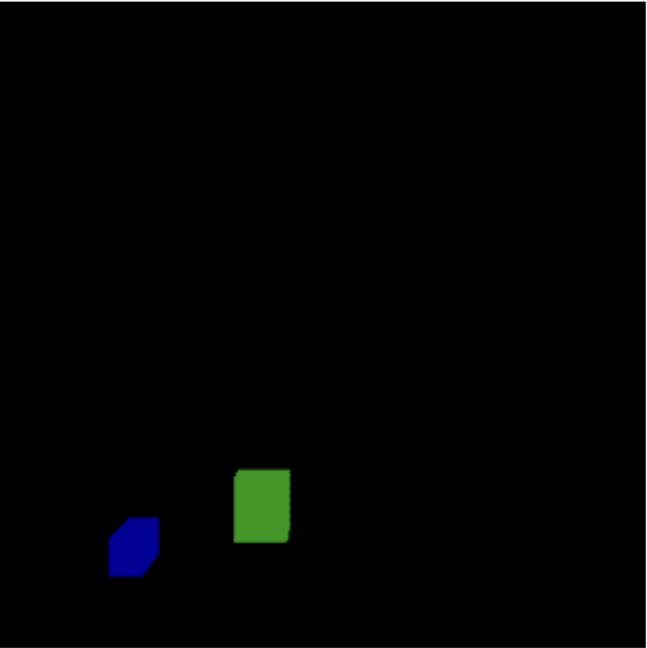

Part-2:
Extended the ray casting system with realistic lighting using the Blinn-Phong shading model:
- Lighting Setup: Single light source positioned at (-0.5, 1.5, -0.5)
- Shading Model: Full Blinn-Phong with ambient, diffuse, and specular components
- Material Properties: Uses ambient, diffuse, specular coefficients and shininess values from box data
- Normal Calculation: Computes surface normals from AABB intersection results
- Vector Mathematics: Proper normalization of light, view, and half vectors for accurate shading
Shading Components:
- Ambient: Ka * La for base illumination
- Diffuse: Kd * Ld * max(0, N·L) for matte surface reflection
- Specular: Ks * Ls * (N·H)^n for glossy highlights using half-vector approach
The result shows boxes with realistic 3D shading that preserves depth ordering from Part 1

Output:
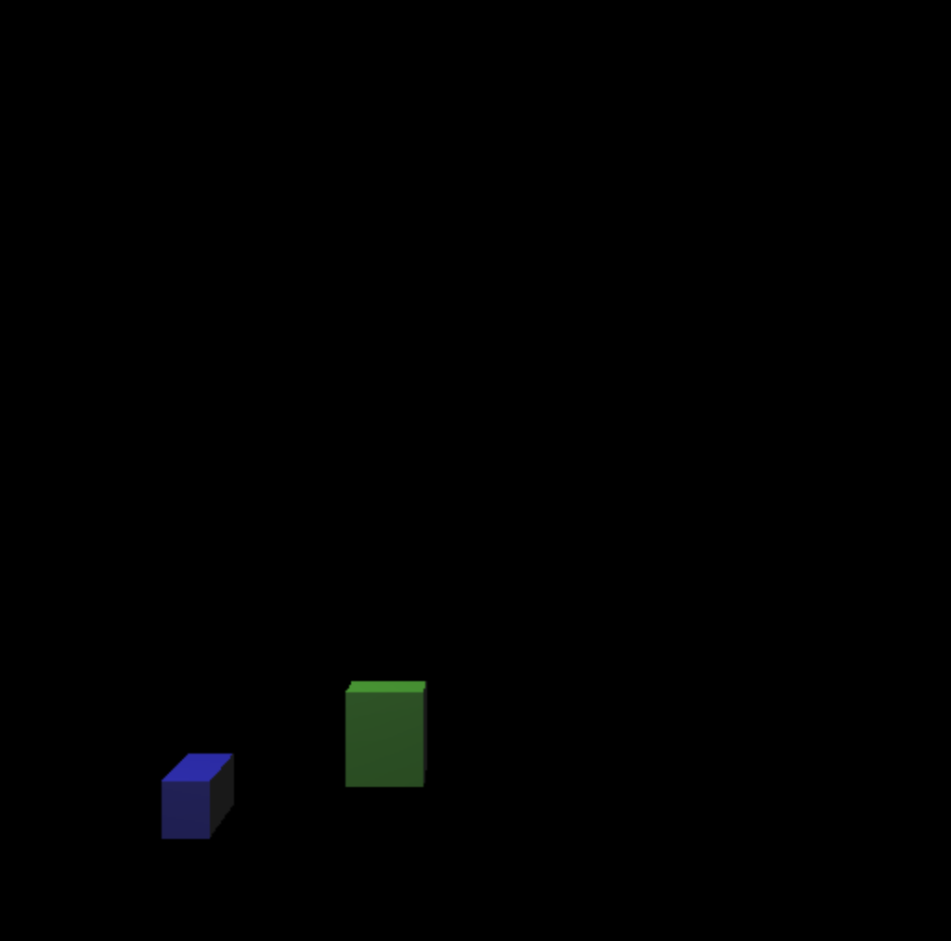

Part-3:
Created an original scene featuring a charming retro robot character with enhanced rendering features:

Scene Composition:
- Robot Body: Blue metallic torso (main box) with dark gray arms
- Robot Head: Red reflective sphere positioned above torso
- Eyes: Two small glowing spheres (yellow-left, cyan-right) for character
- Antenna: Golden sphere on top of head for retro sci-fi aesthetic
- Control Panel: Orange front-mounted panel for detail
- Decorative Elements: Green and red accent spheres at robot's feet
- Environment: Checkered floor plane with alternating light/dark pattern

Advanced Rendering Features:
Multiple Lights System:
- Key light: White light from (-0.5, 1.8, -0.5) for primary illumination
- Fill light: Blue-tinted light from (1.2, 1.0, -0.2) for ambient fill
- Per-light contribution accumulation with different intensities
Shadow Casting:
- Hard shadows implemented via shadow ray testing
- isOccluded() function tests ray paths to each light source
- Shadows cast by both boxes and spheres onto all surfaces
- Epsilon offset prevents self-shadowing artifacts
Sphere Rendering:
- Analytic ray-sphere intersection using quadratic formula
- Proper surface normal calculation for smooth shading
- Mixed primitive scene with both boxes and spheres
Enhanced Materials:
- Emissive properties for glowing robot eyes
- High shininess values for metallic surfaces
- Varied material properties create visual interest

Extra Credit Features:
- Multiple, arbitrarily located lights - Two-light setup with different colors and positions
- Shadows during ray casting - Per-pixel shadow ray testing against all scene geometry
- Render spheres - Full analytic sphere intersection integrated with box rendering
- Procedural texturing - Checkered floor pattern generated mathematically

User Interface:
- Space key: Switch to retro robot scene
- 'B' key: Return to boxes scene
- Smooth transitions between different rendering modes

Output:

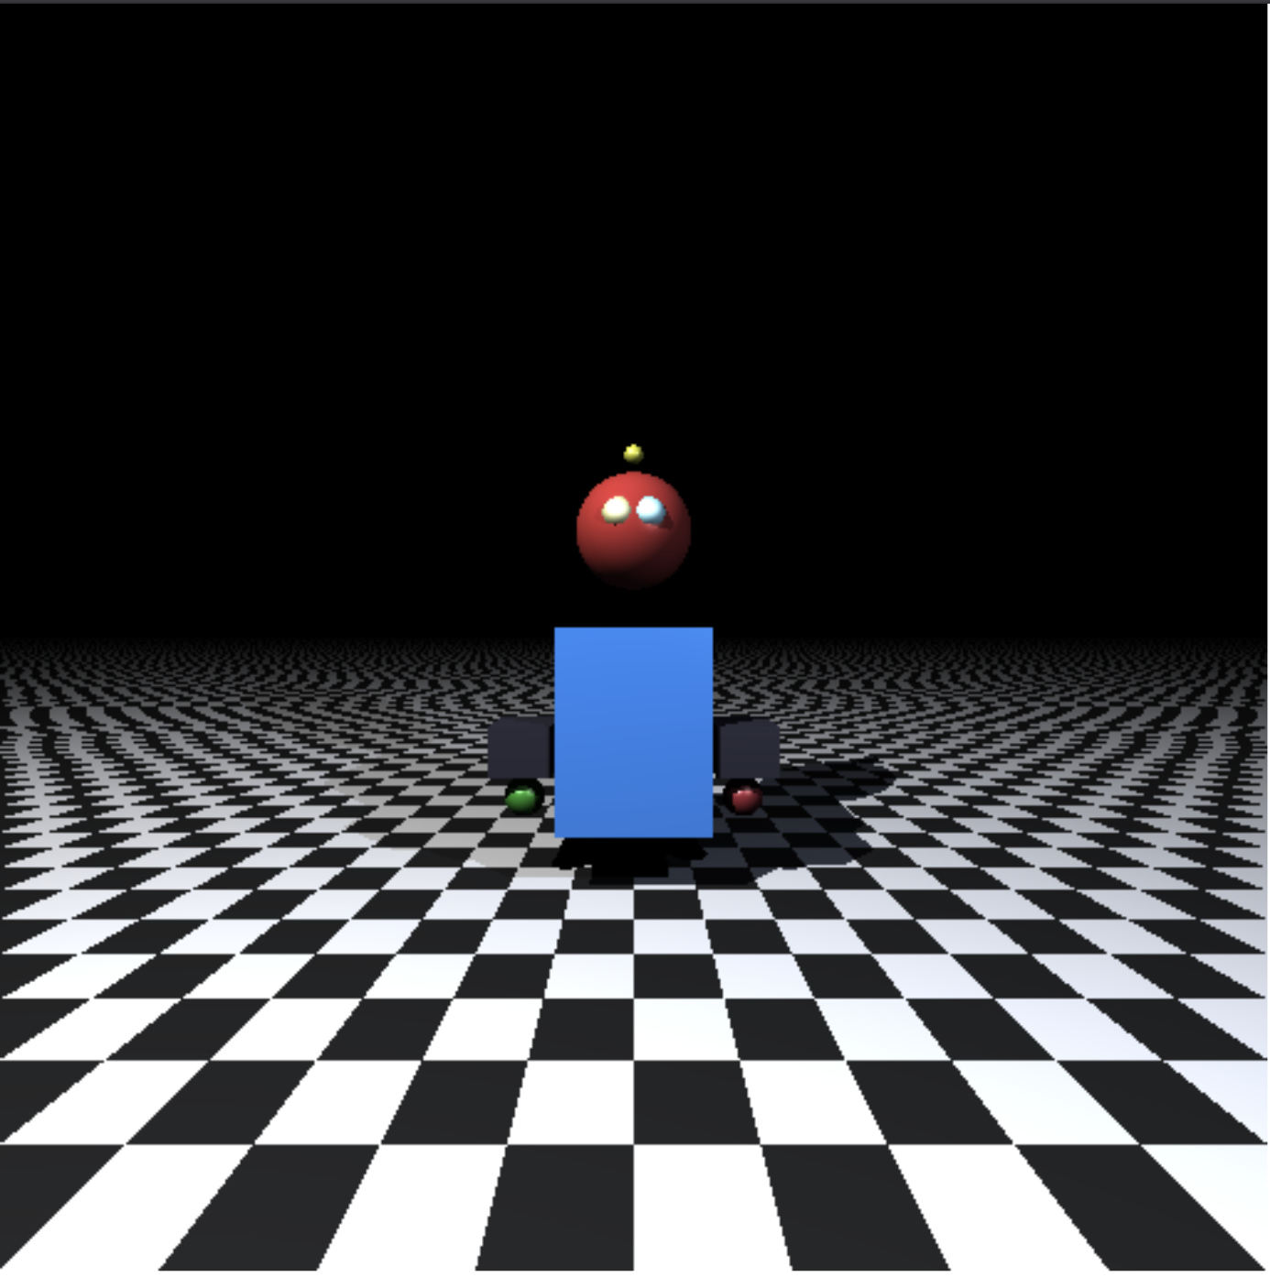

How to Run
- Open in Chrome: Load index.html in Chrome browser (recommended for testing)
- Default View: Program starts with Part 2 (boxes with Blinn-Phong lighting)
- Navigation:
  - Press Space to view Part 3 (Retro Robot scene)
  - Press 'B' to return to boxes scene
- Requirements:
  - Internet connection required for loading JSON data from class repository
  - Tested on Chrome; other browsers may have rendering differences

Technical Implementation Notes
- Ray casting performed at per-pixel level for maximum quality
- Efficient AABB intersection using slab method with early termination
- Proper vector normalization and mathematical operations throughout
- Robust error handling for edge cases and malformed data
- Modular code structure allows easy extension for additional primitives

Code: https://github.com/aayushhhb-prog/aayushhhb-prog.github.io/blob/gh-pages/drawstuff.js

