Week 1: Data Cleaning and Exploratory Data Analysis of the Mammal Sleep Dataset (msleep)
Aayushi Yaduvanshi
19 October 2026
Table of Contents

1. Introduction and Execution Note
This report completes Week 1 of the Virtual R Data Analyst Internship. All work is done in R. Every table, output and graph in this document is produced by the R code shown, at the moment the document is generated (knitted). Nothing is typed in by hand.
This report was generated with R version 4.6.1 (2026-06-24) on 19 October 2026 at 12:40.

2. Dataset Overview

2.1 Source
The analysis uses the msleep dataset, which ships with the R package ggplot2, a publicly available package on CRAN. The dataset is an updated and expanded version of mammal sleep data originally published by Savage and West (2007), “A quantitative, theoretical framework for understanding mammalian sleep”, Proceedings of the National Academy of Sciences, 104(3), 1051-1056. Running ?msleep in R shows the official documentation and citation.

2.2 Why this dataset is suitable
It contains numerical variables (sleep hours, brain weight, body weight), categorical variables (diet type, taxonomic order, conservation status) and a realistic amount of missing data. This makes it a good fit for practising every Week 1 cleaning step.

2.3 Variables
Variable | Type | Meaning
name | Categorical (text) | Common name of the mammal
genus | Categorical (text) | Genus
vore | Categorical | Diet: carnivore, herbivore, insectivore, omnivore
order | Categorical | Taxonomic order
conservation | Categorical | Conservation status code
sleep_total | Numeric | Total sleep per day (hours)
sleep_rem | Numeric | REM sleep per day (hours)
sleep_cycle | Numeric | Length of a sleep cycle (hours)
awake | Numeric | Time awake per day (hours)
brainwt | Numeric | Brain weight (kg)
bodywt | Numeric | Body weight (kg)
# Load the raw data and keep an untouched copy called "raw"
raw <- as.data.frame(ggplot2::msleep)
The dataset has 83 rows (animals) and 11 columns (variables).

3. Initial Exploration of the Raw Data

3.1 Structure: str()
str(raw)
#> 'data.frame': 83 obs. of 11 variables:
#> $ name : chr "Cheetah" "Owl monkey" "Mountain beaver" "Greater short-tailed shrew" ...
#> $ genus : chr "Acinonyx" "Aotus" "Aplodontia" "Blarina" ...
#> $ vore : chr "carni" "omni" "herbi" "omni" ...
#> $ order : chr "Carnivora" "Primates" "Rodentia" "Soricomorpha" ...
#> $ conservation: chr "lc" NA "nt" "lc" ...
#> $ sleep_total : num 12.1 17 14.4 14.9 4 14.4 8.7 7 10.1 3 ...
#> $ sleep_rem : num NA 1.8 2.4 2.3 0.7 2.2 1.4 NA 2.9 NA ...
#> $ sleep_cycle : num NA NA NA 0.133 0.667 ...
#> $ awake : num 11.9 7 9.6 9.1 20 9.6 15.3 17 13.9 21 ...
#> $ brainwt : num NA 0.0155 NA 0.00029 0.423 NA NA NA 0.07 0.0982 ...
#> $ bodywt : num 50 0.48 1.35 0.019 600 ...

3.2 First rows: head()
kable(head(raw[, c("name", "vore", "order", "conservation", "sleep_total",
"sleep_rem", "sleep_cycle", "brainwt", "bodywt")], 6))
name | vore | order | conservation | sleep_total | sleep_rem | sleep_cycle | brainwt | bodywt
Cheetah | carni | Carnivora | lc | 12.1 | NA | NA | NA | 50.000
Owl monkey | omni | Primates | NA | 17.0 | 1.8 | NA | 0.01550 | 0.480
Mountain beaver | herbi | Rodentia | nt | 14.4 | 2.4 | NA | NA | 1.350
Greater short-tailed shrew | omni | Soricomorpha | lc | 14.9 | 2.3 | 0.1333333 | 0.00029 | 0.019
Cow | herbi | Artiodactyla | domesticated | 4.0 | 0.7 | 0.6666667 | 0.42300 | 600.000
Three-toed sloth | herbi | Pilosa | NA | 14.4 | 2.2 | 0.7666667 | NA | 3.850

3.3 Summary: summary()
summary(raw)
#> name genus vore order conservation sleep_total sleep_rem sleep_cycle
#> Length :83 Length :83 Length :83 Length :83 Length :83 Min. : 1.90 Min. :0.100 Min. :0.1167
#> N.unique :83 N.unique :77 N.unique : 4 N.unique :19 N.unique : 6 1st Qu.: 7.85 1st Qu.:0.900 1st Qu.:0.1833
#> N.blank : 0 N.blank : 0 N.blank : 0 N.blank : 0 N.blank : 0 Median :10.10 Median :1.500 Median :0.3333
#> Min.nchar: 3 Min.nchar: 3 Min.nchar: 4 Min.nchar: 6 Min.nchar: 2 Mean :10.43 Mean :1.875 Mean :0.4396
#> Max.nchar:30 Max.nchar:13 Max.nchar: 7 Max.nchar:15 Max.nchar:12 3rd Qu.:13.75 3rd Qu.:2.400 3rd Qu.:0.5792
#> NAs : 7 NAs :29 Max. :19.90 Max. :6.600 Max. :1.5000
#> NAs :22 NAs :51
#> awake brainwt bodywt
#> Min. : 4.10 Min. :0.00014 Min. : 0.005
#> 1st Qu.:10.25 1st Qu.:0.00290 1st Qu.: 0.174
#> Median :13.90 Median :0.01240 Median : 1.670
#> Mean :13.57 Mean :0.28158 Mean : 166.136
#> 3rd Qu.:16.15 3rd Qu.:0.12550 3rd Qu.: 41.750
#> Max. :22.10 Max. :5.71200 Max. :6654.000
#> NAs :27
For numeric variables, summary() also reports the number of NA (missing) values. For text variables it only reports length and class, so missing values in text columns are counted separately in the next section.

4. Data Cleaning

4.1 Missing values
miss_tab <- data.frame(
Variable = names(raw),
Missing = colSums(is.na(raw)),
Percent = round(colMeans(is.na(raw)) * 100, 1),
row.names = NULL
)
kable(miss_tab, caption = "Missing values per variable in the raw data")
Missing values per variable in the raw data
Variable | Missing | Percent
name | 0 | 0.0
genus | 0 | 0.0
vore | 7 | 8.4
order | 0 | 0.0
conservation | 29 | 34.9
sleep_total | 0 | 0.0
sleep_rem | 22 | 26.5
sleep_cycle | 51 | 61.4
awake | 0 | 0.0
brainwt | 27 | 32.5
bodywt | 0 | 0.0
miss_plot <- miss_tab[miss_tab$Missing > 0, ]
ggplot(miss_plot, aes(x = reorder(Variable, Percent), y = Percent)) +
geom_col(fill = "steelblue") +
coord_flip() +
labs(title = "Percentage of missing values by variable",
x = "Variable", y = "Missing (%)") +
theme_minimal()
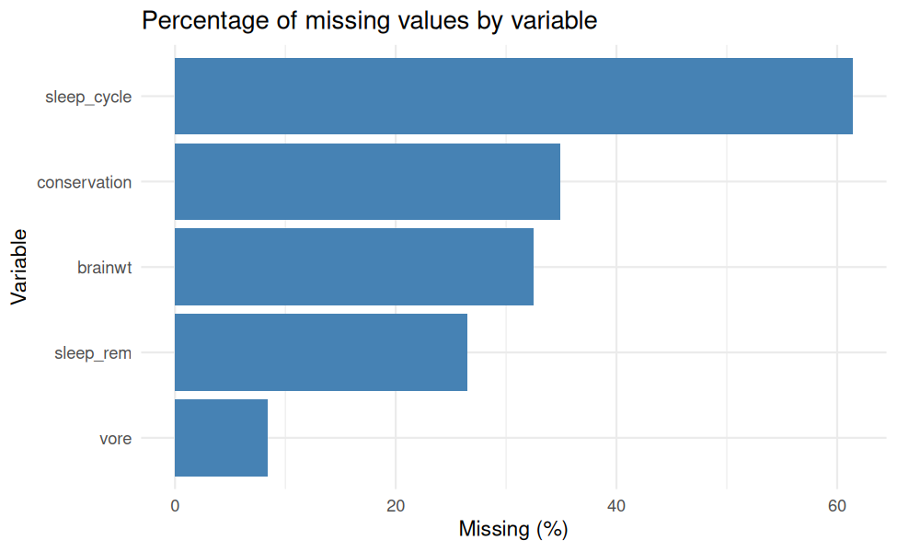
Interpretation. The table and chart show which variables have gaps. The variable sleep_cycle has 61.4% missing, which is the highest share among the numeric variables, so any result involving it should be read with extra caution.
Cleaning strategy.
- Categorical variables (vore, conservation): missing values are replaced with the label “unknown”. This keeps the animals in the data without guessing a category.
- Numeric variables: missing values are replaced with the median of the observed values. The median is used instead of the mean because it is not pulled around by extreme values (and several variables here are highly skewed, as shown later).
clean <- raw
# Categorical: replace NA with "unknown", then convert to factor
for (v in c("vore", "conservation")) {
clean[[v]] <- as.character(clean[[v]])
clean[[v]][is.na(clean[[v]])] <- "unknown"
clean[[v]] <- factor(clean[[v]])
}
# Numeric: replace NA with the median; keep a log of what was done
imputed_log <- data.frame(Variable = character(), N_imputed = integer(),
Median_used = numeric())
for (v in names(clean)[sapply(clean, is.numeric)]) {
n_na <- sum(is.na(clean[[v]]))
if (n_na > 0) {
med <- median(clean[[v]], na.rm = TRUE)
clean[[v]][is.na(clean[[v]])] <- med
imputed_log <- rbind(imputed_log,
data.frame(Variable = v, N_imputed = n_na,
Median_used = round(med, 4)))
}
}
kable(imputed_log, caption = "Numeric values imputed with the median")
Numeric values imputed with the median
Variable | N_imputed | Median_used
sleep_rem | 22 | 1.5000
sleep_cycle | 51 | 0.3333
brainwt | 27 | 0.0124
cat("Missing values remaining in the cleaned data:",
sum(is.na(clean[, c("vore", "conservation", "sleep_total", "sleep_rem",
"sleep_cycle", "awake", "brainwt", "bodywt")])), "\n")
#> Missing values remaining in the cleaned data: 0

4.2 Outlier detection
Outliers are detected with the IQR rule: a value is flagged if it is below Q1 - 1.5 x IQR or above Q3 + 1.5 x IQR. Detection uses the original observed values only (not the imputed ones).
numeric_vars <- c("sleep_total", "sleep_rem", "sleep_cycle", "awake",
"brainwt", "bodywt")
iqr_outliers <- function(x) {
x <- x[!is.na(x)]
q <- unname(quantile(x, c(0.25, 0.75)))
i <- q[2] - q[1]
lo <- q[1] - 1.5 * i
hi <- q[2] + 1.5 * i
c(lower_fence = lo, upper_fence = hi, n_outliers = sum(x < lo | x > hi))
}
out_tab <- t(sapply(raw[numeric_vars], iqr_outliers))
kable(round(out_tab, 3), caption = "IQR outlier fences and outlier counts")
IQR outlier fences and outlier counts
 | lower_fence | upper_fence | n_outliers
sleep_total | -1.000 | 22.600 | 0
sleep_rem | -1.350 | 4.650 | 3
sleep_cycle | -0.410 | 1.173 | 2
awake | 1.400 | 25.000 | 0
brainwt | -0.181 | 0.309 | 8
bodywt | -62.190 | 104.114 | 11
long <- stack(raw[numeric_vars])
ggplot(long, aes(x = ind, y = values)) +
geom_boxplot(fill = "lightblue", outlier.colour = "red") +
facet_wrap(~ ind, scales = "free") +
labs(title = "Boxplots of numeric variables (red points = IQR outliers)",
x = NULL, y = "Value") +
theme_minimal() +
theme(axis.text.x = element_blank(), axis.ticks.x = element_blank())
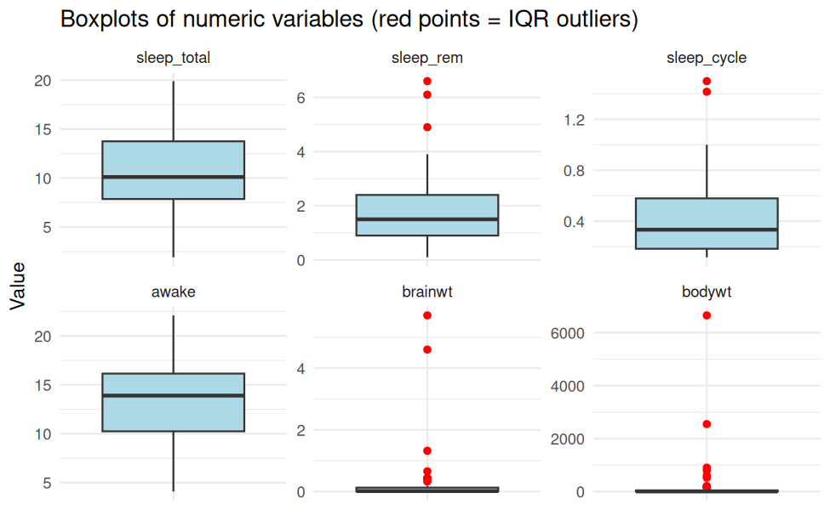
Which animals are the largest body-weight outliers?
big <- raw[!is.na(raw$bodywt) & raw$bodywt > out_tab["bodywt", "upper_fence"],
c("name", "bodywt", "brainwt")]
kable(head(big[order(-big$bodywt), ], 10), row.names = FALSE)
name | bodywt | brainwt
African elephant | 6654.000 | 5.712
Asian elephant | 2547.000 | 4.603
Giraffe | 899.995 | NA
Pilot whale | 800.000 | NA
Cow | 600.000 | 0.423
Horse | 521.000 | 0.655
Brazilian tapir | 207.501 | 0.169
Donkey | 187.000 | 0.419
Bottle-nosed dolphin | 173.330 | NA
Tiger | 162.564 | NA
Decision. Outliers are checked against what is biologically sensible. Very heavy animals (for example elephants) are genuine data points, not errors, so they are not deleted. Instead, the heavily right-skewed variables brainwt and bodywt are reduced in influence with a log10 transformation.
clean$log_brainwt <- log10(clean$brainwt)
clean$log_bodywt <- log10(clean$bodywt)
tr <- data.frame(
value = c(raw$bodywt, log10(raw$bodywt)),
scale = rep(c("Original body weight (kg)", "log10 body weight"),
each = nrow(raw))
)
ggplot(tr, aes(x = value)) +
geom_histogram(bins = 20, fill = "steelblue", colour = "white") +
facet_wrap(~ scale, scales = "free") +
labs(title = "Effect of the log10 transformation on body weight",
x = "Value", y = "Count") +
theme_minimal()
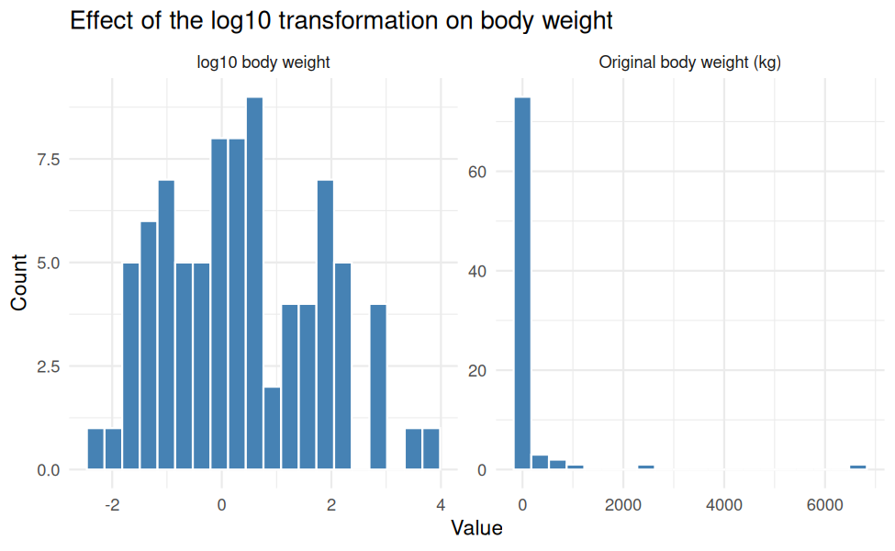
The left panel is strongly skewed, with most animals very light and a few extremely heavy. The right panel is far more balanced, which is better suited to correlation and regression analysis.

4.3 Normalization
Two common rescaling methods are applied to the numeric analysis variables so that variables measured in different units can be compared fairly:
- Min-max scaling: (x - min) / (max - min), giving values between 0 and 1.
- Z-score standardization: (x - mean) / sd, giving mean 0 and standard deviation 1.
minmax <- function(x) (x - min(x)) / (max(x) - min(x))
scale_vars <- c("sleep_total", "sleep_rem", "sleep_cycle", "awake",
"log_brainwt", "log_bodywt")
for (v in scale_vars) {
clean[[paste0(v, "_minmax")]] <- minmax(clean[[v]])
clean[[paste0(v, "_z")]] <- as.numeric(scale(clean[[v]]))
}
mm_cols <- grep("_minmax$", names(clean), value = TRUE)
z_cols <- grep("_z$", names(clean), value = TRUE)
kable(round(sapply(clean[mm_cols], range), 3),
caption = "Min-max scaled variables: minimum (row 1) and maximum (row 2)")
Min-max scaled variables: minimum (row 1) and maximum (row 2)
sleep_total_minmax | sleep_rem_minmax | sleep_cycle_minmax | awake_minmax | log_brainwt_minmax | log_bodywt_minmax
0 | 0 | 0 | 0 | 0 | 0
1 | 1 | 1 | 1 | 1 | 1
kable(round(rbind(mean = sapply(clean[z_cols], mean),
sd = sapply(clean[z_cols], sd)), 3),
caption = "Z-score variables: mean and standard deviation")
Z-score variables: mean and standard deviation
 | sleep_total_z | sleep_rem_z | sleep_cycle_z | awake_z | log_brainwt_z | log_bodywt_z
mean | 0 | 0 | 0 | 0 | 0 | 0
sd | 1 | 1 | 1 | 1 | 1 | 1

4.4 Categorical encoding
Two encodings are shown:
- Label encoding: each category becomes an integer code (stored in vore_code).
- One-hot encoding: each category becomes its own 0/1 column (using model.matrix()).
# Label encoding
clean$vore_code <- as.integer(clean$vore)
kable(unique(data.frame(vore = clean$vore, vore_code = clean$vore_code)),
row.names = FALSE, caption = "Label encoding of vore")
Label encoding of vore
vore | vore_code
carni | 1
omni | 4
herbi | 2
unknown | 5
insecti | 3
# One-hot encoding for vore and conservation
onehot_vore <- model.matrix(~ vore - 1, data = clean)
colnames(onehot_vore) <- sub("^vore", "vore_", colnames(onehot_vore))
onehot_cons <- model.matrix(~ conservation - 1, data = clean)
colnames(onehot_cons) <- sub("^conservation", "cons_", colnames(onehot_cons))
clean <- cbind(clean, as.data.frame(onehot_vore), as.data.frame(onehot_cons))
kable(head(clean[, c("name", "vore", colnames(onehot_vore))], 6),
row.names = FALSE, caption = "One-hot encoding of vore (first 6 rows)")
One-hot encoding of vore (first 6 rows)
name | vore | vore_carni | vore_herbi | vore_insecti | vore_omni | vore_unknown
Cheetah | carni | 1 | 0 | 0 | 0 | 0
Owl monkey | omni | 0 | 0 | 0 | 1 | 0
Mountain beaver | herbi | 0 | 1 | 0 | 0 | 0
Greater short-tailed shrew | omni | 0 | 0 | 0 | 1 | 0
Cow | herbi | 0 | 1 | 0 | 0 | 0
Three-toed sloth | herbi | 0 | 1 | 0 | 0 | 0

4.5 Verification checks
These automatic checks confirm the cleaning worked as intended.
checks <- c(
"No missing values in key variables" =
!anyNA(clean[, c("vore", "conservation", numeric_vars)]),
"Row count unchanged (no animals dropped)" =
nrow(clean) == nrow(raw),
"Min-max variables lie exactly in [0, 1]" =
all(sapply(clean[mm_cols], function(x) abs(min(x)) < 1e-12 && abs(max(x) - 1) < 1e-12)),
"Z-score variables have mean approximately 0" =
all(abs(sapply(clean[z_cols], mean)) < 1e-8),
"Z-score variables have standard deviation 1" =
all(abs(sapply(clean[z_cols], sd) - 1) < 1e-8),
"Each animal has exactly one vore one-hot flag" =
all(rowSums(onehot_vore) == 1)
)
kable(data.frame(Check = names(checks), Passed = unname(checks)), row.names = FALSE)
Check | Passed
No missing values in key variables | TRUE
Row count unchanged (no animals dropped) | TRUE
Min-max variables lie exactly in [0, 1] | TRUE
Z-score variables have mean approximately 0 | TRUE
Z-score variables have standard deviation 1 | TRUE
Each animal has exactly one vore one-hot flag | TRUE

5. Exploratory Data Analysis (EDA)

5.1 Structure and summary of the cleaned data
str(clean[, c("name", "vore", "order", "conservation", numeric_vars,
"log_brainwt", "log_bodywt")])
#> 'data.frame': 83 obs. of 12 variables:
#> $ name : chr "Cheetah" "Owl monkey" "Mountain beaver" "Greater short-tailed shrew" ...
#> $ vore : Factor w/ 5 levels "carni","herbi",..: 1 4 2 4 2 2 1 5 1 2 ...
#> $ order : chr "Carnivora" "Primates" "Rodentia" "Soricomorpha" ...
#> $ conservation: Factor w/ 7 levels "cd","domesticated",..: 4 6 5 4 2 6 7 6 2 4 ...
#> $ sleep_total : num 12.1 17 14.4 14.9 4 14.4 8.7 7 10.1 3 ...
#> $ sleep_rem : num 1.5 1.8 2.4 2.3 0.7 2.2 1.4 1.5 2.9 1.5 ...
#> $ sleep_cycle : num 0.333 0.333 0.333 0.133 0.667 ...
#> $ awake : num 11.9 7 9.6 9.1 20 9.6 15.3 17 13.9 21 ...
#> $ brainwt : num 0.0124 0.0155 0.0124 0.00029 0.423 0.0124 0.0124 0.0124 0.07 0.0982 ...
#> $ bodywt : num 50 0.48 1.35 0.019 600 ...
#> $ log_brainwt : num -1.907 -1.81 -1.907 -3.538 -0.374 ...
#> $ log_bodywt : num 1.699 -0.319 0.13 -1.721 2.778 ...
summary(clean[, c("vore", "conservation", numeric_vars, "log_brainwt", "log_bodywt")])
#> vore conservation sleep_total sleep_rem sleep_cycle awake brainwt bodywt
#> carni :19 cd : 2 Min. : 1.90 Min. :0.100 Min. :0.1167 Min. : 4.10 Min. :0.00014 Min. : 0.005
#> herbi :32 domesticated:10 1st Qu.: 7.85 1st Qu.:1.150 1st Qu.:0.3333 1st Qu.:10.25 1st Qu.:0.00635 1st Qu.: 0.174
#> insecti: 5 en : 4 Median :10.10 Median :1.500 Median :0.3333 Median :13.90 Median :0.01240 Median : 1.670
#> omni :20 lc :27 Mean :10.43 Mean :1.776 Mean :0.3743 Mean :13.57 Mean :0.19402 Mean : 166.136
#> unknown: 7 nt : 4 3rd Qu.:13.75 3rd Qu.:2.200 3rd Qu.:0.3333 3rd Qu.:16.15 3rd Qu.:0.03505 3rd Qu.: 41.750
#> unknown :29 Max. :19.90 Max. :6.600 Max. :1.5000 Max. :22.10 Max. :5.71200 Max. :6654.000
#> vu : 7
#> log_brainwt log_bodywt
#> Min. :-3.8539 Min. :-2.3010
#> 1st Qu.:-2.1972 1st Qu.:-0.7644
#> Median :-1.9066 Median : 0.2227
#> Mean :-1.8107 Mean : 0.3662
#> 3rd Qu.:-1.4717 3rd Qu.: 1.6120
#> Max. : 0.7568 Max. : 3.8231
#>

5.2 Category counts
kable(as.data.frame(table(Diet = clean$vore)), caption = "Number of animals by diet (vore)")
Number of animals by diet (vore)
Diet | Freq
carni | 19
herbi | 32
insecti | 5
omni | 20
unknown | 7
kable(as.data.frame(table(Conservation = clean$conservation)),
caption = "Number of animals by conservation status")
Number of animals by conservation status
Conservation | Freq
cd | 2
domesticated | 10
en | 4
lc | 27
nt | 4
unknown | 29
vu | 7

5.3 Total sleep by diet group
grp <- do.call(rbind, lapply(split(clean$sleep_total, clean$vore), function(x) {
data.frame(n = length(x), mean_sleep = mean(x), sd_sleep = sd(x))
}))
kable(round(grp, 2), caption = "Total sleep (hours) by diet group")
Total sleep (hours) by diet group
 | n | mean_sleep | sd_sleep
carni | 19 | 10.38 | 4.67
herbi | 32 | 9.51 | 4.88
insecti | 5 | 14.94 | 5.92
omni | 20 | 10.93 | 2.95
unknown | 7 | 10.19 | 3.00
known <- grp[rownames(grp) != "unknown", ]
top_group <- rownames(known)[which.max(known$mean_sleep)]
low_group <- rownames(known)[which.min(known$mean_sleep)]
Among animals with a known diet, the group with the highest average sleep is insecti (14.94 hours), and the group with the lowest is herbi (9.51 hours). Groups with few animals should be interpreted carefully (see the n column).

6. Descriptive Statistics
Statistics below use the original observed values (missing values excluded), so they are not affected by imputation.
skew <- function(x) {
x <- x[!is.na(x)]
mean((x - mean(x))^3) / sd(x)^3
}
desc <- data.frame(
n = sapply(raw[numeric_vars], function(x) sum(!is.na(x))),
mean = sapply(raw[numeric_vars], mean, na.rm = TRUE),
median = sapply(raw[numeric_vars], median, na.rm = TRUE),
sd = sapply(raw[numeric_vars], sd, na.rm = TRUE),
min = sapply(raw[numeric_vars], min, na.rm = TRUE),
max = sapply(raw[numeric_vars], max, na.rm = TRUE),
skewness = sapply(raw[numeric_vars], skew)
)
kable(round(desc, 3), caption = "Descriptive statistics of numeric variables (observed values)")
Descriptive statistics of numeric variables (observed values)
 | n | mean | median | sd | min | max | skewness
sleep_total | 83 | 10.434 | 10.100 | 4.450 | 1.900 | 19.900 | 0.052
sleep_rem | 61 | 1.875 | 1.500 | 1.298 | 0.100 | 6.600 | 1.462
sleep_cycle | 32 | 0.440 | 0.333 | 0.359 | 0.117 | 1.500 | 1.495
awake | 83 | 13.567 | 13.900 | 4.452 | 4.100 | 22.100 | -0.051
brainwt | 56 | 0.282 | 0.012 | 0.976 | 0.000 | 5.712 | 4.628
bodywt | 83 | 166.136 | 1.670 | 786.840 | 0.005 | 6654.000 | 7.100
Interpretation. Where the mean is far larger than the median and the skewness is strongly positive, the variable is right-skewed. In this dataset, bodywt has a skewness of 7.1 and brainwt has 4.63, while sleep_total has 0.05. This supports the earlier decision to log-transform the two weight variables but not the sleep variables.

7. Correlation Analysis
Correlations use the observed (non-imputed) data with pairwise deletion of missing values, so that imputed medians do not artificially distort the relationships. Weights are log10-transformed because of their skewness.
cor_data <- data.frame(
sleep_total = raw$sleep_total,
sleep_rem = raw$sleep_rem,
sleep_cycle = raw$sleep_cycle,
awake = raw$awake,
log_brainwt = log10(raw$brainwt),
log_bodywt = log10(raw$bodywt)
)
cm <- cor(cor_data, use = "pairwise.complete.obs", method = "pearson")
kable(round(cm, 2), caption = "Pearson correlation matrix")
Pearson correlation matrix
 | sleep_total | sleep_rem | sleep_cycle | awake | log_brainwt | log_bodywt
sleep_total | 1.00 | 0.75 | -0.47 | -1.00 | -0.59 | -0.57
sleep_rem | 0.75 | 1.00 | -0.34 | -0.75 | -0.28 | -0.32
sleep_cycle | -0.47 | -0.34 | 1.00 | 0.47 | 0.83 | 0.74
awake | -1.00 | -0.75 | 0.47 | 1.00 | 0.59 | 0.57
log_brainwt | -0.59 | -0.28 | 0.83 | 0.59 | 1.00 | 0.97
log_bodywt | -0.57 | -0.32 | 0.74 | 0.57 | 0.97 | 1.00
cm_long <- as.data.frame(as.table(cm))
names(cm_long) <- c("Var1", "Var2", "r")
ggplot(cm_long, aes(x = Var1, y = Var2, fill = r)) +
geom_tile(colour = "white") +
geom_text(aes(label = round(r, 2)), size = 3) +
scale_fill_gradient2(low = "firebrick", mid = "white", high = "steelblue",
midpoint = 0, limits = c(-1, 1)) +
labs(title = "Correlation heatmap", x = NULL, y = NULL, fill = "r") +
theme_minimal() +
theme(axis.text.x = element_text(angle = 45, hjust = 1))
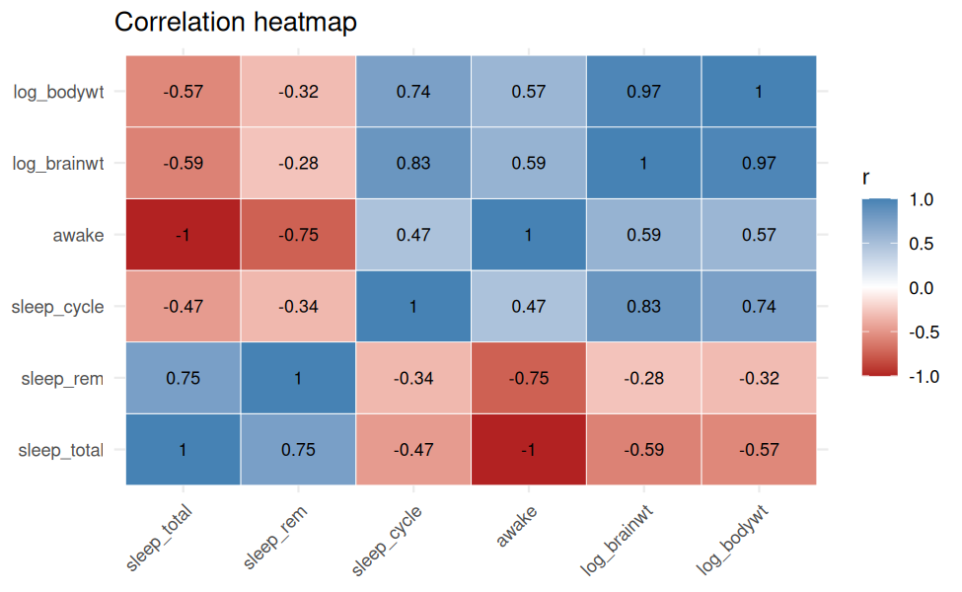
ct <- cor.test(cor_data$sleep_total, cor_data$log_bodywt, method = "pearson")
ct
#>
#> Pearson's product-moment correlation
#>
#> data: cor_data$sleep_total and cor_data$log_bodywt
#> t = -6.2215, df = 81, p-value = 2.046e-08
#> alternative hypothesis: true correlation is not equal to 0
#> 95 percent confidence interval:
#> -0.6986395 -0.4022888
#> sample estimates:
#> cor
#> -0.5686377
sp <- cor.test(cor_data$sleep_total, cor_data$log_bodywt, method = "spearman",
exact = FALSE)
r_st <- cm["sleep_total", setdiff(colnames(cm), c("sleep_total", "awake"))]
best_pred <- names(which.max(abs(r_st)))
Interpretation.
- Total sleep and log body weight have a moderate negative Pearson correlation (r = -0.57, p = 2.05^{-8}). The Spearman rank correlation, which does not assume a straight-line relationship, is -0.53.
- Excluding awake, the variable most strongly correlated with sleep_total is sleep_rem (r = 0.75).
- awake is derived from sleep_total (24 hours minus sleep), so their correlation is expected to be -1. It carries no independent information and should not be used alongside sleep_total in a model.
- Correlation does not prove causation.

8. Visualizations

8.1 Distribution of total sleep
ggplot(clean, aes(x = sleep_total)) +
geom_histogram(bins = 15, fill = "steelblue", colour = "white") +
geom_vline(xintercept = mean(clean$sleep_total), linetype = "dashed", colour = "red") +
labs(title = "Distribution of total sleep (dashed line = mean)",
x = "Total sleep (hours per day)", y = "Number of animals") +
theme_minimal()
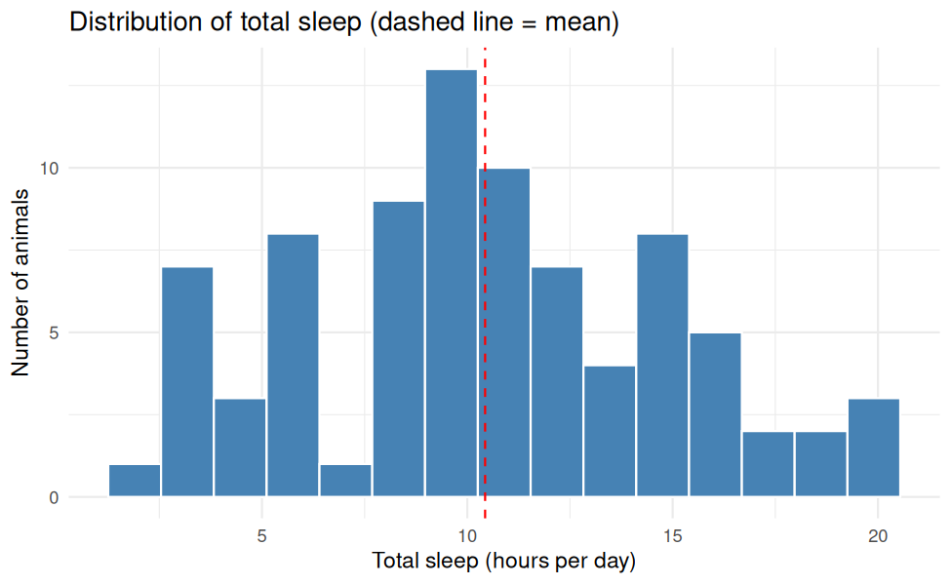

8.2 Total sleep by diet
ggplot(clean, aes(x = vore, y = sleep_total, fill = vore)) +
geom_boxplot(show.legend = FALSE) +
labs(title = "Total sleep by diet group", x = "Diet (vore)",
y = "Total sleep (hours per day)") +
theme_minimal()
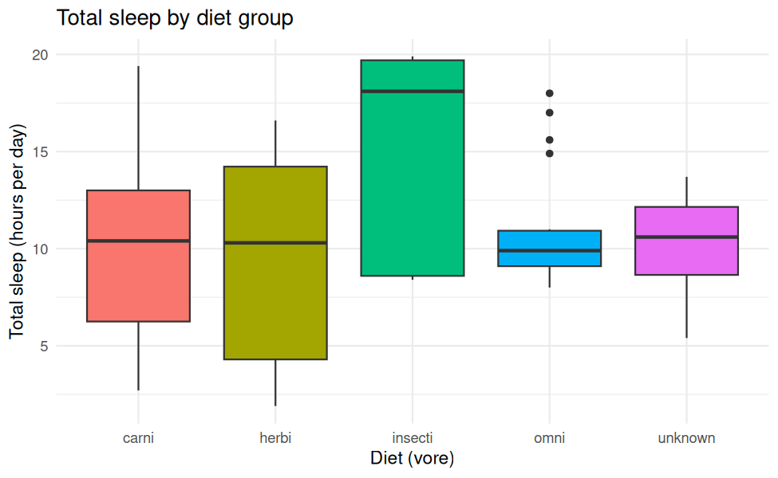

8.3 Body weight versus sleep
cor_data$vore <- clean$vore
ggplot(cor_data, aes(x = log_bodywt, y = sleep_total)) +
geom_point(aes(colour = vore), size = 2, alpha = 0.8) +
geom_smooth(method = "lm", formula = y ~ x, colour = "black", se = TRUE) +
labs(title = "Total sleep versus log10 body weight",
x = "log10 body weight (kg)", y = "Total sleep (hours per day)",
colour = "Diet") +
theme_minimal()
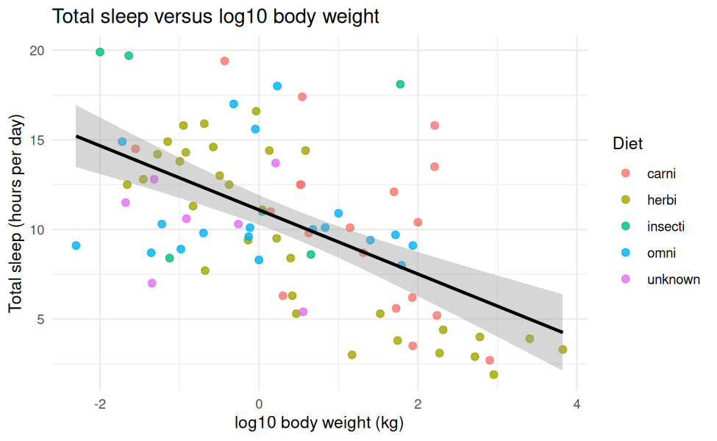

8.4 Number of animals by diet
ggplot(clean, aes(x = vore, fill = vore)) +
geom_bar(show.legend = FALSE) +
labs(title = "Number of animals by diet group", x = "Diet (vore)", y = "Count") +
theme_minimal()
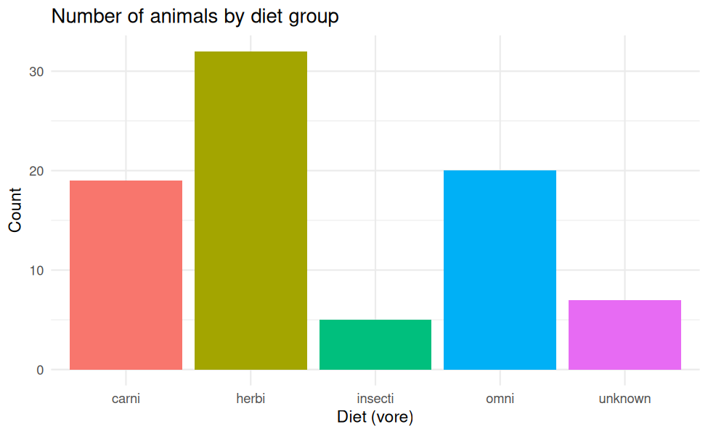

9. Key Findings
The numbers below are calculated directly from the data when the report is generated.
- The dataset contains 83 mammals. After cleaning, no missing values remain in the key variables, and no animals were removed.
- The average mammal in the dataset sleeps 10.43 hours per day (median 10.1).
- Body weight and brain weight are highly right-skewed (skewness 7.1 and 4.6), so a log10 transformation was applied.
- Total sleep has a moderate, negative relationship with log body weight (r = -0.57).
- Among diet groups with a known diet, insecti animals sleep the most on average and herbi animals sleep the least.

10. Conclusion
This project took the msleep dataset through a complete Week 1 workflow in R: inspecting its structure, quantifying and handling missing values, detecting outliers with the IQR rule, transforming skewed variables, normalizing numeric variables, encoding categorical variables, and then summarizing the data with descriptive statistics, correlations and graphs. Automatic verification checks confirmed that the cleaned data meets the expected properties.
Limitations.
- Median imputation keeps all animals in the data but reduces natural variability, particularly for sleep_cycle, which has a large share of missing values. Results involving imputed variables should be treated as approximate. The correlation analysis therefore used the original observed values.
- The dataset covers a limited number of species, and some diet groups contain very few animals.
- Correlations describe association only, not cause and effect.
Next steps. Possible follow-ups include testing for differences between diet groups, fitting a regression of sleep on body weight, and exploring multiple imputation as an alternative to median imputation.

Appendix A: Screenshots as Visual Evidence
Screenshots taken in the R environment while running this analysis are shown below, if any were uploaded alongside this file (named screenshot1.png, screenshot2.png, and so on).
No screenshots were uploaded with this run.

Appendix B: Session Information
sessionInfo()
#> R version 4.6.1 (2026-06-24)
#> Platform: x86_64-pc-linux-gnu
#> Running under: Ubuntu 24.04.4 LTS
#>
#> Matrix products: default
#> BLAS: /usr/lib/x86_64-linux-gnu/openblas-pthread/libblas.so.3
#> LAPACK: /usr/lib/x86_64-linux-gnu/openblas-pthread/libopenblasp-r0.3.26.so; LAPACK version 3.12.0
#>
#> locale:
#> [1] LC_CTYPE=C.UTF-8 LC_NUMERIC=C LC_TIME=C.UTF-8 LC_COLLATE=C.UTF-8 LC_MONETARY=C.UTF-8
#> [6] LC_MESSAGES=C.UTF-8 LC_PAPER=C.UTF-8 LC_NAME=C LC_ADDRESS=C LC_TELEPHONE=C
#> [11] LC_MEASUREMENT=C.UTF-8 LC_IDENTIFICATION=C
#>
#> time zone: UTC
#> tzcode source: system (glibc)
#>
#> attached base packages:
#> [1] stats graphics grDevices utils datasets methods base
#>
#> other attached packages:
#> [1] knitr_1.52 ggplot2_4.0.3
#>
#> loaded via a namespace (and not attached):
#> [1] vctrs_0.7.3 nlme_3.1-169 cli_3.6.6 rlang_1.3.0 xfun_0.62 S7_0.2.2 glue_1.8.1
#> [8] labeling_0.4.3 htmltools_0.5.9 scales_1.4.0 rmarkdown_2.32 grid_4.6.1 evaluate_1.0.5 fastmap_1.2.0
#> [15] yaml_2.3.12 lifecycle_1.0.5 compiler_4.6.1 RColorBrewer_1.1-3 mgcv_1.9-4 farver_2.1.2 lattice_0.22-9
#> [22] digest_0.6.39 R6_2.6.1 splines_4.6.1 Matrix_1.7-5 tools_4.6.1 withr_3.0.3 gtable_0.3.6

