BhashaRAG
Multilingual Retrieval-Augmented Generation for Indian Documents
Final Year Project Report

Table of Contents
1. Abstract 3
2. Introduction and Motivation 3
3. Background and Related Work 3
4. Problem Statement 4
4.1 Research Question 4
5. Key Features 4
6. System Architecture 5
6.1 Indexing Phase 6
6.2 Query Phase 6
7. Technology Stack 6
8. Methodology and Design Justification 7
9. Evaluation Plan 8
10. Did We Train a Model? 9
11. Use Cases 9
12. Limitations 9
13. Future Work 10
14. Conclusion 10
15. References 10

1. Abstract
Most existing “chat with PDF” tools are built for English and break down when a document and a user’s question are in different languages — a common situation in India, where government forms, research papers, and policy documents are frequently written in one language while the reader is more comfortable asking questions in another, and where more than 20 languages are in everyday official use. BhashaRAG addresses this gap with a Retrieval-Augmented Generation (RAG) system built on a multilingual embedding model supporting 50+ languages. English, Hindi, and Hinglish are the languages validated in this project; because the embedding model is multilingual, the same pipeline is expected to extend to other major Indian languages, which is planned as future work. Rather than translating documents or questions outright, the system embeds both into a shared multilingual semantic space, retrieves relevant passages using a hybrid of dense vector similarity and BM25 keyword search, expands each question into alternate phrasings and translations, refines the merged results with cross-encoder reranking, and grounds every generated answer, produced by Google’s Gemini model, in cited source text to minimize hallucination. The system is exposed through a FastAPI backend and a React web interface, with optional spoken answers through Sarvam AI text-to-speech. This report describes the motivation, architecture, methodology, and evaluation approach behind the system, along with its current limitations and planned extensions.

2. Introduction and Motivation
India is a linguistically diverse country where official, legal, academic, and healthcare information is published in multiple languages, but individuals often prefer to communicate in whichever language they are most comfortable with — which may not match the document’s language. Standard document question-answering tools generally assume both the document and the query share one language, which excludes a large share of real users.
Before designing BhashaRAG, existing open-source “chat with PDF” projects were reviewed. Three recurring limitations were identified:
- Most support only English documents and English queries.
- Even multilingual tools rarely support genuine cross-lingual retrieval — asking a question in one language and retrieving the correct answer from a document written in another.
- Very few provide source citations, making it difficult to verify whether an answer is trustworthy or hallucinated.
BhashaRAG was designed specifically to address these three gaps, using techniques established in Retrieval-Augmented Generation and multilingual NLP research rather than inventing an entirely new architecture from scratch (see Section 3, Background and Related Work). A key design decision was to build on a multilingual embedding model rather than a bilingual (English-Hindi only) one, so that the same pipeline that supports Hindi and Hinglish today can extend to other major Indian languages, such as Bengali, Tamil, Telugu, and Marathi, with little architectural change once those languages have been benchmarked.

3. Background and Related Work
The project’s design choices are grounded in established techniques from the retrieval and question-answering literature:
- Retrieval-Augmented Generation (RAG): Combining a retriever with a generative language model, so that the model answers using retrieved evidence instead of relying purely on its parametric memory. This is the standard approach for reducing hallucination in document QA systems and is the foundation of BhashaRAG’s architecture.
- Dense multilingual embeddings: Sentence-embedding models trained across many languages place semantically similar sentences from different languages close together in vector space, which is what enables a Hindi question to retrieve an English passage without an explicit translation step.
- Hybrid retrieval (dense + sparse): Pure vector search can miss exact keyword, name, or number matches that a classical keyword method (BM25) catches reliably. Combining both, and merging their rankings (commonly via Reciprocal Rank Fusion), is a well-documented way to improve retrieval quality over either method alone.
- Cross-encoder reranking: A second-stage model that scores a query and a candidate passage jointly (rather than via cosine similarity) to more precisely judge relevance before the final top passages are chosen.
- Retrieval evaluation metrics: Standard information-retrieval metrics such as Hit Rate@K and Mean Reciprocal Rank (MRR), along with LLM-based faithfulness judging, are used to measure whether a RAG system is actually retrieving and grounding correctly, rather than only “appearing” to work.
Each design decision described in Section 8 (Methodology and Design Justification) traces back to one of these established ideas, adapted specifically to the cross-lingual Indian-document setting.

4. Problem Statement
Given a collection of documents in one or more languages and a user question in English, Hindi, or Hinglish, retrieve the passages most relevant to the question regardless of the language mismatch between query and document, and generate an answer that is grounded strictly in the retrieved text, with citations back to the exact source page.

4.1 Research Question
Does combining hybrid retrieval, cross-encoder reranking, and query expansion improve cross-lingual retrieval accuracy and answer faithfulness over a standard dense-vector-only RAG baseline, in the context of Hindi–English–Hinglish document question answering?

5. Key Features
- Indic multilingual foundation — built on an embedding model covering 50+ languages; English, Hindi, and Hinglish are the validated languages, and other Indian languages are expected to work through the same shared embedding space but have not yet been benchmarked (see Section 12).
- Cross-lingual semantic retrieval — a question in one language can retrieve the correct passage from a document in another language.
- Multi-document chat — upload and query several PDFs together.
- Source citations — every answer references the exact page and document it came from.
- Configurable retrieval — query expansion and reranking can be switched on or off for each question, which also supports the ablation study in Section 9.
- Grounded generation — the language model is instructed to answer only from retrieved context, reducing hallucination.
- Local, fast vector search — embeddings are stored and searched locally via ChromaDB, with no external database setup required.
- Graceful degradation — if the reranker model cannot be loaded, the system falls back to the fused ranking; if query expansion fails, it falls back to the original question; and voice output is skipped rather than failing the request.
- Web interface and REST API — a React (Vite and Tailwind CSS) web application backed by a FastAPI REST API for uploading, indexing, and querying documents. A Gradio interface and a command-line tool are also provided.
- Voice output — answers can optionally be synthesized as speech using the Sarvam AI text-to-speech API (Bulbul v3), with a selectable voice language (Hindi, English, Bengali, Tamil, Telugu, Marathi, Gujarati, Kannada, Malayalam, Punjabi, or Odia); the web interface includes an audio player with speed control.

6. System Architecture
The pipeline has two phases: an offline indexing phase and an online query phase. Figure 1 below shows the full flow from PDF ingestion through to a cited, grounded answer.
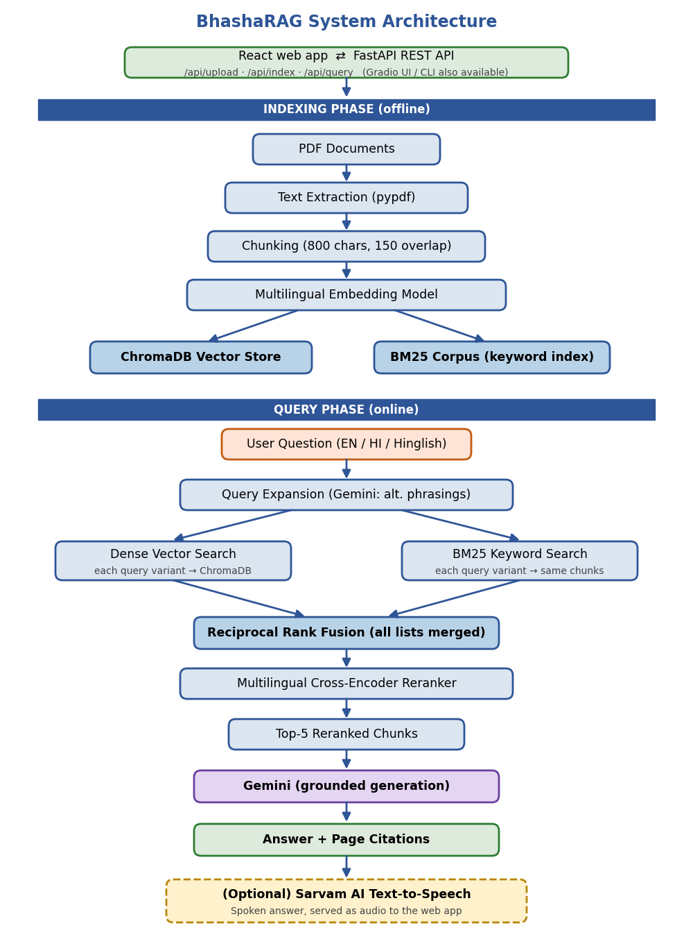
Figure 1: BhashaRAG end-to-end pipeline (indexing phase and query phase), with the React/FastAPI interface layer

6.1 Indexing Phase
- PDF documents are parsed page by page and their text is extracted (pages with no text layer, such as scans, are skipped).
- Text is split into overlapping character-based chunks (800 characters with 150 characters of overlap, breaking at word boundaries) to preserve context across chunk boundaries; every chunk keeps its source file name and page number for citation.
- Each chunk is converted, in batches, into a multilingual embedding vector using a sentence-transformer model.
- Embeddings are stored in a local ChromaDB vector database, indexed for fast similarity search.
- A parallel BM25 corpus of tokenized chunks is saved for keyword search. The tokenizer splits on whitespace and strips punctuation, because a regular-expression word tokenizer would split Devanagari words at their combining vowel marks and break Hindi keyword matching.

6.2 Query Phase
- The user submits a question in English, Hindi, or Hinglish through the web interface, the REST API, or the command line.
- Query expansion (optional): the language model generates alternate phrasings of the question, including at least one English and one Hindi version, giving the original question plus up to three variants.
- For every variant, the question is embedded with the same multilingual model used for indexing and searched against ChromaDB (dense search), and is also searched with BM25 keyword search over the same chunks.
- All dense and BM25 ranked lists, across all variants, are merged in a single Reciprocal Rank Fusion pass, so the best hits from every variant compete on equal terms; the top candidates (about 20) are kept for reranking.
- A cross-encoder reranker (optional) scores each (question, passage) pair jointly and keeps the top 5 chunks; if the reranker is unavailable, the fused ranking is used instead.
- The top-ranked chunks are passed to Google’s Gemini model along with the original question, with an explicit instruction to answer only using the provided context and to say so when the answer is not in it.
- The answer is returned with citations to the source document and page, and optionally converted to speech through the Sarvam AI text-to-speech API and served to the interface as audio.

7. Technology Stack
Component | Technology
Language | Python
User Interface | React 18 + Vite + TypeScript + Tailwind CSS (primary web app); Gradio (alternative built-in UI)
API Layer | FastAPI + Uvicorn (REST endpoints for upload, indexing, querying, and audio)
PDF Parsing | pypdf
Chunking | Custom overlapping character chunker (800 characters, 150 overlap, word-boundary aware)
Embeddings | sentence-transformers (paraphrase-multilingual-MiniLM-L12-v2) — 50+ languages
Sparse Retrieval | BM25 (rank_bm25)
Reranking | Multilingual cross-encoder — default cross-encoder/mmarco-mMiniLMv2-L12-H384-v1 (lightweight, covers Hindi); BAAI/bge-reranker-v2-m3 optional for higher accuracy
Vector Database | ChromaDB (local, persistent)
Answer Generation | Google Gemini (free-tier Flash model, set in config.py) via the google-genai SDK — used for answer generation, query expansion, and the faithfulness judge
Text-to-Speech (optional) | Sarvam AI Bulbul v3 TTS API
Evaluation | Custom ablation script (Hit Rate@K, MRR, LLM-as-judge faithfulness)
Environment Management | python-dotenv

8. Methodology and Design Justification

8.1 Why multilingual embeddings instead of translation
An alternative design would translate every document or query into a single pivot language (e.g. English) before retrieval. This was deliberately avoided because translation introduces an extra failure point and can lose nuance, especially for domain-specific or legal terminology. Using a shared multilingual embedding space allows semantic matching across languages directly, without a lossy intermediate translation step.

8.2 Why chunking with overlap
Splitting documents into overlapping chunks, rather than indexing whole pages or the whole document, keeps each retrieval unit small enough for precise matching while overlap prevents important context from being cut across a chunk boundary.

8.3 Why hybrid retrieval rather than vector search alone
Dense embeddings are strong at capturing semantic meaning but can under-perform on exact matches — proper nouns, numbers, dates, and rare terms, which are common in government and policy documents. Adding BM25 keyword search alongside vector search, and merging the two rankings, compensates for this weakness. This is a design choice validated by common practice in production RAG systems, not an arbitrary addition.

8.4 Why cross-encoder reranking
Initial retrieval (dense or hybrid) scores candidates independently and quickly, which is efficient but less precise. A cross-encoder reranker evaluates the query and each candidate passage together, producing a more accurate relevance ranking for the smaller shortlist that is ultimately passed to the language model.

8.5 Why query expansion for cross-lingual queries
Cross-lingual retrieval is harder than same-language retrieval because embedding alignment across languages is imperfect. Generating a few alternate phrasings or translated variants of the user’s question and retrieving for each variant increases the chance of matching the correct passage, directly reinforcing the project’s core cross-lingual objective.

8.6 Why grounded generation with citations
The language model is explicitly instructed to answer only from the retrieved context, to say so when the context does not contain the answer, and to reference the source page. This directly targets hallucination, a well-known failure mode of large language models, and makes every answer verifiable against the original document. In the implementation this is enforced through a system prompt to Gemini, and the source document and page of each retrieved chunk are also returned to the interface as structured references, shown as citation chips beside the answer.

8.7 Key implementation parameters
All tunable values are kept in a single configuration file so that each design number can be traced and changed in one place:
Parameter | Value
Chunk size / overlap | 800 / 150 characters
Dense and BM25 candidates | 20 each, per query variant
Rank Fusion constant (k) | 60 (Cormack et al., 2009)
Candidates sent to reranker | up to 20
Chunks passed to the language model | 5
Query variants | original question + 3 generated
Generation temperature | 0.2 (query expansion 0.3; faithfulness judge 0.0)

9. Evaluation Plan
To move beyond a working demo and produce measurable results, the system is evaluated using an ablation study across four configurations on a common test set of question–answer pairs spanning English, Hindi, and Hinglish queries:
- Configuration A (baseline): dense vector search only.
- Configuration B: dense vector search + BM25 hybrid retrieval.
- Configuration C: Configuration B + cross-encoder reranking.
- Configuration D (full system): Configuration C + query expansion.
Each configuration is measured on:
- Hit Rate@K — whether the correct passage appears in the top K retrieved chunks.
- Mean Reciprocal Rank (MRR) — how highly the correct passage is ranked, on average.
- Faithfulness score — an LLM-as-judge check on whether the generated answer relies only on the retrieved context, rather than the model’s own prior knowledge.
Comparing all four configurations on identical questions demonstrates, with numbers rather than assertions, which components meaningfully improve the system and by how much.
The ablation is implemented in a script that reads a labeled test set in which each question is paired with the expected source PDF and page. A question counts as a hit at K when any of the top K retrieved chunks comes from the labeled page. All four configurations are run on the same questions with the same K. Retrieval metrics are deterministic for a given index, whereas faithfulness relies on an LLM judge and on generated answers, so it should be read as an indicative score rather than an exact one. With a small test set, differences between configurations may not be statistically meaningful, so the test set should be as large and varied as practical.

10. Did We Train a Model?
No component of BhashaRAG was trained from scratch. The project uses pretrained models — an open-source multilingual sentence-embedding model for retrieval, a pretrained multilingual cross-encoder for reranking, and Google’s Gemini model, accessed through its API, for answer generation, query expansion, and faithfulness judging — and focuses engineering effort on the retrieval and grounding pipeline built around them: chunking strategy, hybrid search, reranking, cross-lingual query handling, and citation-based grounding.
This is a deliberate and standard choice. Training a language model or embedding model from scratch requires computational resources, training data, and time far beyond the scope of a final-year project, and is not how most real-world RAG applications are built either — production systems typically combine pretrained models with carefully engineered retrieval pipelines, which is exactly the approach taken here. The technical contribution of this project lies in how information is retrieved, filtered, and grounded, not in retraining the underlying language models.

11. Use Cases
- Government scheme and policy documents
- Legal documents and contracts
- Research papers and academic material
- Healthcare guidelines
- Company policy documents
- Educational notes and textbooks
- Financial reports

12. Limitations
- Image-only or scanned PDFs require OCR, which is not yet integrated.
- Retrieval quality is sensitive to chunk size and overlap settings.
- Very large document collections may eventually require more scalable retrieval infrastructure.
- The embedding model supports 50+ languages, but rigorous testing and evaluation (Section 9) has so far been carried out primarily on English, Hindi, and Hinglish; other Indic languages are expected to work given the shared embedding space but have not yet been benchmarked.
- PDFs that use legacy, non-Unicode Hindi fonts can produce garbled text on extraction, which the pipeline cannot repair without OCR.
- BM25 matches exact tokens within one script, so a Romanized (Hinglish) question will not lexically match Devanagari text; cross-script matching depends on the dense embeddings and on query expansion.
- Answer generation depends on an external LLM service whose free tier is rate-limited; reranking, expansion, and voice degrade gracefully, but generation itself does not work without it.
- The quality of spoken output across the supported voice languages has not been evaluated, and voice output requires a Sarvam AI API key and network access.
- The API has no authentication and allows requests from any origin, which is suitable for local use and demonstration but must be hardened before any public deployment.

13. Future Work
- OCR support for scanned documents (e.g. via Tesseract)
- Benchmark and validate retrieval/generation quality on additional Indic languages beyond English, Hindi, and Hinglish (e.g. Bengali, Tamil, Telugu, Marathi)
- Multi-turn conversational memory
- Metadata filtering (by document, date range, section)
- A persistent retrieval-evaluation dashboard
- Evaluate spoken-answer quality across all supported voice languages, and add streaming responses
- Authentication and per-user document isolation for multi-user deployment

14. Conclusion
BhashaRAG demonstrates that cross-lingual, citation-grounded document question answering is achievable using established retrieval-augmented generation techniques, without requiring custom model training. By combining multilingual embeddings, hybrid retrieval, cross-encoder reranking, and query expansion, and by evaluating each addition through a structured ablation study, the project goes beyond a basic “chat with PDF” demo to a system whose individual components can each be measured and justified, and that is directly applicable to the multilingual reality of Indian government, legal, healthcare, and educational documents. The full pipeline is implemented end to end — from PDF ingestion through a FastAPI service to a React interface with optional spoken answers.

15. References
Lewis, P. et al. (2020). Retrieval-Augmented Generation for Knowledge-Intensive NLP Tasks.
Karpukhin, V. et al. (2020). Dense Passage Retrieval for Open-Domain Question Answering.
Cormack, G. V., Clarke, C. L. A., & Buettcher, S. (2009). Reciprocal Rank Fusion outperforms Condorcet and individual rank learning methods.
Reimers, N., & Gurevych, I. (2019). Sentence-BERT: Sentence Embeddings using Siamese BERT-Networks.
Reimers, N., & Gurevych, I. (2020). Making Monolingual Sentence Embeddings Multilingual using Knowledge Distillation. EMNLP 2020.
Robertson, S., & Zaragoza, H. (2009). The Probabilistic Relevance Framework: BM25 and Beyond. Foundations and Trends in Information Retrieval, 3(4).
Bonifacio, L. et al. (2021). mMARCO: A Multilingual Version of the MS MARCO Passage Ranking Dataset. arXiv:2108.13897.
Zheng, L. et al. (2023). Judging LLM-as-a-Judge with MT-Bench and Chatbot Arena. NeurIPS 2023 Datasets and Benchmarks.
Sarvam AI Documentation — docs.sarvam.ai
ChromaDB Documentation — trychroma.com
Google AI Studio and Gemini API Documentation — ai.google.dev
FastAPI Documentation — fastapi.tiangolo.com

