LOOPS

Assignment Questions

Assignment Questions

Q1. Write a Java program to calculate the sum of natural numbers up to a given positive integer 'n'.

//Write a Java program to calculate the sum of natural numbers

// up to a given positive integer 'n'.

package loops;

import java.util.Scanner;

public class assignment1 {

public static void main(String[] args) {

Scanner sc=new Scanner(System.*in*);

System.*out*.println("Enter the value of n:");

int n= sc.nextInt();

int sum=0;

for(int i=1;i<=n;i++){

sum+=i;

}

System.*out*.println("The sum of natural no. is:"+sum);

}

}

Output:

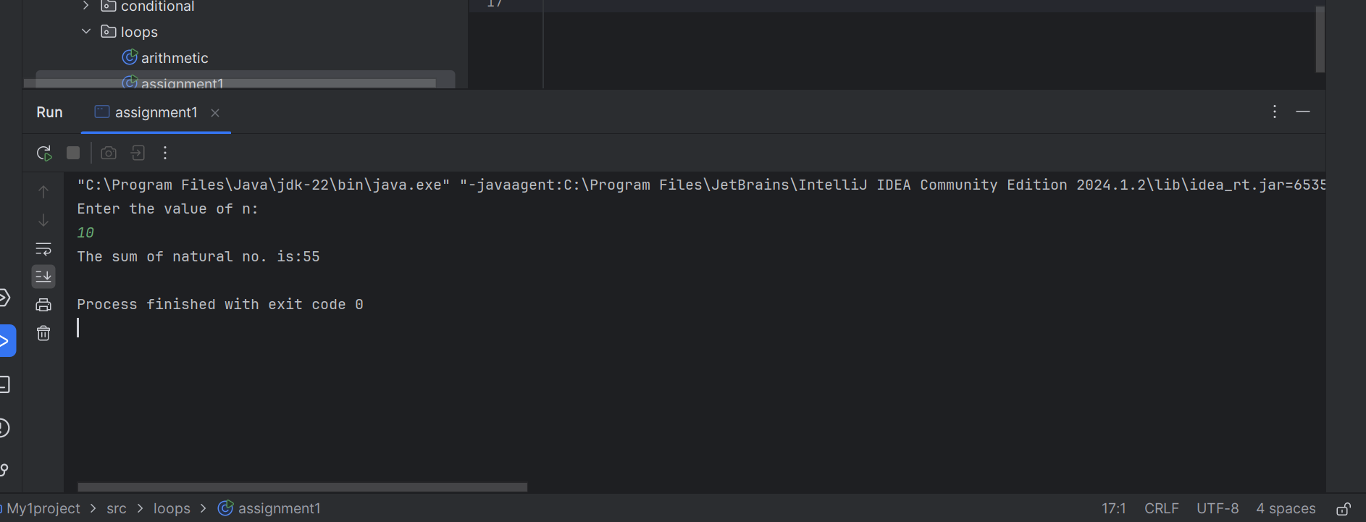

Q2. Write a Java program to print a multiplication table for a given number 'n'.

//Write a Java program to print a multiplication table for a given number 'n'.

package loops;

import java.util.Scanner;

public class assignment12 {

public static void main(String[] args) {

Scanner sc=new Scanner(System.*in*);

System.*out*.println("Enter the value of n:");

int n= sc.nextInt();

for(int i=1;i<=10;i++){

System.*out*.println(n+"\*"+i+"="+(n\*i));

}

}

}

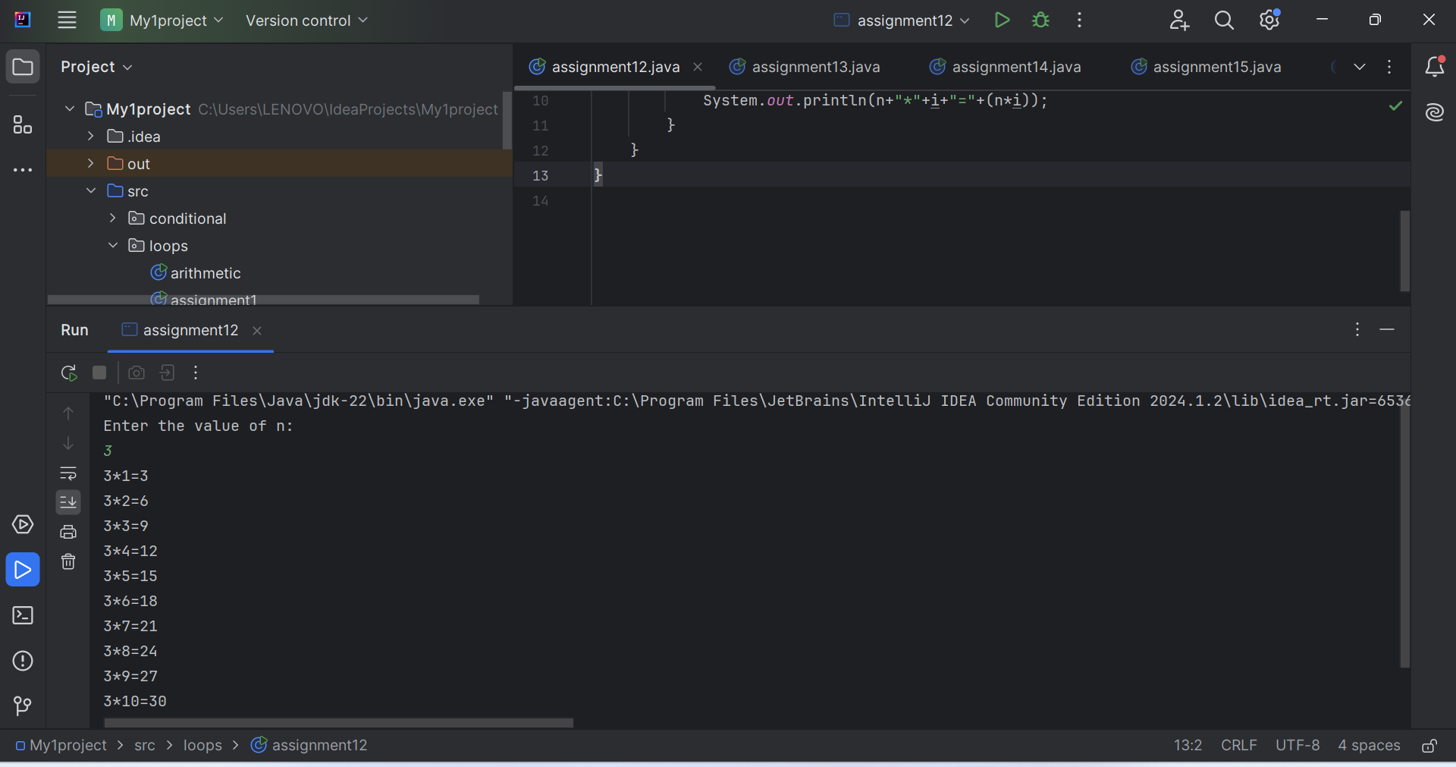

Q3. Write a Java program to find the GCD (Greatest Common Divisor) of two numbers using a loop.

//Write a Java program to find the GCD

// (Greatest Common Divisor) of two numbers using a loop.

package loops;

import java.util.Scanner;

public class assignment13 {

public static void main(String[] args) {

Scanner sc=new Scanner(System.*in*);

System.*out*.println("Enter the number1 :");

int n1= sc.nextInt();

System.*out*.println("Enter the number2 :");

int n2= sc.nextInt();

int g=0;

for(int i=1;i<=n1;i++){

if(n1%i==0 && n2%i==0){

g=i;

}

}

System.*out*.println("The gcd of number is:"+g);

}

}

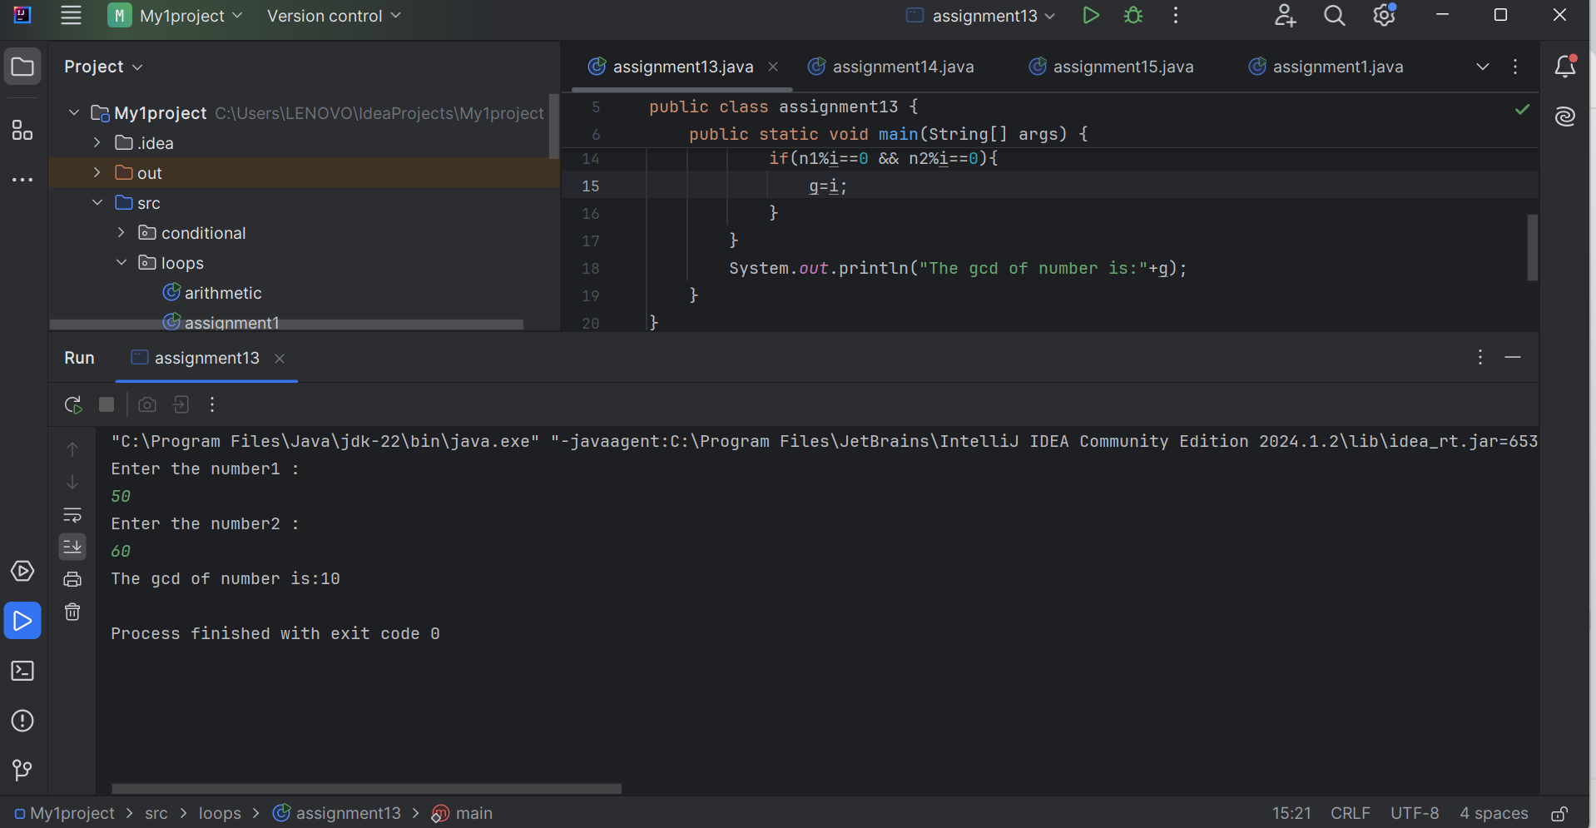

Q4. Write a Java program to check if a given string is a palindrome or not using a loop.

//Write a Java program to check if a given string is a

// palindrome or not using a loop.

package loops;

public class assignment14 {

public static void main(String[] args) {

String s="aayushi" ;

String r="";

for(int i=s.length()-1;i>=0;i--){

r=r+s.charAt(i);

}

System.*out*.println(r);

if(s.equals(r)){

System.*out*.println("Palindrome");

}

else System.*out*.println("Not a palindrome");

}

}

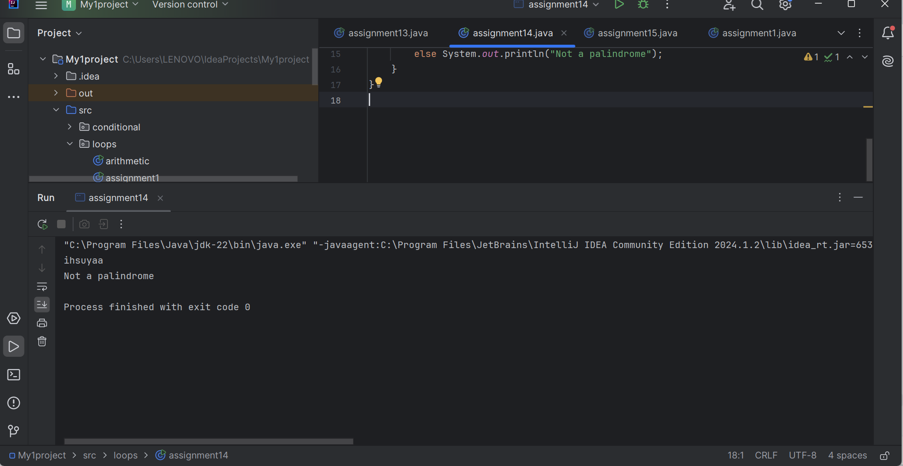

Q5. Write a Java program to generate and print the first 'n' terms of the Fibonacci series.

//Write a Java program to generate and print

// the first 'n' terms of the Fibonacci series.

package loops;

import java.util.Scanner;

public class assignment15 {

public static void main(String[] args) {

Scanner sc=new Scanner(System.*in*);

System.*out*.println("Enter the no.:");

int n= sc.nextInt();

int a=0;

int b=1;

int c;

System.*out*.println(a+" "+b);

for(int i=0;i<=n;i++){

c=a+b;

System.*out*.print(c);

a=b;

b=c;

}

}

}

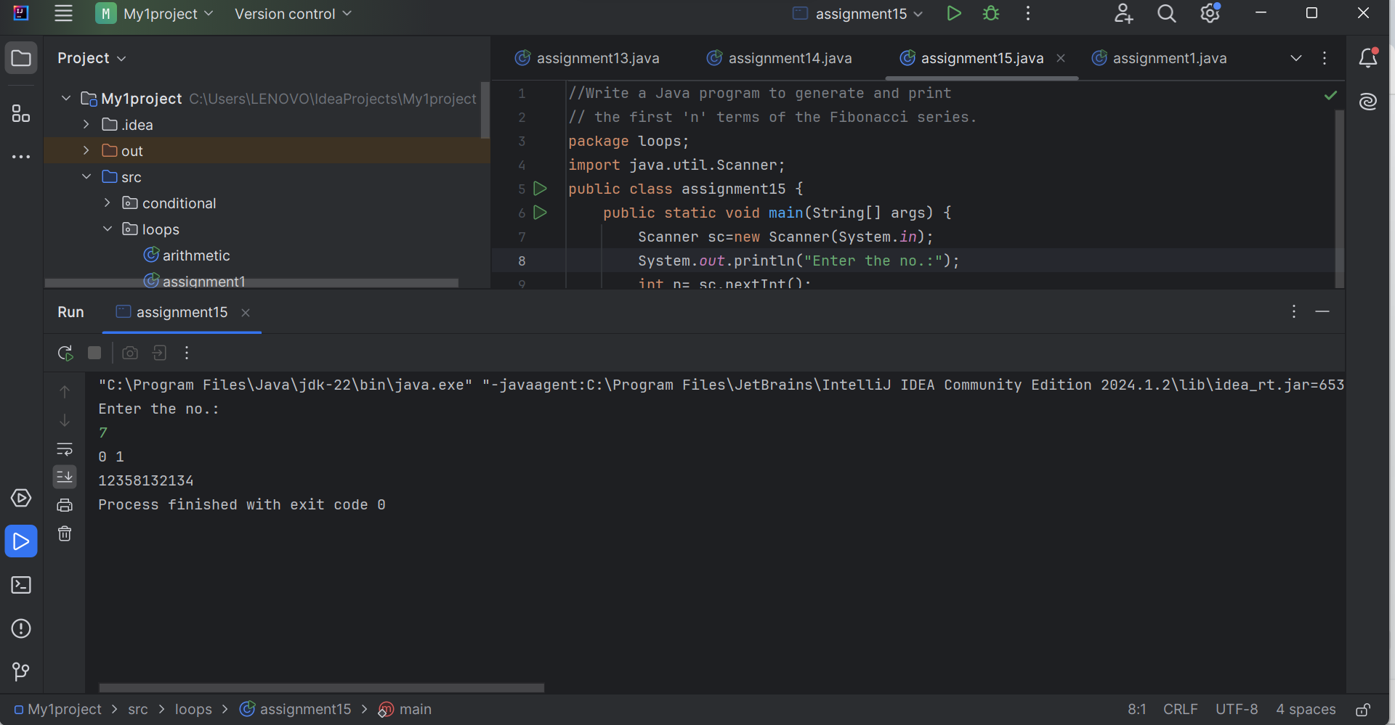

Java + DSA

THANK YOU !