MY HYBRID TASK – 1
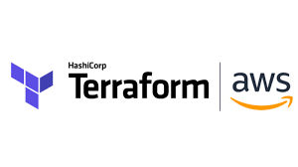

In this task we had to set up the AWS cloud using terraform to run a webapp with the public-read enabled.

Ques1. What is Cloud?
Ans-- "The cloud" refers to servers that are accessed over the Internet, and the software and databases that run on those servers.

Ques2. What is Cloud Computing?
Ans-- Cloud computing is the on-demand availability of computer system resources, especially data storage and computing power, without direct active management by the user.

Ques3. What are the Types of Cloud Computing?
Ans-- There are mainly 3 types of Cloud Computing:
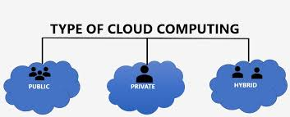

Ques4. What is Key-Pair?
Ans-- The public and private keys are known as a key pair. Public key cryptography enables you to securely access your instances using a private key instead of a password.

Ques5. What are Security Groups?
Ans-- Security groups are used to collect user accounts, computer accounts, and other groups into manageable units.

Ques6. What is an EC2 Instance?
Ans-- An EC2 instance is a virtual server in Amazon's Elastic Compute Cloud (EC2) for running applications on the Amazon Web Services (AWS) infrastructure.

Ques7. What is a EBS Volume?
Ans-- An Amazon EBS volume is a durable, block-level storage device that you can attach to your instances. ... You can use EBS volumes as primary storage for data that requires frequent updates.

Ques8. What is S3 bucket?
Ans-- An Amazon S3 bucket is a public cloud storage resource available in Amazon Web Services' (AWS) Simple Storage Service (S3), an object storage offering. Amazon S3 buckets, which are similar to file folders, store objects, which consist of data and its descriptive metadata.

Ques9. What is Cloud Front?
Ans-- Amazon CloudFront is a content delivery network offered by Amazon Web Services. Content delivery networks provide a globally-distributed network of proxy servers which cache content, such as web videos or other bulky media, more locally to consumers, thus improving access speed for downloading the content.

The task details are as follows:

1. Create the key and security group which allow the port 80.
2. Launch EC2 instance.
3. In this Ec2 instance use the key and security group which we have created in step 1.
4. Launch one Volume (EBS) and mount that volume into /var/www/html
5. Developer have uploded the code into github repo also the repo has some images.
6. Copy the github repo code into /var/www/html
7. Create S3 bucket, and copy/deploy the images from github repo into the s3 bucket and change the permission to public readable.
8. Create a Cloudfront using s3 bucket(which contains images) and use the Cloudfront URL to update in code in /var/www/html.

Here we go ----

1. Login to our profile created in a specific region
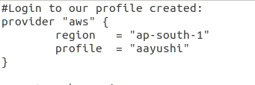

2. Create a key-pair
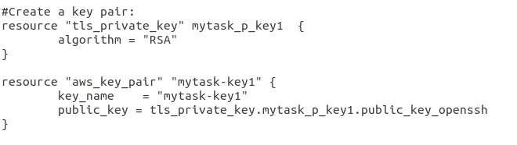

3. Create a Security Group

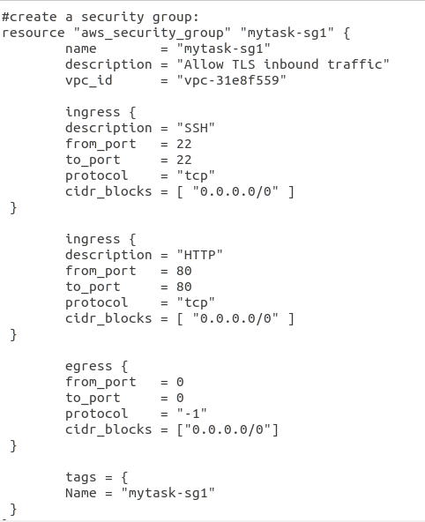

4. Launching an EC2 instance using the key-pair and security group we created
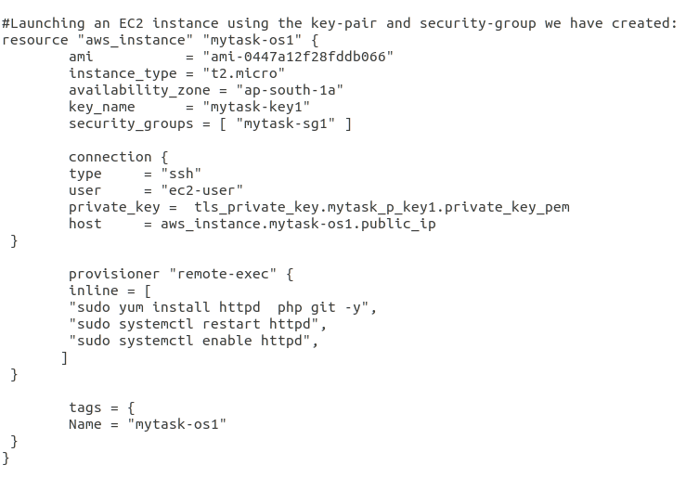
5. Create EBS Volume of size 1 GB
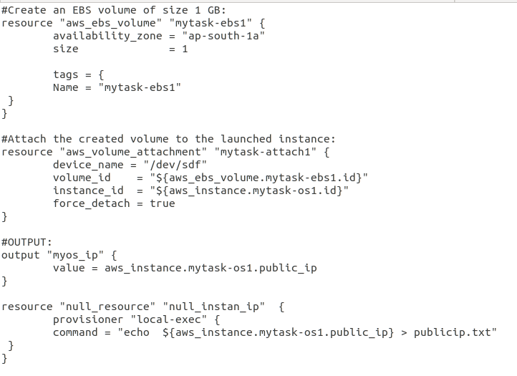
6. Mounting EBS Volume with var/www/html and copying the code from GitHub to the var/www/html
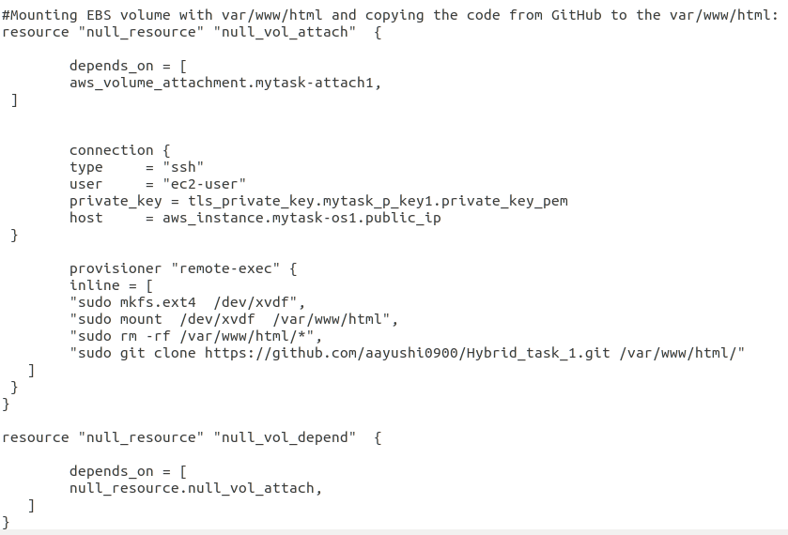
8. Create a S3 bucket to store the static data
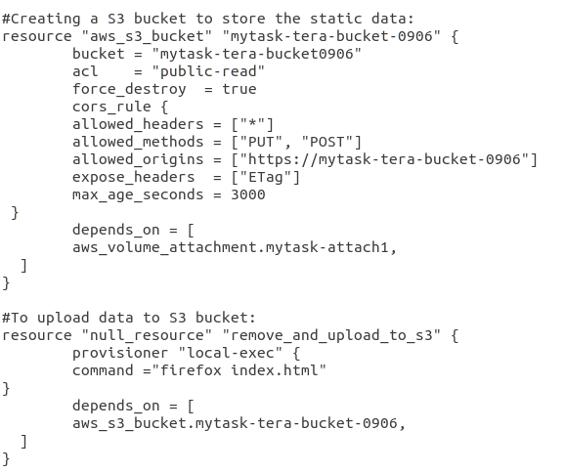
9. Create a CloudFront giving an origin as S3
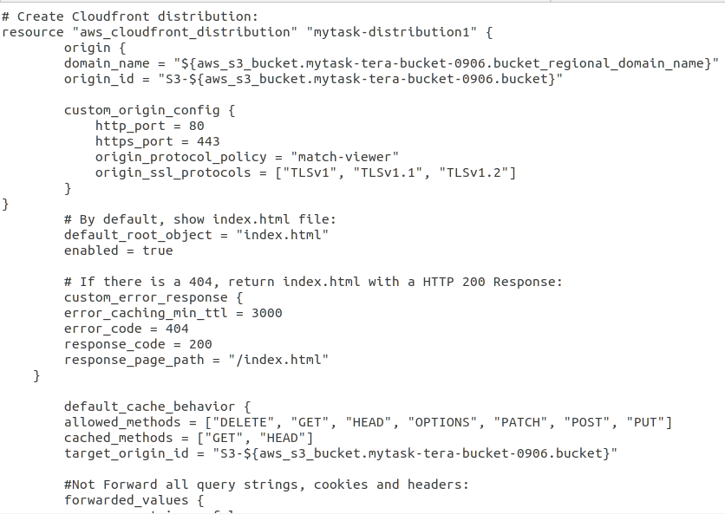
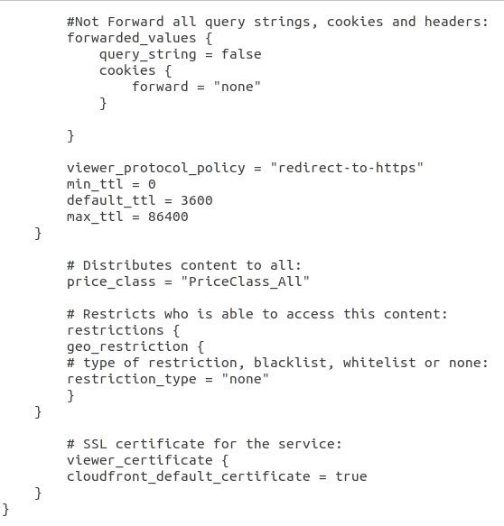
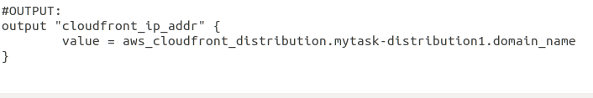

To apply terraform :
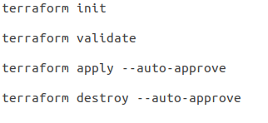

The output was :
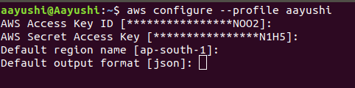

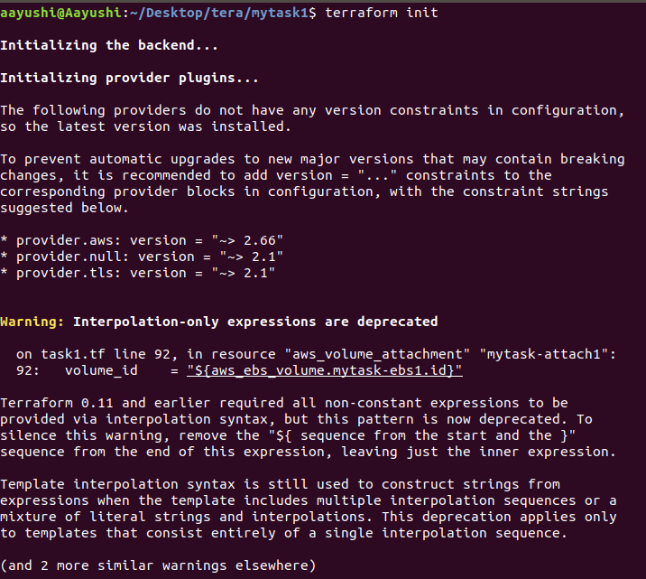
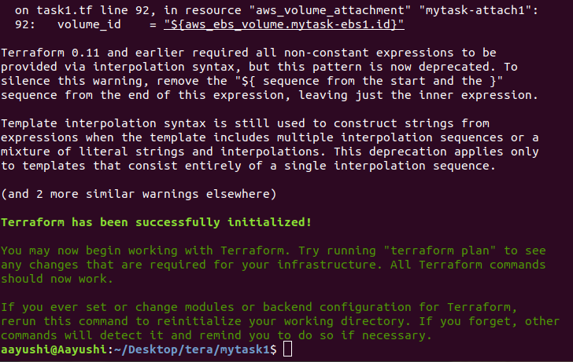

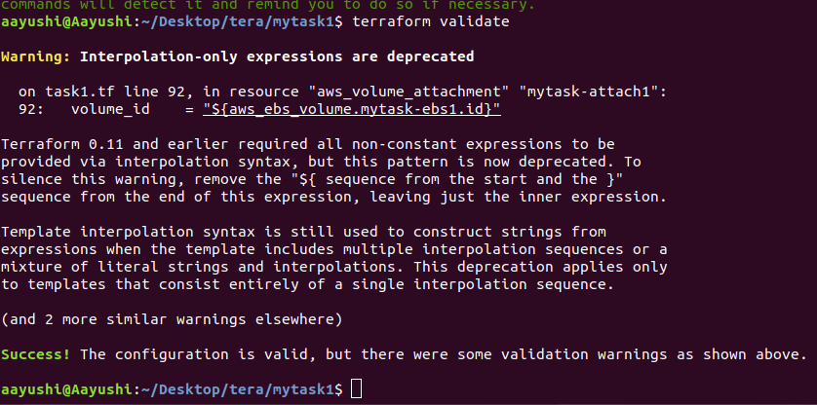

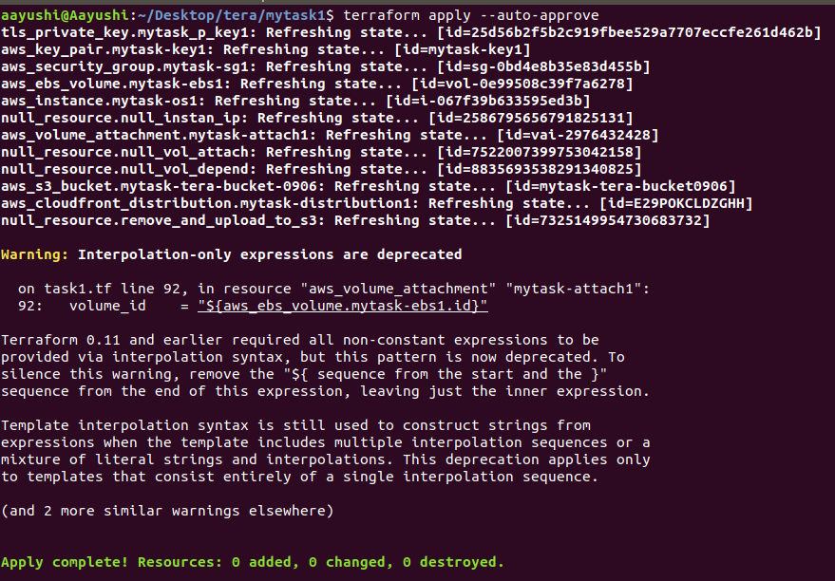

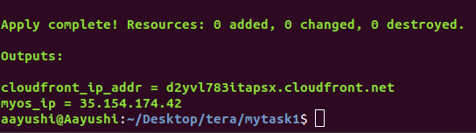

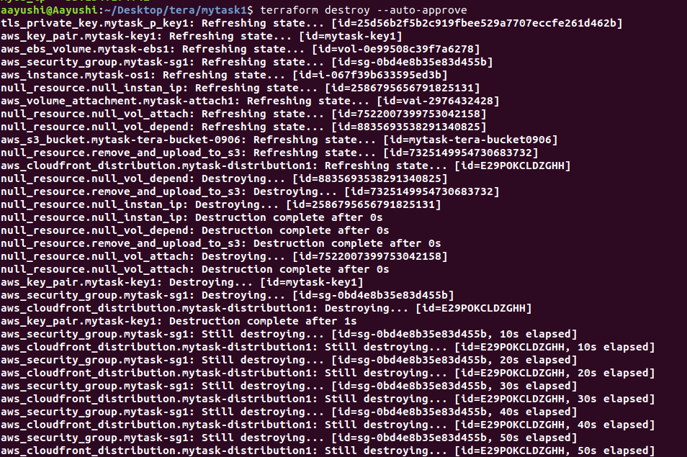
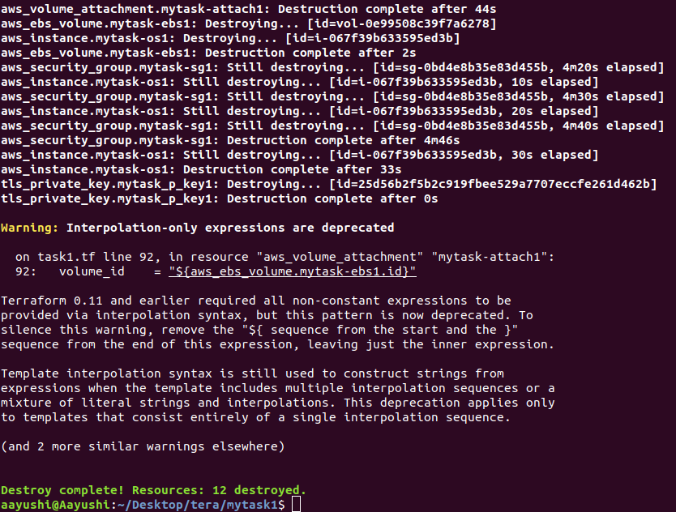

My GitHub Repo link: https://github.com/aayushi0900/Hybrid_task_1

