GIT ASSIGNMENTS
Section - 0
1. Create a directory 'project_dir' & cd to 'project_dir'.
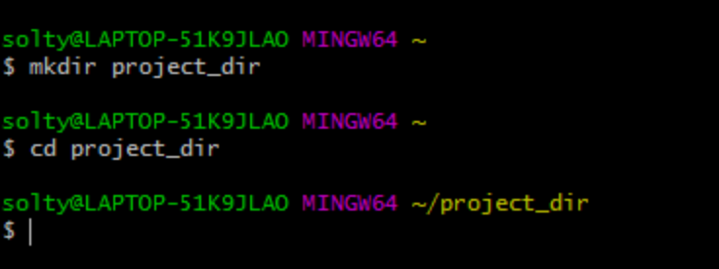
2. Initialize git version database.
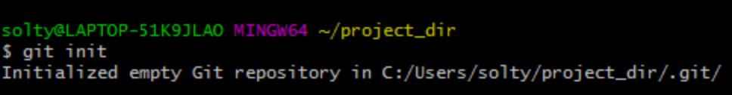
3. Create a new file index.html
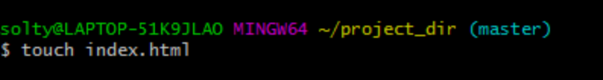
4. Check the git status. You should find index.html as untracked file.
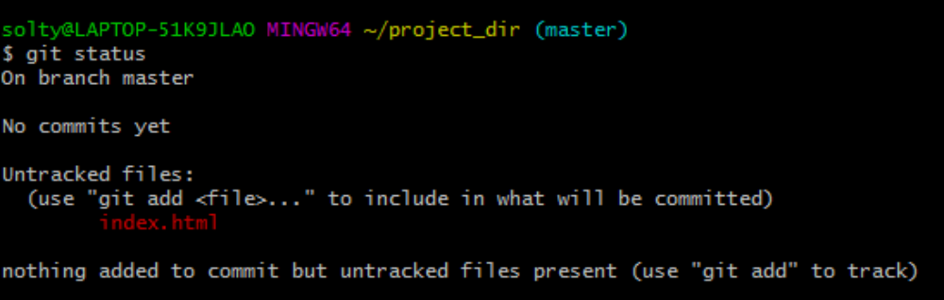
5. Stage the index.html file.
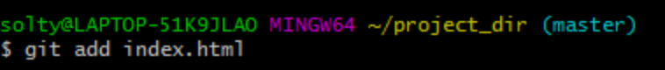
6. Commit index.html.
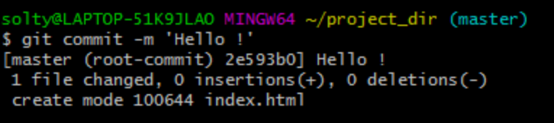
7. Make a few changes in index.html & create a new file info.txt file.
*The changes have been made*
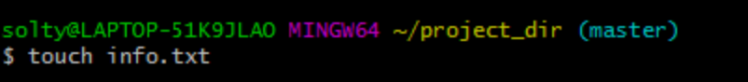
8. Check git status. You should find index.html and info.txt as untracked file.
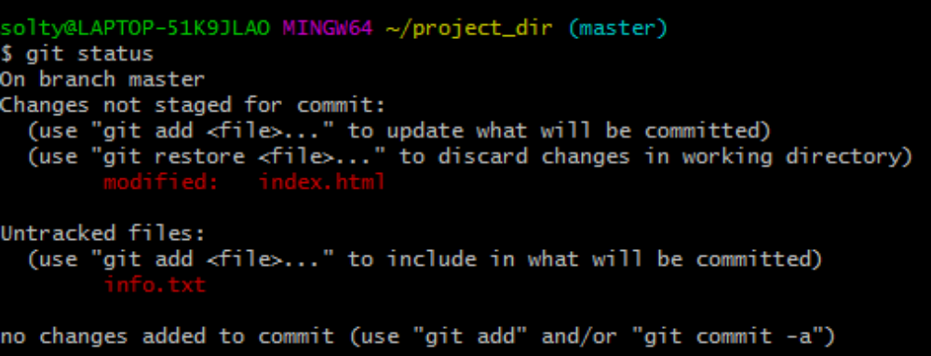
9. Configure git to ignore all txt files.
*The changes have been made*
10. Again check git status.
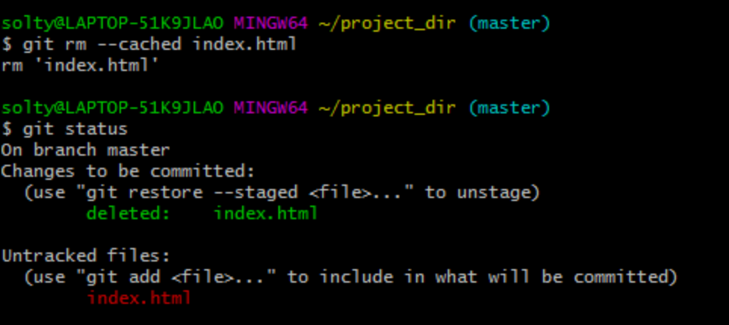

11. State & commit index.html.
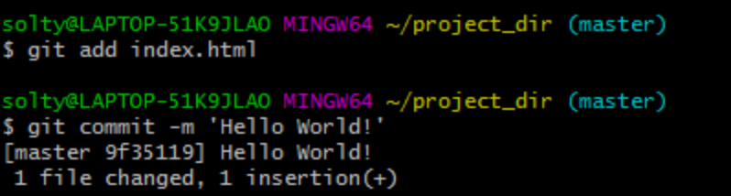
12. Log all your comments so far.
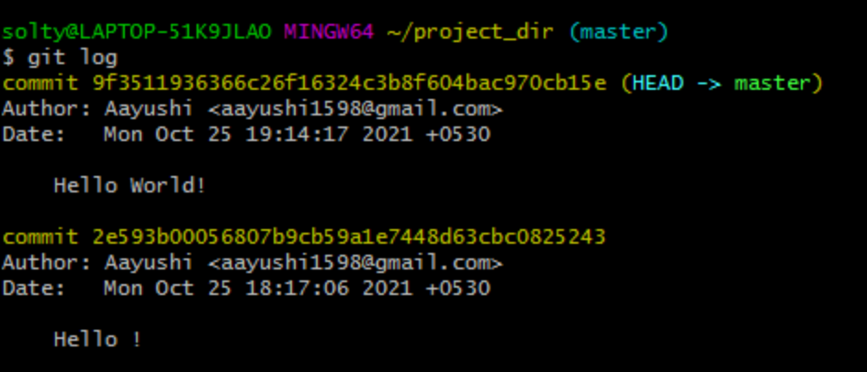
13. Make some changes in index.html
*The changes have been made*
14. Revert the change made in the previous step using git command.
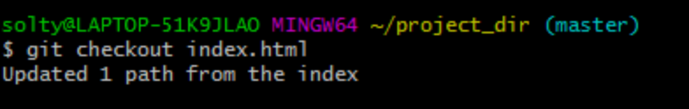
15. Again change index.html.
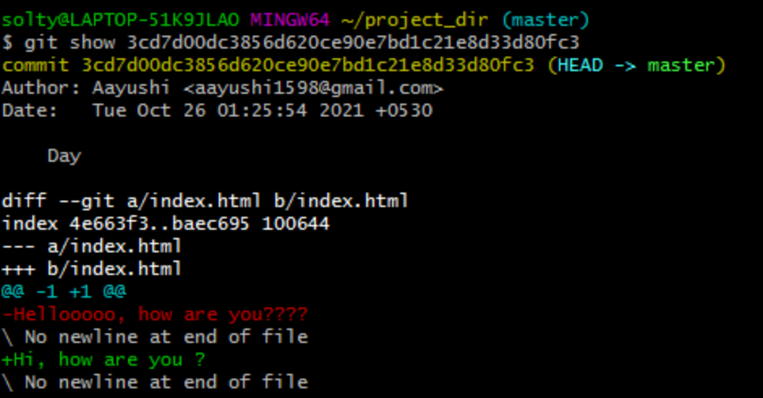
16. Stage index.html.
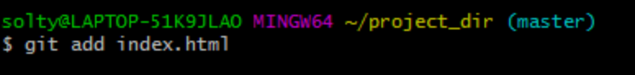
17. Revert back last stage.
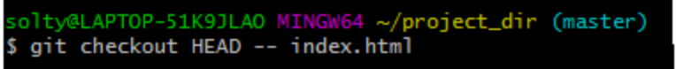
18. Rename 'add' command to 'my-add'.
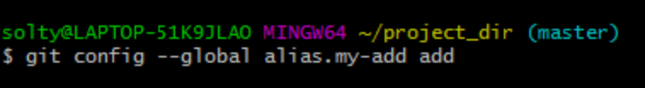
19. Using my-add command, stage index.html again & commit the changes.
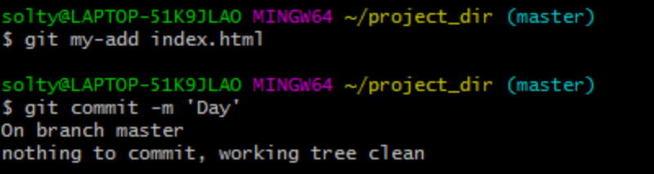
20. Revert the last commit.
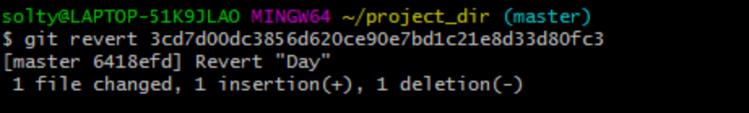
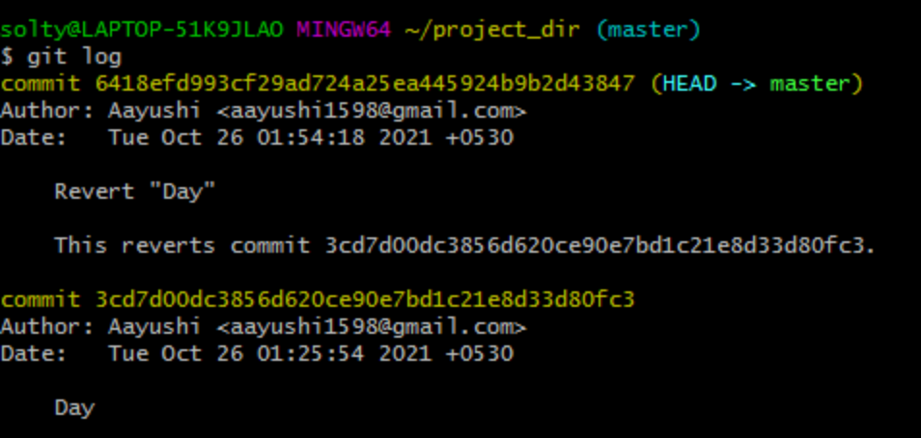

SECTION - 1
21. Take the backup of your assignments and projects.
*Backup has been made.*
22. Create an empty directory 'Assignments' & cd to 'Assignments'.
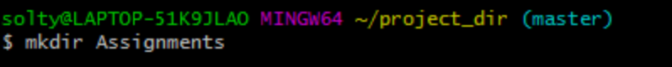
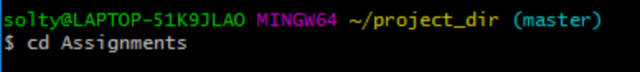
23. Create a file README.txt inside 'Assignments' & write few lines about the contents of 'Assignments' folder.
24. Commit README.txt file.
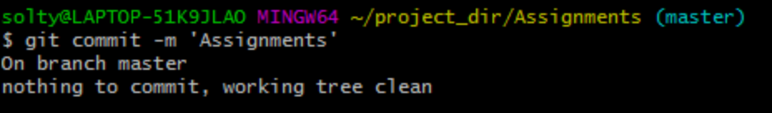
25. Now create a new branch 'html-assignments'.
26. Switch to 'html-assignments' beanch.
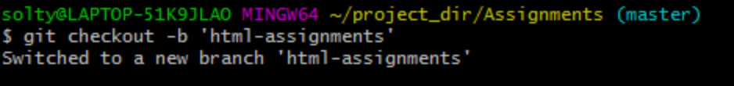
27. Copy all HTML assignments inside 'Assignments' folder.
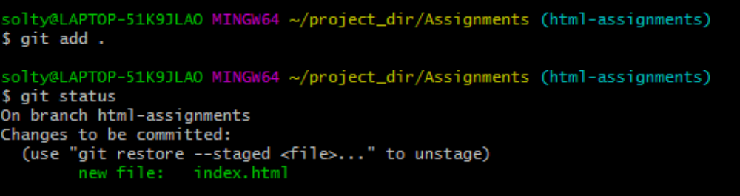
28. Commit HTML assignments into 'html-assignments' branch.
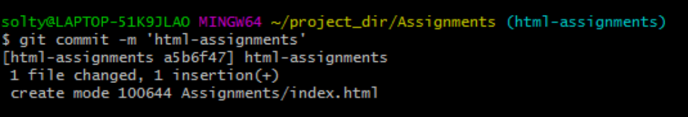
29. Make minor changes into few files belonging to 'html-assignments' branch.
*Changes have been made.*
30. Commit those changes files.
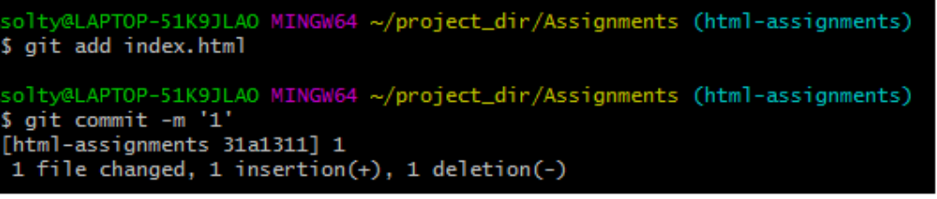
31. Switch to master branch.
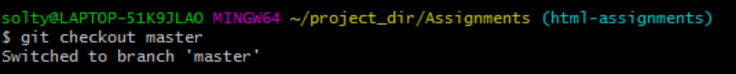
32. Make minor changes into README.txt file & commit those changes into master.
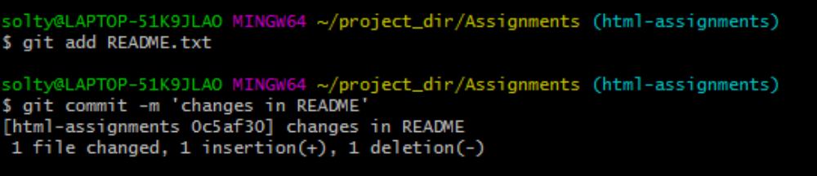

33. Again switch to 'html-assignment' branch.
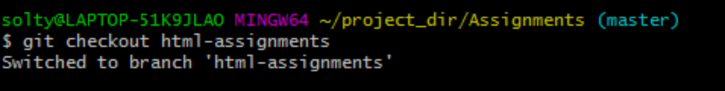
34. Make minor changes into few files belonging to 'html-assignments' branch.
*Changes have been made.*
35. Commit those changes.
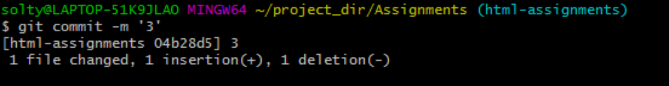
36. Switch to master.
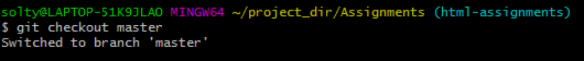
37. Merge 'html-assignments' branch into master. Confirm all html assignments are shown in master.
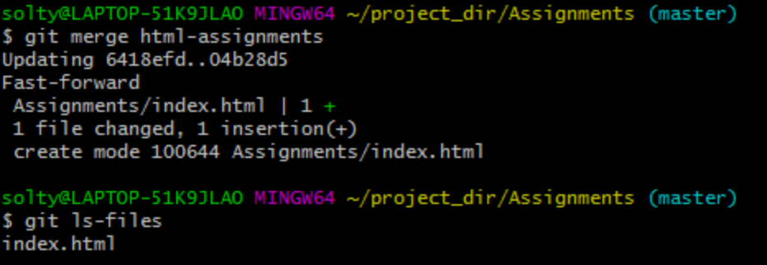
38. Finally delete the 'html-assignments' branch.
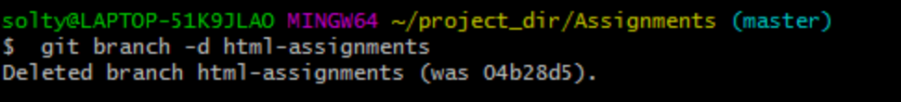

Section -2
39. Create a new branch 'css-assignments'.
40. Switch to css-assignments branch.
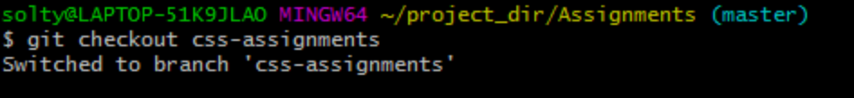
41. Copy all CSS assignments inside 'Assignments' folder
42. Commit CSS assignments into 'css-assignments' branch.
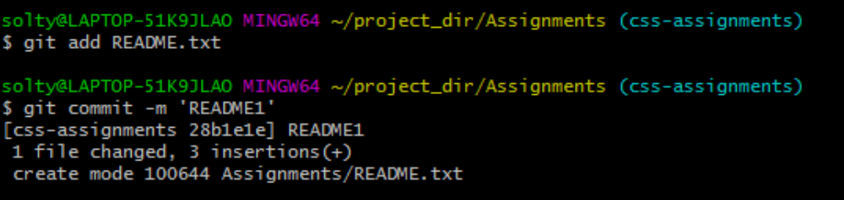
43. Make minor changes into README.txt file on line 1 belonging to 'css-assignments' branch.
44. Commit those changed files.
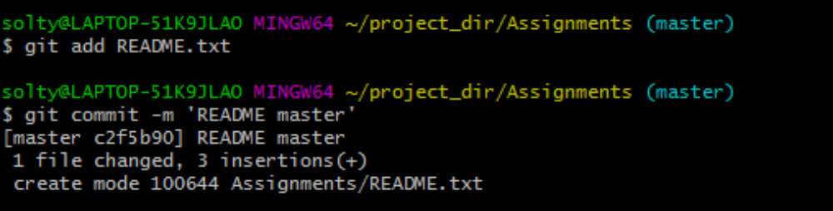
45. Switch to master branch.
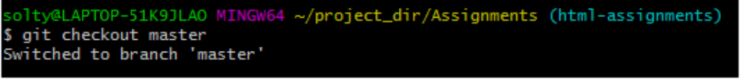
46. Make a minor change into README.txt file on line 3 & commit those changes into master.
47. Again switch to 'css-assignments' branch.
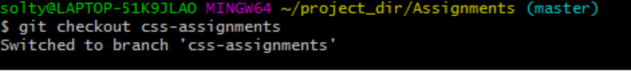
48. Make minor changes into few files belonging to 'css-assignments' branch.
49. Commit those changes.
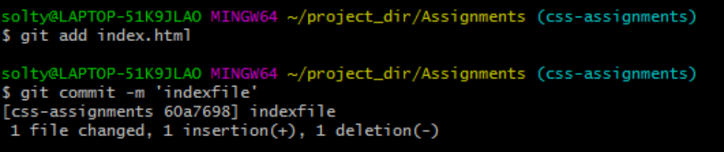
50. Switch to master.
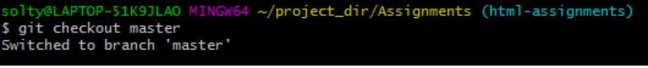
51. Merge 'css-assignments' branch into master. Confirm all css assignments are shown in master.
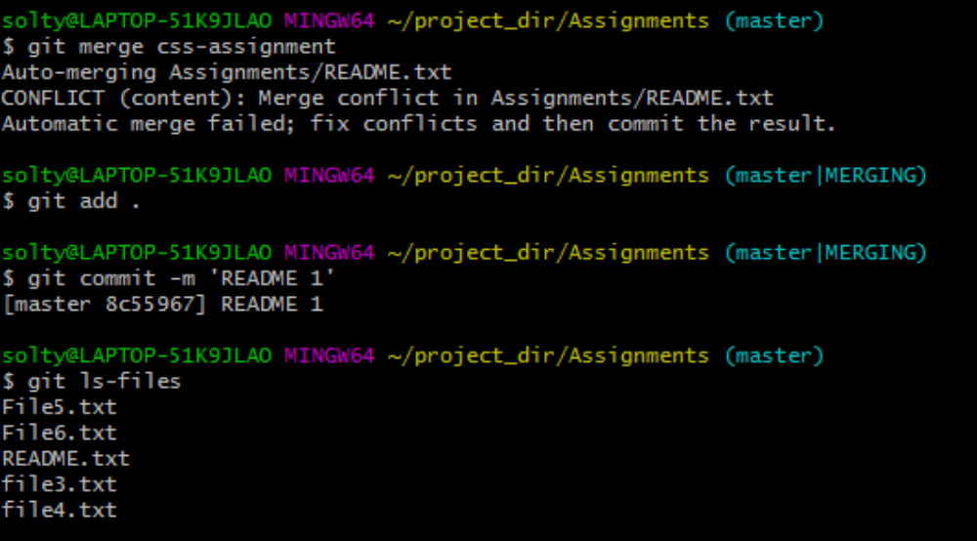
52. Finally delete the 'css-assignments' branch.
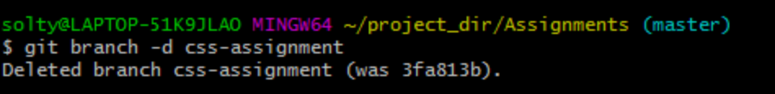

Section - 3

53. Create a new branch 'js-assignments'.
54. Switch to js-assignments branch.
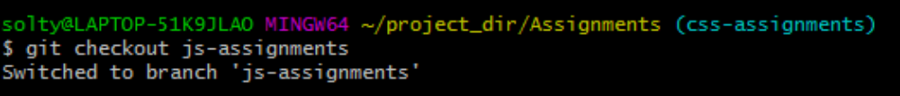
55. Copy all JavaScript assignments inside 'Assignments' folder.
56. Commit JavaScript assignments into 'js-assignments' branch.
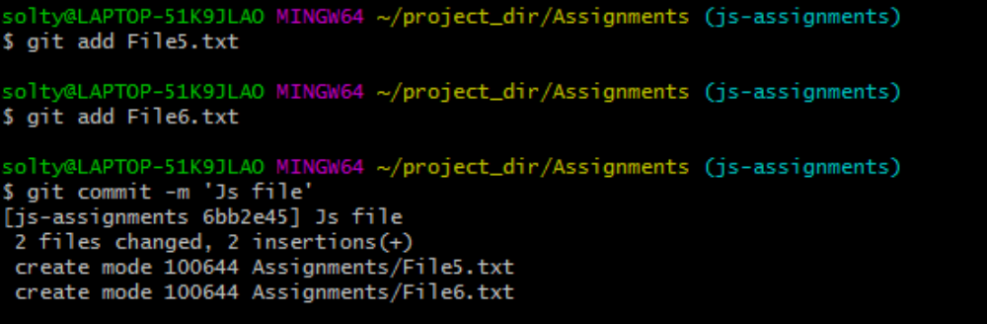
57. Make minor changes into README.txt file on line 1 belonging to 'js-assignments' branch.
58. Commit those changed files.
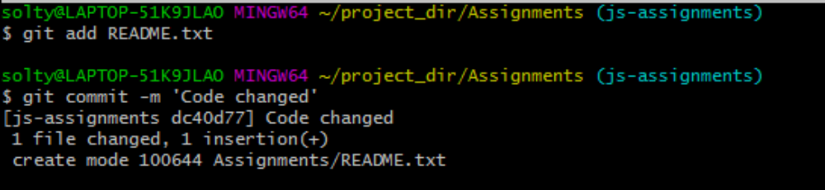
59. Switch to master branch.
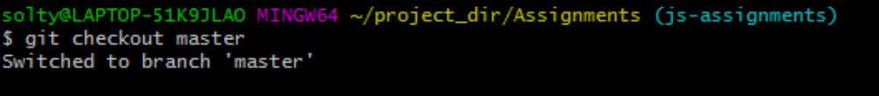
60. Make a minor change into README.txt file on line 3 & commit those changes into master.
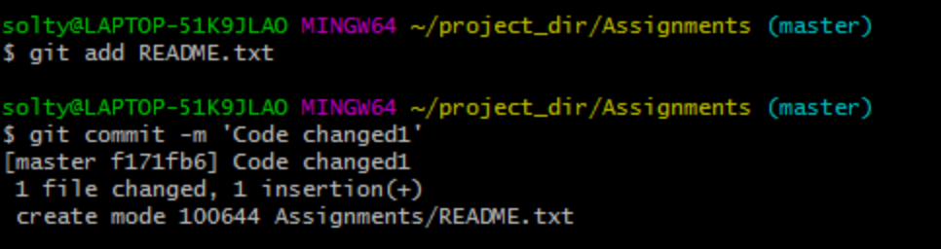

61. Again switch to 'js-assignments' branch.
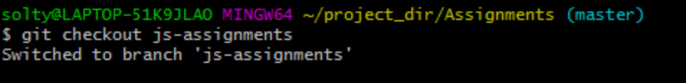

62. Make minor changes into few files belonging to 'js-assignments' branch.
63. Commit those changes.
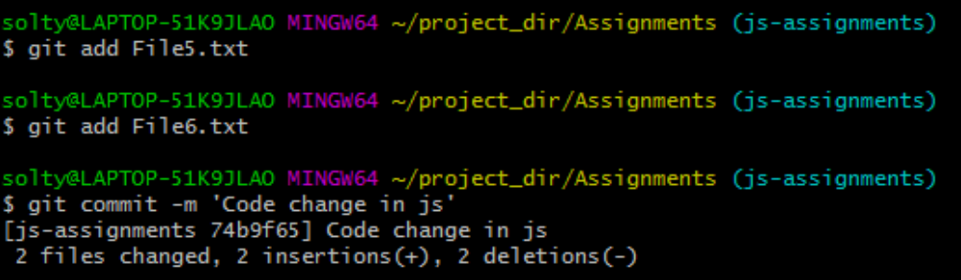
64. Switch to master.
65. Merge 'js-assignments' branch into master. Confirm all JavaScript assignments are shown in master.
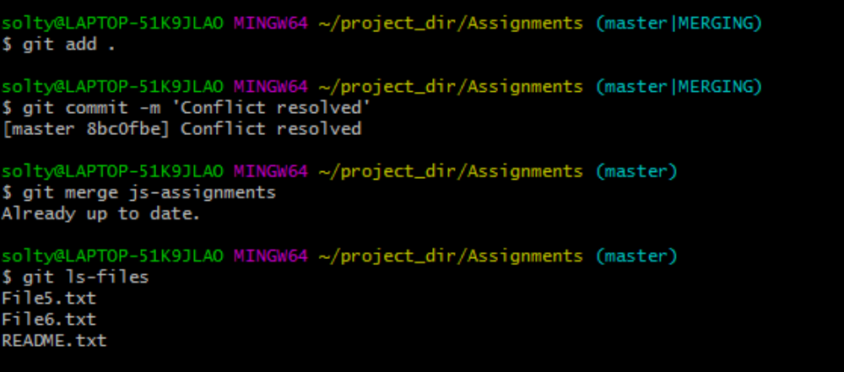
66. Finally delete the 'js-assignments' branch.
