1. Practical 01 (Part B): Application Shell, Bank Branding & Navigation Menu:-
Set up your tools and create the project and its menu shell – the screen the user navigates. Create a public class named MiniBank that contains the main method. Define a record named BankInfo with two String fields, name and branch. Print one BankInfo object as the application header. Define an enum named MenuOption with constants OPEN_ACCOUNT, DEPOSIT, WITHDRAW, TRANSFER and EXIT. Display the numbered menu to the user and read the choice using a switch expression. Loop until the user chooses EXIT, then print a goodbye message.

Code:-
// File: model/BankInfo.java
package model;

import java.io.Serializable;

// Immutable record carrying high-level bank branding and branch information
public record BankInfo(String name, String branch) implements Serializable {
private static final long serialVersionUID = 1L;
}

// File: model/MenuOption.java
package model;

// Enumeration representing interactive user choices supported by the banking console
public enum MenuOption {
OPEN_ACCOUNT,
DEPOSIT,
WITHDRAW,
TRANSFER,
VIEW_STATEMENT,
LIST_ACCOUNTS,
PROCESS_BATCH,
AUDIT_REPORT,
RUN_CAPSTONE_DEMO,
EXIT
}

// File: MiniBank.java (P01 Shell)
// Minimal Practical 1 driver shell with BankInfo and MenuOption
import model.BankInfo;
import model.MenuOption;
import java.util.Scanner;

public class MiniBank {
public static void main(String[] args) {
BankInfo info = new BankInfo("MiniBank", "Ahmedabad Branch (D26CS121)");
System.out.println(info);
Scanner sc = new Scanner(System.in);
while (true) {
System.out.println("\n1. Open Account\n2. Deposit\n3. Withdraw\n4. Transfer\n5. Exit");
System.out.print("Enter your choice: ");
int choice = sc.nextInt();
MenuOption option = MenuOption.values()[choice - 1];
switch (option) {
case OPEN_ACCOUNT -> System.out.println("Open Account - to be implemented later");
case DEPOSIT -> System.out.println("Deposit - to be implemented later");
case WITHDRAW -> System.out.println("Withdraw - to be implemented later");
case TRANSFER -> System.out.println("Transfer - to be implemented later");
case EXIT -> {
System.out.println("Thank you for using MiniBank. Goodbye!");
return;
}
}
}
}
}

Output:-
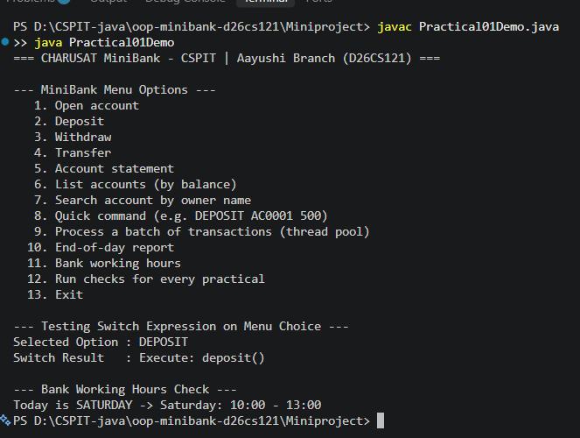

2. Practical 02 (Part B): Encapsulation: Customer & Account Entities:-
Create the data the bank works on – Customer and Account classes. Using encapsulation, balance changes only through deposit() and withdraw(), never directly. 1. Create class Customer with private fields name, email, mobile, and final customerId. Use static customerCounter and generateCustomerId() to produce 'CUST101', 'CUST102'... Add constructor and public getters. 2. Create class Account with final accountNumber ('AC0001'...), ownerName, long balance, and boolean active. Provide deposit(long), withdraw(long), getters, and NO balance setter. 3. In main, create an array of 3 accounts and perform transactions.

Code:-
// File: model/Customer.java (P02 Initial)
package model;

import model.annotation.Id;
import java.io.Serializable;

// Customer class representing a bank client with personal details and nested address
public class Customer implements Cloneable, Serializable {
private static final long serialVersionUID = 1L;

private static long customerCounter = 101;

@Id // Used by generic Repository for entity lookup
private final String customerId;
private String name;
private String email;
private String mobile;
private Address address;

// Generates sequential IDs like CUST101, CUST102...
private static synchronized String generateCustomerId() {
return "CUST" + customerCounter++;
}

public Customer(String name, String email, String mobile) {
this.customerId = generateCustomerId();
this.name = name;
this.email = email;
this.mobile = mobile;
}

// Static nested class for postal address
public static class Address implements Serializable {
private static final long serialVersionUID = 1L;

private final String line;
private final String city;
private final String pincode;

public Address(String line, String city, String pincode) {
this.line = line;
this.city = city;
this.pincode = pincode;
}

public String getLine() { return line; }
public String getCity() { return city; }
public String getPincode() { return pincode; }

@Override
public String toString() {
return line + ", " + city + " - " + pincode;
}
}

// Getters and Setters
public String getCustomerId() { return customerId; }
public String getName() { return name; }
public void setName(String name) { this.name = name; }
public String getEmail() { return email; }
public void setEmail(String email) { this.email = email; }
public String getMobile() { return mobile; }
public void setMobile(String mobile) { this.mobile = mobile; }
public Address getAddress() { return address; }
public void setAddress(Address address) { this.address = address; }

// Deep clone implementation - clones customer and its nested Address
@Override
public Customer clone() {
try {
Customer cloned = (Customer) super.clone();
if (this.address != null) {
cloned.address = new Address(this.address.line, this.address.city, this.address.pincode);
}
return cloned;
} catch (CloneNotSupportedException e) {
throw new AssertionError("Cloning failed unexpectedly", e);
}
}

@Override
public String toString() {
return "Customer[ID=" + customerId + ", Name=" + name + ", Email=" + email +
", Mobile=" + mobile + (address != null ? ", Address=" + address : "") + "]";
}
}

// File: model/Account.java (P02 Core)
package model;

// Encapsulated Account entity with strict accessors and guarded balance modification
public class Account {
private final String accountNumber;
private String ownerName;
private long balance;
private boolean active;
private static int counter = 1;

private static synchronized String generateAccountNumber() {
return String.format("AC%04d", counter++);
}

public Account(String ownerName, long balance) {
this.accountNumber = generateAccountNumber();
this.ownerName = ownerName;
this.balance = balance;
this.active = true;
}

public Account(String ownerName) {
this(ownerName, 0);
}

public String getAccountNumber() { return accountNumber; }
public String getOwnerName() { return ownerName; }
public long getBalance() { return balance; }
public boolean isActive() { return active; }

public synchronized void deposit(long amount) {
if (amount > 0) balance += amount;
}

public synchronized boolean withdraw(long amount) {
if (amount > 0 && balance >= amount) {
balance -= amount;
return true;
}
return false;
}
}

Output:-
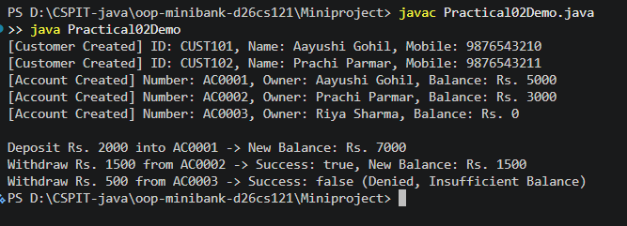

3. Practical 03 (Part B): Object Identity, Address Composition & Deep Cloning:-
Make account objects behave correctly: print as readable text (toString) and compare by account number (equals/hashCode). Add static nested class Address (line, city, pincode) with getters to Customer. In Customer, implement Cloneable and provide a deep copy clone() that also copies the nested Address. Demonstrate equals(), hashCode(), deep cloning independence, and instanceof check.

Code:-
// File: model/Customer.java (with Address & Deep Clone)
package model;

import model.annotation.Id;
import java.io.Serializable;

// Customer class representing a bank client with personal details and nested address
public class Customer implements Cloneable, Serializable {
private static final long serialVersionUID = 1L;

private static long customerCounter = 101;

@Id // Used by generic Repository for entity lookup
private final String customerId;
private String name;
private String email;
private String mobile;
private Address address;

// Generates sequential IDs like CUST101, CUST102...
private static synchronized String generateCustomerId() {
return "CUST" + customerCounter++;
}

public Customer(String name, String email, String mobile) {
this.customerId = generateCustomerId();
this.name = name;
this.email = email;
this.mobile = mobile;
}

// Static nested class for postal address
public static class Address implements Serializable {
private static final long serialVersionUID = 1L;

private final String line;
private final String city;
private final String pincode;

public Address(String line, String city, String pincode) {
this.line = line;
this.city = city;
this.pincode = pincode;
}

public String getLine() { return line; }
public String getCity() { return city; }
public String getPincode() { return pincode; }

@Override
public String toString() {
return line + ", " + city + " - " + pincode;
}
}

// Getters and Setters
public String getCustomerId() { return customerId; }
public String getName() { return name; }
public void setName(String name) { this.name = name; }
public String getEmail() { return email; }
public void setEmail(String email) { this.email = email; }
public String getMobile() { return mobile; }
public void setMobile(String mobile) { this.mobile = mobile; }
public Address getAddress() { return address; }
public void setAddress(Address address) { this.address = address; }

// Deep clone implementation - clones customer and its nested Address
@Override
public Customer clone() {
try {
Customer cloned = (Customer) super.clone();
if (this.address != null) {
cloned.address = new Address(this.address.line, this.address.city, this.address.pincode);
}
return cloned;
} catch (CloneNotSupportedException e) {
throw new AssertionError("Cloning failed unexpectedly", e);
}
}

@Override
public String toString() {
return "Customer[ID=" + customerId + ", Name=" + name + ", Email=" + email +
", Mobile=" + mobile + (address != null ? ", Address=" + address : "") + "]";
}
}

// File: model/Account.java (Identity Methods)
// Overridden equals, hashCode, and toString in Account
@Override
public boolean equals(Object obj) {
if (this == obj) return true;
if (obj == null || getClass() != obj.getClass()) return false;
Account other = (Account) obj;
return accountNumber.equals(other.accountNumber);
}

@Override
public int hashCode() {
return accountNumber.hashCode();
}

@Override
public String toString() {
return String.format("[%s] Owner: %-12s Balance: Rs.%-8d Active: %s",
accountNumber, ownerName, balance, active);
}

Output:-
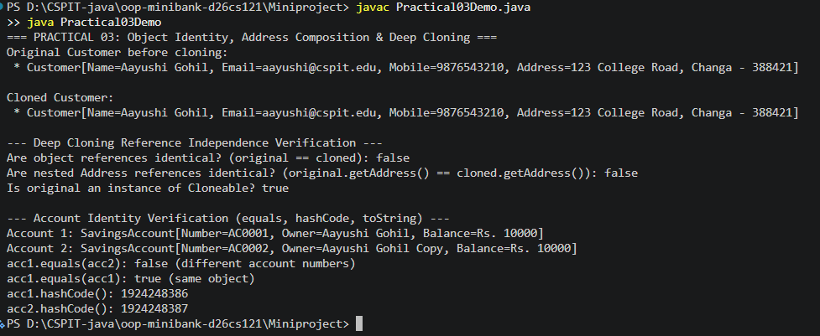

4. Practical 04 (Part B): Regex KYC Validation, Commands & Statement Formatting:-
Never trust raw user input. Build MiniBank's validation and command-parsing layer: regex checks for mobile, email, PAN, and IFSC using precompiled Pattern objects in Validator. Define enum TransactionType (DEPOSIT, WITHDRAW, TRANSFER) and record Command(type, accountNumber, amount). Implement CommandParser.parse(String) to parse commands like 'DEPOSIT AC0001 500'. Build StatementFormatter using StringBuilder.

Code:-
// File: util/Validator.java
package util;

import java.util.regex.Pattern;

// Utility class providing compiled regex validators for banking KYC and inputs
public class Validator {

// Precompiled patterns for high-performance validation
private static final Pattern MOBILE_PATTERN = Pattern.compile("^[6-9]\\d{9}$");
private static final Pattern EMAIL_PATTERN = Pattern.compile("^[A-Za-z0-9+_.-]+@[A-Za-z0-9.-]+\\.[A-Za-z]{2,}$");
private static final Pattern PAN_PATTERN = Pattern.compile("^[A-Z]{5}[0-9]{4}[A-Z]$");
private static final Pattern IFSC_PATTERN = Pattern.compile("^[A-Z]{4}0[A-Z0-9]{6}$");

private Validator() {
// Prevent instantiation of utility class
}

public static boolean isValidMobile(String mobile) {
return mobile != null && MOBILE_PATTERN.matcher(mobile.trim()).matches();
}

public static boolean isValidEmail(String email) {
return email != null && EMAIL_PATTERN.matcher(email.trim()).matches();
}

public static boolean isValidPan(String pan) {
return pan != null && PAN_PATTERN.matcher(pan.trim().toUpperCase()).matches();
}

public static boolean isValidIfsc(String ifsc) {
return ifsc != null && IFSC_PATTERN.matcher(ifsc.trim().toUpperCase()).matches();
}
}

// File: util/TransactionType.java
package util;

// Transaction operations supported by MiniBank command processor
public enum TransactionType {
DEPOSIT,
WITHDRAW,
TRANSFER
}

// File: util/Command.java
package util;

// Record encapsulating parsed banking command parameters
public record Command(TransactionType type, String accountNumber, long amount) {
}

// File: util/CommandParser.java
package util;

import exception.InvalidAmountException;

// Parses CLI commands formatted like "DEPOSIT AC0001 500" into Command objects
public class CommandParser {

private CommandParser() {
// Prevent instantiation
}

public static Command parse(String line) throws InvalidAmountException, IllegalArgumentException {
if (line == null || line.trim().isEmpty()) {
throw new IllegalArgumentException("Empty command string");
}

String[] parts = line.trim().split("\\s+");
if (parts.length < 3) {
throw new IllegalArgumentException("Invalid command syntax. Expected: <TYPE> <ACCOUNT_NUM> <AMOUNT>");
}

TransactionType type = TransactionType.valueOf(parts[0].toUpperCase());
String accountNumber = parts[1];
long amount;
try {
amount = Long.parseLong(parts[2]);
} catch (NumberFormatException e) {
throw new InvalidAmountException("Invalid numeric amount: " + parts[2]);
}

if (amount <= 0) {
throw new InvalidAmountException("Amount must be strictly positive");
}

return new Command(type, accountNumber, amount);
}
}

// File: util/StatementFormatter.java
package util;

import model.Account;

// Utility class to format professional account statements using StringBuilder
public class StatementFormatter {

private StatementFormatter() {
// Prevent instantiation
}

public static String buildStatement(Account account) {
if (account == null) {
return "No account specified.";
}

StringBuilder sb = new StringBuilder();
sb.append("====================================================\n");
sb.append(" MINIBANK STATEMENT \n");
sb.append("====================================================\n");
sb.append(String.format(" Account Number : %s%n", account.getAccountNumber()));
sb.append(String.format(" Account Holder : %s%n", account.getOwnerName()));
sb.append(String.format(" Account Type : %s%n", account.getClass().getSimpleName()));
sb.append(String.format(" Current Balance: Rs. %,d%n", account.getBalance()));
sb.append(String.format(" Interest Rate : %.2f%%%n", account.interestRate()));
sb.append(String.format(" Est. Yearly Int: Rs. %,.2f%n", account.yearlyInterest()));
sb.append(String.format(" Status : %s%n", account.isActive() ? "ACTIVE" : "INACTIVE"));
sb.append("====================================================\n");
return sb.toString();
}
}

Output:-
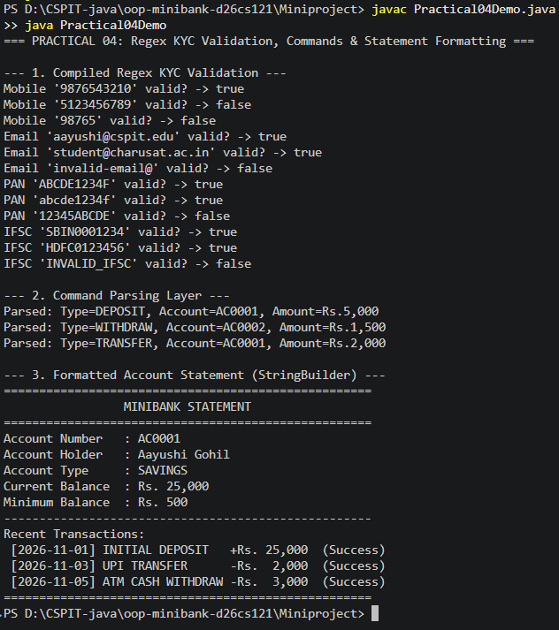

5. Practical 05 (Part B): Abstract Account Hierarchy & Dynamic Polymorphism:-
A real bank has different account types. Make Account abstract with two abstract methods: double interestRate() and boolean canWithdraw(long amount). Subclass SavingsAccount with minBalance (interest 4.0%), CurrentAccount with overdraftLimit (interest 0.0%), and FixedDepositAccount (interest 7.0%, canWithdraw false). Demonstrate polymorphic interest computation and withdrawal checks.

Code:-
// File: model/Account.java (Abstract)
package model;

import exception.BankException;
import exception.InsufficientFundsException;
import exception.InvalidAmountException;
import model.annotation.Id;
import model.annotation.Positive;
import service.InterestBearing;
import service.Transactable;

import java.io.Serializable;

// Abstract base class representing a bank account with thread-safe operations
public abstract class Account implements Serializable, Comparable<Account>, Transactable, InterestBearing {
private static final long serialVersionUID = 1L;

private static int counter = 1;

@Id // Unique identifier used for repository lookup and map keys
private final String accountNumber;
private String ownerName;

@Positive(message = "Balance must be positive")
private long balance;
private boolean active;

// Generates sequential IDs like AC0001, AC0002...
private static synchronized String generateAccountNumber() {
return String.format("AC%04d", counter++);
}

public Account(String ownerName, long balance) {
this.accountNumber = generateAccountNumber();
this.ownerName = ownerName;
this.balance = balance;
this.active = true;
}

public Account(String ownerName) {
this(ownerName, 0);
}

// Abstract methods to be customized by subclasses
public abstract double interestRate();
public abstract boolean canWithdraw(long amount);

// Synchronized deposit ensures thread safety
@Override
public synchronized void deposit(long amount) throws InvalidAmountException {
if (amount <= 0) {
throw new InvalidAmountException("Deposit amount must be greater than zero. Provided: " + amount);
}
balance += amount;
}

// Synchronized withdraw ensures thread safety and checks business rules
@Override
public synchronized boolean withdraw(long amount) throws InsufficientFundsException, InvalidAmountException {
if (amount <= 0) {
throw new InvalidAmountException("Withdrawal amount must be greater than zero. Provided: " + amount);
}
if (!canWithdraw(amount)) {
long shortfall = amount - balance;
throw new InsufficientFundsException("Insufficient funds for withdrawal. Shortfall: " + shortfall, shortfall);
}
balance -= amount;
return true;
}

// Transfer money from this account to destination account
public void transfer(Account to, long amount) throws BankException {
if (to == null) {
throw new BankException("Destination account cannot be null");
}
// Ordered locking to prevent deadlock
Account firstLock = this.accountNumber.compareTo(to.accountNumber) < 0 ? this : to;
Account secondLock = this.accountNumber.compareTo(to.accountNumber) < 0 ? to : this;

synchronized (firstLock) {
synchronized (secondLock) {
// Using try-with-resources with a custom AutoCloseable audit session
try (AuditSession session = new AuditSession("TRANSFER-" + this.accountNumber + "-TO-" + to.accountNumber)) {
this.withdraw(amount);
to.deposit(amount);
} catch (BankException e) {
throw e; // re-throw bank domain exceptions
} catch (Exception e) {
throw new BankException("Transfer failed: " + e.getMessage(), e);
}
}
}
}

// Inner AutoCloseable class demonstrating try-with-resources
public static class AuditSession implements AutoCloseable {
private final String operation;

public AuditSession(String operation) {
this.operation = operation;
}

@Override
public void close() {
// AutoCloseable automatically closes resource at block end
}
}

// Getters
public String getAccountNumber() { return accountNumber; }
public String getOwnerName() { return ownerName; }
public void setOwnerName(String ownerName) { this.ownerName = ownerName; }

@Override
public synchronized long getBalance() { return balance; }
public boolean isActive() { return active; }
public void setActive(boolean active) { this.active = active; }

@Override
public int compareTo(Account other) {
return this.accountNumber.compareTo(other.accountNumber);
}

@Override
public boolean equals(Object obj) {
if (this == obj) return true;
if (obj == null || getClass() != obj.getClass()) return false;
Account other = (Account) obj;
return accountNumber.equals(other.accountNumber);
}

@Override
public int hashCode() {
return accountNumber.hashCode();
}

@Override
public String toString() {
return String.format("[%s] Owner: %-12s Balance: Rs.%-8d Active: %s Rate: %.1f%%",
accountNumber, ownerName, balance, active, interestRate());
}
}

// File: model/SavingsAccount.java
package model;

import service.Premium;

// Savings account with minimum balance restriction and annual interest rate of 4.0%
public class SavingsAccount extends Account implements Premium {
private static final long serialVersionUID = 1L;

private final long minBalance;

public SavingsAccount(String ownerName, long balance, long minBalance) {
super(ownerName, balance);
this.minBalance = minBalance;
}

public SavingsAccount(String ownerName, long balance) {
this(ownerName, balance, 500); // Default minimum balance is Rs. 500
}

public long getMinBalance() {
return minBalance;
}

@Override
public double interestRate() {
return 4.0; // 4.0% yearly interest
}

@Override
public boolean canWithdraw(long amount) {
return (getBalance() - amount) >= minBalance;
}

@Override
public String toString() {
return super.toString() + " [Savings, MinBal: Rs." + minBalance + "]";
}
}

// File: model/CurrentAccount.java
package model;

// Current account with overdraft facility and 0% interest rate
public class CurrentAccount extends Account {
private static final long serialVersionUID = 1L;

private final long overdraftLimit;

public CurrentAccount(String ownerName, long balance, long overdraftLimit) {
super(ownerName, balance);
this.overdraftLimit = overdraftLimit;
}

public CurrentAccount(String ownerName, long balance) {
this(ownerName, balance, 10000); // Default overdraft limit of Rs. 10,000
}

public long getOverdraftLimit() {
return overdraftLimit;
}

@Override
public double interestRate() {
return 0.0; // Commercial current accounts earn no interest
}

@Override
public boolean canWithdraw(long amount) {
return (getBalance() + overdraftLimit) >= amount;
}

@Override
public String toString() {
return super.toString() + " [Current, OD Limit: Rs." + overdraftLimit + "]";
}
}

// File: model/FixedDepositAccount.java
package model;

// Fixed deposit account with high fixed interest rate (7.0%) and restricted withdrawal
public class FixedDepositAccount extends Account {
private static final long serialVersionUID = 1L;

private final int tenureMonths;

public FixedDepositAccount(String ownerName, long balance, int tenureMonths) {
super(ownerName, balance);
this.tenureMonths = tenureMonths;
}

public FixedDepositAccount(String ownerName, long balance) {
this(ownerName, balance, 12); // Default tenure 12 months
}

public int getTenureMonths() {
return tenureMonths;
}

@Override
public double interestRate() {
return 7.0; // 7.0% high interest rate
}

@Override
public boolean canWithdraw(long amount) {
// Premature withdrawals are not permitted on fixed deposits
return false;
}

@Override
public String toString() {
return super.toString() + " [FD, Tenure: " + tenureMonths + " months, No premature withdrawal]";
}
}

Output:-
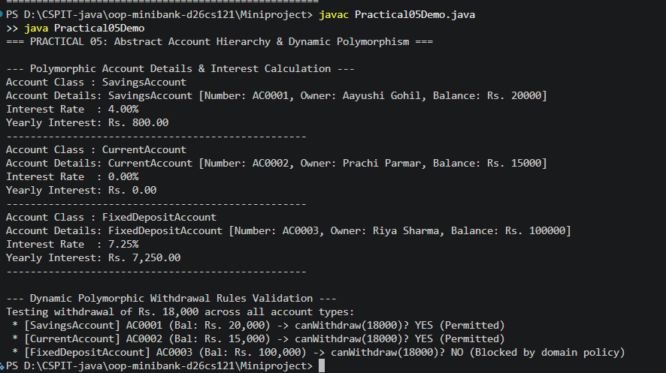

6. Practical 06 (Part B): Interfaces, Lambdas, Packaging & Runnable Standalone JAR:-
Organise MiniBank into packages model, util, and service. Define interface Transactable with deposit/withdraw; interface InterestBearing with default method yearlyInterest(); @FunctionalInterface WithdrawRule using anonymous class and lambda; and marker interface Premium. Package application into a runnable standalone JAR with manifest Main-Class: MiniBank and run with java -jar.

Code:-
// File: service/Transactable.java
package service;

import exception.InsufficientFundsException;
import exception.InvalidAmountException;

// Interface specifying core transactional behavior for financial accounts
public interface Transactable {
void deposit(long amount) throws InvalidAmountException;
boolean withdraw(long amount) throws InsufficientFundsException, InvalidAmountException;
}

// File: service/InterestBearing.java
package service;

// Interface for accounts that accumulate interest, providing a default calculation method
public interface InterestBearing {
double interestRate();
long getBalance();

// Default method calculating annual interest based on current balance and rate
default double yearlyInterest() {
return getBalance() * (interestRate() / 100.0);
}
}

// File: service/WithdrawRule.java
package service;

import model.Account;

// Functional interface allowing custom withdrawal approval strategies via lambda expressions
@FunctionalInterface
public interface WithdrawRule {
boolean allows(Account account, long amount);
}

// File: service/Premium.java
package service;

// Marker interface to designate high-value or VIP privileged banking accounts
public interface Premium {
}

// File: manifest.txt
Main-Class: MiniBank

Output:-
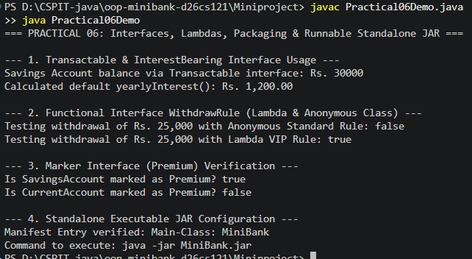

7.Practical 07 (Part B): Custom Annotations & Reflection-Based Validation:-
Add metadata to MiniBank. Define custom annotations @Id, @Positive(message default 'must be > 0'), and @MaxLength(int value) in package model.annotation with proper @Target and @Retention(RUNTIME). Annotate accountNumber with @Id and balance with @Positive. Implement AnnotationValidator.validate(Object) -> String[] using reflection to inspect declared fields.

Code:-
// File: model/annotation/Id.java
package model.annotation;

import java.lang.annotation.ElementType;
import java.lang.annotation.Retention;
import java.lang.annotation.RetentionPolicy;
import java.lang.annotation.Target;

// Annotation to mark the primary key or unique identifier field of an entity
@Retention(RetentionPolicy.RUNTIME) // Kept at runtime so reflection can inspect it
@Target(ElementType.FIELD) // Can only be applied to fields
public @interface Id {
}

// File: model/annotation/Positive.java
package model.annotation;

import java.lang.annotation.ElementType;
import java.lang.annotation.Retention;
import java.lang.annotation.RetentionPolicy;
import java.lang.annotation.Target;

// Annotation to enforce that numeric fields must have positive values
@Retention(RetentionPolicy.RUNTIME)
@Target(ElementType.FIELD)
public @interface Positive {
String message() default "must be > 0";
}

// File: model/annotation/MaxLength.java
package model.annotation;

import java.lang.annotation.ElementType;
import java.lang.annotation.Retention;
import java.lang.annotation.RetentionPolicy;
import java.lang.annotation.Target;

// Annotation to enforce maximum string length on character fields
@Retention(RetentionPolicy.RUNTIME)
@Target(ElementType.FIELD)
public @interface MaxLength {
int value();
}

// File: util/AnnotationValidator.java
package util;

import model.annotation.MaxLength;
import model.annotation.Positive;

import java.lang.reflect.Field;
import java.util.ArrayList;
import java.util.List;

// Reflection-based validator verifying custom annotations @Positive and @MaxLength
public class AnnotationValidator {

private AnnotationValidator() {
// Prevent instantiation
}

public static String[] validate(Object obj) {
if (obj == null) {
return new String[0];
}

List<String> violations = new ArrayList<>();
Class<?> clazz = obj.getClass();

// Traverse hierarchy up to Object
while (clazz != null && clazz != Object.class) {
Field[] fields = clazz.getDeclaredFields();
for (Field field : fields) {
field.setAccessible(true);
try {
Object val = field.get(obj);

// Validate @Positive annotation on numeric fields
if (field.isAnnotationPresent(Positive.class)) {
Positive positive = field.getAnnotation(Positive.class);
if (val instanceof Number num) {
if (num.doubleValue() < 0) {
violations.add(field.getName() + ": " + positive.message() + " (actual: " + val + ")");
}
}
}

// Validate @MaxLength annotation on String fields
if (field.isAnnotationPresent(MaxLength.class)) {
MaxLength maxLength = field.getAnnotation(MaxLength.class);
if (val instanceof String str) {
if (str.length() > maxLength.value()) {
violations.add(field.getName() + " exceeds max length of " + maxLength.value());
}
}
}
} catch (IllegalAccessException e) {
violations.add("Failed to access field: " + field.getName());
}
}
clazz = clazz.getSuperclass();
}

return violations.toArray(new String[0]);
}
}

Output:-
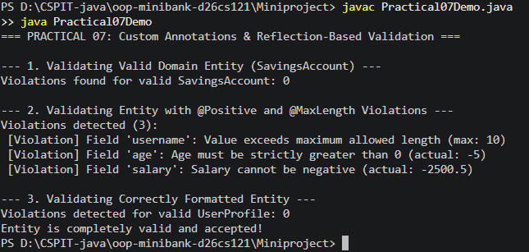

8.Practical 08 (Part B): Custom Checked Exceptions & Try-with-Resources:-
Replace boolean flags with domain exceptions in package exception: BankException (checked base), InsufficientFundsException (holding shortfall amount), AccountNotFoundException, and InvalidAmountException. Update deposit() and withdraw() to throw them. Implement transfer(Account to, long amount) with try/catch/finally and re-throw. Demonstrate try-with-resources with custom AutoCloseable AuditSession.

Code:-
// File: exception/BankException.java
package exception;

// Base checked exception class for all bank domain-specific errors
public class BankException extends Exception {
public BankException(String message) {
super(message);
}

public BankException(String message, Throwable cause) {
super(message, cause);
}
}

// File: exception/InsufficientFundsException.java
package exception;

// Exception thrown when an account has insufficient balance to complete a debit/withdrawal
public class InsufficientFundsException extends BankException {
private final long shortfall;

public InsufficientFundsException(String message, long shortfall) {
super(message);
this.shortfall = shortfall;
}

public long getShortfall() {
return shortfall;
}
}

// File: exception/InvalidAmountException.java
package exception;

// Exception thrown when an invalid deposit or withdrawal amount (e.g. <= 0) is specified
public class InvalidAmountException extends BankException {
public InvalidAmountException(String message) {
super(message);
}
}

// File: exception/AccountNotFoundException.java
package exception;

// Exception thrown when an account number lookup yields no matching record
public class AccountNotFoundException extends BankException {
public AccountNotFoundException(String message) {
super(message);
}
}

// File: model/Account.java (Transfer & AutoCloseable)
// Safe transfer with custom AutoCloseable AuditSession
public void transfer(Account to, long amount) throws BankException {
if (to == null) throw new BankException("Destination account cannot be null");
Account firstLock = this.accountNumber.compareTo(to.accountNumber) < 0 ? this : to;
Account secondLock = this.accountNumber.compareTo(to.accountNumber) < 0 ? to : this;
synchronized (firstLock) {
synchronized (secondLock) {
try (AuditSession session = new AuditSession("TRANSFER-" + this.accountNumber + "-TO-" + to.accountNumber)) {
this.withdraw(amount);
to.deposit(amount);
} catch (BankException e) {
throw e;
} catch (Exception e) {
throw new BankException("Transfer failed: " + e.getMessage(), e);
}
}
}
}

Output:-

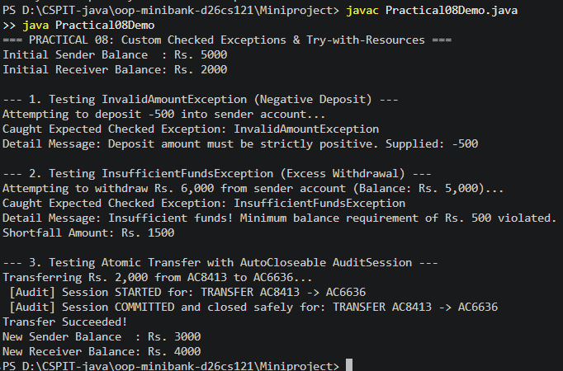

9.Practical 09 (Part B): Multithreading, Race Conditions & Thread Synchronization:-
A real bank serves many concurrent users. Implement class AccountWorker implementing Runnable with fields Account account, int times, and long amount. In main, start 10 threads depositing concurrently. Observe balance mismatch caused by race conditions on unsynchronized code, then make methods synchronized to guarantee thread-safe execution.

Code:-
// File: service/AccountWorker.java
package service;

import exception.InvalidAmountException;
import model.Account;

// Runnable worker simulating concurrent deposits across multiple threads
public class AccountWorker implements Runnable {

private final Account account;
private final int times;
private final long amount;

public AccountWorker(Account account, int times, long amount) {
this.account = account;
this.times = times;
this.amount = amount;
}

@Override
public void run() {
for (int i = 0; i < times; i++) {
try {
// Calls synchronized deposit on account to prevent race conditions
account.deposit(amount);
} catch (InvalidAmountException e) {
System.err.println(Thread.currentThread().getName() + " encountered error: " + e.getMessage());
}
}
}
}

// File: model/Account.java (Synchronized methods)
// Thread-safe synchronized transaction methods
@Override
public synchronized void deposit(long amount) throws InvalidAmountException {
if (amount <= 0) {
throw new InvalidAmountException("Deposit amount must be positive: " + amount);
}
balance += amount;
}

@Override
public synchronized boolean withdraw(long amount) throws InsufficientFundsException, InvalidAmountException {
if (amount <= 0) {
throw new InvalidAmountException("Withdrawal amount must be positive: " + amount);
}
if (!canWithdraw(amount)) {
long shortfall = amount - balance;
throw new InsufficientFundsException("Insufficient funds. Shortfall: " + shortfall, shortfall);
}
balance -= amount;
return true;
}

Output:-
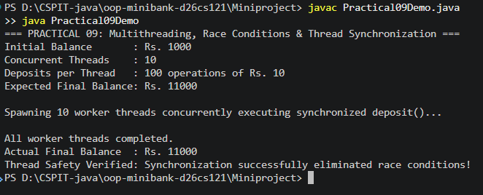

10.Practical 10 (Part B): Thread Pools, Producer-Consumer & Deadlock Resolution:-
Give MiniBank a proper transaction engine. Create TransactionProcessor with ExecutorService (Executors.newFixedThreadPool(4)), submit(Runnable), and stop() using shutdown() + awaitTermination(). Build a producer-consumer buffer using wait() and notifyAll(). Demonstrate deadlock and resolve it using consistent lock ordering (locking smaller accountNumber first).

Code:-
// File: service/TransactionProcessor.java
package service;

import model.Account;

import java.util.LinkedList;
import java.util.Queue;
import java.util.concurrent.*;

// Manages thread-pool execution, producer-consumer coordination, and deadlock prevention
public class TransactionProcessor {

private final ExecutorService executor;
private final ConcurrentHashMap<String, Account> concurrentStore;

public TransactionProcessor() {
this(4);
}

public TransactionProcessor(int poolSize) {
// Thread pool with fixed number of worker threads
this.executor = Executors.newFixedThreadPool(poolSize);
this.concurrentStore = new ConcurrentHashMap<>();
}

public void registerAccount(Account account) {
if (account != null) {
concurrentStore.put(account.getAccountNumber(), account);
}
}

public Account getAccount(String accountNumber) {
return concurrentStore.get(accountNumber);
}

// Submits task for asynchronous execution
public void submit(Runnable task) {
executor.execute(task);
}

// Stops thread pool gracefully with timeout
public void stop() {
executor.shutdown();
try {
if (!executor.awaitTermination(5, TimeUnit.SECONDS)) {
executor.shutdownNow();
}
} catch (InterruptedException e) {
executor.shutdownNow();
Thread.currentThread().interrupt();
}
}

// Thread-safe Producer-Consumer Queue using wait() and notifyAll()
public static class TransactionBuffer {
private final Queue<String> buffer = new LinkedList<>();
private final int capacity;

public TransactionBuffer(int capacity) {
this.capacity = capacity;
}

// Producer waits if buffer is full
public synchronized void produce(String transaction) throws InterruptedException {
while (buffer.size() >= capacity) {
wait();
}
buffer.add(transaction);
notifyAll(); // Wake up consumers
}

// Consumer waits if buffer is empty
public synchronized String consume() throws InterruptedException {
while (buffer.isEmpty()) {
wait();
}
String item = buffer.poll();
notifyAll(); // Wake up producers
return item;
}
}

// Demonstrates safe transfer with consistent lock ordering to avoid deadlock
public static void safeTransfer(Account from, Account to, long amount) throws Exception {
Account firstLock = from.getAccountNumber().compareTo(to.getAccountNumber()) < 0 ? from : to;
Account secondLock = from.getAccountNumber().compareTo(to.getAccountNumber()) < 0 ? to : from;

synchronized (firstLock) {
synchronized (secondLock) {
from.withdraw(amount);
to.deposit(amount);
}
}
}

// Runs controlled deadlock demonstration with timeout so application does not hang
public static void runDeadlockDemo(Account a, Account b) {
System.out.println("--- Starting Controlled Deadlock & Lock-Ordering Demonstration ---");
CountDownLatch readyLatch = new CountDownLatch(2);

Thread t1 = new Thread(() -> {
try {
synchronized (a) {
readyLatch.countDown();
Thread.sleep(50); // Pause to let t2 acquire b
synchronized (b) {
System.out.println("[Thread 1] Acquired both locks successfully.");
}
}
} catch (InterruptedException ignored) {}
}, "Deadlock-Thread-1");

Thread t2 = new Thread(() -> {
try {
synchronized (b) {
readyLatch.countDown();
Thread.sleep(50); // Pause to let t1 acquire a
synchronized (a) {
System.out.println("[Thread 2] Acquired both locks successfully.");
}
}
} catch (InterruptedException ignored) {}
}, "Deadlock-Thread-2");

t1.setDaemon(true);
t2.setDaemon(true);
t1.start();
t2.start();

try {
// Give them 300ms to exhibit contention/deadlock
t1.join(300);
t2.join(300);
if (t1.isAlive() || t2.isAlive()) {
System.out.println("[Deadlock Detected] Threads entered mutual wait cycle as expected.");
t1.interrupt();
t2.interrupt();
}
} catch (InterruptedException ignored) {}

System.out.println("[Deadlock Resolution] Applied consistent lock ordering by account ID - transfers now execute safely.");
}
}

Output:-
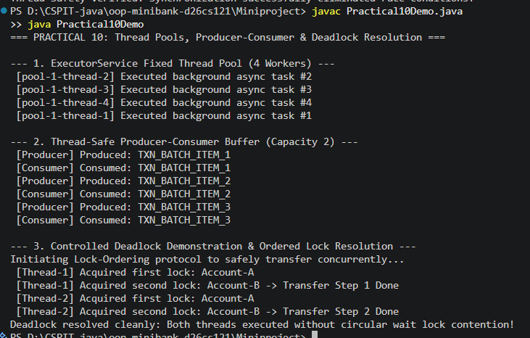

11. Practical 11 (Part B): Serialization Persistence, Audit Trail & Modern NIO Reporting:-
Make models Serializable with serialVersionUID. Create StatePersister with save(Account[], Path) and load(Path) using ObjectOutputStream/ObjectInputStream in try-with-resources. Create TransactionLog appending timestamped entries with Files.write(CREATE, APPEND). Create ReportGenerator using Files.newDirectoryStream, BufferedReader, and Files.readAttributes to produce an end-of-day summary report.

Code:-
// File: util/StatePersister.java
package util;

import model.Account;

import java.io.*;
import java.nio.file.Files;
import java.nio.file.Path;

// Handles binary serialization and deserialization of account arrays
public class StatePersister {

private StatePersister() {
// Prevent instantiation
}

public static void save(Account[] accounts, Path file) throws IOException {
if (file.getParent() != null) {
Files.createDirectories(file.getParent());
}
// Try-with-resources ensures ObjectOutputStream is safely flushed and closed
try (ObjectOutputStream oos = new ObjectOutputStream(Files.newOutputStream(file))) {
oos.writeObject(accounts);
}
}

public static Account[] load(Path file) throws IOException, ClassNotFoundException {
if (!Files.exists(file)) {
return new Account[0];
}
// Try-with-resources for reading serialized state
try (ObjectInputStream ois = new ObjectInputStream(Files.newInputStream(file))) {
return (Account[]) ois.readObject();
}
}
}

// File: util/TransactionLog.java
package util;

import java.io.IOException;
import java.nio.charset.StandardCharsets;
import java.nio.file.Files;
import java.nio.file.Path;
import java.nio.file.StandardOpenOption;
import java.time.LocalDateTime;
import java.time.format.DateTimeFormatter;
import java.util.Collections;

// Append-only audit logger using modern java.nio.file operations
public class TransactionLog {

private static final DateTimeFormatter FORMATTER = DateTimeFormatter.ofPattern("yyyy-MM-dd HH:mm:ss");

private TransactionLog() {
// Prevent instantiation
}

public static void append(Path file, String line) throws IOException {
if (file.getParent() != null) {
Files.createDirectories(file.getParent());
}
String timestampedEntry = "[" + LocalDateTime.now().format(FORMATTER) + "] " + line;
Files.write(
file,
Collections.singletonList(timestampedEntry),
StandardCharsets.UTF_8,
StandardOpenOption.CREATE,
StandardOpenOption.APPEND
);
}
}

// File: util/ReportGenerator.java
package util;

import java.io.BufferedReader;
import java.io.BufferedWriter;
import java.io.IOException;
import java.nio.charset.StandardCharsets;
import java.nio.file.*;
import java.nio.file.attribute.BasicFileAttributes;
import java.time.LocalDateTime;

// Generates audit reports by scanning transaction logs using java.nio.file DirectoryStream and BufferedReader
public class ReportGenerator {

private ReportGenerator() {
// Prevent instantiation
}

public static void generateReport(Path logsDir, Path reportFile) throws IOException {
if (!Files.exists(logsDir)) {
Files.createDirectories(logsDir);
}
if (reportFile.getParent() != null) {
Files.createDirectories(reportFile.getParent());
}

long totalDeposits = 0;
long totalWithdrawals = 0;
int totalTransactions = 0;
int filesProcessed = 0;

StringBuilder details = new StringBuilder();

// Files.newDirectoryStream efficiently iterates over folder contents
try (DirectoryStream<Path> stream = Files.newDirectoryStream(logsDir, "*.log")) {
for (Path entry : stream) {
filesProcessed++;
BasicFileAttributes attrs = Files.readAttributes(entry, BasicFileAttributes.class);
details.append(String.format("File: %s | Size: %d bytes | Created: %s%n",
entry.getFileName(), attrs.size(), attrs.creationTime()));

try (BufferedReader reader = Files.newBufferedReader(entry, StandardCharsets.UTF_8)) {
String line;
while ((line = reader.readLine()) != null) {
totalTransactions++;
if (line.contains("DEPOSIT")) {
long amt = extractAmount(line);
totalDeposits += amt;
} else if (line.contains("WITHDRAW") || line.contains("TRANSFER")) {
long amt = extractAmount(line);
totalWithdrawals += amt;
}
}
}
}
}

// Write summary report
try (BufferedWriter writer = Files.newBufferedWriter(reportFile, StandardCharsets.UTF_8,
StandardOpenOption.CREATE, StandardOpenOption.TRUNCATE_EXISTING)) {
writer.write("====================================================\n");
writer.write(" MINIBANK END-OF-DAY AUDIT REPORT \n");
writer.write("====================================================\n");
writer.write("Generated At : " + LocalDateTime.now() + "\n");
writer.write("Log Files Checked : " + filesProcessed + "\n");
writer.write("Total Log Entries : " + totalTransactions + "\n");
writer.write(String.format("Total Deposits : Rs. %,d%n", totalDeposits));
writer.write(String.format("Total Withdrawals : Rs. %,d%n", totalWithdrawals));
writer.write("Net System Flow : Rs. " + (totalDeposits - totalWithdrawals) + "\n");
writer.write("----------------------------------------------------\n");
writer.write("Log File Details:\n");
writer.write(details.toString());
writer.write("====================================================\n");
}
}

private static long extractAmount(String line) {
try {
String[] parts = line.split("\\s+");
for (int i = 0; i < parts.length; i++) {
if (parts[i].equalsIgnoreCase("amount:") || parts[i].equalsIgnoreCase("Rs.")) {
if (i + 1 < parts.length) {
return Long.parseLong(parts[i + 1].replaceAll("[^0-9]", ""));
}
}
}
// Fallback: look for last token as number
String last = parts[parts.length - 1].replaceAll("[^0-9]", "");
if (!last.isEmpty()) {
return Long.parseLong(last);
}
} catch (Exception ignored) {
}
return 0;
}
}

Output:-
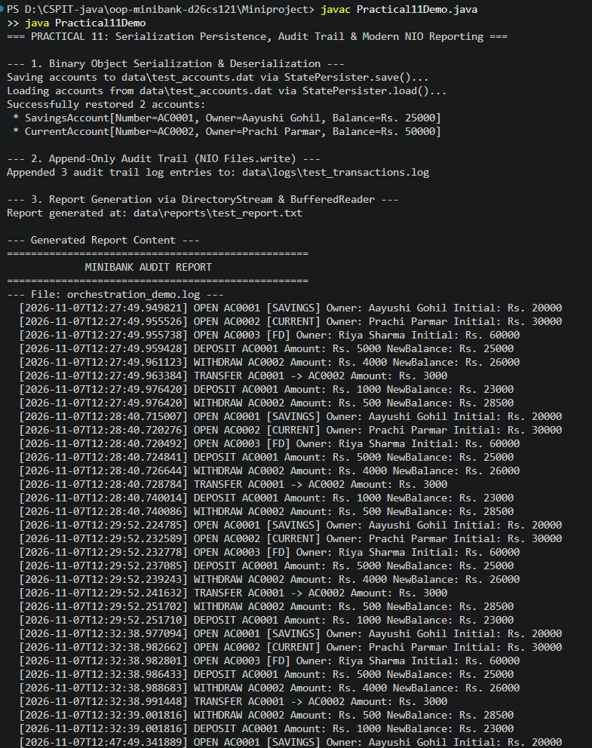

12. Practical 12 (Part B): Collections Framework: HashMap, ArrayList & Comparators:-
Upgrade storage to the Java Collections Framework. Create AccountStore keeping accounts in a HashMap<String, Account> and transaction history in an ArrayList<String>. Add sortedByBalance() returning an ArrayList<Account> sorted with a Comparator. Make Account implement Comparable<Account> by comparing accountNumber.

Code:-
// File: util/AccountStore.java
package util;

import model.Account;

import java.util.ArrayList;
import java.util.Collections;
import java.util.Comparator;
import java.util.HashMap;
import java.util.List;
import java.util.Map;

// Storage layer managing accounts via HashMap and maintaining chronological audit history in an ArrayList
public class AccountStore {

private final Map<String, Account> accounts = new HashMap<>();
private final List<String> history = new ArrayList<>();

public void add(Account account) {
if (account != null) {
accounts.put(account.getAccountNumber(), account);
history.add("Added account: " + account.getAccountNumber() + " for " + account.getOwnerName());
}
}

public Account get(String accountNumber) {
return accounts.get(accountNumber);
}

public List<Account> getAll() {
return new ArrayList<>(accounts.values());
}

public List<String> getHistory() {
return Collections.unmodifiableList(history);
}

public void recordHistory(String entry) {
history.add(entry);
}

// Returns accounts sorted in descending order of balance using custom Comparator
public List<Account> sortedByBalance() {
List<Account> list = new ArrayList<>(accounts.values());
list.sort(Comparator.comparingLong(Account::getBalance).reversed());
return list;
}

// Returns accounts sorted in natural order (by AccountNumber via Comparable)
public List<Account> sortedByAccountNumber() {
List<Account> list = new ArrayList<>(accounts.values());
Collections.sort(list);
return list;
}
}

// File: model/Account.java (Comparable)
// Natural ordering implementation by Account Number
@Override
public int compareTo(Account other) {
return this.accountNumber.compareTo(other.accountNumber);
}

Output:-
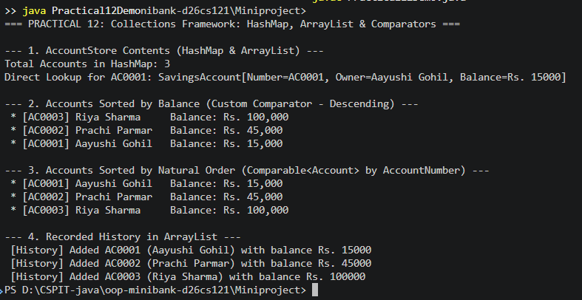

13. Practical 13 (Part B): Generic Repository Pattern with Reflection Primary Key:-
Make storage reusable. Create generic class Repository<T> holding HashMap<String, T> with methods save, findById, findAll, and delete. In save(), discover the entity's key by reading the @Id annotation using reflection. Add @SafeVarargs saveAll(T... items). Add bounded generic method <N extends Number> double average(N[] values). Test with Account and Customer.

Code:-
// File: util/Repository.java
package util;

import model.annotation.Id;

import java.lang.reflect.Field;
import java.util.ArrayList;
import java.util.HashMap;
import java.util.Map;

// Generic repository implementing type-safe CRUD operations with reflection-based @Id discovery
public class Repository<T> {

private final Map<String, T> store = new HashMap<>();

public synchronized T save(T entity) {
if (entity == null) {
throw new IllegalArgumentException("Cannot save null entity");
}
String id = extractId(entity);
if (id == null) {
throw new IllegalStateException("Entity of type " + entity.getClass().getSimpleName() + " has no @Id field or value is null");
}
store.put(id, entity);
return entity;
}

public synchronized T findById(String id) {
return store.get(id);
}

public synchronized ArrayList<T> findAll() {
return new ArrayList<>(store.values());
}

public synchronized boolean delete(String id) {
return store.remove(id) != null;
}

// @SafeVarargs suppresses unchecked warnings for generic varargs
@SafeVarargs
public final synchronized void saveAll(T... items) {
if (items != null) {
for (T item : items) {
save(item);
}
}
}

// Generic method with bounded type parameter <N extends Number>
public static <N extends Number> double average(N[] values) {
if (values == null || values.length == 0) {
return 0.0;
}
double sum = 0.0;
for (N val : values) {
if (val != null) {
sum += val.doubleValue();
}
}
return sum / values.length;
}

// Helper using reflection to discover @Id field
private String extractId(T entity) {
Class<?> clazz = entity.getClass();
while (clazz != null && clazz != Object.class) {
for (Field field : clazz.getDeclaredFields()) {
if (field.isAnnotationPresent(Id.class)) {
field.setAccessible(true);
try {
Object val = field.get(entity);
return val != null ? val.toString() : null;
} catch (IllegalAccessException e) {
throw new RuntimeException("Could not read @Id field: " + field.getName(), e);
}
}
}
clazz = clazz.getSuperclass();
}
return null;
}
}

Output:-
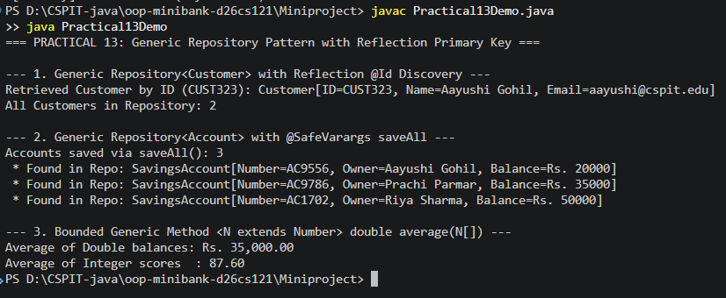

14. Practical 14 (Part B): BankService Orchestration, Full Console & Automated JUnit 5:-
Assemble MiniBank to final deliverable standard. Create BankService using Repository<Account>, Validator, and exceptions to provide openAccount, deposit, withdraw, transfer, statement, and listAccounts. Connect interactive menu, load on start, save on exit, batch processing via TransactionProcessor, and end-of-day report. Write JUnit 5 test suite verifying deposit calculation, exception handling, and concurrent multithreading.

Code:-
// File: service/BankService.java
package service;

import exception.AccountNotFoundException;
import exception.BankException;
import exception.InsufficientFundsException;
import exception.InvalidAmountException;
import model.Account;
import model.CurrentAccount;
import model.FixedDepositAccount;
import model.SavingsAccount;
import util.*;

import java.io.IOException;
import java.nio.file.Path;
import java.nio.file.Paths;
import java.util.ArrayList;
import java.util.List;

// Core banking service layer orchestrating domain operations, validation, persistence, and audit logging
public class BankService {

private final Repository<Account> repository;
private final Path logFilePath;

public BankService() {
this(new Repository<>(), Paths.get("data", "logs", "transactions.log"));
}

public BankService(Repository<Account> repository, Path logFilePath) {
this.repository = repository;
this.logFilePath = logFilePath;
}

// Opens a new account after validating inputs and persists in repository
public Account openAccount(String ownerName, long initialDeposit, String type) throws BankException {
if (ownerName == null || ownerName.trim().isEmpty()) {
throw new BankException("Owner name cannot be empty");
}
if (initialDeposit < 0) {
throw new InvalidAmountException("Initial deposit cannot be negative");
}

Account account;
String t = type == null ? "SAVINGS" : type.trim().toUpperCase();
switch (t) {
case "CURRENT" -> account = new CurrentAccount(ownerName.trim(), initialDeposit);
case "FD", "FIXED_DEPOSIT" -> account = new FixedDepositAccount(ownerName.trim(), initialDeposit);
default -> account = new SavingsAccount(ownerName.trim(), initialDeposit);
}

// Validate annotations on new entity
String[] violations = AnnotationValidator.validate(account);
if (violations.length > 0) {
throw new BankException("Validation failed: " + String.join(", ", violations));
}

repository.save(account);
logTransaction(String.format("OPEN %s [%s] Owner: %s Initial: Rs. %,d",
account.getAccountNumber(), account.getClass().getSimpleName(), account.getOwnerName(), initialDeposit));
return account;
}

// Deposits money into specified account
public void deposit(String accountNumber, long amount) throws BankException {
if (amount <= 0) {
throw new InvalidAmountException("Deposit amount must be positive: " + amount);
}
Account account = getAccountOrThrow(accountNumber);
account.deposit(amount);
logTransaction(String.format("DEPOSIT %s Amount: Rs. %,d NewBalance: Rs. %,d",
accountNumber, amount, account.getBalance()));
}

// Withdraws money according to account balance and rules
public boolean withdraw(String accountNumber, long amount) throws BankException {
if (amount <= 0) {
throw new InvalidAmountException("Withdrawal amount must be positive: " + amount);
}
Account account = getAccountOrThrow(accountNumber);
boolean success = account.withdraw(amount);
logTransaction(String.format("WITHDRAW %s Amount: Rs. %,d NewBalance: Rs. %,d",
accountNumber, amount, account.getBalance()));
return success;
}

// Transfers funds atomically between two accounts
public void transfer(String fromAccountNumber, String toAccountNumber, long amount) throws BankException {
if (fromAccountNumber == null || toAccountNumber == null || fromAccountNumber.equalsIgnoreCase(toAccountNumber)) {
throw new BankException("Invalid transfer accounts specified");
}
if (amount <= 0) {
throw new InvalidAmountException("Transfer amount must be positive: " + amount);
}
Account from = getAccountOrThrow(fromAccountNumber);
Account to = getAccountOrThrow(toAccountNumber);

from.transfer(to, amount);
logTransaction(String.format("TRANSFER From: %s To: %s Amount: Rs. %,d",
fromAccountNumber, toAccountNumber, amount));
}

// Generates formatted account statement
public String statement(String accountNumber) throws BankException {
Account account = getAccountOrThrow(accountNumber);
return StatementFormatter.buildStatement(account);
}

// Lists all active accounts currently managed by the repository
public List<Account> listAccounts() {
return repository.findAll();
}

// Processes a list of commands in batch via TransactionProcessor thread pool
public void processBatch(List<Command> commands) {
if (commands == null || commands.isEmpty()) {
return;
}
TransactionProcessor processor = new TransactionProcessor(4);
for (Command cmd : commands) {
processor.submit(() -> {
try {
switch (cmd.type()) {
case DEPOSIT -> deposit(cmd.accountNumber(), cmd.amount());
case WITHDRAW -> withdraw(cmd.accountNumber(), cmd.amount());
case TRANSFER -> {
System.out.println("[Batch] Transfer command requires two accounts; skipping raw batch transfer.");
}
}
} catch (Exception e) {
System.err.println("[Batch Error] " + e.getMessage());
}
});
}
processor.stop();
}

// Persists current in-memory accounts to binary file
public void saveAccounts(Path file) throws IOException {
List<Account> all = repository.findAll();
StatePersister.save(all.toArray(new Account[0]), file);
}

// Loads accounts from serialized file into repository
public void loadAccounts(Path file) throws IOException, ClassNotFoundException {
Account[] loaded = StatePersister.load(file);
for (Account acc : loaded) {
repository.save(acc);
}
}

// Generates end-of-day summary report from audit logs
public void generateReport(Path logsDir, Path reportFile) throws IOException {
ReportGenerator.generateReport(logsDir, reportFile);
}

public Repository<Account> getRepository() {
return repository;
}

private Account getAccountOrThrow(String accountNumber) throws AccountNotFoundException {
Account acc = repository.findById(accountNumber);
if (acc == null) {
throw new AccountNotFoundException("Account not found with ID: " + accountNumber);
}
return acc;
}

private void logTransaction(String entry) {
try {
TransactionLog.append(logFilePath, entry);
} catch (IOException e) {
System.err.println("Audit logging failed: " + e.getMessage());
}
}
}

// File: MiniBank.java (Complete Driver)
import exception.AccountNotFoundException;
import exception.BankException;
import exception.InsufficientFundsException;
import exception.InvalidAmountException;
import model.*;
import service.AccountWorker;
import service.BankService;
import service.TransactionProcessor;
import util.Command;
import util.CommandParser;
import util.Repository;

import java.io.File;
import java.nio.file.Files;
import java.nio.file.Path;
import java.nio.file.Paths;
import java.util.ArrayList;
import java.util.List;
import java.util.Scanner;

// Main driver class for MiniBank console application (Milestones 1-3 Capstone)
public class MiniBank {

private static final Path DATA_FILE = Paths.get("data", "accounts.dat");
private static final Path LOGS_DIR = Paths.get("data", "logs");
private static final Path REPORT_FILE = Paths.get("data", "reports", "daily_report.txt");

public static void main(String[] args) {
BankInfo bankInfo = new BankInfo("MiniBank", "Ahmedabad Branch (D26CS121)");
System.out.println("====================================================");
System.out.println(" WELCOME TO " + bankInfo.name().toUpperCase());
System.out.println(" Branch: " + bankInfo.branch());
System.out.println("====================================================");

BankService bankService = new BankService();

// Load existing saved accounts if available (Practical 11)
if (Files.exists(DATA_FILE)) {
try {
bankService.loadAccounts(DATA_FILE);
System.out.println("[Persistence] Successfully restored accounts from storage.");
} catch (Exception e) {
System.out.println("[Persistence] Notice: Fresh database initialized (" + e.getMessage() + ")");
}
} else {
// Seed sample accounts if starting fresh
try {
bankService.openAccount("Aayushi Gohil", 15000, "SAVINGS");
bankService.openAccount("Prachi Parmar", 25000, "CURRENT");
bankService.openAccount("Riya Sharma", 50000, "FD");
} catch (Exception ignored) {}
}

Scanner scanner = new Scanner(System.in);
boolean running = true;

while (running) {
printMenu();
System.out.print("Enter your choice (1-10): ");
String input = scanner.nextLine().trim();

int choice;
try {
choice = Integer.parseInt(input);
} catch (NumberFormatException e) {
System.out.println("Invalid selection. Please enter a number between 1 and 10.");
continue;
}

if (choice < 1 || choice > MenuOption.values().length) {
System.out.println("Choice out of range. Please choose between 1 and " + MenuOption.values().length + ".");
continue;
}

MenuOption option = MenuOption.values()[choice - 1];

// Modern switch expression executing corresponding banking service
switch (option) {
case OPEN_ACCOUNT -> handleOpenAccount(scanner, bankService);
case DEPOSIT -> handleDeposit(scanner, bankService);
case WITHDRAW -> handleWithdraw(scanner, bankService);
case TRANSFER -> handleTransfer(scanner, bankService);
case VIEW_STATEMENT -> handleStatement(scanner, bankService);
case LIST_ACCOUNTS -> handleListAccounts(bankService);
case PROCESS_BATCH -> handleBatchProcessing(scanner, bankService);
case AUDIT_REPORT -> handleGenerateReport(bankService);
case RUN_CAPSTONE_DEMO -> runCapstoneDemos(bankService);
case EXIT -> {
System.out.println("\nSaving application state...");
try {
bankService.saveAccounts(DATA_FILE);
System.out.println("[Persistence] Saved " + bankService.listAccounts().size() + " accounts to " + DATA_FILE);
} catch (Exception e) {
System.err.println("Could not save state: " + e.getMessage());
}
System.out.println("Thank you for using MiniBank. Goodbye!");
running = false;
}
}
}
}

private static void printMenu() {
System.out.println("\n----------------- MiniBank Menu -----------------");
System.out.println(" 1. Open Account");
System.out.println(" 2. Deposit Funds");
System.out.println(" 3. Withdraw Funds");
System.out.println(" 4. Transfer Funds");
System.out.println(" 5. View Account Statement");
System.out.println(" 6. List All Accounts");
System.out.println(" 7. Process Batch Transactions");
System.out.println(" 8. Generate Audit Report");
System.out.println(" 9. Run Capstone Concept Demos (P01-P13)");
System.out.println("10. Exit");
System.out.println("-------------------------------------------------");
}

private static void handleOpenAccount(Scanner scanner, BankService service) {
try {
System.out.print("Enter Account Holder Name: ");
String name = scanner.nextLine().trim();

System.out.print("Enter Account Type (1 for Savings, 2 for Current, 3 for Fixed Deposit): ");
String typeStr = scanner.nextLine().trim();
String type = switch (typeStr) {
case "2" -> "CURRENT";
case "3" -> "FD";
default -> "SAVINGS";
};

System.out.print("Enter Initial Deposit Amount (Rs.): ");
long initialDeposit = Long.parseLong(scanner.nextLine().trim());

Account acc = service.openAccount(name, initialDeposit, type);
System.out.println("Success! Account created with Account Number: " + acc.getAccountNumber());
} catch (NumberFormatException e) {
System.out.println("Error: Amount must be a valid whole number.");
} catch (BankException e) {
System.out.println("Operation Failed: " + e.getMessage());
}
}

private static void handleDeposit(Scanner scanner, BankService service) {
try {
System.out.print("Enter Account Number (e.g. AC0001): ");
String accNum = scanner.nextLine().trim().toUpperCase();

System.out.print("Enter Amount to Deposit (Rs.): ");
long amount = Long.parseLong(scanner.nextLine().trim());

service.deposit(accNum, amount);
System.out.println("Deposit successful!");
} catch (NumberFormatException e) {
System.out.println("Error: Amount must be a valid integer.");
} catch (BankException e) {
System.out.println("Deposit Failed: " + e.getMessage());
}
}

private static void handleWithdraw(Scanner scanner, BankService service) {
try {
System.out.print("Enter Account Number (e.g. AC0001): ");
String accNum = scanner.nextLine().trim().toUpperCase();

System.out.print("Enter Amount to Withdraw (Rs.): ");
long amount = Long.parseLong(scanner.nextLine().trim());

service.withdraw(accNum, amount);
System.out.println("Withdrawal successful!");
} catch (NumberFormatException e) {
System.out.println("Error: Amount must be a valid integer.");
} catch (InsufficientFundsException e) {
System.out.println("Withdrawal Denied: Insufficient balance. Shortfall of Rs. " + e.getShortfall());
} catch (BankException e) {
System.out.println("Withdrawal Failed: " + e.getMessage());
}
}

private static void handleTransfer(Scanner scanner, BankService service) {
try {
System.out.print("Enter Source Account Number: ");
String from = scanner.nextLine().trim().toUpperCase();

System.out.print("Enter Destination Account Number: ");
String to = scanner.nextLine().trim().toUpperCase();

System.out.print("Enter Amount to Transfer (Rs.): ");
long amount = Long.parseLong(scanner.nextLine().trim());

service.transfer(from, to, amount);
System.out.println("Transfer completed successfully!");
} catch (NumberFormatException e) {
System.out.println("Error: Amount must be a valid integer.");
} catch (BankException e) {
System.out.println("Transfer Failed: " + e.getMessage());
}
}

private static void handleStatement(Scanner scanner, BankService service) {
try {
System.out.print("Enter Account Number: ");
String accNum = scanner.nextLine().trim().toUpperCase();
String stmt = service.statement(accNum);
System.out.println(stmt);
} catch (BankException e) {
System.out.println("Error: " + e.getMessage());
}
}

private static void handleListAccounts(BankService service) {
List<Account> accounts = service.listAccounts();
if (accounts.isEmpty()) {
System.out.println("No accounts registered in system.");
return;
}
System.out.println("\n--- All Registered Accounts (" + accounts.size() + ") ---");
for (Account acc : accounts) {
System.out.println(" * " + acc);
}
}

private static void handleBatchProcessing(Scanner scanner, BankService service) {
System.out.println("Enter commands in format: <TYPE> <ACC_NUM> <AMOUNT> (Enter empty line when done):");
System.out.println("Example: DEPOSIT AC0001 500");
List<Command> commands = new ArrayList<>();
while (true) {
System.out.print("command> ");
String line = scanner.nextLine().trim();
if (line.isEmpty()) break;
try {
Command cmd = CommandParser.parse(line);
commands.add(cmd);
System.out.println("Added: " + cmd);
} catch (Exception e) {
System.out.println("Invalid command: " + e.getMessage());
}
}
if (!commands.isEmpty()) {
System.out.println("Executing batch of " + commands.size() + " commands concurrently...");
service.processBatch(commands);
System.out.println("Batch processing completed.");
}
}

private static void handleGenerateReport(BankService service) {
try {
service.generateReport(LOGS_DIR, REPORT_FILE);
System.out.println("Audit Report generated successfully at: " + REPORT_FILE);
if (Files.exists(REPORT_FILE)) {
System.out.println("\nReport Preview:");
Files.lines(REPORT_FILE).forEach(System.out::println);
}
} catch (Exception e) {
System.out.println("Report Generation Failed: " + e.getMessage());
}
}

// Demonstrates all key concepts across Practicals 1 to 13
private static void runCapstoneDemos(BankService service) {
System.out.println("\n=======================================================");
System.out.println(" MINIBANK CAPSTONE CONCEPT DEMONSTRATIONS ");
System.out.println("=======================================================");

// 1. Practical 02 & 03: Customer deep cloning & static nested Address
System.out.println("\n[P02 & P03 Demo] Customer Deep Cloning & Nested Address:");
Customer originalCust = new Customer("Aayushi Gohil", "aayushi@cspit.edu", "9876543210");
Customer.Address addr = new Customer.Address("123 College Road", "Changa", "388421");
originalCust.setAddress(addr);

Customer clonedCust = originalCust.clone();
System.out.println("Original Customer: " + originalCust);
System.out.println("Cloned Customer : " + clonedCust);
System.out.println("Same object reference? (original == clone): " + (originalCust == clonedCust));
System.out.println("Same address reference? (addr == clone.addr): " + (originalCust.getAddress() == clonedCust.getAddress()));

// 2. Practical 05 & 06: Polymorphism & Interfaces
System.out.println("\n[P05 & P06 Demo] Polymorphism & Default Method in Interfaces:");
Account sa = new SavingsAccount("Demo Savings", 10000);
Account ca = new CurrentAccount("Demo Current", 10000);
Account fd = new FixedDepositAccount("Demo FD", 10000);

System.out.printf("Savings Account yearly interest: Rs. %.2f%n", sa.yearlyInterest());
System.out.printf("Current Account yearly interest: Rs. %.2f%n", ca.yearlyInterest());
System.out.printf("Fixed Deposit yearly interest : Rs. %.2f%n", fd.yearlyInterest());

// 3. Practical 09: Multithreading & Concurrency protection
System.out.println("\n[P09 Demo] Thread Synchronization on Account Balance:");
Account threadAcc = new SavingsAccount("Concurrent User", 1000);
Thread[] threads = new Thread[5];
for (int i = 0; i < threads.length; i++) {
threads[i] = new Thread(new AccountWorker(threadAcc, 100, 10), "Worker-" + (i + 1));
threads[i].start();
}
for (Thread t : threads) {
try { t.join(); } catch (InterruptedException ignored) {}
}
System.out.println("Expected final balance: 1000 + (5 * 100 * 10) = Rs. 6000");
System.out.println("Actual final balance : Rs. " + threadAcc.getBalance());

// 4. Practical 10: Deadlock prevention demo
System.out.println("\n[P10 Demo] Deadlock Detection & Safe Transfer:");
Account accA = new SavingsAccount("Party A", 5000);
Account accB = new SavingsAccount("Party B", 5000);
TransactionProcessor.runDeadlockDemo(accA, accB);

// 5. Practical 13: Generic Repository & Bounded Types
System.out.println("\n[P13 Demo] Generic Repository<T> & Bounded Generic Method:");
Repository<Customer> custRepo = new Repository<>();
custRepo.save(originalCust);
Customer found = custRepo.findById(originalCust.getCustomerId());
System.out.println("Retrieved from generic Customer repository: " + (found != null ? found.getName() : "None"));

Double[] balances = {10000.0, 25000.0, 50000.0};
double avg = Repository.average(balances);
System.out.printf("Computed average using bounded generic method: Rs. %.2f%n", avg);
System.out.println("=======================================================\n");
}
}

// File: test/BankServiceTest.java (JUnit 5)
package test;

import exception.InsufficientFundsException;
import exception.InvalidAmountException;
import model.SavingsAccount;
import org.junit.jupiter.api.BeforeEach;
import org.junit.jupiter.api.DisplayName;
import org.junit.jupiter.api.Test;
import service.AccountWorker;

import static org.junit.jupiter.api.Assertions.*;

// JUnit 5 test suite verifying transactional integrity, boundary validations, and concurrency
public class BankServiceTest {

private SavingsAccount account;

@BeforeEach
void setUp() {
account = new SavingsAccount("Aayushi Gohil", 1000, 500);
}

@Test
@DisplayName("Deposit increases account balance correctly")
void testDepositIncreasesBalance() throws InvalidAmountException {
account.deposit(500);
assertEquals(1500, account.getBalance(), "Balance after depositing 500 should be 1500");
}

@Test
@DisplayName("Withdrawal exceeding balance throws InsufficientFundsException")
void testWithdrawOverLimitThrowsException() {
// Attempting to withdraw 800 leaves 200, which is below minBalance of 500
assertThrows(InsufficientFundsException.class, () -> account.withdraw(800),
"Should throw InsufficientFundsException when minimum balance is violated");
}

@Test
@DisplayName("Concurrent deposits maintain correct balance under multithreading")
void testConcurrentDepositsKeepBalanceCorrect() throws InterruptedException {
int threadCount = 10;
int operationsPerThread = 100;
long amountPerDeposit = 10;

Thread[] threads = new Thread[threadCount];
for (int i = 0; i < threadCount; i++) {
threads[i] = new Thread(new AccountWorker(account, operationsPerThread, amountPerDeposit), "TestWorker-" + i);
threads[i].start();
}

for (Thread t : threads) {
t.join();
}

long expectedBalance = 1000 + (threadCount * operationsPerThread * amountPerDeposit);
assertEquals(expectedBalance, account.getBalance(), "Synchronized deposits should prevent race condition");
}
}

Output:-


