
Vishal Sanjay Yadav
MCA Batch ( 2024 - 26 )

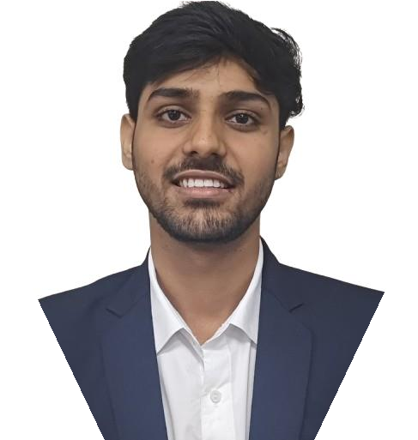




EDUCATION
ABOUT ME
Date of Birth: 30/01/2004 Gender: Male
Birth Place: Uttar Pradesh
CONTACT
TECHNICAL SKILLS
Programming Languages:
Java, Python, Javascript, PHP, MERN
Databases:
MongoDB, Oracle, SQL
Software Packages and Tools:
Power BI, Kali Linux, Wireshark, BurpSuite, Hydra, Visual Studio, Git, GitHub, Docker
INTERESTS
Music Gaming Reading
LANGUAGES KNOWN
English Hindi
Bhojpuri
Marathi

MCA | Thakur Institute of Management Studies Career Development& Research (TIMSCDR), Mumbai| Pursuing | 9.67 (GPA)|2025
University of Mumbai

BACHELOR DEGREE | Ramniranjan Jhunjhunwala | 9.64 (CGPA) | 2024
Bachelor of Science in Information Technology
University of Mumbai

XII (HSC)| Guru Nanak Junior College| 83.50 % | 2021
Science
Maharashtra State Board of Secondary and Higher Secondary

X (SSC) | Guru Nanak High School| 72.80 % | 2019
Maharashtra State Board of Secondary and Higher Secondary

EXPERIENCE

SEQURETEK PVT. LTD (26th Feb – 16th Sep 2024)
Position : Linux System Administrator Roles & Responsibilities:
Tank Road, Bhandup-(W),
Mumbai-400078.
+91 7506892139
30vishalyadav@gmail.com
https://www.linkedin.com/in/vishal-
yadav-4a9742280/
https://www.hackerrank.com/profile/ 30vishalyadav
https://github.com/yvishal30

- Conducted Vulnerability and Compliance Assessments to identify and address security risks.
- Applied OS patching via RPM and YUM to maintain system security.
- Implemented server hardening to minimize attack surfaces and enhance protection.

PROJECTS UNDERTAKEN
Real Estate Portal | MERN | Live | 2025 https://real-estate-portal-nine.vercel.app/
  - Implemented role-based access with secure auth for Admin, Agent, and Client.
  - Enabled portfolio creation with property listings and image carousels.
  - Designed responsive UI with Tailwind CSS and deployed live on Vercel.

Voice-Based Authentication & Bias Detection System | MATLAB, Deep Learning | 2025
  - Built a 1D-CNN voice authentication model using MFCC features (~75% accuracy).
  - Reduced demographic bias through fairness-focused preprocessing.
  - Evaluated performance and user trust via a 90-person survey.

CERTIFICATION PROGRAM
- Foundational C# with Microsoft (Microsoft) February 2025
- Introduction To Cyber Security (Cisco) March 2024
- Network Support and Security (Cisco) March 2024
- Cyber Threat Management (Cisco) May 2024

CO-CURRICULAR AND EXTRA-CURRICULAR ACTIVITIES
- Headed the Research Paper Editorial Team for the ICAIM event.
- Led a team in Synapse Product Development Program, securing 3rd place for a UN SDG-based solution.
- Volunteered in college events including Yuvotsav and Vista.

Institute Address: Thakur Institute of Management Studies Career Development and Research - Thakur Education Campus, Thakur Village, Kandivali East. Mumbai 400101.
Phone Nos: 022- 28840484/91. E-mail ID: timscdr.tnp@thakureducation.org

