**Market Segmentation**

Analyze the respective Markets in India using Segmentation analysis and come up with a feasible strategy to enter the market targeting the segments most likely to use their services in a tax consultancy firm.

By

Aayushi Bohra

Gurgeet Singh Bhogal

Yashvardhan Mahecha

Manav

OVERVIEW

To analyze the respective Markets in India using Segmentation analysis and come up with a feasible strategy to enter the market targeting the segments most likely to use their services in a tax consultancy firm.

Market segmentation is the process of dividing a target market into smaller, more defined categories. It segments customers and audiences into groups that share similar characteristics such as demographics, interests, needs, or location. The importance of market segmentation is that it makes it easier to focus marketing efforts and resources on reaching the most valuable audiences and achieving business goals. Market segmentation allows you to get to know your customers, identify what is needed in your market segment, and determine how you can best meet those needs with your product or service. This helps you design and execute better marketing strategies from top to bottom.

As the project focuses upon using market segmentation analysis and produce a feasible strategy to enter the targeting market in the area of taxes we first define taxes.

Taxes are mandatory contributions levied on individuals or corporations by a government entity—whether local, regional or national. Tax revenues finance government activities, including such public works and services as roads and schools, or programs like Social Security and Medicare. In economics, taxes fall on whoever pays the burden of the tax, whether this is the entity being taxed, such as a business, or the end consumers of the business's goods.

Taxation has been the primary source of revenue for states across the world for centuries and India is no exception to this. The nation has a structured tax system that employs both progressive and proportional taxation based on income and other factors and is determined by central and state governments. The money received by the government is known as tax revenue and may be utilized for a broad spectrum of purposes such as infrastructure development in the form of roads, railways, bridges, dams etc., public healthcare and education, defense and civil services, to name a few. Helping the government fulfill its development goals is the main importance of taxes.

India’s tax to GDP ratio as of 2018-19 was 10.9%, a worryingly low number given that the average ratio for OECD member states is around 34%. A high tax to GDP ratio signifies the government’s ability to manage its spending effectively, without relying on excess borrowing. High ratios are also generally associated with developed nations. India’s relatively low figures could be indicative of the reduced collection of service taxes, comparatively high GDP growth as well as income tax evasion prevalent among large corporations and the upper strata of society.

The majority of tax payers are the middle class public of the country. Middle class is also the backbone of economy as it constitutes a large part of tax payers.

The middle classes constitute a critical market for most goods and services. A sizable portion of any nation’s tax revenue is collected either directly or indirectly from this group, and they also have an important role in any relative political stability that a country experiences. The significance of this class was best elucidated by the late Lester Thurow, the eminent MIT economist: “A healthy middle class is necessary to have a healthy political democracy. A society made up of rich and poor has no mediating group either politically or economically.”

The middle class falls in the middle of the social hierarchy and occupies a socioeconomic position between the working and upper classes. The measures of what constitutes members of this class differ significantly among nations because of international cultural and economic variations.

Market Overview

India collects ₹3 tn a year from individual taxpayers. Who are they, and what does the salaried class contribute?

Income growth for the salaried class has collapsed. In fact, it has barely moved post demonetization, while the average business income has risen by around 7.2% per year.

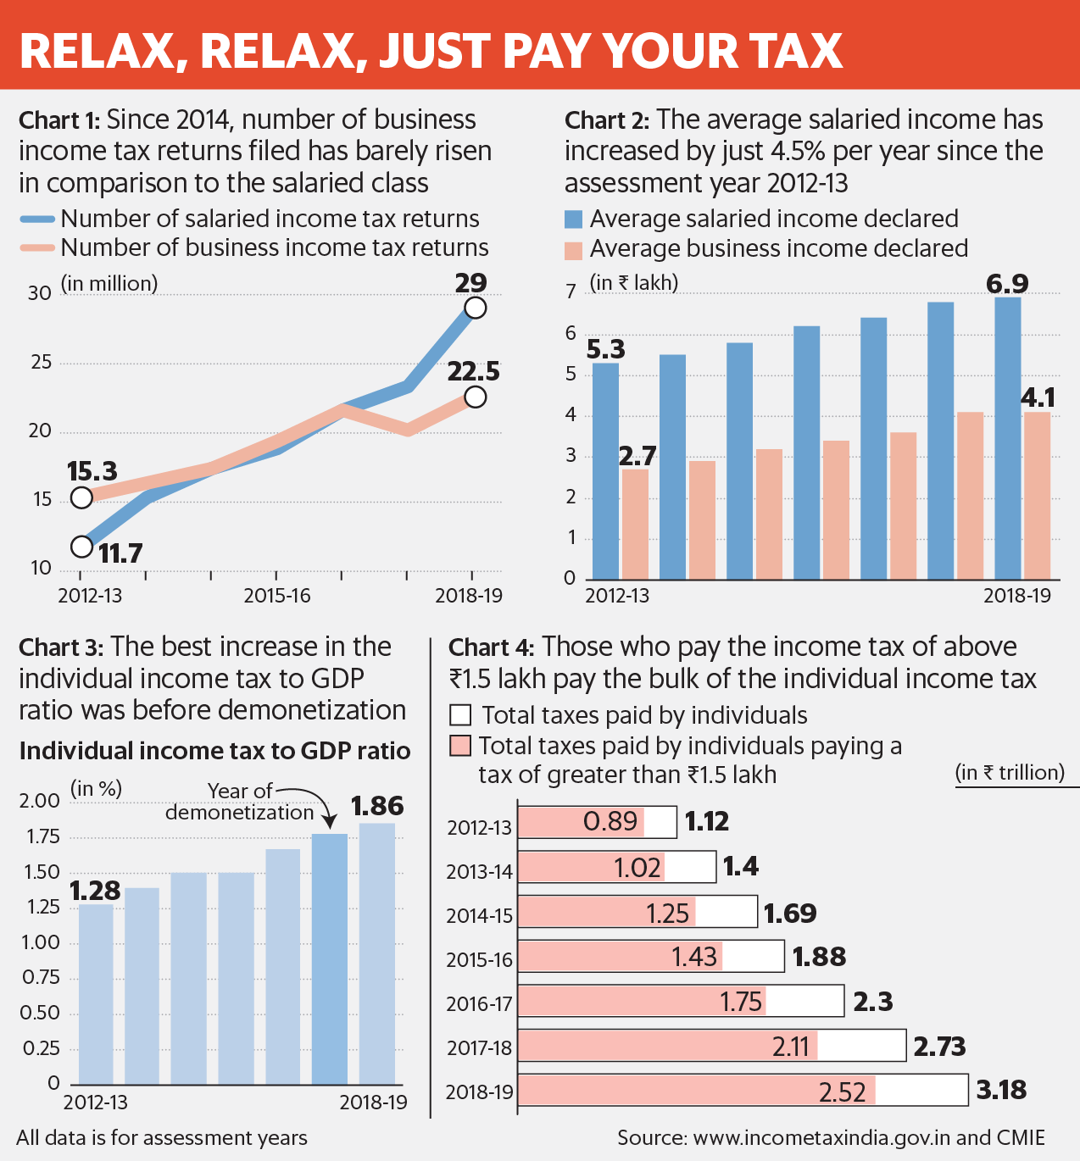

It is rather common to hear or read in popular media that only 1% of Indian population pays income tax. The Economic Survey 2017-18, corrects this misinformation and puts the number of income tax payers at 5.9 crore people or 4.5% of total population. While certainly higher than the earlier claim of 1%, the number 4.5% is still very small; and it seems like the remaining 95% of Indians are not paying income tax. However, it should be noted that expressing the number of tax payers as percentage of population gives an inflated sense of large number of tax evaders, because the population also includes many groups which are not required to pay income tax ; like children, students, those with income below the exemption limit, or those earning income from agriculture. To find out how many Indians are evading income tax, i.e. – those who should be paying income tax but are not, it is required first that we have some estimate of how many people in India should actually pay income tax, in other words – what is the income tax base of the country.

Talking about states in India, Maharashtra pays the highest tax as compared to the other states in India. The reason of this is the number of jobs in the state.

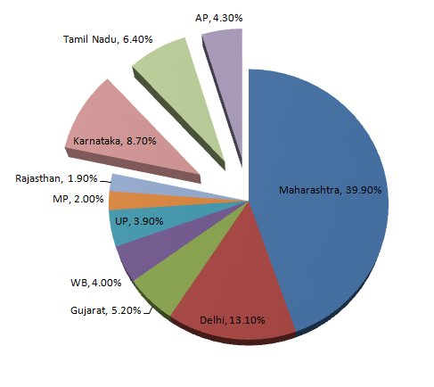

**Market Segmentation**

What is need for segmentation?

Taxes are important for the nation, because it contributes to the inflow of the money. Hence the market segmentation can pinpoint the insights which can help us to organized the sector better.

According to the data given on the website of <https://www.incometaxindia.gov.in/Pages/Direct-Taxes-Data.aspx> , the subdivision is done on the people who filed the income tax return [1].

1. AOP (Association of Person): Group of individuals who are joined together to achieve a common objective.
2. BOI (Body of Individual): Group of individuals who join together for to earn income.
3. Company: It is an association of people, joined together for any activity which generates income.
4. Firm: It is an association of people, joined together generally for selling of the services.
5. Government: This is body which governs the nation.
6. HUF (Hindu Undivided Family): It is the family which acts as a single unit in paying the taxes collectively.
7. AJP (Artificial Juridical Person): It is similar to AOP, but here the body or the group is incorporated under statue.
8. Local Authority: Here local authority is the administrative body in the local government.
9. Individual: These are the ones which includes all the entities i.e., person which do not come in the other categories.
10. AOP(Trust): Trust is a system in which, the owner of the property leases it to some other person, where there are association of person in this category, it is called as AOP (Trust)

According to the data collected, the maximum number of the people who pay taxes comes under individual category.

And when we find out the difference between the eligible tax payers according to the category and the ones who pay the pay taxes. Here also the maximum number is of the individuals.

After the individual category which are the ones who paid tax in maximum number according to their strength are: Firm> HUF>Company.

The incomes source of the individual category person is mainly from the salary i.e. they are the employed persons or someone who are associated in employer and employee relation. Going further in this maximum number of tax payers which comes under the individual category have the income range of 2.5 lakhs to 10 lakhs, which is considered to be the average income of the middle class in India according to India's National Council for Applied Economic Research (NCAER).

Below shown is the flow chart according to the conclusion from the above data.

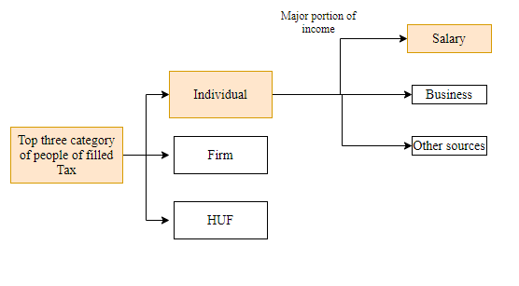

Further if we indulge in the expansion of the middle-class India. According to the study done by OECD Development Centre, there is increase in the middle class in India in comparison with the other countries.

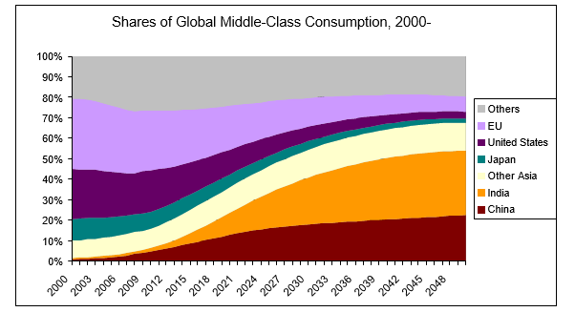

In this, majority contribution is of the middle class, which are also the highest number of tax paying class groups [2].

Segmentation on the basis of the geographical location

There are certain states which shares the majority of the employment because of the available companies, due to which many people migrate from their home state to these states.

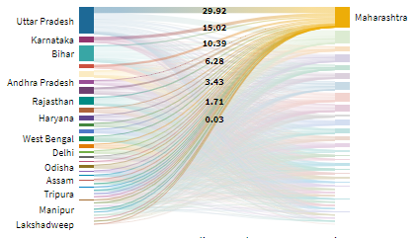

Here the states present on the left show the outflow of the people and states on the right shows the inflow of the people. In the maximum majority is enjoyed by the Maharashtra. This migration is majorly because of the employment basis [3].

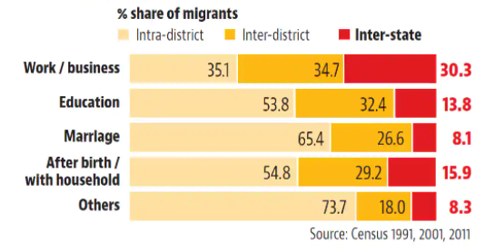

It can be seen by the graph that majority of Interstate migration takes place due to work/business [4]. Hence it can also be the reason the Maharashtra pays tax more than every state.

If we talk about the overall terms, the labour class i.e., the class which can be employed or has the potential to be employed will be increasing in India, according to the reports of OECD.

The Global Labour Force, 2008 to 2039

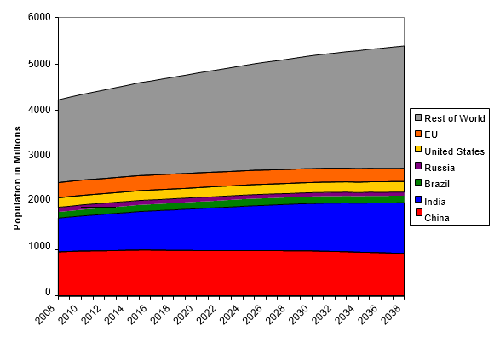

The growth in the China which constitute to the major global labour force will have stagnant growth in the coming years and India will take over the first rank in the majority labour force in the whole world [5].

Market dynamics

As per the data the focus is on the salaried person in the geographical location of Maharashtra, which constitute to the majority of the immigration also, responsible for paying the maximum amount of the taxes.

1. Due to Covid-19 there is shrinkage of the middle-class all-over India:

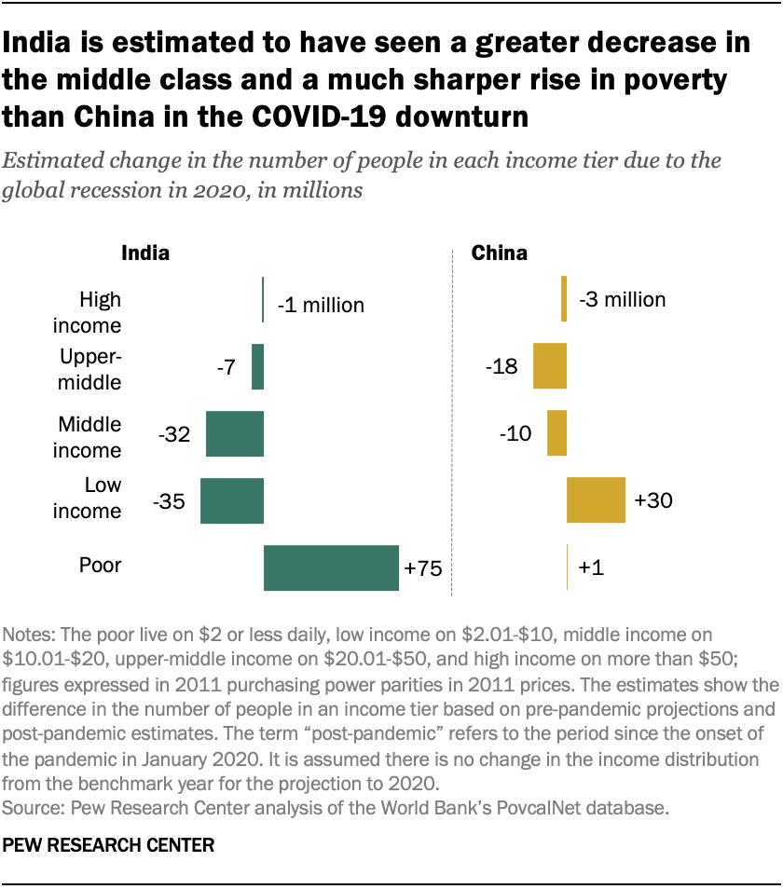

As per the research of Pew research centre survey on the impact of the covid on the middle class, it is shown that it has sever effect and there is heavy percentage decrease in the middle-class group which are plunged into in lower class [6]. Eventually what is predicted will happen with little deviation while consideration of the Covid-19.

1. In Maharashtra, tax paid is more can be because of the fact it constitutes many millionaires: The number of millionaires is the highest out of all the states in the India, this can also be considered one of the reasons about the high amount of the tax paid by the Maharashtra state [7]. As our focus is on the numbers not the amount. What I mean by that is, we looking for the category of people who have maximum strength in paying the taxes. In the data it is well presented the number is more of the person earning income from 2-10 lakhs. Hence, we are assuming though Maharashtra pays high amount of tax due to the presence of the highest number of rich people in the state, but the strength of the people lying the lower slabs are more, and most migration due to the need of employment is done in Maharashtra who have average earnings.
2. Work from home can be partially followed, hence can impact the intra-state migration pattern.: According to the study performed by the Microsoft India on the work trend index, nearly 74% of Indian want to work remote and also 73% wants to work in person. This has started a dilemma about the present working condition. The dilemma can change the present work condition to the hybrid one. This can impact the migration of the people for the purpose of the employment [8]. Though the hybrid work condition will decrease the amount of migration occurring due to the employment. But that can only be in the profile in which the work can be done from the home. The covid has bring a lot of changes, like now the focus of India is change to develop its manufacturing sector, health sector, and other sector which required more in-person work profile.

Project Purpose

The main focus of this project is to present segmented group the platform to learn about the tax and ease the mode of filling the taxes.

For the first step, the program is created to calculate the tax on the income of the person according to the tax slab.

# Tax Calculation based on Revenue/ Salary

while True:

try:

income = int(input("Please enter your taxable income in india: "))

except ValueError:

print("Sorry, We didn't understand that please enter taxable income as a number")

continue

else:

break

if income <= 250000: #2 Lakh 50 thousand

tax = 0

elif income <= 500000: #5 Lakh

tax = (income - 250000) * 0.05

elif income <= 750000: #7 lakh 50 thousand

tax = (income - 500000) * 0.10 + 12500

elif income <= 1000000: #10 Lakh

tax = (income - 750000) * 0.15 + 37500

elif income <= 1250000: #12 lakh 50 thousand

tax = (income - 1000000) * 0.20 + 75000

elif income <= 1500000: #15 lakh

tax = (income - 1250000) * 0.25 + 125000

else:

tax = (income - 1500000) * 0.30 + 187500

print("you owe", tax, "Rupees in tax!")

References

[1] C. B. O. D. TAXES, “Income Tax Department Time Series Data Financial Year 2000-01 to 2018-19,” pp. 5–6, 2018, [Online]. Available: https://www.incometaxindia.gov.in/Documents/Direct Tax Data/IT-Department-Time-Series-Data-FY-2000-01-to-2018-19.pdf.

[2] H. Kharas, “The Emerging Middle Class In Developing Countries,” doi: 10.32677/ijch.2015.v02.i03.009.

[3] “Inter-state migrations in India _ Flourish.” [Online]. Available: https://public.flourish.studio/visualisation/526207/?utm_source=showcase&utm_campaign=visualisation/526207.

[4] A. Jha and V. M. Kawoosa, “What the 2011 census data on migration tells us | Latest News India - Hindustan Times.” [Online]. Available: https://www.hindustantimes.com/delhi-news/migration-from-up-bihar-disproportionately-high/story-K3WAio8TrrvBhd22VbAPLN.html.

[5] A. Roy, “The Middle Class in India: From 1947 to the Present and Beyond - Association for Asian Studies,” *Education about Asia*, vol. 23, no. 1. pp. 32–37, 2018, [Online]. Available: https://www.asianstudies.org/publications/eaa/archives/the-middle-class-in-india-from-1947-to-the-present-and-beyond/.

[6] R. KOCHHAR, “India’s middle class shrinks amid COVID-19 as China sees less change | Pew Research Center.” [Online]. Available: https://www.pewresearch.org/fact-tank/2021/03/18/in-the-pandemic-indias-middle-class-shrinks-and-poverty-spreads-while-china-sees-smaller-changes/.

[7] “Maharashtra has 56,000 millionaire households; highest in India_ Report - The Economic Times.” [Online]. Available: https://economictimes.indiatimes.com/news/economy/indicators/maharashtra-has-56000-millionaire-households-highest-in-india-report/articleshow/81534500.cms?from=mdr.

[8] B. Reporter, “74% of Indian workers back more flexible work options_ MS Work Trend Index _ Business Standard News.” [Online]. Available: https://www.business-standard.com/article/companies/74-of-indian-workers-back-more-flexible-work-options-ms-world-trend-index-121061000538_1.html.