**Coding Assignment NBC :**

1. Kaggle Score

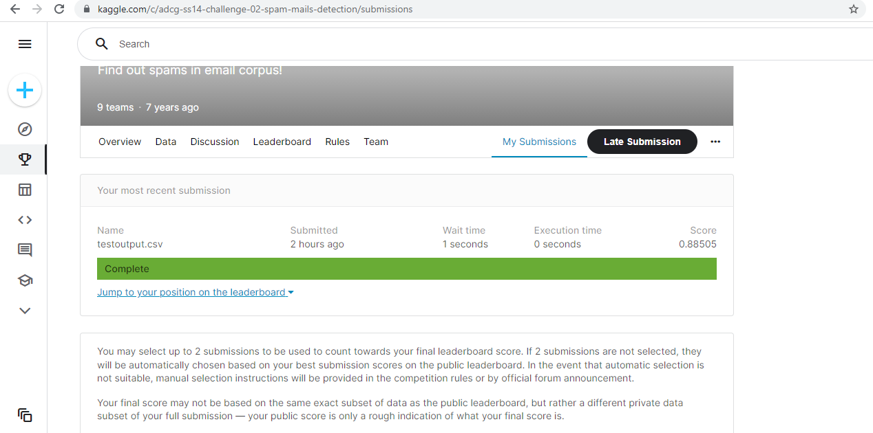

1. Code Output

