**Aayushi Dutta  
Superset ID – 6363122  
WebAPI - 6**

Question 1

**KafkaChatConsumerApp/Program.cs**

using System;

using System.Threading;

using Confluent.Kafka;

class Program

{

static void Main(string[] args)

{

var config = new ConsumerConfig

{

GroupId = "chat-group",

BootstrapServers = "localhost:9092",

AutoOffsetReset = AutoOffsetReset.Earliest

};

using var consumer = new ConsumerBuilder<Ignore, string>(config).Build();

consumer.Subscribe("chat-topic");

Console.WriteLine("=== Kafka Chat Consumer Started ===");

Console.WriteLine("Waiting for messages...\n");

while (true)

{

var cr = consumer.Consume(CancellationToken.None);

Console.WriteLine("Friend: " + cr.Message.Value);

}

}

}

**KafkaChatProducerApp/Program.cs**

using System;

using System.Threading.Tasks;

using Confluent.Kafka;

class Program

{

static async Task Main(string[] args)

{

var config = new ProducerConfig

{

BootstrapServers = "localhost:9092"

};

using var producer = new ProducerBuilder<Null, string>(config).Build();

Console.WriteLine("=== Kafka Chat Producer Started ===");

Console.WriteLine("Type a message and press Enter. Type 'exit' to quit.\n");

while (true)

{

Console.Write("You: ");

string message = Console.ReadLine();

if (message.ToLower() == "exit") break;

await producer.ProduceAsync("chat-topic", new Message<Null, string> { Value = message });

Console.WriteLine("Sent");

}

}

}

Kafka Server Running:

.\bin\windows\kafka-server-start.bat .\config\server.properties

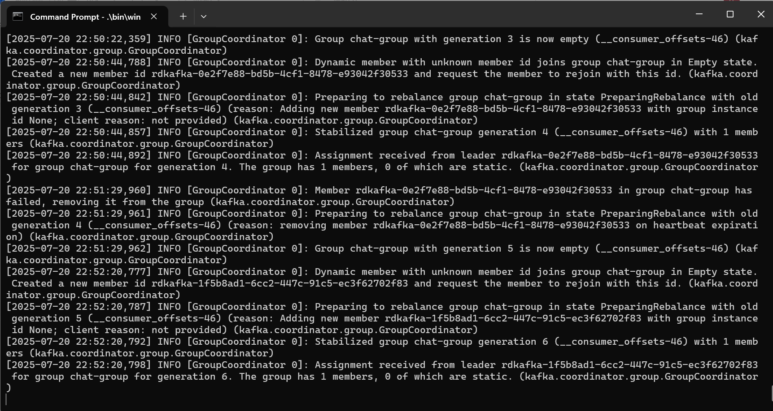

Zookeeper Running:

.\bin\windows\zookeeper-server-start.bat .\config\zookeeper.properties

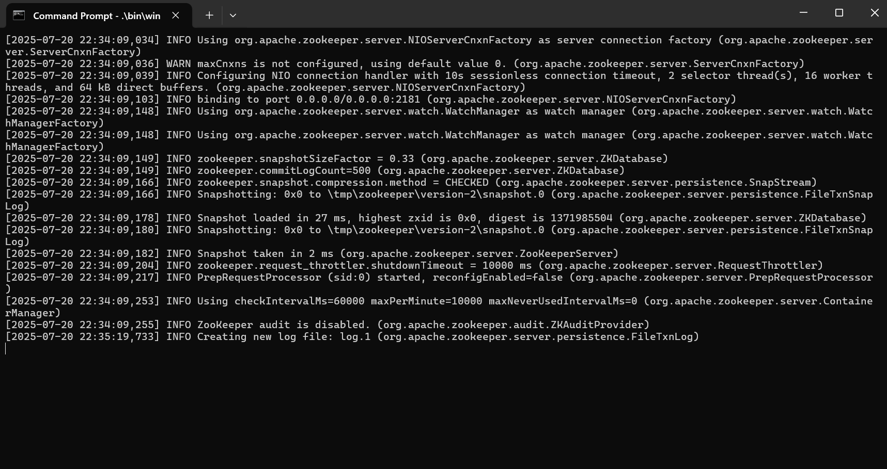

Topic Created:

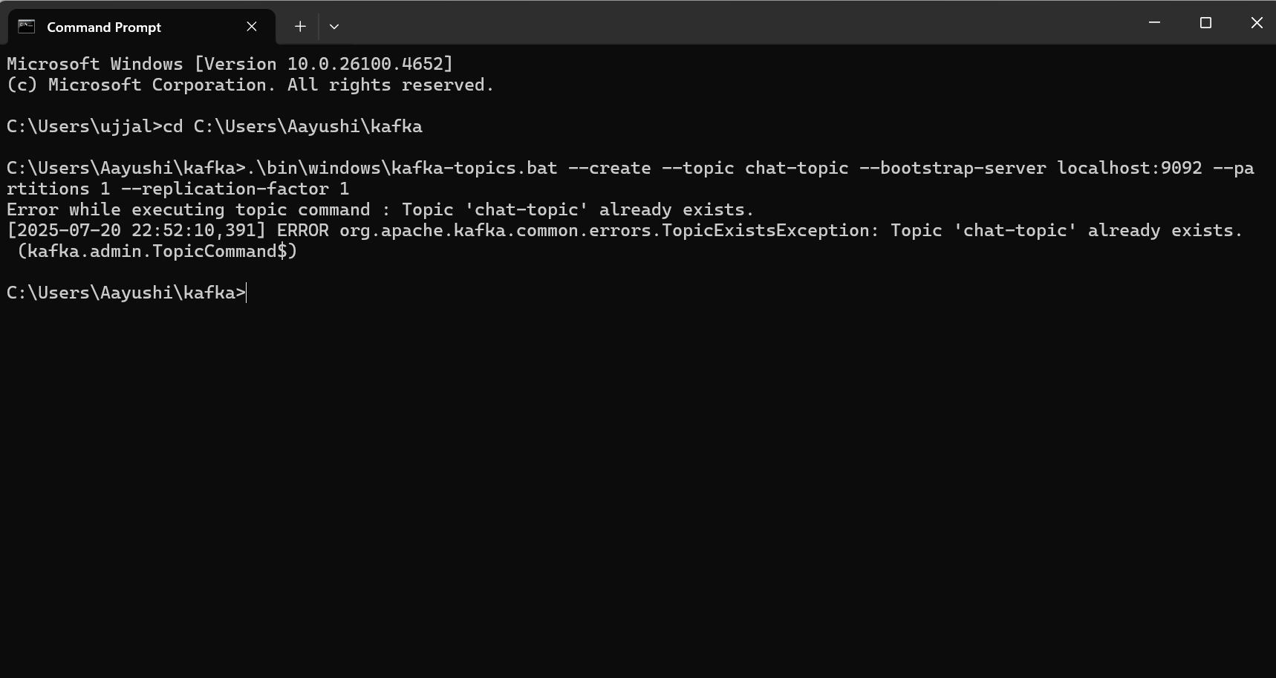

Creating Publisher in Command Prompt:

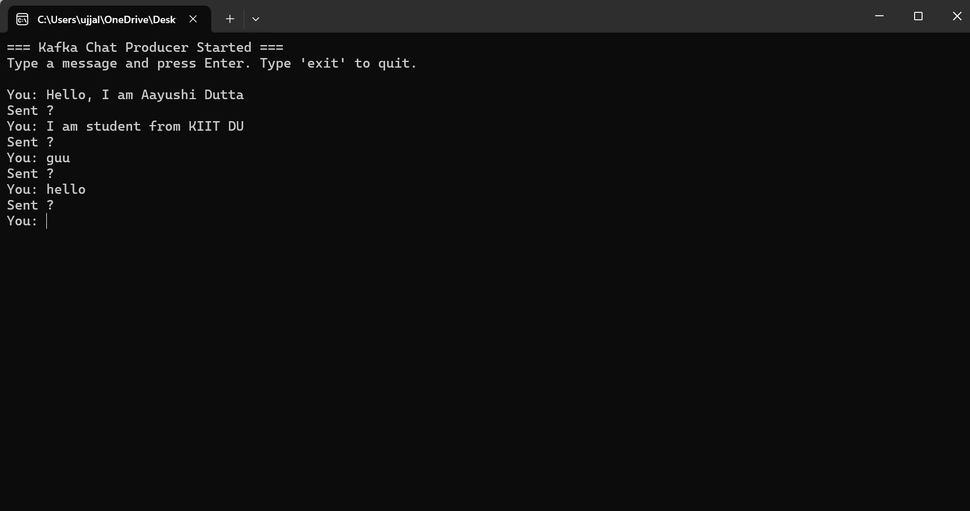

Client Application:

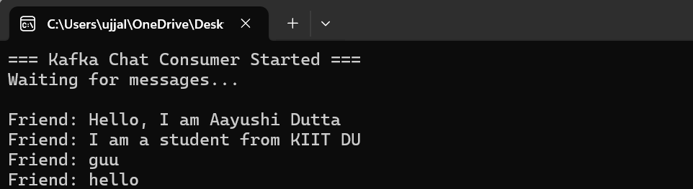

Question 2 :

**Form1.cs**

using Confluent.Kafka;

using System;

using System.Threading;

using System.Windows.Forms;

namespace KafkaChatWinFormApp

{

public partial class Form1 : Form

{

private readonly string bootstrapServers = "localhost:9092";

private readonly string topic = "chat-topic";

private Thread consumerThread;

private bool keepConsuming = true;

public Form1()

{

InitializeComponent();

}

private void Form1_Load(object sender, EventArgs e)

{

StartKafkaConsumer();

}

private void btnSend_Click(object sender, EventArgs e)

{

var config = new ProducerConfig { BootstrapServers = bootstrapServers };

using (var producer = new ProducerBuilder<Null, string>(config).Build())

{

string message = txtMessageBox.Text;

if (!string.IsNullOrEmpty(message))

{

producer.ProduceAsync(topic, new Message<Null, string> { Value = message }).Wait();

lstChat.Items.Add("You: " + message);

txtMessageBox.Clear();

}

}

}

private void StartKafkaConsumer()

{

consumerThread = new Thread(() =>

{

var config = new ConsumerConfig

{

GroupId = "chat-group",

BootstrapServers = bootstrapServers,

AutoOffsetReset = AutoOffsetReset.Earliest

};

using (var consumer = new ConsumerBuilder<Ignore, string>(config).Build())

{

consumer.Subscribe(topic);

while (keepConsuming)

{

try

{

var result = consumer.Consume(TimeSpan.FromMilliseconds(500));

if (result != null)

{

Invoke(new Action(() =>

{

lstChat.Items.Add("Friend: " + result.Message.Value);

}));

}

}

catch

{

// optional: log errors

}

}

consumer.Close();

}

});

consumerThread.IsBackground = true;

consumerThread.Start();

}

private void btnCancel_Click(object sender, EventArgs e)

{

keepConsuming = false;

this.Close();

}

}

}

**Form1.Designer.cs**

namespace KafkaChatWinFormApp

{

partial class Form1

{

private System.ComponentModel.IContainer components = null;

private System.Windows.Forms.TextBox txtMessageBox;

private System.Windows.Forms.Button btnSend;

private System.Windows.Forms.Button btnCancel;

private System.Windows.Forms.ListBox lstChat;

private System.Windows.Forms.Label label1;

protected override void Dispose(bool disposing)

{

if (disposing && (components != null)) components.Dispose();

base.Dispose(disposing);

}

private void InitializeComponent()

{

this.txtMessageBox = new System.Windows.Forms.TextBox();

this.btnSend = new System.Windows.Forms.Button();

this.btnCancel = new System.Windows.Forms.Button();

this.lstChat = new System.Windows.Forms.ListBox();

this.label1 = new System.Windows.Forms.Label();

this.SuspendLayout();

// txtMessageBox

this.txtMessageBox.Location = new System.Drawing.Point(12, 32);

this.txtMessageBox.Multiline = true;

this.txtMessageBox.Name = "txtMessageBox";

this.txtMessageBox.Size = new System.Drawing.Size(360, 80);

// btnSend

this.btnSend.Location = new System.Drawing.Point(297, 118);

this.btnSend.Name = "btnSend";

this.btnSend.Size = new System.Drawing.Size(75, 23);

this.btnSend.Text = "Send";

this.btnSend.UseVisualStyleBackColor = true;

this.btnSend.Click += new System.EventHandler(this.btnSend_Click);

// btnCancel

this.btnCancel.Location = new System.Drawing.Point(216, 118);

this.btnCancel.Name = "btnCancel";

this.btnCancel.Size = new System.Drawing.Size(75, 23);

this.btnCancel.Text = "Cancel";

this.btnCancel.UseVisualStyleBackColor = true;

this.btnCancel.Click += new System.EventHandler(this.btnCancel_Click);

// lstChat

this.lstChat.FormattingEnabled = true;

this.lstChat.ItemHeight = 15;

this.lstChat.Location = new System.Drawing.Point(12, 147);

this.lstChat.Name = "lstChat";

this.lstChat.Size = new System.Drawing.Size(360, 154);

// label1

this.label1.AutoSize = true;

this.label1.Location = new System.Drawing.Point(12, 14);

this.label1.Name = "label1";

this.label1.Size = new System.Drawing.Size(165, 15);

this.label1.Text = "Please Enter your Message Here:";

// Form1

this.AutoScaleDimensions = new System.Drawing.SizeF(7F, 15F);

this.AutoScaleMode = System.Windows.Forms.AutoScaleMode.Font;

this.ClientSize = new System.Drawing.Size(384, 311);

this.Controls.Add(this.label1);

this.Controls.Add(this.lstChat);

this.Controls.Add(this.btnCancel);

this.Controls.Add(this.btnSend);

this.Controls.Add(this.txtMessageBox);

this.Name = "Form1";

this.Text = "Kafka Chat App";

this.Load += new System.EventHandler(this.Form1_Load);

this.ResumeLayout(false);

this.PerformLayout();

}

}

}

