 | TRUSTEE PROFILE  S3 Impact Foundation
Aayushi Hariharan  Aayushi serves on the foundation’s board of trustees and helps shape its creative direction. A strategic designer trained at Central Saint Martins, she has created work at every scale, from large installations and print campaigns to websites and mobile apps, always centred on people and the stories that move them to act. |  | 
  TRUSTEE

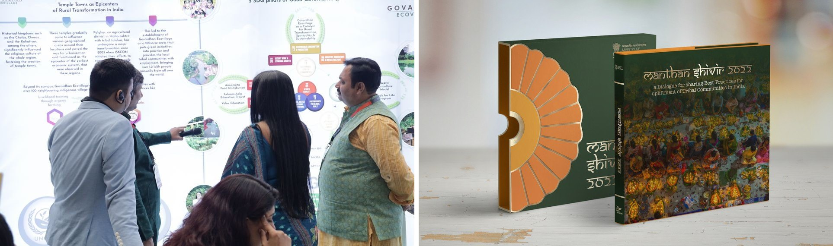
Aayushi’s work: infographic panels on the 17 SDGs for Govardhan Ecovillage, and the Manthan Shivir book.
Aayushi graduated with First Class Honours in Graphic Communication Design from Central Saint Martins, University of the Arts London, specialising in strategy and identity, future technologies and sustainability, after completing its Foundation Diploma in Art and Design with Distinction. She is a certified IBM Enterprise Design Thinking Practitioner.  Since 2019 she has worked as a brand strategist with numerous clients around the world, shaping brand narratives, positioning and creative direction. From 2022 she served as Chief Creative Officer of Simple Vedas, an online platform that teaches Vedic wisdom for everyday life, leading its design strategy, its visual identity and the launch of its mobile apps, built to international accessibility standards.  In the same years she was Design Lead at Govardhan Ecovillage, directing and creating, hands on, the reports, infographics and installations for more than 17 initiatives aligned with the United Nations Sustainable Development Goals. She designed the website for Govardhan Annakshetra, part of a redesign of the community’s websites that raised their traffic by 70%, and her cultural placemaking work turned public spaces into art installations that drew visitors to the community.  As Strategic Creative Lead at Healy World GmbH, an international wellness company, she led the redesign of its website and the development of its visual identity, and managed its graphics and marketing teams. She shaped its social media, communications and product launches, bringing strategy and craft together across every channel through which the brand meets its audience. |  | AT A GLANCE  1st  First Class Honours, Central Saint Martins  17+  Initiatives aligned with the UN Sustainable Development Goals  70%  Rise in traffic after the websites’ redesign  IBM  Certified Enterprise Design Thinking Practitioner  EDUCATION  BA (Hons), Graphic Communication Design, Central Saint Martins, UAL  Foundation Diploma, Art and Design, with Distinction  AREAS OF FOCUS  ■ Brand strategy and identity  ■ Websites and mobile apps  ■ Campaigns and social media  ■ Reports and infographics  ■ Installations and placemaking
MILESTONES
2019  Brand strategist for clients around the world | 2022  Chief Creative Officer, Simple Vedas | 2022  Design Lead, Govardhan Ecovillage | 2025  Strategic Creative Lead, Healy World GmbH

“
Aayushi’s practice is rooted in human-centred design: understanding people first, then shaping the experiences, stories and systems that serve them. She brings to S3 a global eye and a deep respect for the communities it serves, helping the foundation share its work with clarity, dignity and care.

EMAIL contact@s3impact.org.in WEB s3impact.org.in

