 | TRUSTEE PROFILE  S3 Impact Foundation
Harneet Hariharan  Rādhikā Līlā Devī Dāsī  As Managing Trustee, Harneet sets the direction of S3 Impact Foundation and follows its projects closely, from community kitchens and village classrooms to the sacred ponds of Braj. She brings three decades of building and leading a national business, and a long commitment to service. |  | 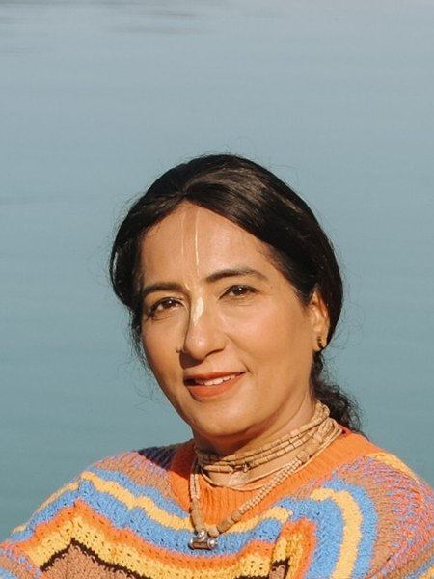
  MANAGING TRUSTEE

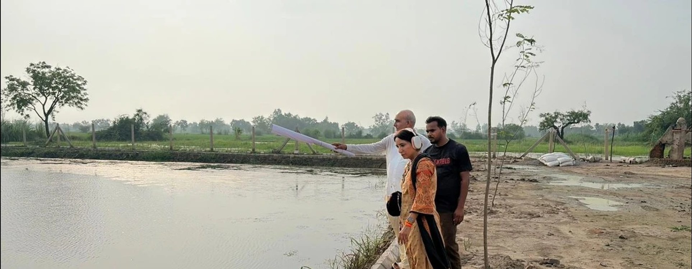
Harneet on site with the project team, reviewing restoration plans.
Harneet holds a degree in physics, chemistry and mathematics, and an MBA in International Marketing from the Faculty of Management Studies, M.S. University of Baroda. In 1993 she founded Pace Setters Business Solutions with a team of fifteen, and as its Chairperson and Managing Director has grown it into a national business-process company of more than 5,000 people.  In 2022 she began dedicating the profits of her company to service, supporting Govardhan Annakshetra, the renewal of the temple at Govardhan Ecovillage, the Govardhan Skill Centre, the Bhakti Bhavan project in Kolkata and the revival of the sacred kunds of Braj. Her work is anchored in daily spiritual practice and the study of scripture, under the guidance of His Holiness Rādhānāth Swāmī Mahārāja and His Grace Gaurāṅga Dās.  A year later she became CEO of the Social Impact Initiatives of ISKCON Govardhan Ecovillage, where she leads work in nutrition, water and skilling. Govardhan Annakshetra has served more than 7.18 million free meals in Palghar. In Braj, she initiated and coordinated the revival of the sacred kunds: Priya Kund and Prem Sarovar are complete, five more sites are progressing with the government, and local Kund Mitras now care for the ponds. The Braj Tirtha Vikas Parishad has encouraged the model’s expansion. She also set up the Centre of Excellence for electric-vehicle skilling at Boisar with Tata Capital, linking young people from tribal communities to employers. |  | AT A GLANCE  1993  Founded Pace Setters Business Solutions  5,000+  People in the company she leads  7.18M  Free meals served by Govardhan Annakshetra  2 + 5  Kunds revived in Braj, with five more under way  EDUCATION  MBA, International Marketing, Faculty of Management Studies, M.S. University of Baroda  B.Sc., Physics, Chemistry and Mathematics  AREAS OF FOCUS  ■ Nutrition and food security  ■ Water and sacred ponds  ■ Skills and livelihoods  ■ Heritage and temples  ■ Institution building
MILESTONES
1990  MBA, Faculty of Management Studies, Baroda | 1993  Founds Pace Setters with a team of fifteen | 2022  Dedicates her company’s profits to service | 2023  CEO, Social Impact Initiatives, Govardhan Ecovillage
RECOGNITION
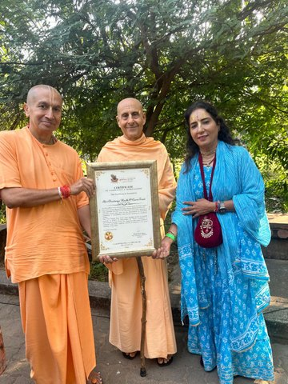  From left: His Grace Gaurāṅga Dās, His Holiness Rādhānāth Swāmī Mahārāja and Harneet. |  | Priya Kund, Barsana  In November 2024 the Uttar Pradesh Braj Tirtha Vikas Parishad awarded a Certificate of Completion and Appreciation to Shri Chaitanya Health & Care Trust, Govardhan Ecovillage, for the eco-restoration of Priya Kund (Pili Pokhar) in Barsana, the revival Harneet initiated and coordinated. The Parishad recognised the work as a lasting contribution to preserving the heritage of Braj.

“
Those who work with Harneet describe a decisive, hands-on leader who brings boardroom discipline and on-ground compassion to building institutions, in business and in service. Hers is the profile of a contemporary dhārmic leader: a builder of enterprises and ecosystems, a committed sevā-kārī and a sincere sādhikā, showing that business excellence, a life guided by the Sanātana Dharma śāstras and service to society do not merely coexist, but strengthen one another.

EMAIL contact@s3impact.org.in WEB s3impact.org.in

