 | ORGANISATION PROFILE  October 2026
Rooted in service  S3 Impact Foundation is a charitable foundation based in Mumbai. We turn compassion into change that can be seen, measured and sustained, and we stand beside each project long enough to see the lives it transforms.  Our mission: a full plate, a fair chance, a living land and an awakened spirit, for every life we touch. | 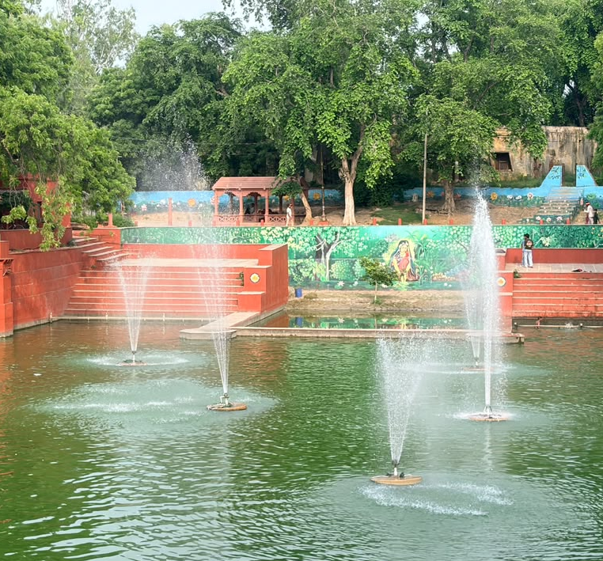

Social Impact  For the people we serve | Sustainability  For the land that sustains them | Self Transformation  For the growth that makes change last
WHAT WE DO
S3 Impact Foundation invests in work that feeds, teaches, heals and restores: from food and farming to education, water, health, elder care and culture. Here are the projects the Foundation has carried out, and those it is preparing to support next.
Rural Development at GEV  Farming, water, schools, skills and care in the tribal villages of Palghar. | Govardhan Annakshetra  A community kitchen that served 2.4 million free meals in a single year. | Spiritual & Culture  Restoring sacred places and passing timeless values to the next generation.
Braj Kunds  Reviving the sacred ponds of Braj with natural methods and local hands. | Beyond GEV  A school campus in Pune and a charitable hospital in Vrindavan. | Policy & Advocacy  Carrying grassroots experience to national and global conversations on food and governance.
HOW WE SERVE
With every project, start to finish. We back trusted partners on the ground and stay closely involved, from the first survey to the final report.
We see the results. Water is lab-tested, learning is tracked from baseline to endline, and harvests are recorded every month.
We begin close to home. Many of our projects start in the villages around Govardhan Ecovillage, where we can see needs clearly and respond with care.
WHAT WE STAND FOR
Service to all. Our work is open to every community, without discrimination.
Compassion in action. Care for the whole person, body, mind and spirit, especially those who are most vulnerable.
Local hands, local pride. Villagers, farmers and “friends of the kund” are partners in the work, not just its beneficiaries.
Honest results. We test, measure and share what we find, including what is still in progress.
Stewardship. Of land, water, heritage and every rupee entrusted to us.
IMPACT AT A GLANCE
2.4M  Free meals, 2025-26 | 67%  Rise in learning scores | 12,000  Litres of safe water an hour | 81%  Women earning within 3 months
2,000  Fruit saplings planted | 55  EV technicians trained | 8,11,071  Visitors in a year | 6  Sacred kunds in revival
ON WIDER STAGES
C20 Working Group. A project we support at Govardhan EcoVillage co-led the C20 Working Group on Food Systems, Hunger and Poverty during Brazil's 2024 G20 Presidency.
Sushasan Mahotsav. With our support, Govardhan EcoVillage was invited to partner in a national festival of good governance, in recognition of its work on food security.
A Braj Break-through. The revival of Braj's kunds was reported by Braj Breaking, a local Braj news site, which called restoring the kunds and cleaning their water the first need of the day.
LEADERSHIP
Harneet Hariharan | Rādhikā Līlā Devī Dāsī MANAGING TRUSTEE
As Managing Trustee, Harneet sets the direction of S3 Impact Foundation and follows its projects closely, from community kitchens and village classrooms to the sacred ponds of Braj. She brings three decades of building and leading a national business, and a long commitment to service.
Aayushi Hariharan TRUSTEE
Aayushi serves on the foundation’s board of trustees and helps shape its creative direction. A strategic designer trained at Central Saint Martins, she has created work at every scale, from large installations and print campaigns to websites and mobile apps, always centred on people and the stories that move them to act.
LOOKING AHEAD
Seven new projects are taking shape, each one growing from work already under way.
Surya Kund Water Conservation Project · Braj kunds: Jal Vihar, Kamal and Vihval Kund · AgriVoltaics Pilot · Palghar Dog Welfare Sanctuary · Vedic Value Education Programme · Govardhan English Medium School · GEV Madhya
Walk this path with us
Companies, foundations and institutions can co-fund a project, from a single programme to a whole site. We keep partners closely informed, from the first plan to the final report.
S3 IMPACT FOUNDATION EMAIL contact@s3impact.org.in WEB s3impact.org.in | EMAIL contact@s3impact.org.in WEB s3impact.org.in
