**Remedy Acknowledgement**

A Dissertation submitted

for the partial fulfillment of the degree of

**Bachelor of Engineering in**

**Computer Science Engineering**

**(Session 2018 – 2019)**

**Guided By: Vinay Agnihotri Submitted By:**

**<Traine Name> <Intern Name (Intern Id)>**

**Trainer Aayushi Panwar 768833**

**Department of Computer Science Engineering**

**Chandigarh Engineering College**

**Landran,Mohali**

**Dissertation Approval Sheet**

The dissertation entitled **“Remedy Acknowledgement**”submitted by **Aayushi Panwar** is approved as partial fulfilment for the award of **Bachelor of Engineering in Computer Science Engineering**.

**Internal Examiner External Examiner**

**Director**

**Chandigarh Engineering College**

**Landran**

**Mohali**

**Candidate Declaration**

We hereby declare that the work which is being presented in this project entitled Remedy Acknowledgement in partial fulfilment of degree of Bachelor of Engineering in Computer Science Engineering is an authentic record of our own work carried out under the supervision and guidance of **Vinay Agnihotri**, **Trainer.**

We are fully responsible for the matter embodied in this project in case of any discrepancy found in the project and the project has not been submitted for the award of any other degree.

**Date:**

**Place:**

**CERTIFICATE**

**ACKNOWLEDGEMENT**

For the successful completion of this project, I'd extend a sincere thanks to our project guide as well as trainer Mr. Vinay Agnihotri Sir, who has been there with us while building the complete code from scratch. Without his guidance and teaching, it'd have been impossible of us to create the project.

I'm also grateful to our batch owners and people who've helped us out in every way possible, Shilpa Mahajani Ma’am, Mohit Kariya Sir, Gerard Thomas Sir and Komal Sanjay Pawar Ma’am. Without them, internship at such a huge company would have not been completed successfully. They ensured our smooth functioning and handled all the quirks and doubts while the sessions which helped us a lot in order to calmly finish the project.

I'd also like to thank our college director Mr. Jagtar Singh Khatra Sir for giving us such an amazing opportunity to work through the college semester in order to get a corporate experience and education. It is only because of his thought that we were able to gain such a training with a parallel balance of college academics.

**ABSTRACT**

This report is aimed at documenting the “Remedy Acknowledgement” that has been developed as a solution of a common interface between the allocators and the nominees. While starting with the project we went through some similar existing platforms that inspired the project to be developed in the first place, however it provided the motivation to do it even better. Remedy Acknowledgment is a JAVA based Web Application where a user raises a concerned problem by logging into this application and sends a mail for receiving the possible remedy. The user will select one of the resources mentioned in the summary and will provide the details of the issue along with his contact number. This would help the administrator to sort the users' issue mentioned in his details. As soon as the user sends the mail, a ticket is automatically generated according to the priority of the problem selected by the user. Now the administrator plays the role of providing the resources to the user. As mentioned in the My Request table, a unique record Id would be assigned along with the summary. The Status field is mentioned in the My Request table where administrator will provide the status whether it's assigned or unassigned.

**TABLE OF CONTENTS Page No**

1. **Introduction 3**

**1.1 Purpose of this document 3**

**1.2 Project Overview 3**

**1.2**.**1** **Objectives 3**

**1.3 Intended Audience 3**

**2.0 Process Architecture 4**

**3.0 High Level Business Requirements 5**

**4.0 Detailed Business Requirements 5**

**4.1 Functional Requirements 5**

**5.0 References 7**

**5.1 Table 1.0 7**

**5.2 Table 1.1 7**

**6.0 Terms and conditions 7**

**7.0 Change Log** **8**

**CHAPTER 1**

1. **Introduction**

## 1.1 Purpose & Scope of the document

The purpose of this Use case document is to systematically capture requirements for the project and the system to be developed in terms of use cases. Functional use cases are captured in this document. It also serves as the input for the project scoping.

The scope of this document is limited to addressing the use cases from a user, quality, and non-functional perspective.

## Intended Audience

Each member of the project team

## Use case ‘User Registration’

### Use case attributes

**Use Case Description:**

This use case deals with the capture of user details. The ‘user’ here shall be the operator of the system and will be keying in the user details into the system.

**Scope:**

* User registration

**Actors:**

* User – the operator

**Trigger:**

Click ‘Submit’ button in the ‘User Registration’ page

**Pre-Condition:**

User being able to access the homepage & get redirected to the ‘User Registration’ page upon click of ‘Register if new’ link.

**Post Condition:**

User is in the request page & submit details.

**Flow of Events:**

User at homepage 🡪 Click ‘Sign Up’ if new’ link 🡪 User is in the Sign up page 🡪 User details are submitted and added onto the database.

1. **Process Architecture**

Below is the overall functional flow of the project including the components of interaction

**2.1Methodology**

* SDLC:

In [software engineering](https://en.wikipedia.org/wiki/Software_engineering), a software development process is the process of dividing [software development](https://en.wikipedia.org/wiki/Software_development) work into distinct phases to improve [design](https://en.wikipedia.org/wiki/Software_design), [product management](https://en.wikipedia.org/wiki/Software_product_management), and [project management](https://en.wikipedia.org/wiki/Software_project_management). It is also known as a **software development life cycle**. The methodology may include the pre-definition of specific [deliverables](https://en.wikipedia.org/wiki/Deliverable) and artifacts that are created and completed by a project team to develop or maintain an application.

Most modern development processes can be vaguely described as [**agile**](https://en.wikipedia.org/wiki/Agile_software_development). Other methodologies include [*waterfall*](https://en.wikipedia.org/wiki/Waterfall_model)*,*[*prototyping*](https://en.wikipedia.org/wiki/Software_prototyping)*,*[*iterative and incremental development*](https://en.wikipedia.org/wiki/Iterative_and_incremental_development)*,*[*spiral development*](https://en.wikipedia.org/wiki/Spiral_development)*,*[*rapid application development*](https://en.wikipedia.org/wiki/Rapid_application_development)*, and*[*extreme programming*](https://en.wikipedia.org/wiki/Extreme_programming)*.*

Some people consider a life-cycle "model" a more general term for a category of methodologies and a software development "process" a more specific term to refer to a specific process chosen by a specific organization.

* Agile:

"Agile software development" refers to a group of software development methodologies based on iterative development, where requirements and solutions evolve via collaboration between self-organizing cross-functional teams

Agile software development uses iterative development as a basis but advocates a lighter and more people-centric viewpoint than traditional approaches. Agile processes fundamentally incorporate iteration and the continuous feedback that it provides to successively refine and deliver a software system.

There are many agile methodologies, including:

* [Dynamic systems development method](https://en.wikipedia.org/wiki/Dynamic_systems_development_method) (DSDM)
* [Kanban](https://en.wikipedia.org/wiki/Kanban_(development))
* [Scrum](https://en.wikipedia.org/wiki/Scrum_(development))
* Client–server model:

**Client–server model** is a [distributed application](https://en.wikipedia.org/wiki/Distributed_application) structure that partitions tasks or workloads between the providers of a resource or service, called [servers](https://en.wikipedia.org/wiki/Server_(computing)), and service requesters, called [clients](https://en.wikipedia.org/wiki/Client_(computing)).[[1]](https://en.wikipedia.org/wiki/Client%E2%80%93server_model#cite_note-1) Often clients and servers communicate over a [computer network](https://en.wikipedia.org/wiki/Computer_network) on separate hardware, but both client and server may reside in the same system. A server [host](https://en.wikipedia.org/wiki/Host_(network)) runs one or more server programs which share their resources with clients. A client does not share any of its resources, but requests a server's content or service function. Clients therefore initiate communication sessions with servers which await incoming requests.

**2.2Technology and Tools**

* + **Front End:**
    - **Java (HTML, CSS, JavaScript)** 
      * **HTML:**
* **Hypertext Markup Language** (**HTML**) is the standard [markup language](https://en.wikipedia.org/wiki/Markup_language) for creating [web pages](https://en.wikipedia.org/wiki/Web_page) and [web applications](https://en.wikipedia.org/wiki/Web_application). With [Cascading Style Sheets](https://en.wikipedia.org/wiki/Cascading_Style_Sheets) (CSS) and [JavaScript](https://en.wikipedia.org/wiki/JavaScript), it forms a triad of [cornerstone](https://en.wikipedia.org/wiki/Cornerstone) technologies for the [World Wide Web](https://en.wikipedia.org/wiki/World_Wide_Web).
* [Web browsers](https://en.wikipedia.org/wiki/Web_browser) receive HTML documents from a [web server](https://en.wikipedia.org/wiki/Web_server) or from local storage and [render](https://en.wikipedia.org/wiki/Browser_engine) the documents into multimedia web pages. HTML describes the structure of a web page [semantically](https://en.wikipedia.org/wiki/Semantic_Web) and originally included cues for the appearance of the document.
  + - * **CSS:**
* **Cascading Style Sheets** (**CSS**) is a [style sheet language](https://en.wikipedia.org/wiki/Style_sheet_language) used for describing the [presentation](https://en.wikipedia.org/wiki/Presentation_semantics) of a document written in a [markup language](https://en.wikipedia.org/wiki/Markup_language) like [HTML](https://en.wikipedia.org/wiki/HTML). CSS is a cornerstone technology of the [World Wide Web](https://en.wikipedia.org/wiki/World_Wide_Web), alongside HTML and [JavaScript](https://en.wikipedia.org/wiki/JavaScript).
* CSS is designed to enable the separation of presentation and content, including [layout](https://en.wikipedia.org/wiki/Page_layout), [colors](https://en.wikipedia.org/wiki/Color), and [fonts](https://en.wikipedia.org/wiki/Typeface).[[3]](https://en.wikipedia.org/wiki/Cascading_Style_Sheets#cite_note-3) This separation can improve content [accessibility](https://en.wikipedia.org/wiki/Accessibility), provide more flexibility and control in the specification of presentation characteristics, enable multiple [web pages](https://en.wikipedia.org/wiki/Web_page) to share formatting by specifying the relevant CSS in a separate .css file, and reduce complexity and repetition in the structural content.
  + - * **JavaScript:**
* **JavaScript** often abbreviated as **JS**, is a [high-level](https://en.wikipedia.org/wiki/High-level_programming_language), [interpreted](https://en.wikipedia.org/wiki/Interpreted_language) [programming language](https://en.wikipedia.org/wiki/Programming_language) that conforms to the [ECMAScript](https://en.wikipedia.org/wiki/ECMAScript) specification. It is a programming language that is characterized as [dynamic](https://en.wikipedia.org/wiki/Dynamic_programming_language), [weakly typed](https://en.wikipedia.org/wiki/Weak_typing), [prototype-based](https://en.wikipedia.org/wiki/Prototype-based_programming) and [multi-paradigm](https://en.wikipedia.org/wiki/Multi-paradigm_programming_language).
* Alongside [HTML](https://en.wikipedia.org/wiki/HTML) and [CSS](https://en.wikipedia.org/wiki/CSS), JavaScript is one of the core technologies of the [World Wide Web](https://en.wikipedia.org/wiki/World_Wide_Web). JavaScript enables interactive [web pages](https://en.wikipedia.org/wiki/Web_page) and is an essential part of [web applications](https://en.wikipedia.org/wiki/Web_application). The vast majority of [websites](https://en.wikipedia.org/wiki/Website) use it, and major [web browsers](https://en.wikipedia.org/wiki/Web_browser) have a dedicated [JavaScript engine](https://en.wikipedia.org/wiki/JavaScript_engine) to execute it.
  + **Middleware:**
    - **Java (Java Servlet, JDBC)**

* + - * + **Java Servlet:**
* A Java servlet processes or stores a [Java class](https://en.wikipedia.org/wiki/Java_class) in [Java EE](https://en.wikipedia.org/wiki/Java_EE) that conforms to the Java Servlet API,,a standard for implementing Java classes that respond to requests. Servlets could in principle communicate over any [client–server](https://en.wikipedia.org/wiki/Client%E2%80%93server_model) protocol, but they are most often used with the [HTTP](https://en.wikipedia.org/wiki/Hypertext_Transfer_Protocol).
* Thus "servlet" is often used as shorthand for "HTTP servlet". Thus, a [software developer](https://en.wikipedia.org/wiki/Software_developer) may use a servlet to add [dynamic content](https://en.wikipedia.org/wiki/Dynamic_web_page) to a [web server](https://en.wikipedia.org/wiki/Web_server) using the [Java platform](https://en.wikipedia.org/wiki/Java_platform). The generated content is commonly [HTML](https://en.wikipedia.org/wiki/HTML), but may be other data such as [XML](https://en.wikipedia.org/wiki/XML) and more commonly, JSON. Servlets can maintain [state](https://en.wikipedia.org/wiki/State_(computer_science)) in [session](https://en.wikipedia.org/wiki/Session_(computer_science)) variables across many server transactions by using [HTTP cookies](https://en.wikipedia.org/wiki/HTTP_cookie), or [URL mapping](https://en.wikipedia.org/wiki/URL_mapping).
  + - * + **JDBC:**

**Java Database Connectivity** (**JDBC**) is an [application programming interface](https://en.wikipedia.org/wiki/Application_programming_interface) (API) for the programming language [Java](https://en.wikipedia.org/wiki/Java_(programming_language)), which defines how a client may access a [database](https://en.wikipedia.org/wiki/Database). It is a Java-based data access technology used for Java database connectivity. It is part of the [Java Standard Edition](https://en.wikipedia.org/wiki/Java_Standard_Edition) platform, from [Oracle Corporation](https://en.wikipedia.org/wiki/Oracle_Corporation). It provides methods to query and update data in a database, and is oriented towards [relational databases](https://en.wikipedia.org/wiki/Relational_database). A JDBC-to-[ODBC](https://en.wikipedia.org/wiki/ODBC) bridge enables connections to any ODBC-accessible data source in the [Java virtual machine](https://en.wikipedia.org/wiki/Java_virtual_machine) (JVM) host environment.

* + **Backend:** *{can run on any database}*
    - **Oracle/SQL Server**
* **MySQL:**
* **MySQL**  is an [open source](https://en.wikipedia.org/wiki/Open-source_software) [relational database management system](https://en.wikipedia.org/wiki/Relational_database_management_system) (RDBMS). "[SQL](https://en.wikipedia.org/wiki/SQL)", is abbreviation for [Structured Query Language](https://en.wikipedia.org/wiki/Structured_Query_Language).
* MySQL is [free and open-source software](https://en.wikipedia.org/wiki/Free_and_open-source_software) under the terms of the [GNU General Public License](https://en.wikipedia.org/wiki/GNU_General_Public_License), and is also available under a variety of [proprietary](https://en.wikipedia.org/wiki/Proprietary_software) licenses. MySQL was owned and sponsored by the [Swedish](https://en.wikipedia.org/wiki/Sweden) company [MySQL AB](https://en.wikipedia.org/wiki/MySQL_AB), which was bought by Sun Microsystems (now [Oracle Corporation](https://en.wikipedia.org/wiki/Oracle_Corporation)).

**CHAPTER 3**

1. **Requirements**

|  |  |  |
| --- | --- | --- |
| Hardware and Software RequirementsTechnology | Hardware | Software |
| Java | Desktop PC with 8GB RAM | 1. Node.js 10.15.1  2. Angular 5.0  3. Visual Studio Code 1.30  4. Eclipse IDE for Java EE Developers (Oxygen)  5. Maven 3.6.0  6. Tomcat 9  7. MySQL Community Server 8.0  8. MySQL Workbench 8.0.14  9. Putty  10. WinSCP 5.9.4  11. Oracle 11g express version |

**CHAPTER 4**

**4. DESIGN**

**4.1 FLOW CHART**

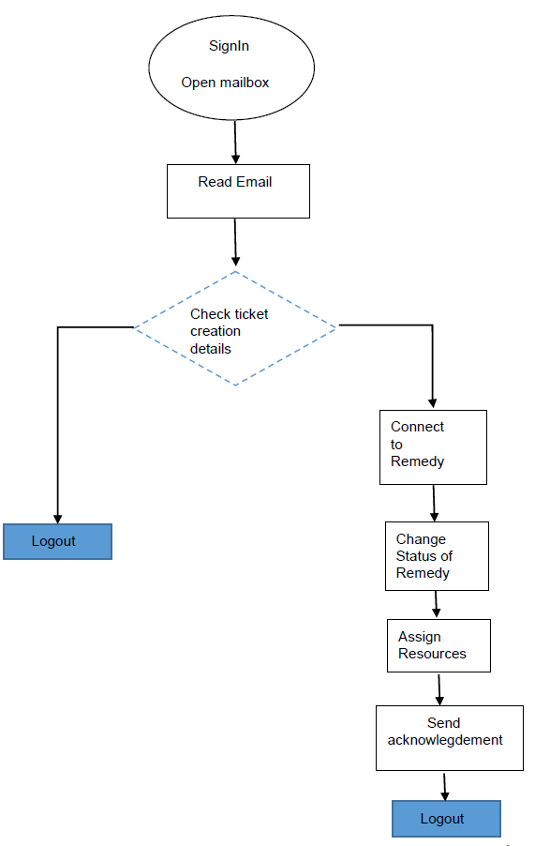

**4.2 DATA FLOW DIAGRAM**

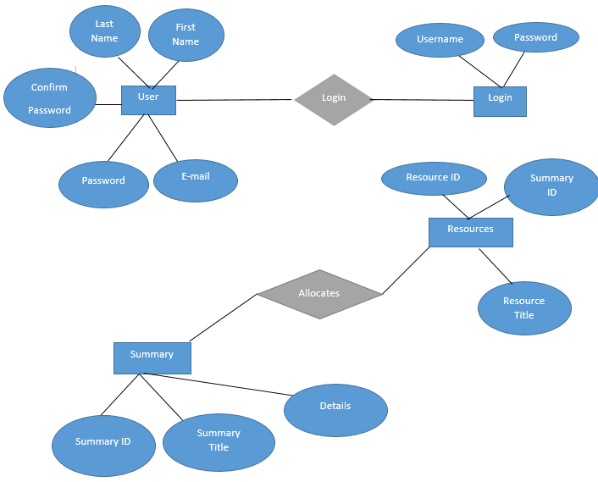

**4.3 Tables**

USER

|  |  |  |  |
| --- | --- | --- | --- |
| Field Name | Field Type | Data Type | Mandatory |
| UserName | Text (20) | Varchar | Yes |
| Password | Text (20) | Varchar | Yes |

*Table 1*

User Details

|  |  |  |  |
| --- | --- | --- | --- |
| Field Name | Field Type | Data Type | Mandatory |
| UserID | Numeric | Number | Yes |
| First Name | Text (50) | Varchar | Yes |
| Last Name | Text (50) | Varchar | Yes |
| Contact Number | Numeric (13) | Integer | Yes |
| email | Text (20) | Varchar | Yes |
| Password | Text (20) | Varchar | Yes |
| Confirm Password | Text(20) | Varchar | Yes |

*Table 2*

Resource

|  |  |  |  |
| --- | --- | --- | --- |
| Field Name | Field Type | Data Type | Mandatory |
| Resource_ID | Numeric | Integer | Yes |
| Summary_ID | Numeric | Integer | Yes |
| Resource_Title | Text | Varchar | Yes |

*Table 3*

Summary

|  |  |  |  |
| --- | --- | --- | --- |
| Field Name | Field Type | Data Type | Mandatory |
| Summary_ID | Numeric | Integer | Yes |
| Summary_Title | Numeric | Integer | Yes |
| Details | Text | Varchar | Yes |

*Table 4*

**CHAPTER 5**

1. **Conclusion**

The Remedy Acknowledgement System guided us through the proper architecture of a management system, making us learn the structured levels of development. Being new to the software, a little problem was faced while writing the complete code from scratch however learning the new technologies in order to build the project has leveled up the making process of management system. As a limitation of project, there could be a few more functionalities added to enhance the system and similarly a better architecture can be used to make it smoother. But whatever is made, it has surely cleared our basics and taught us a lot. Concluding to it, we look forward to enhance the features of the system as well as expanding the possible opportunities that come its way.

**REFERENCES**

* w3schools.com
* docs.oracle.com
* stackoverflow.com
* css-tricks.com
* [www.techonthenet.com](http://www.techonthenet.com)
* [www.tutorialspoint.com](http://www.tutorialspoint.com)
* beginnersbook.com