Customer Churn Analysis & Retention Dashboard
Data Science & Analytics – Task 2
Prepared By:
Aayushi Shirole
Submitted To:
Future Interns
Tools Used:
Python (Google Colab), Power BI, CSV Dataset
Dataset Used:
Telco Customer Churn Dataset
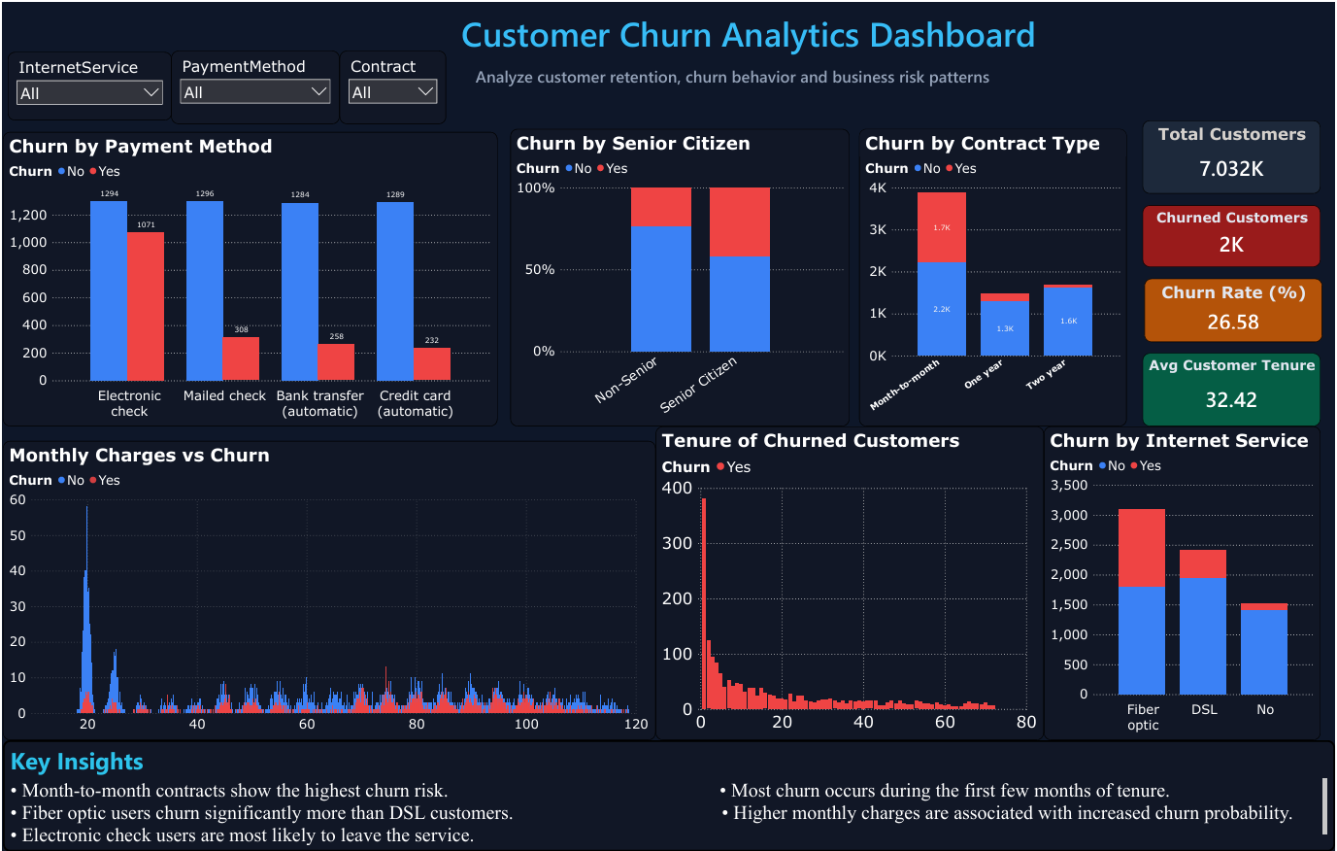

Project Overview

Customer churn is one of the most significant challenges faced by subscription-based businesses, SaaS companies, telecommunication providers, and digital platforms. Customer churn refers to the percentage of customers who stop using a service over a given period.

Understanding customer behavior and identifying churn factors is essential because retaining existing customers is often more cost-effective than acquiring new ones. Businesses can improve customer satisfaction, reduce revenue loss, and optimize services through churn analysis.

This project focuses on analyzing customer churn behavior using the Telco Customer Churn Dataset. The analysis was conducted using Python in Google Colab for exploratory data analysis and Power BI for dashboard visualization.

The objective of this project was to identify customer segments with high churn probability, analyze retention patterns, understand factors affecting churn, and provide actionable business recommendations to improve customer retention.

The final outcome of this project is an interactive business dashboard that enables stakeholders to understand churn trends and make data-driven decisions.

Project Objectives

The main objectives of this project are:
1. Analyze Customer Churn
To identify the percentage of customers leaving the service and understand overall churn behavior.
2. Understand Retention Patterns
To study how long customers stay with the company and identify customer lifetime trends.
3. Identify Churn Drivers
To analyze how contract type, internet service, payment methods, monthly charges, and senior citizen status influence churn.
4. Customer Segmentation
To identify which customer groups are more likely to churn.
5. Build Interactive Dashboard
To create a professional dashboard that presents business insights clearly for stakeholders.
6. Generate Business Recommendations
To suggest actionable strategies that can reduce churn and improve customer retention.

Dataset Information
Dataset Name:
Telco Customer Churn Dataset
Dataset Source:
Kaggle
Total Records:
7,043 Customers
Total Features:
21 Columns
Dataset Description
The dataset contains customer-related information from a telecommunications company. It includes demographic information, subscription details, payment methods, contract information, monthly billing details, and churn status.
The target variable in this dataset is “Churn”, which indicates whether a customer left the service or stayed.
Important Features in Dataset
- Customer ID
- Gender
- Senior Citizen Status
- Partner Status
- Dependents
- Tenure
- Internet Service
- Contract Type
- Payment Method
- Monthly Charges
- Total Charges
- Churn Status
Data Quality
The dataset was examined for missing values, duplicate records, and data inconsistencies.
Observations:
- Total rows: 7,043
- Total columns: 21
- Missing values: None
- Dataset quality: Clean and suitable for analysis
The dataset required minimal preprocessing before visualization and analysis.

Tools & Technologies Used

The following tools and technologies were used to complete this project:
Tool/Technology | Purpose
Python | Data analysis and preprocessing
Google Colab | Python execution environment
Pandas | Data cleaning and manipulation
Matplotlib | Data visualization
Power BI | Interactive dashboard development
CSV Dataset | Data source for analysis

Why These Tools Were Used
Python & Pandas were used for performing data preprocessing and exploratory data analysis.
Matplotlib was used to create charts for churn distribution and behavioral analysis.
Power BI was used to build a visually interactive business dashboard for stakeholders.
The combination of Python and Power BI helped integrate both technical analysis and business storytelling.

Data Cleaning & Preprocessing
Before performing analysis, the dataset was cleaned and examined to ensure accuracy and consistency.
The following preprocessing steps were performed:
Step 1: Dataset Import
The CSV dataset was imported into Google Colab using Pandas.
Step 2: Dataset Shape Analysis
The number of rows and columns in the dataset was examined.
Result:
- Rows: 7,043
- Columns: 21
Step 3: Missing Value Analysis
The dataset was checked for null or missing values.
Result:
- No missing values were found.
Step 4: Data Type Inspection
Data types of all columns were analyzed to understand categorical and numerical variables.
Step 5: Churn Distribution Analysis
The target variable “Churn” was analyzed.
Results:
- Customers Stayed: 5,174 (73.46%)
- Customers Churned: 1,869 (26.54%)
This indicates that nearly one-fourth of the customers discontinued the service.
Step 6: Data Preparation for Dashboard
The cleaned dataset was exported and imported into Power BI for dashboard creation.
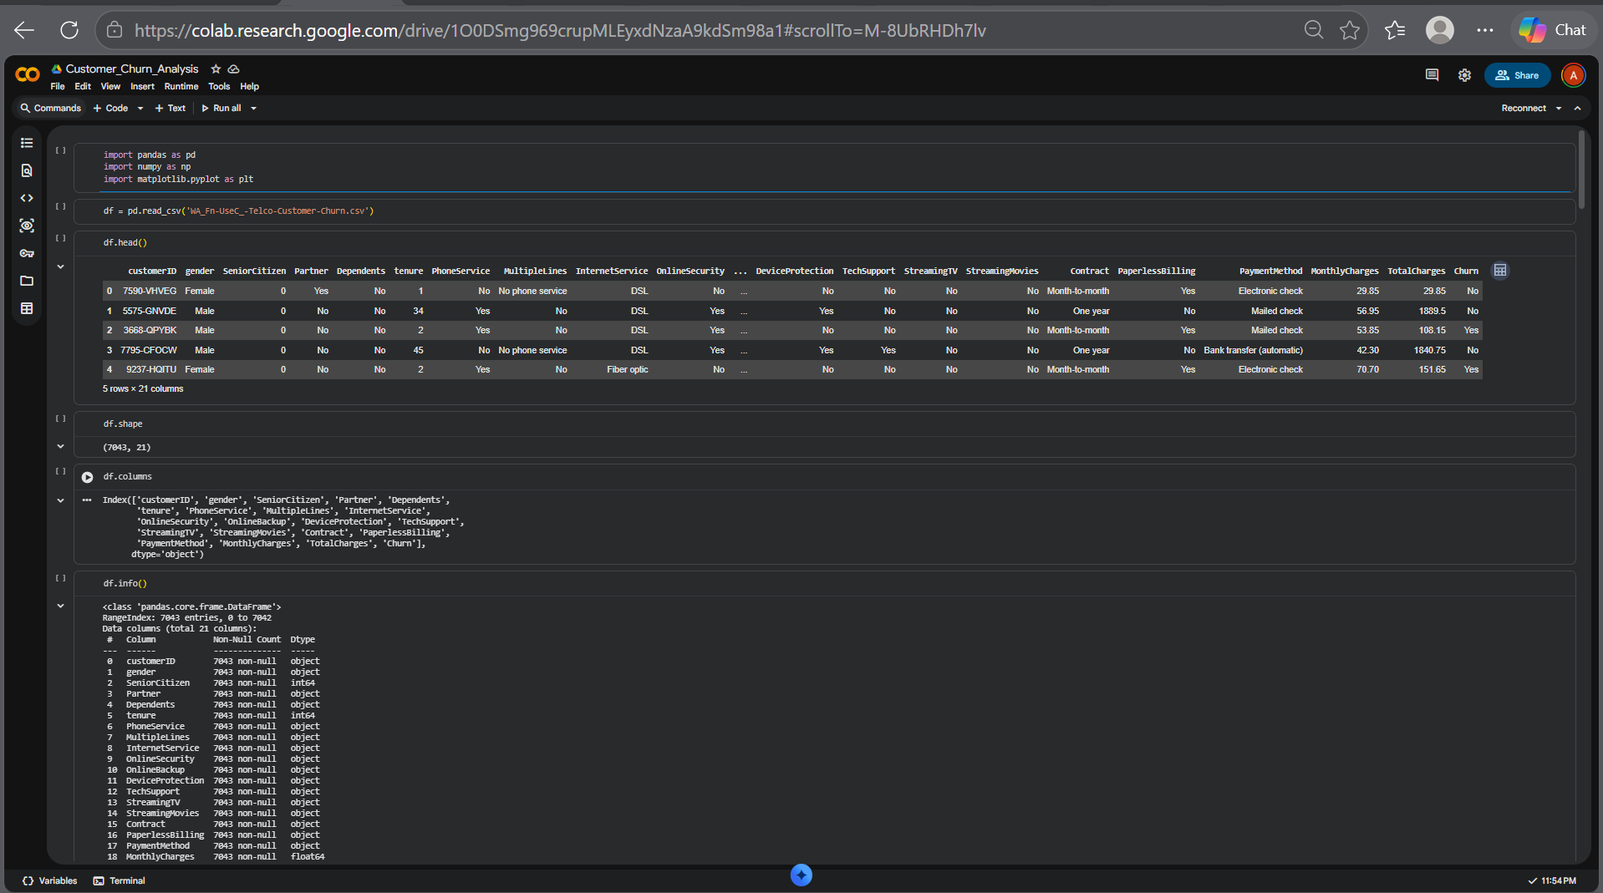
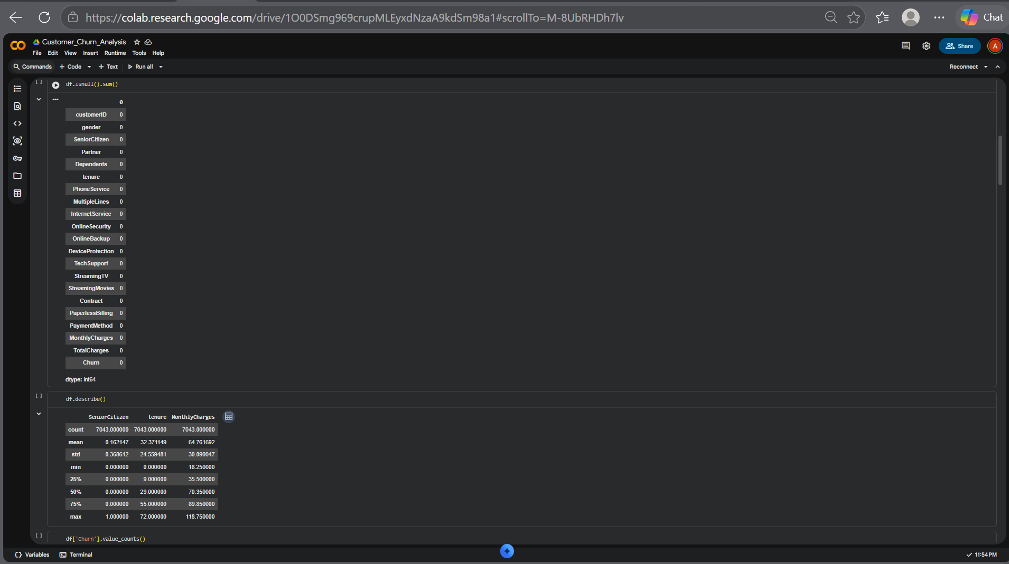
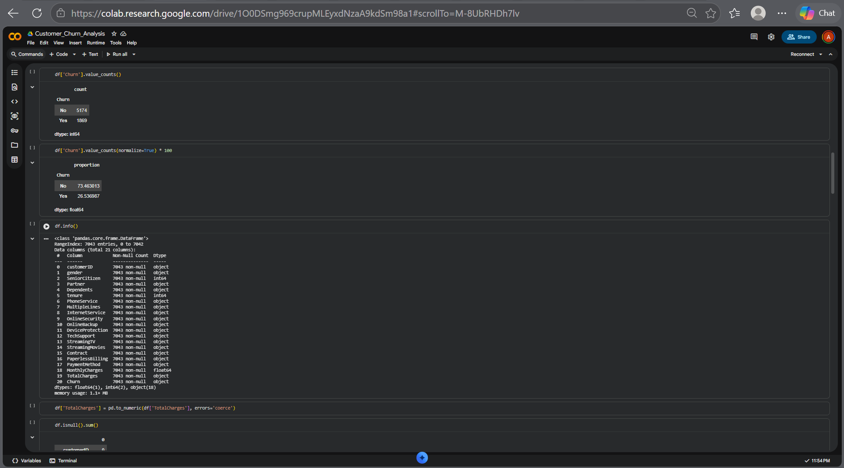
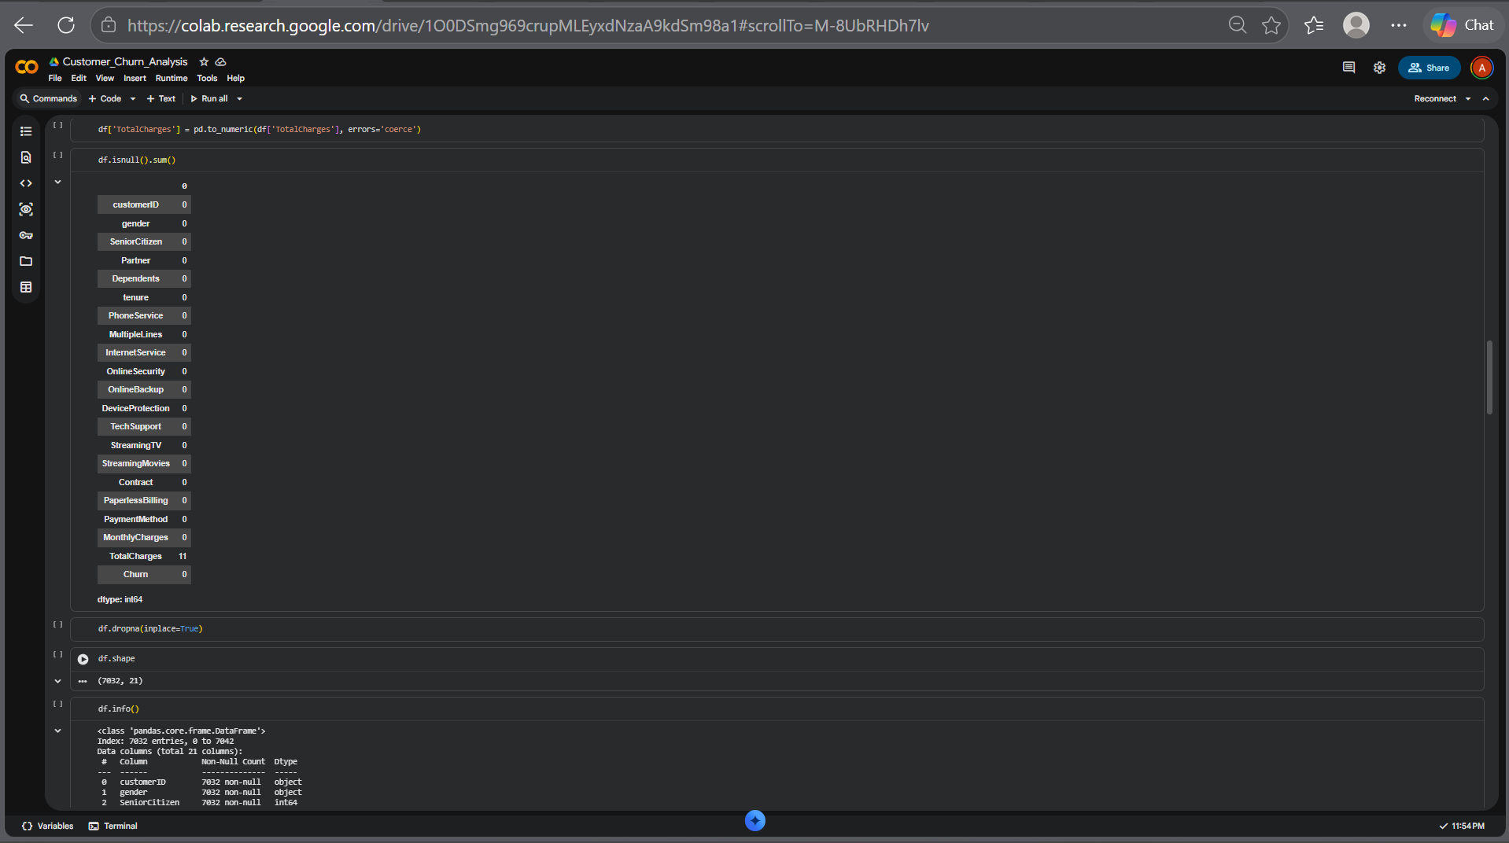
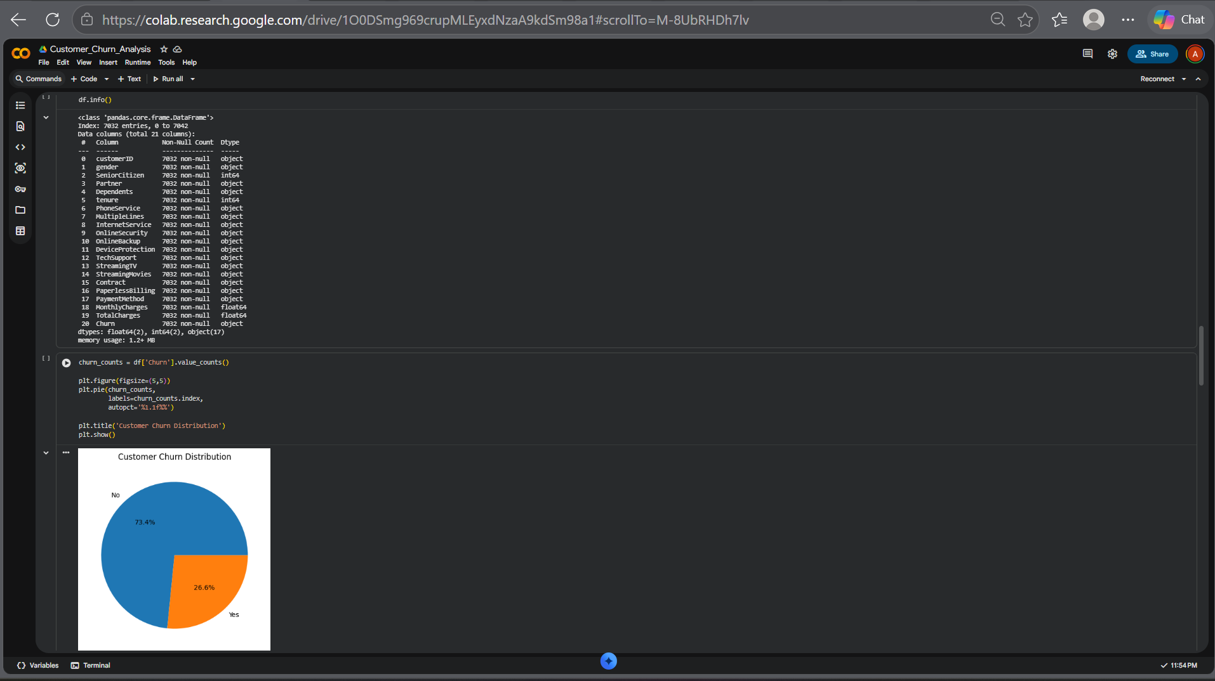
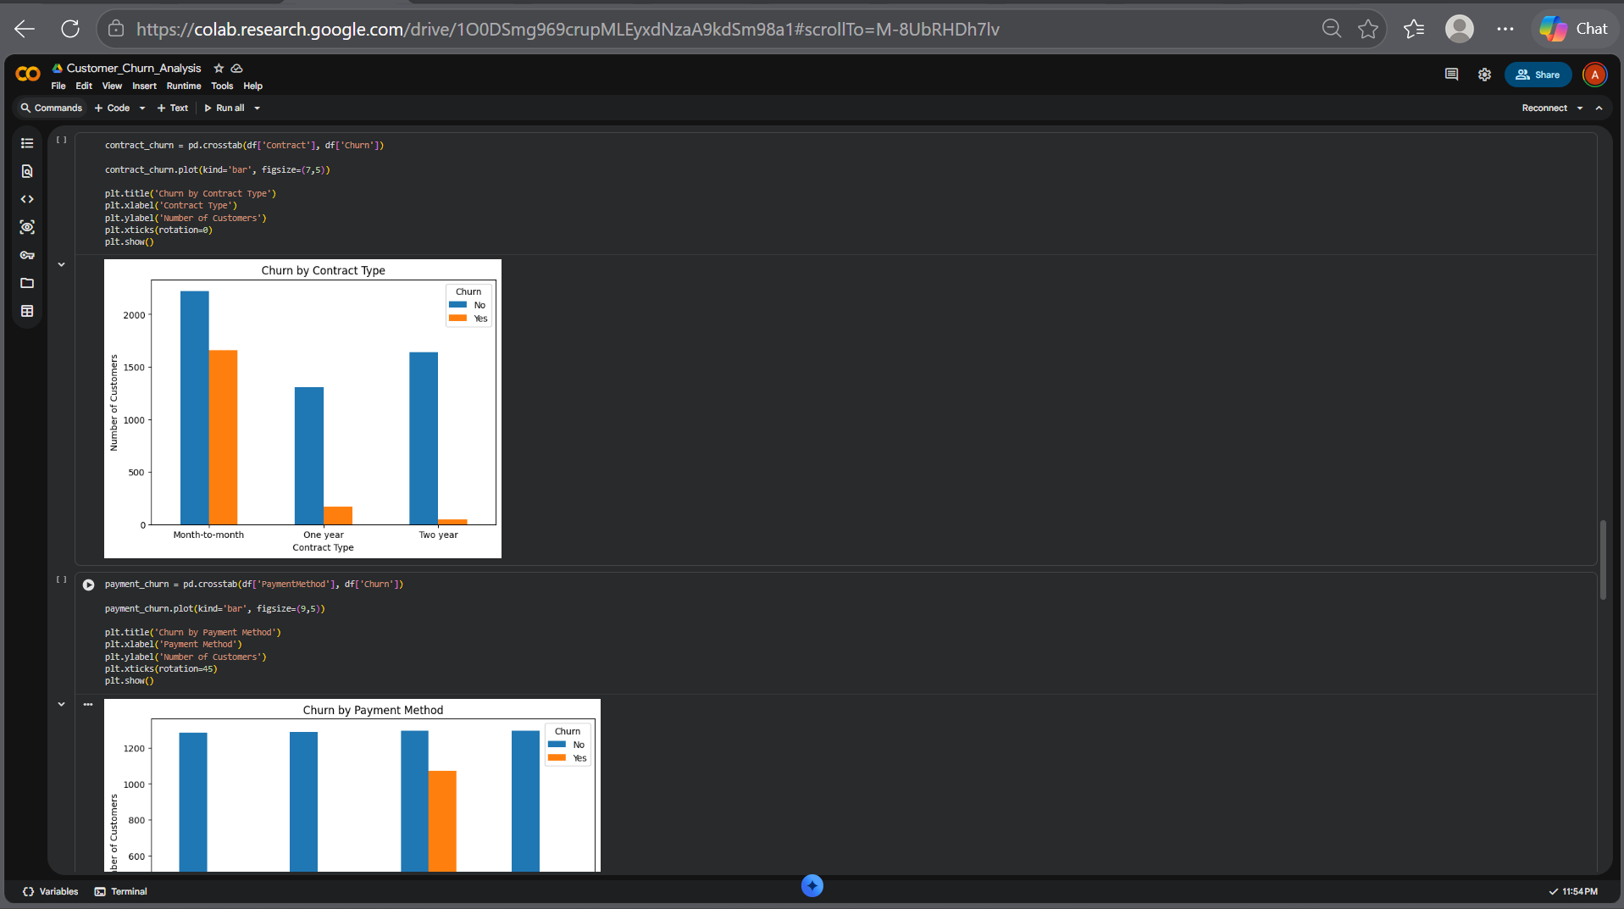
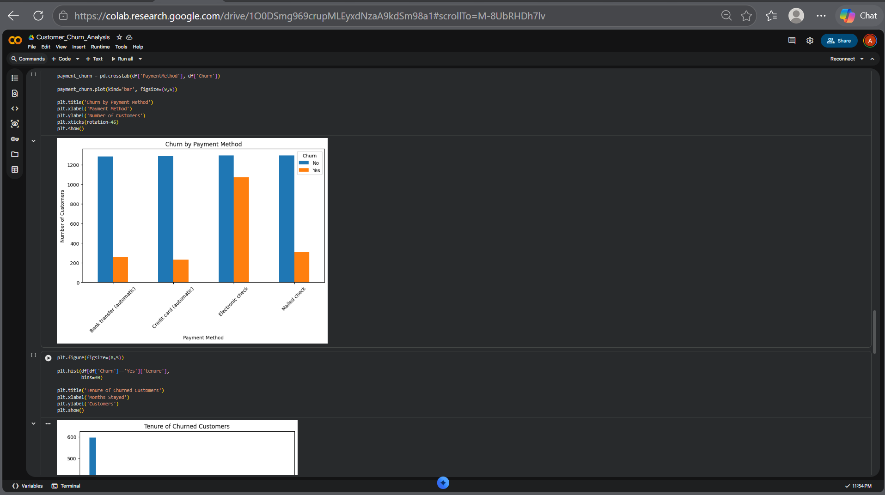
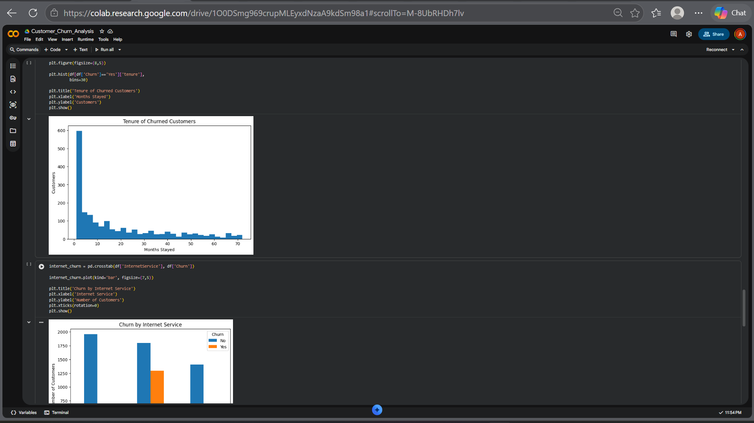
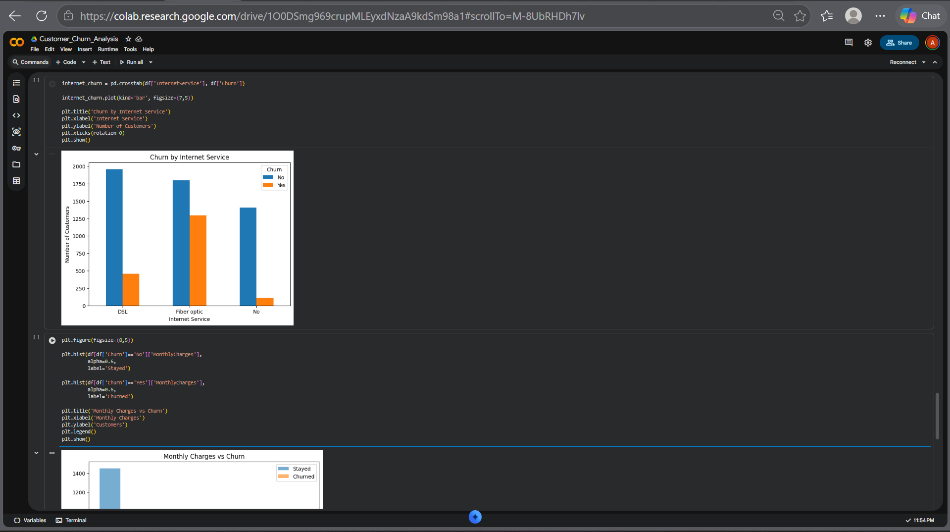
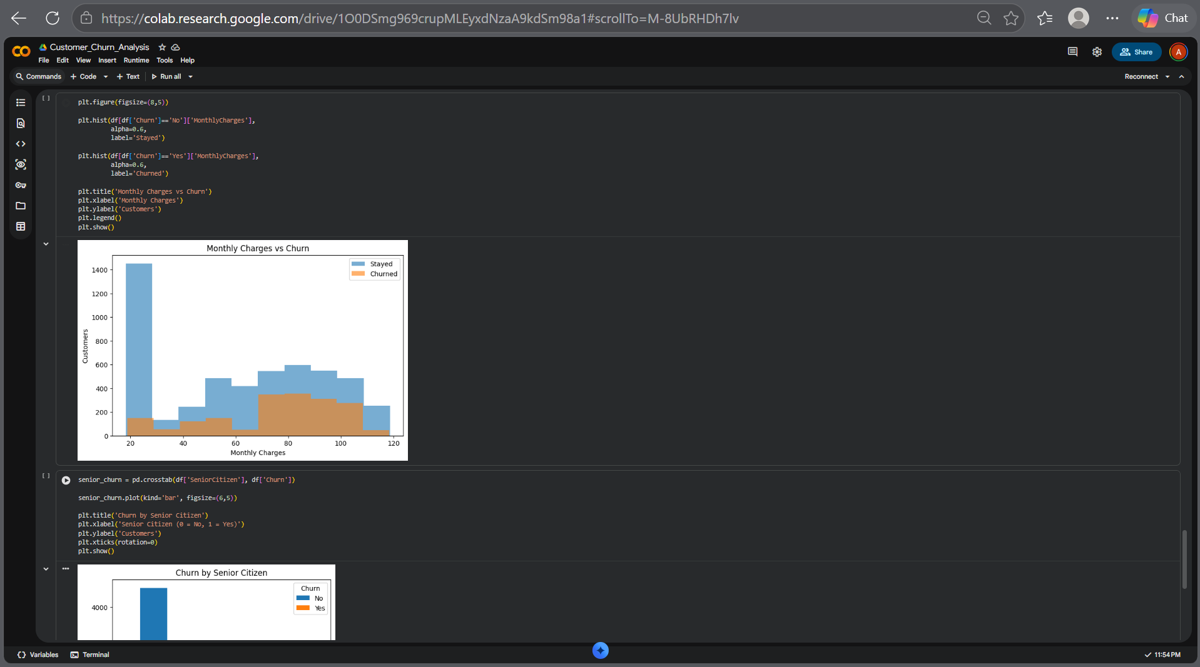
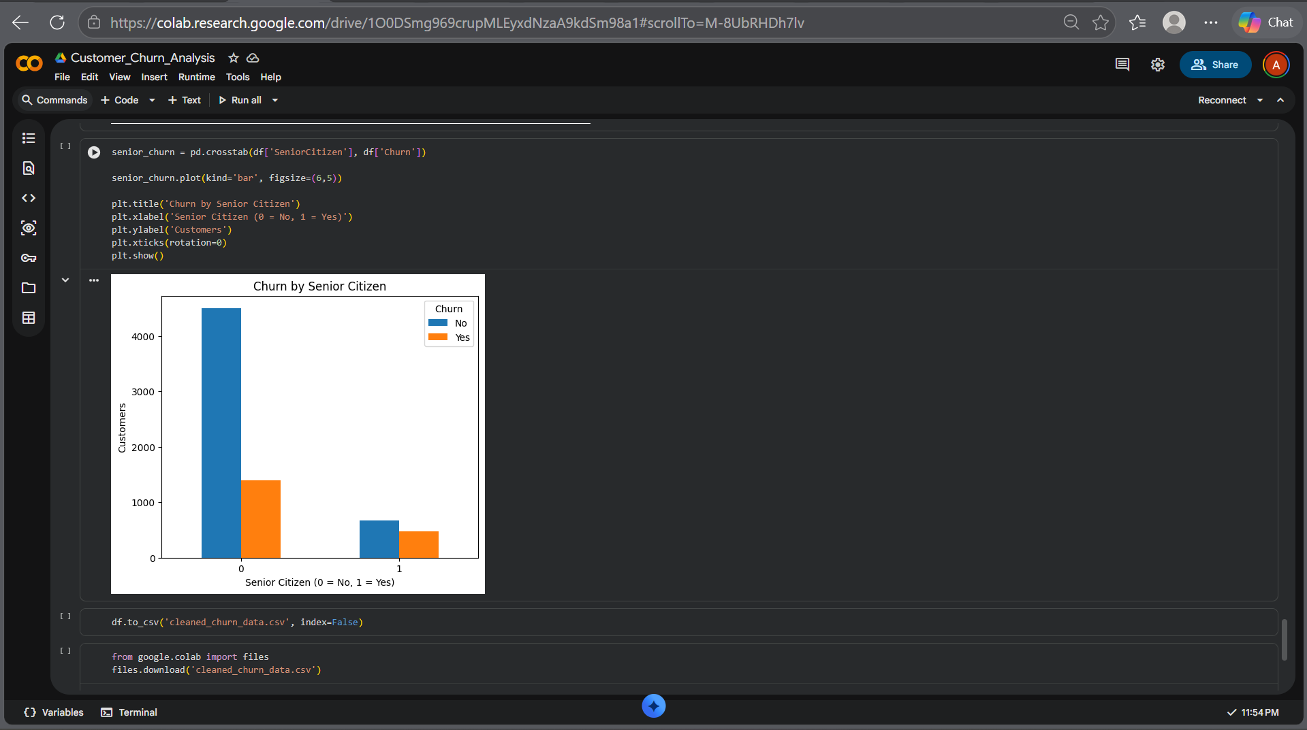

Exploratory Data Analysis
Several visual analyses were performed to understand customer churn behavior.
1. Churn by Contract Type
The analysis showed that customers with Month-to-Month contracts had the highest churn rates compared to customers with yearly contracts.
Customers with One-Year and Two-Year contracts showed significantly lower churn, indicating better retention.
2. Churn by Internet Service
Customers using Fiber Optic internet service showed higher churn rates than DSL users.
This suggests possible dissatisfaction related to pricing, performance, or customer expectations.
3. Churn by Payment Method
Customers using Electronic Check payment method showed the highest churn.
This indicates that payment preferences may influence customer retention.
4. Monthly Charges vs Churn
Customers with higher monthly charges were observed to have greater churn probability.
This suggests price sensitivity among customers.
5. Senior Citizen Analysis
Senior citizens showed relatively higher churn behavior compared to non-senior customers.
6. Customer Tenure Analysis
Most customer churn occurred during the first few months of subscription.
Long-term customers were more likely to stay.

Dashboard Overview
An interactive Power BI dashboard was developed to visualize customer churn behavior effectively.
The dashboard includes:
KPI Cards
- Total Customers
- Churned Customers
- Churn Rate (%)
- Average Customer Tenure
Visual Analysis
- Churn by Contract Type
- Churn by Internet Service
- Churn by Payment Method
- Monthly Charges vs Churn
- Tenure of Churned Customers
- Churn by Senior Citizen
Interactive Features
The dashboard includes slicers for:
- Contract Type
- Internet Service
- Payment Method
These slicers allow dynamic filtering and interactive exploration of churn behavior.
The dashboard was designed using a dark-themed professional layout for improved readability and business presentation.

Key Insights
Based on the analysis, the following insights were identified:
1. Month-to-Month Contracts Have Highest Churn
Customers with monthly contracts showed the highest churn risk.
2. Fiber Optic Users Churn More
Fiber optic internet users demonstrated significantly higher churn compared to DSL users.
3. Electronic Check Customers Are High-Risk
Customers using electronic check payment methods were more likely to discontinue services.
4. Early Subscription Period Is Critical
Most customers churned during the initial months of subscription.
5. Higher Charges Increase Churn
Customers paying higher monthly charges showed greater probability of churn.
6. Senior Citizens Require Better Retention
Senior citizen customers displayed relatively higher churn behavior.

Business Recommendations
Based on the analysis, the following recommendations are suggested:
1. Promote Long-Term Contracts
Offer discounts and loyalty benefits for yearly contracts to reduce churn.
2. Improve Fiber Optic Service Experience
Investigate pricing, service quality, and customer complaints for fiber optic users.
3. Payment Method Incentives
Encourage auto-payment methods by providing cashback or discounts.
4. Improve Customer Onboarding
Provide better onboarding and support during the first few months of subscription.
5. Pricing Optimization
Introduce flexible pricing plans to reduce churn among price-sensitive customers.
6. Personalized Retention Campaigns
Design targeted offers for high-risk customer groups such as senior citizens.

Conclusion
This project successfully analyzed customer churn behavior using the Telco Customer Churn Dataset.
Through exploratory data analysis and dashboard visualization, major churn drivers such as contract type, internet service, payment methods, monthly charges, and tenure were identified.
The analysis revealed that month-to-month customers, fiber optic users, and electronic check customers were more likely to churn.
The interactive Power BI dashboard provided meaningful business insights and enabled stakeholder-friendly decision-making.
This project demonstrates the practical application of data analytics in solving real-world business problems and improving customer retention.

Future Scope
This project can be enhanced further by:
- Applying machine learning models for churn prediction.
- Building customer risk scoring systems.
- Performing cohort analysis for deeper retention tracking.
- Adding customer sentiment analysis.
- Deploying the dashboard online for real-time business monitoring.
The future implementation of predictive analytics can help businesses proactively reduce churn and improve customer retention strategies.

