Week 1 Report
Data Acquisition, Cleaning and Exploratory Data Analysis
Case study: Titanic passenger dataset (891 passengers)
Tools: Python 3, pandas, NumPy, Matplotlib, Seaborn
Date: October 16, 2026

1. Introduction and Objectives
Almost every data science project begins with the same three activities, and this report walks through each of them end to end:
- Acquisition: finding a public dataset and loading it into Python.
- Cleaning: fixing missing values, duplicates and wrong data types so that later analysis can be trusted.
- Exploratory Data Analysis (EDA): using statistics and charts to understand what the data says before any model is built.
Why this matters: Real-world data is rarely analysis-ready. Models trained on unclean data produce unreliable results ("garbage in, garbage out"). Practitioners commonly estimate that cleaning and exploration take the majority of project time, which is why this is Week 1.

1.1 Questions this analysis tries to answer
The dataset records who survived the 1912 sinking of the RMS Titanic. Rather than exploring aimlessly, the EDA is guided by these questions:
- Which passenger attributes (sex, class, age, family situation, fare) are associated with survival?
- How much data is missing, where, and how should it be handled?
- Are the numeric variables well behaved (skewness, outliers), and which are correlated?

1.2 Workflow overview
Step | Stage | What happens
1 | Acquire | Download the CSV directly from a public GitHub repository using pandas
2 | Inspect | Check shape, data types, summary statistics, missing values and duplicates
3 | Clean | Impute or encode missing values, fix types, flag outliers, engineer features
4 | Explore | Summary statistics, histograms, bar charts, box plots, correlation heatmap, scatter plot
5 | Conclude | Summarize insights and propose further analysis

2. Data Acquisition

2.1 Dataset selection
I chose the Titanic passenger dataset. It is publicly available, widely used in teaching, and a good fit for a cleaning exercise because it contains all three classic problems: a numeric column with moderate missingness (Age), a categorical column that is mostly empty (Cabin), and a few isolated gaps (Embarked). It also has a clear target variable (Survived), which gives the EDA a purpose.
Property | Detail
Source | datasciencedojo/datasets repository on GitHub (titanic.csv)
Access method | Direct CSV download through pandas.read_csv(URL)
Size | 891 rows, 12 columns
Domain | Transportation history / survival analysis
Target variable | Survived (0 = died, 1 = survived)

2.2 Data dictionary
Column | Meaning | Notes
PassengerId | Unique row identifier | Not informative for analysis
Survived | Survival flag | Target variable
Pclass | Ticket class (1 = upper, 3 = lower) | Proxy for socio-economic status
Name | Passenger name incl. title | Title (Mr, Mrs, ...) can be extracted
Sex | male / female
Age | Age in years | Has missing values
SibSp | Siblings / spouses aboard
Parch | Parents / children aboard
Ticket | Ticket number | Free-form text
Fare | Ticket price | Heavily right-skewed
Cabin | Cabin number | 77% missing
Embarked | Port of embarkation (C, Q, S) | 2 missing values

2.3 Loading the data
import pandas as pd, numpy as np
import matplotlib.pyplot as plt, seaborn as sns

URL = "https://raw.githubusercontent.com/datasciencedojo/datasets/master/titanic.csv"
df_raw = pd.read_csv(URL) # keep an untouched copy of the original
df = df_raw.copy() # all cleaning happens on this copy
print(df.shape) # (891, 12)

Keeping the untouched original (df_raw) is good practice: if a cleaning decision turns out to be wrong, the data can be reloaded and the step revised without re-downloading.

3. Initial Data Inspection
Before changing anything, I inspected the data to find out what actually needs fixing.
df.info() # dtypes and non-null counts
df.describe() # numeric summary
df.isna().sum() # missing values per column
df.duplicated().sum() # fully duplicated rows
df.PassengerId.duplicated().sum() # duplicated IDs

3.1 Findings
Check | Result | Interpretation
Missing: Cabin | 687 (77.1%) | Too sparse to impute reliably
Missing: Age | 177 (19.87%) | Important predictor; needs careful imputation
Missing: Embarked | 2 (0.22%) | Negligible; simple fill is safe
Duplicate rows | 0 | None found
Duplicate PassengerId | 0 | IDs are unique
Duplicate names | 0 | No repeated passengers
Fare = 0 | 15 | Likely crew/staff or recording gaps; kept

Honest note: The brief asks for duplicate removal. This dataset contains no duplicates, so the check returns zero and no rows are dropped. The code still includes drop_duplicates() because a robust pipeline should always run this check, and the same script would work on a noisier dataset.
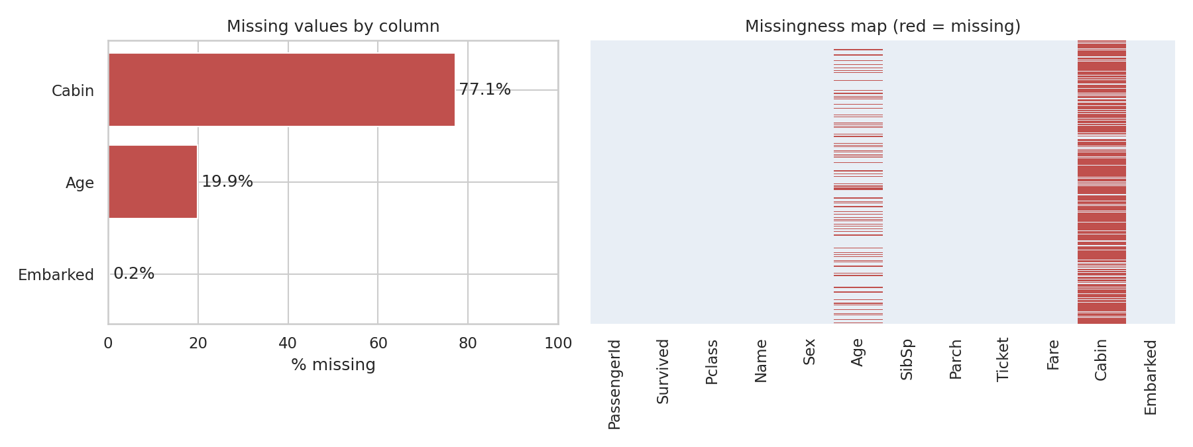
Figure 1: Missing values by column (left) and missingness map (right)
Figure 1 shows that missingness is concentrated in two columns. The right panel also shows that Cabin and Age gaps are scattered across the file rather than clustered in one block, so there is no sign of a corrupted section of the file.

4. Data Cleaning
Each step below states the problem, the decision, and the reasoning behind it.
Issue | Decision | Rationale
Duplicates | drop_duplicates() | Duplicates would double-count passengers and bias statistics
Age (19.9% missing) | Median by Title and Pclass, plus AgeWasMissing flag | Median is robust to outliers; Title and class capture age differences (e.g. Master = boy); the flag preserves the information that the value was imputed
Embarked (2 missing) | Fill with mode (Southampton) | With only 2 rows, the most common value is the lowest-risk choice
Cabin (77.1% missing) | Drop column; create HasCabin and Deck | Imputing 77% of a column would invent data; missingness itself is informative (cabins were recorded mostly for upper-class passengers)
Data types | Convert to int8 / category | Reduces memory and makes categorical intent explicit
Fare outliers | Flag with IQR rule; keep rows | High fares are real first-class tickets, not errors; removing them would discard a real group
Fare skew | Add log(1+Fare) | Reduces skew for later modelling and for readable plots
New features | FamilySize, IsAlone, AgeGroup, Title | Turn raw columns into more meaningful signals

4.1 Removing duplicates and standardizing text
df = df.drop_duplicates()
for c in ["Name", "Sex", "Ticket", "Cabin", "Embarked"]:
df[c] = df[c].astype("string").str.strip() # remove stray whitespace

4.2 Extracting a title from the name
Names follow the pattern "Surname, Title. Given names". A regular expression extracts the title, which is later used for smarter age imputation. Rare titles (fewer than 10 passengers) are grouped as "Rare".
df["Title"] = df["Name"].str.extract(r",\s*([^\.]+)\.", expand=False).str.strip()
df["Title"] = df["Title"].replace({"Mlle": "Miss", "Ms": "Miss", "Mme": "Mrs"})
counts = df["Title"].value_counts()
df["Title"] = df["Title"].where(df["Title"].map(counts) >= 10, "Rare")

Resulting groups: Mr (517), Miss (185), Mrs (126), Master (40), Rare (23).

4.3 Handling missing Age
A single overall median (28) would treat a boy titled "Master" the same as a first-class "Mr". Grouping by Title and Pclass gives each passenger a more realistic estimate. A binary flag records which values were imputed, so that later analysis can test whether imputation affected results.
df["AgeWasMissing"] = df["Age"].isna().astype(int)
group_median = df.groupby(["Title", "Pclass"])["Age"].transform("median")
df["Age"] = df["Age"].fillna(group_median).fillna(df["Age"].median())

Effect of imputation: the mean age moved from 29.7 to 29.14 and the median from 28 to 26. The shift is small, which suggests the imputation did not distort the distribution badly. Standard deviation fell from 14.53 to 13.49, which is expected because imputed values sit near the centre.

4.4 Handling Embarked and Cabin
df["Embarked"] = df["Embarked"].fillna(df["Embarked"].mode()[0]) # 'S'

df["HasCabin"] = df["Cabin"].notna().astype(int) # was a cabin recorded?
df["Deck"] = df["Cabin"].str[0].fillna("Unknown") # first letter = deck
df = df.drop(columns=["Cabin"])

4.5 Correcting data types
for c in ["Survived", "Pclass"]:
df[c] = df[c].astype("int8")
for c in ["Sex", "Embarked", "Title", "Deck"]:
df[c] = df[c].astype("category")
df["Embarked"] = df["Embarked"].cat.rename_categories(
{"S": "Southampton", "C": "Cherbourg", "Q": "Queenstown"})

4.6 Outlier flagging and feature engineering
q1, q3 = df.Fare.quantile([.25, .75]); iqr = q3 - q1
upper = q3 + 1.5 * iqr # = 65.63
df["FareOutlier"] = (df.Fare > upper).astype(int) # flag, do not delete

df["FamilySize"] = df.SibSp + df.Parch + 1
df["IsAlone"] = (df.FamilySize == 1).astype(int)
df["AgeGroup"] = pd.cut(df.Age, [0, 12, 18, 35, 60, 100],
labels=["Child", "Teen", "Young Adult", "Adult", "Senior"])
df["FareLog"] = np.log1p(df.Fare)

The IQR rule flags 116 passengers (about 13.0%) as fare outliers (above 65.63). I kept them: these are genuine expensive tickets, and the highest value (512.33) corresponds to a real first-class fare, not a typing error.

4.7 Result of cleaning
Metric | Before | After
Rows | 891 | 891
Columns | 12 | 20
Total missing values | 866 | 0
Duplicate rows | 0 | 0

The cleaned dataset was saved as titanic_clean.csv for use in later weeks.

5. Exploratory Data Analysis

5.1 Summary statistics
df[["Age", "Fare", "SibSp", "Parch", "FamilySize"]].describe().round(2)

Statistic | Age | Fare | SibSp | Parch | FamilySize
mean | 29.14 | 32.2 | 0.52 | 0.38 | 1.9
std | 13.49 | 49.69 | 1.1 | 0.81 | 1.61
min | 0.42 | 0 | 0 | 0 | 1
25% | 21 | 7.91 | 0 | 0 | 1
50% | 26 | 14.45 | 0 | 0 | 1
75% | 36.75 | 31 | 1 | 0 | 2
max | 80 | 512.33 | 8 | 6 | 11

Reading the table: The average passenger was about 29 years old. Fare has a mean (32.2) more than double its median (14.45), a typical sign of a right-skewed variable. Most passengers travelled without siblings, spouses, parents or children (median SibSp and Parch are both 0). Overall, 38.4% of passengers survived.

5.2 Distributions
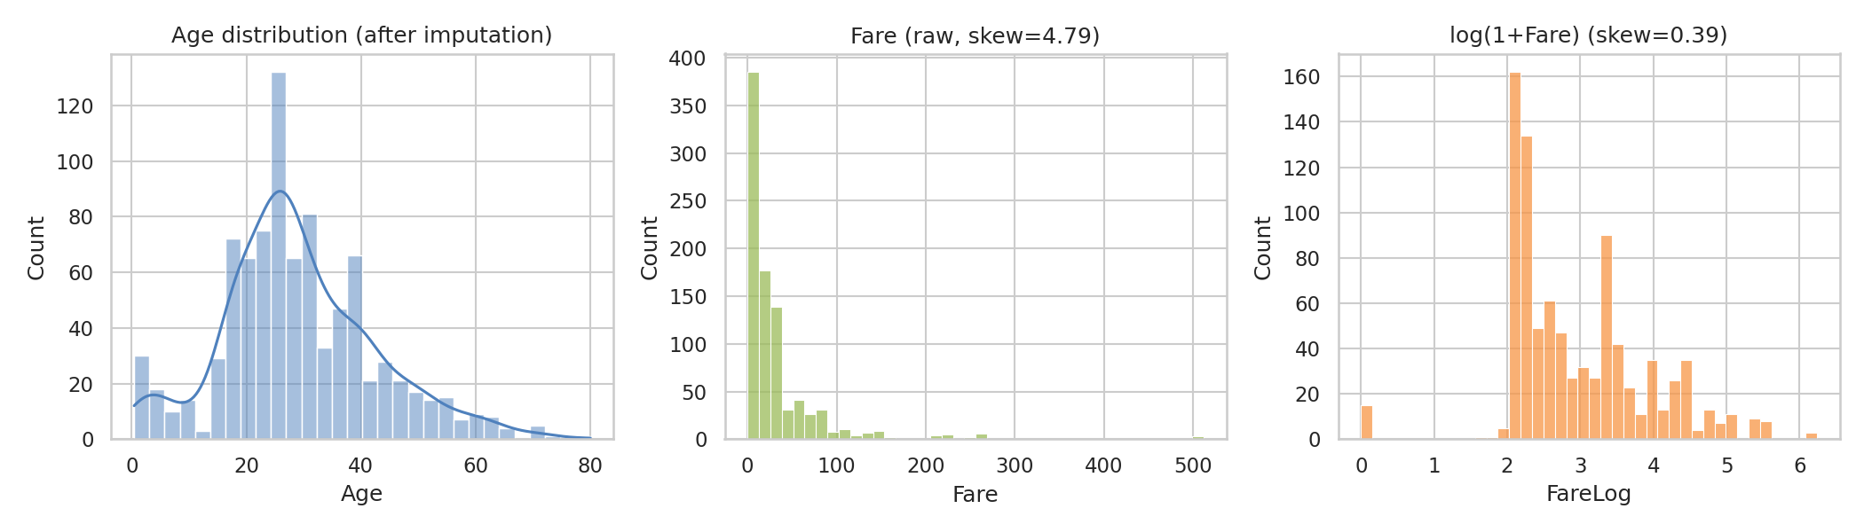
Figure 2: Distributions of Age, Fare and log-transformed Fare
- Age is roughly bell-shaped with a peak in the 20s and a small bump of infants and young children.
- Fare is strongly right-skewed (skewness 4.79). Most tickets are cheap and a few are very expensive.
- log(1+Fare) brings skewness down to 0.39, confirming the transformation is useful for modelling.
Note: the spike in Age near the centre comes partly from imputation, since missing values were filled with group medians. This is a known side effect and is the reason the AgeWasMissing flag was kept.

5.3 Survival patterns
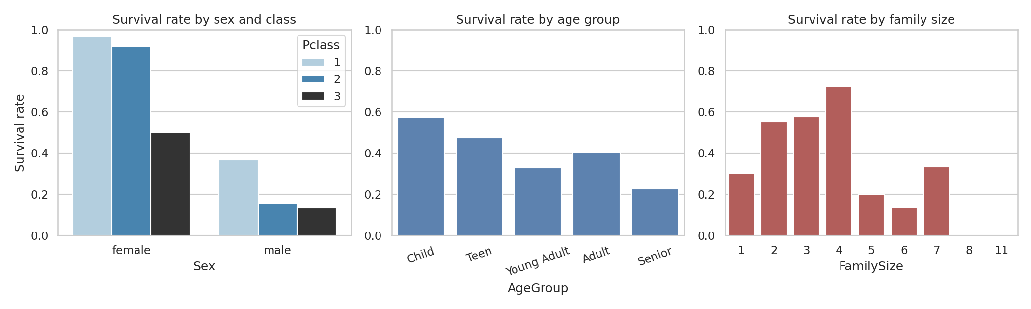
Figure 3: Survival rate by sex and class, age group and family size
Survival rates (percent) by group, computed with groupby on the cleaned data:
Group | Category | Survival rate
Sex | Female | 74.2%
Sex | Male | 18.9%
Class | 1st | 63%
Class | 2nd | 47.3%
Class | 3rd | 24.2%
Age group | Child (0-12) | 57.5%
Age group | Senior (60+) | 22.7%
Travelling | Alone | 30.4%
Travelling | With family | 50.6%
Embarked | Cherbourg | 55.4%
Embarked | Southampton | 33.9%

- Sex is the strongest pattern. Women survived at 74.2% versus 18.9% for men.
- Class matters, and interacts with sex. First-class women survived at 96.8%, while third-class men survived at only 13.5%. Third-class women (50%) did much worse than first and second-class women.
- Children were prioritized. Children aged 12 or under survived at 57.5%, the highest of any age group; seniors had the lowest rate (22.7%).
- Family size has a non-linear effect. Small families (2-4 people) survived at much higher rates than solo travellers (30.4%) or large families of 5 or more. Groups of 8 and 11 had zero survivors, but these groups contain very few people, so those rates are unreliable.
- Port of embarkation: Cherbourg passengers survived most often (55.4%). This is probably confounded by class, since a larger share of first-class passengers boarded there; it should not be read as a direct effect of the port.

5.4 Fare and age by class (box plots)
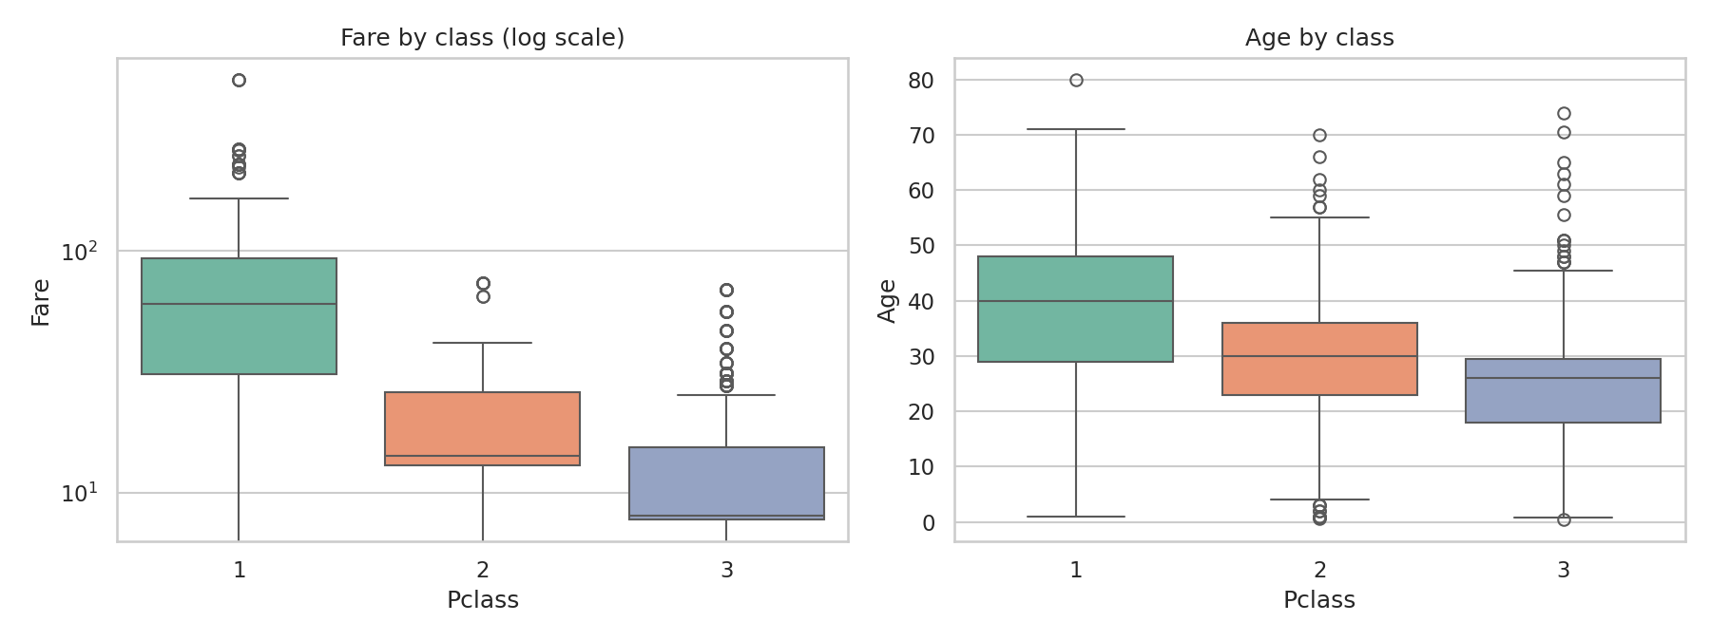
Figure 4: Fare (log scale) and Age by passenger class
Median fare falls steeply with class: 60.29 (1st), 14.25 (2nd) and 8.05 (3rd). First-class passengers were also older (median 40 years, versus 26 in third class). The box plot shows the high fare outliers almost entirely in first class, supporting the decision to keep them rather than treat them as errors.

5.5 Correlation analysis
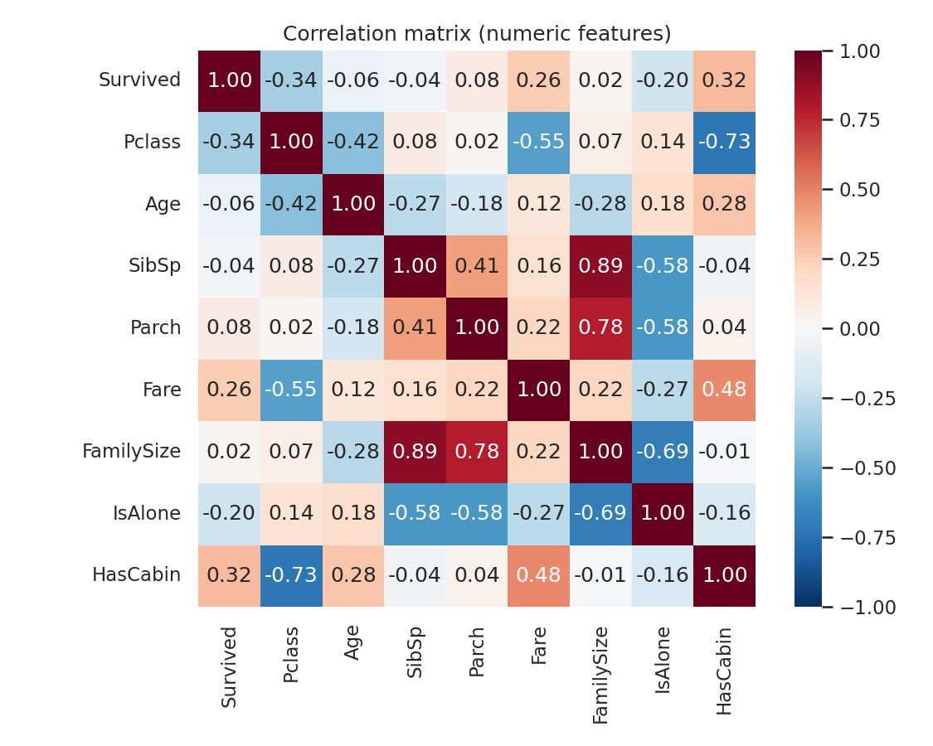
Figure 5: Correlation matrix of numeric features
- Survived correlates most strongly with HasCabin (0.317), Pclass (-0.338, negative because 1st class is the lowest number) and Fare (0.257).
- Pclass and Fare are moderately negatively correlated (-0.549), as expected: higher class means a higher fare.
- IsAlone has a negative association with survival (-0.203), consistent with the family-size pattern above.
- Age has only a weak linear relationship with survival (-0.063). The age effect is mostly concentrated in children, which a linear correlation understates.
Caution: Sex is not in the correlation matrix because it is categorical. Its effect (74.2% vs 18.9% survival) is larger than any correlation shown here. Correlation also does not imply causation; class, sex and fare are intertwined.

5.6 Age versus Fare
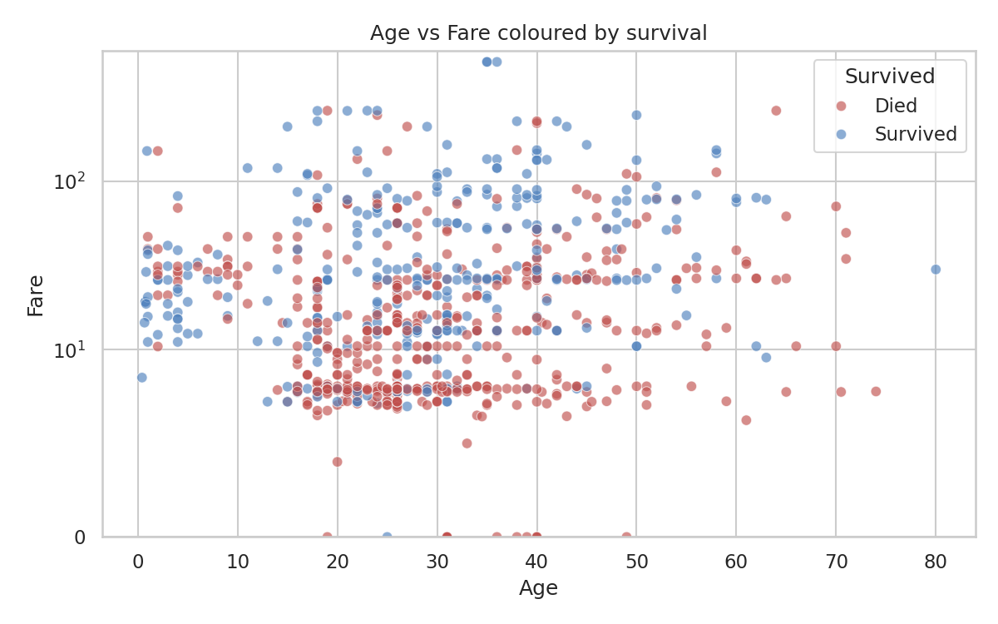
Figure 6: Age vs Fare, coloured by survival (symmetric-log y-axis)
The scatter plot shows no strong relationship between age and fare (correlation 0.12). Fare is much more closely tied to survival: the 116 passengers flagged as fare outliers (above 65.63) survived at 68.1%, while the 336 passengers who paid 10 or less survived at 19.9%. Because fare is largely a stand-in for class, this should be read together with the class results above, not as a separate effect.

6. Summary of Insights
- Data quality: Only three columns had missing values. Cabin (77%) was converted to a HasCabin flag instead of imputed, Age (20%) was imputed using Title and class, and Embarked (0.2%) was filled with the mode. No duplicates were present.
- Overall survival: 38.4% of the 891 passengers survived.
- Sex and class dominate: Being a woman in 1st or 2nd class meant survival above 90%; being a man in 2nd or 3rd class meant survival below 16%.
- Age: Children were favoured; older passengers fared worst.
- Family: Travelling in a small group was better than travelling alone or in a very large group.
- Fare: Fare is highly skewed and a strong proxy for class; a log transform makes it much better behaved.
- Missingness is informative: Passengers with a recorded cabin survived at 66.7% versus 30.0% without one. Passengers whose age was missing also survived less often (29.4% versus 40.6%), which supports keeping the AgeWasMissing flag.

7. Limitations and Further Analysis

7.1 Limitations
- Median imputation reduces variance and can mask real variation in Age. A model-based imputer (for example KNN or iterative imputation) could be compared.
- Cabin missingness is probably not random (cabins of lower-class passengers were less likely to be recorded), so the HasCabin signal partly reflects record-keeping rather than anything physical.
- Several subgroup rates (large families, rare titles) rest on very small counts; no significance testing was done in this week's work.
- The patterns are associations in one historical dataset and should not be generalized to other events.

7.2 Possible next steps
- Statistical tests: chi-square tests for categorical associations (Sex, Pclass, Embarked vs Survived) and a t-test or Mann-Whitney test on Age and Fare.
- Predictive modelling: baseline logistic regression, then tree-based models, using the engineered features (Title, FamilySize, HasCabin, FareLog).
- More feature engineering: ticket-group size (passengers sharing a ticket), deck-level analysis, and interaction terms such as Sex x Pclass.
- Imputation comparison: measure how different Age imputation strategies change model performance.

Appendix: Reproducing the Analysis
All steps above are contained in a single script (analysis.py) that downloads the data, cleans it, produces all six figures and saves titanic_clean.csv. To run it:
pip install pandas numpy matplotlib seaborn
python analysis.py

Dataset credit: Titanic passenger data as hosted in the public datasciencedojo/datasets repository on GitHub.

