Week 2 Report
Advanced Data Visualization and Storytelling with Python
Health and Wealth of Nations, 1952 to 2007
A visual story for a non-technical audience, built from the Gapminder dataset (142 countries, 12 time points)
Tools: Python 3, pandas, NumPy, SciPy, Matplotlib
Date: October 17, 2026

1. Introduction

1.1 Purpose of this report
Week 1 was about preparing data. Week 2 is about communicating it. A table of numbers rarely persuades anyone, but a well designed chart can make a pattern obvious in seconds. This report builds a short visual story, a sequence of six charts where each one answers a question raised by the one before it, and explains why every design choice was made.

1.2 The story in one sentence
Headline: Between 1952 and 2007 the typical person gained about two decades of life, and the world became much richer and healthier, but progress was uneven, it was not guaranteed, and money alone does not explain who lived longer.

1.3 Intended audience
The charts are designed for a general audience, such as a manager, a policy reader, or a student with no statistics background. That choice drives the rules used throughout: each chart has a plain-language title that states the takeaway, no jargon in labels, colours that remain readable for colour-blind viewers, and direct labels on the data instead of hard-to-read legends.

1.4 How this document is organized
Section | Content
2. Data and Methods | The dataset, quality checks, story planning, design rules, chart alternatives that were considered, and key code
3. Visual Analyses | Six visualizations. For each: what it shows, why this chart type, how it advances the story, and the insight
4. Implications | What the findings could mean for business and for scientific or public health work
5. Limitations | What this analysis cannot tell us
6. Conclusion | The story, summarized

2. Data and Methods

2.1 Dataset
I used the Gapminder dataset, a well-known public dataset on global development. It is loaded directly from a public GitHub repository (plotly/datasets). I chose it because it combines three variables that naturally tell a story together: how long people live, how rich their country is, and how many people live there. It also covers 55 years, which allows change over time to be shown.
Variable | Meaning
country, continent | 142 countries in 5 continents (Africa 52, Asia 33, Europe 30, Americas 25, Oceania 2)
year | 12 snapshots, every 5 years from 1952 to 2007
lifeExp | Life expectancy at birth, in years
gdpPercap | Average income per person (GDP per capita), in US dollars adjusted for inflation and price differences
pop | Population of the country

2.2 Data quality check
Week 1 covered cleaning in depth. Here a quick audit confirmed the data was ready for visualization:
- 1,704 rows (142 countries x 12 years), 6 columns.
- No missing values and no duplicate rows, so no imputation or removal was needed.
- Income is strongly right-skewed (a few very rich countries), so a log10 version (logGDP) was added for plotting and for the regression in Figure 5.
URL = ("https://raw.githubusercontent.com/plotly/datasets/"
"master/gapminderDataFiveYear.csv")
df = pd.read_csv(URL)
assert df.isna().sum().sum() == 0 and df.duplicated().sum() == 0
df["logGDP"] = np.log10(df.gdpPercap)

2.3 Story structure
Before drawing anything I planned the narrative as a short arc. Each chart answers one question and sets up the next.
Act | Question | Chart
1 | How different was the world in 1952 and 2007? | Figure 1: Side-by-side bubble charts
2 | Did the gap between countries close? | Figure 2: Ridgeline of life expectancy over time
3 | Who gained the most, and who gained least? | Figure 3: Dumbbell chart of gains
4 | Was progress steady for everyone? | Figure 4: Highlighted line chart of reversals
5 | Is wealth the whole explanation? | Figure 5: Scatter plot with outliers labelled
6 | What did the overall journey look like by continent? | Figure 6: Path chart of wealth and health

2.4 Design principles
- Titles state the finding. "The world moved up and to the right" tells a reader what to notice, where "Life expectancy vs income" would only describe the axes.
- Colour-blind-safe palette. Continents use the Okabe-Ito palette, which stays distinguishable for the most common types of colour blindness. The same colour always means the same continent across all figures.
- Grey for context, colour for the point. In Figure 4 all 142 countries are drawn in light grey and only the story countries in colour, so the eye goes straight to the message.
- Direct labels. Countries are named on the chart so readers do not have to match colours to a legend.
- A log scale for income, explained in plain words. Income differs by a factor of 100 between the poorest and richest countries. On a normal axis most countries would be squashed into the left edge. On a log scale each step to the right means "double", so a move from $1,000 to $2,000 looks as big as $10,000 to $20,000. Axis labels show real dollar amounts to avoid confusion.
- Minimal clutter. Top and right borders removed, light gridlines, and no 3D effects or decorative elements.

2.5 Chart types considered
The task asks to experiment with different chart types. For each question I weighed alternatives and picked the one that answered it most clearly:
Question | Alternative rejected | Reason; chart chosen
Compare two years across 142 countries | Two bar charts, or a table | Too many countries for bars. A bubble chart shows income, health, population and continent at once. Chosen: side-by-side bubbles
How the whole distribution changed | Box plot, or a single histogram per year | Box plots hide the second hump of 1952. Overlapping histograms are cluttered. Chosen: ridgeline
Gains for specific countries | Grouped bar chart | Bars show levels, but the story is the distance travelled. Chosen: dumbbell
Declines over time | Plain 142-line spaghetti plot | Unreadable. Chosen: grey context lines plus highlighted countries
Who beats or misses expectations | Table of residuals | Hard to read quickly. Chosen: labelled scatter with a trend line
Continent-level change in two variables | Two separate line charts | Splits one story in two. Chosen: connected path chart

2.6 Implementation notes and key code
All charts were produced with Matplotlib using a shared style so the document looks consistent. Key techniques are shown below; the complete script is included with this submission.
Shared style and palette:
# Okabe-Ito palette (colour-blind safe)
PAL = {"Africa": "#D55E00", "Americas": "#009E73", "Asia": "#E69F00",
"Europe": "#0072B2", "Oceania": "#CC79A7"}
plt.rcParams.update({"axes.spines.top": False, "axes.spines.right": False,
"grid.color": "#E5E7EB", "savefig.dpi": 170})

Bubble chart (Figure 1), size shows population:
ax.scatter(s.gdpPercap, s.lifeExp, s=s["pop"] / 1.1e6 + 14,
c=s.continent.map(PAL), alpha=.72, edgecolor="white")
ax.set_xscale("log")

Ridgeline (Figure 2), one smoothed distribution (KDE) per year:
from scipy.stats import gaussian_kde
x = np.linspace(20, 90, 400)
for i, yr in enumerate(years):
y = gaussian_kde(p[yr], bw_method=.25)(x)
base = (len(years) - 1 - i) * 1.0 # vertical offset
ax.fill_between(x, base, base + y / y.max() * 1.55, color=ramp[i])

Highlight against context (Figure 4):
for c in p.index:
if c not in highlight:
ax.plot(p.columns, p.loc[c], color="#D1D5DB", lw=.8) # grey context
for c, col in highlight.items():
ax.plot(p.columns, p.loc[c], color=col, lw=2.6, marker="o")

Finding over- and under-performers (Figure 5):
# trend line of life expectancy vs log income
slope, icpt = np.polyfit(d7.logGDP, d7.lifeExp, 1)
# residual = actual minus predicted
d7["residual"] = d7.lifeExp - (slope * d7.logGDP + icpt)
over, under = d7.nlargest(5, "residual"), d7.nsmallest(5, "residual")

3. Visual Analyses
Each subsection below follows the same four-part pattern: what the chart shows, why this chart type was chosen, how it moves the story forward, and what it reveals.

3.1 Act 1: The world moved up and to the right
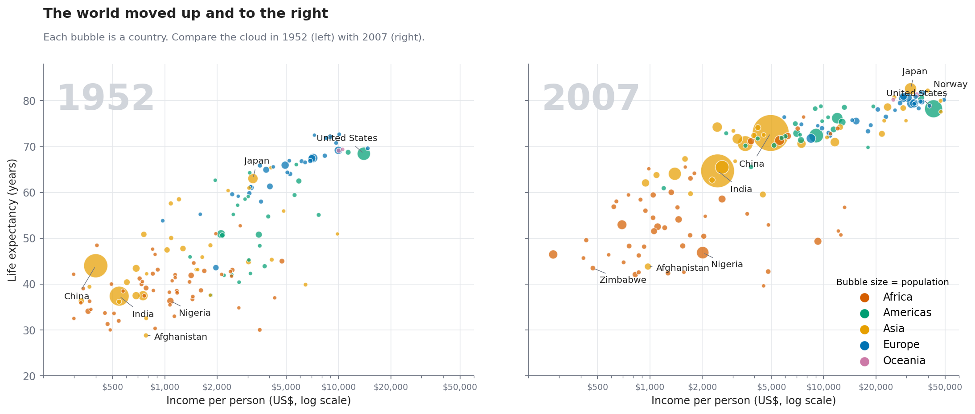
Figure 1: Income, life expectancy and population in 1952 and 2007
What it shows. Each bubble is a country. Across means richer, up means longer-lived, bubble size is population and colour is continent. In 1952 (left) most countries cluster at the bottom left, with life expectancy mostly between 30 and 60 years. By 2007 (right) the whole cloud has shifted up and to the right.
Why this chart. A bubble chart is one of the few charts that can show four variables at once without overwhelming a reader, and placing two years side by side with identical axes makes the change visible without needing to read a single number. The axes are shared so that the eye can compare positions directly.
Role in the story. It is the opening scene. It establishes that something big changed and introduces the colour code and the axes that every later chart reuses.
Insight. The population-weighted average life expectancy rose from 48.9 to 68.9 years. The median country went from 45.1 to 71.9 years and the median income grew about 3.1 times (from $1,969 to $6,124). In 1952, 82 of the 142 countries, home to 64.1% of the people in this dataset, had a life expectancy below 50. By 2007 that was 19 countries and 6.5% of people. The orange (Africa) bubbles stay concentrated in the lower part of the chart in both years, hinting at the uneven picture explored next.

3.2 Act 2: A rising tide, but a long tail was left behind
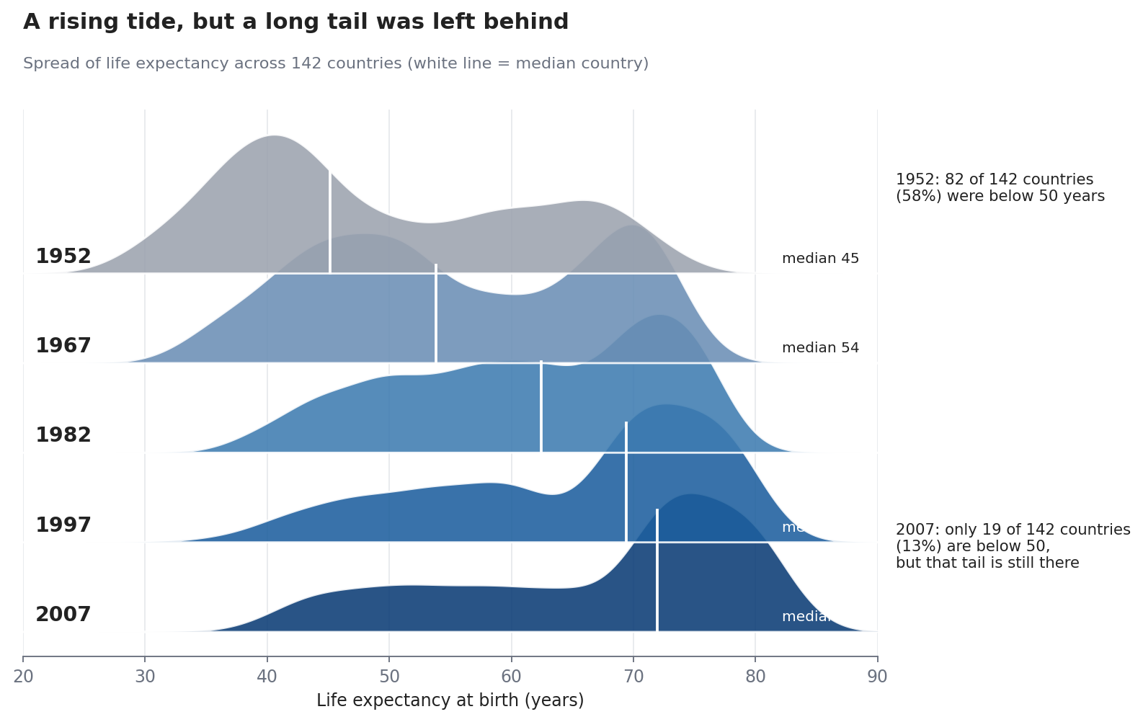
Figure 2: How life expectancy was distributed across countries over time
What it shows. Each coloured hill shows how countries are spread across life expectancy values in one year. A tall hill means many countries have values near that point. The white line marks the median country.
Why this chart. A single average would hide the shape of the story. The ridgeline shows the entire distribution for five years stacked in one view, so readers can see it move, split and reshape. Stacking years vertically gives a natural "time flows downward" reading.
Role in the story. It answers the obvious follow-up question: if the average went up, did everyone catch up? The answer is more nuanced than a simple "yes", which is what makes it interesting.
Insight. In 1952 most countries clustered around 40 years, with a smaller group in the high 60s. By 2007 the main peak sits in the mid 70s. The median country gained about 27 years. However, a long tail of countries remained stuck lower. The spread did not narrow: the standard deviation was 12.2 years in 1952 and 12.1 in 2007, and the gap between the longest-lived and shortest-lived country was 43.9 years in 1952 versus 43 in 2007. In other words, many countries moved up together, but the distance between the top and bottom stayed about the same. I deliberately titled the chart around this finding rather than a simpler "convergence" headline, because the data does not support one.
Why this matters for honesty: My first draft title for this chart was "Two worlds merged into one". Checking the numbers showed the spread had not shrunk, so the title was changed. A chart title is a claim, and it should be one the data supports.

3.3 Act 3: Some countries gained 30+ years; a few gained almost nothing
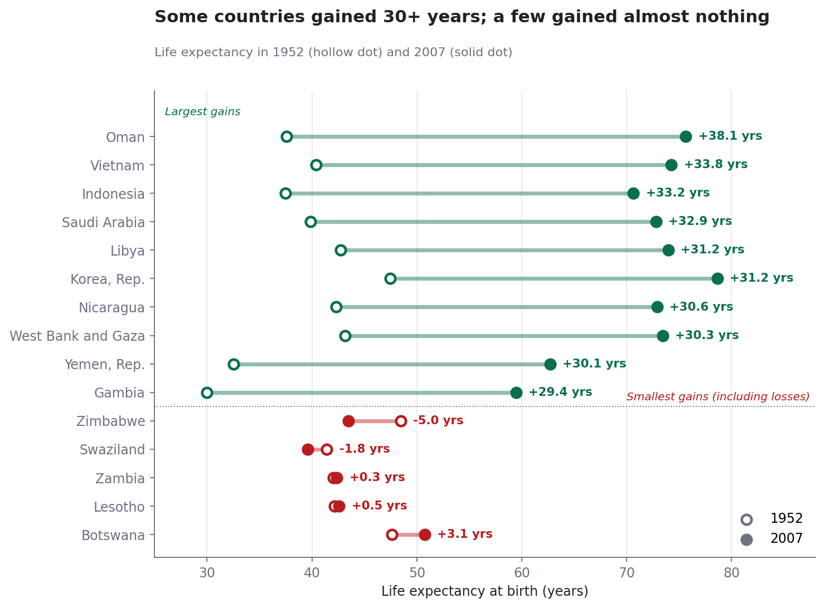
Figure 3: Life expectancy in 1952 and 2007 for the biggest and smallest gainers
What it shows. Each row is a country. The hollow dot is 1952 and the solid dot is 2007, joined by a line, so the length of the line is the number of years gained. Green rows are the ten biggest gainers; red rows are the five smallest.
Why this chart. The story here is distance travelled, not a level. A bar chart would show where each country ended up but make readers subtract mentally. A dumbbell puts the journey itself on the page, and sorting by gain gives an instant ranking.
Role in the story. It moves from the world as a whole (Figures 1 and 2) to named countries, which makes the story concrete, and it plants the idea of the red group that Figure 4 explores.
Insight. The average country gained 17.9 years. The largest gains were in Oman (+38.1), Vietnam (+33.8), Indonesia (+33.2), Saudi Arabia (+32.9) and Libya (+31.2); many of these started from very low levels in 1952, so large gains were possible. At the other end, only 2 countries ended up lower than in 1952: Zimbabwe (-5 years) and Swaziland (-1.8). Zambia (+0.3) and Lesotho (+0.5) gained almost nothing in 55 years.

3.4 Act 4: But progress is not guaranteed
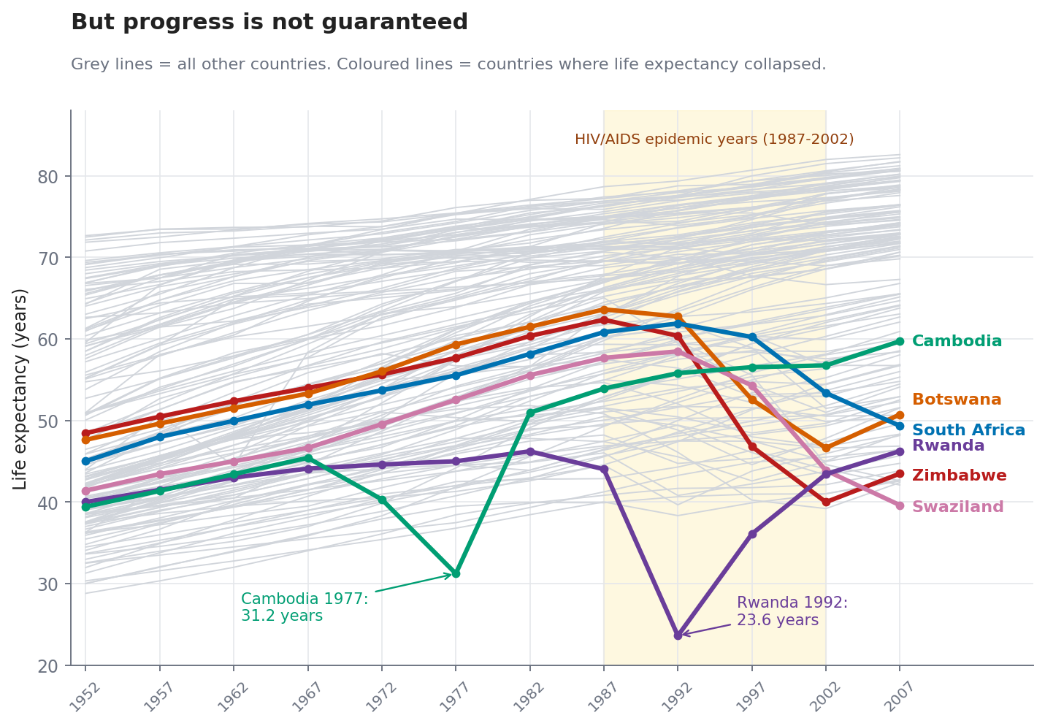
Figure 4: Life expectancy over time, with countries that experienced collapses highlighted
What it shows. Every thin grey line is a country's life expectancy over time. Most rise steadily. The coloured lines are countries where life expectancy fell sharply. The yellow band marks 1987 to 2002, roughly the years when the HIV/AIDS epidemic hit southern Africa hardest.
Why this chart. Line charts are the natural way to show change over time. Drawing all 142 countries in grey gives a sense of the normal trend while the colour draws attention to the exceptions. Highlighting only six countries avoids the unreadable "spaghetti" effect.
Role in the story. It is the turning point. After three charts of good news, this one introduces the complication that makes the story honest: progress can reverse.
Insight. Between 1987 and 2002, 12 countries lost more than 5 years of life expectancy. The largest drops were Zimbabwe (-22.4 years, from 62.4 to 40), Botswana (-17), Swaziland (-13.8), Lesotho (-12.6) and Zambia (-11.6), all in southern Africa. Two other collapses stand out, both linked to conflict: Rwanda fell from 44 in 1987 to 23.6 in 1992, and Cambodia dropped to 31.2 in 1977. Both recovered in later years. Across the whole dataset, 102 of 1562 five-year steps (about 6.5%) were declines, so reversals were rare, but when they happened they were often severe.
Note on causes: the dataset only contains numbers, not reasons. The HIV/AIDS, genocide and conflict explanations come from well-documented historical context, not from this data, and the chart is meant to show where and when the drops occurred.

3.5 Act 5: Money buys health, but not automatically
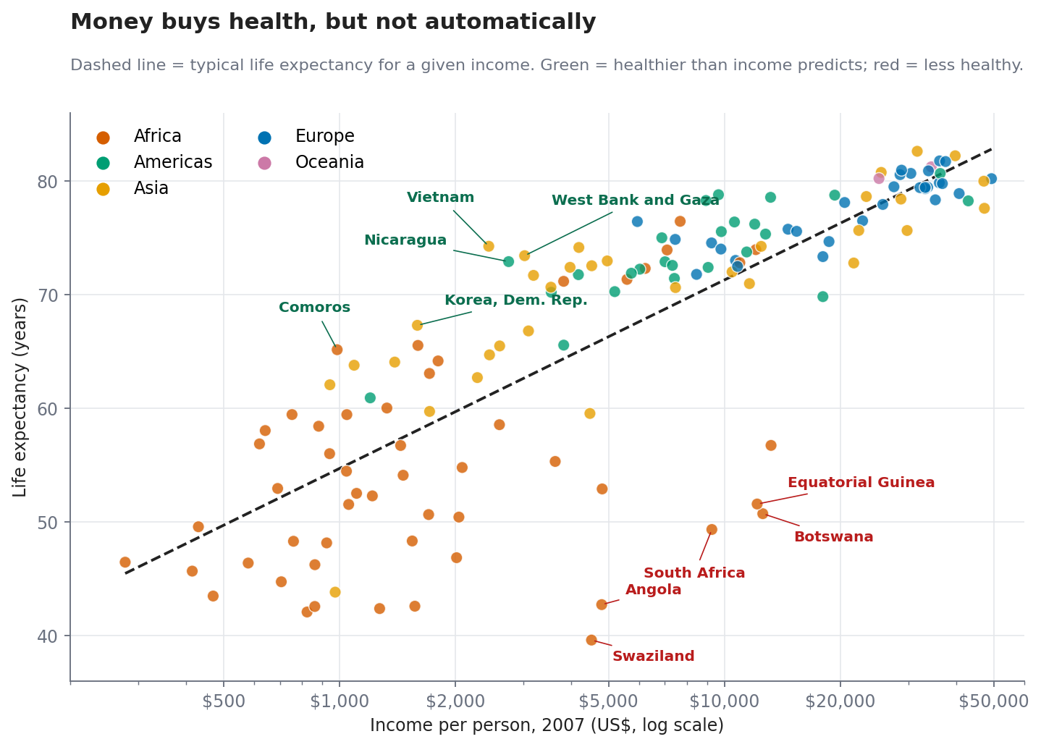
Figure 5: Life expectancy against income in 2007, with unusual countries labelled
What it shows. Each dot is a country in 2007. The dashed line shows the typical life expectancy for each income level. Dots above the line are healthier than their income would predict, dots below are less healthy. The five biggest over-performers are labelled in green and the five biggest under-performers in red.
Why this chart. A scatter plot with a trend line is the standard way to show a relationship, and the labelled outliers are where the interesting stories are. Labelling only ten of the 142 countries keeps the chart clean while still turning the statistics into recognisable names.
Role in the story. It tests the assumption that has been quietly building: that richer means healthier. The answer is "mostly, but not entirely", which leads naturally into the implications.
Insight. Income alone explains about 65% of the variation in life expectancy between countries in 2007 (R-squared = 0.65). In this data, each doubling of income is associated with about 5 extra years of life expectancy. But the gaps are large. Vietnam (+13.1 years above prediction), Nicaragua (+10.9), the West Bank and Gaza (+10.7), Comoros (+10.5) and North Korea (+9.2) live longer than their income suggests. Swaziland (-25.9), Angola (-23.3), Botswana (-22.2), South Africa (-21.4) and Equatorial Guinea (-21.1) fall well short. Three of the five under-performers (Swaziland, Botswana and South Africa) also appear in Figure 4, which suggests the two charts are telling connected stories.
Reading tip: A dot far from the line does not prove why a country is different. Possible explanations include disease burden, income inequality (an average income can hide that most people are poor, as may be the case in resource-rich Angola and Equatorial Guinea), health systems, and conflict. These are hypotheses to investigate, not conclusions from this chart.

3.6 Act 6: Five continents, five different journeys
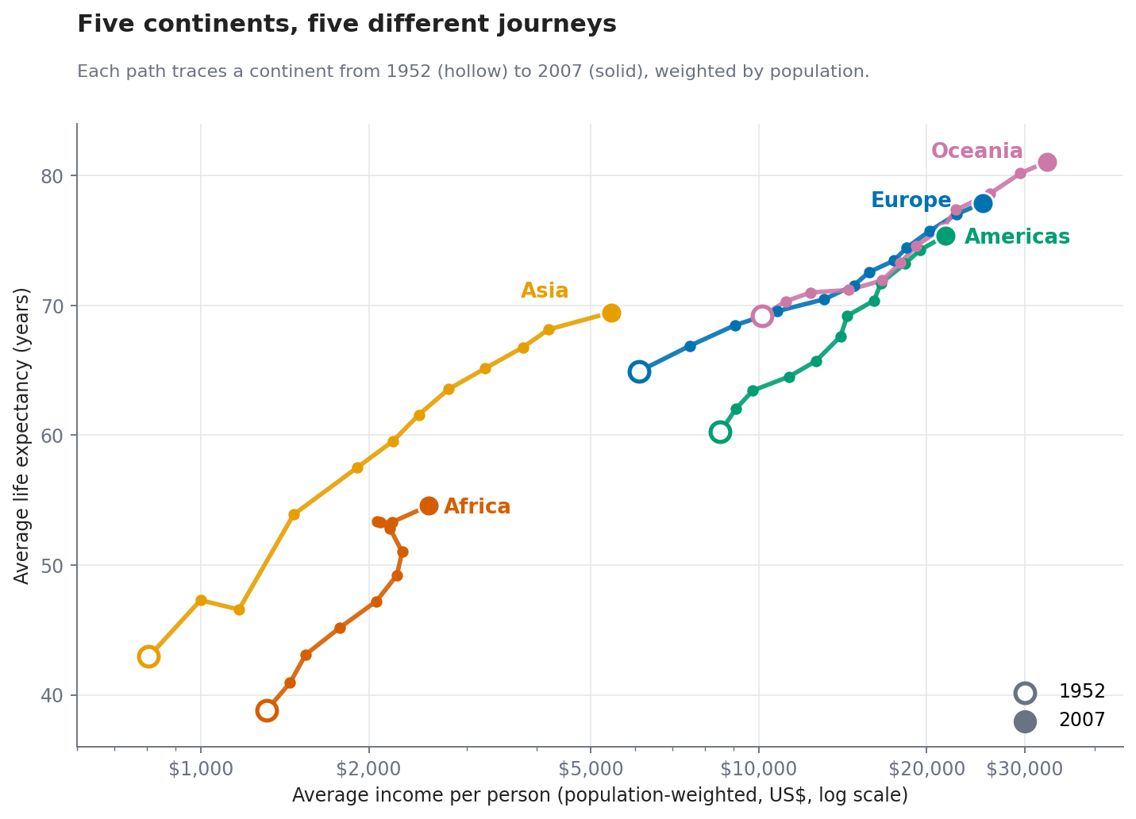
Figure 6: Path of each continent through income and life expectancy, 1952 to 2007
What it shows. Each coloured path follows one continent across 12 time points from 1952 (hollow circle) to 2007 (solid circle), using population-weighted averages so that large countries count in proportion to their size. Moving right means richer and moving up means longer-lived.
Why this chart. This is a connected scatter plot. It combines two variables and time in a single view, so you can see not just where each continent ended up but the route it took. That route is the story: speed, direction, and detours.
Role in the story. It is the closing scene. It zooms back out to the big picture of Figure 1 but adds the dimension of time, and ties together everything that came before.
Insight. Asia made the biggest leap, with average life expectancy rising from 42.9 to 69.4 years (+26.5) while average income grew from about $806 to $5,432. China and India, the two most populous countries, drive this: China's life expectancy went from 44 to 73 years and India's from 37.4 to 64.7. Europe, the Americas and Oceania rose along a similar diagonal, finishing at 77.9, 75.4 and 81.1 years. Africa's path is different: it went from 38.8 to 54.6 years (+15.8), but its line stalls and tangles, with population-weighted life expectancy stuck near 53.4 to 53.3 years from 1992 to 2002. That stall is the HIV/AIDS era visible in Figure 4. By 2007 Africa still trailed Europe by 23.3 years, though in 1952 the gap was 26.1 years.

4. Implications

4.1 Business implications
- Markets are shifting. Asia's rise in both income and health (from $806 to $5,432 average income) means large populations moved into the consumer class. Companies planning market entry can use this kind of wealth-and-health view to segment regions by development stage, rather than treating "emerging markets" as one block.
- Longer lives create demand. In countries where life expectancy is now in the high 70s and early 80s, populations are ageing. This points to growing demand for healthcare, insurance, pensions, and age-friendly products and services, and to workforce planning challenges.
- Averages can hide opportunity and risk. Figure 5 shows countries with similar incomes can have very different health outcomes. A firm in health, insurance or consumer goods should look at outcome data, not income alone, when sizing a market.
- Shocks matter for risk planning. Figure 4 shows that large reversals do occur and can persist for a decade or more. Supply chain, workforce and investment risk models for affected regions should allow for such shocks.

4.2 Scientific and public health implications
- Wealth helps, but it is not destiny. Vietnam, Nicaragua and Comoros live far longer than their income predicts, while several southern African countries fall far short. Studying what the over-performers do differently (primary care, vaccination, education, equity) is a useful hypothesis-generating exercise for health researchers.
- Disease and conflict can erase decades of progress. The collapses in Figure 4 show how a single epidemic or conflict can undo gains within a few years, which supports sustained investment in epidemic preparedness and in health system resilience.
- Look beyond the global average. The global average improved steadily, but the distribution in Figure 2 and the continent paths in Figure 6 show that some regions lagged. Reporting only one global number would hide this. Good monitoring tracks the lowest-performing groups, not just the mean.
- Next research steps. Follow up with data on inequality, health spending, education and disease burden, and apply statistical models (for example regression with multiple predictors or time-series methods) to test the hypotheses suggested by the outliers.

5. Limitations
- Data ends in 2007. Conclusions describe 1952 to 2007 and should not be assumed to hold for later years.
- Averages hide differences within countries. GDP per capita is a national average and says nothing about how income is distributed. Life expectancy also differs between regions, genders and social groups inside a country.
- Five-year snapshots. Shorter events can fall between data points. For example, Rwanda's lowest point may have been even lower than the value recorded in 1992.
- Correlation is not causation. Figure 5 shows a strong association between income and health, not proof that income causes longer life. Health also affects income, and other factors affect both.
- Explanations come from outside the data. References to HIV/AIDS, genocide and conflict are historical context to help interpret the charts. The dataset itself does not contain causes.
- Equal weight for countries in Figures 2, 3 and 5. A tiny country counts the same as China. Figures 1 and 6 account for population size, which gives a complementary view.
- Static charts. Interactive versions (for example with Plotly) would let readers hover for exact values. They were not used here because the deliverable is a static document.

6. Conclusion
Between 1952 and 2007 the world changed dramatically for the better. The median country gained about 27 years of life expectancy, income roughly tripled for the median country, and the share of people in this dataset living in countries with a life expectancy below 50 fell from 64.1% to 6.5%. Yet the story is not simply one of steady progress for everyone. The gap between the best and worst-off countries barely narrowed, some countries suffered devastating reversals, and income alone explains only part of the differences in health.
The six charts work together as one narrative: they open with a broad view of change, test whether the gap closed, name the winners and the laggards, show where progress broke down, question the simple link between money and health, and close with the journeys of whole continents. Each design choice, from the colour palette to the chart type to the wording of the titles, was made to help a non-technical reader see the pattern quickly and trust what they are seeing.

Appendix: Reproducing the Charts
The complete script (story.py) downloads the data, creates all six figures and saves the summary numbers used in this document (results.json). To run it:
pip install pandas numpy scipy matplotlib
python story.py

Dataset credit: Gapminder data as hosted in the public plotly/datasets repository on GitHub.

