Week 3 Report
Statistical Analysis and Hypothesis Testing in Python
Does health follow wealth? Testing claims about global life expectancy
Dataset: Gapminder (142 countries, 1952 to 2007) | Tools: Python, pandas, SciPy, Statsmodels, Matplotlib
Date: October 18, 2026

1. Introduction and Hypotheses

1.1 What this report does
Charts can suggest a pattern, but they cannot tell us whether the pattern is real or just the kind of difference that appears by chance. Hypothesis testing is the tool for that. This report takes the Gapminder data used in Week 2 and tests five specific claims about global health using formal statistical tests. For each test I state the hypothesis in advance, check whether the test's assumptions hold, run the test, report the effect size and a confidence interval, and interpret the result in plain language.

1.2 The real-world problem
Imagine a global health funder or development agency deciding where to focus its resources. Before committing money, it needs evidence on five practical questions: Are regional differences in life expectancy real? Has life expectancy genuinely improved over time? Did Africa progress more slowly than elsewhere? How closely is income tied to health? And can a country's income level be used as a quick screening signal for health outcomes? The five hypotheses below correspond to these questions.

1.3 Hypotheses
All tests use a significance level of 0.05 and are two-sided. H0 is the null hypothesis (no effect) and H1 is the alternative.
# | Null hypothesis (H0) | Alternative hypothesis (H1)
1 | Mean life expectancy in 2007 is the same in Africa, the Americas, Asia and Europe | At least one continent has a different mean
2 | The mean change in life expectancy from 1952 to 2007 is zero | The mean change is not zero
3 | African countries gained the same number of years (1952 to 2007) as countries elsewhere | The average gain differs between Africa and other continents
4 | There is no linear relationship between log income and life expectancy in 2007 (rho = 0) | There is a relationship (rho is not 0)
5 | Being above or below the median income is independent of having a life expectancy of 70+ | Income group and high life expectancy are associated

2. Methodology

2.1 Data
The data is the Gapminder dataset (public, from the plotly/datasets GitHub repository): 142 countries observed every five years from 1952 to 2007, with life expectancy, income per person (GDP per capita) and population. Quality checks from Weeks 1 and 2 showed no missing values and no duplicates. Because income is strongly right-skewed, I used log10(income) wherever income enters a model. Oceania has only two countries, so it is left out of the continent comparison (Test 1) to avoid unreliable estimates.
A note on what "sample" means here: The 142 countries are close to every country in the world, not a random sample from a larger population. The tests therefore treat the observed countries as one realisation of a wider process (a common "superpopulation" view). The p-values answer: "could differences this large arise from random variation alone?" They do not mean other countries exist that we have not measured.

2.2 Choice of test
Question | Test | Main assumptions | Effect size reported
1. Continent differences | One-way ANOVA, with Welch ANOVA, Kruskal-Wallis and Tukey post hoc as checks | Independence, normality in groups, equal variances | Eta-squared
2. Change over time | Paired t-test, with Wilcoxon signed-rank as a check | Differences roughly normal | Cohen's dz, 95% CI of mean change
3. Africa vs others | Welch two-sample t-test, with Mann-Whitney as a check | Independence; no equal-variance assumption | Cohen's d, 95% CI of difference
4. Income and health | Pearson correlation and simple linear regression, with Spearman as a check | Linearity, roughly normal and constant-variance residuals | r with 95% CI, R-squared, slope
5. Income group and longevity | Chi-square test of independence, with Fisher's exact test as a check | Expected counts of at least 5 | Cramer's V, odds ratio with 95% CI

2.3 Analytical approach
- Check assumptions first. Normality is examined with Shapiro-Wilk tests and Q-Q plots, equal variance with Levene's test, and expected counts for the chi-square test. If an assumption is shaky, a robust alternative is run alongside.
- Report more than a p-value. A p-value says whether an effect is distinguishable from chance, not whether it is big. Each test therefore also reports an effect size and a confidence interval.
- Control for multiple testing. Running five tests raises the chance that at least one looks significant by luck. A Holm correction is applied to the five primary p-values (Section 4).

2.4 Tools and set-up
import pandas as pd, numpy as np
from scipy import stats
import statsmodels.api as sm
from statsmodels.stats.oneway import anova_oneway
from statsmodels.stats.multicomp import pairwise_tukeyhsd
from statsmodels.stats.multitest import multipletests

URL = "https://raw.githubusercontent.com/plotly/datasets/master/gapminderDataFiveYear.csv"
df = pd.read_csv(URL)
df["logGDP"] = np.log10(df.gdpPercap)
d07 = df[df.year == 2007] # snapshot used for Tests 1, 4, 5
wide = df.pivot(index="country", columns="year", values="lifeExp") # one row per country

3. Analysis and Results

3.1 Test 1: Does life expectancy differ by continent? (ANOVA)
In 2007 the mean life expectancy was 54.8 years in Africa (n = 52), 70.7 in Asia (n = 33), 73.6 in the Americas (n = 25) and 77.6 in Europe (n = 30).
Assumption checks. Levene's test indicates unequal variances (F = 8.39, p < 0.001); the spread is large in Africa (SD 9.6) and small in Europe (SD 3). Shapiro-Wilk p-values are 0.011 (Africa), 0.109 (Americas), 0.021 (Asia) and 0.033 (Europe), so normality is questionable in three groups. Because of this, the classic ANOVA is accompanied by the Welch ANOVA (no equal-variance assumption) and the Kruskal-Wallis test (no normality assumption).
groups = [grp[grp.continent == c].lifeExp for c in ["Africa", "Americas", "Asia", "Europe"]]
stats.levene(*groups, center="median") # equal variances?
stats.f_oneway(*groups) # classic one-way ANOVA
anova_oneway(groups, use_var="unequal", welch_correction=True) # Welch ANOVA
stats.kruskal(*groups) # non-parametric check
pairwise_tukeyhsd(grp.lifeExp, grp.continent, alpha=0.05) # which pairs differ?

Test | Statistic | p-value
Classic one-way ANOVA | F(3, 136) = 76.7 | p < 0.001
Welch ANOVA | F = 84.1 | p < 0.001
Kruskal-Wallis | H = 85.2 | p < 0.001

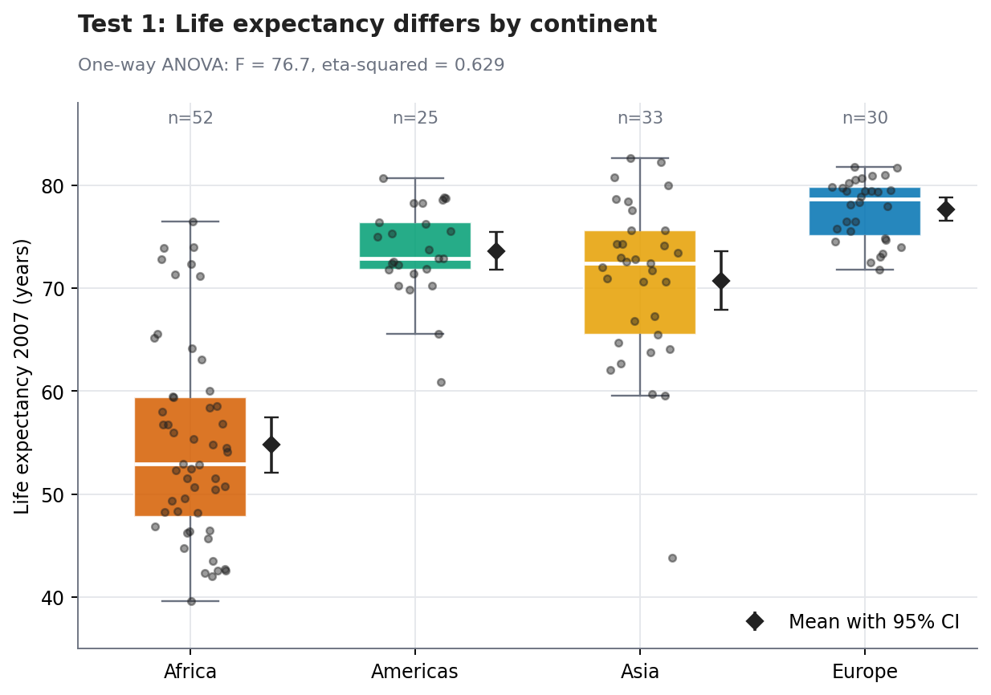
Figure 1: Life expectancy in 2007 by continent (boxes, individual countries and mean with 95% CI)
Post hoc comparisons (Tukey HSD). Differences in mean life expectancy (years) with 95% confidence intervals:
Pair | Difference | 95% CI | Adjusted p | Significant?
Africa vs Americas | +18.8 | [14.1, 23.5] | < 0.001 | Yes
Africa vs Asia | +15.9 | [11.6, 20.2] | < 0.001 | Yes
Africa vs Europe | +22.8 | [18.4, 27.3] | < 0.001 | Yes
Americas vs Asia | -2.9 | [-8, 2.2] | 0.463 | No
Americas vs Europe | +4 | [-1.2, 9.3] | 0.189 | No
Asia vs Europe | +6.9 | [2.1, 11.8] | 0.002 | Yes

Interpretation. All three tests agree: the continent means are not equal (p < 0.001). Continent explains about 63% of the variation in life expectancy (eta-squared = 0.629), which is a very large effect. The post hoc table shows that Africa is far below every other continent, by roughly 16 to 23 years, and that these intervals are nowhere near zero. Europe is also about 7 years above Asia. In contrast, the Americas are not clearly different from Asia or Europe (their intervals include zero). One caution: Tukey's method assumes equal variances, which Levene's test questioned, so borderline pairs (such as Asia vs Europe, p = 0.002) should be treated with care. The large differences involving Africa are not borderline.

3.2 Test 2: Did life expectancy really increase? (paired t-test)
Each country is measured twice (1952 and 2007), so the observations are paired, and the right quantity to analyse is each country's change. The mean change was 17.95 years (SD 8.12), and 140 of 142 countries improved.
Assumption check. The paired t-test assumes the differences are roughly normal. The Shapiro-Wilk test gives W = 0.984, p = 0.089, with skewness -0.04, and the Q-Q plot (Figure 6, left) follows the line closely, so the assumption is reasonable.
diff = wide[2007] - wide[1952]
res = stats.ttest_rel(wide[2007], wide[1952])
res.confidence_interval() # 95% CI of the mean change
diff.mean() / diff.std(ddof=1) # Cohen's dz
stats.wilcoxon(wide[2007], wide[1952]) # non-parametric check

Quantity | Result
t statistic | t(141) = 26.33, p < 0.001
Mean change (95% CI) | 17.95 years [16.6, 19.3]
Effect size | Cohen's dz = 2.21 (very large)
Wilcoxon signed-rank | p < 0.001

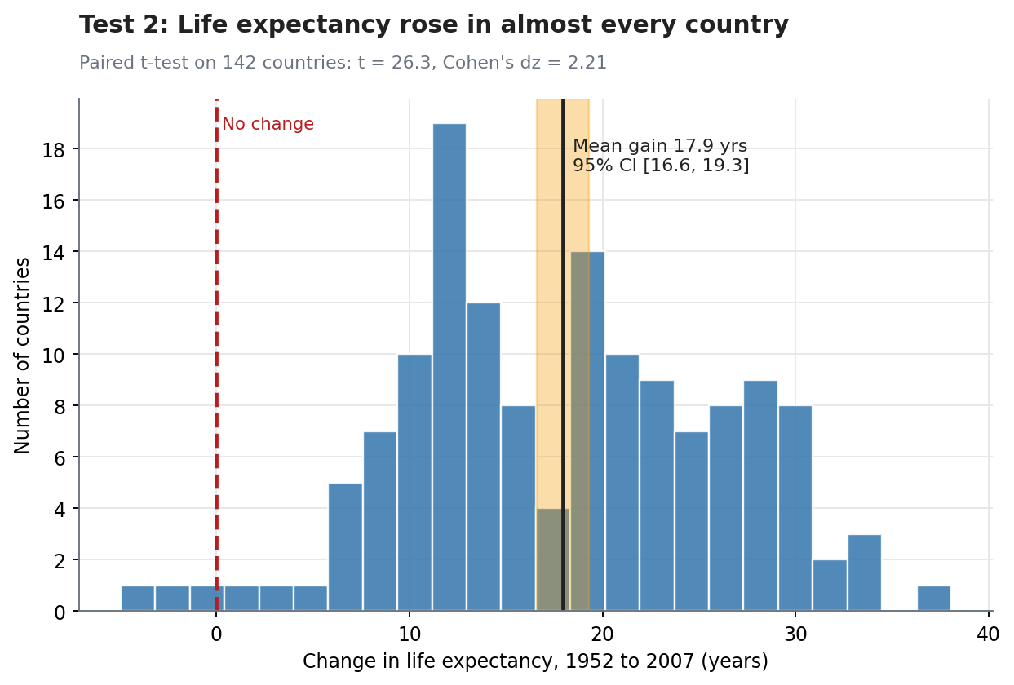
Figure 2: Distribution of each country's change in life expectancy, with the mean and its 95% CI
Interpretation. We reject H0. The average country gained about 17.95 years, and the 95% confidence interval runs from 16.6 to 19.3 years, so any plausible true average gain is large and positive. The effect size (dz = 2.21) means the average change is more than two standard deviations of the changes, so this is not a marginal result. Only two countries (Zimbabwe and Swaziland) lie to the left of zero in Figure 2.
Reading a p-value correctly: The p-value here is far below 0.001. It does not mean that the probability H0 is true is tiny in some absolute sense; it means that if life expectancy had not changed on average, a mean change this large would be extremely unlikely to appear. The confidence interval is more informative: it tells us how large the change is.

3.3 Test 3: Did African countries gain less? (Welch t-test)
Comparing the 1952 to 2007 gain in Africa (n = 52, mean 15.7, SD 8.7) with all other countries (n = 90, mean 19.3, SD 7.5). Levene's test for equal variances is not significant (p = 0.370), but the Welch version of the t-test was still used because it is safe either way and the groups have different sizes.
gain = wide[2007] - wide[1952]
res = stats.ttest_ind(gain[~is_africa], gain[is_africa], equal_var=False) # Welch
res.confidence_interval()
stats.mannwhitneyu(gain[~is_africa], gain[is_africa]) # non-parametric check

Quantity | Result
Welch t statistic | t(94.9) = 2.5, p = 0.014
Mean difference (others minus Africa), 95% CI | 3.6 years [0.74, 6.46]
Effect size | Cohen's d = 0.45 (small to medium)
Mann-Whitney U | p = 0.029

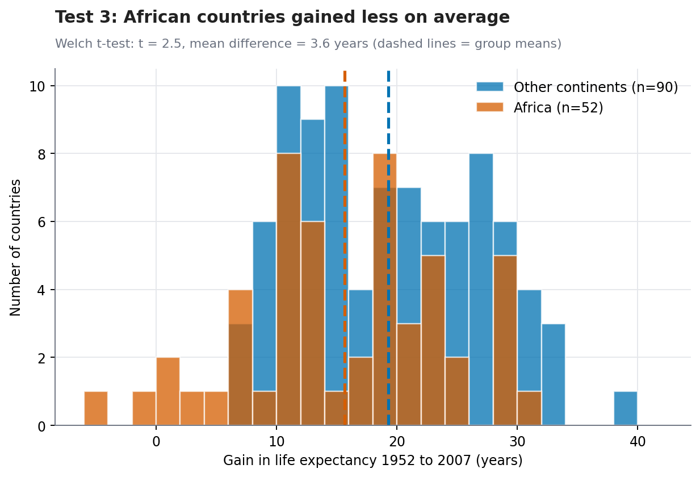
Figure 3: Gain in life expectancy since 1952, Africa vs all other continents
Interpretation. We reject H0 at the 0.05 level, but this is a much weaker result than Tests 1 and 2. Countries outside Africa gained about 3.6 years more on average, and the confidence interval [0.74, 6.46] shows the true gap could plausibly be anywhere from under one year to about six and a half. The effect size is small to medium (d = 0.45). The distributions overlap heavily in Figure 3: many African countries gained as much as the typical country elsewhere.
An important caveat: Because Africa started lower in 1952, there was more room to gain, which would favour Africa, yet it still gained less on average. On the other hand, this comparison does not account for different starting points or events such as HIV/AIDS in particular countries. It shows that Africa's average gain was smaller, not why.

3.4 Test 4: How strongly are income and life expectancy related? (correlation and regression)
stats.pearsonr(d07.logGDP, d07.lifeExp).confidence_interval() # r and its 95% CI
stats.spearmanr(d07.logGDP, d07.lifeExp) # rank-based check
ols = sm.OLS(d07.lifeExp, sm.add_constant(d07.logGDP)).fit()
ols.conf_int() # CI of the slope

Quantity | Result
Pearson correlation | r = 0.809, 95% CI [0.743, 0.859], p < 0.001
Spearman correlation | rho = 0.857, p < 0.001
Regression slope per doubling of income | 4.99 years, 95% CI [4.39, 5.6]
R-squared | 0.654 (n = 142)

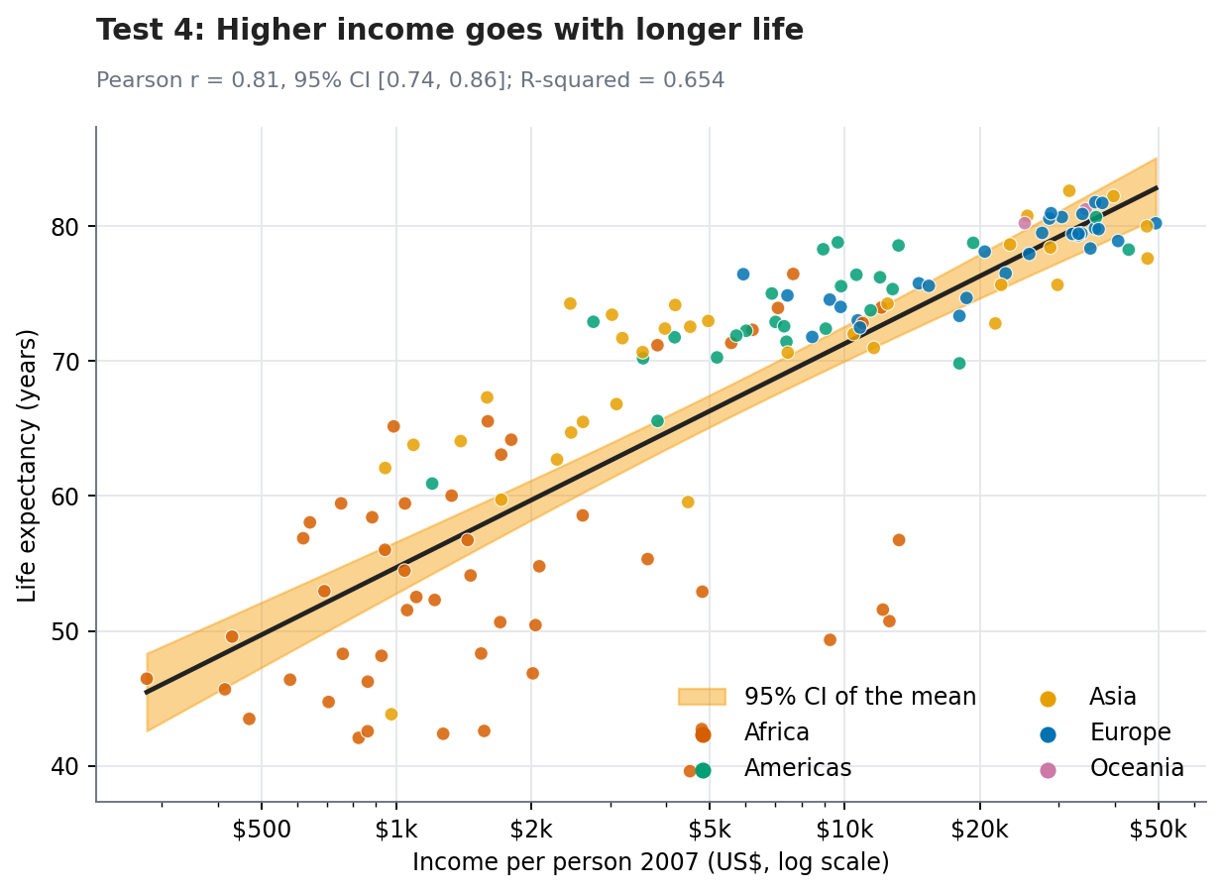
Figure 4: Life expectancy against income (log scale) with the fitted line and 95% CI of the mean
Assumption checks. The Breusch-Pagan test does not indicate unequal residual variance (p = 0.151), but the residuals are not perfectly normal (Shapiro-Wilk p < 0.001; see the Q-Q plot on the right of Figure 6, which shows a heavy lower tail). With 142 observations the confidence intervals are still reliable, and the Spearman correlation, which does not need normality, gives the same conclusion (rho = 0.857).
Interpretation. We reject H0. The correlation is strong (r = 0.809), and the confidence interval is narrow and well above zero. Income explains about 65% of the variation in life expectancy. Each doubling of income is associated with roughly 4.99 more years of life expectancy (95% CI 4.39 to 5.6). The remaining 35% is unexplained by income, which matches the large scatter around the line in Figure 4 (the low points are mostly African countries). Correlation is not causation: income may raise health, health may raise income, and other factors such as education or disease control can affect both.

3.5 Test 5: Is income group linked to high life expectancy? (chi-square)
Countries were split at the median 2007 income ($6,124) and classed as having life expectancy of 70 years or more, or under 70.
 | Life expectancy 70+ | Under 70
Above-median income | 66 (expected 41.5) | 5 (expected 29.5)
Below-median income | 17 (expected 41.5) | 54 (expected 29.5)

Assumption check. All expected counts are at least 29, well above the minimum of 5, so the chi-square approximation is valid.
ct = pd.crosstab(d07.incomeGroup, d07.leGroup)
chi2, p, dof, expected = stats.chi2_contingency(ct, correction=False)
cramers_v = np.sqrt(chi2 / ct.values.sum())
t22 = Table2x2(ct.values); t22.oddsratio, t22.oddsratio_confint()
stats.fisher_exact(ct.values) # exact check

Quantity | Result
Chi-square test | chi-square(1) = 69.62, p < 0.001
With continuity correction | chi-square = 66.81, p < 0.001
Fisher's exact test | p < 0.001
Effect size | Cramer's V = 0.7 (large)
Odds ratio (95% CI) | 41.9 [14.5, 121]

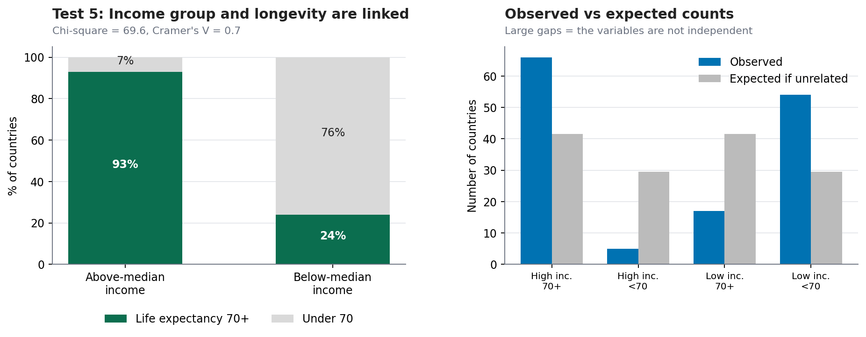
Figure 5: Share of countries with life expectancy 70+ by income group (left) and observed vs expected counts (right)
Interpretation. We reject H0. 93% of above-median-income countries had a life expectancy of 70 or more, versus 23.9% of below-median-income countries. The odds of high life expectancy were about 41.9 times higher in the richer group; the confidence interval is wide (14.5 to 121) because some cells contain few countries, but even its lower end indicates a very strong association. Note that splitting at the median throws away detail and creates equal-sized groups by construction, which is why Test 4's continuous analysis is preferable for estimating the strength of the relationship; the chi-square test is useful for the simple screening question asked in Hypothesis 5.

3.6 Assumption diagnostics
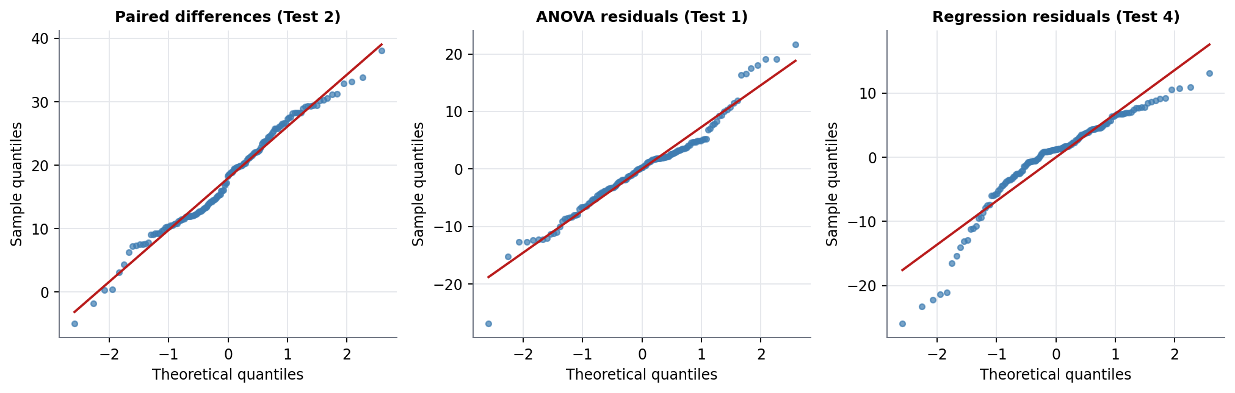
Figure 6: Q-Q plots for paired differences (Test 2), ANOVA residuals (Test 1) and regression residuals (Test 4)
In a Q-Q plot, points on the red line mean the data match a normal distribution. The paired differences and ANOVA residuals follow the line well, apart from a few points in the tails. The regression residuals show a heavier lower tail, which is the group of countries with much lower life expectancy than their income predicts (largely southern Africa). This is why the report always pairs the parametric test with a rank-based check.

4. Summary of Results
Test | Main result | Effect size | Raw p | Holm-adjusted p | Reject H0?
1. ANOVA (continent) | Welch F = 84.1 | eta-sq 0.629 | < 0.001 | < 0.001 | Yes
2. Paired t (1952 vs 2007) | +17.95 years | dz 2.21 | < 0.001 | < 0.001 | Yes
3. Welch t (Africa vs others) | 3.6 years | d 0.45 | 0.014 | 0.014 | Yes
4. Pearson (income and life exp.) | r = 0.809 | R-sq 0.654 | < 0.001 | < 0.001 | Yes
5. Chi-square (income group) | chi-sq = 69.62 | V 0.7 | < 0.001 | < 0.001 | Yes

All five null hypotheses are rejected, and the conclusions survive the Holm correction for running five tests. The strength of evidence differs a lot, though: Tests 1, 2, 4 and 5 are overwhelming, while Test 3 is the only one where the result is modest in size and where the p-value (0.014) is much closer to the threshold.

5. Discussion

5.1 Validity of the hypotheses
- H1 (continent differences): supported, strongly. Africa's average life expectancy in 2007 was 16 to 23 years lower than every other continent's.
- H2 (change over time): supported, strongly. Life expectancy rose by about 17.95 years on average (95% CI 16.6 to 19.3), with only 2 of 142 countries showing a decline.
- H3 (Africa gained less): supported, modestly. The gap of about 3.6 years is statistically detectable but small to medium in size, and the interval is wide.
- H4 (income and health): supported, strongly. Roughly 4.99 extra years per doubling of income, but income leaves about a third of the variation unexplained.
- H5 (income group and longevity): supported, strongly. Useful as a rough screening signal, though some countries clearly break the pattern.

5.2 What the statistics do not tell us
- Statistical significance is not practical importance. With 142 countries, even a small difference can reach significance. That is why each test is paired with an effect size and a confidence interval, and why Test 3 is described as modest despite p < 0.05.
- Correlation is not causation. Tests 4 and 5 show association only.
- Observations are not fully independent. Neighbouring countries share climate, history, disease and trade, so effective sample sizes may be smaller than 142 and p-values somewhat too optimistic. The very small p-values in Tests 1, 2, 4 and 5 leave a comfortable margin, but Test 3 is more fragile.
- Countries are weighted equally. Tiny and very large countries count the same, so results describe the typical country, not the typical person.
- Multiple testing and data-driven choices. The five hypotheses were fixed in advance, and Holm correction was applied. Splitting at the median in Test 5, and excluding Oceania in Test 1, are analyst choices; neither changes the conclusions in this case.

5.3 Implications
For the funder in the scenario, the evidence supports focusing on regional gaps (Africa in particular), but it also warns against using income as the only targeting rule, because a third of the variation in life expectancy is not explained by income. These ideas are carried forward in Week 4, where a model is built to predict which countries reach 70 years, and in Week 5, where recommendations are drawn together.

6. Conclusion
Five hypotheses about global health were tested with formal statistical methods, after checking assumptions and adding robust alternatives where needed. The evidence confirms that life expectancy differs sharply between continents (eta-squared = 0.629), that it rose by about 17.95 years in the typical country between 1952 and 2007, that Africa's gain was modestly smaller, and that income is strongly, but not completely, tied to health (r = 0.809). Throughout, results were interpreted through effect sizes and confidence intervals rather than p-values alone, and the limitations of the data and the methods were stated alongside the findings.

Appendix: Reproducing the Analysis
The script hypothesis_tests.py downloads the data, runs all five tests with their assumption checks and robust alternatives, saves the six figures, and writes all numbers used in this document to results3.json.
pip install pandas numpy scipy statsmodels matplotlib
python hypothesis_tests.py

