Week 4 Report
Machine Learning Model Development and Evaluation
Predicting which countries reach a life expectancy of 70 years
Dataset: Gapminder (1,704 country-year records) | Tools: Python, scikit-learn, pandas, Matplotlib
Date: October 19, 2026

1. Introduction

1.1 Objective
Week 3 showed statistically that income, continent and time are strongly linked to life expectancy. Week 4 asks a different, practical question: can those same few pieces of information be used to predict whether a country has reached a life expectancy of 70 years? A model like this could act as a quick screening tool when direct health data is missing or out of date. This report documents the full process of building and judging such a model: data preparation, algorithm choice, training, evaluation, and a critical look at its errors.

1.2 The prediction task
Item | Definition
Type of problem | Binary classification
Target | High = 1 if a country's life expectancy in that year is 70 years or more, otherwise 0
Inputs (features) | Income per person (log10), population (log10), year, continent
Unit of observation | One country in one year (1,704 rows, 142 countries)
Class balance | 29% positive overall, but only 4% of countries in 1952 against 58% in 2007

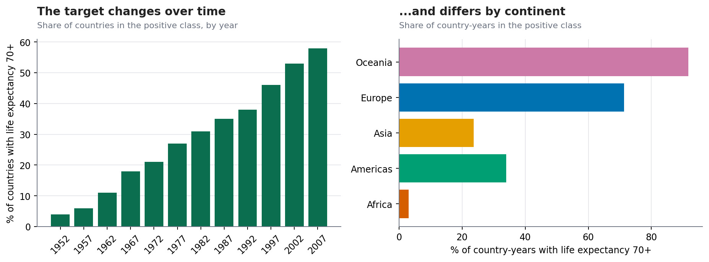
Figure 1: The target class is rare early on and common later (left) and differs strongly by continent (right)
Figure 1 matters for how the model is judged. Because 71% of records are in the negative class, a lazy model that always answers "under 70" would already be right about 7 times out of 10. Every result below is therefore compared with this baseline.

2. Data Preparation

2.1 Cleaning and checks
The dataset has no missing values and no duplicate rows (confirmed in Weeks 1 to 3), so no imputation or removal was needed. The preparation steps were instead about making the data suitable for modelling.
Step | What was done | Why
Define the target | life expectancy >= 70 turned into a 0/1 label | A classification task was needed for ROC curves and confusion matrices
Log transform | log10 of income and of population | Both are heavily right-skewed; logs make relationships closer to linear and stop a few huge values dominating
Scale numeric features | StandardScaler (mean 0, spread 1) | Logistic regression is sensitive to feature scales, and scaling makes its coefficients comparable
Encode continent | One-hot encoding (first level dropped) | Models need numbers; one-hot avoids implying an order between continents
Keep year as a feature | Included | The proportion of high-life-expectancy countries rises steadily over time (Figure 1), so ignoring year would throw away real signal

df["logGDP"] = np.log10(df.gdpPercap)
df["logPop"] = np.log10(df["pop"])
df["High"] = (df.lifeExp >= 70).astype(int) # target

FEATS_NUM, FEATS_CAT = ["logGDP", "logPop", "year"], ["continent"]
pre = ColumnTransformer([("num", StandardScaler(), FEATS_NUM),
("cat", OneHotEncoder(drop="first"), FEATS_CAT)])

2.2 Train and test split (by country, not by row)
A random split by row would be a serious mistake here. A country's life expectancy changes slowly, so France in 1992 and France in 1997 look almost identical. If one went to training and the other to testing, the model could score well simply by recognising the country, which is a form of data leakage. Instead, the split is grouped by country: 106 countries (1,272 rows) are used for training and 36 completely unseen countries (432 rows) are held out for testing. The share of positive cases is similar in the two sets (29.4% and 27.8%). The test set is used only once, at the end.
gss = GroupShuffleSplit(n_splits=1, test_size=.25, random_state=42)
train_idx, test_idx = next(gss.split(X, y, groups=df.country))

3. Model Selection
Three algorithms of increasing flexibility were compared against a do-nothing baseline. The aim was not to find the fanciest model but to see whether extra complexity actually pays off.
Model | Why chosen | Main risk
Baseline (always predicts the majority class) | Gives the minimum score any useful model must beat | None; it is only a reference
Logistic regression | Simple, fast, and its coefficients are easy to explain to a non-technical audience. A natural first choice for a yes/no outcome driven by a few features | Assumes a roughly linear link between log-odds and features, so it may miss interactions
Decision tree (depth 3) | Produces human-readable if/then rules and can capture interactions without feature engineering | Unstable, and very prone to overfitting if allowed to grow deep
Random forest (300 trees) | Averages many trees to reduce variance; a strong general-purpose benchmark | Less interpretable, and can overfit if trees are too deep

models = {
"Baseline": DummyClassifier(strategy="most_frequent"),
"Logistic regression": LogisticRegression(max_iter=1000),
"Decision tree": DecisionTreeClassifier(max_depth=3, random_state=42),
"Random forest": RandomForestClassifier(
n_estimators=300, max_depth=6, min_samples_leaf=3, random_state=42),
}
# preprocessing lives inside each pipeline
pipes = {k: Pipeline([("pre", pre), ("clf", m)]) for k, m in models.items()}

Putting preprocessing inside a scikit-learn Pipeline means the scaler and encoder are learned from training data only and then applied to new data. This prevents another form of leakage, where information from the test set accidentally influences the preprocessing.

4. Training and Evaluation

4.1 Cross-validation on the training set
Before touching the test set, each model was checked with 5-fold cross-validation on the training data, again grouped by country so that a country never appears in both the training and validation part of a fold. This gives an estimate of performance and how much it varies.
gkf = GroupKFold(n_splits=5)
cv = cross_validate(pipe, Xtr, ytr, groups=groups_tr, cv=gkf, scoring=["accuracy", "roc_auc"])

Model | CV accuracy | (SD) | CV ROC AUC | (SD)
Baseline (majority class) | 0.705 | 0.092 | 0.500 | 0.000
Logistic regression | 0.896 | 0.035 | 0.961 | 0.021
Decision tree (depth 3) | 0.858 | 0.047 | 0.889 | 0.057
Random forest | 0.887 | 0.023 | 0.962 | 0.008

All three real models beat the baseline by a wide margin (about 0.86 to 0.90 accuracy against 0.705). Logistic regression and the random forest have almost identical AUC (0.961 and 0.962), and the depth-3 tree is clearly weaker (0.889), with larger variation between folds.

4.2 Evaluation metrics explained
- Accuracy: the share of all predictions that are correct. Misleading on its own when one class is much larger.
- Precision: of the countries predicted to be 70+, how many really were. Low precision means many false alarms.
- Recall: of the countries that really were 70+, how many the model found. Low recall means missed cases.
- F1 score: a single number balancing precision and recall.
- ROC AUC: how well the model ranks countries overall, independent of the 0.5 cut-off. 0.5 is chance and 1.0 is perfect.

4.3 Results on the held-out test set
Model | Accuracy | Precision | Recall | F1 | ROC AUC | Train acc.
Baseline (majority class) | 0.722 | 0.000 | 0.000 | 0.000 | 0.500 | 0.706
Logistic regression | 0.900 | 0.798 | 0.858 | 0.827 | 0.959 | 0.910
Decision tree (depth 3) | 0.891 | 0.823 | 0.775 | 0.798 | 0.919 | 0.892
Random forest | 0.898 | 0.828 | 0.800 | 0.814 | 0.958 | 0.947

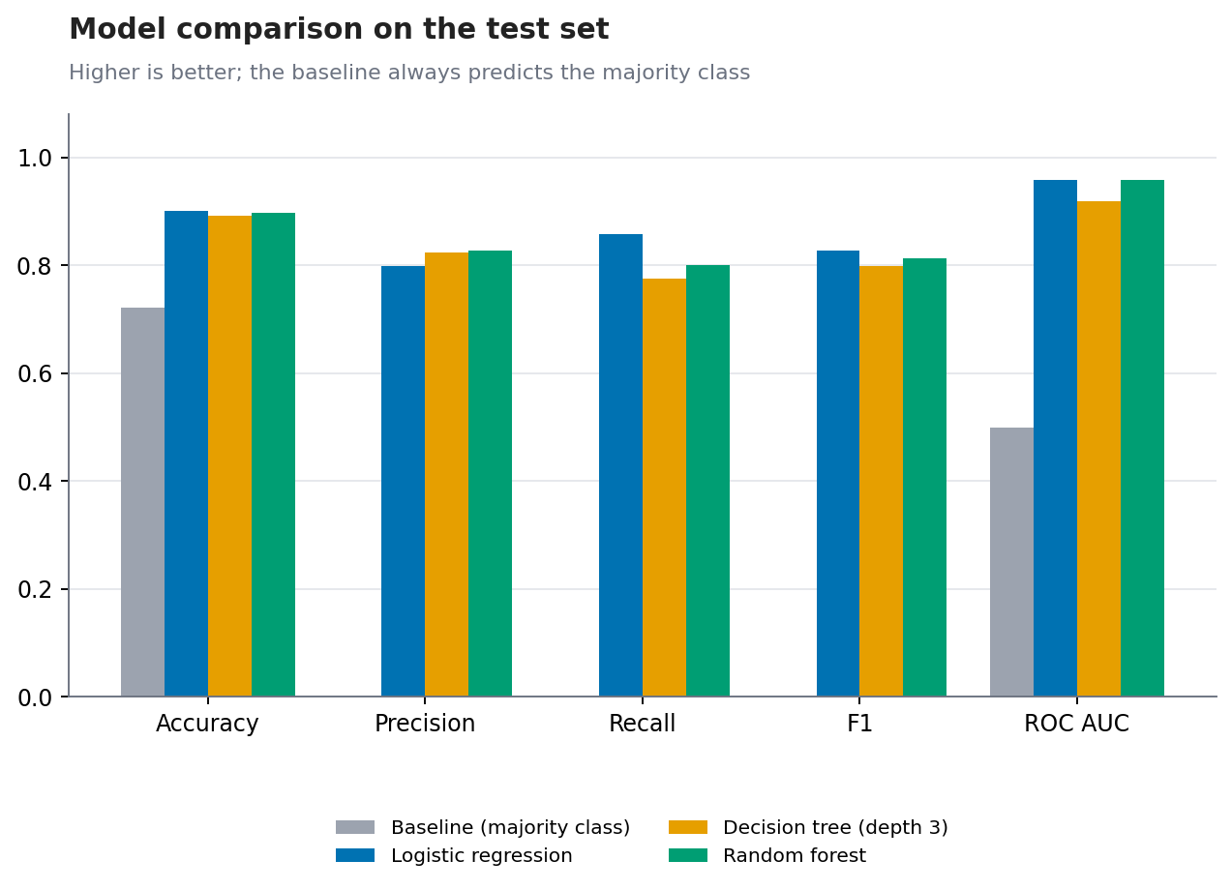
Figure 2: Test-set metrics for all models; the grey baseline shows the minimum bar
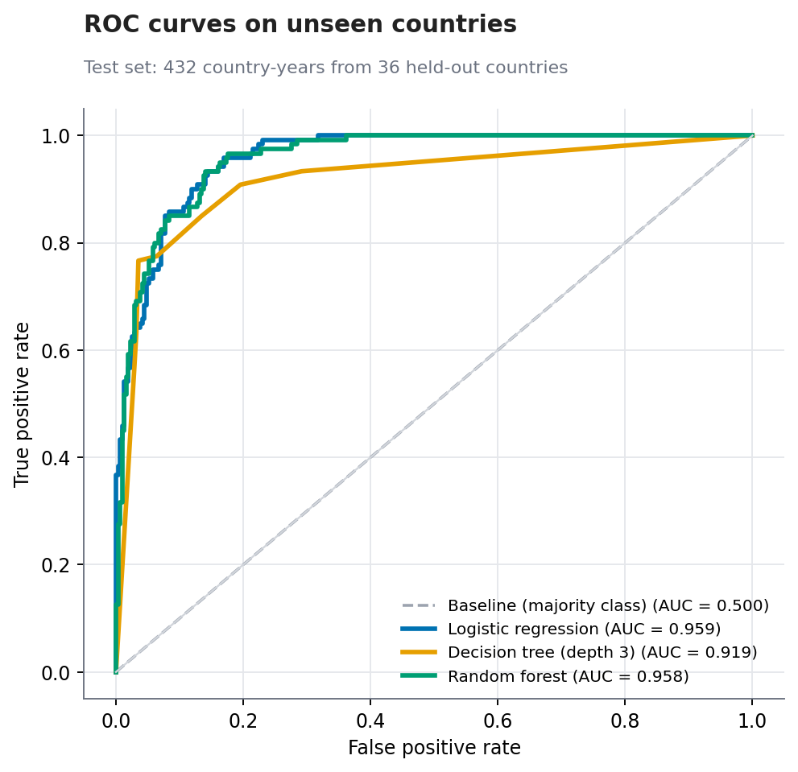
Figure 3: ROC curves on 36 countries the model never saw during training
The ROC curves for logistic regression and the random forest sit almost on top of each other, close to the top-left corner (AUC about 0.96). The depth-3 tree produces a visibly blockier curve (AUC 0.919) because a shallow tree can output only a handful of different probabilities.
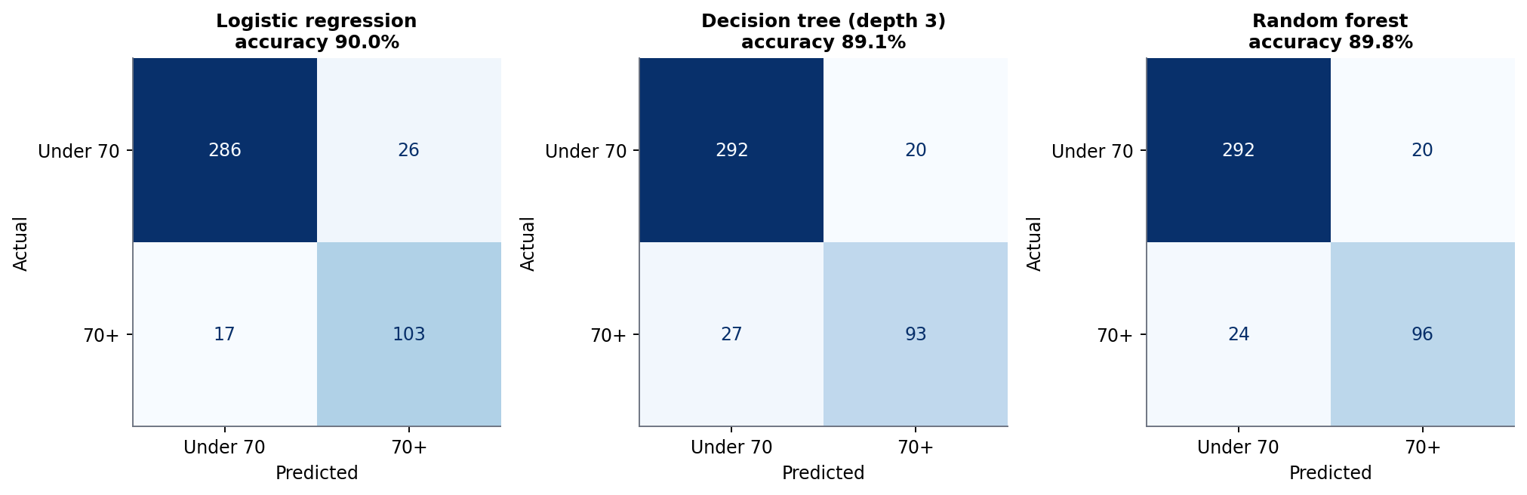
Figure 4: Confusion matrices on the test set
For logistic regression, the confusion matrix shows 286 true negatives, 26 false positives, 17 false negatives and 103 true positives. In plain terms: of 432 country-years, the model got 389 right (90.0%), wrongly called 26 countries "70+", and missed 17 that really were 70+.

4.4 Which model is best?
Choice: Logistic regression. It has the highest test accuracy (90.0%), the best recall (0.858) and joint-best AUC (0.959 against 0.958 for the random forest). The random forest, the more complex model, offers no real accuracy gain, and its gap between training and test accuracy is larger (see Section 5). When a simple and an elaborate model perform the same, the simple one is preferred because it is easier to explain, less prone to overfitting and cheaper to maintain.
An honest caveat: the test set has only 36 countries, so these figures carry some sampling uncertainty, and the differences between logistic regression and the random forest (less than one percentage point) are too small to be meaningful. A different random split of countries might rank them differently. The cross-validation results, which use all training countries, tell the same story.

4.5 What the models learned
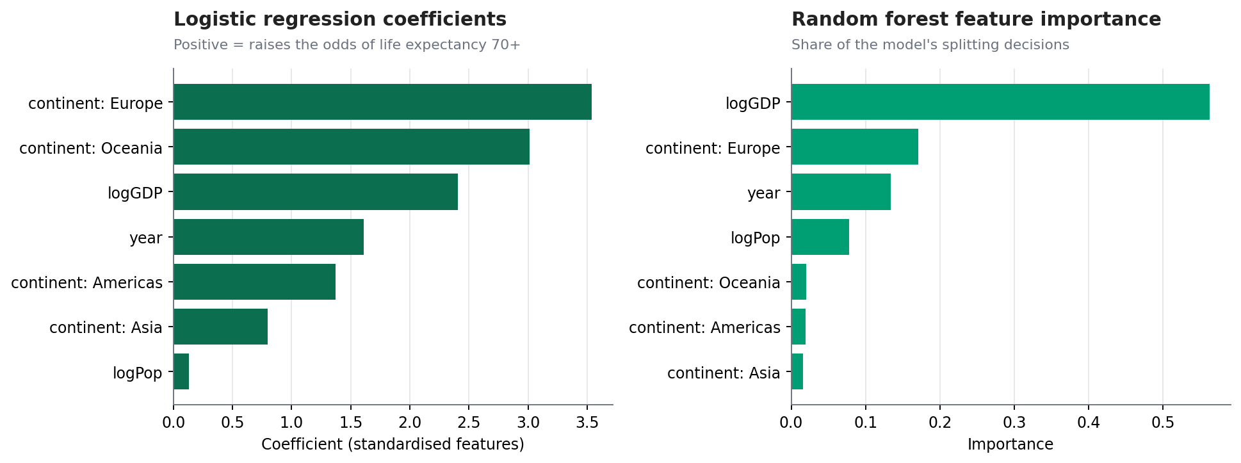
Figure 5: Logistic regression coefficients (left) and random forest feature importance (right)
Both models agree that income is a central driver, along with being in Europe or Oceania and the year. Logistic regression coefficients (standardised) are largest for Europe (3.54), Oceania (3.01) and log income (2.41), then year (1.61). Population adds almost nothing (0.13), which makes sense because country size has no obvious link to health. The coefficients for continents are relative to Africa (the dropped reference level), so they measure how much better the odds are than in an African country with the same income and year.

5. Overfitting and Underfitting
Overfitting means a model memorises its training data, including random noise, and then does worse on new data. Underfitting means a model is too simple to capture real patterns. Both show up as a gap or a ceiling in performance.
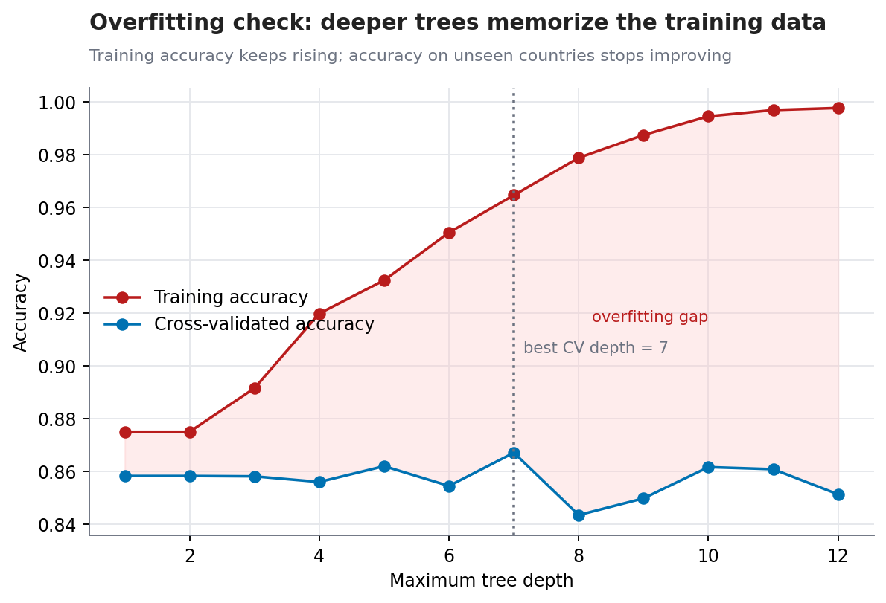
Figure 6: Decision tree accuracy as the tree gets deeper, on training data and on unseen countries
- Evidence of overfitting in deep trees. Training accuracy climbs from 0.875 (depth 1) to 0.998 (depth 12), almost memorising the training set, while cross-validated accuracy stays flat at about 0.84 to 0.87. The widening gap is the signature of overfitting. This is why the final tree was limited to depth 3.
- Mild overfitting in the random forest. Its training accuracy is 0.947 but its test accuracy is 0.898, a gap of about 5 percentage points, compared with 1 points for logistic regression (0.910 vs 0.900). Limits on depth (6) and leaf size (3) were set to restrain this.
- No sign of serious underfitting. Logistic regression, the simplest model, already scores well above the baseline and matches the random forest, so the problem is not too simple for a linear model. The remaining errors are better explained by missing information (Section 6) than by model capacity.

6. Error Analysis
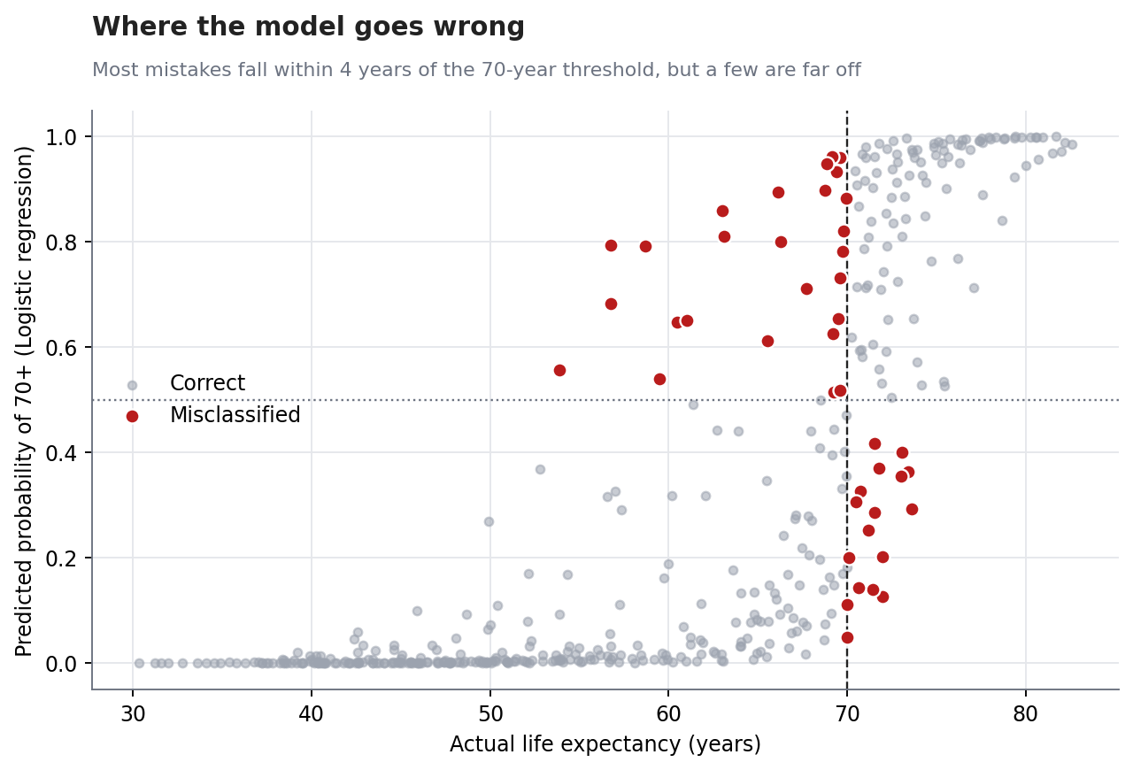
Figure 7: Predicted probability against actual life expectancy; red points are misclassified
Logistic regression made 43 mistakes on 432 test records: 26 false positives (predicted 70+, actually below) and 17 false negatives. Several patterns stand out:
- Most errors are near-misses. About 76.7% of the mistakes (33 of 43) are countries whose true life expectancy was within 4 years of the 70-year line. A hard cut-off at 70 inevitably produces some misclassification for countries sitting at 68 or 71. This is partly an artefact of how the target was defined, not purely a model failure.
- False positives are countries with high income but weaker health. Saudi Arabia (5 errors, 1972 to 1992), Gabon (3 errors, 1997 to 2007), Hungary (6 errors, 1967 to 1992) and Turkey (5 errors, 1977 to 1997) were all predicted to be 70+ when they were not. A likely explanation is that oil wealth (Saudi Arabia, Gabon) or stagnating health outcomes in Eastern Europe (Hungary) meant income overstated health, although this dataset cannot confirm the causes. These are the kind of countries seen below the trend line in Week 2.
- False negatives are countries that beat their income. Hong Kong (1967 to 1977) and Jamaica (1977 to 1987) reached 70+ earlier than their income, continent and year would suggest, so the model under-predicted them. This matches the over-performers (Vietnam, Nicaragua, Comoros) identified in Weeks 2 and 3.
- Errors by region. By continent the mistakes were Europe 16, Asia 14, Africa 7 and the Americas 6. Africa's low count probably reflects that most African countries sit clearly below the threshold, which the model gets right.

6.1 Robustness check: predicting the future from the past
A split by country tests generalisation to new countries, but a model used in practice would be asked about later years. As a stricter check, the models were trained only on data up to 1987 and tested on 1992 to 2007. Logistic regression still reached 88.4% accuracy and an AUC of 0.956 (the baseline accuracy on that period is 51.2%). The random forest's accuracy fell to 82.0% even though its AUC stayed at 0.957. A likely reason is that tree models cannot extrapolate beyond the range of years they saw, so they cope poorly when the share of high-life-expectancy countries has changed. This was not tested directly, but it is a further reason to prefer logistic regression here.
train_mask, test_mask = df.year <= 1987, df.year >= 1992 # forward-in-time split
pipe.fit(X[train_mask], y[train_mask])
roc_auc_score(y[test_mask], pipe.predict_proba(X[test_mask])[:, 1])

7. Sources of Error and Suggestions for Improvement

7.1 Potential sources of error
Source | Explanation
Missing explanatory variables | Income, continent and year say nothing about health spending, disease, conflict, education or inequality. Many errors involve exactly these factors (oil states, Eastern Europe, HIV in southern Africa)
Arbitrary threshold | Splitting at 70 turns a continuous quantity into a yes/no label. A country at 69.9 and one at 70.1 are treated as opposites
Small test set | Only 36 countries were held out, so test metrics could change noticeably with a different split
Correlated rows | The same country appears in many years, so rows are not independent. Grouped splitting handles leakage but effective sample size is smaller than 1,704
Shifting class balance | The share of positive cases rises from 4% to 58% over time, so a single decision rule is being applied to a moving target
Data limits | Gapminder values are estimates, particularly for early years and poorer countries, and the data ends in 2007

7.2 Suggestions for improvement
- Add informative features. Health spending, education levels, urbanisation, inequality, and disease burden would address the main errors.
- Predict the number, not the label. A regression model for life expectancy itself avoids the arbitrary cut-off and could be converted to a yes/no answer afterwards.
- Use lagged features. A country's previous life expectancy is by far the best predictor of its next value; including it would turn the task into forecasting.
- Tune and calibrate. Use grid search with grouped cross-validation, choose the decision threshold according to the cost of false positives versus false negatives, and check that predicted probabilities match observed frequencies.
- Test more thoroughly. Repeat the grouped split many times (or use nested cross-validation) to get confidence intervals on the metrics.
- Handle class imbalance if needed. For a rarer target, use class weights or resampling, and judge the model with precision-recall curves.

8. Strengths, Limitations and Conclusion

8.1 Strengths
- The split and cross-validation are grouped by country, so the reported scores reflect performance on genuinely new countries, not memorised ones.
- Preprocessing is inside a pipeline, preventing leakage from the test set.
- Models are compared against a baseline and judged with several metrics, not accuracy alone.
- The best model is simple and explainable, and its errors have understandable causes.

8.2 Limitations
- It predicts an association, not a cause. A rise in income does not guarantee a rise in life expectancy.
- It is a screening aid and not a replacement for real health data. Its errors are concentrated in exactly the unusual countries where policy attention may matter most.
- Results are based on one dataset ending in 2007 and one train-test partition.

8.3 Conclusion
A logistic regression using only income, population, year and continent predicts whether a country has reached a life expectancy of 70 years with 90.0% accuracy and an AUC of 0.96 on unseen countries, well above the 72.2% accuracy of the baseline. A random forest and a decision tree did not improve on it, and deeper trees clearly overfit. The model's mistakes are not random: they are near-threshold cases and countries whose health departs from what their income suggests, which is consistent with the statistical findings of Week 3. The model is therefore best used as a first-pass screening tool and as a way to flag countries that deserve a closer look.

Appendix: Reproducing the Model
The script ml_model.py downloads the data, builds the pipelines, runs cross-validation and test evaluation, saves the seven figures and writes the numbers used in this document to results4.json.
pip install pandas numpy scikit-learn matplotlib
python ml_model.py

