Week 5 Report
Data Science Project Report and Strategic Recommendations
Health and Wealth of Nations: from raw data to decisions
An integrated report covering data preparation, visual storytelling, statistical testing, predictive modelling and recommendations
Date: October 20, 2026

Executive Summary

Purpose
This report brings together five weeks of work on one question: what does the data say about how long people live, what drives differences between countries, and how can that evidence guide resource decisions? It combines data preparation, visual storytelling, hypothesis testing and a predictive model, and ends with recommendations for a funder or development agency.

Key findings
- The world got healthier, and fast. Population-weighted life expectancy rose from 48.9 to 68.9 years between 1952 and 2007. The share of people living in countries below 50 years fell from 64.1% to 6.5%. A paired t-test puts the average national gain at 17.95 years (95% CI 16.6 to 19.3).
- Large gaps persist. Continent explains about 63% of the variation in 2007 life expectancy. African countries averaged 54.8 years against 77.6 in Europe, and the best-to-worst country gap barely changed (43.9 years in 1952, 43 in 2007).
- Progress is not guaranteed. Between 1987 and 2002, 12 countries lost more than five years of life expectancy, mainly in southern Africa, with further collapses linked to conflict in Rwanda and Cambodia.
- Income matters but is not enough. Each doubling of income is associated with about 4.99 extra years, yet income explains only 65% of the variation. Countries like Vietnam beat their income by 13 years, while Swaziland, Angola, Botswana and South Africa fall more than 20 years short.
- A simple model can screen, but not decide. A logistic regression using income, population, year and continent identifies countries at 70+ years with 90.0% accuracy and 0.96 AUC on unseen countries (baseline 72.2%), but still makes errors on exactly the countries that depart from the income pattern.

Headline recommendations
# | Recommendation | Main evidence
1 | Direct priority attention to the lagging region and the lowest-performing countries rather than to global averages | ANOVA, Tukey, Figures 3 and 6
2 | Do not use income alone to target support; combine it with health outcome data | Regression, residual analysis, model errors
3 | Set up early-warning monitoring for stalls and reversals in life expectancy | Reversal analysis, Figure 4
4 | Use the predictive model only as a first-pass screening and triage aid with human review | Model evaluation, error analysis
5 | Adopt documented, transparent data practices as a standard for all analytical products | Lessons from all five weeks

Section 5 details each recommendation. They are proposals: the data cannot establish cost-effectiveness or causation, so pilots are advised before large commitments.

1. Introduction

1.1 Background and stakeholder
The analysis is framed for a fictional but realistic stakeholder: a global health funder or development agency with a limited budget that must decide which countries and problems to prioritise. Such a decision-maker needs to know whether regional gaps are real, how fast the world is improving, where progress has broken down, how far income can serve as a guide, and whether a simple tool can help flag countries that need attention.

1.2 Objectives
- Prepare reliable data and document every cleaning decision.
- Communicate the main patterns visually to a non-technical audience.
- Test the main claims with formal statistics and report effect sizes and uncertainty.
- Build and honestly evaluate a model that predicts which countries reach 70 years of life expectancy.
- Turn the evidence into prioritised, actionable recommendations, with limits stated.

1.3 Structure of the report
Section 2 summarises the methods used in each stage. Section 3 presents the integrated results. Section 4 discusses the cross-cutting patterns. Section 5 gives the strategic recommendations. Section 6 covers business and research impacts, and Sections 7 and 8 cover limitations and future work. Appendices list the code and a short glossary.

2. Methodology

2.1 Project pipeline
Week | Dataset | Methods | Output
1 | Titanic passengers (891 rows) | Acquisition from GitHub, missing-value handling, type correction, outlier flagging, feature engineering, EDA | Cleaned dataset, 6 charts, data-preparation playbook
2 | Gapminder (1,704 rows, 142 countries, 1952 to 2007) | Six annotated visualizations designed for a non-technical audience | Visual narrative: rising tide, persistent gap, reversals
3 | Gapminder | ANOVA, paired t-test, Welch t-test, correlation and regression, chi-square, with assumption checks and Holm correction | Statistical evidence with effect sizes and CIs
4 | Gapminder | Grouped train-test split, logistic regression, decision tree, random forest, cross-validation, ROC, confusion matrices | Screening model and error analysis
5 | All of the above | Synthesis and strategic analysis | This report

2.2 Why two datasets?
Week 1 used the Titanic passenger dataset as a compact, well-known example with all the classic data problems (missing ages, an almost empty cabin column, outliers). It served as a training ground for data preparation. The later weeks used the Gapminder dataset, whose country-level health and income data suit the stakeholder question. The two are connected by method rather than topic: the preparation practices proven on the Titanic data were applied to everything that followed.

2.3 Data preparation principles carried through the project
- Keep the original data untouched and work on a copy, so any decision can be revisited.
- Never impute silently. Missing ages were filled using group medians, but a flag column recorded which values were filled in.
- Do not invent data for nearly empty columns. The cabin column was 77% missing, so it was turned into a has-cabin indicator instead of being filled.
- Flag, do not delete, outliers that are real. High fares were genuine first-class tickets, and very high incomes in the later data were real countries.
- Transform skewed variables (log of income and population) before modelling.
df = df_raw.copy() # original stays untouched
df["AgeWasMissing"] = df["Age"].isna().astype(int) # flag before imputing
med = df.groupby(["Title", "Pclass"])["Age"].transform("median")
df["Age"] = df["Age"].fillna(med)
df["HasCabin"] = df["Cabin"].notna().astype(int) # keep the signal, drop the column
df["logGDP"] = np.log10(df.gdpPercap) # tame the skew

2.4 Analytical approach in later weeks
- Visuals: takeaway titles, a colour-blind-safe palette, grey for context and colour for the point, and direct labels.
- Statistics: hypotheses fixed in advance, assumptions checked, robust alternatives run alongside, effect sizes and confidence intervals reported, and a Holm correction for five tests.
- Modelling: a split by country so no country appears in both training and test data, preprocessing inside pipelines, a baseline for comparison, and a time-forward robustness check.

3. Results

3.1 Data foundation (Week 1)
The Titanic dataset arrived with 177 missing ages (19.87%), 687 missing cabins (77.1%) and 2 missing ports of embarkation. After cleaning, the dataset had 891 rows, 20 columns and no missing values. No duplicates were found, and the report says so rather than pretending otherwise.
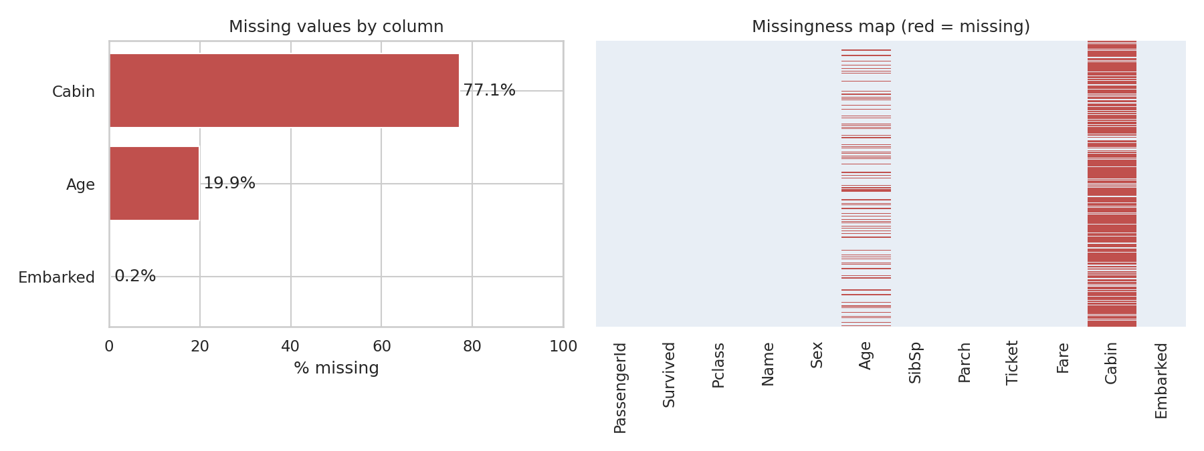
Figure 1: Missing values in the raw Titanic data (Week 1)
The exploratory analysis also illustrated a lesson that echoes through the later work: risk was spread unevenly. 74.2% of women survived compared with 18.9% of men, and survival fell from 63% in first class to 24.2% in third class. Averages (overall survival 38.4%) hid very different group experiences. Missingness itself carried information: passengers with a recorded cabin survived at 66.7% against 30% for those without.
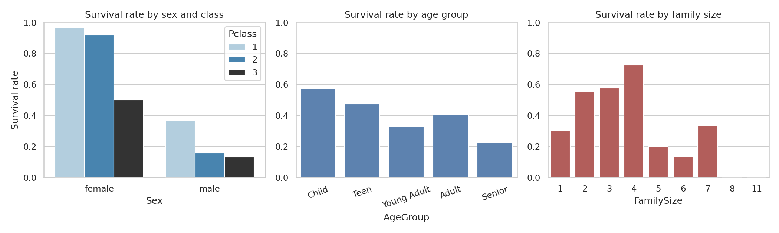
Figure 2: Titanic survival rates by sex and class, age group and family size (Week 1)

3.2 The visual story (Week 2)
The Gapminder data was turned into six charts that build a narrative. Three of them carry the main messages.
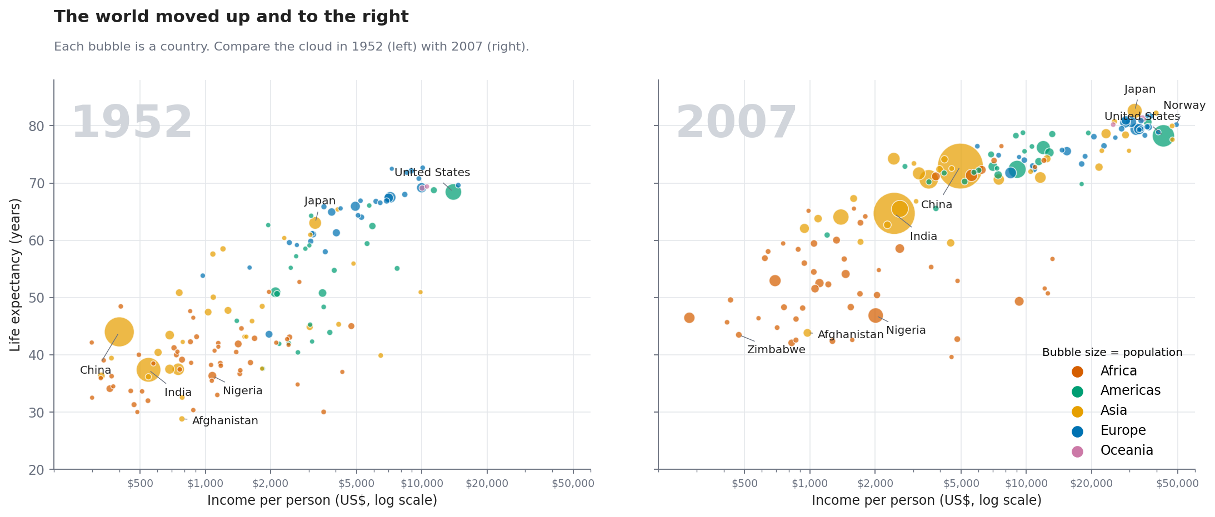
Figure 3: The world moved up and to the right between 1952 and 2007 (Week 2)
Figure 3 shows the scale of improvement. The median country went from 45.1 to 71.9 years, and the number of countries below 50 years fell from 82 to 19. Income for the median country rose about 3.1 times.
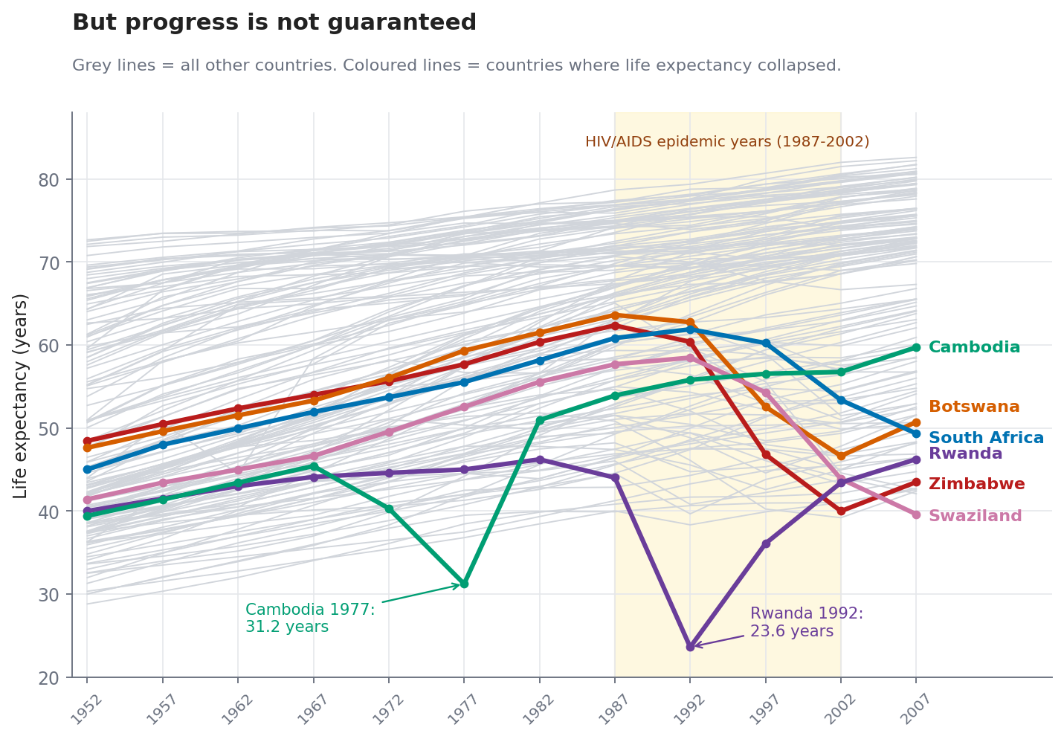
Figure 4: Countries where life expectancy collapsed (Week 2)
Figure 4 is the turning point of the story. Most countries rise steadily, but a minority suffered sharp reversals: for example Zimbabwe fell from 62.4 years in 1987 to 40 in 2002, and Rwanda dropped to 23.6 in 1992. Only 6.5% of all five-year steps were declines, so reversals are rare, yet severe when they occur.
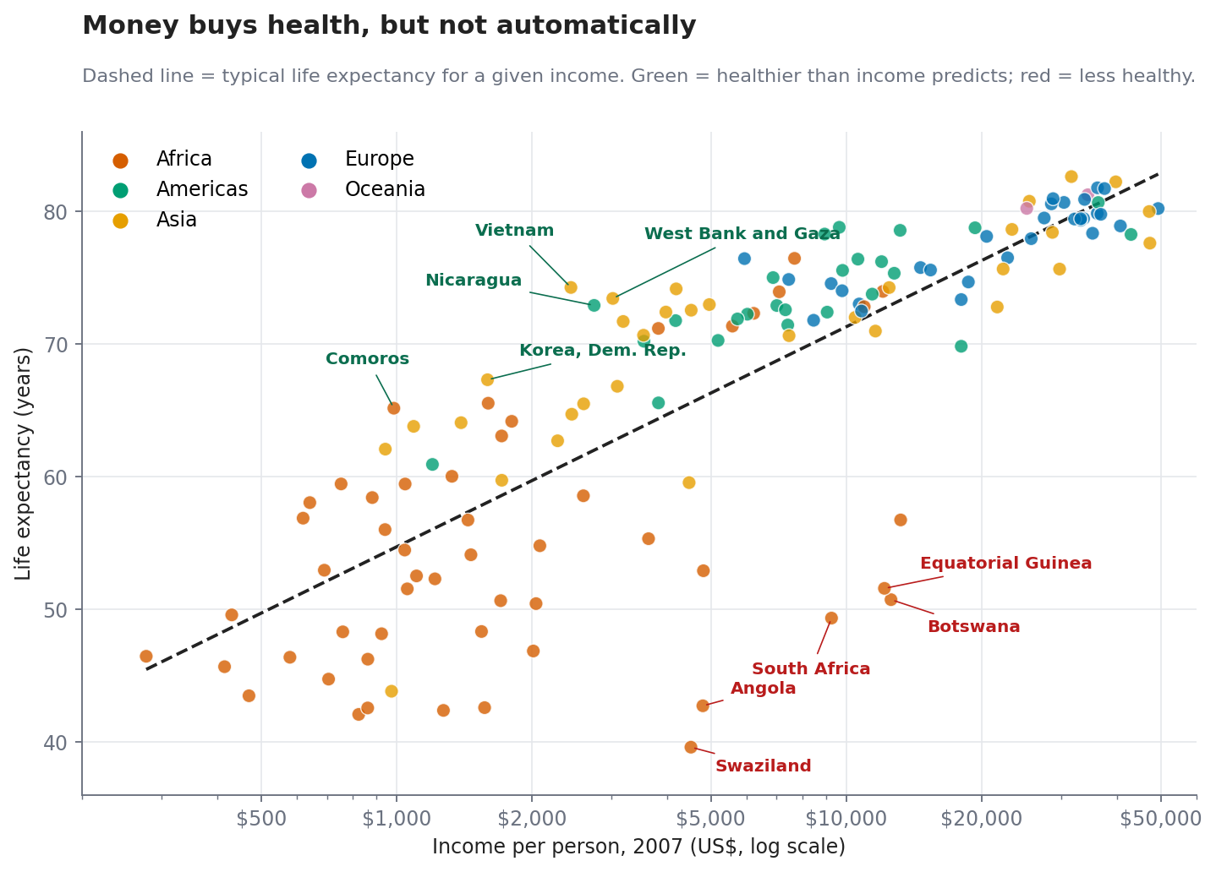
Figure 5: Life expectancy against income in 2007, with over- and under-performers labelled (Week 2)
Figure 5 shows that income alone does not determine health. Vietnam, Nicaragua, the West Bank and Gaza, Comoros and North Korea live 9 to 13 years longer than their income predicts; Swaziland, Angola, Botswana, South Africa and Equatorial Guinea fall 21 to 26 years short.

3.3 Statistical evidence (Week 3)
Five hypotheses were tested at the 5% level. All five null hypotheses were rejected, and all conclusions survived the Holm correction for multiple testing.
Question | Result | Effect size | p-value
Do continents differ in 2007 life expectancy? (ANOVA) | Africa 54.8, Asia 70.7, Americas 73.6, Europe 77.6 years | eta-sq = 0.629 | < 0.001
Did life expectancy change 1952 to 2007? (paired t) | +17.95 years (95% CI 16.6 to 19.3) | dz = 2.21 | < 0.001
Did Africa gain less than others? (Welch t) | 3.6 years less (95% CI 0.74 to 6.46) | d = 0.45 | 0.014
Are income and life expectancy related? (Pearson) | r = 0.809; +4.99 years per doubling | R-sq = 0.654 | < 0.001
Is income group linked to 70+ life expectancy? (chi-square) | 93% vs 23.9% reach 70+ | V = 0.7 | < 0.001

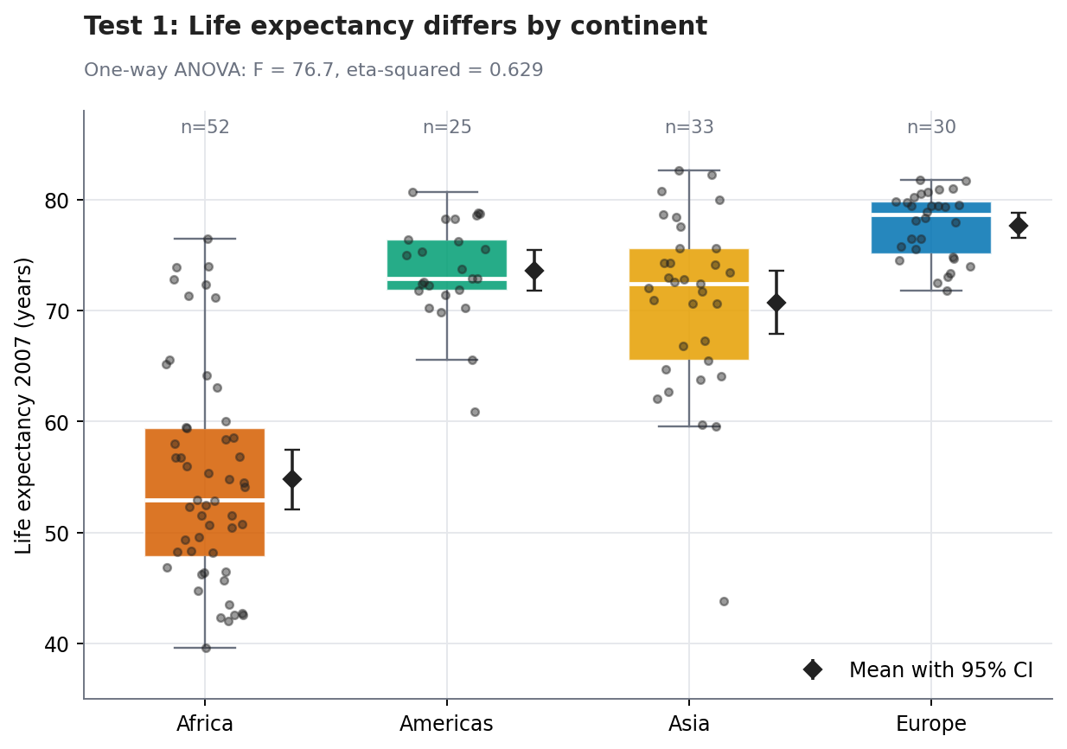
Figure 6: Life expectancy by continent in 2007 with 95% confidence intervals for the mean (Week 3)
Africa was 16 to 23 years below every other continent, and none of those intervals is anywhere near zero. By contrast, the Africa-versus-rest difference in how much countries gained since 1952 was modest (about 3.6 years with a wide interval), and it is the one result where the evidence is closest to the threshold.
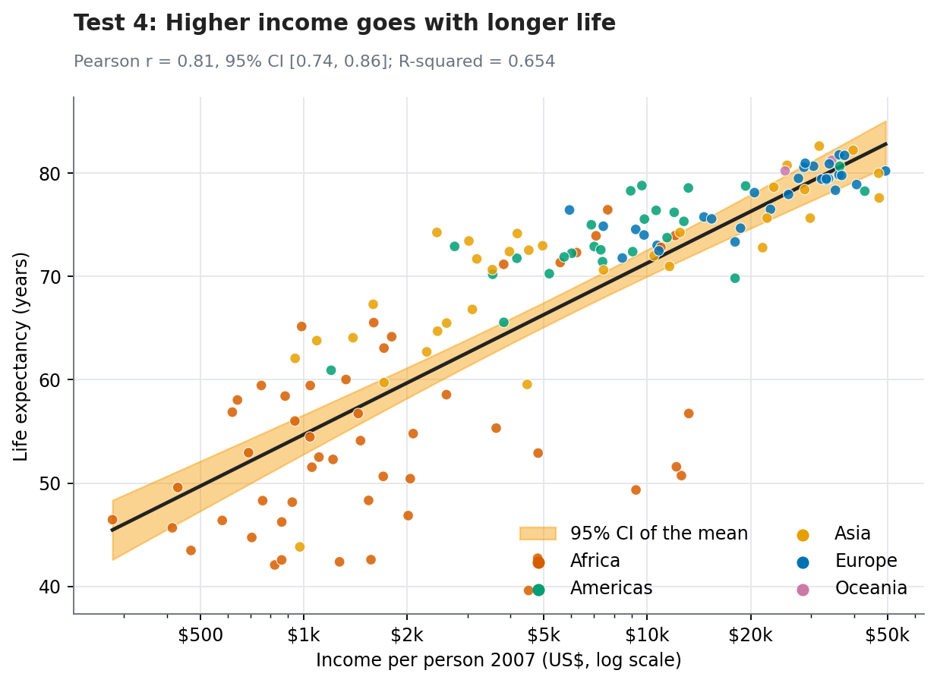
Figure 7: Income against life expectancy with the fitted regression line and confidence band (Week 3)

3.4 Predictive model (Week 4)
A logistic regression predicted whether a country-year had life expectancy of at least 70 years. It was trained on 106 countries and tested on 36 countries it had never seen.
Model | Accuracy | Recall | F1 | ROC AUC
Baseline (always 'under 70') | 0.722 | 0.000 | 0.000 | 0.500
Logistic regression | 0.900 | 0.858 | 0.827 | 0.959
Decision tree (depth 3) | 0.891 | 0.775 | 0.798 | 0.919
Random forest | 0.898 | 0.800 | 0.814 | 0.958

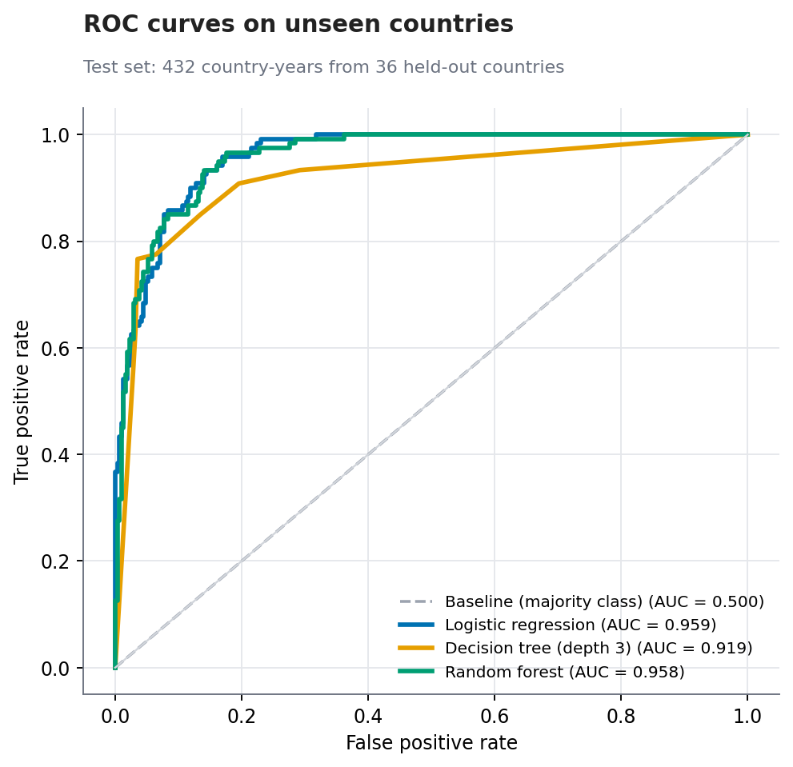
Figure 8: ROC curves on held-out countries (Week 4)
The simple logistic regression performed as well as the random forest, and deeper decision trees overfit the training data. On a stricter forward-in-time test (train up to 1987, test 1992 to 2007), logistic regression still achieved 88.4% accuracy and 0.956 AUC.
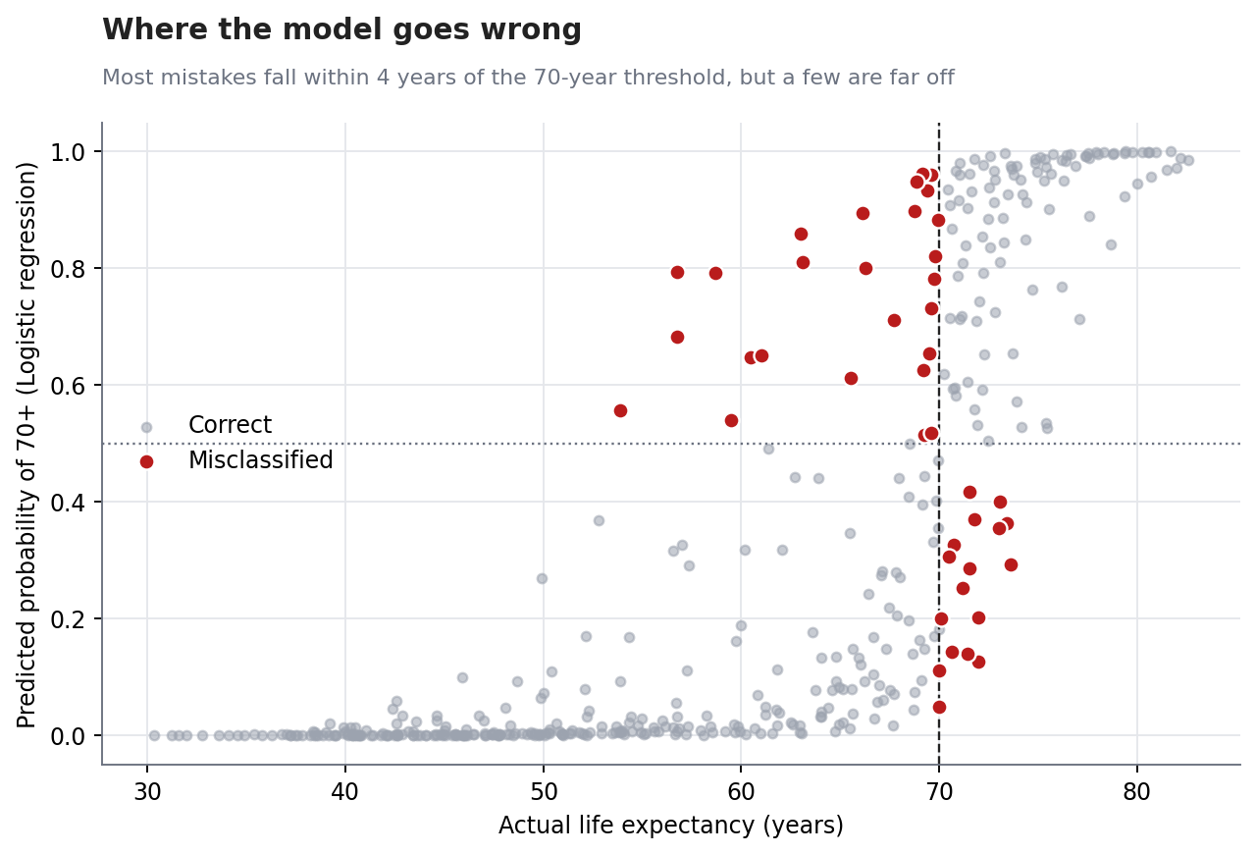
Figure 9: Model errors cluster near the 70-year threshold, but some are far off (Week 4)
The model made 43 errors on 432 test records. About three quarters were within 4 years of the threshold. The larger errors involved countries whose health departed from their income: Saudi Arabia, Gabon, Hungary and Turkey were over-predicted; Hong Kong and Jamaica were under-predicted. These are the same exceptions found in Week 2.

4. Discussion: Cross-Cutting Patterns
Pattern | Evidence across the project
A rising tide | Descriptive (Fig. 3), inferential (paired t: +17.95 years) and population-weighted (48.9 to 68.9 years) results all agree
A persistent gap | The gap between best and worst country did not shrink (43.9 to 43 years); Africa trails every other continent by 16 to 23 years (ANOVA, Tukey)
Fragility | 12 countries lost over 5 years of life expectancy in 1987 to 2002; reversals are rare but can erase decades of progress
Income is a guide, not a rule | Strong correlation (r = 0.809), but a third of the variation is unexplained; model errors and Week 2 outliers involve the same countries
Averages hide groups | Both the Titanic data (sex and class) and the global data (continent) show group experiences that differ sharply from the overall mean
Simple is enough | A transparent logistic regression matched the more complex random forest and held up better over time

Taken together, these patterns support a consistent message: the overall trend is encouraging, but a decision based only on averages or on income would miss the countries and groups where need is greatest and where outcomes can change abruptly.

5. Strategic Recommendations
Each recommendation links an evidence base to a concrete action, a way to measure success and the main risks. They are written for the funder or agency described in Section 1.1.

5.1 Recommendation 1: Prioritise the lagging region and lowest-performing countries
Evidence. Africa's 2007 mean life expectancy (54.8 years) was 16 to 23 years below the other continents (Tukey intervals exclude zero), and the best-to-worst gap did not narrow between 1952 and 2007. The continent explains about 63% of the variation across countries. Africa's gain since 1952 was also modestly smaller than elsewhere (3.6 years, 95% CI 0.74 to 6.46).
Suggested action. Set funding and programme targets on the distribution of outcomes (for example, the number of countries below 60 years) rather than on the global average, which hides the tail. Direct additional attention to the lowest-performing countries within each region, not just to the region as a whole.
How it improves decisions. Africa is not uniform: some African countries are close to the global trend, and the Welch result is modest. Country-level analysis is needed before allocating funds. Averages equal-weight countries, so population-weighted views should be shown alongside.
Success measures. Targeting the tail focuses limited resources where the measured shortfall is largest, and avoids declaring success because the average improved.
Risks and caveats. Track the share of countries and of population below a chosen life-expectancy floor, and the gap between the top and bottom quartiles.

5.2 Recommendation 2: Do not use income alone to target support; add health outcome data
Evidence. Income explains 65% of the variation in life expectancy, leaving about a third unexplained. Vietnam, Nicaragua and Comoros live 10 to 13 years longer than income predicts, while Swaziland, Angola, Botswana and South Africa fall over 20 years short. The Week 4 model's largest errors involve the same kinds of countries.
Suggested action. Use a two-part screen: income level plus recent health outcomes. Flag countries well below the income-predicted line as priority cases, and study the over-performers (so-called positive deviants) to learn which policies and systems let them beat their income.
How it improves decisions. The dataset cannot say why countries deviate (health systems, inequality, disease and conflict are plausible). The recommendation is to investigate, not to assume. Average income also hides how it is distributed.
Success measures. It prevents mid- or high-income countries with poor health outcomes (for instance resource-rich economies) from being overlooked, and surfaces transferable lessons from low-income countries that did well.
Risks and caveats. Share of priority countries identified by outcomes who would have been missed by an income-only rule; documented case studies of over-performers.

5.3 Recommendation 3: Build an early-warning system for stalls and reversals
Evidence. 12 of 142 countries lost more than five years of life expectancy between 1987 and 2002 (Zimbabwe -22.4, Botswana -17, Swaziland -13.8 years), and Rwanda fell to 23.6 years in 1992. Africa's population-weighted life expectancy was almost flat from 1992 to 2002 (53.4 to 53.3 years). Such reversals are rare (6.5% of five-year steps) but severe.
Suggested action. Monitor life expectancy and its change for every country at each data release, and trigger a review when a country declines or stalls over consecutive periods (the exact thresholds should be set with domain experts). Pair the monitoring with contingency funding for rapid response.
How it improves decisions. Five-year data and publication delays limit how early detection can be; more frequent data would be needed in practice. The causes of reversals (such as epidemics and conflict) are historical context, not something this dataset proves.
Success measures. Reversals took years to become visible in aggregated figures. Systematic monitoring would move the response from after-the-fact to early-detection.
Risks and caveats. Time from onset of a decline to response; number of reversals detected within one reporting period; false-alarm rate of the trigger.

5.4 Recommendation 4: Use the predictive model only as a screening and triage aid
Evidence. Logistic regression reached 90.0% accuracy and 0.96 AUC on unseen countries (baseline 72.2%) and 88.4% accuracy when predicting forward in time. It still made 43 errors in 432 cases, about three quarters near the threshold, and the larger ones in unusual countries.
Suggested action. Use the model for first-pass screening where direct health data is missing or outdated, with every flagged or unflagged case reviewed by an analyst. Report the predicted probability, not just a yes/no answer, and retrain regularly with new data and added features such as health spending and education.
How it improves decisions. It predicts association, not cause. The test set is small (36 countries), and errors are concentrated in precisely the exceptions that matter. It should not be used to withhold support.
Success measures. It saves analyst time on obvious cases and directs attention to uncertain ones, while keeping a human in the decision loop.
Risks and caveats. Agreement between model screening and later observed outcomes; share of analyst reviews that overturn the model; improvement in recall after adding new features.

5.5 Recommendation 5: Standardise transparent data practices
Evidence. Throughout the project, decisions that were documented and checked improved the result: an initial chart title was corrected after the numbers showed the spread had not narrowed; imputation was flagged rather than hidden; non-parametric checks supported parametric tests; and a grouped split prevented leakage that would have inflated model scores.
Suggested action. Adopt a short standard for analytical products: keep raw data untouched, record every cleaning decision and its rationale, flag imputed values, report effect sizes with confidence intervals, validate models on genuinely unseen groups, and state limitations next to findings. Use takeaway titles and plain-language captions for stakeholder-facing charts.
How it improves decisions. Adds modest up-front effort; needs buy-in from the people producing the analyses.
Success measures. Decision-makers can trust, audit and reproduce the numbers they rely on, and avoid being misled by headline averages or inflated model scores.
Risks and caveats. Share of reports with documented methods and limitations; reproducibility of results from code; number of corrections found in review.

5.6 Prioritisation
Recommendation | Effort | Time frame | Suggested first step
1. Prioritise lagging region and countries | Medium | Short to medium | Report tail-based indicators next to the average
2. Combine income with health outcomes | Low | Short | Add the residual (outcome vs income) view to briefings
3. Early-warning monitoring | Medium to high | Medium | Define triggers with experts and test on historic data
4. Model as screening aid | Medium | Medium | Pilot on countries with missing data, with analyst review
5. Transparent data practices | Low | Short | Adopt a one-page checklist for all reports

6. Business and Research Impact

6.1 Impact for funders and policymakers
- More targeted use of limited budgets by looking at outcomes and the tail of the distribution, not just averages or income.
- Earlier recognition of countries entering a decline, enabling faster response.
- A reusable, explainable screening tool that helps where health data is sparse.

6.2 Impact for businesses
- Market planning: the move of large populations into longer lives and higher incomes (for example in Asia, where population-weighted life expectancy rose from 42.9 to 69.4 years) points to growing demand for healthcare, insurance and pensions.
- Risk planning: the historical record shows that sharp reversals can occur; supply-chain, workforce and investment risk models for affected regions should allow for them.
- Segmenting markets by development stage and outcomes, rather than treating emerging markets as one block.

6.3 Impact for research
- The over- and under-performers identified provide a ready list of cases for deeper study.
- The project provides a reproducible template that can be extended with causal methods, more variables and newer data.
About quantified impact: No monetary or lives-saved figures are given because the data contains no cost, programme or intervention information. Impact is expressed through measurable indicators (Section 5) that a pilot could track.

7. Limitations
- Data ends in 2007. Findings describe 1952 to 2007 and may not hold today.
- National averages. Income and life expectancy are country means that conceal differences between regions, genders and social groups within countries.
- Association, not causation. None of the analyses establishes that a change in income or policy causes a change in health.
- Explanations come from outside the data. References to HIV/AIDS, conflict or oil wealth are historical context used to interpret results, not findings of the analysis.
- Equal weighting and dependence. Countries were treated as equal and independent in the tests, although neighbours share conditions, and population-weighted views were provided only in some charts.
- Model evaluation on a small test set. One split of 36 held-out countries gives results with sampling uncertainty.
- Two different datasets. The Titanic data (Week 1) illustrates methods and an uneven-risk pattern; it is not substantive evidence about global health.

8. Future Improvements
- Update the data. Extend to recent years using World Bank, UN or WHO sources and re-run every analysis.
- Add explanatory variables. Health spending, education, inequality, disease burden, conflict and governance indicators.
- Move toward causal analysis. Panel models with country and year effects, difference-in-differences or synthetic-control designs for specific events.
- Improve prediction. Forecast life expectancy as a number with lagged features, calibrate probabilities, use repeated grouped cross-validation and report confidence intervals for metrics.
- Better communication. Build an interactive dashboard (for example with Plotly or Streamlit) so stakeholders can explore countries and time periods.
- Quantify cost-effectiveness. Combine outcome data with programme cost data so that recommendations can be ranked by value for money.

9. Conclusion
Over five stages, this project moved from raw data to recommendations. Careful preparation produced trustworthy data; visual storytelling revealed a world that became far healthier (population-weighted life expectancy from 48.9 to 68.9 years) yet remained unequal and vulnerable to sudden reversals; formal tests confirmed the main patterns and measured their size; and a simple model showed that screening is feasible but imperfect. The recommendations that follow all rest on the same principle: act on outcomes and distributions rather than on averages or income alone, monitor for trouble early, use models as aids rather than judges, and be transparent about how numbers are produced and what they cannot tell us.

Appendix A: Code and Repository Guide
All code is written in Python and organised by week. Each script downloads its public data directly, so it runs without any local data files.
Week | Script | What it does
1 | week1/analysis.py | Downloads Titanic data, cleans it, saves titanic_clean.csv and six figures
2 | week2/story.py | Downloads Gapminder data, creates six visualizations and results.json
3 | week3/hypothesis_tests.py | Runs five hypothesis tests with assumption checks, six figures, results3.json
4 | week4/ml_model.py | Builds and evaluates the models, seven figures, results4.json
5 | (no new script) | Synthesis of Weeks 1 to 4; reuses their outputs and figures

Key snippet: grouped evaluation of the model (Week 4).
gss = GroupShuffleSplit(n_splits=1, test_size=.25, random_state=42)
train_idx, test_idx = next(gss.split(X, y, groups=df.country)) # no shared countries
pipe = Pipeline([("pre", pre), ("clf", LogisticRegression(max_iter=1000))])
pipe.fit(X.iloc[train_idx], y.iloc[train_idx])
roc_auc_score(y.iloc[test_idx], pipe.predict_proba(X.iloc[test_idx])[:, 1])

Key snippet: testing, with a robust check and an effect size (Week 3).
res = stats.ttest_ind(gain[~is_af], gain[is_af], equal_var=False) # Welch t-test
res.confidence_interval() # 95% CI of the difference
stats.mannwhitneyu(gain[~is_af], gain[is_af]) # non-parametric check

Appendix B: Glossary
Term | Plain-language meaning
p-value | How surprising the data would be if there were truly no effect. Small values mean the data are hard to explain by chance alone. It does not measure how big or important an effect is
Confidence interval (95%) | A range of plausible values for the true quantity, such as the average gain in life expectancy
Effect size | How large a difference or relationship is, regardless of sample size (for example eta-squared, Cohen's d, Cramer's V)
ANOVA | A test of whether the averages of three or more groups differ
Accuracy, precision, recall | Share correct overall; share of flagged cases that are truly positive; share of true positives that were found
ROC AUC | How well a model ranks cases from most to least likely to be positive; 0.5 is chance and 1 is perfect
Overfitting | When a model memorises its training data and performs worse on new data
Data leakage | When information from the test data accidentally influences training, making scores look better than they really are

