**AI Assignment 2**

**Report**

This program is a Road Route System which takes input from the user to select Search Technique, Start and Goal City. After processing, it displays the Route and Total Distance.

Search techniques implemented are:-

1. Depth first search
2. Best first search

There is one folder named **AI Assignment 2**

For running the script, the user needs to follow the mentioned steps:

1. Consult the main.pl file in Prolog Software, and then type: ?- start.

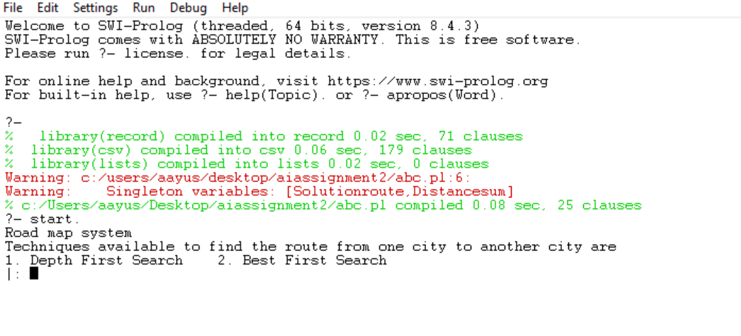

1. Now, the Road Route System will prompt the user to select the search technique.

After choosing the search technique, the system will ask to enter the Start City and Goal City.

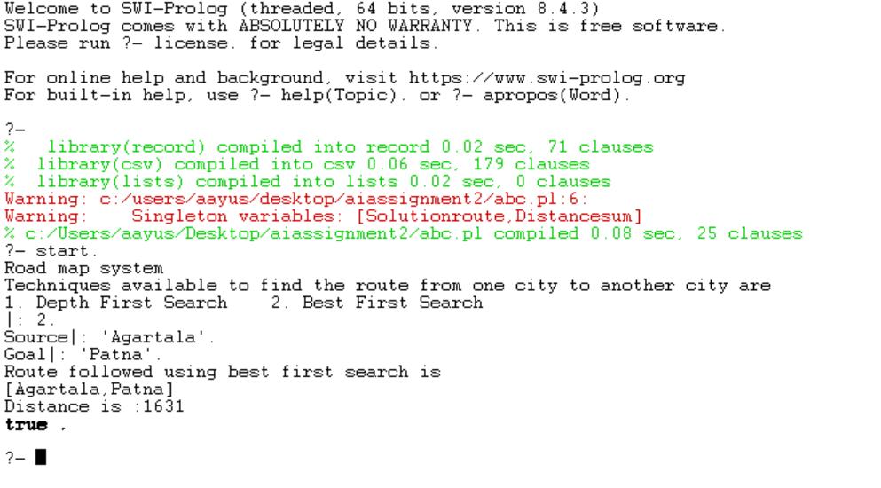

1. Once all the details are entered, the system will display the route used to reach the goal node from the start node and the total distance covered .
2. Trying out other Search technique:

