Project Plan
Date: Thursday, January 17, 2015
m-Banking Application

Aayush Karwatkar(12BCE0424)
Nikhil Choudhary(12BCE0072)
Saurabh Bharadwaj(12BCE0228)

Table of Contents:

- Introduction
- Problem Statement
- Project Objectives
  - Details
  - Work Distribution
- Feasibility Report
  - Completion of project in the chosen time frame
  - Technical and operational feasibility
- Process Model
- Deliverables
  - Results and outcomes
  - Platforms and frameworks used
- Project Scheduling
  - Major project milestones
  - Gantt chart and pert chart

- Introduction

The Indian smartphone market has grown rapidly in the last year. With the trend of consumers shifting from traditional desktop based computing to mobile handset based computing it is essential to meet requirement of the consumer. Thus this project focuses on the banking sector application that will help users to use and manage all their banking needs on the mobile handset.

- Problem Statement

This project focuses on making an m-Banking application. The application will be a single standalone application which will be used by all the stakeholders associated with banking.

- Project Objectives

Details:
The project is divided into three domains. The three domains are:
- Security issues
- Loans and Transactions
- Customer services

The security issues domain deals with the following:
- Handling the secure identification and preventing fake identities and phishing.
- Encryption of data. The data must be encrypted while sending and storing. All this data is highly vulnerable as it includes the user and bank details.
- User alerts and notifications while using the application. The end user must be intimated properly.
- Database maintenance. The database is the place where all the data is stored and so it must be properly preserved and maintained.
- Network Security. Common network is used while using the application and so the network security must be enhanced and maintained by us.

The loans and transactions domain deals with the following:
- Transfer of money from one bank account to another. This is one of the major features of this application. Chiefly, bank services are used for money transfer feature.
- Loan required information. The application can be used for getting the loan required information.
- Apply for a loan. The application can be used for applying for a loan.
- Getting and checking status of ongoing loan.
- Loan cancellation and paying it back.

The customer services domain deals with the following:
- History of payments. The history of payments will be maintained and monitored through the application.
- Payment of bill using mobile application. Various types of bills can be paid using the application.
- Balance checking. The application will be used to check and monitor the bank balance.
- Shopping on various e-commerce platforms and paying the amount using our mobile application.
- Searching of nearby ATM and banks.

Work Distribution:
The team consists of three members. Each of the members is assigned a specific domain.
The distribution is as follows:
Aayush : Customer Services Domain
Nikhil : Security Domain
Saurabh: Loans and transactions domain.

Key Contacts
Name | Registration Number | Phone Number
Aayush Karwatkar | 12BCE0424 | 8508205420
Nikhil Choudhary | 12BCE0072 | 8056934603
Saurabh Bharadwaj | 12BCE0228 | 9597440871

- Feasibilty Report

The time frame chosen for the project is January, 2015 to April, 2015. The time frame is optimum and the project should be completed in the given time frame.

The team and experience required for the project is already gathered and the project is ready to work upon.

- Process Model : Waterfall Model

Waterfall is defined as a sequential development model with clearly defined deliverables for every phase. Many industry practitioners are strict in performing audit reviews to ensure that the project has satisfied the input criteria before continuing to the next phase.
The standard phases of waterfall are shown in the diagram below:

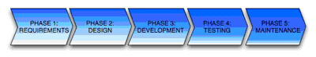
The process model followed in this project is shown in the following diagram:
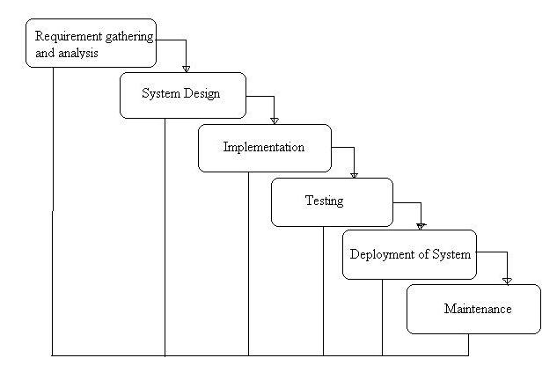

- Deliverables

Results:
The project is expected to produce a complete application to be used for banking purposes from the mobile directly.
The project should result in a simplified way of handling banking needs of people related to banks.
For example, if one has to pay for a e-shopping then he can checkout with the mobile application and the amount will be safely deducted from his bank balance.

Platforms and frameworks used:

For the project:
- Hardware requirements:
- Minimum RAM: 512 MB
- Minimum disk space: 500 MB
- Processor Intel Core 2 DUO 2.4 GHz minimum
- Software requirements:
- Windows 7 or later.
- Eclipse IDE with Android Developer Tools.
- Google App Engine
- Rational Rose Enterprise Edition
- Microsoft Visio 2010
For running the application:
- Mobile phone running on Android V4.0 or later.

- Project Scheduling:
Major deadlines:

Milestone | Estimated Start Date | Estimated Completion Date | Submission Date | Number of Resources | Number of Days
Code repository Setup | 30/1/2015 | 31/1/2015 | 31/1/2015 | 3 | 1
Project Plan Preparation and Submission | 31/1/2015 | 3/2/2015 | 3/2/2015 | 3 | 3
Requirements Documentation Preparation and submission | 3/2/2015 | 11/2/2015 | 11/2/2015 | 3 | 8
Design Documentation Preparation and submission | 11/2/2015 | 24/2/2015 | 24/2/2015 | 3 | 10
Test Plan and Test Case documentation Preparation and submission | 24/2/2015 | 12/3/2015 | 12/3/2015 | 3 | 16
First review period of the application | 12/3/2015 | 24/4/2015 | 24/4/2015 | 3 | 11
Second review period of the application | 24/3/2015 | 9/4/2015 | 9/4/2015 | 3 | 15
Project Demo | 9/4/2015 | 30/4/2015 | 30/4/2015 | 3 | 21
Retrospective preparation and submission | 30/4/2015 | 6/5/2015 | 6/5/2015 | 3 | 6
Total Days |  |  | 91

Pert and Gantt chart:
Gantt Chart:
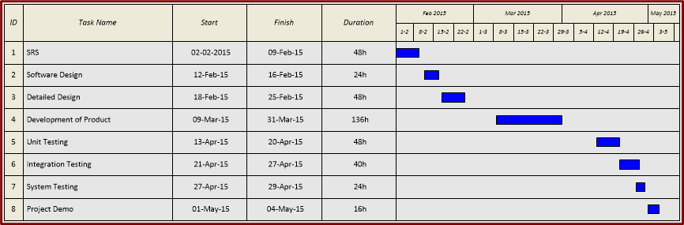

Pert Chart:

