Software Requirements Specification

February 11, 2015

m-Banking Application

Aayush Karwatkar(12BCE0424)
Nikhil Choudhary(12BCE0072)
Siddarth Panigrahi(12BCE0326)
Submitted in partial fulfillment
Of the requirements of
CSE 325 Software Engineering

Table of Contents

Table of Contents:

- Introduction
  - Purpose
  - Scope of Project
  - Glossary
  - Overview of Document
- Overall Development
  - System Environment
  - Use-case diagrams and explanation
  - User characteristics
  - Non-functional requirements
- Requirements Specifications
  - External interface requirements
  - Security

Introduction

1.1. Purpose
The purpose of this document is to present a detailed description of the m-Banking Application. It will explain the purpose and features of the system, the interfaces of the system, what the system will do, the constraints under which it must operate and how the system will react to external stimuli. This document is intended for both the stakeholders and the developers of the system and will be proposed to the Regional Historical Society for its approval.

1.2. Scope of Project
This software system will be an m-Banking Application for the end user of banking and its related services. This system will be designed to maximize the user’s productivity by providing various options to fasten and to ease the overall process of banking.
More specifically, this system is designed to allow a user to perform his banking needs through application , a bank employee to use application for his banking needs and a system administrator to perform his work through the mobile application. The software will facilitate communication between users, bank employees, and the system administrator via mobile application. Preformatted reply forms are used in every stage of the mobile application through the system to maintain consistency.

1.3. Glossary
Term | Definition
User | The customer of the bank using the mobile application.
Bank Employee | The employee of the bank using mobile application.
System Administrator | The administrator (or a team) who manages the digital storage and security of the application and also does the mobile application maintenance.

1.4. Overview of Document
The next chapter, the Overall Description section, of this document gives an overview of the functionality of the product. It describes the informal requirements and is used to establish a context for the technical requirements specification in the next chapter.
The third chapter, Requirements Specification section, of this document is written primarily for the developers and describes in technical terms the details of the functionality of the product.
Both sections of the document describe the same software product in its entirety, but are intended for different audiences and thus use different language.

2.0. Overall Description

2.1 System Environment
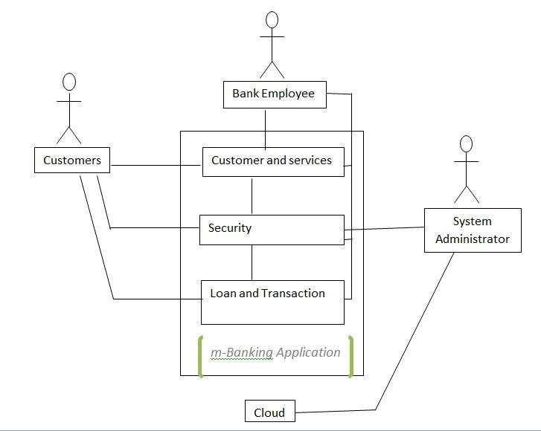

Figure 1 - System Environment

The m-Banking system has three active actors and one cooperating system. The customer, bank employee, or system administrator accesses the banking needs through the mobile application.

2.2 Functional Requirements Specification
2.2.1
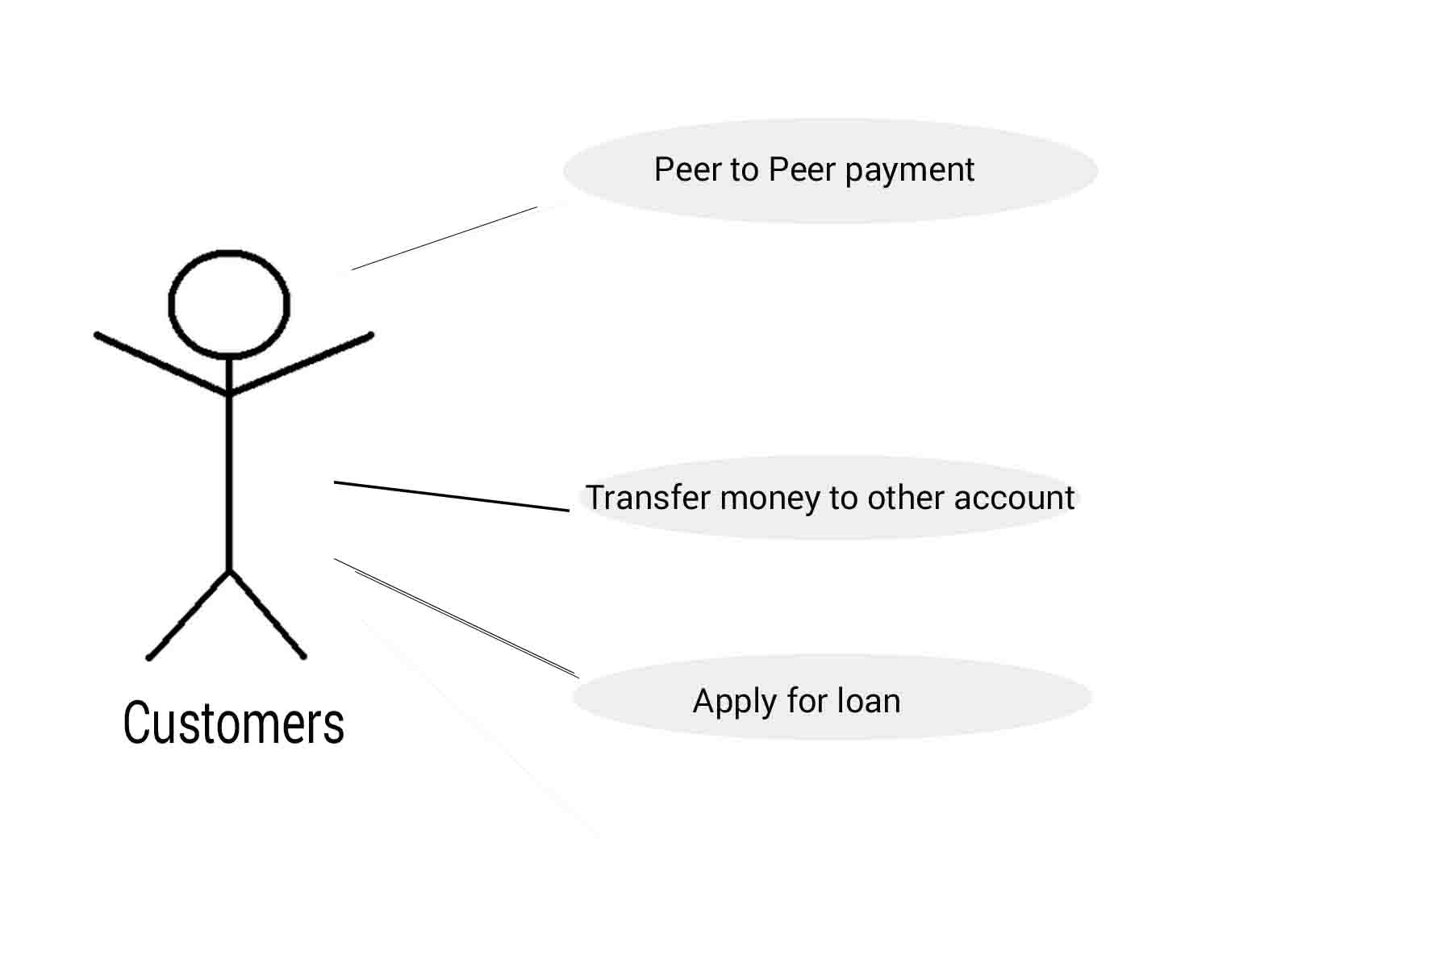
Brief Description:
The customer can use the services provided by the bank for his day-to-day needs related to bank.
Initial Step-By-Step Description:
Before this use case can be initiated, the customer has to install the application onto his/her mobile.
- The customer can use the option transfer funds option in the mobile application and transfer funds to accounts. The user can follow the onscreen instructions given in the option.
- The customer can use the option pay to a person to transfer funds to a person. This transaction can be fulfilled by adding the person first using his/her account number registered in any of the banks worldwide.
3. User can also apply for a loan in the loan section of the application. First option is apply loan in the given section. If the user fits in properly for the loan requirements and is eligible then he/she can also get loan approved.
2.2.2
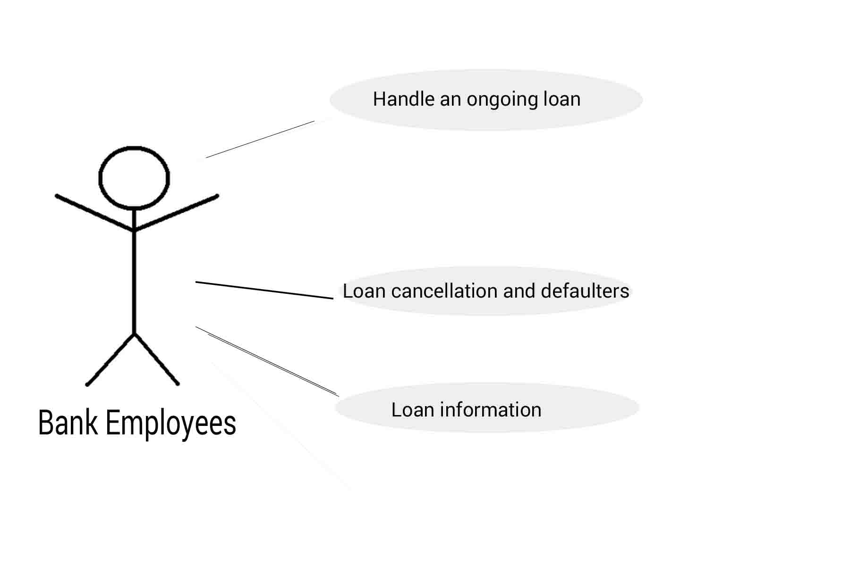
Brief Description:
The bank employee can use the application to perform parts of the job via mobile application.
Initial Step-By-Step Description:
The bank employee can accesses the services and uses of the app by installing it firstly on their mobile handsets
- The employee goes into the loan section of the application and his/her application will show him with the above mentioned utilities.
- Loan cancellation is in the hands of the employee, the employee can approve a loan cancellation request of the person applied for it. Option is provided in the loan section.
- The employee can handle and ongoing loan can check and modify it. Option is provided in the loan section.
- Bank employee can alter and setup the loan information to be available for the customer. Option is provided in the loan section.
2.2.3
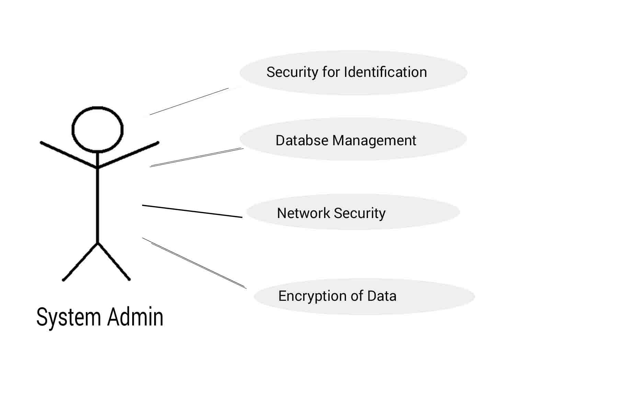
Brief Description:
The system admin can use the application to perform the tasks that he/she has to do.
Initial Step-By-Step Description:
Before this use case can be initiated, the system admin must have access to the mobile handset and must have pre-installed application.
1. The system admin can modify/check the security for identification is working properly or not. Once the admin logs into the application he/she will have the option displayed on the home screen of the application.
2. The system admin can manage the data and can modify the database. Once the admin logs into the application he/she will have the option displayed on the home screen of the application.
3. The system admin can manage/check and modify the security used of network operations. Once the admin logs into the application he/she will have the option displayed on the home screen of the application.
4. The admin can verify the encryption of data. Once the admin logs into the application he/she will have the option displayed on the home screen of the application.

2.2.4
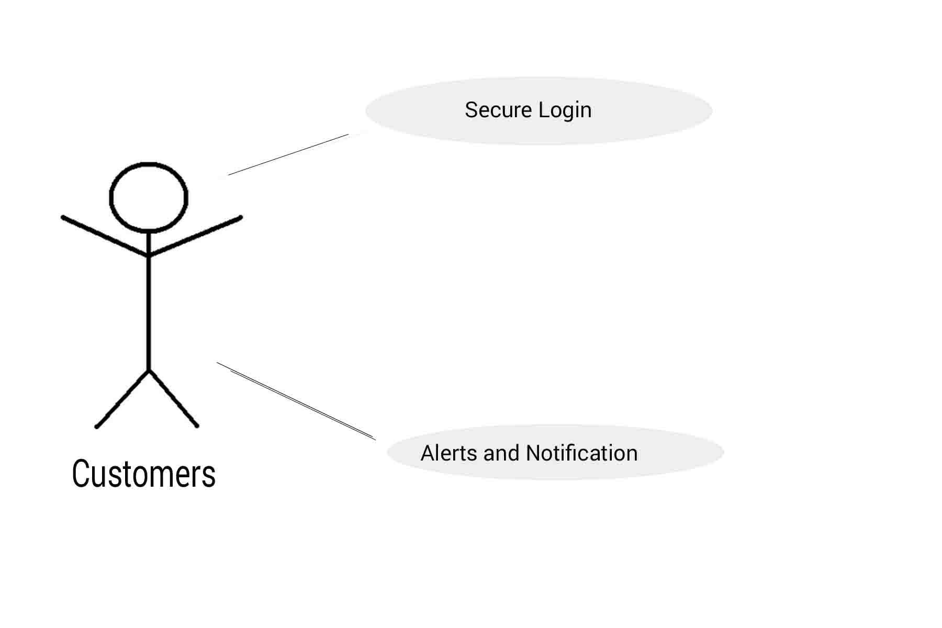
Brief Description:
The customer can use the services provided by the bank for his day-to-day needs related to bank.
Initial Step-By-Step Description:
Before this use case can be initiated, the customer has to install the application onto his/her mobile.
- The customer can use login feature to login securely onto the mobile application.
- The customer will receive alerts and notifications over his mobile. Using the default notification panel.

2.2.5
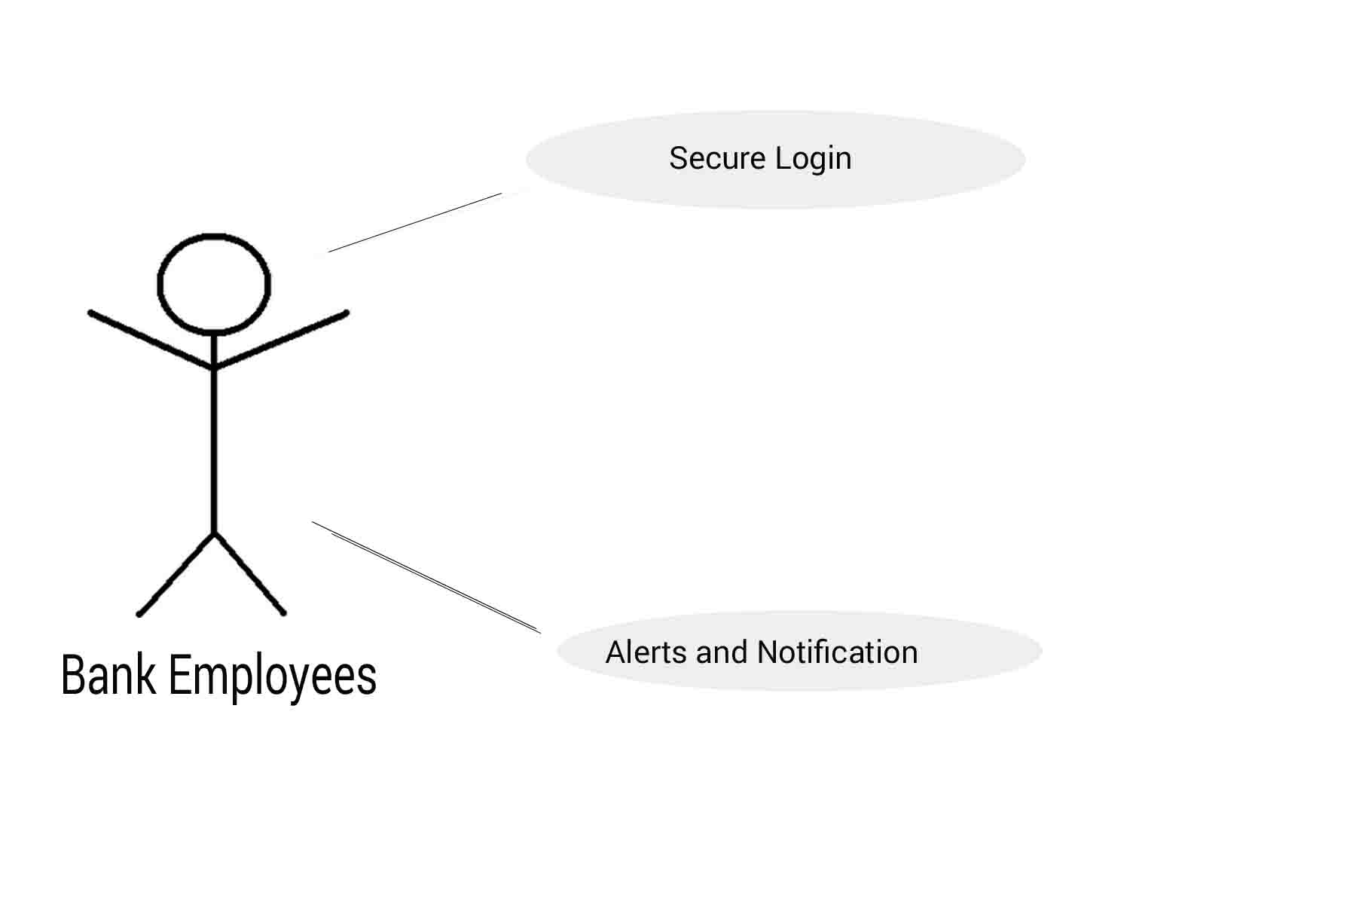
Brief Description:
The bank employee can use the application to perform parts of the job via mobile application.
Initial Step-By-Step Description:
Before this use case can be initiated, the customer has to install the application onto his/her mobile.
- The employee the login feature to securely login.
- The customer will receive alerts and notifications over his mobile. Using the default notification panel.

2.2.6

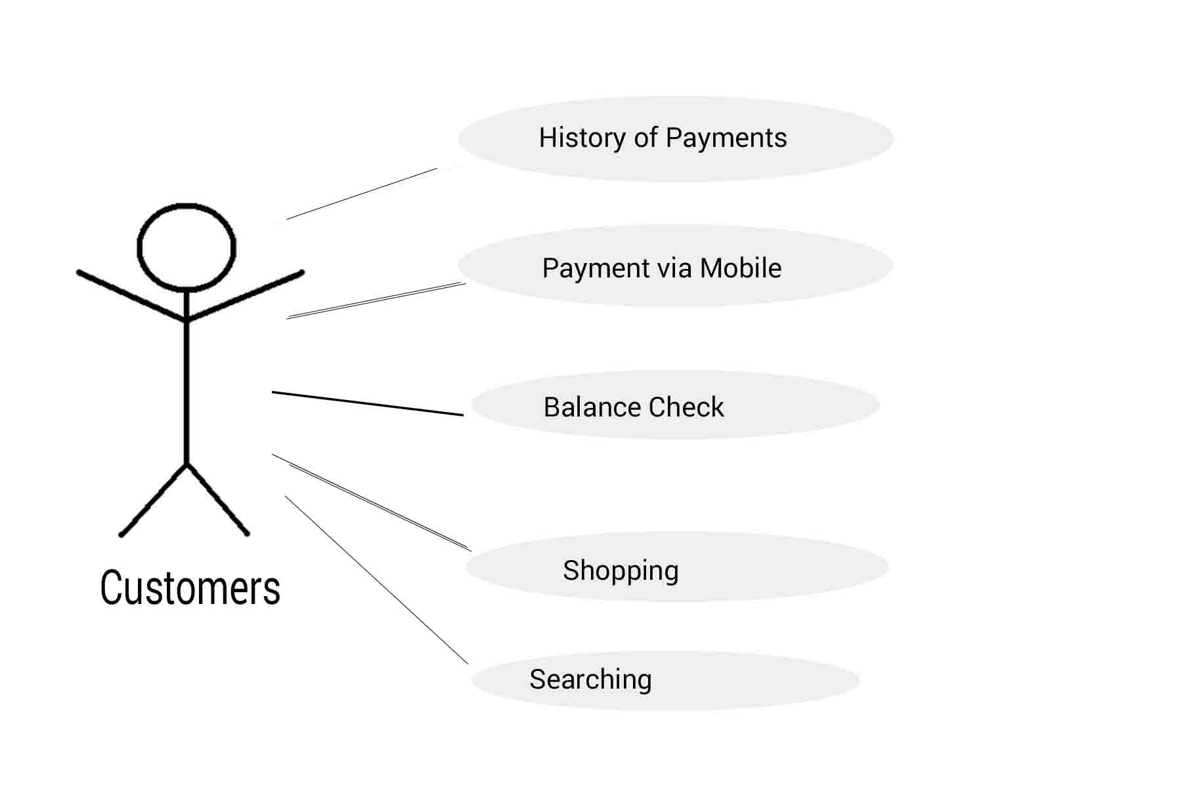

The customer can use the services provided by the bank for his day-to-day needs related to bank.
Initial Step-By-Step Description:
Before this use case can be initiated, the customer has to install the application onto his/her mobile.
- The customer can check the history of payments or the transaction details with the help of this application.
- The customer can do online transactions and can make payments online to other account with the help of this application.
- The customers can do shopping online through e-commerce websites and can make payments via this application.
- The customers can search for nearby banks and can track their locations with the help of this app.

2.2.7
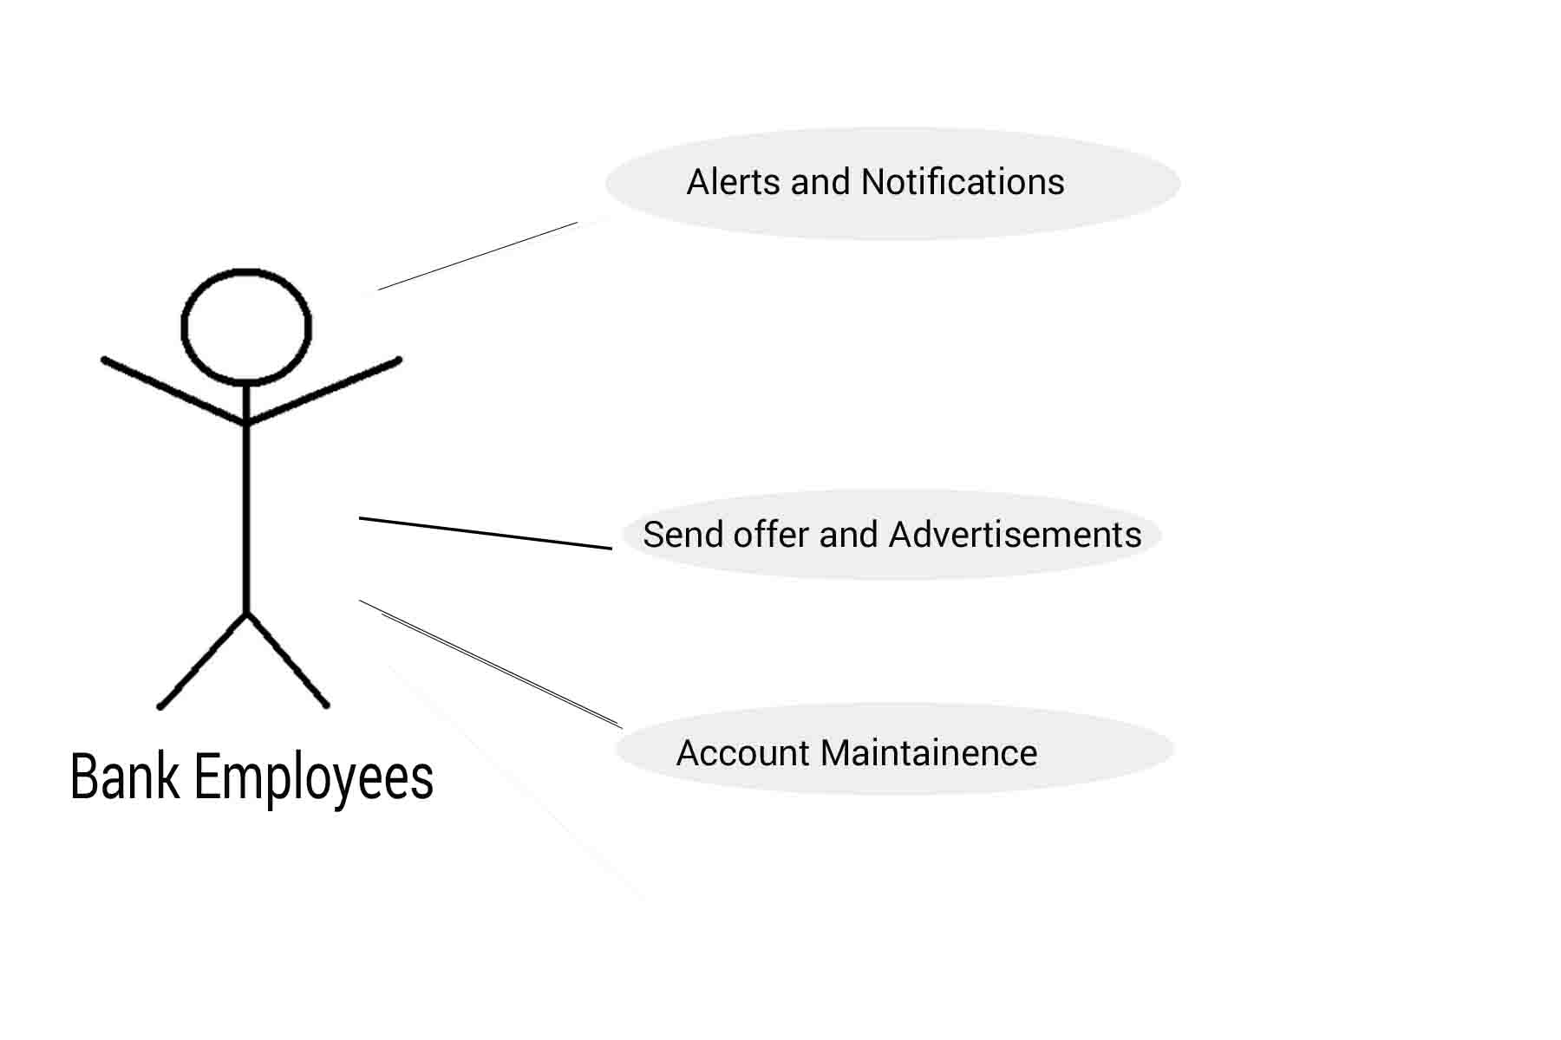
The customer can use the services provided by the bank for his day-to-day needs related to bank.
Initial Step-By-Step Description:
Before this use case can be initiated, the customer has to install the application onto his/her mobile.
- The bank employees can send alerts to the customers and can also notify customers for their transactions.
- Customers can receive offers from bank and related advertisements if they want.
- The main job of bank employees is to maintain the customer’s account and to protect their account details from unknown persons.

2.3 User Characteristics
The customer is expected to be mobile and internet literate and be able to use a bank account. The main screen of the application will have the basic functions.
The employees are expected to be Internet and mobile literate and to be able the mobile applications.
The system admin is expected to be mobile and internet literate and to be able to and work with databases, security algorithms, networks and mobile apps.

2.4 Non-Functional Requirements
The mobile backend will be on a server with high speed Internet capability. The physical machine to be used will be determined by the bank. The software developed here assumes the use of a tool such as Tomcat for connection between the Web pages and the database. The speed of the Reader’s connection will depend on the hardware used rather than characteristics of this system.
The application will run on the user’s mobile and will contain an Access database.
The other non-functional requirements are as such as secure authentication. The network usage must be encrypted properly. The user must be prevented from malicious attacks.

3.0. Requirements Specification

3.1 External Interface Requirements

The only link to an external system is the link to the bank’s database to verify the membership of a user. The system admin believes that a user is much more likely to be an effective customer or a bank employee and has imposed a membership requirement for the role. The bank’s database fields of interest to the mobile application are user’s name, customer (ID) number, and password.

3.2 Security

The server on which the mobile backend resides will have its own security to prevent unauthorized write/delete access. There is no restriction on read access.
The mobile on which the application resides will have its own security. Only the system admin will have physical access to the server and the program on it.

