**Week 6 Assignment**

Kritartha Dhakal

Westcliff University

PRG402: Mobile Application Development

Dr. Ram Naresh Thakur

February 18, 2024

**CRUD on Firebase**

**Steps to Follow**

**Firebase Setup**

1. To perform Create, Read, Update, and Delete (CRUD) operations on a database, first we need to configure a database. Here, we are using Firebase as our choice of database as it provides hosted backend services such as a real-time database. To create a database, first we go to the Firebase official website: <https://firebase.google.com/>
2. There we click on ‘Get Started’. Then a new page appears where we can create or add a new project. We click on that and then provide the project name and complete the project setup.

1. Once we create the project, we need to create an app inside. For this, we select ‘</>’ option which stands for a Webapp. We provide the name for the app and click on ‘Register app’.
2. Once the app is created, under ‘Add Firebase SDK’ we see a few lines of code which is used to connect a React app with Firebase. For me, the configuration looks like this:

1. Then, we go ‘Continue to Console’ which takes us back to the project page. There, we click on ‘Build’ and then select the option of ‘Realtime Database’.
2. Here, we are again greeted with a new page where we see the option of ‘Create Database’. We click on that, and new prompt appears where we configure our database location and security rules. We choose the US location and for security rules, we select ‘Test Mode’.
3. Then click on ‘Enable’ and the Realtime Database is created.

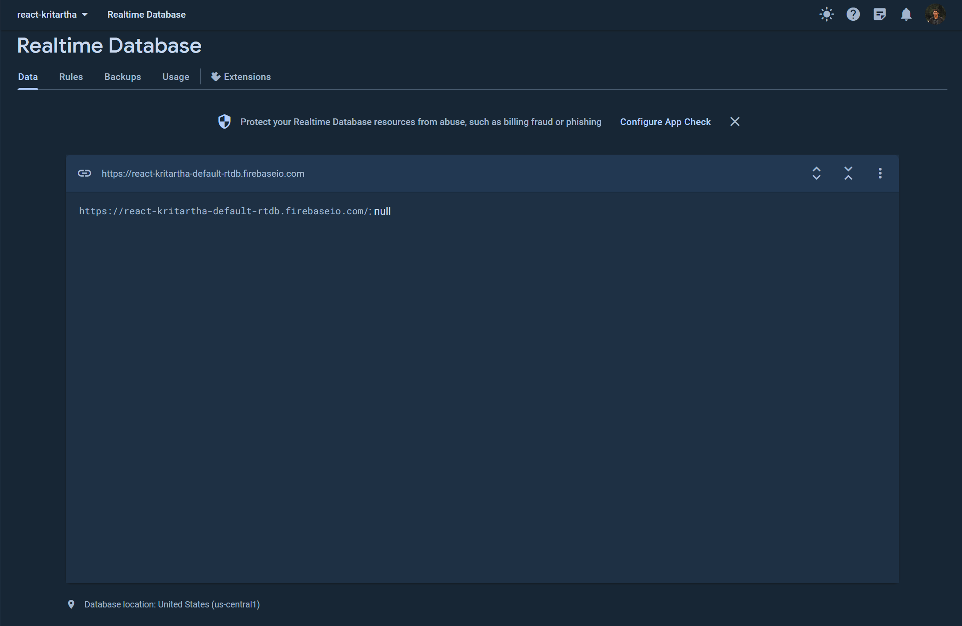

**React Project Setup**

1. We need to perform CRUD operations in the Firebase database using a React app. So, to create one we use Vite as it has a faster development server and better built-in support for React projects. To start a Vite project, we simply make a new folder where we want to store the project and then use the command: npm create vite@latest
2. Once we run the command, we need to provide the project name and package name. Then, we need to select the framework. For us, the framework will be React. Then, we select the variant as JavaScript. Once we complete all these steps, the project will be created. Vite will also provide us with a list of commands to run.

1. We perform the steps provided by Vite concurrently and this will run the development server for our React project.

**Firebase Connection in React Project**

1. To access the Firebase database, we created from the React project, we need to connect the two. Remember that we had a Firebase SDK configuration code provided by Firebase when we created the Firebase app. We will use that to connect Firebase to our React project.
2. We open the project folder using VSCode. Before we can set up the connection, we need to install Firebase in our React project. To do this, we open a terminal in VSCode and run the command: npm install firebase
3. Once that is done, under the ‘src’ folder, we create a new file with the name: ‘firebase.conn.js’ and then we copy and paste the Firebase SDK configuration. Also remember to add ‘export’ in the beginning of the last line of code.

**Components for CRUD**

1. To perform the CRUD operations, we need to create a program that does each of the CRUD operations. For this, we create a new folder under the ‘src’ folder named ‘components’ and then a file for each of performing each of the operation.
2. In a file named ‘add.components.jsx’ we write a program to add data to the database. Similarly, in ‘get.component.jsx’ we write a program to get all the data from the database. To update and remove the data, we create ‘edit.component.jsx’ and ‘delete.component.jsx’ file.
3. Now, the connection we set up before connects our React project to our Firebase app. But to access the Realtime Database and perform operations on it, we need to make a few changes to the connection file.

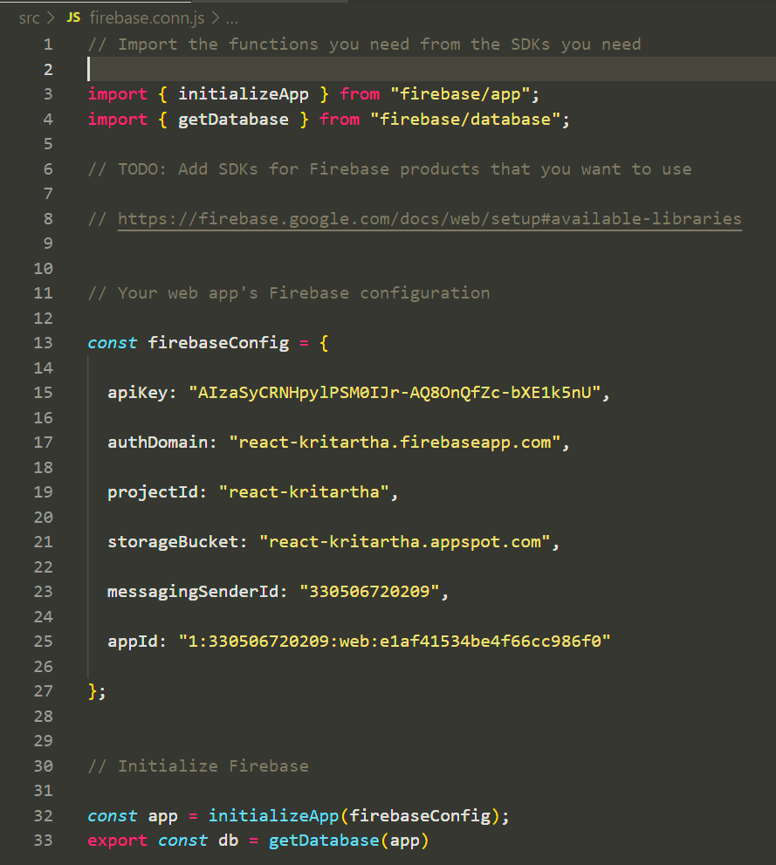

1. Now, we make changes in the ‘App.jsx’ file to make our page show the ‘Add’ component and the ‘Get’ component.

1. We do not need to show the ‘Edit’ and ‘Delete’ component on the main page. We can perform these activities from the ‘Get’ component.

**Output of the Project**

The CSS has been changed in the ‘index.css’ file.

1. **Data Table in the Project**

1. **Firebase Database**

**References**

GeeksforGeeks. (July 15, 2021). Firebase Introduction. Retrieved from GeeksforGeeks. <https://www.geeksforgeeks.org/firebase-introduction/>

GeeksforGeeks. (November 8, 2023). How to setup ReactJS with Vite? Retrieved from GeeksforGeeks. <https://www.geeksforgeeks.org/how-to-setup-reactjs-with-vite/>

Moroney, L., & Moroney, L. (2017). The Firebase Realtime Database. *The Definitive Guide to Firebase: Build Android Apps on Google's Mobile Platform*, 51-71. <https://link.springer.com/chapter/10.1007/978-1-4842-2943-9_3>