


A
Project Report
on
Sustainable Energy Management in 5G Networks
submitted as partial fulfillment for the award of

BACHELOR OF TECHNOLOGY
DEGREE
SESSION 2025-26
in
CSE-AI
By
Aayushker Singh(2200291520006)
Akshat Srivastav(2200291520027)
Anshika Agarwal(2200291520040)
Pari Gupta (2200291520123)

Under the supervision of
Dr. Sapna Juneja
KIET Group of Institutions, Ghaziabad
Affiliated to

Dr. A.P.J. Abdul Kalam Technical University, Lucknow
(Formerly UPTU)

May, 2026
DECLARATION
We hereby declare that this submission is our own work and that, to the best of our knowledge and belief, it contains no material previously published or written by another person nor material which to a substantial extent has been accepted for the award of any other degree or diploma of the university or other institute of higher learning, except where due acknowledgment has been made in the text.

Aayushker Singh (2200291520006) 
Akshat Srivastav (2200291520027) 
Anshika Agarwal (2200291520040) 
Pari Gupta (2200291520123) 

Date: 11-03-2026



CERTIFICATE

This is to certify that Project Report entitled “Sustainable Energy Management in 5G Networks” which is submitted by Aayushker Singh, Akshat Srivastav, Anshika Agarwal, Pari Gupta in partial fulfillment of the requirement for the award of degree B. Tech. in Department of CSE (AI) of Dr. A.P.J. Abdul Kalam Technical University, Lucknow is a record of the candidates own work carried out by them under my supervision. The matter embodied in this report is original and has not been submitted for the award of any other degree.

Dr. Sapna Juneja Dr. Rekha Kashyap
Professor – CSE(AI) Dean – CSE (AI/AI&ML)

Date: 11-03-2026

ACKNOWLEDGEMENT

It gives us a great sense of pleasure to present the report of the B. Tech Project undertaken during B. Tech. Final Year. We owe special debt of gratitude to Dr. Sapna Juneja, Department of CSE(AI), KIET, Ghaziabad, for her constant support and guidance throughout the course of our work. Her sincerity, thoroughness and perseverance have been a constant source of inspiration for us. It is only her cognizant efforts that our endeavors have seen light of the day.
We also take the opportunity to acknowledge the contribution of Dr. Rekha Kashyap, Dean of the Department of Computer Science & Engineering (AI/AIML), KIET, Ghaziabad, for her full support and assistance during the development of the project. We also do not like to miss the opportunity to acknowledge the contribution of all the faculty members of the department for their kind assistance and cooperation during the development of our project.
We also do not like to miss the opportunity to acknowledge the contribution of all faculty members of the department for their kind assistance and cooperation during the development of our project. Last but not the least, we acknowledge our friends for their contribution in the completion of the project.
Aayushker Singh (2200291520006) 
Akshat Srivastav (2200291520027) 
Anshika Agarwal (2200291520040) 
Pari Gupta (2200291520123) 

ABSTRACT

The move to 5G networks, with their unimaginable speeds and capacity, has placed the question of power consumption into the stark light despite the fact that the 5G technology is more energy-efficient per bit than its predecessor 4G technology. The very density of deployment and the escalation of traffic, however, implies that the absolute consumption of the total network infrastructure is a primary concern. Most importantly, this consumption is mainly credited to the Radio Access Network (RAN) where over 70 percent of this energy is allocated to the energy-consuming base stations.
A multi-pronged strategy towards energy- savings is essential to deal with this huge operational expense and environmental cost. This will require careful optimization of base station hardware, programs and operational settings including the use of advanced energy saving policies. The overall energy footprint of a 5G cell site is a complicated process that is influenced by a number of interconnected elements: the physical characteristics and effectiveness of the implemented hardware; the operational settings, including transmission power control and sleep states, the dynamic character of network traffic, and the effectiveness of optimization methods, including both scheduling algorithms and resource allocation policies.
This complexity and the variability of network load demands a proactive, data-driven solution that will be truly energy efficient. As a result, the development of extremely stable and precise models to help predict energy consumption is not just an academic project, but a groundwork to sustainable and cost-effective implementation of 5G globally.
This research work taking a particular turn to the presence of advanced computational methods, where machine learning (ML) approaches are expected to be effectively used in addressing those urgent issues. ML provides the possibility to process high volumes of operational data, such as traffic patterns, environmental conditions, and configuration metrics, and derive data-driven solutions to be taken. ML can also allow real-time network optimization by predictively modifying network parameters and using reinforcement learning to optimally run base stations to fit the demand with the capacity, resulting in significant improvements in the energy efficiency of networks without quality-of-service (QoS) deterioration.

TABLE OF CONTENTS | Page No.
DECLARATION……………………………………………………………………. | ii
CERTIFICATE……………………………………………………………………… | iii
ACKNOWLEDGEMENT..…………………………………………………………. | iv
ABSTRACT………………………………………………………………………..... | v
LIST OF FIGURES…………………………………………………………………. | ix
LIST OF TABLES…………………………………………………………………… | xi
LIST OF ABBREVIATIONS………………………………………………………. | xii
CHAPTER 1 (INTRODUCTION) | 1
1.1. Introduction | 1
1.1. Introduction | 2
1.1. Introduction | 3
1.2. Project Description | 3
1.2.1 Problem Statement | 3
1.2.2 Motivation | 4
1.2.3 Objectives | 4
1.2.3 Objectives | 5
1.2.4 Overview of Methodology and Model Selection | 5
1.2.4 Overview of Methodology and Model Selection | 6
1.2.4 Overview of Methodology and Model Selection | 7
1.2.5 Scope of the Project | 7
1.2.6 Organization of the Report | 8
CHAPTER 2 (LITERATURE REVIEW) | 9
2.1. Literature Overview | 9
2.2 5G Networks Energy Consumption Features | 10
2.3 Key Characteristics of 5G Energy Consumption | 10
2.4 4G Vs 5G Energy Efficiency Comparison | 11
2.5 Energy Comparision Of Network Generation | 11
2.6 Elements Affecting Base Station Power Usage | 12
2.7 Modeling Techniques Of Energy Efficiency | 12
2.8 Modelling Techniques In Literature | 13
2.9 Energy Forecasting For Machine Learning | 13
2.10 Green 5G Network Deployment Techniques | 14
2.11 Patterns Of Energy Used In Urban Areas | 14
2.11.1 Urban Vs Rural Comparision Trends | 15
2.12 Identification In Research Gap | 15
2.13 Literature Review Synopsis | 16
CHAPTER 3 (PROPOSED METHODOLOGY) | 17
3.1. Overview of System Implementation | 17
3.2. Development Environment and Tools | 17
3.2.1. Programming Language | 17
3.2.2. Execution Platform | 18
3.3. Dataset Acquisition and Integration | 19
3.3.1. Dataset Sources | 19
3.4. Data Preprocessing Pipeline | 19
3.4.1. Handling Missing and Inconsistent Values | 19
3.4.2. Data Cleaning and Transformation | 20
3.5. Advanced Feature Engineering Implementation | 20
3.5.1. Time-Based Feature Extraction | 20
3.5.2. Lag Features (Temporal Memory Modeling) | 20
3.5.3. Rolling Statistical Features | 21
3.5.4. Signal Processing Features | 21
3.5.5. Interaction and Derived Features | 21
3.6. Model Development and Benchmarking Strategy | 21
3.6.1. Deep Learning Models Tested | 22
3.6.2. Ensemble Models Implemented | 22
3.7. Final Model Selection: Random Forest | 22
3.8. Training and Validation Methodology | 23
3.8.1. Cross-Validation Strategy | 23
3.9. System Architecture and Workflow | 23
3.10. Implementation Challenges and Solutions | 24
3.11. Output Generation and Deployment | 25
CHAPTER 4 (RESULTS AND DISCUSSION) | 26
4.1 Introduction | 26
4.2 Experimental Setup | 26
4.2.1 Feature Engineering | 27
4.3 Evaluation Metrics | 27
4.4 Model Comparison | 28
4.4.1 Deep Learning and Hybrid Models | 28
4.4.2 Traditional Machine Learning Models | 29
4.5 Random Forest Model Analysis | 29
4.6 Feature Importance Analysis | 30
4.7 Validation and Generalization Testing | 31
4.7.1 Feature Dependency Testing | 31
4.7.2 Time-Series Cross Validation | 31
4.7.3 Distant Future Testing | 32
4.8 Actual vs Predicted Energy Analysis | 32
4.8.1 Scatter Plot Analysis | 32
4.8.2 Time-Series Prediction Analysis | 33
4.8.3 Feature Relationship Analysis | 34
4.9 Discussion | 35
CHAPTER 5 (CONCLUSIONS AND FUTURE SCOPE) | 36
5.1. Conclusion | 36
5.2. Contributions of the Work | 36
5.3 Future Scope | 37
5.4 Final Remarks | 38
REFERENCES. | 39
APPENDEX1 | 41
RESEARCH PAPER/PATENT  PROOF OF SUBMISSION/ACCEPTANCE/PUBLICATION  PLAGIARISM REPORT | 42

LIST OF FIGURES

Figure No. | Description | Page No.
1.1 | Conceptual Representation of Factors Influencing Energy Consumption in 5G Base Stations | 2
3.1 | System Architecture | 23
4.1 | Feature Importance Plot | 29
4.2 | Actual vs Predicted Energy Consumption (Scatter Plot) | 31
4.3 | Actual vs Predicted Energy Consumption Over Time | 32
4.4 | Feature Correlation Heatmap | 33

LIST OF TABLES

Table. No. | Description | Page No.
2.1 | Factors Affecting Energy Consumption | 9
2.2 | 4G VS 5G | 10
2.3 | Limitations And Advantages Of Different Models | 12
2.4 | Strengths Of Different Models | 13
2.5 | Urban Vs Rural Consumption Comparison | 14
3.1 | Libraries and Frameworks Used | 17
3.2 | Dataset Characteristics | 18
4.1 | Model Performance Comparison | 27
4.2 | Evaluation Metrics of Traditional Machine Learning Models | 28

LIST OF ABBREVIATIONS

RAN Radio Access Network
LTE Long Term Evolution
ITU International Telecommunication Union
MIMO Multiple Input Multiple Output
LSTM Long Short Term Memory
AI Artificial Intelligence
DL Deep Learning
ML Machine Learning
CPU Central Processing Unit
GPU Graphics Processing Unit
BS Base Station
ID Identification
NaN Not a Number
MLP Multi Layer Perceptron
CSV Comma-Separated Values
MAE Mean Absolute Error
RMSE Root Mean Squared Error
MAPE Mean Absolute Percentage Error
R² Coefficient of Determination

CHAPTER 1
INTRODUCTION

1.1 Introduction

The fast development of the wireless communication technologies has changed how the contemporary world communicates, socializes, and does business. The fifth generation (5G) of mobile networks is one of such impressive technological improvements, which promises to provide extremely high data rates, exceptionally low latency, a significant increase in reliability, and the ability to provide connections to large numbers of devices. The 5G, in contrast to other previous generations, is not confined to better mobile broadband; 5G is the heart of new technologies like the Internet of things (IoT), smart cities, autonomous vehicles, augmented and virtual reality, industrial automation, and smart healthcare systems. The 5G networks are emerging as an imperative part of the global infrastructure as countries and industries are increasingly becoming reliant on digital connectivity.
The implementation of 5G networks has also come with significant energy usage challenges despite all the benefits that the network has. Despite the fact that the 5G technology should be significantly more energy-saving per transmitted bit than the 4G as it can be estimated that 4G networks use almost four times less energy, the high-energy consumption of 5G networks is much higher. The main reasons that cause this increment include intensive coverage of base stations, the use of elevated frequency bands, work with wider bandwidths, and intricate signal processing to provide huge connectivity and sophisticated services. This is causing the overall power consumption of telecom networks to increase as opposed to going down.
Radio Access Network (RAN), particularly base stations contribute to a considerable chunk of this energy consumption. Research has shown that the total energy consumption of the network is over 70 percent due to operations of the base stations. Though other parts of the whole consumption like data centers and transport networks have a role, their contribution to the overall consumption is relatively lesser. This demand is also augmented by the exponential growth of linked devices triggered by network IoT and intelligent infrastructure. It is now an urgent research and industrial issue due to the projections that telecommunications will contribute to a noticeable segment of global electricity usage in the next decade, which implies energy efficiency in 5G networks.
There are various impacts of high consumption of energy. Economically, the cost of energy is a significant part of operational expense (OPEX) to telecom operators, and can be as large as 20-40 percent of total expense. The profitability and affordability of services can be the direct result of unoptimized use of energy. Environmental wise, more consumption of electricity leads to greater carbon emissions, which are problematic to the global sustainability objectives and climate commitments. With governments, and international bodies highlighting the need towards sustainable development and climate action, and industries take to reducing their footprint on the environment, the telecommunications industry included, must go about it intelligently.
The 5G network sustainable energy management concept has acquired a considerable importance in this regard. Old methods of energy saved like the static configuration optimisation or hardware upgrades are not enough to deal with the dynamic and large scale demands of network environment. Rather, data-driven smart solutions are needed to comprehend network behavior and estimate the patterns of energy consumption as well as prescribe proactive optimization strategies.
Machine Learning (ML) has turned out to be a potent complex systems modeler and hidden insights in big data. ML methods in telecommunications have the ability to examine various parameters including network load, hardware configuration, transmission power, bandwidth allocation and time usage behaviour to predict energy consumption at high accuracy. Through predictive analytics, telecom operators will be able to shift towards proactive and optimally effective decision-making, as opposed to reactive energy management.
Hence, the incorporation of machine learning approaches to the 5G energy management framework is a new avenue that promises the creation of network solutions not only with high performance but also with low energy and environmental sustainability. The present project is aimed at overcoming this difficulty by keeping predictive models that can estimate and optimize energy use in 5G base stations.

1.2 PROJECT DESCRIPTION

1.2.1 Problem Statement
Massive implementation of the 5G networks has remarkably escalated the energy requirement of the telecom infrastructure, especially the base station. The 5G technology is more effective in terms of data transmission per unit of energy, but the necessity to install base stations at a dense level, use frequencies, and need the processing capabilities leads to a significant total power consumption. Over two-thirds of network energy expenditure falls in Radio Access Network and therefore base stations are the main contributors of the operational energy costs and carbon emissions.
The methods of current energy management tend to be based at the static rules or conventional optimization methods, which can not be adequate in processing the dynamic traffic variations of the networks and the dynamic interactions among the various configuration parameters. Optimization strategies can be useless or even counterintuitive without proper forecasting systems. Thus, a robust predictor system that is capable of estimating the energy usage under changing operating conditions and giving information toward smart decisions of saving energy is desperately required.
The issue that is tackled in this project is the issue of prediction of hourly energy consumption of 5G base stations using machine learning and through these predictions, they can support sustainable energy expansion plans.

1.2.2 Motivation
This research is driven by the technological issues as well as environmental issues. Because 5G networks are increasingly becoming common all around the world, their aggregate energy consumption is very problematic in terms of sustainability. Without optimization, massive 5G implementation would dramatically raise the cost of operation by the telecommunication companies and will act as a catalyst to the escalation of carbon emission.
The concept of the project was based off of a real world data science challenge on an open research competition platform that was centered around creating AI-driven solutions in energy efficiency of 5G base stations. Real data sets on operational tasks opened up an ability to examine advanced machine learning methods to a practical and socially swaying issue.
Besides, this project is in line with a number of Sustainable Development Goals (SDGs) such as:
- Ensuring infrastructure energy efficiency (SDG 7 – Affordable and Clean Energy)
- Promoting industry and environmentally-friendly infrastructure (SDG 9)
- Smart and sustainable urban development (SDG 11) must be supported.
- Engaging in climate action through lessening carbon emissions (SDG 13)
All these reasons underscore the need to have smart and sustainable energy management provision in next-generation network.

1.2.3 Objectives
The major objectives of this project are:
- To create a machine learning structures-based prediction system that can clearly predict the hourly energy consumption of 5G base stations.
- In order to monitor and determining factors that affect energy consumption such as network load, hardware setups, frequency, bandwidth, and transmitting power, and temporal behavior.
- To compare and contrast various machine learning models, deep learning and ensemble models in particular, to establish which predictive method is the most effective.
- To deploy a powerful Random Forest regression model, which has a good balance of accuracy, interpretability, and generalization performance.
- To offer evidence-based energy-saving guidelines to be used in proactive optimization strategies in the 5G networks.

1.2.4 Overview of Methodology and Model Selection
The project has taken an open research dataset that is availed as a part of an international data science competition. The data contains a sophisticated base station data regarding load levels, record of consumed energy, radio unit models, operating modes, frequencies, bandwidth, and amount of transmitted power. The time and base station identifiers were combined to create one analytical structure out of multiple datasets.
In offering a conceptual insight into the functionality of various operational and structural parameters, which affect power consumption in 5G base stations, Figure 1.1 elucidates the connection existing between system critical parameters and energy consumption.
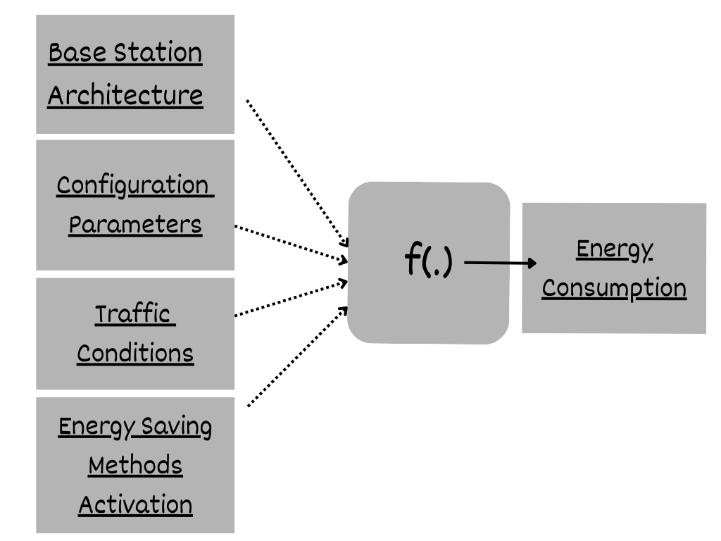
FIGURE 1.1: Conceptual Representation of Factors Influencing Energy Consumption in 5G Base Stations
The Figure 1.1 shows that the 5G base station energy consumption can be modeled as a functional of various interdependent components. These are base station architecture, configuration settings, traffic settings and enabling energy saving mechanisms. Hardware characteristics of the hardware used to design an architectural part include the antenna system and radio units. Such parameters as transmission power, operating frequency, and bandwidth allocation are included as configuration parameters. Traffic conditions are changes in the load of a network dynamically in time, whereas energy-saving techniques are operational modes that are applied during the reduction of unwarranted power consumption.
The function f(.) distinguishes the predictive modeling framework as a result of the interactions between these cause and effect that is quite complex and non-linear in nature and this is represented via f(.) in the figure. The model uses this information to learn the relationship between different operational conditions and predicts the amount of energy consumed in different conditions based on the real world data. The proposed machine learning based prediction and optimization system in this project is based on this conceptual framework.
A lot of preprocessing was done to address the missing and the exceptionally large values, normalized the numbers attributes as well as coded the categorical values. Predictive performance was improved by applying advanced feature engineering methods. These were time based characteristics, lag variables, rolling statistics and smoothing signals through filtering methods and periodic encoding to detect cyclical characteristics in network activity.
A number of machine learning models were experimented and compared. These included:
- TabTransformer for handling categorical feature interactions
- TabNet combined with XGBoost for attention-based learning on tabular data
- Deep neural network models implemented using Keras
- FastAI tabular learners
- Gradient boosting methods such as XGBoost
Although these models showed competitive output, the Random Forest Regressor consistently showed better output in terms of prediction accuracy, robustness, and time stability in terms of results during the time-series validation. This capability to support non-linear relationships, mixed types of features and engineered time-related features made it especially well-suited in this purpose.
The last model was found to be having a high predictive performance and a high degree of generalization, which makes it reliable in predicting hourly base station energy. Based on these forecasts, it is possible to suggest such intelligent energy optimization techniques as dynamic power modulation and adaptive configuration control.

1.2.5 Scope of the Project
This project covers the following scope:
- The 5G base station hourly energy consumption predictive modeling.
- Using machine learning to process structured telecom data.
- Determination of vital energy-driving forces.
- Prototyping of energy prediction system.
The project is not real-time deployment in an actual live telecom infrastructure but is designed as a research level outlay that can be furthered in the industry to be applied to other industries. Future developments can involve real time adaptive optimization, network management system interoperability and support to 6G conditions.

1.2.6 Organization of the Report
The rest of this report will be structured as follows:
- Chapter 2 – Literature Review: Reviews the current literature on energy efficiency wireless networks and machine learning application in telecom energy management.
- Chapter 3 – Proposed Methodology: This section will outline the dataset, preprocessing techniques, feature engineering methods, model development and system architecture.
- Chapter 4 – Results and Discussion: The chapter gives results of the experiment, metrics of evaluation, comparison of the performance with the predictive models analysis.
- Chapter 5 – Conclusion and Future Scope: Provides a concluding statement of the gains of the project, limitations, and future research opportunities.

CHAPTER 2
LITERATURE REVIEW

2.1 Overview
Telecommunications in the modern world has been altered owing to the rapid deployment of fifth-generation (5G) wireless networks with high data speeds, low-latency communication, and high levels of connectivity. However, besides these technological benefits, there is a major problem that is energy consumption. A study by organizations such as the International Telecommunication Union indicates that the device setup, the level of deployment density, and the amount of traffic placed on it have a significant influence on the amount of energy consumed by the 5G infrastructure.
Most of the energy involved in the Radio Access Network (RAN) goes to the base stations which, in most cases, has been referred to in the literature as the biggest share of energy in the network. The optimization of power consumption is important to sustainable telecommunications with network operators deploying elaborate antenna designs and dense cell patterns.
This chapter analyzes previous studies on:
- Energy consumption behaviour in 5G networks.
- The comparison with previous generations (4G/LTE) is unlike.
- Base station factors that influence the amount of power consumed.
- Algorithms of modeling and machine learning.
- Green networks utility deployment techniques.
2.2 Energy Consumption Characteristics of 5 G Networks.
Research has it that 5G energy consumption is dynamic rather than being static. Unlike legacy networks, 5G base stations reconfigurate their power consumption dynamically based on signal processing load, antenna operation, and load.
The last studies revealed that:
- The higher the user load, the higher the amount of energy consumed.
- Still, idle power consumption is high due to signaling.
- Hardware configuration has a great influence on efficiency.
- Itu technical publications claim that efficient energy management practices are necessary since power use does not reduce in line with reduction of traffic.

2.3 Key Characteristics of 5G Energy Consumption

TABLE 2.1 Factors Affecting Energy Consumption
Factor | Effect On Power Usage
Traffic Load | Higher Throughput Increasing Processing Energy
Antenna Count | Massive MIMO increases hardware energy demand
Frequency Bands | High-frequency operation raises signal processing cost
Deployment Density | More base stations increase network energy footprint

2.4 Comparing the Energy Efficiency of 4G and 5G
There exists an enormous literature comparing current 5G implementations and LTE (4G) networks. The more complex equipment introduced by 5G is represented by massive MIMO arrays and beamforming radios, but it also uses far less energy per transmitted bit.
However, the general energy consumption is generally increased due to:
- A rise in the need for data
- High concentrations of tiny cells.
- Complexity of processing increases.
Consequently, despite the technical efficiency of 5G, networks are transmitting a lot more data, and this increases the total energy usage.

2.5 Energy Comparison of Network Generations

TABLE 2.2 4G VS 5G
Feature | 4G (LTE) | 5G
Energy Per Bit | Higher | Lower
Hardware Complexity | Moderate | Hard
Network Density | Low | High
Total Energy Usage | Lower | Higher

2.6 Elements Affecting Base Station Power Usage
Many important factors that affect base station energy consumption are commonly found in research:
- Multidimensional signal processing.
- The number of used antennas.
- Demand and traffic of the user.
- Parameters of radio setup
During periods of idleness, base stations are rather energy-consuming since the control signaling and synchronization should not be turned off. Thus, the standards bodies like the 3rd Generation Partnership Project have suggested energy-saving features like using micro-sleep modes and antenna muting.

2.7 Modeling Techniques for Energy Efficiency
Modeling power consumption is one of the most important steps in the optimization process. Earlier work has suggested both the use of analytical and machine learning-based approaches.
Models of Analysis
- The traditional models estimate energy by the following:
- Levels of throughput
- Power transmission
- Antenna configuration.
Even though the results obtained by them can be interpreted, they struggle to discover nonlinear patterns.
According to recent studies, the complex relationship between the network parameters and energy consumption is recapturable through machine learning algorithms.

The characteristics used in these models include:
- Patterns of traffic load
- Use by time of day
- Configuration of the base station
- Environmental states
.
2.8 Modeling Techniques in Literature

TABLE 2.3 Limitations And Advantages Of Different Models
Model Type | Limitations | Advantage
Analytical Models | Interpretable, simple | Poor At Non-Linear Predictions
Regression Models | Moderate Accuracy | Sensitive To Feature Scaling
Tree-based Ensembles | High accuracy | Less interpretable
Deep Learning Models | Capture complex patterns | Requires Large Datasets

2.9 Energy Forecasting using Machine Learning
The use of machine learning to predict telecom network is a trend being popular as per the recent research. Random Forest, XGBoost, LightGBM and LSTM net algorithms are commonly evaluated in terms of energy forecasting applications.
Critical conclusions are:
- Feature engineering frequently outperforms complex systems in terms of performance improvement.
- On structured datasets, ensemble approaches consistently yield good results.
- improve prediction quality.
Given that ensemble techniques employing engineered features yielded exceptionally high predicted accuracy, your project is consistent with these findings.

TABLE 2.4 Strengths Of Different Models
Model | Typical Strength
Random Forest | Robust and stable predictions
Gradient Boosting | High accuracy with tuned parameters
LSTM Networks | Effective for temporal dependencies
Hybrid Models | Combine temporal and tabular strengths

2.10 Green 5G Network Deployment Techniques
Several tactics are suggested by researchers to lower network energy consumption:
- Switching between base stations dynamically
- Sleep modes that consider traffic
- AI-powered load distribution
- Choosing gear that uses less energy
Combining these strategies can dramatically lower network power consumption without sacrificing service quality, according to simulation studies and field observations.
2.11 Patterns of Energy Use in Urban and Rural Areas
Energy use varies significantly by geographic environment, according to field measurements:
- Because of the increased traffic density, urban stations need more energyUnderutilization causes energy waste at rural stations.
- Therefore, compared to uniform models, location-aware models offer more accurate energy projections.

2.11.1 Urban vs Rural Consumption Trends

TABLE 2.5 Urban Vs Rural Consumption Comparison
Environment | Key Challenge | Optimization Approach
Urban Areas | High load | Traffic Adaptive Scheduling
Rural Areas | Underutilization | Dynamic power scaling

2.12 Identification of Research Gaps
Several gaps are revealed by the reviewed literature:
- Lack of generalized models across multiple base station types
- Absence of generalized models for many types of base stations
- Predictive modeling and feature engineering are not fully integrated.
- Real-time, flexible forecasting systems are required.
- Inadequate comparison between ML and DL methodologies
By creating feature-rich datasets and methodically assessing several model classes, your project fills up these gaps.

2.13 Literature Review Synopsis
Combined, it can be seen that the reviewed literature demonstrates that 5G network energy efficiency is a complicated problem that depends on traffic dynamics, the network configuration, hardware design, and intelligent optimization approaches.
ML-based models have shown much promise with regard to making the appropriate prediction of the energy consumption, placed in the context of using ensemble methods and designed traits. The studies that should be carried out in the future should however focus on the realtime adaptive systems which are capable of generalizing themselves in different deployment environments.
The theoretical basis of the proposed research is built in this chapter, as well as the importance of predictive modeling in making the next-generation networks energy-saving and sustainable.

CHAPTER 3
PROPOSED METHODOLOGY

3.1 Overview of System Implementation
The proposed system implementation step is aimed at the creation of an efficient machine learning pipeline of 5G base stations energy consumption prediction and optimization based on engineered telecom data.
The system combines data cleaning, feature engineering, benchmarking of models, ensemble learning, and final models deployment in a workflow. This project involves focusing on the time-series feature engineering, signal processing method, and the sophisticated ensemble modeling in order to correctly predict the energy usage patterns at various base stations and in various conditions over time, as compared to the traditional prediction systems.
It has been implemented with Python-based machine learning frameworks and run in a controlled experimental setting in order to guarantee reproducibility, scalability, and model reliability.

3.2 Development Environment and Tools

3.2.1 Programming Language

Python is a machine learning and data science ecosystem that was chosen strategically. It was based on its high readability and excellent libraries such as scikit-learn, pandas and NumPy. Development of specialized systems such as TensorFlow and PyTorch facilitated the use of deep learning. Such an integrated environment simplified the development, reduced the integration problems and used the support of the community. Python therefore provided an effective and current system construction.

TABLE 3.1. Libraries and Frameworks Used
Category | Tools Used | Purpose
Data Processing | Pandas, NumPy | Data cleaning and transformation
Visualization | Seaborn, Matplotlib | Exploratory analysis
Machine Learning | Scikit-learn, XGBoost, FastAI, TensorFlow/Keras | Model training and evaluation
Signal Processing | SciPy | Feature smoothing and filtering
Deep Learning Backend | PyTorch (via FastAI) | Tabular neural modeling
Validation | Scikit-learn (KFold, Time Series Split) | Model validation

3.2.2 Execution Platform

The project was developed/executed using the Kaggle Notebook Environment and with the support of a GPU/CPU Hybrid Execution setup as it is a more powerful hardware, which thus greatly supported the machine learning models training process and the evaluation process of the models as well. This was a high-performance environment that was essential in managing the huge amount of computation and delivery of timely results. The data set contained more than 160 000 engineered samples, with a greater number of than 90 engineered features.

3.3 Dataset Acquisition and Integration

3.3.1 Dataset Sources

The data set utilized in this project has a variety of telecom data which are Base Station (BS) Data, Cell Load Data, Energy Consumption Logs and Network Configuration Data. The merging of these datasets was done according to similar keys like Time, Base Station ID (BS), and Cell Name. This merging has made it possible to produce a single rich feature data which can be used in model in machine learning.

TABLE 3.2. Dataset Characteristics
Parameter | Value
Total Samples | 160,000+
Features (After Engineering) | 90+
Target Variable | Energy Consumption
Data Type | Time-Series Telecom Data

3.4 Data Preprocessing Pipeline

3.4.1 Handling Missing and Inconsistent Values

In preprocessing, forward fill, interpolation and controlled imputation methods were used in handling missing values that occurred during lag and rolling feature generation processes. This methodological practice played a very important role in ensuring the integrity of data and making the following machine learning models to have as much predictive power as possible. Values that were extreme and infinite were identified and replaced to bring about numerical stability in model training.

3.4.2 Data Cleaning and Transformation
Preprocessing steps as follows were important:
- Elimination of superfluous columns (Time, CellName, etc.).
- Transformation of categorical telecom characteristics (RUType, Mode).
- Numerical variable normalization.
- Lag features create NaN values which need to be dealt with.
- Ranking data in time-series integrity.
This preprocessing helped a lot in enhancing the stability of models and minimizing noise during training.

3.5 Advanced Feature Engineering Implementation
The main asset of this project was feature engineering and it made this project to have a high predictive accuracy level particularly by converting raw data into meaningful inputs which enhanced the model performance and generalization significantly.

3.5.1 Time-Based Feature Extraction
The subsequent features were obtained to identify the time variations in energy use: Hour of Day, Day of Month, Weekday Number as well as Cyclical Hour Encoding based on Spline Transformer. The cyclical spline transformation was particularly used to conserve the natural periodic activity which can be witnessed in the energy use patterns on a daily basis, which is essential in proper forecasting and modeling.

3.5.2 Lag Features (Temporal Memory Modeling)
Lag features were created to capture the past history behaviour into the prediction model: Energy Lag (1 hour, 3 hours, 6 hours, 24 hours), Load Lag Features and ESMode Historical Values. Such characteristics as Energy_lag_1 (Energy at t-1) and Energy_lag_24 (Energy at t-24) allow the model to acquire temporal correlations and repetitive consumption patterns.

3.5.3 Rolling Statistical Features
To evenly spread out noise and extract patterns of trend, rolling window statistics were calculated, and Rolling Mean Energy, Rolling Maximum Energy, Rolling Minimum Load and Rolling Window statistics were calculated over 3, 6, 12 and 24 hours, all good exercise that made the model robust to short-term fluctuations.

3.5.4 Signal Processing Features
In order to sharpen telecom load signals, state-of-the-art filtering was used:
- Savitzky-Golay Filter (Load Smoothing & Derivatives)
- Butterworth Filter (Noise Reduction)
- Load Gradient and Differential Features.
The methods aided in deriving concealed designs of noisy telecommunications signals.

3.5.5 Interaction and Derived Features
Further domain specific characteristics were developed to enhance the model learning performance such as Load × Antennas Interaction, Energy Efficiency Metrics, Load Change Rate, and Load Binning to represent loads as categorical values and this multi-level feature engineering gave great gains.

3.6 Model Development and Benchmarking Strategy
Various machine learning and deep learning models including the different neural network structures and classical algorithms were constructed and later evaluated rigorously. Such extensive measure was to ensure the most suitable predictive model in this complicated classification process was identified and picked according to performance measures.

3.6.1 Deep Learning Models Tested
The TabTransformer, FastAI Tabular Neural Network, and the Keras Multi-Layer Perceptron (MLP) were the models employed in order to model the nonlinear relationships in the tabular telecom data.

3.6.2 Ensemble Models Implemented

Enhancing the predictive accuracy substantially required an in-depth search in diverse ensemble models where single-model structures were no longer used. In particular, three different ensemble strategies were explored, including, first, a hybrid approach based on TabNet learning of features and XGBoost strong predictors on the output of the latter; second, an advanced one, where Keras deep learning model output is used as the input to an XGBoost meta-learner; and third, a smart combination of FastAI models and a Keras-written model. The essence was that the effective capturing of the features of neural models is to be joyfully combined with a powerful generalization and performance of tree-based algorithms such as XGBoost. Such a combined strategy eventually brought a significant increase in predictive accuracy.

3.7 Final Model Selection: Random Forest
Random Forest has been chosen as the final model to be used following several experiments because it performs better when using engineered tabular data.

Reasons for Selection:
- Manages nonlinear telecommunication information.
- Robust against overfitting
- Exceptional use of lag and roll performance.
- Large interpretability through feature significance.
- Constant performance over time-series validation.
The model had almost perfect predictive ability because of solid structured associations in engineered features.

3.8 Training and Validation Methodology

3.8.1 Cross-Validation Strategy

A broad range of validation methods was used to strictly determine the performance of the model and make sure the model is capable of a sound generalization. It involved K-Fold Cross Validation, in this case, 5-fold, in order to assess the uniformity of the model in varying processes of the information. Moreover, since the data in it is time-based, Time-Series Cross Validation was carried out to ensure the chronological order of training and testing. Lastly, testing apparently an out of distribution test which is known as Distant Future Testing was done to ensure that indeed the model was not given a one-sided evaluation as to whether it did not overfit the data to certain future temporal data with no prior data as it was originally supposed to do.

3.9 System Architecture and Workflow
The entire system workflow is made up of the following phases:
- Data Collection and Merging
- Data Preprocessing
- Feature Engineering
- Model Training
- Model Evaluation
- Prediction Generation
- Output Export (CSV)

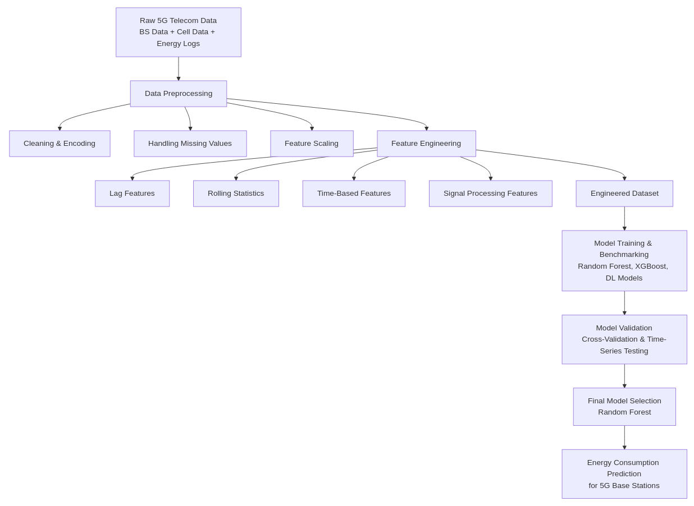

FIGURE 3.1. System Architecture

3.10 Implementation Challenges and Solutions
There are various obstacles that were experienced during the project. These were controlling the risk of NaN explosion in the generation of lag features, controlling the risk of data leakages that occurred due to time-series modeling, managing the issue of model instability that occurred due the utilization of crude preprocessing methods, and effectively operating at the high-dimensional feature space.
The measures that were taken comprised controlled imputation plans, time-sensitive dataset separation, validation of feature significance, and powerful group benchmarking. These methodological enhancements proved very very instrumental towards not only improving the predictive quality of the end model, but also improving its interpretability.

3.11 Output Generation and Deployment
The last step was to create Predicted Energy Consumption based on the trained model on unknown data. The findings, such as the Base Station ID and the prediction are sent out as an easily digestible CSV file. Importantly, the scaler, the data on feature importance and the trained model files were all saved. This guarantees auditory reproducibility and eases further implementation into production or real-time systems.
CHAPTER 4
RESULTS AND DISCUSSION

4.1 Introduction
The chapter provides the experimental findings of the proposed energy consumption prediction framework of 5G base stations. The aim of the experiments was to compare various machine learning and deep learning methods, learn the effect of feature engineering, and determine which model was the most reliable to apply in practice.
They did a systematic evaluation procedure which involved model comparison, feature importance analysis, time-series validation and testing on unseen future data. The discussion is aimed at learning model behaviour in verbal form instead of documenting numerical performance only.

4.2 Experimental Setup
The experiments were conducted on a combined set of hourly base station records (network load, configuration parameters, energy-saving modes, and measured energy consumption) of the merging dataset. The resulting dataset, which was produced after preprocessing and feature engineering, comprised around 160,000 records, and it had almost 90 informative features.

4.2.1 Feature Engineering
In order to generate temporal and operational behaviour of base stations, the following feature engineering strategies were introduced:
- Mining of time related features like hour, day and weekday.
- Periodic cyclical time spline transformations.
- Lag characteristic of historical values of energy and load.
- Sliding statistical characteristics (mean, max, min).
- Signal smoothing with Butterworth and Savitzky Golay filter.
- Combination characteristics of interaction parameters inserting load and hardware parameters.
- Elimination of low-value and high-sparsity features.
These artificial features contributed a lot in enhancing the capability of the model to generate temporal dependencies.

4.3 Evaluation Metrics
Given that the issue is a regression task, the evaluation of performance was made through:
- Mean Absolute Error (MAE) – mean true value versus predicted value.
- Root Mean Squared Error (RMSE) – puts more weight on larger prediction errors.
- Mean Absolute Percentage Error (MAPE) – relative measure of error.
- Coefficient of Determination (R²) – explicates variance included by the model.
Also, time-series cross-validation and distant-future testing were conducted as an embodiment of robustness and to ensure against temporal leakage.

4.4 Model Comparison

4.4.1 Deep Learning and Hybrid Models
First a few sophisticated models were tested:
TABLE 4.1. Model Performance Comparison.
Model | MAE | MAPE | Accuracy (Approx.)
TabTransformer | 3.3257 | 0.1289 | 87.11%
TabNet + XGBoost | 2.7663 | 0.1074 | 89.26%
Keras + XGBoost | 2.6161 | 0.1081 | 89.19%
FastAI + Keras | 3.3307 | 0.1352 | 86.48%
These models are not very sensitive to preprocessing and hyperparameter settings even though they captured nonlinear relationships.

4.4.2 Traditional Machine Learning Models
Classical machine learning models were benchmarked following the enhancement of feature engineering.
TABLE 4.2.Evaluation Metrics of Traditional Machine Learning Models.
Model | Test RMSE | Test MAE | Test R²
Random Forest | 0.4853 | 0.1119 | 0.9990
Gradient Boosting | 0.5215 | 0.2843 | 0.9988
XGBoost | 0.5288 | 0.2905 | 0.9988
LightGBM | 0.5823 | 0.2965 | 0.9985
Linear Regression | 2.0389 | 1.1211 | 0.9820
Random Forest was the highest performer with high predictive stability and minimum error.

4.5 Random Forest Model Analysis
Random Forest is an ensemble method that utilizes multiple decision trees, and works by building multiple decision trees using randomly sampled data. The trees would learn their own relationships and the end predictions would be obtained by averaging the outputs of the trees. This avoids the overfitting characteristic of a single decision tree that it tends to have, and results in more stable results and improved generalization.

This randomness is done through bootstrap aggregating (bagging) to choose data, and at every split random feature selection. Bagging uses a wholly random sample of training data. This is so that the trees are trained using separate datasets. Random Forest uses only a random sample of features in case of a tree being constructed. This correlates the trees, and this makes the model very strong. Majority voting is the last classification prediction; and it is average individual tree predictions in case of regression. Random Forest is a very popular algorithm, which is due to its effectiveness.
The model was successful since:
- It was naturally capable of working with a variety of features.
- The use of random feature selection eliminated correlation of models.
- Prediction averaging reduced overfitting.
- The nonlinear elements between load, time and configuration parameters were well captured.
Random Forest became very appropriate with complex energy consumption trends.

4.6 Feature Importance Analysis
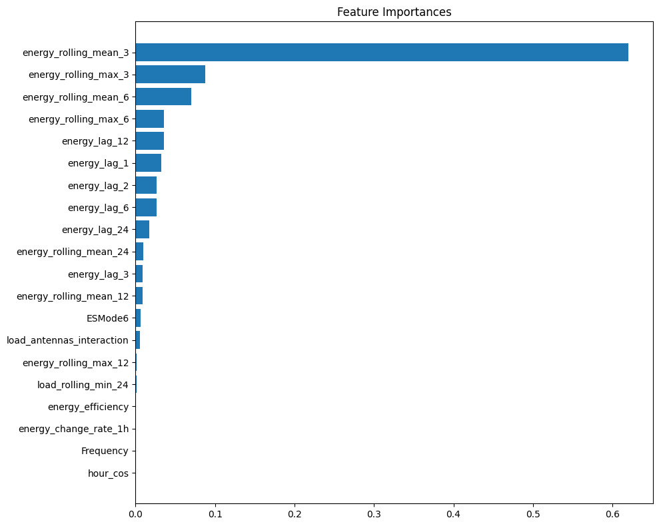
The importance of features analysis revealed that historical energy features were the most important predictors.

Figure 4.1. Feature Importance Plot.
The most donating features were:
- energy_rolling_mean_3
- energy_rolling_max_3
- energy_lag_1, energy_lag_2, energy_lag_6
- energy_rolling_mean_6
- load interaction features
These characteristics prevailing prove that short-term temporal memory is one of the key factors that determine energy consumption.

4.7 Validation and Generalization Testing

4.7.1 Feature Dependency Testing
To confirm the reliability of the models, experiments were conducted with and without features derived by energy.
Findings demonstrated that a significant decrease in performance was observed when historical energy characteristics were eliminated, meaning that the model does not memorize information, but learns useful temporal-dependency relationships.

4.7.2 Time-Series Cross Validation
Cross-validation was found to be time-aware:
- Average R² ≈ 0.9849
- Low variance across folds
This means that there are regular performances across time intervals.

4.7.3 Distant Future Testing
The model was trained using the past time windows and assessed using future unknown time.
Results:
- Train R² ≈ 0.9992
- Test R² ≈ 0.9952
These findings show high generalization ability to make predictions on the real world.

4.8 Actual vs Predicted Energy Analysis
4.8.1 Scatter Plot Analysis
This visual evaluation of the model performance is through the scatter plot comparing actual and the predicted energy values. Preferably, predictions are supposed to be on the diagonal reference line, which is perfect prediction.
The results are plotted and the result indicates a strong alignment along the diagonal line, which implies that the model prediction was in agreement with the actual measurements of energy.
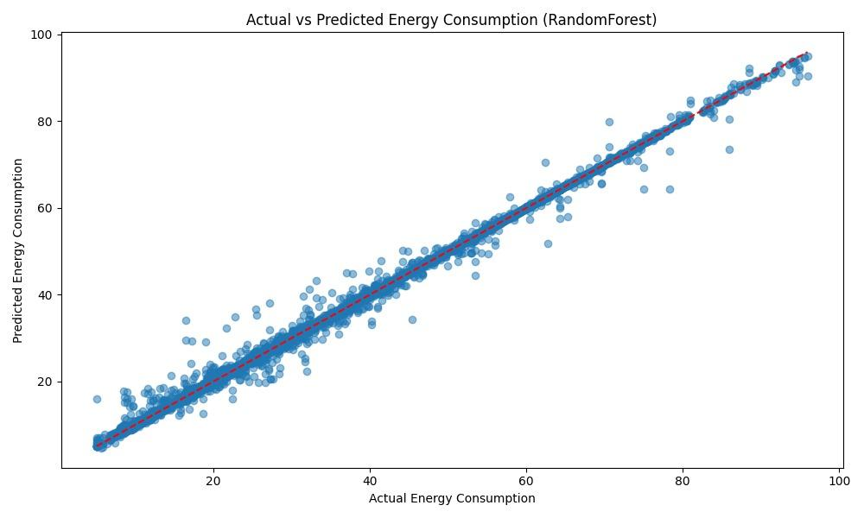
Figure 4.2. Actual vs Predicted Energy Consumption (Scatter Plot).
Key observations include:
- The forecasts are close to the optimal diagonal line.
- There is low error distribution in the various energy ranges.
- The number of outliers is very few.
These results affirm that the random forest model is a successful model to represent underlying energy consumption trends.
4.8.2 Time-Series Prediction Analysis
Although the scatter plot can be used to judge overall accuracy, it is also possible to analyse predictions with time to determine the stability and predictability of the model in time.
Time-series comparison reveals that forecasted values are much closer to the actual energy trends over the course of the test, which means that the model can trace the fluctuations in the time.
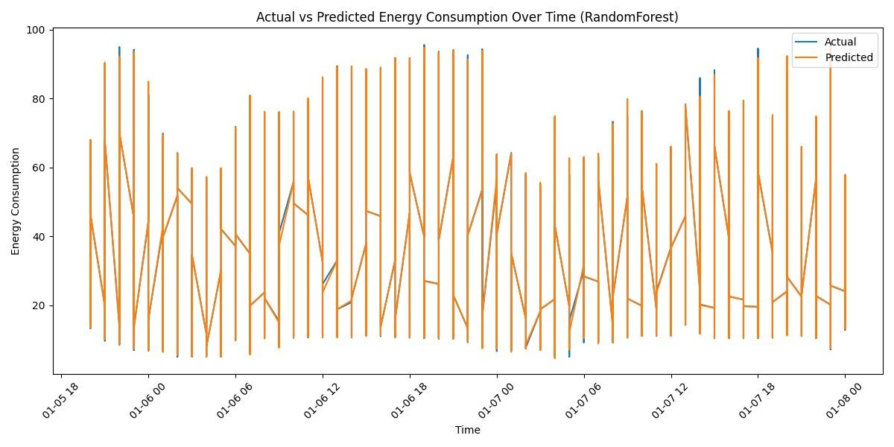

Figure 4.3. Actual vs Predicted Energy Consumption Over Time.
The fact that the actual and predicted curves are too close to each other implies:
- Effective temporal generalization.
- Constant operation on different loads.
- Minimal delay in response time in prediction.
4.8.3 Feature Relationship Analysis
The ability to know the correlation between engineered features is useful in understanding the behavior of a model and contribution by features.
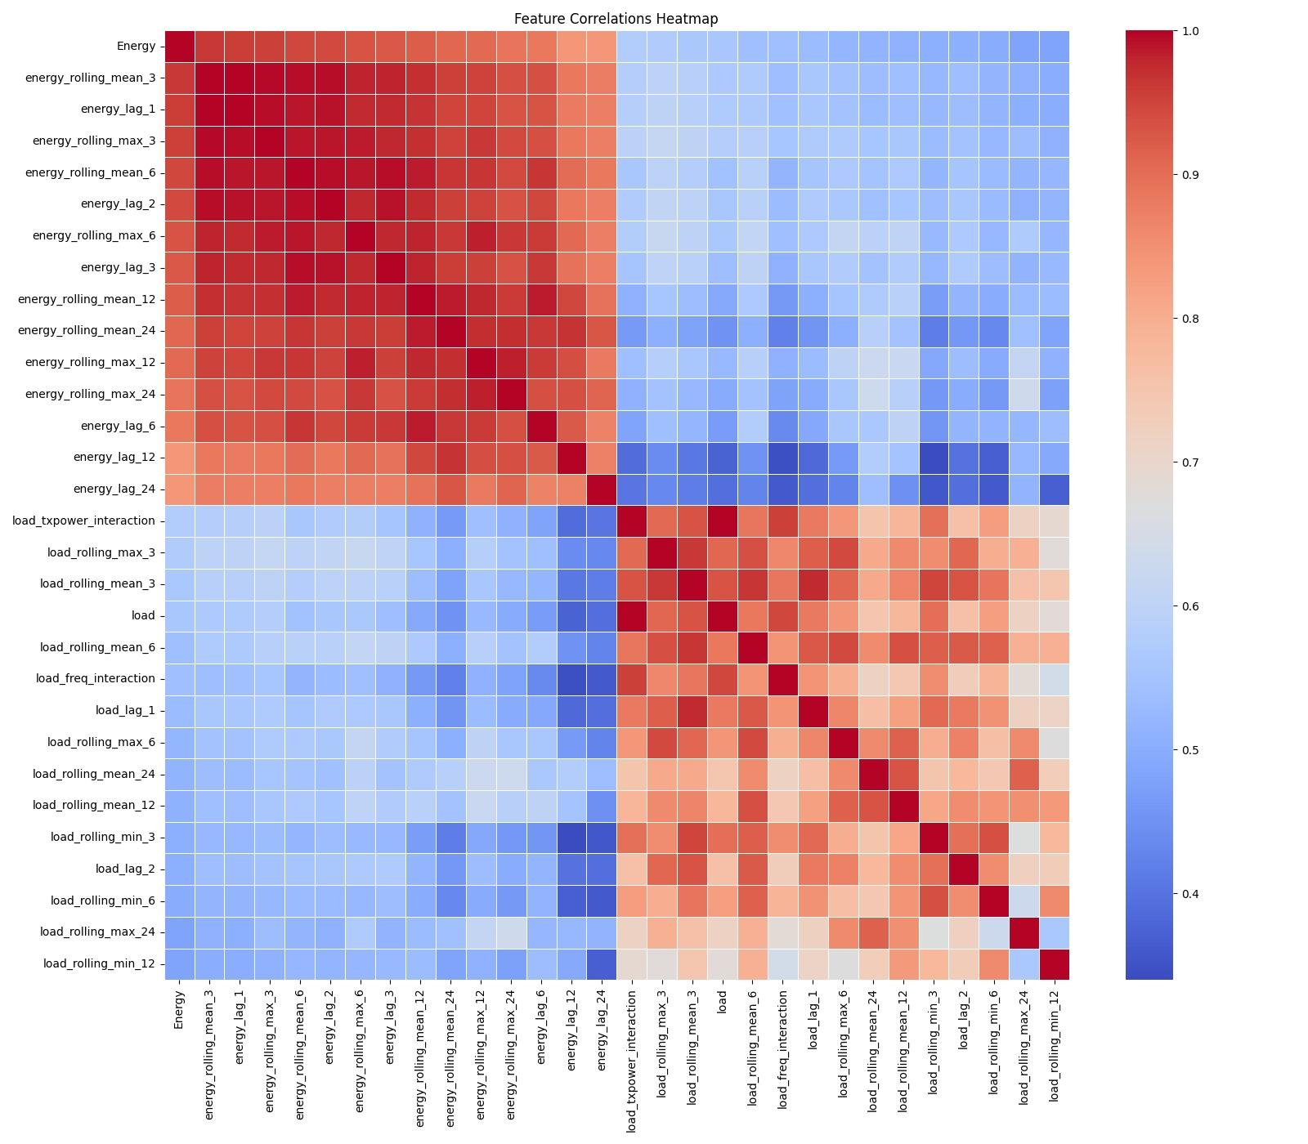Figure 4.4. Feature Correlation Heatmap.
The heatmap shows associations between time and energy-based features, which allow considering feature engineering as the key to the enhancement of prediction performance.

4.9 Discussion
Based on the experiments, a number of insights have been realized:
- The model complexity had a lesser contribution to the performance improvement when compared to feature engineering.
- Temporal and rolling characteristics showed a great deal of improvement in predicting.
- The ensemble tree-based models performed better when compared to the deep learning models in this tabular data.
- Random Forest was accurate and its interpretation and stability were high.
The presented framework, on the whole, is able to model the trends in energy consumption in 5G base stations and is highly applicable in practice.

CHAPTER 5
CONCLUSION AND FUTURE SCOPE

5.1 Conclusion
In this project, they provided an entire machine learning architecture in predicting energy use in 5G base stations. The experiment was a combination of domain knowledge, widespread feature engineering, and model benchmarking to develop a predictive system which was reliable.
Its significant accomplishments are:
- Merging and pre processing several network data sets.
- Construction of time and statistical characteristics which mirror energy behaviour.
- Comparison of deep and classic machine learning models.
- Strict validation in terms of time-series cross-validation and future period testing.
Random Forest provided the highest accuracy and good generalization on unseen data when compared to other models, and thus it was the best among all models.
The paper establishes that energy in contemporary cellular networks is exceptionally reliant on temporary dynamics and interaction of network loads.

5.2 Contributions of the Work
The main deliverables of this project are:
- End to end energy prediction pipeline development.
- Evidence of the significance of feature engineering when tackling a tabular time-series problem.
- Checking of strong model performance without having to use excessively complex architecture.
- Distribution of a scalable structure that can be used in sustainable energy management.

5.3 Future Scope
This work can be further improved by a number of directions:
- Deep Learning Models in sequence
Application of LSTM or GRU models to longer temporal dependencies.
- Advanced Ensemble Stacking
Meta-learning with Random Forest, XGBoost and LightGBM.
- Real-Time Deployment
Connection to network monitoring systems of live energy forecasting.
- Feature Optimization
Eliminating unnecessary complexity of models by choosing the best ranking features to infer with.
- Adaptive Energy Control
Predictions can be used to automatically optimise energy saving modes in live networks.

5.4 Final Remarks
This project shows that to construct efficient machine learning systems, one needs to be careful in data preparation, meaningful feature engineering, and systematic validation. The model developed is not only well-performing in terms of prediction but also interpretable and scalable, which makes it an appropriate choice in future studies as well as application in the sustainable 5G network management.

REFERENCES
[1] C. M. Bishop, Pattern Recognition and Machine Learning. Springer, 2006.
[2] T. Hastie, R. Tibshirani, and J. Friedman, The Elements of Statistical Learning: Data Mining, Inference, and Prediction. Springer, 2009.
[3] A. Ge´ron, Hands-On Machine Learning with Scikit-Learn, Keras, and TensorFlow. O’Reilly Media, 2019.
[4] Scikit-learn Documentation. Available: https://scikit-learn.org/stable/
[5] Towards Data Science (Medium). Available: https://towardsdatascience.com/
[6] Analytics Vidhya. Available: https://www.analyticsvidhya.com/
[7] N. Gupta, et al., “Enhanced Virtualization-Based Dynamic Bin-Packing Optimized Energy Management Solution for Heterogeneous Clouds,” Mathematical Problems in Engineering, vol. 2022, no. 1, p. 8734198, 2022.
[8] D. Gupta, et al., “Energy saving implementation in hydraulic press using industrial Internet of Things (IIoT),” Electronics, vol. 11, no. 23, p. 4061, 2022.
[9] K. Sathya and D. R. Kumar, “Energy efficient clustering in sensor net- works using Cluster Manager,” in Proc. 2012 Int. Conf. on Computing, Communication and Applications, IEEE, 2012.
[10] R. K. Dhanaraj, et al., “Optimal clone attack detection model using an energy-efficient GSA based simulated annealing in wireless sensor net- works,” Asian Journal of Research in Social Sciences and Humanities, vol. 6, no. 11, pp. 201–217, 2016.
[11] A. Zappone, M. Di Renzo, and M. Debbah, “A Survey on Machine Learning for Energy-Efficient Wireless Communications,” IEEE Communications Surveys & Tutorials, vol. 21, no. 2, pp. 1435-1478, Second Quarter 2019.
[12] I. Chih-Lin et al., “Toward green and soft: a 5G perspective,” IEEE Communications Magazine, vol. 52, no. 2, pp. 66-73, Feb. 2014.
[13] G. P. Fettweis, “The Tactile Internet: Applications and Challenges,” IEEE Vehicular Technology Magazine, vol. 9, no. 1, pp. 64-70, Mar. 2014.
[14] F. Boccardi, R. W. Heath, A. Lozano, T. L. Marzetta, and P. Popovski, “Five disruptive technology directions for 5G,” IEEE Communications Magazine, vol. 52, no. 2, pp. 74-80, Feb. 2014.
[15] Y. Zhang, S. Fowler, and S. G. Srinivasa, “Predicting Power Consump- tion of Cellular Base Stations using Machine Learning,” in Proc. 2019 IEEE International Conference on Communications (ICC), Shanghai, China, 2019, pp. 1-6.
[16] J. Wu, Z. Zhang, Y. Hong, and Y. Wen, “Deep Reinforcement Learning for Energy-Efficient Networking in 5G-and-Beyond,” IEEE Transactions on Network and Service Management, vol. 18, no. 2, pp. 1108-1121, June 2021.
[17] E. Bjo¨rnson, J. Hoydis, and L. Sanguinetti, “Massive MIMO Networks: Spectral, Energy, and Hardware Efficiency,” Foundations and Trends® in Signal Processing, vol. 11, no. 3-4, pp. 154-655, 2017.
[18] S. M. B. H. Shah, K. M. R. Alam, and M. A. Gregory, “Energy Efficient 5G Cellular Networks: A Survey,” in Proc. 2019 International Conference on Electrical, Computer and Communication Engineering (ECCE), 2019, pp. 1-6.
[19] L. S. Van der Meulen, D. J. Van der Veen, and S. Pollin, “A Tutorial on Machine Learning for Energy-Efficient Networking in 5G,” IEEE Communications Surveys & Tutorials, vol. 23, no. 1, pp. 216-249, First Quarter 2021.
[20] R. Li, Z. Zhao, X. Zhou, J. Ding, Y. Chen, Z. Wang, and H. Zhang, “Intelligent 5G: When Cellular Networks Meet Artificial Intelligence,” IEEE Wireless Communications, vol. 24, no. 5, pp. 175-183, Oct. 2017.

APPENDIX 1
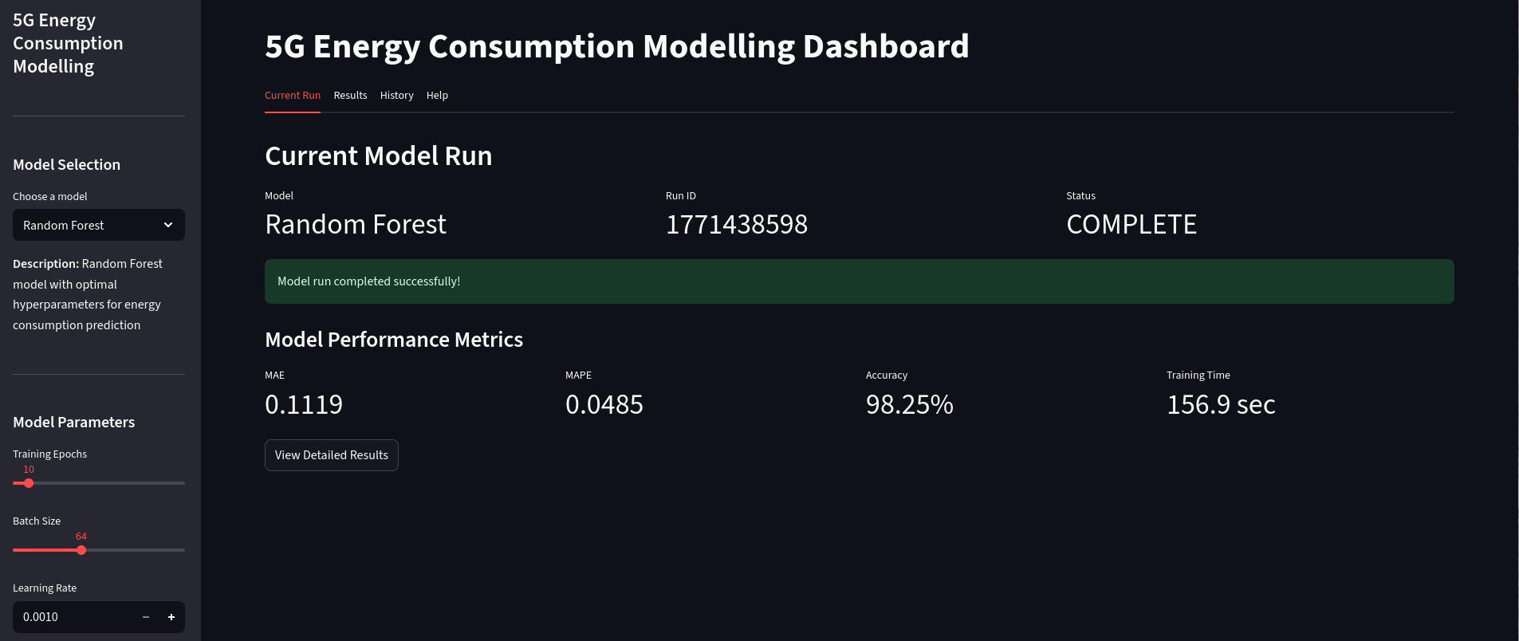
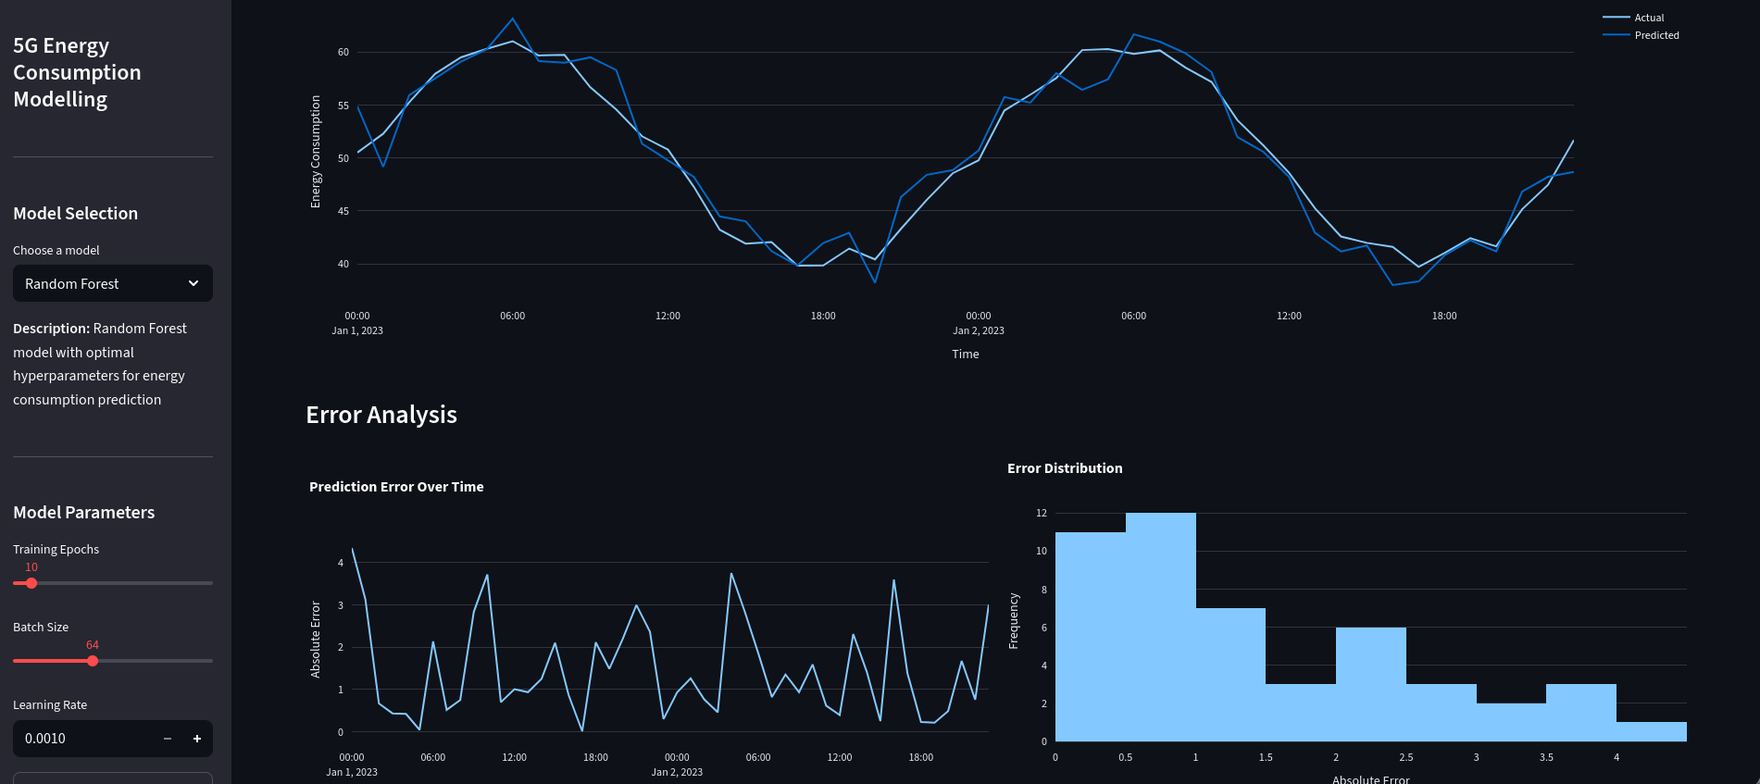
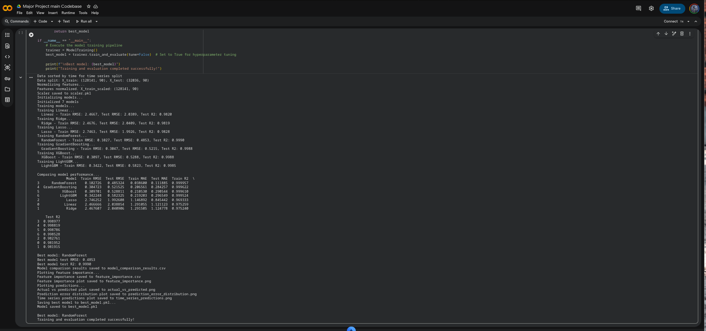
RESEARCH PAPER/PATENT



PROOF OF SUBMISSION/ACCEPTANCE/PUBLICATION


Link for Presentation certificates : - (ICAICCIT_0736)

PLAGIARISM REPORT


