connect Aayush/Aayush; //connection

create table emp(emp_id number(11),emp_name varchar(20),salary number(11),dept_id varchar(20),Primary key(emp_id)); //create table

desc emp; //describe table

desc dept;//describe dept

alter table dept modify(dept_id number(11));//alter table

subquerries :-

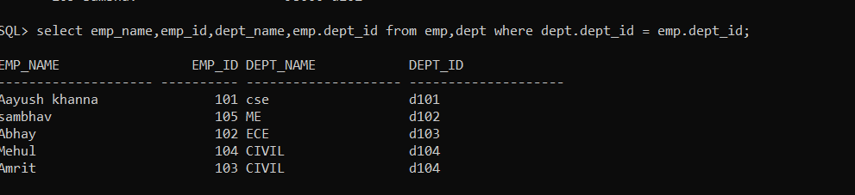

Or operator

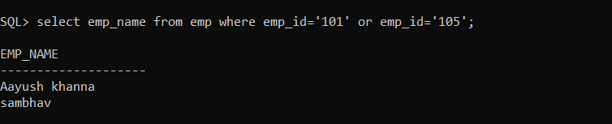

And operator

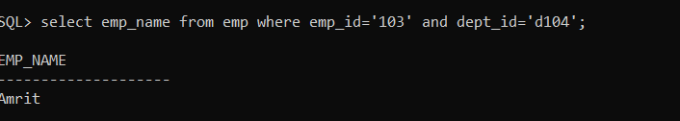

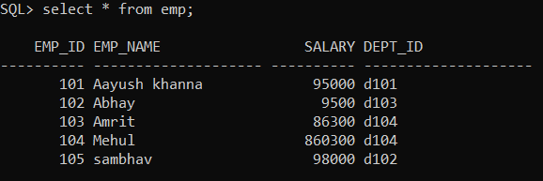

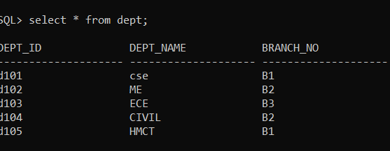

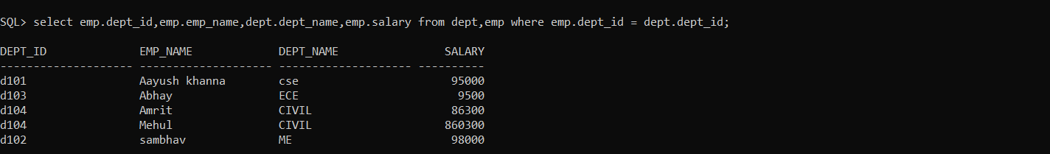

Correlated querry

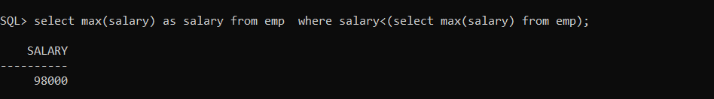

Multi column querry

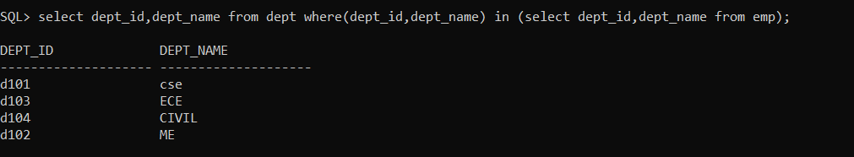

Sub querry with order by

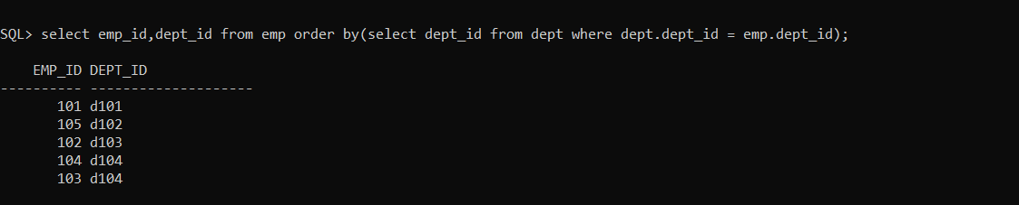

Inner join

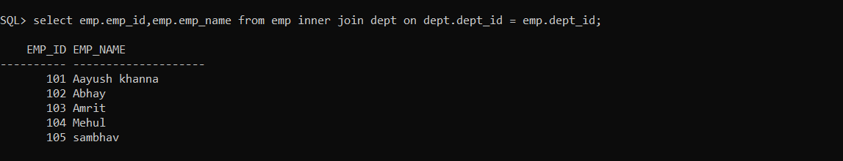

Inner join with where clause

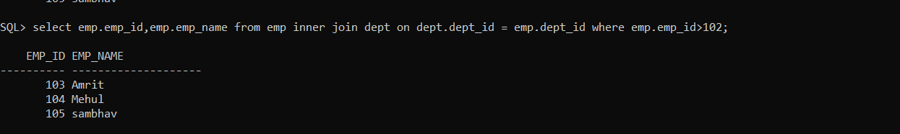

Outer join - Left

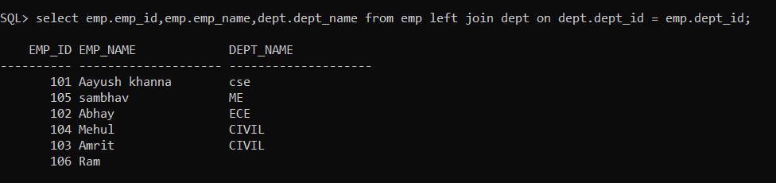

Right join

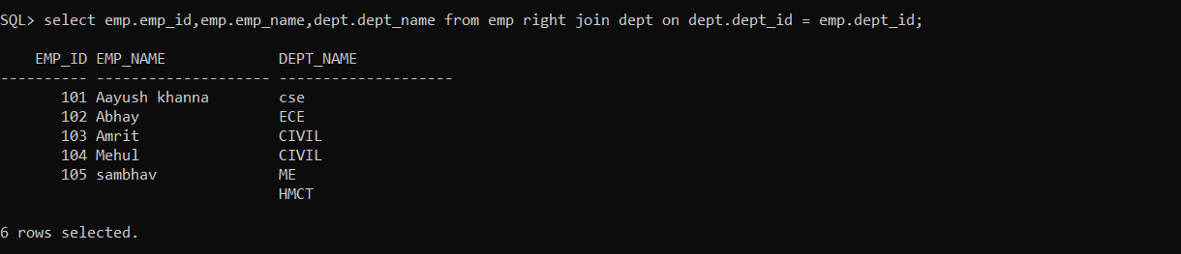

cross join

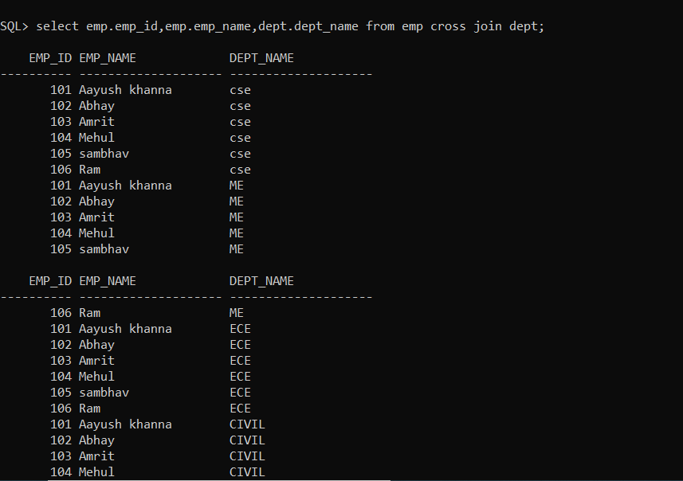

Self join

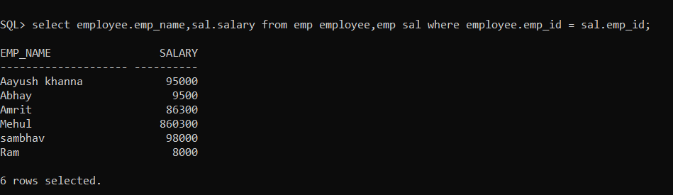

UNIONS

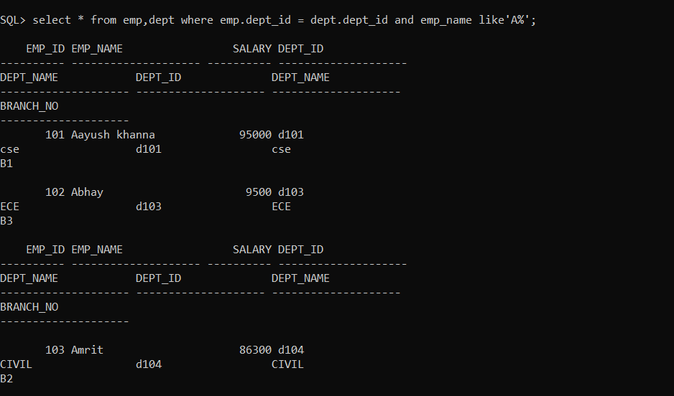

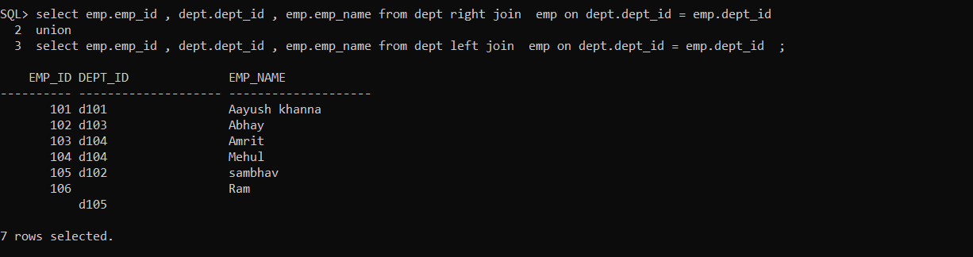

Full outer join / union

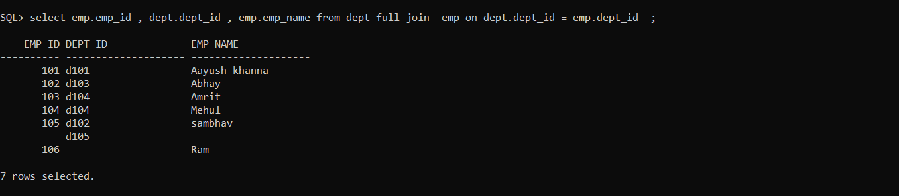

Intersection

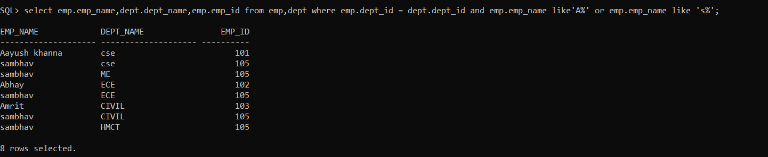

update



Left join

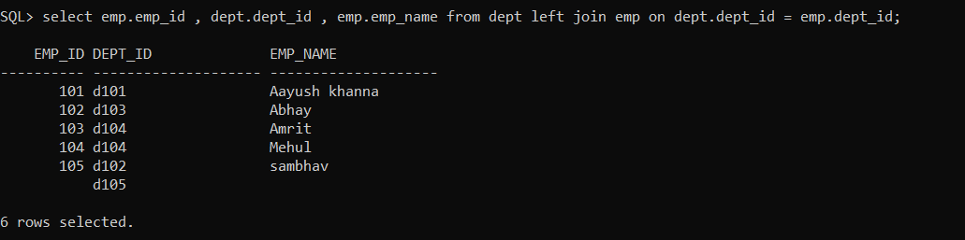

Left join with + operator

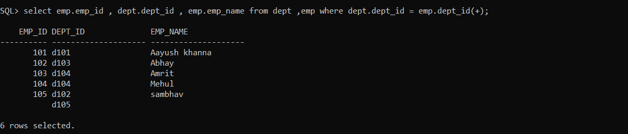

Jis side pe + lagaoge uski opposite wale table k records show hoyenge

Right join

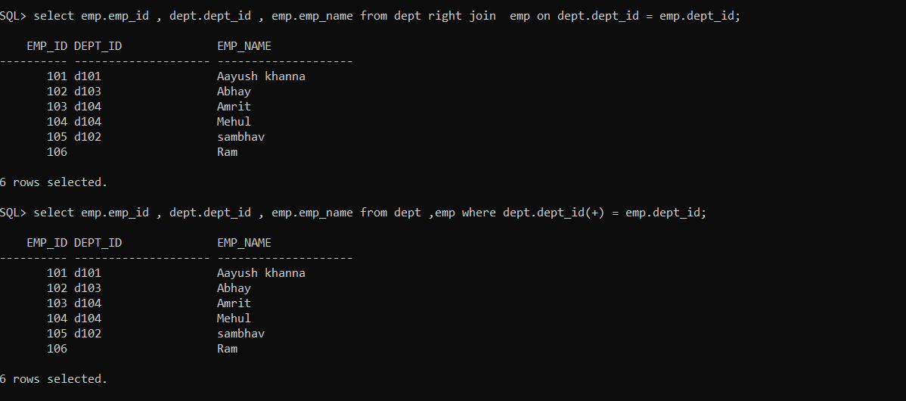

Both + and right join method

set linesize 100;