Teaching a machine to spot missing DNA — and catching the test that was too easy
How learning without answers made our deletion caller work from a handful of labelled examples — and why the more interesting result was a negative one
Igor Novikov (curator) · Ayush Kumar (team lead) · Nicolas Baranov · Alisa Chernysheva · Baowen Zeng 曾宝文 · Haoxin Bai 白昊欣 · Zicong Guan 关紫聪

In brief
Every human genome is missing chunks of DNA that other genomes have. Some of those missing chunks cause disease. Finding them in raw sequencing data is a decade-old problem, and since 2019 the standard approach has been to draw the data as a colour picture and hand it to an image-recognition neural network. We asked two questions. First: can a network learn what normal sequencing data looks like without being told any answers, so that it then needs far fewer labelled examples? Second — and this is the question that changed the paper — is the benchmark everyone uses actually hard enough to tell good methods from bad ones?
The answers were yes, and no. Pre-training without labels let our model reach an accuracy of 0.51 from just 210 labelled examples, where the same network trained the ordinary way managed 0.05. But twelve simple numbers you can compute with a pocket calculator, fed to a standard machine-learning method, beat every neural network on the same test. That is a negative result about the benchmark, not about the networks — and we think reporting it is more useful than another leaderboard entry.

The problem: reading what is not there
A genome is three billion letters long. A sequencing machine does not read it end to end; it shreds the DNA into tens of millions of short fragments of roughly a hundred letters each, reads those, and leaves you to work out where each fragment came from. Software called an aligner does that matching, pinning every fragment — a “read” — onto a reference copy of the human genome.
A deletion is a stretch of DNA, anywhere from fifty letters to hundreds of thousands, that a particular person simply does not have. Because the person does not have it, no read can come from it. The evidence is therefore indirect, and it arrives in three forms at once: a region where the pile of reads suddenly thins out or vanishes; pairs of reads that were cut from opposite ends of one fragment but land much further apart than they should, because the DNA between them is gone; and reads that straddle the boundary and get sliced in half by the aligner, matching cleanly on one side and not at all on the other.
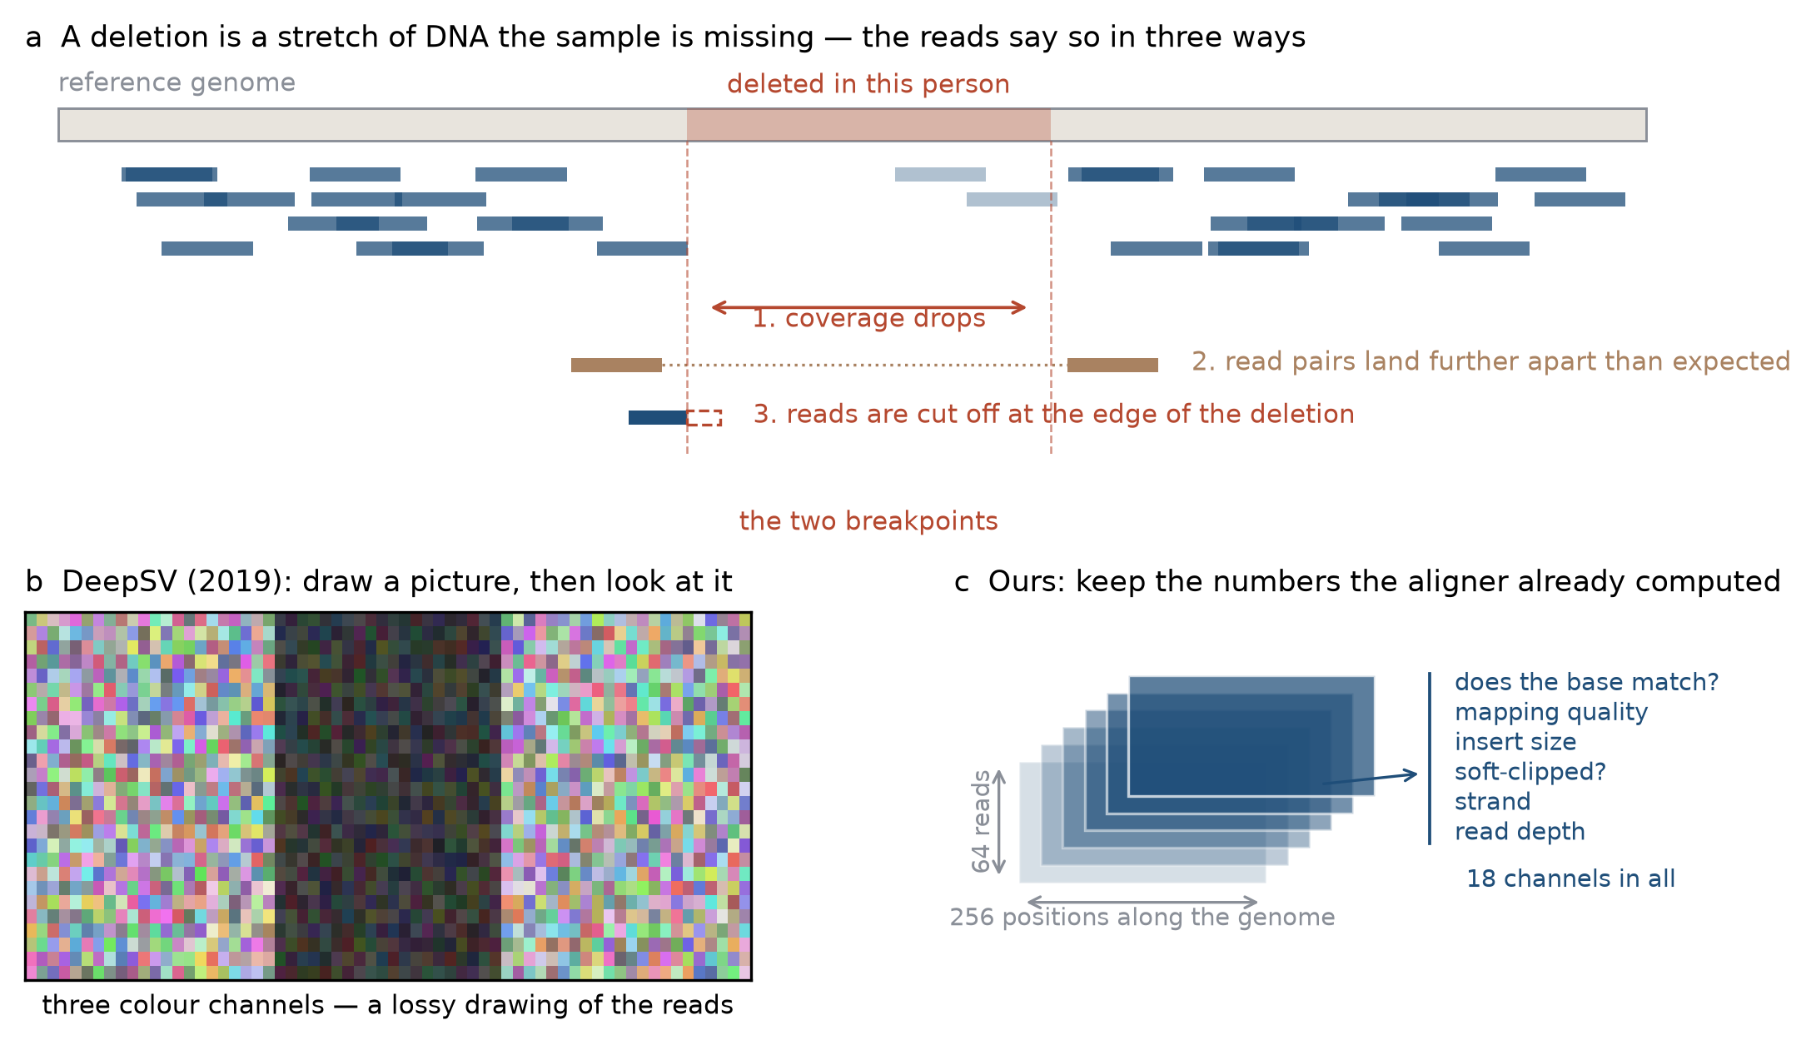
Figure 1. What a deletion does to sequencing data, and two ways of showing that evidence to a neural network. Panel a: reads thin out over the deleted stretch, paired reads land too far apart, and reads crossing the boundary are cut short. Panel b: the 2019 approach paints this into a colour image. Panel c: our approach keeps the numbers the aligner already computed, one layer per kind of evidence.
Deletions matter clinically. They are enriched among disease-causing variants, and collectively they change more letters of a genome than the single-letter typos that get most of the attention. They are also the hardest common class of variation to call reliably: different tools disagree with each other on the same data, and their confidence scores are rarely trustworthy enough to act on.

The same problem, stated mathematically
Take a window of the genome around a candidate site. Stack the reads that overlap it, one per row, and for each read record what the aligner already knows at each position: whether the base matches the reference, how confident the aligner is about where the read belongs, how far away its partner landed, whether it was cut short, which strand it came from, how deep the pile is. That gives a three-dimensional array of numbers — an alignment tensor:
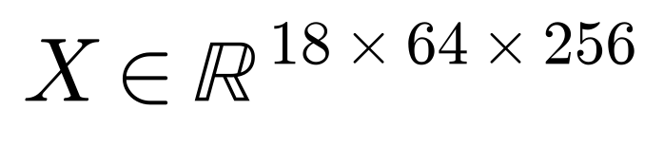
Eighteen kinds of evidence, sixty-four reads, two hundred and fifty-six positions. The task is then a function that maps this array to a single answer: is there a deletion here or not. Learning that function from examples is what the rest of this note is about.

What was already known, and what was wrong with it
In 2019 a paper called DeepSV made an influential move. Rather than hand-engineering rules about read depth and insert size, it rendered the pile of reads as an ordinary RGB image — base identity, base quality and strand encoded as colours — and trained an image classifier on it. It worked, and it started a whole family of “pileup image” methods that are still the mainstream today.
But that first move fixed three decisions that the field has largely inherited without re-examining:
- The picture is a human invention, not something the model learns. Whatever does not survive the translation into colours — the fine structure of insert sizes, the geometry of where reads got cut — is thrown away before the network ever sees it.
- Training needs a lot of labelled answers. Every new sequencing machine, coverage level, or population needs a fresh truth set, and reliable truth sets exist for only a handful of reference samples.
- The confidence numbers do not mean what they look like. A network that says “95 % sure” is not right 95 % of the time, which makes the output hard to threshold in a clinic.
Meanwhile, machine learning as a field had developed a direct remedy for the second problem: self-supervised pre-training. Show a model enormous amounts of unlabelled data, hide part of it, and make the model fill in what was hidden. To do that well it has to learn the structure of the data — and it can then be fine-tuned on a small labelled set. This is how modern language models are built. In genomics it has been applied to the reference DNA sequence, but essentially not to the alignment evidence that actually tells you a deletion is there.

What we did and what we found

Learning without answers
We built the alignment tensor described above and trained an encoder on 120,000 windows taken from three people, using no deletion labels at all. The training signal has two parts. We hide a random 60 % of the entries in the tensor and ask the model to reconstruct them; and we show it two differently-corrupted views of the same window and require the two resulting summaries to agree, while a regulariser stops the model from cheating by making every summary identical:
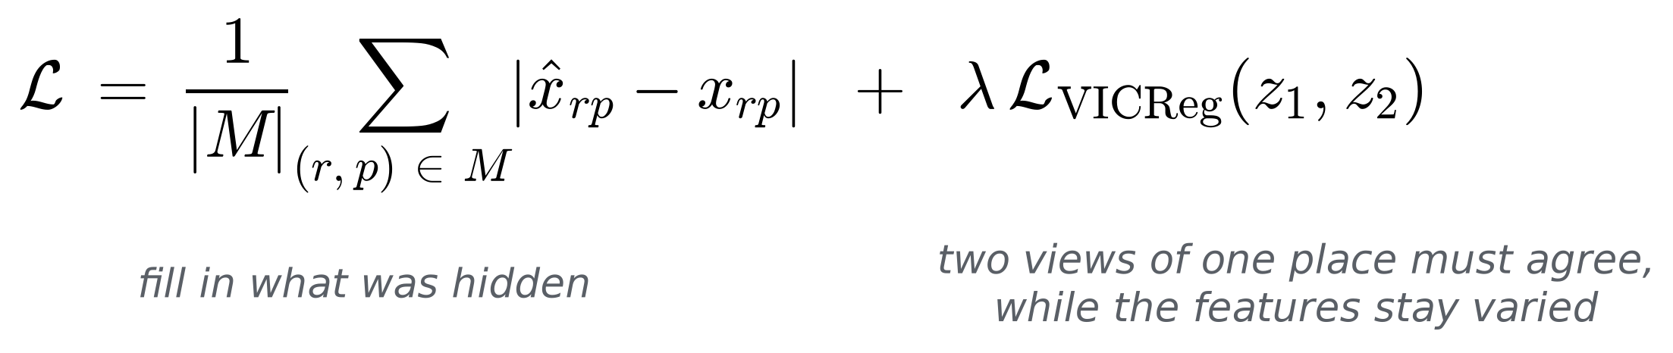
Only after that do labels enter, and only to train a small classification head on top of the frozen-then-fine-tuned encoder. The whole point is to measure how few labels are enough.

The headline: a working detector from 210 examples
We compared four things on data from the 1000 Genomes Project — a panel of six people spanning five continental ancestries, with a seventh held back entirely for testing. The comparison covers our tensor model with pre-training, the identical network trained from scratch, a re-implementation of the 2019 colour-image representation, and, as a sanity check, twelve hand-computed summary numbers fed to classical machine learning.
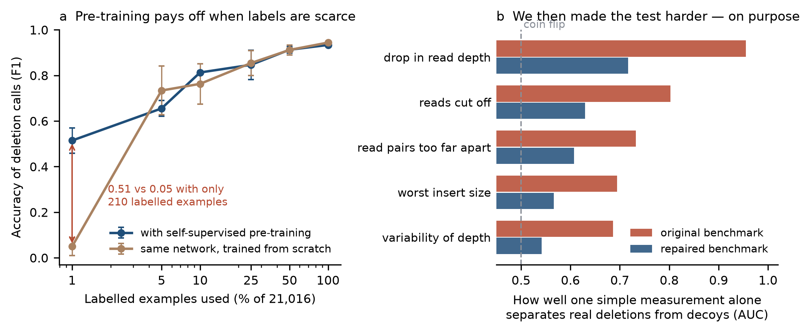
Figure 2. Panel a: accuracy against the number of labelled examples used, for our network with and without self-supervised pre-training. The advantage is largest where labels are scarcest. Panel b: how well a single simple measurement, on its own and with no training at all, separates real deletions from decoys — on the original benchmark and on our repaired one.
Panel a is the result we set out to get. With 210 labelled examples — one per cent of the training set — the pre-trained model reaches an accuracy of 0.51 while the same architecture from scratch reaches 0.05 — a tenfold difference in accuracy. By five per cent of labels the from-scratch model has caught up, and at full supervision it is in fact a hair ahead. Pre-training buys label efficiency, not a higher ceiling, and we say so.

The result we did not go looking for
Then the sanity check misbehaved. Those twelve hand-computed numbers, fed to a gradient-boosted tree, scored 0.894 from the same 210 labels — better than every neural network in the comparison. Worse, a single one of them, the ratio of read depth in the middle of the window to read depth at its edges, separated deletions from non-deletions at an AUC of 0.955 with no training whatsoever.
That is not a story about neural networks. It is a story about the test. The standard way to build such a benchmark is to take known deletions as positive examples and pick random genomic windows as negatives. Random windows are almost never anything like a deletion, so a coverage dip alone gives the answer away. Every method in the comparison, ours included, was largely being scored on how fast it rediscovers one obvious heuristic.
So we rebuilt the benchmark. Instead of random negatives we selected decoys that a real caller would actually have to adjudicate — windows matched to the true deletions on their depth profile, so the easy shortcut is taken away. On this harder task the depth ratio drops from 0.955 to 0.717 (Figure 2b): attenuated, not eliminated, and we report it that way.
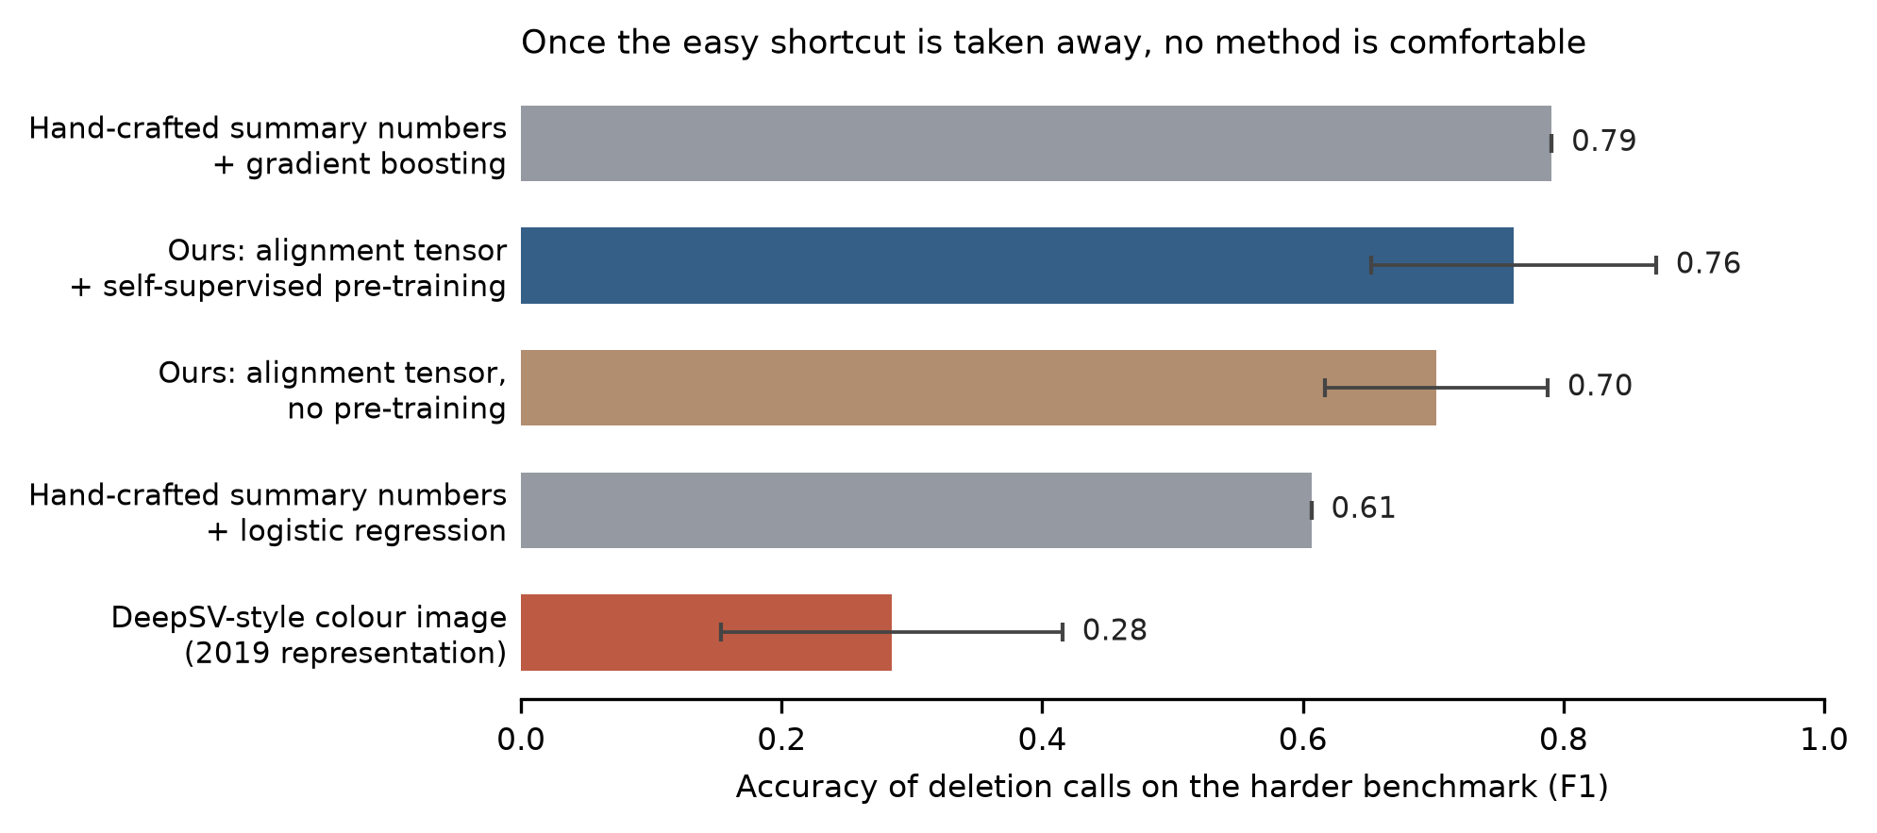
Figure 3. Final accuracy of every approach once the easy shortcut has been removed. Bars show the mean over three independent runs; whiskers show the spread between runs.
Every method falls on the harder benchmark, which is the point of a harder benchmark. Three things survive the change. The label-efficiency result not only survives but sharpens: with one per cent of labels the pre-trained model scores 0.352 and the from-scratch model scores exactly zero. The 2019-style colour representation collapses to 0.28, well below everything else, which is evidence that keeping the aligner's numbers instead of painting them into pixels is worth doing. And the hand-crafted features still lead, at 0.79 against our 0.76.
We could have quietly kept the first benchmark, reported the low-label result, and stopped. The comparison would have looked better. We think the field is better served by the honest version: pileup-style benchmarks built this way cannot support claims about how a caller will behave in practice, and fixing the negative sampling helps but does not finish the job.

How the team worked
Seven of us, in three countries and several time zones, working on a shared university cluster with a hard limit of ten CPUs per user and four GPUs shared with everyone else. Almost every practical decision in the project was shaped by that constraint rather than by the science.
The work split naturally into streams that could run in parallel: getting sequencing data down from public archives and indexed; turning alignments into tensors at scale; the self-supervised pre-training runs; the supervised evaluation and baselines; benchmark design and the statistics; and writing. People moved between streams as the bottleneck moved.
Three habits did most of the work. Everything lived in one public Git repository from the first week, so there was never a private version of the truth. Every number that appears in a figure or in the manuscript is read at build time from a results table that a job on the cluster wrote — nobody types a number by hand, and an automated check refuses to build the paper if a quoted value and its table disagree. And we ran deliberate adversarial review passes on our own work, where one person's job was to attack the result rather than defend it.
That last habit is what produced the interesting half of this project. The hand-crafted-feature control was added as a formality, to have something unflattering to compare against. It won. Taking that seriously, rather than filing it as an anomaly, is the reason there is a negative result to report.
What we learned along the way was mostly unglamorous and mostly transferable: that a shared filesystem can disappear overnight and your recovery plan is only as good as what you wrote down; that a sixty-six-gigabyte array read from network storage will starve a GPU until you stage it into local memory; that a test which imports a library the cluster does not have will fail two hours into a job instead of two seconds into it, unless you write it not to; and that the difference between a result and a publishable result is mostly the controls you ran.

What is left
Several things did not get done. We had planned to validate against the Genome in a Bottle reference sample, the gold standard in this field, and that is still outstanding. Partway through, the shared data workspace holding our sequencing files was lost, and only two of the seven alignments survived; the repaired benchmark therefore rests on a single sample rather than the full panel, which is a real limitation and is labelled as one in the paper. And we only ever attacked deletions. Insertions, inversions and duplications are all harder and all left open.
The near-term plan is to close the gold-standard validation, put the repaired benchmark on the full panel once the data are restaged, and add a head that predicts where the deletion starts and ends rather than only whether one is present. The longer-term question is the one this project backed into: if the standard benchmarks in a field cannot distinguish a twelve-number heuristic from a deep network, then building better benchmarks is worth more than building better networks, and that is where we would rather spend the next year.
The code, the extraction pipeline, every results table and every figure are public at github.com/aayushkrm/AlignSSL-SV under an MIT licence.

